SOFTWARE REQUIREMENTS SPECIFICATION
Smart Complaint Management System
Project ID: 67
B.Tech. (CSE) – Software Engineering Mini Project
PES University, Bengaluru

Prepared by: GPNA
Version 1.0
September 2026

Revision History
Version | Date | Description
1.0 | September 2026 | Initial SRS version for the Smart Complaint Management System.

Table of Contents
1. Introduction
2. Overall Description
3. External Interface Requirements
4. System Features
5. Non-Functional Requirements
6. Other Requirements
7. Use Cases
8. Data Requirements
9. Business Rules
10. Analysis Models
11. Requirement Traceability Matrix
Appendix A – Glossary
Appendix B – Field Layouts

1. Introduction

1.1 Purpose
This Software Requirements Specification (SRS) defines the requirements for the Smart Complaint Management System. The system is intended to provide a centralized platform for submitting, categorizing, prioritizing, assigning, tracking, escalating, and resolving complaints. It serves as the baseline for design, implementation, testing, and validation of the project.

1.2 Intended Audience
This document is intended for the project team, faculty evaluators, developers, testers, project coordinators, administrators, and end users. It provides a common understanding of the system scope, functional requirements, interfaces, constraints, and quality requirements.

1.3 Product Scope
The system will allow users to lodge complaints and monitor their status while administrators or authorized staff can categorize, prioritize, assign, update, escalate, and resolve complaints. An administrative dashboard will provide an overview of complaint volume, status, priority, and resolution performance.

1.4 References
- PES University, Department of Computer Science and Engineering, Jackfruit – Software Engineering Mini-Project Guidelines 2026.
- Smart Complaint Management System – Project Proposal, Project ID 67.

1.5 Definitions and Acronyms
Term | Definition
SRS | Software Requirements Specification
SLA | Service Level Agreement; target time for handling a complaint
Complaint | A problem or issue submitted by a registered user
Admin | Authorized user responsible for system-level management
Priority | Urgency level assigned to a complaint
Escalation | Transfer or elevation of a complaint when it exceeds defined handling conditions

2. Overall Description

2.1 Product Perspective
The Smart Complaint Management System is a web-based, database-driven application. It provides a centralized alternative to informal complaint handling by maintaining complaint records and their lifecycle in one system.

2.2 Product Functions
- User registration and authentication.
- Complaint submission with category, description, and optional supporting information.
- Complaint categorization and priority assignment.
- Complaint assignment to authorized staff or departments.
- Complaint status tracking from submission to resolution.
- SLA/deadline tracking and escalation of overdue complaints.
- Notifications for important complaint status changes.
- Administrative dashboard and complaint reports.
- Complaint history and resolution records.

2.3 User Classes and Characteristics
User Class | Responsibilities
User | Register/login, submit complaints, view submitted complaints, track status, and provide feedback.
Staff/Resolver | View assigned complaints, update status, add resolution details, and handle complaints within SLA.
Administrator | Manage users, categories, priorities, assignments, escalation rules, and dashboard/reporting functions.

2.4 Operating Environment
- Web browser such as Google Chrome, Microsoft Edge, or Mozilla Firefox.
- Application server capable of running the selected backend framework.
- Relational database management system.
- Internet or local network connectivity for client-server communication.

2.5 Design and Implementation Constraints
- The system should use role-based access to restrict privileged functions.
- Complaint status transitions should follow defined business rules.
- Input validation must be applied to user-entered data.

2.6 Assumptions and Dependencies
- Users have access to a supported web browser.
- Administrators and staff are authorized by the system owner.
- SLA durations and escalation rules are configured by the administrator.
- The system is initially intended for a controlled organization such as a college, department, or service organization.
- The project will use a suitable web development stack and relational database selected by the team.
- External notification services, if used, may require separate configuration and credentials.

3. External Interface Requirements

3.1 User Interface
- Login and registration screens.
- Complaint submission form.
- User complaint list and complaint-detail screen.
- Staff dashboard showing assigned and pending complaints.
- Administrator dashboard with filters, status summaries, and reports.

3.2 Software Interfaces
- Relational database for persistent storage of users, complaints, categories, assignments, status history, and related records.
- Backend application interface for processing requests and enforcing business rules.

3.3 Communications Interfaces
- The web client and server shall communicate using HTTP/HTTPS.
- The system shall provide in-app notifications for important complaint events. Where configured, notifications may also be delivered through external channels such as email, SMS, and WhatsApp.

4. System Features

4.1 User and Authentication Management
Priority: High
- FR-01: The system shall allow users to register using required details.
- FR-02: The system shall authenticate users before granting access to protected functions.
- FR-03: The system shall provide role-based access for users, staff, and administrators.
- FR-04: The system shall reject invalid login credentials.

4.2 Complaint Submission and Tracking
Priority: High
- FR-05: The system shall allow an authenticated user to submit a complaint.
- FR-06: A complaint shall contain a unique identifier, category, description, priority, creator, date/time, and status.
- FR-07: The user shall be able to view the current status and history of their complaints.
- FR-08: The system shall prevent submission when mandatory fields are missing.

4.3 Categorization and Priority Management
Priority: High
- FR-09: The system shall classify complaints using predefined categories.
- FR-10: Authorized staff shall be able to assign or modify complaint priority according to defined rules.
- FR-11: The system shall support multiple priority levels such as Low, Medium, High, and Critical.

4.4 Assignment and Resolution
Priority: High
- FR-12: Administrators or authorized staff shall assign complaints to appropriate staff members or departments.
- FR-13: Assigned staff shall be able to update complaint status.
- FR-14: Authorized staff shall record resolution details before marking a complaint as resolved.
- FR-15: The system shall maintain complaint status history.

4.5 SLA Monitoring and Escalation
Priority: Medium
- FR-16: The system shall associate applicable SLA/deadline information with complaints.
- FR-17: The system shall identify complaints approaching or exceeding their SLA.
- FR-18: The system shall escalate eligible overdue complaints according to configured rules.
- FR-19: Escalated complaints shall be visible to authorized administrators.

4.6 Notifications
Priority: Medium
- FR-20: The system shall notify users when significant complaint status changes occur.
- FR-21: The system shall support notifications for newly assigned, status-changed, or escalated complaints through in-app notifications and, where configured, external channels such as email, SMS, and WhatsApp.

4.7 Dashboard and Reporting
Priority: Medium
- FR-22: Administrators shall be able to view complaint counts by status, category, and priority.
- FR-23: The dashboard shall support filtering of complaint records.
- FR-24: The system shall provide summary information useful for monitoring resolution performance.

5. Non-Functional Requirements

5.1 Performance
- NFR-01: The system should respond to normal user requests within 3 seconds under the expected project workload.
- Database queries should be designed to avoid unnecessary duplicate processing.

5.2 Safety
- NFR-02: The system shall avoid destructive operations without appropriate authorization or confirmation where applicable.
- NFR-03: Complaint data shall remain consistent when records are updated or resolved.

5.3 Security
- NFR-04: Passwords shall not be stored in plain text.
- NFR-05: Protected functions shall require authentication.
- NFR-06: Role-based authorization shall prevent unauthorized access to administrative functions.
- NFR-07: User input shall be validated to reduce invalid or malicious input.

5.4 Usability
- The interface should be clear and consistent across major screens.
- Complaint status and required actions should be easy for users to understand.

5.5 Reliability
- Complaint records should remain consistent throughout status and assignment changes.
- The system should handle invalid inputs without crashing.

5.6 Maintainability
- The application should use modular components so individual features can be modified with minimal impact on other features.
- Code and database structures should be documented sufficiently for future maintenance.

5.7 Software Quality Attributes
- The system should be usable, reliable, secure, maintainable, and sufficiently performant for the expected project workload.
- The system should support modular development and testing of individual features.

6. Other Requirements

6.1 Database Requirements
The database shall persist user accounts, roles, complaint details, categories, priorities, assignments, status history, SLA information, notifications, and resolution details.

6.2 Data Validation
- Mandatory fields shall be validated.
- Invalid identifiers, dates, and status transitions shall be rejected.
- Only authorized roles shall modify protected data.

7. Use Cases
Use Case | Primary Actor | Description
Register/Login | User | Creates an account or authenticates into the system.
Submit Complaint | User | Creates and submits a new complaint.
Track Complaint | User | Views complaint status and history.
Assign Complaint | Admin/Staff | Assigns a complaint to a resolver or department.
Update Complaint | Staff | Updates status and resolution information.
Escalate Complaint | System/Admin | Escalates eligible overdue or high-priority complaints.
Manage Users/Categories | Admin | Maintains users and complaint categories.
View Reports | Admin | Views complaint summaries and performance information.

8. Data Requirements
Entity | Key Information
User | User ID, name, email, password hash, role, account status
Complaint | Complaint ID, user ID, category, description, priority, status, created date
Category | Category ID, category name, description
Assignment | Assignment ID, complaint ID, staff ID, assigned date
Status History | History ID, complaint ID, old status, new status, timestamp
SLA | SLA ID, complaint/priority reference, target duration, deadline
Notification | Notification ID, recipient, message, timestamp, read status
Resolution | Resolution ID, complaint ID, resolver, resolution details, resolved date

9. Business Rules
- BR-01: A complaint must be submitted by an authenticated user.
- BR-02: Every complaint must have a valid category and priority.
- BR-03: Only authorized staff or administrators may assign complaints.
- BR-04: Only authorized staff may update the processing status of an assigned complaint.
- BR-05: A complaint cannot be marked Resolved without resolution details.
- BR-06: SLA deadlines shall be determined using the configured priority/category rules.
- BR-07: A complaint that exceeds its applicable SLA may be escalated according to the configured escalation rule.
- BR-08: Users may view only complaints they are authorized to access.
- BR-09: Administrative functions shall be restricted to administrator roles.
- BR-10: Status history shall be retained when a complaint status changes.

10. Analysis Models

10.1 Use Case Model
The following basic UML Use Case Diagram identifies the principal actors and their major interactions with the system.
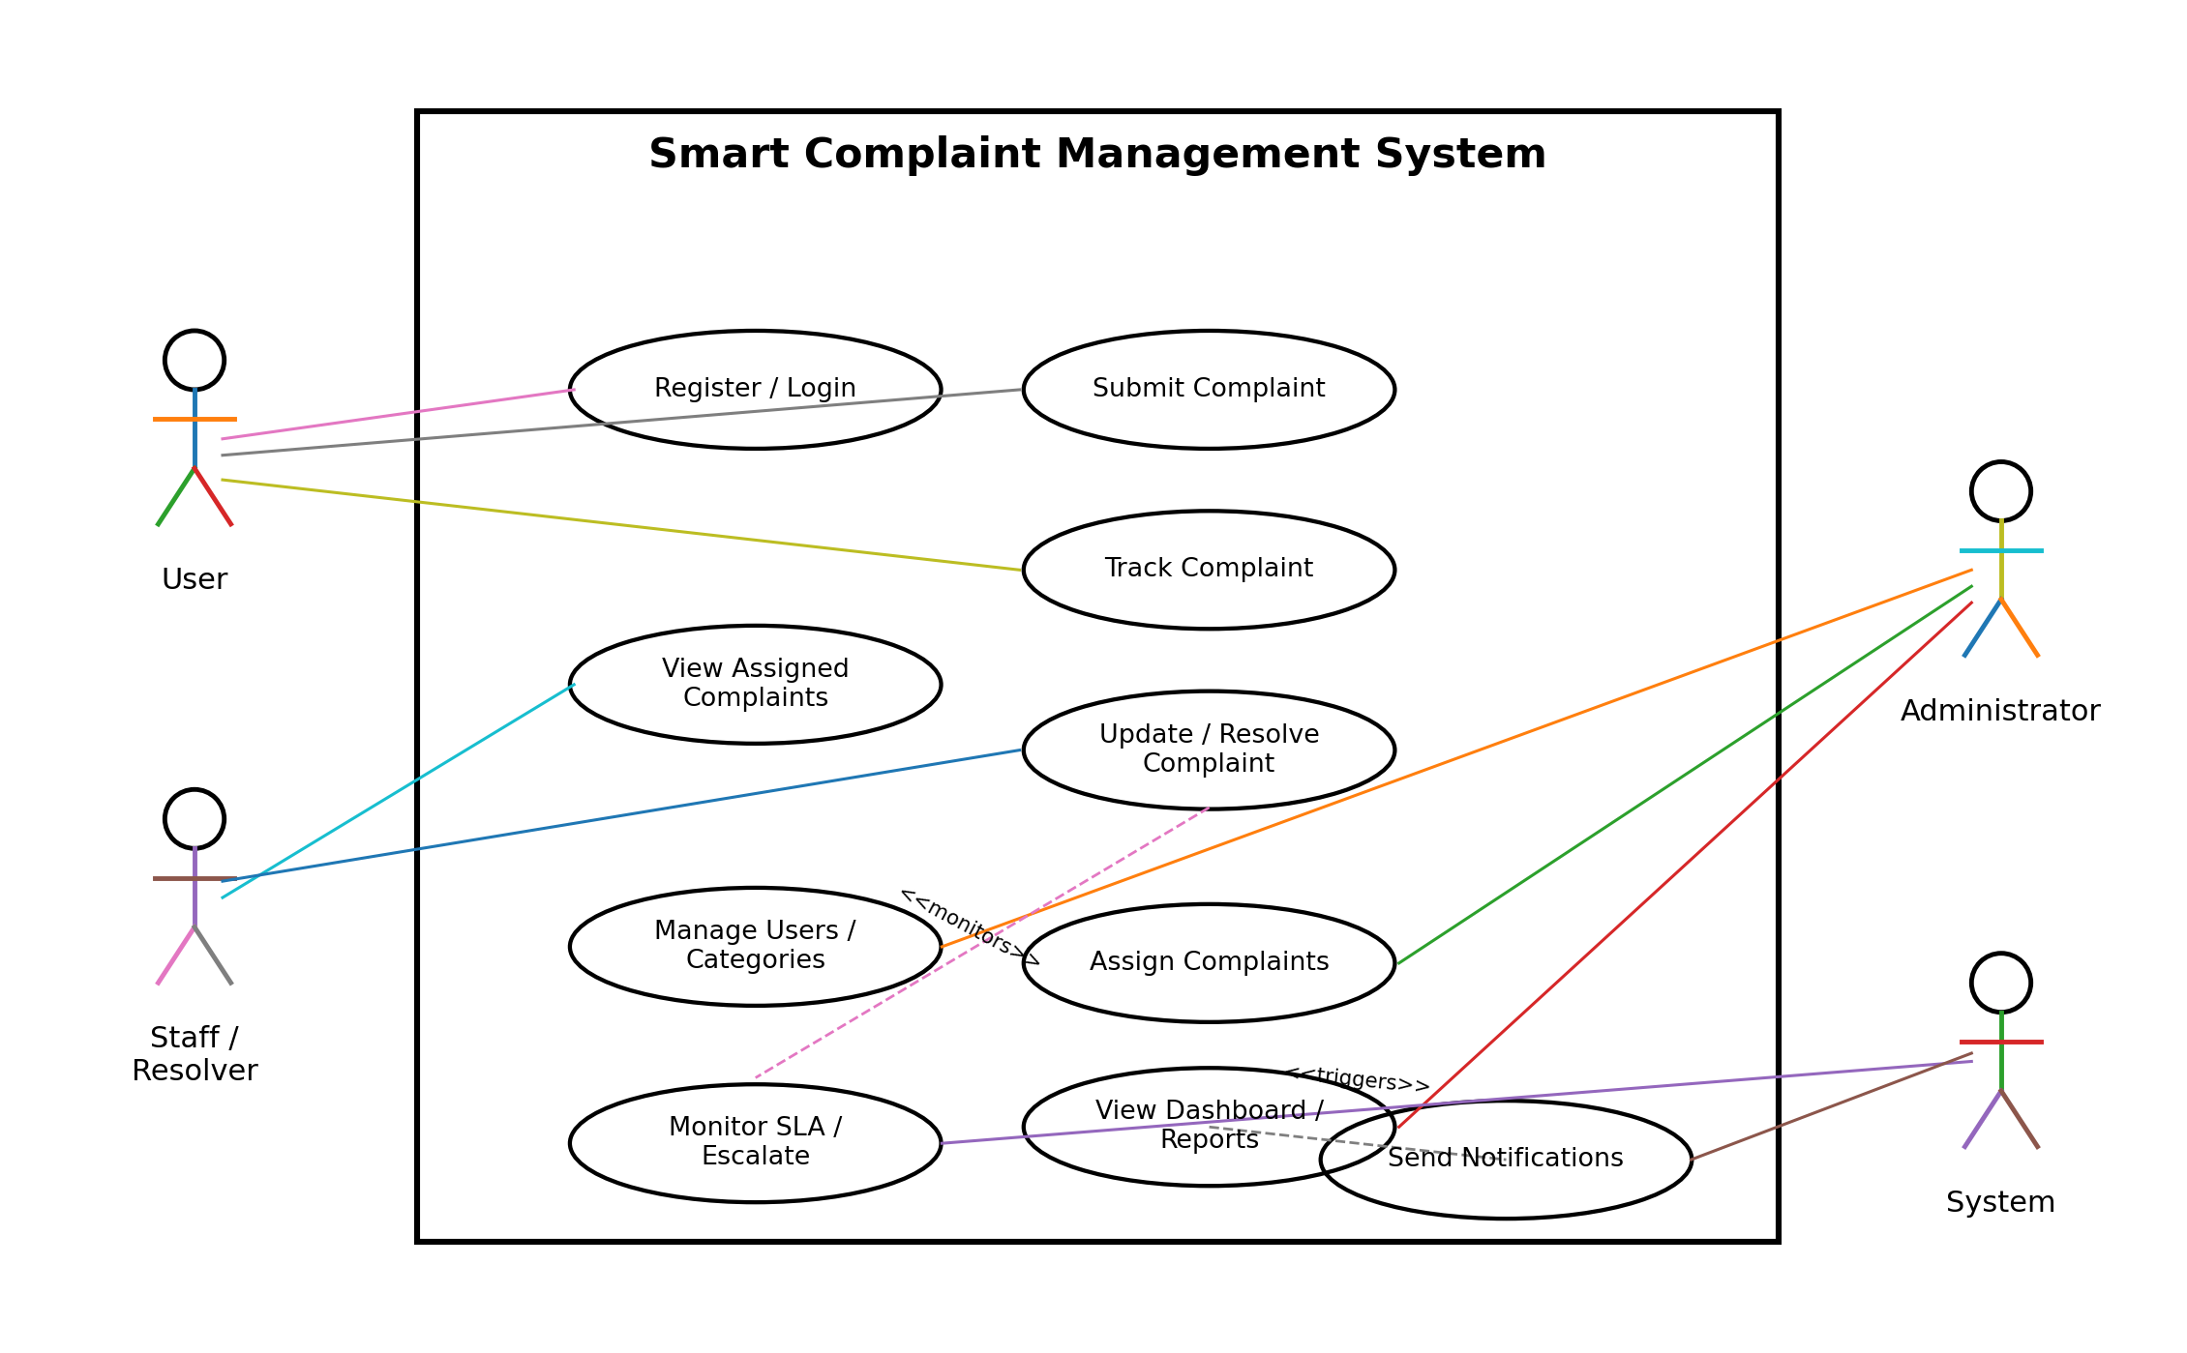
Figure 1. Basic UML Use Case Diagram – Smart Complaint Management System
Actor | Main Use Cases
User | Register/Login; Submit Complaint; Track Complaint
Staff/Resolver | View Assigned Complaints; Update Complaint; Resolve Complaint
Administrator | Manage Users/Categories; Assign Complaints; Configure Priority/SLA; View Dashboard/Reports
System | Monitor SLA; Trigger Eligible Escalations; Generate Notifications

10.2 High-Level Workflow
The basic complaint workflow is: User Login → Submit Complaint → Categorize/Prioritize → Assign to Staff/Department → Process and Update Status → Monitor SLA → Escalate if required → Resolve Complaint → Record Resolution → User Views Final Status.

11. Requirement Traceability Matrix
Requirement ID | Requirement | Related Use Case | Planned Validation
FR-01–FR-04 | User registration and authentication | Register/Login | Authentication and invalid-login tests
FR-05–FR-08 | Complaint submission and tracking | Submit/Track Complaint | Valid/invalid submission and tracking tests
FR-09–FR-11 | Categorization and priority | Submit Complaint / Update Complaint | Category and priority validation tests
FR-12–FR-15 | Assignment, status updates, and resolution | Assign/Update Complaint | Assignment and resolution workflow tests
FR-16–FR-19 | SLA monitoring and escalation | Escalate Complaint | SLA and escalation tests
FR-20–FR-21 | In-app and external notifications | Notification Management | Notification trigger/channel tests
FR-22–FR-24 | Dashboard and reporting | View Reports | Dashboard, filtering, and report tests
NFR-04–NFR-06 | Authentication and role-based security | All protected use cases | Authorization and security tests
NFR-07 | Input validation | All data-entry use cases | Boundary and invalid-input tests
NFR-01 | Performance | Normal system operations | Response-time tests under expected project workload
NFR-02–NFR-03 | Safety and data consistency | Data update/resolution workflows | Safety and consistency tests

Appendix A – Glossary
Term | Meaning
Complaint | Issue submitted by a user for handling and resolution.
SLA | Target time for handling or resolving a complaint.
Escalation | Process of elevating a complaint when defined handling conditions are exceeded.
Resolver | Staff member responsible for processing and resolving a complaint.
Priority | Urgency level assigned to a complaint.
Status History | Record of changes made to a complaint's status over time.

Appendix B – Field Layouts

B.1 Complaint Submission Form
Field | Type | Required | Description
Category | Selection | Yes | Category of the complaint.
Description | Text area | Yes | Detailed description of the issue.
Priority | Selection | Yes | Initial priority of the complaint.
Supporting Information | Text/File | Optional | Additional information or evidence, where supported.

B.2 Complaint Details
Field | Description
Complaint ID | Unique identifier for the complaint.
Created Date/Time | Date and time the complaint was submitted.
Category | Assigned complaint category.
Priority | Current urgency level.
Status | Current complaint lifecycle status.
Assigned Staff/Department | Current resolver or responsible department.
SLA Deadline | Applicable target date/time.
Resolution Details | Information recorded when the complaint is resolved.
End of Software Requirements Specification

