PES UNIVERSITY, BENGALURU
Department of Computer Science and Engineering (AI&ML)
B.Tech. (CSE) – V Semester

UE24CS341A – SOFTWARE ENGINEERING
PROJECT REPORT
ON
SMART COMPLAINT MANAGEMENT SYSTEM
Project ID: 67

SUBMITTED BY
Name | SRN
Purum Gurudev | PES2UG24AM125
Prashyanth V | PES2UG24AM120
Aditya Pradeep | PES2UG24AM900
Nihar S Jain | PES2UG24AM104

Team: Gundu Guru
Sections 1–6 Working Baseline
October 2026

Revision History
Version | Date | Description
0.1 | October 2026 | Initial consolidated project report covering Sections 1–4. Sections 5 (Test Cases) and 6 (Screenshots of Output) will be appended after final execution and evidence capture.
0.2 | October 2026 | Added Section 5: Test Cases using manual UI evidence and the approved automated test-case catalogue/results.
0.3 | October 2026 | Added Section 6: Screenshots of Output using representative application outputs captured during implementation-phase verification.

Contents
1. Proposal of the Project
1.1 Problem Statement
1.2 Proposed Solution
1.3 Objectives
1.4 Scope
1.5 Major Features
1.6 User Roles
1.7 Technology Stack
1.8 Expected Outcome
2. Software Requirements Specification
2.1 Purpose and Audience
2.2 Product Perspective
2.3 Product Functions
2.4 User Classes
2.5 Operating Environment
2.6 Interfaces
2.7 Functional Requirements
2.8 Non-Functional Requirements
2.9 Other Requirements
2.10 Use Cases
2.11 Data Requirements
2.12 Business Rules
2.13 Requirement Traceability
3. Project Plan
3.1 Project Overview
3.2 Development Lifecycle
3.3 Tools and Infrastructure
3.4 Deliverables and Reuse/Build Classification
3.5 Team Responsibilities
3.6 Work Breakdown Structure
3.7 Effort Estimation
3.8 Project Schedule and Gantt Chart
3.9 Sprint Plan
3.10 Risks and Mitigation
3.11 Definition of Done
3.12 Project Tracking and Reporting
4. Design Diagrams
4.1 Design Overview
4.2 System Context Diagram
4.3 Logical Component View
4.4 Deployment View
4.5 Use Case Diagram
4.6 Entity-Relationship / Domain Model
4.7 Complaint State Model
4.8 Sequence Design
4.9 Activity / Workflow Design
5. Test Cases
5.1 Test Case Format and Evidence
5.2 Manual UI Verification Summary
5.3 Automated Test Case Catalogue
5.4 Automated Test Results
5.5 Coverage and Performance Evidence
5.6 Defect / Warning Note
6. Screenshots of Output

1. Proposal of the Project
The Smart Complaint Management System is a web-based, database-driven application proposed to replace fragmented or informal complaint handling with a centralized workflow. The proposal establishes the problem, the intended solution, the users, the major features, and the expected outcome that form the basis for the later software engineering phases.

1.1 Problem Statement
Complaint handling in a controlled organization such as a college, department, or service organization can become difficult when complaints are submitted through informal channels and are not tracked consistently. The project addresses the need for a centralized mechanism through which complaints can be registered, categorized, prioritized, assigned, tracked, escalated when required, and resolved while preserving status history and resolution information.

1.2 Proposed Solution
The proposed system provides a single web-based platform with role-based access for users, staff/resolvers, and administrators. Users can submit and track complaints. Authorized staff can process assigned complaints and record resolutions. Administrators can manage users and categories, configure priority and SLA rules, assign complaints, observe escalations, and view dashboard/reporting information. In-app notifications form the baseline notification mechanism, with external channels available where configured.

1.3 Objectives
- Provide a centralized complaint submission and tracking platform.
- Enforce role-based access for user, staff/resolver, and administrator activities.
- Maintain an explicit complaint lifecycle with status history and resolution records.
- Provide SLA monitoring and configurable escalation handling for overdue complaints.
- Provide notification, dashboard, filtering, and reporting capabilities.
- Demonstrate an Agile software development lifecycle with traceability, testing, CI/CD, security validation, and maintainable modular design.

1.4 Scope
The implemented scope follows the approved SRS baseline: authentication and account management; complaint submission and tracking; categorization and priority handling; assignment, status updates, and resolution; SLA monitoring and escalation; in-app and configurable external notification boundaries; and administrative dashboard/reporting. Functions outside this baseline are treated as future or separately configured capabilities rather than silently included in the core scope.

1.5 Major Features
Feature | Purpose
User registration and authentication | Create accounts, authenticate users, and protect privileged functions.
Complaint submission and tracking | Create complaints and allow authorized users to view current status and history.
Categorization and priority | Classify complaints and apply Low, Medium, High, or Critical priority levels.
Assignment and resolution | Assign complaints to authorized staff, update processing status, and record resolution details.
SLA monitoring and escalation | Associate deadlines, identify overdue complaints, and escalate eligible cases according to configured rules.
Notifications | Create in-app notifications for important complaint events and support configurable external notification adapters.
Dashboard and reporting | Provide complaint counts, filtering, and summary information for administrative monitoring.

1.6 User Roles
Role | Responsibilities
User | Register/login, submit complaints, view submitted complaints, track status and history.
Staff / Resolver | View assigned complaints, update status, process complaints, and record resolutions.
Administrator | Manage users and categories, assign complaints, configure priority/SLA rules, observe escalations, and view dashboard/reports.

1.7 Technology Stack
Layer / Area | Selected Technology
Frontend | HTML, CSS, JavaScript / lightweight web UI
Backend | Python + FastAPI REST API
Database | PostgreSQL
Testing | Pytest, API/client testing, Playwright, Node front-end tests
Version Control | Git + GitHub
CI/CD | Jenkins
Containerization | Docker
Static Analysis | Ruff; SonarQube or equivalent identified in the project plan
Design / Documentation | Draw.io / PlantUML and Microsoft Word

1.8 Expected Outcome
The expected outcome is a working complaint-management application whose implemented functionality can be demonstrated end-to-end and whose development evidence can be traced from requirements through architecture, detailed design, implementation, testing, validation, and final demonstration. The project is intended to demonstrate not only features but also the software engineering practices required by the course guidelines.

2. Software Requirements Specification
This section consolidates the approved SRS baseline into the final project report. It preserves the requirement identifiers used throughout the project so that the later design, test, and validation evidence remains traceable.

2.1 Purpose and Audience
The SRS defines the requirements for the Smart Complaint Management System and serves as the baseline for design, implementation, testing, and validation. The intended readers are the project team, faculty evaluators, developers, testers, project coordinators, administrators, and end users.

2.2 Product Perspective
The Smart Complaint Management System is a web-based, database-driven application that provides a centralized alternative to informal complaint handling by maintaining complaint records and their lifecycle in one system.

2.3 Product Functions
- User registration and authentication.
- Complaint submission with category, description, and optional supporting information.
- Complaint categorization and priority assignment.
- Complaint assignment to authorized staff or departments.
- Complaint status tracking from submission to resolution.
- SLA/deadline tracking and escalation of overdue complaints.
- Notifications for important complaint status changes.
- Administrative dashboard and complaint reports.
- Complaint history and resolution records.

2.4 User Classes
User Class | Characteristics and Responsibilities
User | General end user who registers/logs in, submits complaints, and tracks the complaints they are authorized to view.
Staff / Resolver | Authorized operational user who handles assigned complaints, changes processing status, and records resolutions.
Administrator | Privileged user responsible for user/category administration, assignment, SLA configuration, escalation visibility, and reporting.

2.5 Operating Environment
- Supported web browser such as Google Chrome, Microsoft Edge, or Mozilla Firefox.
- Application server capable of running the selected backend framework.
- Relational database management system using PostgreSQL for the implementation baseline.
- Internet or local network connectivity for client-server communication.

2.6 External Interfaces

2.6.1 User Interface
- Login and registration screens.
- Complaint submission form.
- User complaint list and complaint-detail screen.
- Staff dashboard showing assigned and pending complaints.
- Administrator dashboard with filters, status summaries, and reports.

2.6.2 Software Interfaces
The application uses a relational database for users, complaints, categories, assignments, status history, SLA information, notifications, and resolutions. The backend application interface processes requests and enforces validation and business rules.

2.6.3 Communications Interfaces
The web client and server communicate using HTTP/HTTPS. The system provides in-app notifications for important complaint events, with external notification channels such as email, SMS, and WhatsApp available where configured.

2.7 Functional Requirements
ID | Feature Group | Priority | Requirement
FR-01 | User and Authentication Management | High | Allow users to register using required details.
FR-02 | User and Authentication Management | High | Authenticate users before granting access to protected functions.
FR-03 | User and Authentication Management | High | Provide role-based access for users, staff, and administrators.
FR-04 | User and Authentication Management | High | Reject invalid login credentials.
FR-05 | Complaint Submission and Tracking | High | Allow an authenticated user to submit a complaint.
FR-06 | Complaint Submission and Tracking | High | Store a unique identifier, category, description, priority, creator, date/time, and status for each complaint.
FR-07 | Complaint Submission and Tracking | High | Allow users to view current status and history of their complaints.
FR-08 | Complaint Submission and Tracking | High | Prevent submission when mandatory fields are missing.
FR-09 | Categorization and Priority Management | High | Classify complaints using predefined categories.
FR-10 | Categorization and Priority Management | High | Allow authorized staff to assign or modify complaint priority according to defined rules.
FR-11 | Categorization and Priority Management | High | Support Low, Medium, High, and Critical priority levels.
FR-12 | Assignment and Resolution | High | Allow administrators or authorized staff to assign complaints to appropriate staff members or departments.
FR-13 | Assignment and Resolution | High | Allow assigned staff to update complaint status.
FR-14 | Assignment and Resolution | High | Require resolution details before a complaint is marked resolved.
FR-15 | Assignment and Resolution | High | Maintain complaint status history.
FR-16 | SLA Monitoring and Escalation | Medium | Associate applicable SLA/deadline information with complaints.
FR-17 | SLA Monitoring and Escalation | Medium | Identify complaints approaching or exceeding their SLA.
FR-18 | SLA Monitoring and Escalation | Medium | Escalate eligible overdue complaints according to configured rules.
FR-19 | SLA Monitoring and Escalation | Medium | Make escalated complaints visible to authorized administrators.
FR-20 | Notifications | Medium | Notify users when significant complaint status changes occur.
FR-21 | Notifications | Medium | Support notifications for newly assigned, status-changed, or escalated complaints through in-app notifications and configured external channels.
FR-22 | Dashboard and Reporting | Medium | Allow administrators to view complaint counts by status, category, and priority.
FR-23 | Dashboard and Reporting | Medium | Support filtering of complaint records on the dashboard.
FR-24 | Dashboard and Reporting | Medium | Provide summary information useful for monitoring resolution performance.

2.8 Non-Functional Requirements
ID | Attribute | Requirement
NFR-01 | Performance | Normal user requests should respond within 3 seconds under expected project workload; avoid unnecessary duplicate processing.
NFR-02 | Safety | Avoid destructive operations without appropriate authorization or confirmation where applicable.
NFR-03 | Data consistency | Complaint data shall remain consistent when records are updated or resolved.
NFR-04 | Password security | Passwords shall not be stored in plain text.
NFR-05 | Authentication | Protected functions shall require authentication.
NFR-06 | Role-based authorization | Unauthorized users shall be prevented from accessing administrative functions.
NFR-07 | Input validation | User input shall be validated to reduce invalid or malicious input.
— | Usability | The interface should be clear and consistent and complaint status/actions should be easy to understand.
— | Reliability | Complaint records should remain consistent and invalid inputs should not crash the system.
— | Maintainability | The application should use modular components so individual features can be modified with minimal impact on others.

2.9 Other Requirements

2.9.1 Database Requirements
The database shall persist user accounts, roles, complaint details, categories, priorities, assignments, status history, SLA information, notifications, and resolution details.

2.9.2 Data Validation
Mandatory fields shall be validated. Invalid identifiers, dates, and status transitions shall be rejected. Only authorized roles shall modify protected data.

2.10 Use Cases
ID | Use Case | Primary Actors | Summary
UC-01 | Register / Login | User, Staff, Administrator | Create an account or authenticate to obtain authorized access.
UC-02 | Submit Complaint | User | Create a complaint with category, priority, and description.
UC-03 | Track Complaint | User | View current complaint status and status history.
UC-04 | Update Complaint | Staff / Administrator | Update processing fields and status within authorized rules.
UC-05 | Assign Complaint | Staff / Administrator | Assign a complaint to an authorized resolver.
UC-06 | Resolve Complaint | Staff / authorized administrator | Record resolution details and transition the complaint to RESOLVED.
UC-07 | Monitor / Escalate SLA | Background Scheduler, Staff, Administrator | Monitor deadlines and escalate eligible overdue complaints.
UC-08 | Notifications / Reports | System, User, Staff, Administrator | Generate/consume notifications and provide dashboard/report summaries.

2.11 Data Requirements
Entity | Purpose | Key Data
User | Stores identities, roles, and account state. | user_id, name, email, password_hash, role, account_status
Category | Controlled vocabulary for complaint classification. | category_id, name, description, active_flag
Complaint | Core complaint record. | complaint_id, user_id, category_id, priority, status, description, created_at, updated_at
Assignment | Tracks resolver ownership over time. | assignment_id, complaint_id, staff_id, assigned_at, ended_at
StatusHistory | Records complaint state transitions. | history_id, complaint_id, old_status, new_status, changed_by, changed_at
SLA | Stores applicable deadline and escalation state. | sla_id, complaint_id, target_duration, deadline, escalation_level, escalated_at
Notification | Stores notification events and read/delivery state. | notification_id, recipient_id, complaint_id, event_type, message, channel, read_status
Resolution | Stores resolution details and resolver information. | resolution_id, complaint_id, resolver_id, resolution_details, resolved_at

2.12 Business Rules
Rule | Business Rule
BR-01 | A complaint must be submitted by an authenticated user.
BR-02 | Every complaint must have a valid category and priority.
BR-03 | Only authorized staff or administrators may assign complaints.
BR-04 | Only authorized staff may update the processing status of an assigned complaint.
BR-05 | A complaint cannot be marked Resolved without resolution details.
BR-06 | SLA deadlines shall be determined using configured priority/category rules.
BR-07 | A complaint that exceeds its applicable SLA may be escalated according to the configured escalation rule.
BR-08 | Users may view only complaints they are authorized to access.
BR-09 | Administrative functions shall be restricted to administrator roles.
BR-10 | Status history shall be retained when a complaint status changes.

2.13 Requirement Traceability
The SRS groups the requirements into the following traceability blocks, which are carried forward into the architecture, software design, automated tests, and system validation records.
Requirement Group | Related Use Case(s) | Primary Design / Validation Focus
FR-01–FR-04 | UC-01 | Authentication service, role-based access, login/registration validation.
FR-05–FR-08 | UC-02, UC-03 | Complaint service, complaint schema, submission and tracking tests.
FR-09–FR-11 | UC-02, UC-04 | Category and priority validation.
FR-12–FR-15 | UC-04, UC-05, UC-06 | Assignment, state model, history, and resolution records.
FR-16–FR-19 | UC-07 | SLA service, scheduler, escalation rules.
FR-20–FR-21 | UC-08 | Notification service and notification event handling.
FR-22–FR-24 | UC-08 | Dashboard aggregation, filtering, and reporting.
NFR-01–NFR-07 | All protected use cases | Performance, safety, security, consistency, and input validation.
BR-01–BR-10 | Cross-cutting | Service-layer business rules and database integrity controls.

Detailed requirement-to-design and requirement-to-test evidence is maintained in the dedicated Software Design, Test Plan and Test Report, and System Validation documents.

3. Project Plan

3.1 Project Overview
The project plan defines an Agile execution model with a planned six-week duration, explicit end-to-end feature ownership, a work breakdown structure, effort estimates, sprint increments, risk controls, and project tracking practices.
Field | Value
Project Name | Smart Complaint Management System
Project ID | 67
Team Name | Gundu Guru
Lifecycle | Agile (Scrum-style iterative development)
Planned Duration | 6 weeks
Project Plan Version | 1.0
Prepared | October 2026

3.2 Development Lifecycle
The project follows Agile methodology using short, iterative sprints. Each sprint targets a working increment, continuous feedback, incremental integration, and frequent testing. This is consistent with the course requirement to use Agile methodology.

3.2.1 Justification
- The project contains independent functional modules that can be developed and integrated incrementally.
- Requirements can be refined after reviewing early working increments.
- Frequent testing and integration reduce the risk of major defects appearing only at the end.
- Agile supports visible individual contribution through issues, branches, pull requests, commits, and sprint outcomes.
- The PES course guidelines explicitly require Agile methodology.

3.2.2 Agile Working Cycle
Backlog → Sprint Planning → Development → Unit/Integration Testing → Code Review → Integration → Demonstration/Review → Retrospective → Backlog Refinement → Next Sprint.

3.3 Tools and Infrastructure
Area | Selected Tool | Purpose
Version Control | Git + GitHub | Source control, branching, pull requests, code review, and contribution tracking.
Agile Tracking | GitHub Projects / Issues | User stories, backlog, tasks, sprint tracking, and issue management.
Backend | Python + FastAPI | REST API and business logic.
Frontend | HTML/CSS/JavaScript | User-facing application interface.
Database | PostgreSQL | Persistent relational data storage.
Testing | Pytest + API/client testing tools | Unit and integration testing.
CI | Jenkins | Automated build and test execution.
CD | Jenkins | Deployment pipeline for the project environment.
Containerization | Docker | Consistent development and deployment environments.
Static Analysis | SonarQube or equivalent | Code quality and static analysis; implementation also uses Ruff.
Design / Documentation | Draw.io / PlantUML | Architecture, UML, and design diagrams.

3.4 Deliverables and Reuse/Build Classification
Deliverable / Component | Type | Purpose / Justification
SRS | Build / Document | Project requirements baseline.
Project Plan | Build / Document | Lifecycle, work breakdown, schedule, effort, and ownership.
High-Level Architecture | Build / Document | Defines major components and interactions.
Software Design Document | Build / Document | Detailed UML, API, database, interfaces, and modular design.
Authentication | Build | Core project functionality owned by Member 1.
Complaint Management | Build | Core project functionality owned by Member 2.
Assignment/SLA/Escalation | Build | Core project functionality owned by Member 3.
Notification & Reporting | Build | Core project functionality owned by Member 4.
Database Layer | Build | Project-specific schema and persistence layer.
UI Framework / Libraries | Reuse + Configure | Use established components instead of developing low-level UI primitives from scratch.
Authentication/Hashing Libraries | Reuse + Configure | Use established tested security libraries rather than implementing cryptography manually.
Email/SMS/WhatsApp Providers | Reuse + Integrate | External services may be integrated where configured; messaging infrastructure is not built from scratch.
Docker/Jenkins | Reuse + Configure | Use standard infrastructure tooling for build, testing, and deployment automation.

3.5 Team Responsibilities
Member | Primary Functionality | Core Responsibilities
Purum Gurudev | Authentication & Account Management | Registration, login, password handling, role-based access, account status.
Prashyanth V | Complaint Submission, Categorization & Tracking | Complaint creation, validation, category, priority, status, and history.
Aditya Pradeep | Assignment, SLA & Escalation | Assignment workflow, SLA calculation/tracking, overdue detection, escalation.
Nihar S Jain | Notifications, Dashboard & Reporting | In-app notification handling, external notification adapters, dashboard, filters, reporting.

All team members are expected to participate in requirements, planning, design, implementation, testing, reviews, and documentation. The primary functionality identifies the end-to-end feature ownership used for planning and contribution tracking.

3.6 Work Breakdown Structure (WBS)
WBS ID | Work Package | Major Tasks | Owner
1.0 | Project Initiation | Repository, project board, contribution rules, baseline SRS. | All
2.0 | Planning | Project plan, WBS, effort estimates, Gantt chart. | Purum + All
3.0 | Architecture | High-level architecture, component boundaries, deployment view. | All
4.0 | Detailed Design | UML diagrams, ER model, API definitions, interface design. | All
5.0 | Authentication | Registration, login, roles, protected routes, validation. | Purum
6.0 | Complaint Management | Create complaint, category, priority, tracking, history. | Prashyanth
7.0 | Assignment & SLA | Assignment, resolver workflow, SLA tracking, escalation rules. | Aditya
8.0 | Notifications | In-app notification system and external notification adapters. | Nihar
9.0 | Dashboard & Reporting | Admin dashboard, filters, complaint summaries and reports. | Nihar
10.0 | Integration | Cross-module integration, API consistency, database integration. | All
11.0 | Testing | Unit, integration, system testing, coverage, defect fixing. | All
12.0 | CI/CD & Quality | Jenkins pipeline, Docker, static analysis, code review evidence. | All
13.0 | Validation | Requirements traceability, security validation, system validation. | All
14.0 | Final Documentation | Final report, screenshots, maintenance plan, demo preparation. | All

3.7 Effort Estimation
WBS | Work Package | Estimated Person-Months
1.0 | Project Initiation | 0.20
2.0 | Planning | 0.25
3.0 | Architecture | 0.40
4.0 | Detailed Design | 0.45
5.0 | Authentication | 0.45
6.0 | Complaint Management | 0.60
7.0 | Assignment & SLA | 0.55
8.0 | Notifications | 0.45
9.0 | Dashboard & Reporting | 0.40
10.0 | Integration | 0.45
11.0 | Testing | 0.65
12.0 | CI/CD & Quality | 0.40
13.0 | Validation | 0.35
14.0 | Final Documentation & Demo | 0.35
 | Total Estimated Effort | 5.95

3.8 Project Schedule and Gantt Chart
The planned schedule spans six weeks and overlaps work packages where iterative delivery is useful. Testing, CI/CD, and validation run across multiple implementation weeks rather than being deferred until the end.
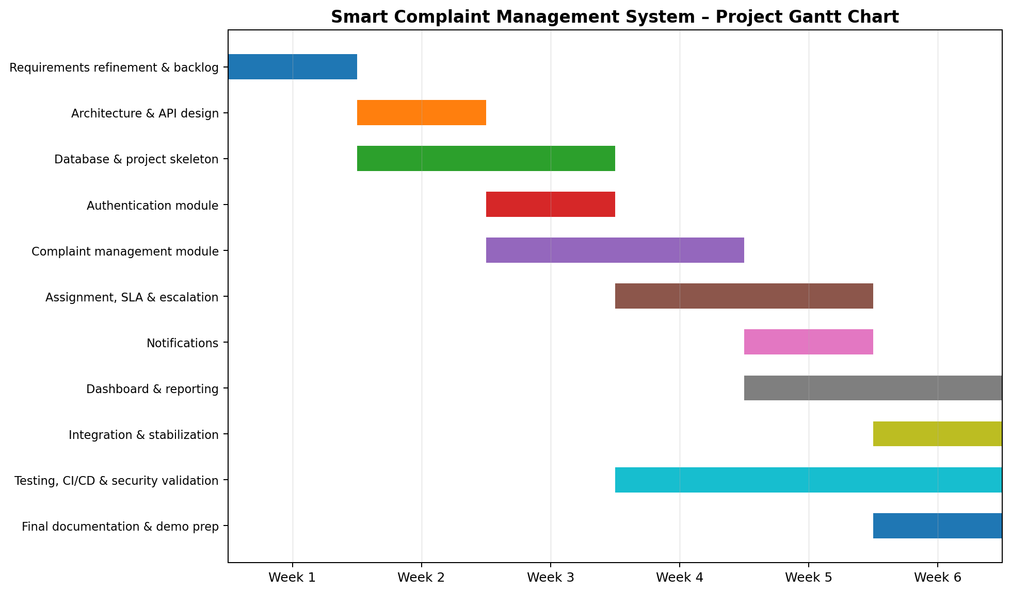
Figure 3.1. Smart Complaint Management System – Project Gantt Chart

3.9 Sprint Plan
Sprint | Focus | Expected Increment | Exit Criteria
Sprint 1 – Week 1 | Planning + Requirements Refinement | Final backlog, refined requirements, project setup, repository and CI baseline. | Backlog approved; repo structure established; initial CI job runs.
Sprint 2 – Week 2 | Architecture + Design | Architecture document, API draft, ER model, UML design. | Design reviewed; interfaces and module boundaries agreed.
Sprint 3 – Week 3 | Authentication + Complaint Core | Registration/login plus complaint creation and tracking. | Protected login works; complaint can be created and viewed.
Sprint 4 – Week 4 | Categorization + Assignment + SLA | Category/priority, assignment, status transitions, SLA tracking. | Complaint can move through assigned workflow; SLA rules testable.
Sprint 5 – Week 5 | Escalation + Notifications + Dashboard | Escalation, in-app notifications, external adapters, dashboard. | Core notification and reporting flows work; integrated build passes tests.
Sprint 6 – Week 6 | Integration + Validation + Finalization | System validation, coverage, security checks, final report and demo. | Critical defects resolved; validation evidence complete; demo build stable.

3.10 Risks and Mitigation
Risk | Impact | Mitigation
Integration conflicts between modules | High | Define APIs early; use feature branches and pull requests; integrate incrementally.
Scope expansion | High | Treat SRS as baseline; add features only through controlled backlog refinement.
External notification service setup | Medium | Use an adapter design; keep in-app notifications as baseline; external channels remain configurable.
Insufficient test coverage | High | Write tests alongside feature development and monitor coverage in CI.
Uneven team contribution | High | Assign end-to-end ownership and review GitHub commits, issues, and PRs.
Deployment/CI issues | Medium | Create the Jenkins/Docker pipeline early and test it on significant integrations.
Security defects | High | Use established security libraries, RBAC, input validation, and security-focused tests.

3.11 Definition of Done
- The functionality satisfies its approved requirement and acceptance conditions.
- The implementation is integrated through version control using the team workflow.
- Unit and integration tests exist for the completed functionality and pass.
- Role and input validation controls are implemented where applicable.
- Code review and static analysis expectations are satisfied.
- The integrated build is usable and does not leave known critical defects unresolved.
- Traceability and documentation are updated for the completed increment.

3.12 Project Tracking and Reporting
The project uses Git and GitHub for source control, branches, pull requests, code review, and contribution tracking. GitHub Issues/Projects are used for user stories, backlog, tasks, and sprint tracking. Jenkins provides CI/CD execution, while Docker provides a repeatable application environment. Documentation is maintained as phase-specific deliverables and consolidated here for the final report.

4. Design Diagrams
This section presents the principal design diagrams from the approved High-Level Architecture and Software Design documents. The diagrams shown here describe the implemented system structure, interfaces, data model, complaint lifecycle, and key execution workflows.

4.1 Design Overview
The design uses a layered modular backend with a web frontend, FastAPI REST API, dedicated services for authentication, complaints, assignment/SLA/escalation, notifications, and reporting, a repository/data-access layer, a PostgreSQL database, a background scheduler, and an external notification boundary. The detailed design further defines the complaint state model, entity relationships, API contracts, validation rules, and security controls.

4.2 System Context Diagram
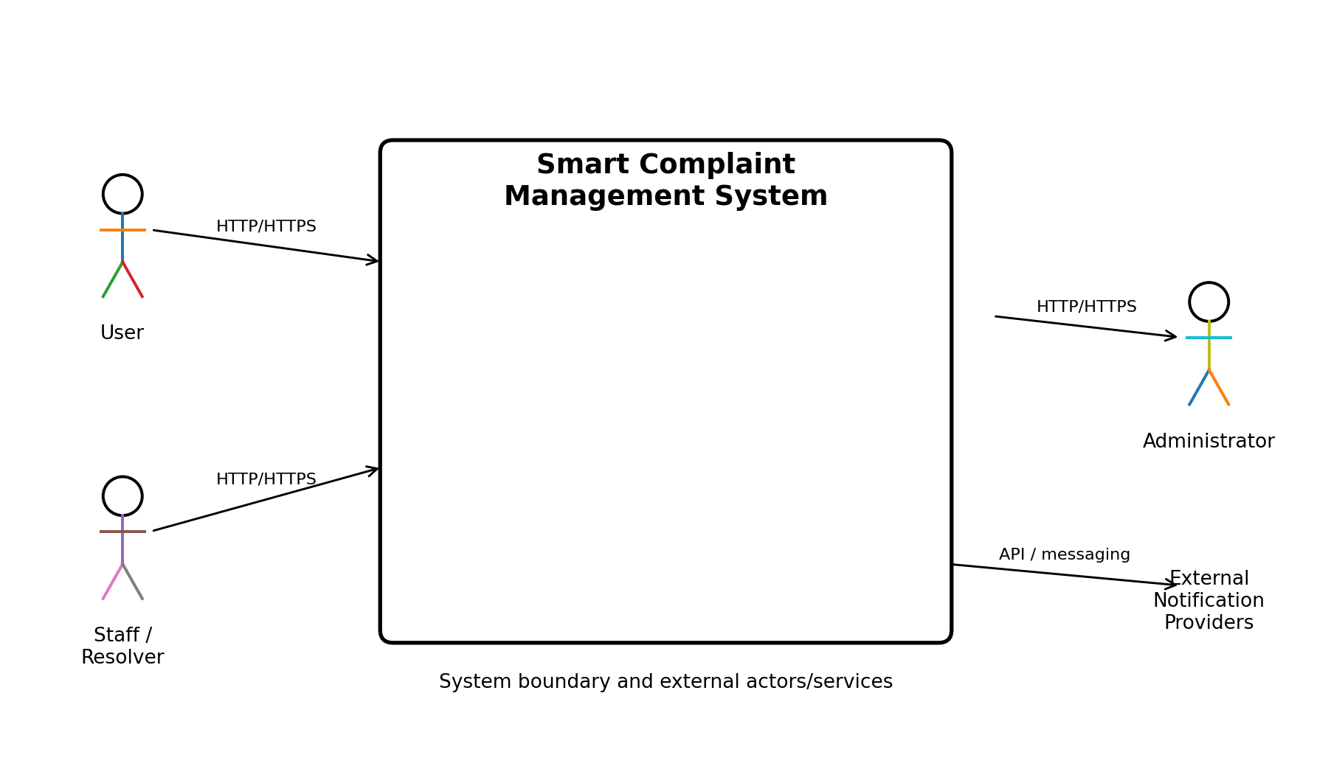
Figure 4.1. System Context Diagram
The system context identifies User, Staff/Resolver, and Administrator as primary human actors. The application communicates with external notification providers through an integration boundary, while the main client-server communication uses HTTP/HTTPS.

4.3 Logical Component View
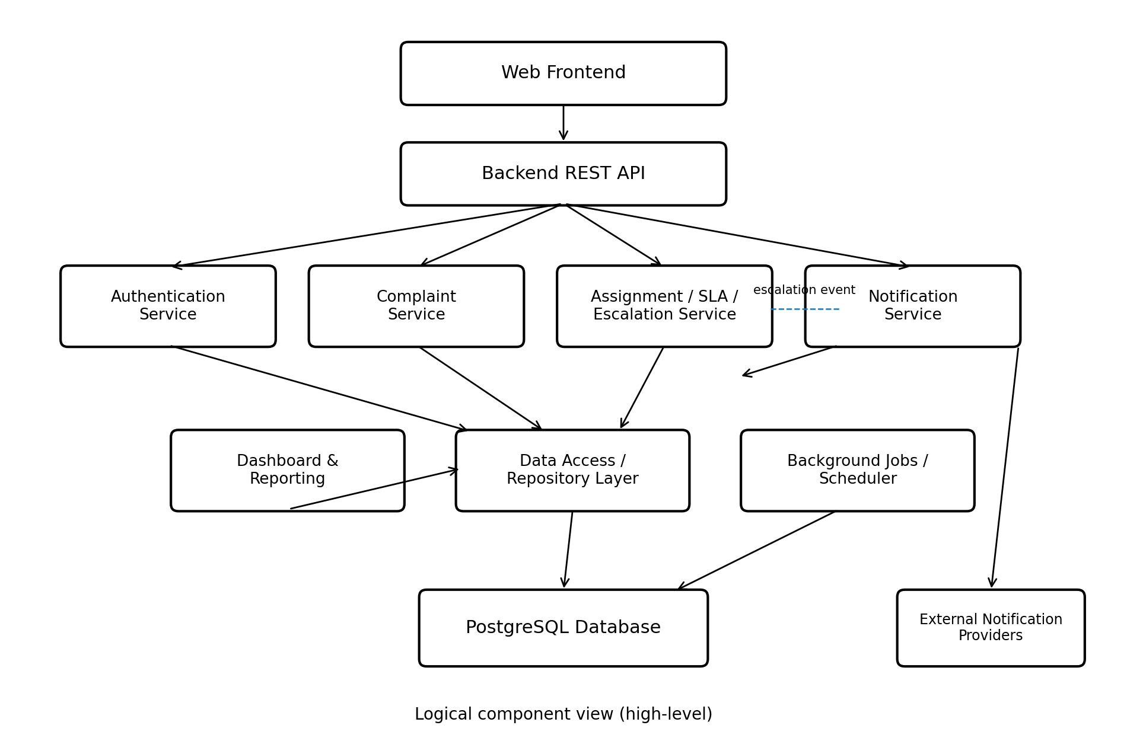
Figure 4.2. Logical Component View
The logical component view separates the web frontend, backend REST API, authentication, complaint, assignment/SLA/escalation, notification, dashboard/reporting, repository/data-access, background scheduler, PostgreSQL database, and external notification providers. This separation supports modular implementation and testing.

4.4 Deployment View
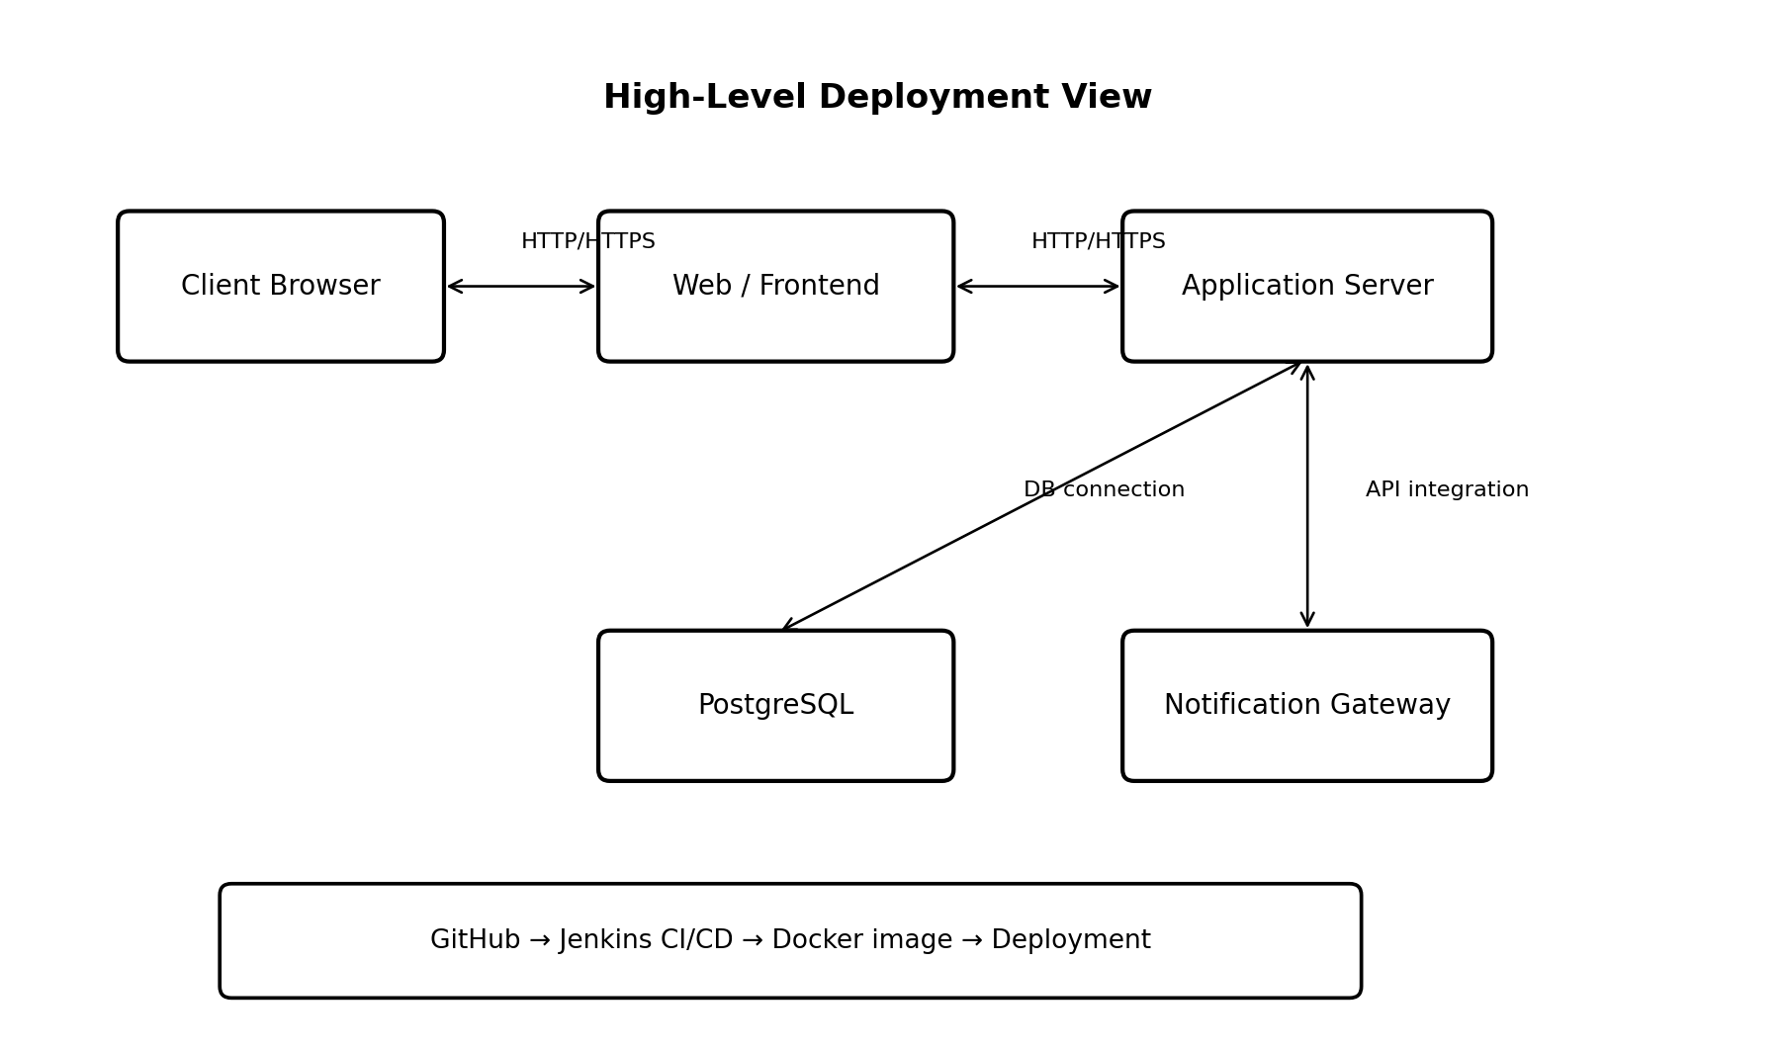
Figure 4.3. High-Level Deployment View
The deployment view places the client browser in front of the web/frontend layer and application server. The application server connects to PostgreSQL and a notification gateway. The architecture also identifies GitHub → Jenkins CI/CD → Docker image → deployment as the delivery path.

4.5 Use Case Diagram
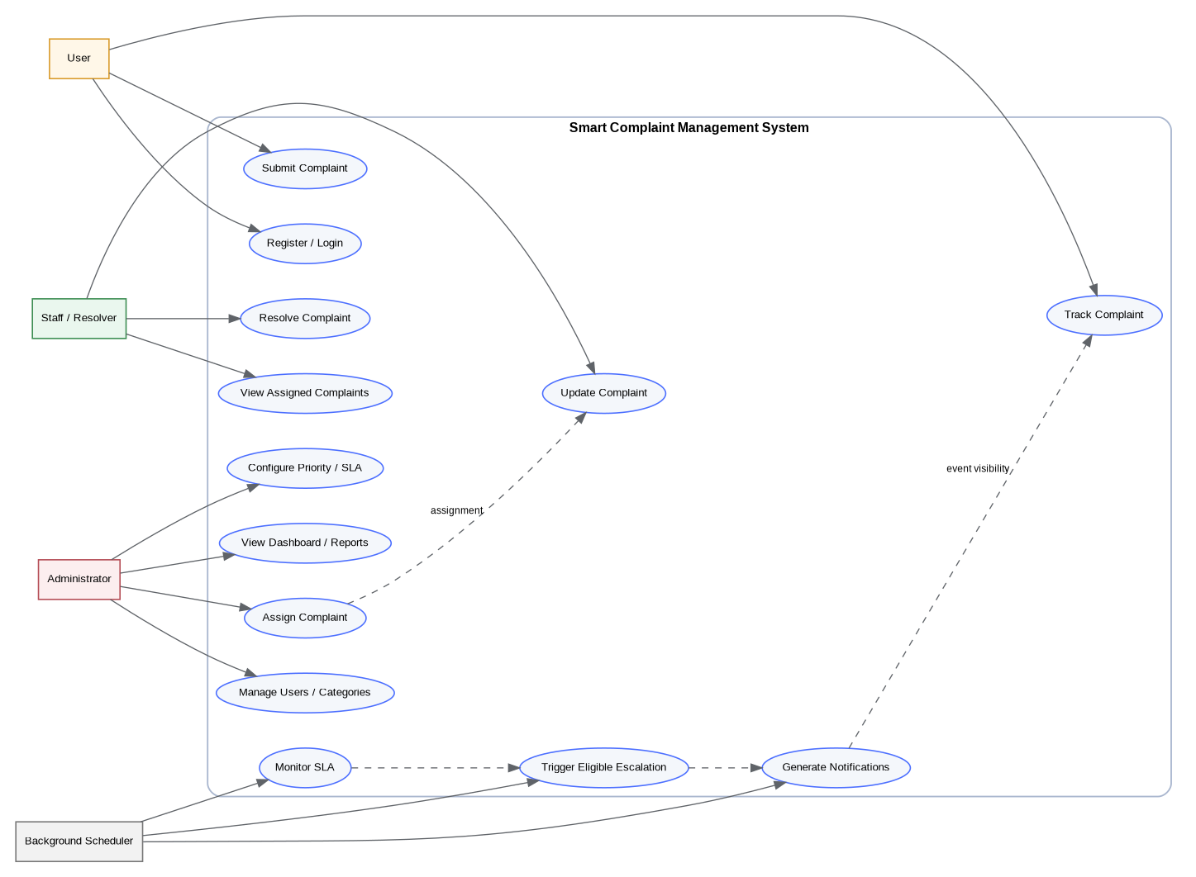
Figure 4.4. UML Use Case Diagram
The use case diagram maps the principal actors to registration/login, complaint submission and tracking, complaint update/resolution, assignment, priority/SLA configuration, dashboard/reporting, user/category management, SLA monitoring, escalation, and notification generation.

4.6 Entity-Relationship / Domain Model
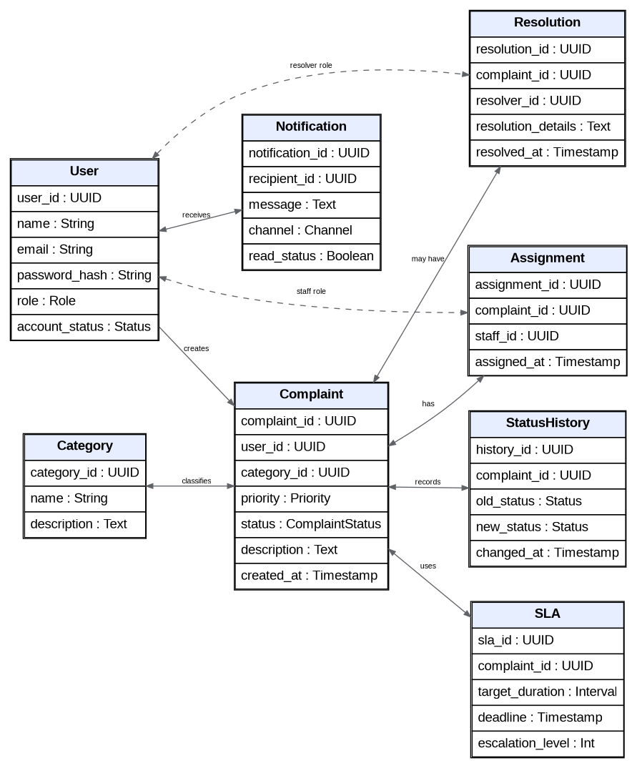
Figure 4.5. Domain / Entity-Relationship Model
The domain model centers on Complaint and connects it with User, Category, Assignment, StatusHistory, SLA, Notification, and Resolution records. This supports persistence of complaint ownership, lifecycle history, SLA state, notification events, and resolution details.

4.7 Complaint State Model
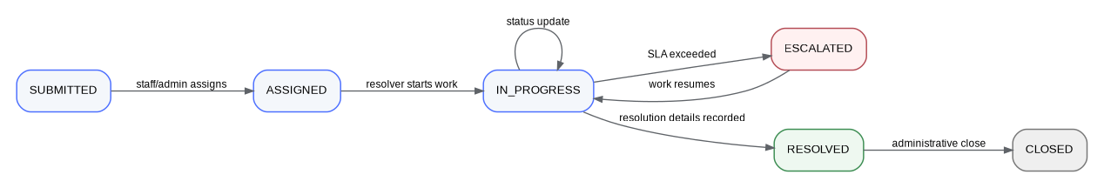
Figure 4.6. Complaint State Model
The complaint lifecycle begins at SUBMITTED, then proceeds through ASSIGNED and IN_PROGRESS. SLA exceedance may move a complaint to ESCALATED, work may resume in IN_PROGRESS, resolution details enable RESOLVED, and an authorized administrative close operation moves the complaint to CLOSED.

4.8 Sequence Design
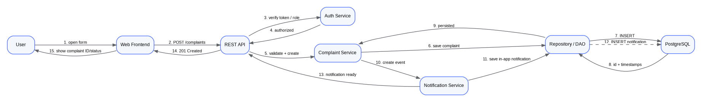
Figure 4.7. Complaint Request Sequence Design
The sequence design shows a user interacting with the web frontend and REST API, which delegates to authentication and complaint services and then to the repository/data-access layer and PostgreSQL. The notification service is invoked where an event requires notification.

4.9 Activity / Workflow Design
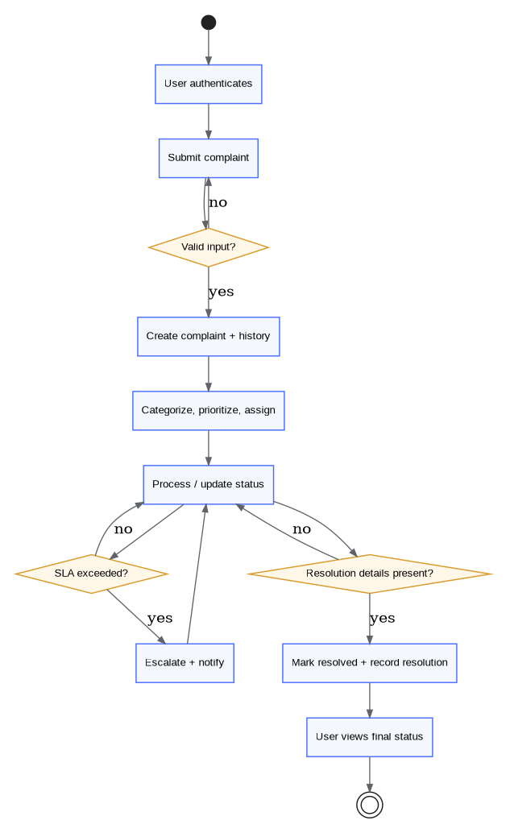
Figure 4.8. Complaint Processing Activity / Workflow
The activity workflow validates the authenticated user and complaint input, creates the complaint and history, categorizes/prioritizes/assigns the complaint, processes status updates, checks SLA exceedance, escalates and notifies when required, records resolution details, and exposes the final status to the user.

Design Source Note
The diagrams in this section are incorporated from the project’s approved High-Level Architecture and Software Design documents. The consolidated report uses those artifacts as the design baseline rather than introducing a different architecture.

5. Test Cases
Purpose. This section records the verification performed for the Smart Complaint Management System. It combines representative manual UI verification performed during the implementation walkthrough with the approved automated test-case catalogue from the project Test Plan and Test Report. The final automated baseline records 207 tests executed, 207 passed, and 0 failed; backend statement coverage was 94.6%.

5.1 Test Case Format and Evidence
Each test case records the test ID, module, test description, preconditions, steps/test data, expected result, actual result, and status. Manual UI evidence was captured as screenshots during execution and will be placed in Section 6. Automated tests are maintained in the repository under the tests/ directory and are executed with pytest, Playwright, and node:test as applicable.

5.2 Manual UI Verification Summary
ID | Module | Test / Description | Preconditions | Steps / Test Data | Expected Result | Actual Result | Status
M-01 | Authentication | Administrator login | Valid admin credentials are seeded. | Enter admin@scms.example.com and the configured password; sign in. | Administrator dashboard opens. | Dashboard loaded successfully. | PASS
M-02 | Authentication | User login | Valid user account exists. | Enter user@scms.example.com / User@1234; sign in. | User is taken to My complaints. | My complaints page loaded for Asha User. | PASS
M-03 | Complaint submission | Submit complaint | Authenticated User. | Category IT & Network; priority High; valid description; submit. | Complaint is created with reference, status and SLA. | CMP-7464CBFF created with Submitted, High, SLA On track. | PASS
M-04 | Assignment | Assign complaint | Administrator authenticated; complaint is unassigned. | Open CMP-7464CBFF; assign to Ravi Staff. | Complaint becomes Assigned and shows assignee. | Assigned to Ravi Staff; history recorded. | PASS
M-05 | Workflow | Start work | Assigned Staff authenticated; complaint assigned to that staff member. | Open complaint; click Start work. | Status changes to In Progress. | Status changed to In Progress; history recorded. | PASS
M-06 | Workflow | Resolve complaint | Complaint is In Progress. | Enter resolution details and click Resolve. | Status becomes Resolved and resolution is stored. | Resolved by Ravi Staff; resolution and SLA met displayed. | PASS
M-07 | User tracking | User views resolved complaint | Complaint was resolved. | Sign in as Asha User; open CMP-7464CBFF. | User can see final status and resolution. | Resolved status, resolver, resolution and history visible. | PASS
M-08 | Dashboard | Administrator metrics | At least one complaint exists. | Open Administrator Dashboard. | Dashboard counts reflect current complaint data. | Total 1; Resolved 1; High 1; SLA compliance 100%. | PASS
M-09 | Notifications | View notifications | Complaint notification exists. | Open the bell notification panel. | Unread notification is displayed. | High-priority assignment notification displayed. | PASS
M-10 | Notifications | Mark all notifications read | Unread notifications exist. | Open notifications; click Mark all read. | Unread count clears. | Notification badge cleared. | PASS
M-11 | Administration | User management | Administrator authenticated. | Open Users page. | Users, roles, status and administration controls display. | All seeded users and controls displayed. | PASS
M-12 | Administration | Categories | Administrator authenticated; categories seeded. | Open Categories page. | Active categories and admin controls display. | Five categories displayed with Active status. | PASS
M-13 | Administration | SLA rules | Administrator authenticated; default SLA rules seeded. | Open SLA rules page. | Priority targets and alert threshold display. | Critical 4 h; High 1 d; Medium 3 d; Low 7 d; 80% alert. | PASS
M-14 | Reporting | Resolved filter | At least one resolved complaint exists. | Open All complaints; select Status = Resolved. | Only resolved complaints are listed. | CMP-7464CBFF displayed as Resolved with SLA met. | PASS
M-15 | Reporting | CSV export | Complaint data exists. | Click Export CSV. | CSV report is downloaded. | complaints_report opened with complaint/reference, priority, status, creator, assignee and SLA fields. | PASS
M-16 | Validation | Invalid login | Login page available. | Use valid email with wrong password. | Login is rejected with generic error. | “Invalid email or password” displayed. | PASS
M-17 | Validation | Missing complaint description | Authenticated User. | Open New complaint; leave description empty; submit. | Submission is rejected and missing field is identified. | “Description is required” displayed. | PASS
M-18 | Validation | Minimum description length | Authenticated User. | Enter 9-character description and submit. | Submission is rejected below 10 characters. | “Description must be at least 10 characters” displayed. | PASS
M-19 | Validation | Invalid email format | Login page available. | Enter not-an-email and submit. | Client validation rejects malformed email. | “Enter a valid email address” displayed. | PASS
M-20 | Security | User route guard | Authenticated User. | Navigate directly to /#/admin/users. | User cannot access admin page and is redirected. | Redirected to My complaints. | PASS
M-21 | Security | Staff route guard | Authenticated Staff. | Navigate directly to /#/admin/users. | Staff cannot access admin page and is redirected. | Redirected to My queue. | PASS
M-22 | SLA / escalation | Manual escalation | Administrator authenticated; critical complaint assigned. | Open CMP-1F32FCF2 and click Escalate. | Complaint becomes Escalated and history records escalation. | Escalated status and timestamp displayed. | PASS
M-23 | SLA / escalation | Resume escalated complaint | Staff authenticated; complaint is Escalated. | Open CMP-1F32FCF2; click Resume work. | Status returns to In Progress. | Status changed to In Progress; history recorded. | PASS
M-24 | Registration | Valid registration | Registration page available. | Register Test User with valid name, email and password. | Account is created with User role. | Test User account created and logged in as User. | PASS
M-25 | Registration | Duplicate email | Existing email already registered. | Register using testuser01@scms.example.com again. | Duplicate registration is rejected. | “An account with this email already exists” displayed. | PASS
M-26 | Registration | Invalid registration data | Registration page available. | Use short name, malformed email and weak password. | Field validation errors are shown. | Name, email and password validation errors displayed. | PASS
M-27 | Administration | Deactivate account | Administrator authenticated; Test User is active. | Deactivate Test User from Users page. | Account status becomes Inactive. | Test User displayed as Inactive with Activate control. | PASS
M-28 | Authentication | Inactive account login | Test User is inactive. | Attempt login with testuser01@scms.example.com / TestUser@1234. | Login is rejected because account is inactive. | “This account is inactive. Contact an administrator.” displayed. | PASS
M-29 | Security | Unauthenticated protected route | No user authenticated. | Navigate directly to /#/admin/users. | Visitor is redirected to login. | Login page displayed. | PASS
M-30 | Dashboard | Staff dashboard | Authenticated Staff account. | Open Dashboard. | Staff-specific workload metrics display. | Dashboard loaded; assigned workload and 100% SLA compliance visible. | PASS

5.3 Automated Test Case Catalogue
The following catalogue is the approved 36-case test baseline from the project Test Plan and Test Report. Each case is mapped to its requirement and automated test source. The Actual Result field records the outcome in the recorded full suite; all listed cases passed.
ID | Module | Description | Req. | Preconditions | Steps / Test Data | Expected Result | Actual Result / Status
TC-01 | Authentication | Register with valid details creates a USER account; role cannot be self-selected. | FR-01 | Registration page available; valid name/email/password. | Submit valid registration data. | User account created with USER role. | PASS — automated suite
TC-02 | Authentication | Duplicate e-mail (case-insensitive) is rejected with 409. | FR-01 | Existing account uses the same email. | Submit registration with duplicate email. | Registration rejected with conflict. | PASS — automated suite
TC-03 | Authentication | Short name, invalid e-mail, weak password and missing field validation. | FR-01, NFR-07 | Registration form. | Submit invalid field combinations. | 422/field validation errors returned. | PASS — automated suite
TC-04 | Authentication | Login returns bearer token and /auth/me returns profile. | FR-02 | Active valid user. | Log in and request profile. | Token issued; profile returned. | PASS — automated suite
TC-05 | Authentication | Unknown e-mail and wrong password both give generic 401. | FR-04 | Login endpoint available. | Try unknown account and wrong password. | Same generic authentication failure. | PASS — automated suite
TC-06 | Authentication | Deactivated account cannot log in and existing token stops working. | FR-04 | Active account then deactivated. | Deactivate account; attempt login/use token. | Access denied. | PASS — automated + manual UI
TC-07 | Authentication | Missing, malformed or non-bearer token gives 401. | NFR-05 | Protected endpoint. | Call endpoint without a valid bearer token. | Request rejected with 401. | PASS — automated suite
TC-08 | Security | Stored password is bcrypt-hashed, never plaintext. | NFR-04 | Registered test account. | Inspect stored credential through test. | Stored value is bcrypt hash. | PASS — automated suite
TC-09 | Complaints | Submit complaint creates reference, category, priority, creator, timestamp, status and SLA. | FR-05, FR-06 | Authenticated User; active category. | Submit valid complaint. | Complaint created with SUBMITTED status and SLA. | PASS — automated + manual UI
TC-10 | Complaints | Each missing mandatory field is rejected and named in the error. | FR-08 | Complaint form/API. | Omit each mandatory field in turn. | Field-specific validation error. | PASS — automated + manual UI
TC-11 | Complaints | Unknown or inactive category is rejected. | FR-09, BR-02 | Complaint submission. | Use unknown/inactive category. | Submission rejected. | PASS — automated suite
TC-12 | Complaints | Users see only their own complaints; others return 404. | BR-08 | Two user accounts and complaints. | Attempt cross-user access. | Other user complaint inaccessible. | PASS — automated suite
TC-13 | Complaints | Priority change by handler recalculates SLA; creator cannot change priority. | FR-10 | Complaint assigned to handler. | Change priority as handler and attempt as creator. | Handler change accepted with SLA recalculated; creator denied. | PASS — automated suite
TC-14 | Complaints | Filtering by priority/status/search and pagination works. | FR-23 | Multiple complaints. | Apply filters, search and paging. | Results match filter criteria. | PASS — automated + manual UI
TC-15 | Workflow | Full lifecycle Submitted → Assigned → In Progress → Resolved → Closed with history. | FR-12–FR-15, BR-10 | Valid complaint and authorized roles. | Perform lifecycle transitions. | All allowed transitions and history records succeed. | PASS — automated suite
TC-16 | Workflow | Normal users cannot assign; assignment target must be active staff. | FR-12, BR-03 | Complaint and role accounts. | Attempt assignment as user and with invalid target. | Only authorized active staff target accepted. | PASS — automated suite
TC-17 | Workflow | Only assigned staff member or admin can update status. | BR-04 | Assigned complaint. | Attempt status update as wrong staff/user/admin. | Only permitted actors can update. | PASS — automated suite
TC-18 | Workflow | Invalid transitions are rejected and status remains unchanged. | FR-13, NFR-03 | Complaint in each relevant state. | Attempt forbidden transitions. | Invalid request rejected; state preserved. | PASS — automated suite
TC-19 | Workflow | Resolve without details is rejected; complaint stays In Progress. | FR-14, BR-05 | Complaint In Progress. | Resolve with empty details. | Resolution rejected; state unchanged. | PASS — automated suite
TC-20 | Workflow | Stale expected_status returns 409 for concurrent update protection. | NFR-03 | Two concurrent update contexts. | Submit stale expected status. | 409 conflict returned. | PASS — automated suite
TC-21 | Notifications | Notifications generated for submit, assign, status changes; mark read/read all. | FR-20, FR-21 | Notification-capable workflow. | Perform workflow and mark notifications read. | Notifications generated and read-state updated. | PASS — automated + manual UI
TC-22 | SLA | SLA target per priority (4 h / 24 h / 72 h / 7 d) and admin updates. | FR-16, BR-06 | Default rules. | Create complaints by priority and update rule. | Correct deadline attached and updated rule applied. | PASS — automated + manual UI
TC-23 | SLA | Due-soon alert sent once at 80% of SLA. | FR-17 | Complaint approaching deadline. | Advance/test SLA time boundary. | One alert generated at threshold. | PASS — automated suite
TC-24 | SLA | Overdue complaint escalated exactly once, visible to admins, then resumed and resolved. | FR-18, FR-19, BR-07 | Overdue assigned complaint. | Trigger escalation; resume; resolve. | Escalated once; resume and resolution succeed. | PASS — automated suite
TC-25 | SLA | Manual escalation is admin-only. | FR-19, BR-09 | Complaint and multiple roles. | Attempt manual escalation under different roles. | Only admin succeeds. | PASS — automated suite + manual UI
TC-26 | Reporting | Dashboard counts by status/priority/category, compliance and trend. | FR-22, FR-24 | Complaint dataset. | Open dashboard and compare metrics. | Counts/metrics match source data. | PASS — automated + manual UI
TC-27 | Reporting | Report filters by priority and date range; invalid range rejected. | FR-23 | Report endpoint/UI. | Apply valid and invalid date filters. | Valid filter works; invalid range rejected. | PASS — automated suite
TC-28 | Reporting | CSV export produces correctly quoted complaint report. | FR-24 | Complaint dataset. | Export CSV. | CSV contains expected fields and correct quoting. | PASS — automated + manual UI
TC-29 | Security / RBAC | Permission matrix: 13 endpoints × 4 roles. | NFR-05, NFR-06, BR-09 | Anonymous, User, Staff, Admin. | Execute permission matrix. | Only authorized role/endpoints succeed. | PASS — automated suite
TC-30 | Security | HTML/script stored as text and rendered harmlessly in browser. | NFR-07 | Complaint description field. | Submit HTML/script payload. | Payload stored/displayed as text; no execution. | PASS — automated suite
TC-31 | Security | SQL-injection strings in search are treated as data. | NFR-07 | Search endpoint. | Submit injection-like search strings. | No query manipulation; inputs treated as data. | PASS — automated suite
TC-32 | Security | No delete endpoints for complaints or users. | NFR-02 | API route set. | Inspect/attempt delete operations. | Delete endpoints unavailable. | PASS — automated suite
TC-33 | Performance | p95 response time < 3 s with 500 complaints. | NFR-01 | 500-complaint dataset and performance harness. | Run performance test. | p95 under 3 s. | PASS — automated suite
TC-34 | System / E2E | Browser complaint journey across User → Admin → Staff → User. | FR-05–FR-15, FR-20 | Chromium; seeded accounts. | Execute complete browser journey. | Journey completes end-to-end. | PASS — E2E suite
TC-35 | System / E2E | Browser route guards hide admin pages from users and signed-out visitors. | NFR-06 | Chromium; protected routes. | Navigate to admin routes under restricted roles. | Restricted roles are redirected/blocked. | PASS — E2E + manual UI
TC-36 | Usability / E2E | 360 px mobile layout has no horizontal scrolling. | Usability | Chromium at 360 px width. | Load application at mobile width. | No horizontal overflow. | PASS — E2E suite

5.4 Automated Test Results
Suite | Executed | Passed | Failed | Pass Rate
Unit + API (PostgreSQL 16) | 192 | 192 | 0 | 100%
Browser E2E (Chromium) | 9 | 9 | 0 | 100%
Front-end unit (node:test) | 6 | 6 | 0 | 100%
Total | 207 | 207 | 0 | 100%

5.5 Coverage and Performance Evidence
- Backend overall statement coverage: 94.6%. This exceeds the project CI gate of 85%.
- Static analysis: ruff reported no findings in the recorded test run.
- Database migrations: Alembic upgrade succeeded on an empty PostgreSQL database and migration drift check passed.
- Load test: 50 concurrent virtual users, 2,050 requests, 0 errors, 59.3 requests/second, overall p95 response time 829 ms. The project performance target of p95 < 3 seconds passed.

5.6 Defect / Warning Note
The pytest runs produced a non-failing FastAPI/Starlette TestClient deprecation warning recommending httpx TestClient usage. The warning did not cause test failures and is treated as a maintenance item rather than a release-blocking defect.

6. Screenshots of Output
This section presents representative screenshots of the implemented Smart Complaint Management System. The outputs were captured during implementation-phase verification using the local Docker deployment. They demonstrate authentication, role-based interfaces, complaint lifecycle processing, administration, SLA management, notification handling, reporting, validation, access control, and escalation behavior.

6.1 Screenshot Index
Figure | Output demonstrated
Figure 6.1 | Application sign-in interface
Figure 6.2 | Administrator dashboard before complaint creation
Figure 6.3 | User My Complaints interface
Figure 6.4 | Complaint submitted with category, priority, history, and SLA
Figure 6.5 | Complaint assigned to Ravi Staff
Figure 6.6 | Complaint in progress under staff handling
Figure 6.7 | Resolved complaint with resolution details and SLA met
Figure 6.8 | User view of the resolved complaint
Figure 6.9 | Staff dashboard showing assigned workload and SLA performance
Figure 6.10 | Administrator dashboard showing complaint metrics
Figure 6.11 | In-app notification panel
Figure 6.12 | Administrator user-management interface
Figure 6.13 | Category-management interface
Figure 6.14 | SLA rules configuration
Figure 6.15 | All Complaints view filtered to Resolved
Figure 6.16 | Exported complaint CSV report
Figure 6.17 | Invalid-login error output
Figure 6.18 | Mandatory complaint description validation
Figure 6.19 | Successful new-user registration
Figure 6.20 | Duplicate registration email validation
Figure 6.21 | Role-based route protection for a normal User
Figure 6.22 | Escalated complaint with escalation history
Figure 6.23 | Escalated complaint resumed by Staff
Figure 6.24 | Final resolved state after escalation workflow
Figure 6.25 | Deactivated account shown in User Management
Figure 6.26 | Inactive-account login rejection

6.2 Representative Application Outputs
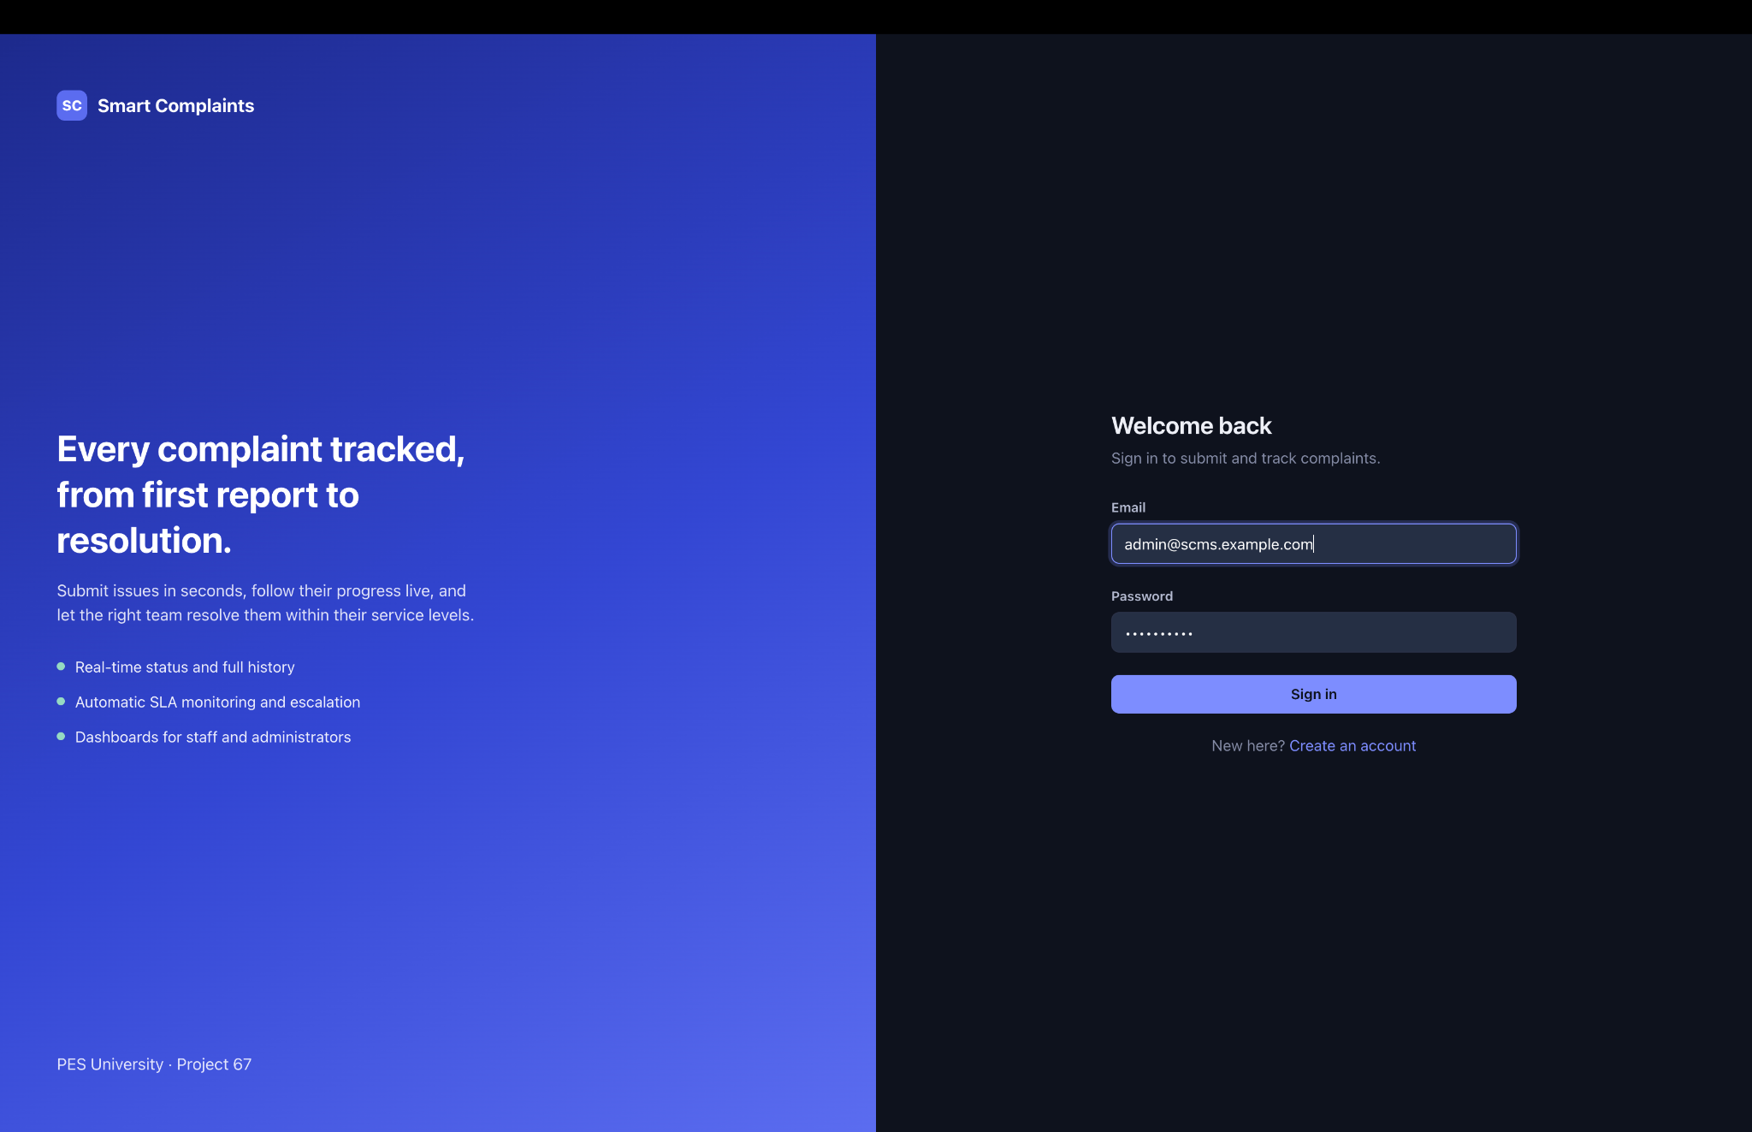
Figure 6.1. Application sign-in interface.
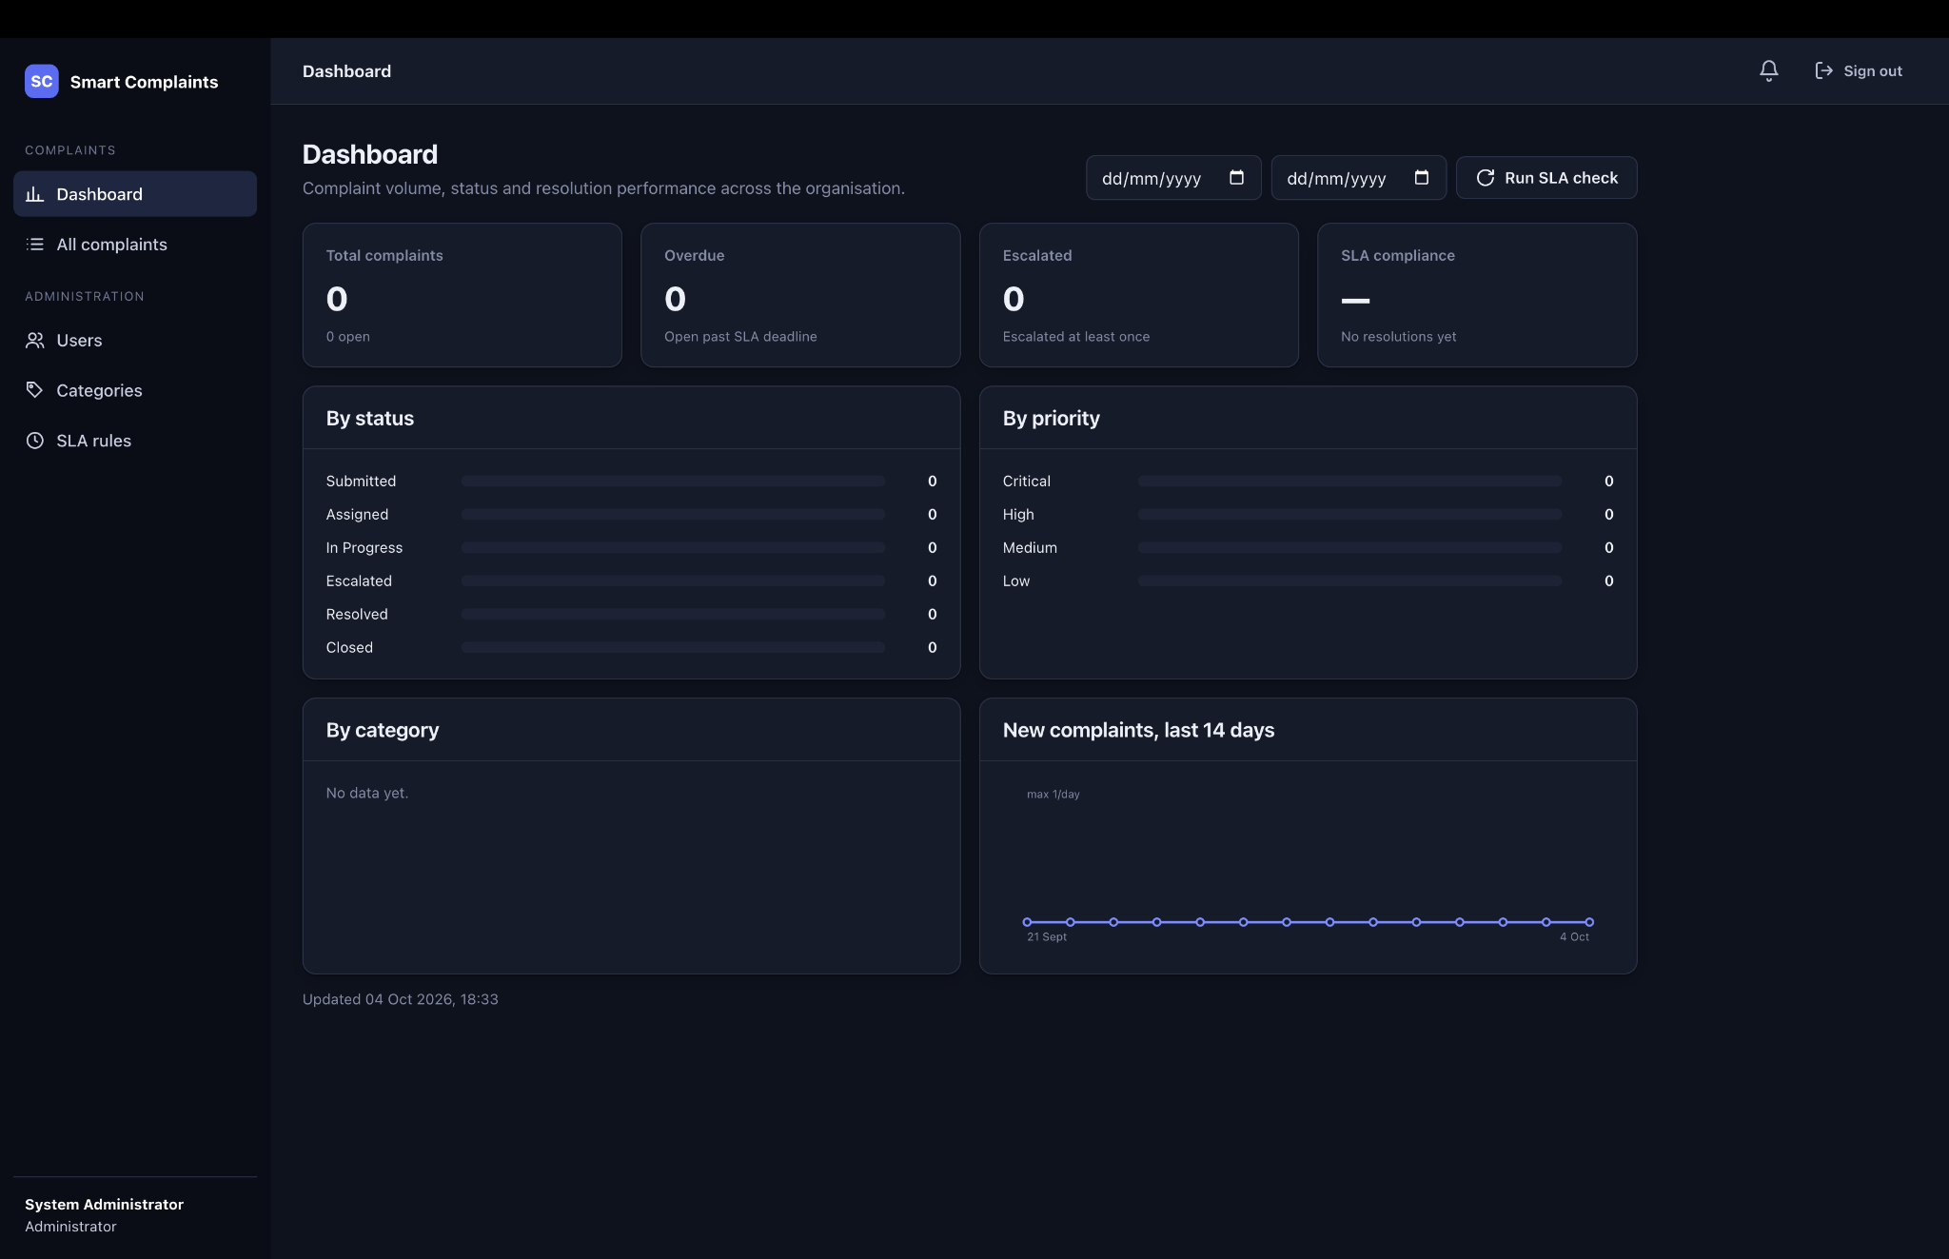
Figure 6.2. Administrator dashboard before complaint creation.

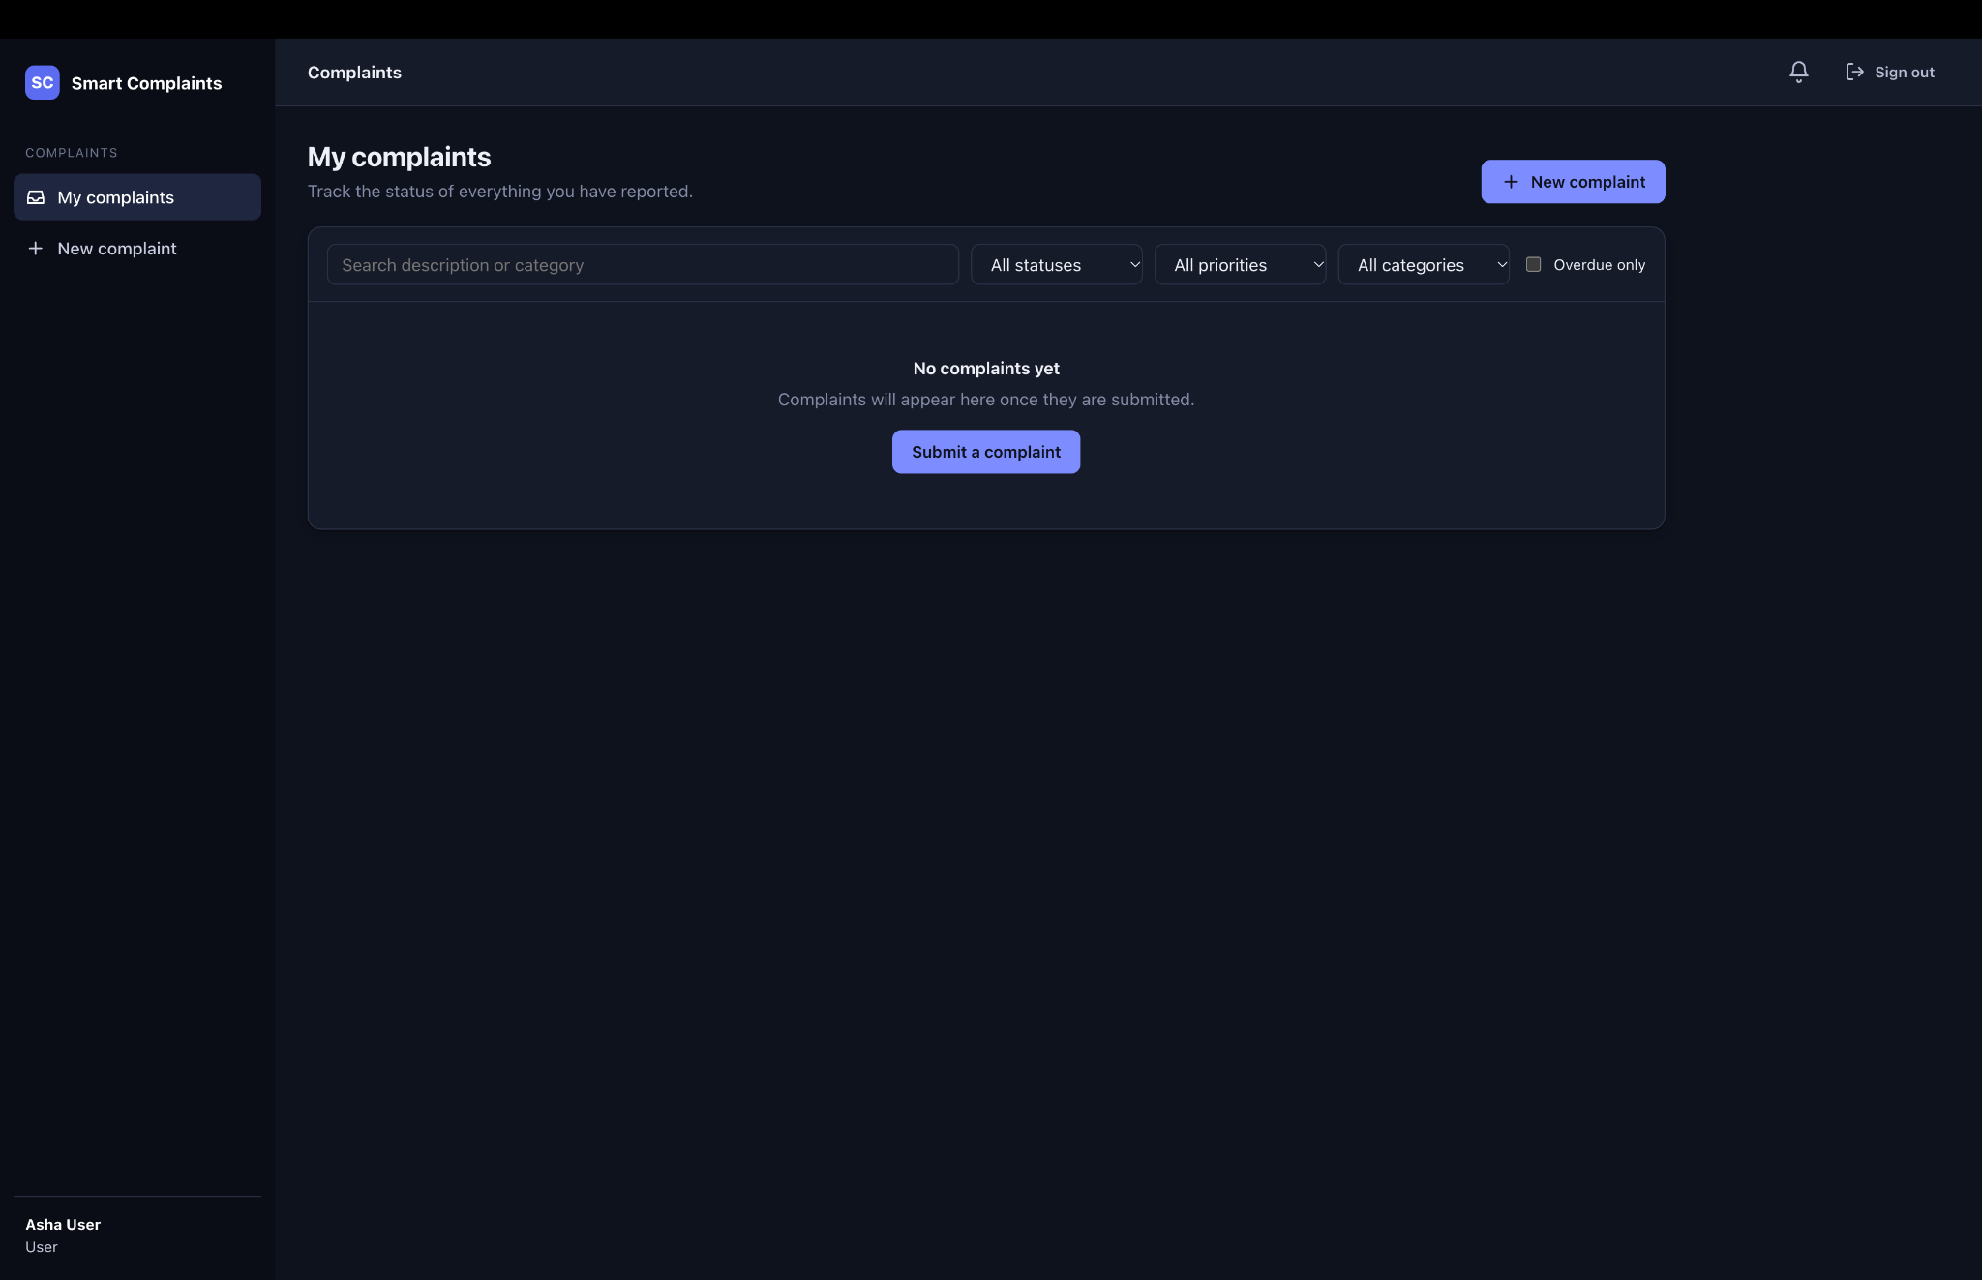
Figure 6.3. User My Complaints interface.
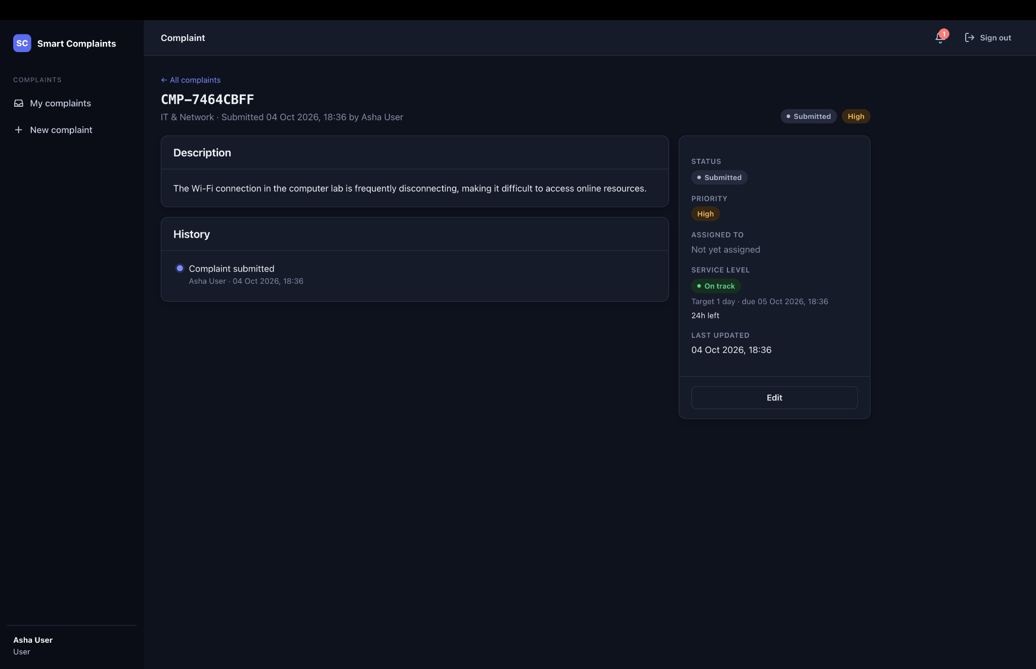
Figure 6.4. Complaint submitted with category, high priority, status history, and SLA information.

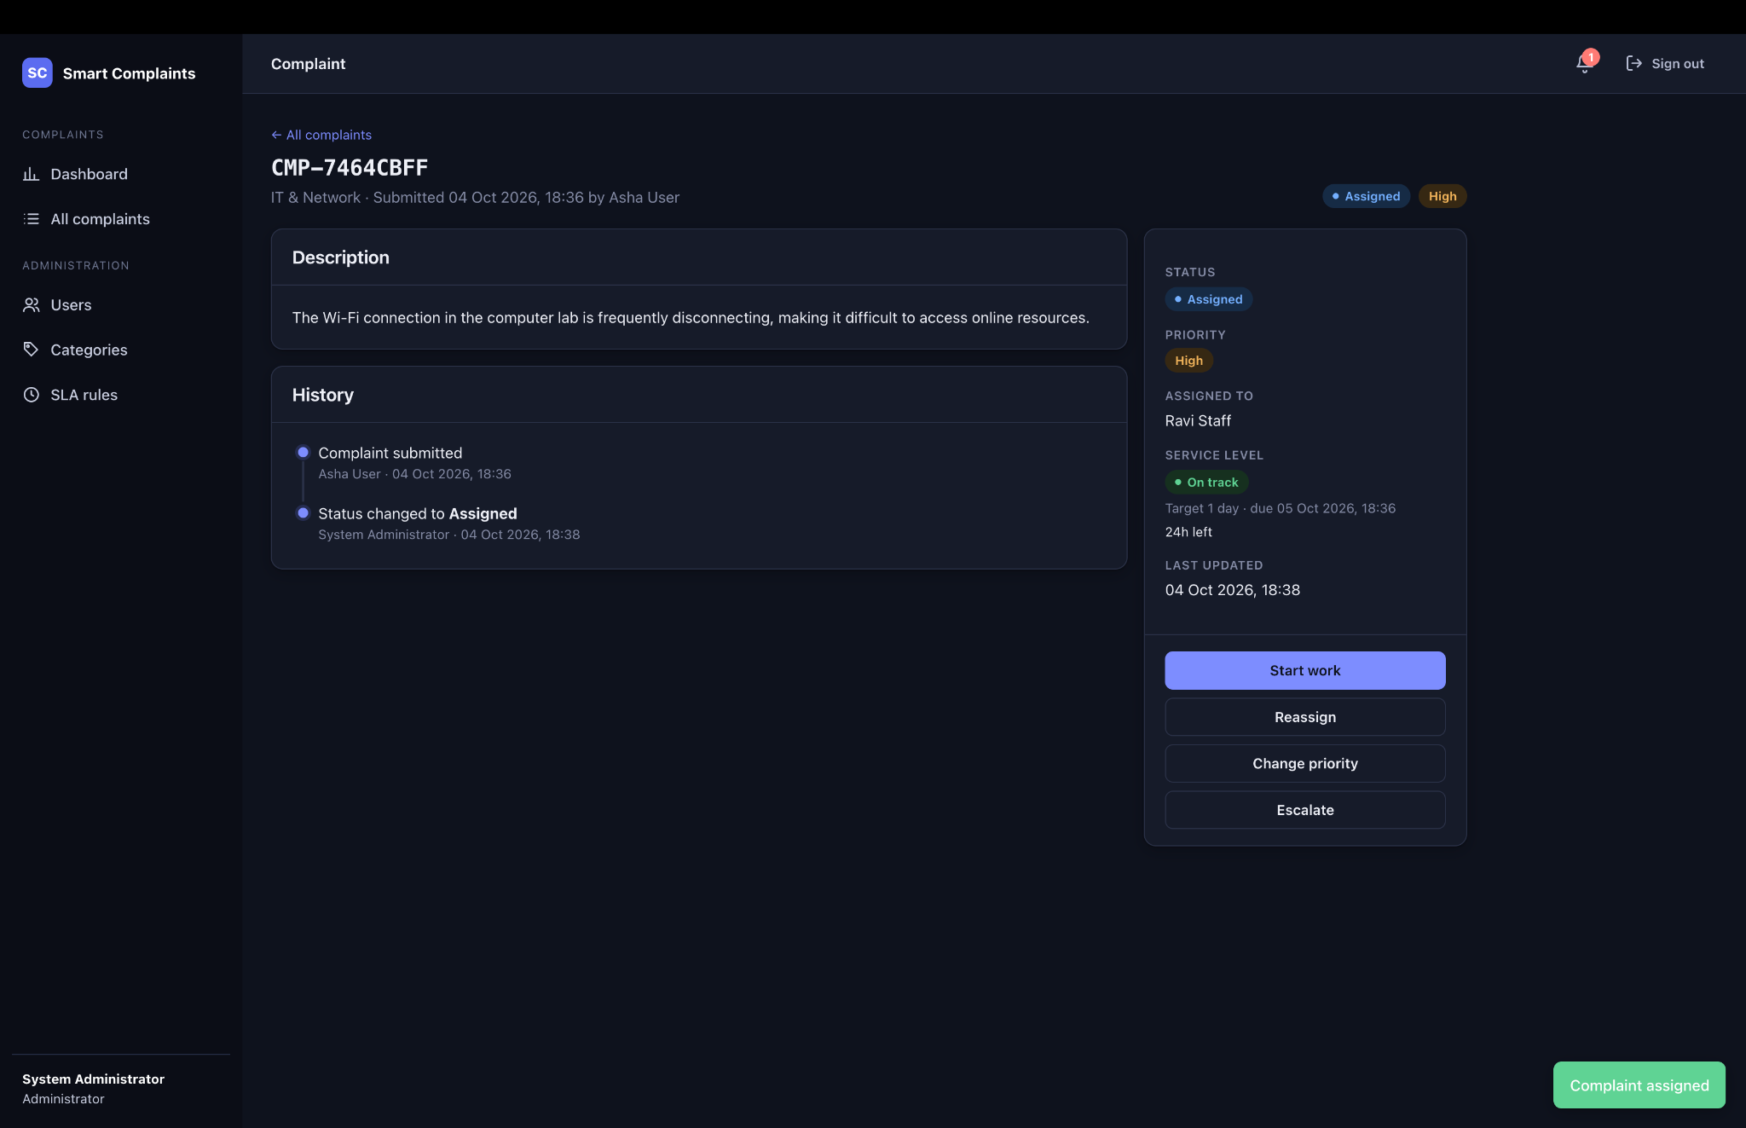
Figure 6.5. Complaint assigned to Ravi Staff.
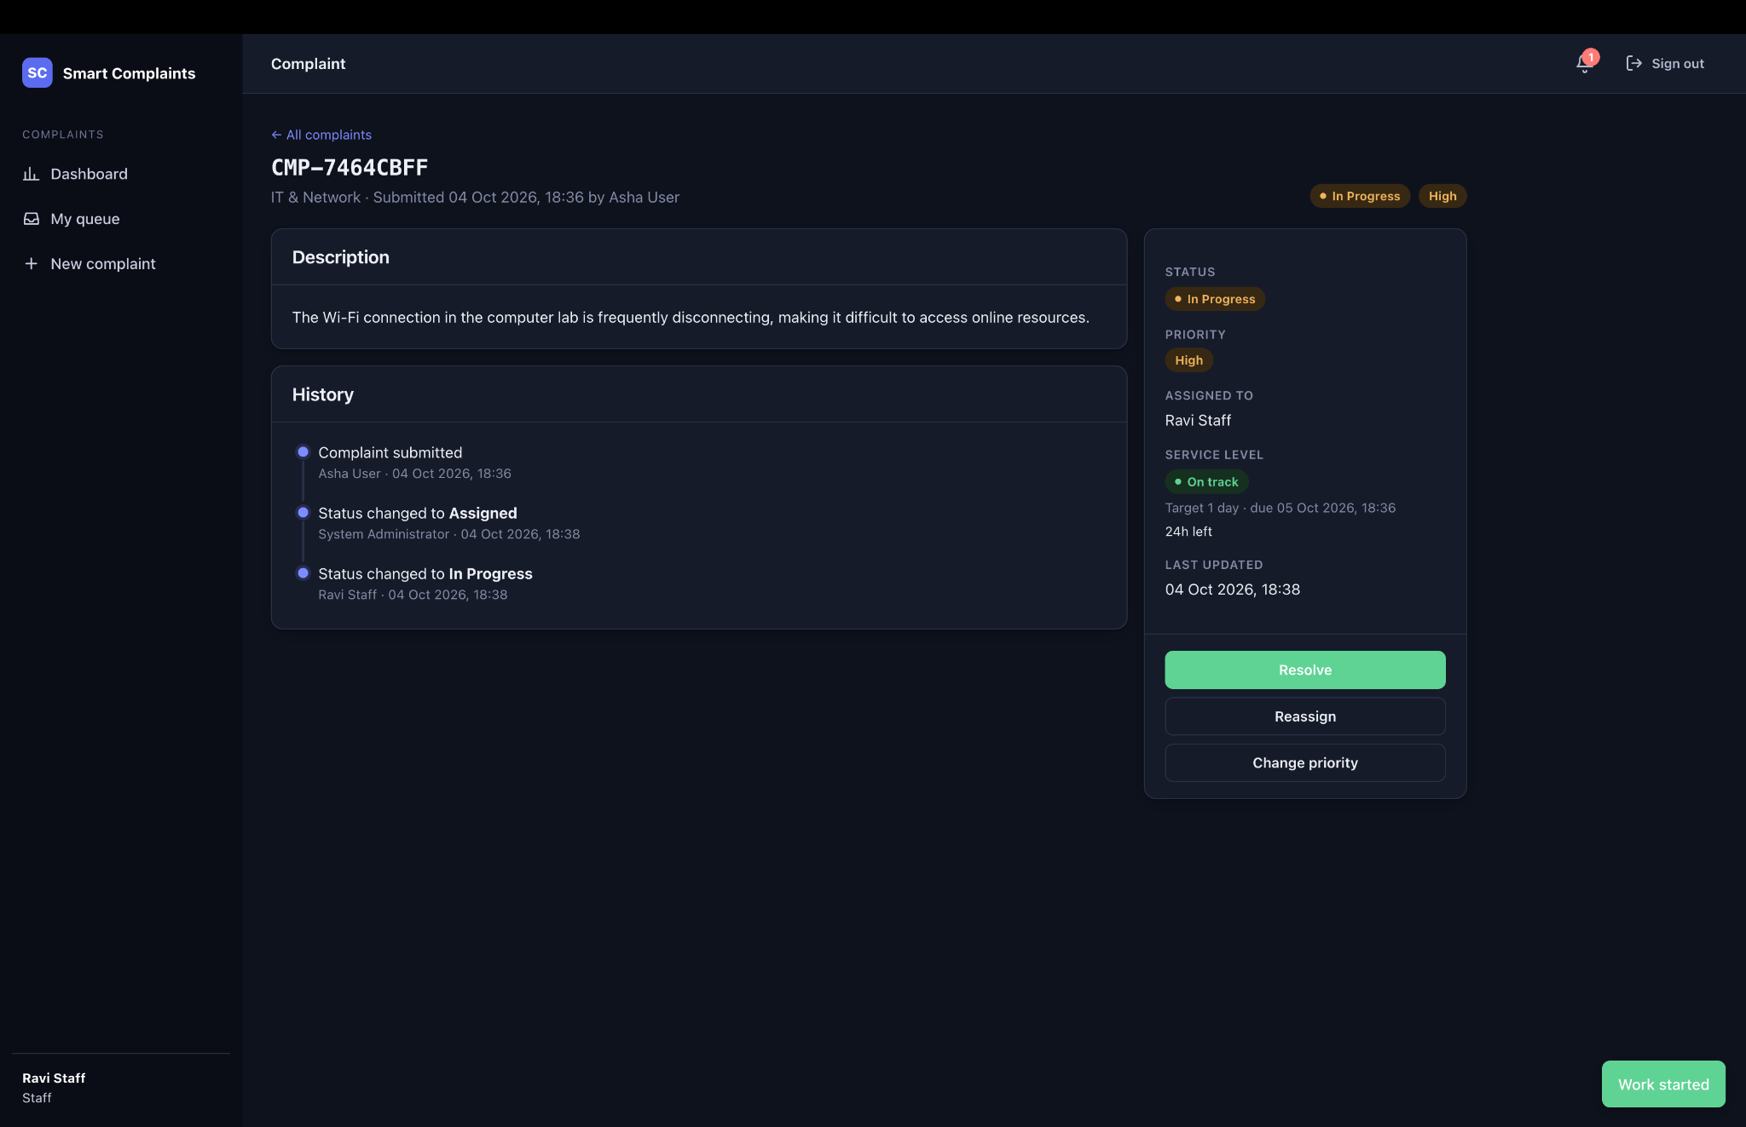
Figure 6.6. Complaint in progress under Ravi Staff.

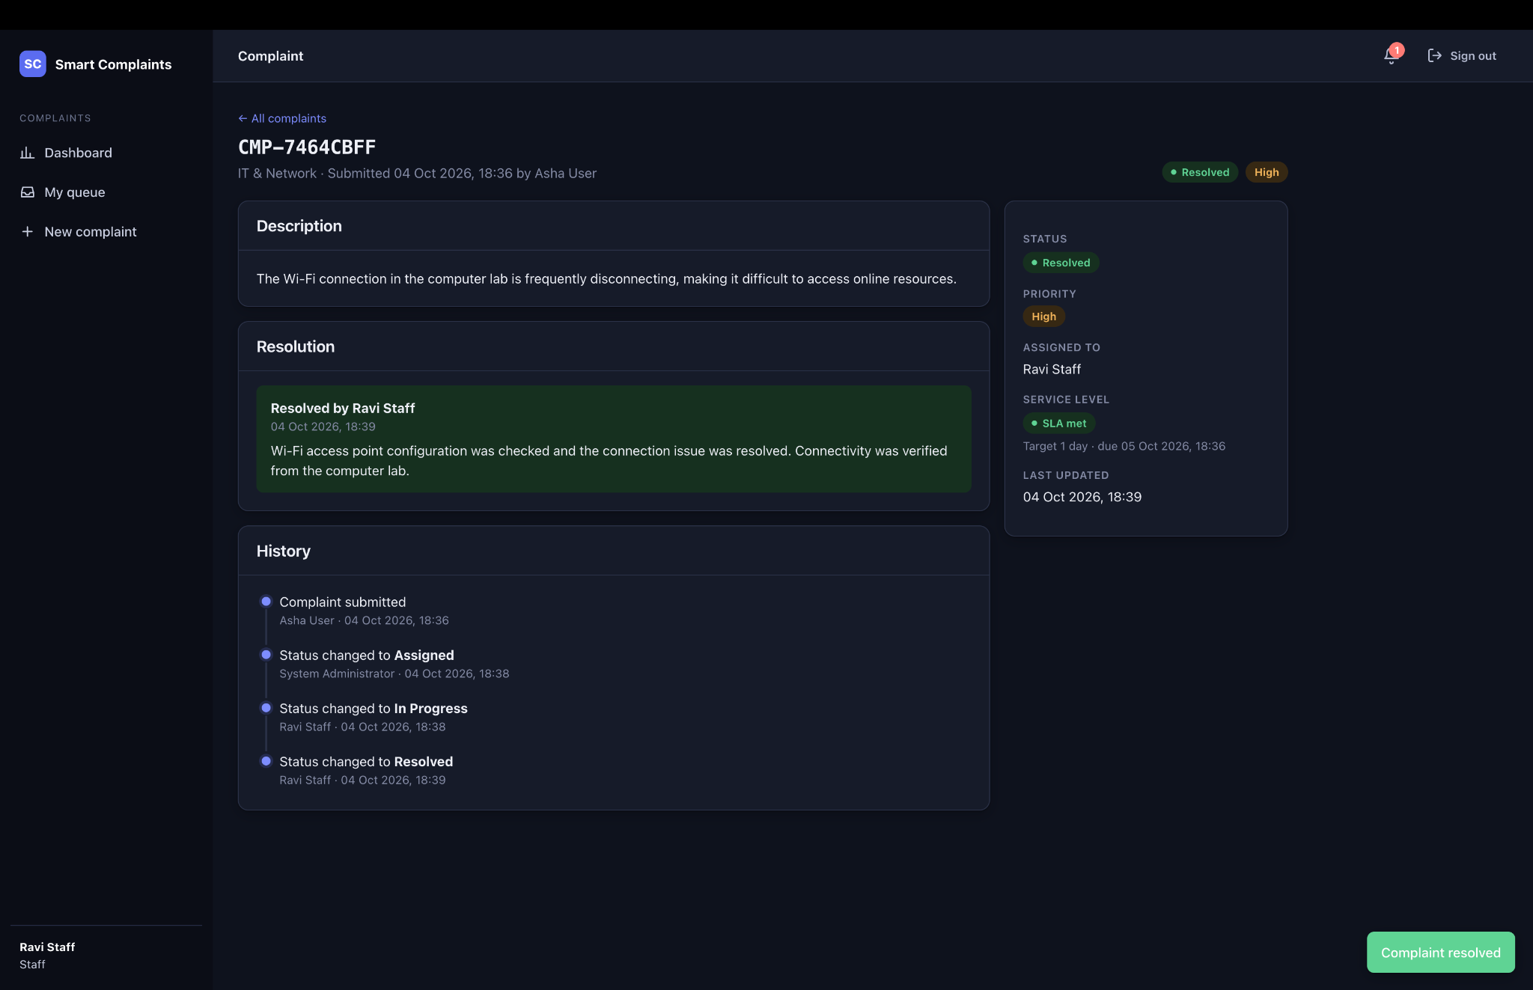
Figure 6.7. Resolved complaint with resolution details, complete history, and SLA met.
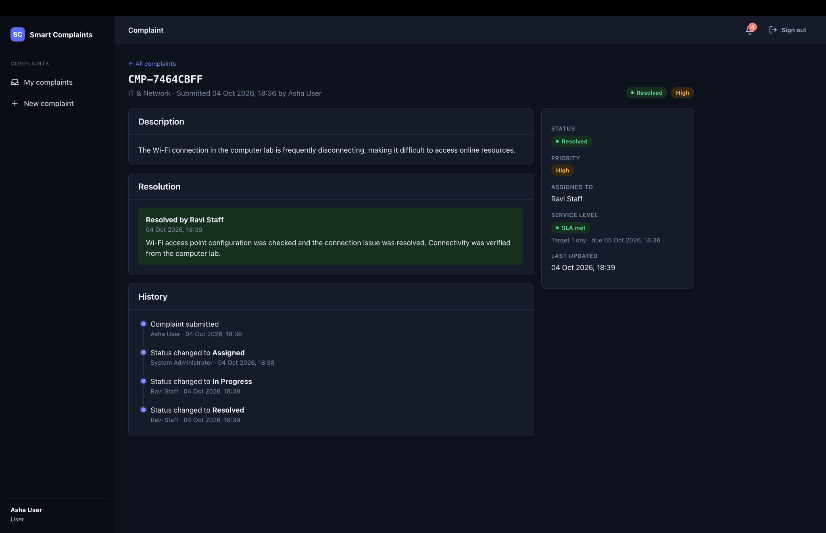
Figure 6.8. User view confirming the resolved complaint and recorded resolution.

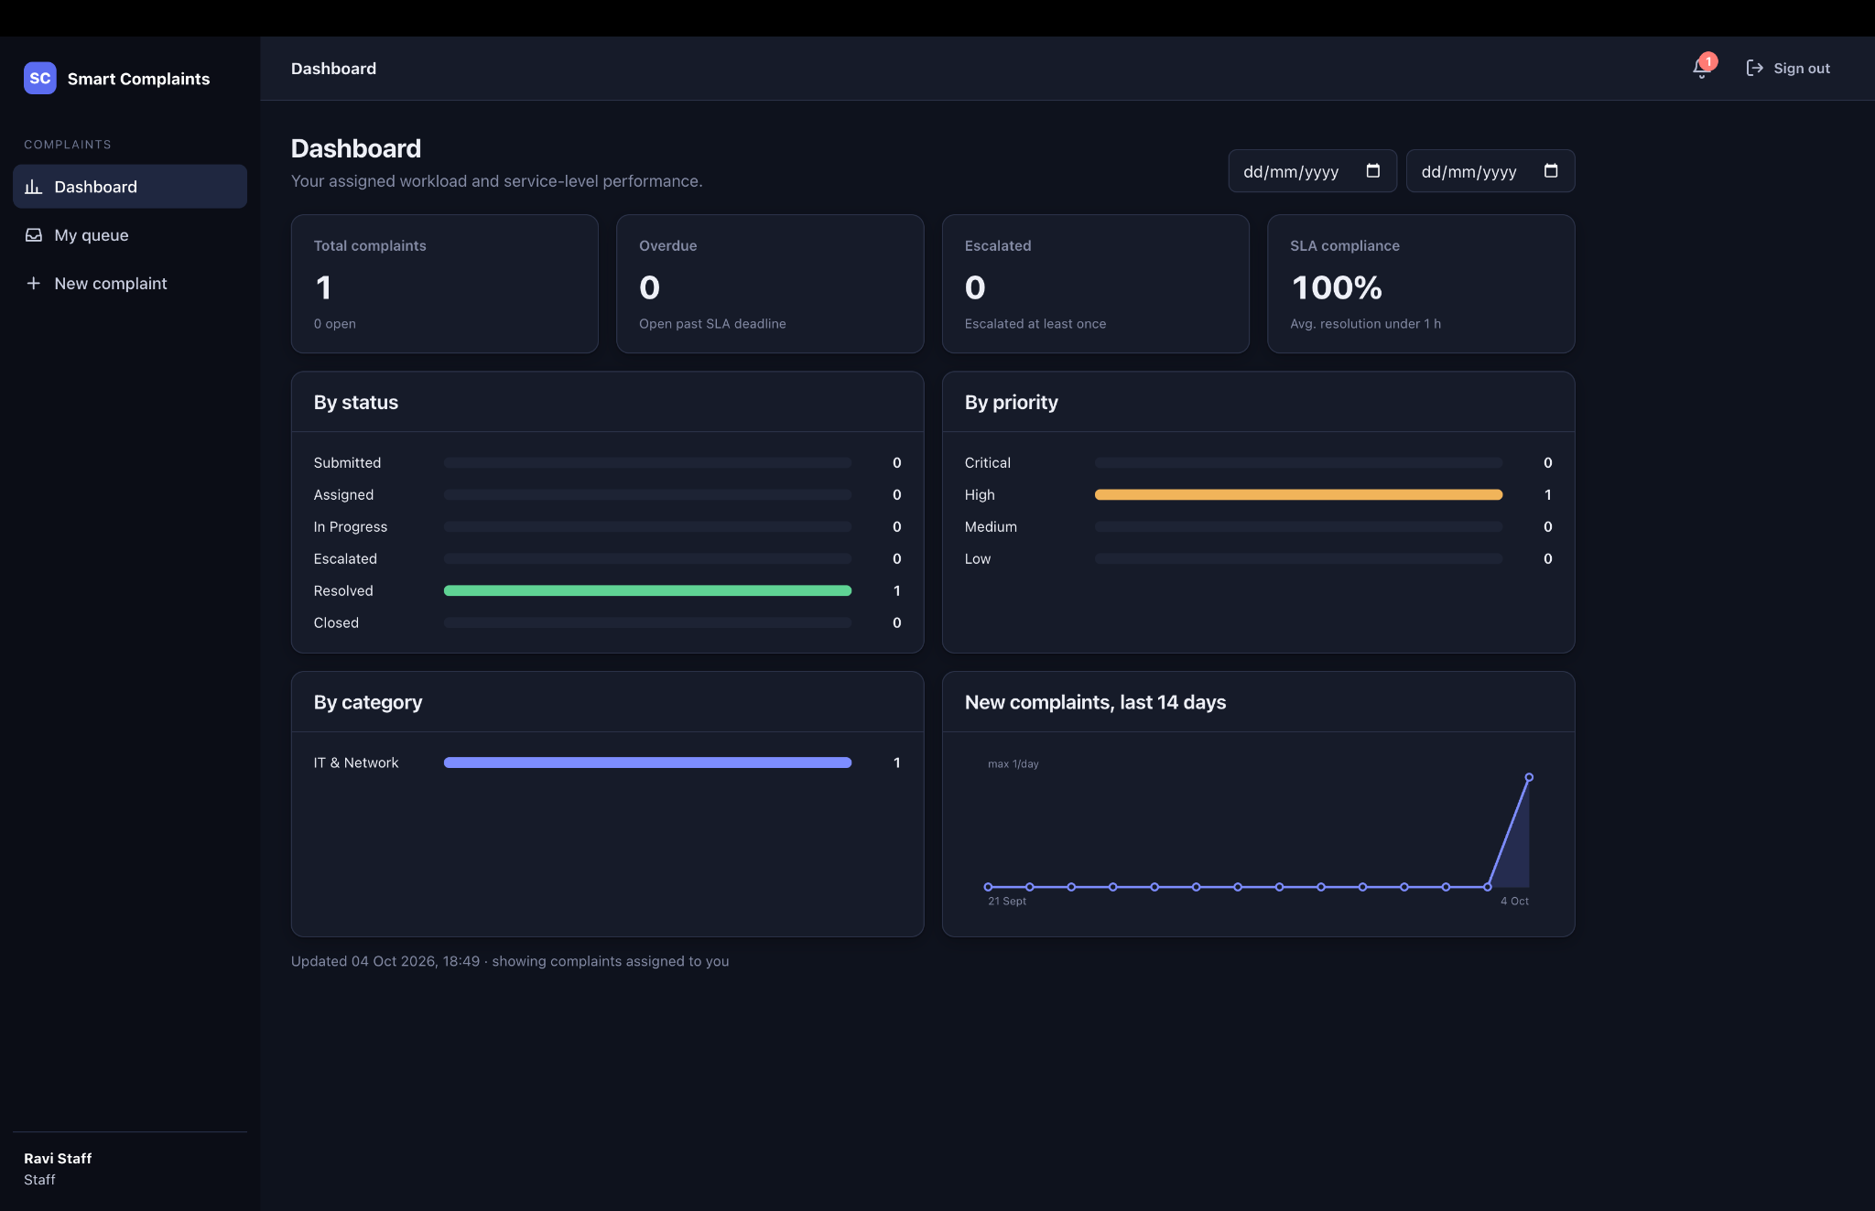
Figure 6.9. Staff dashboard showing assigned workload, status distribution, and SLA compliance.
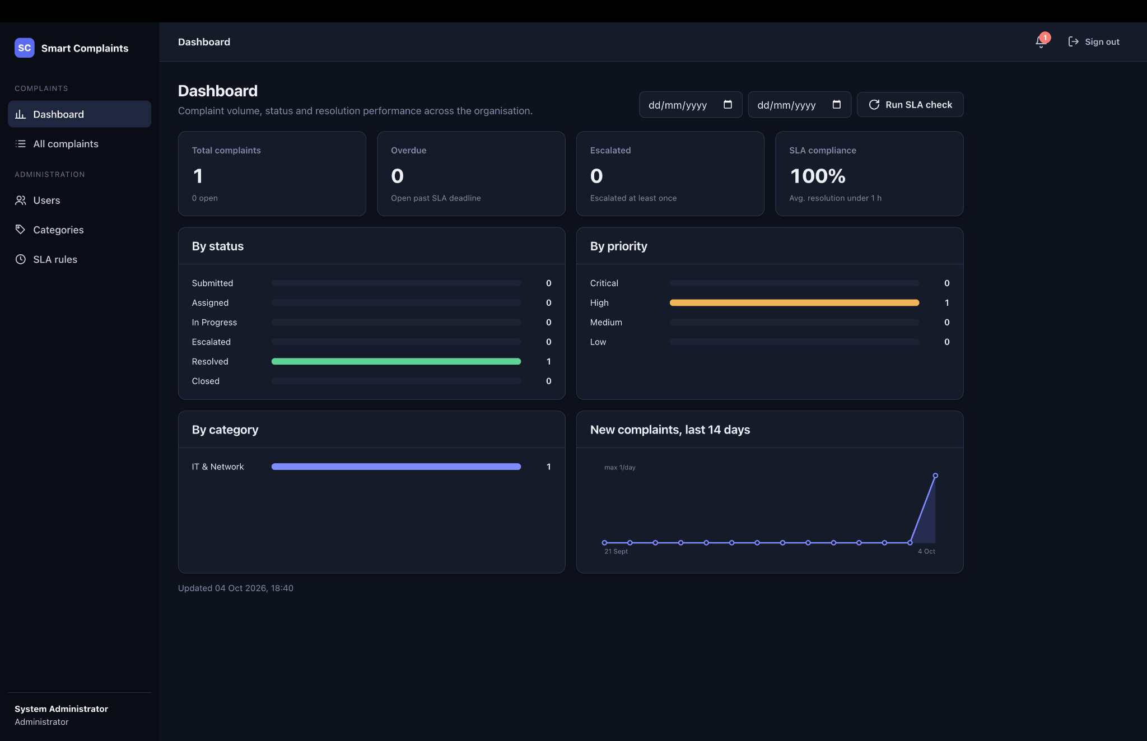
Figure 6.10. Administrator dashboard after resolution showing complaint, priority, category, and SLA metrics.

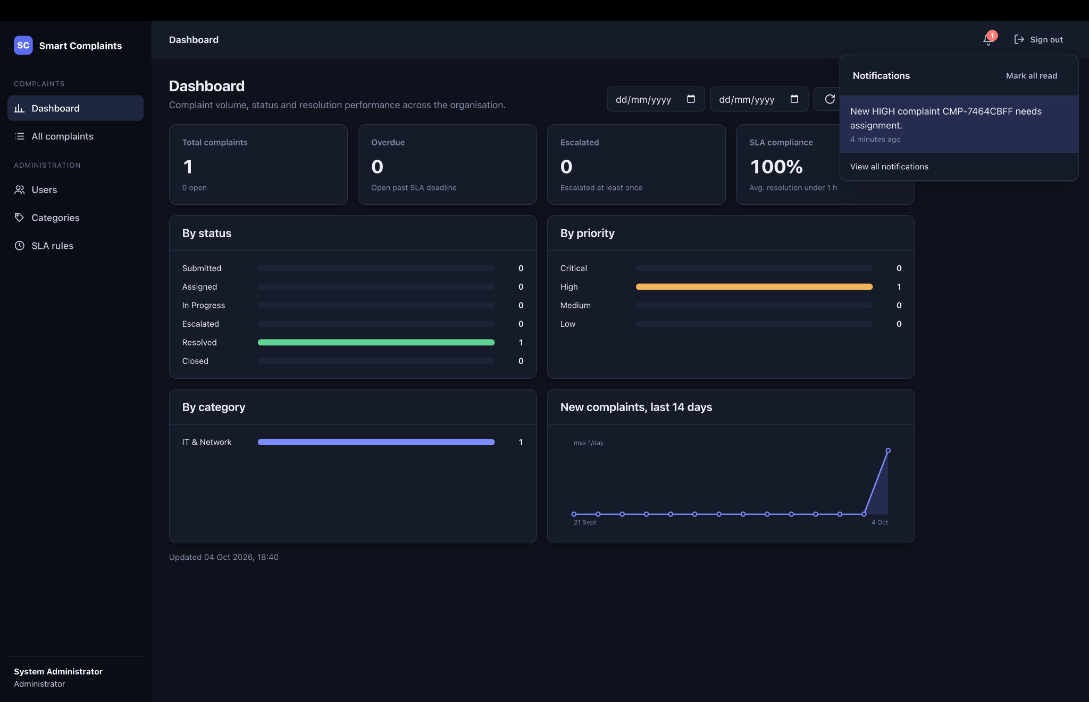
Figure 6.11. In-app notification panel showing a complaint-related notification.
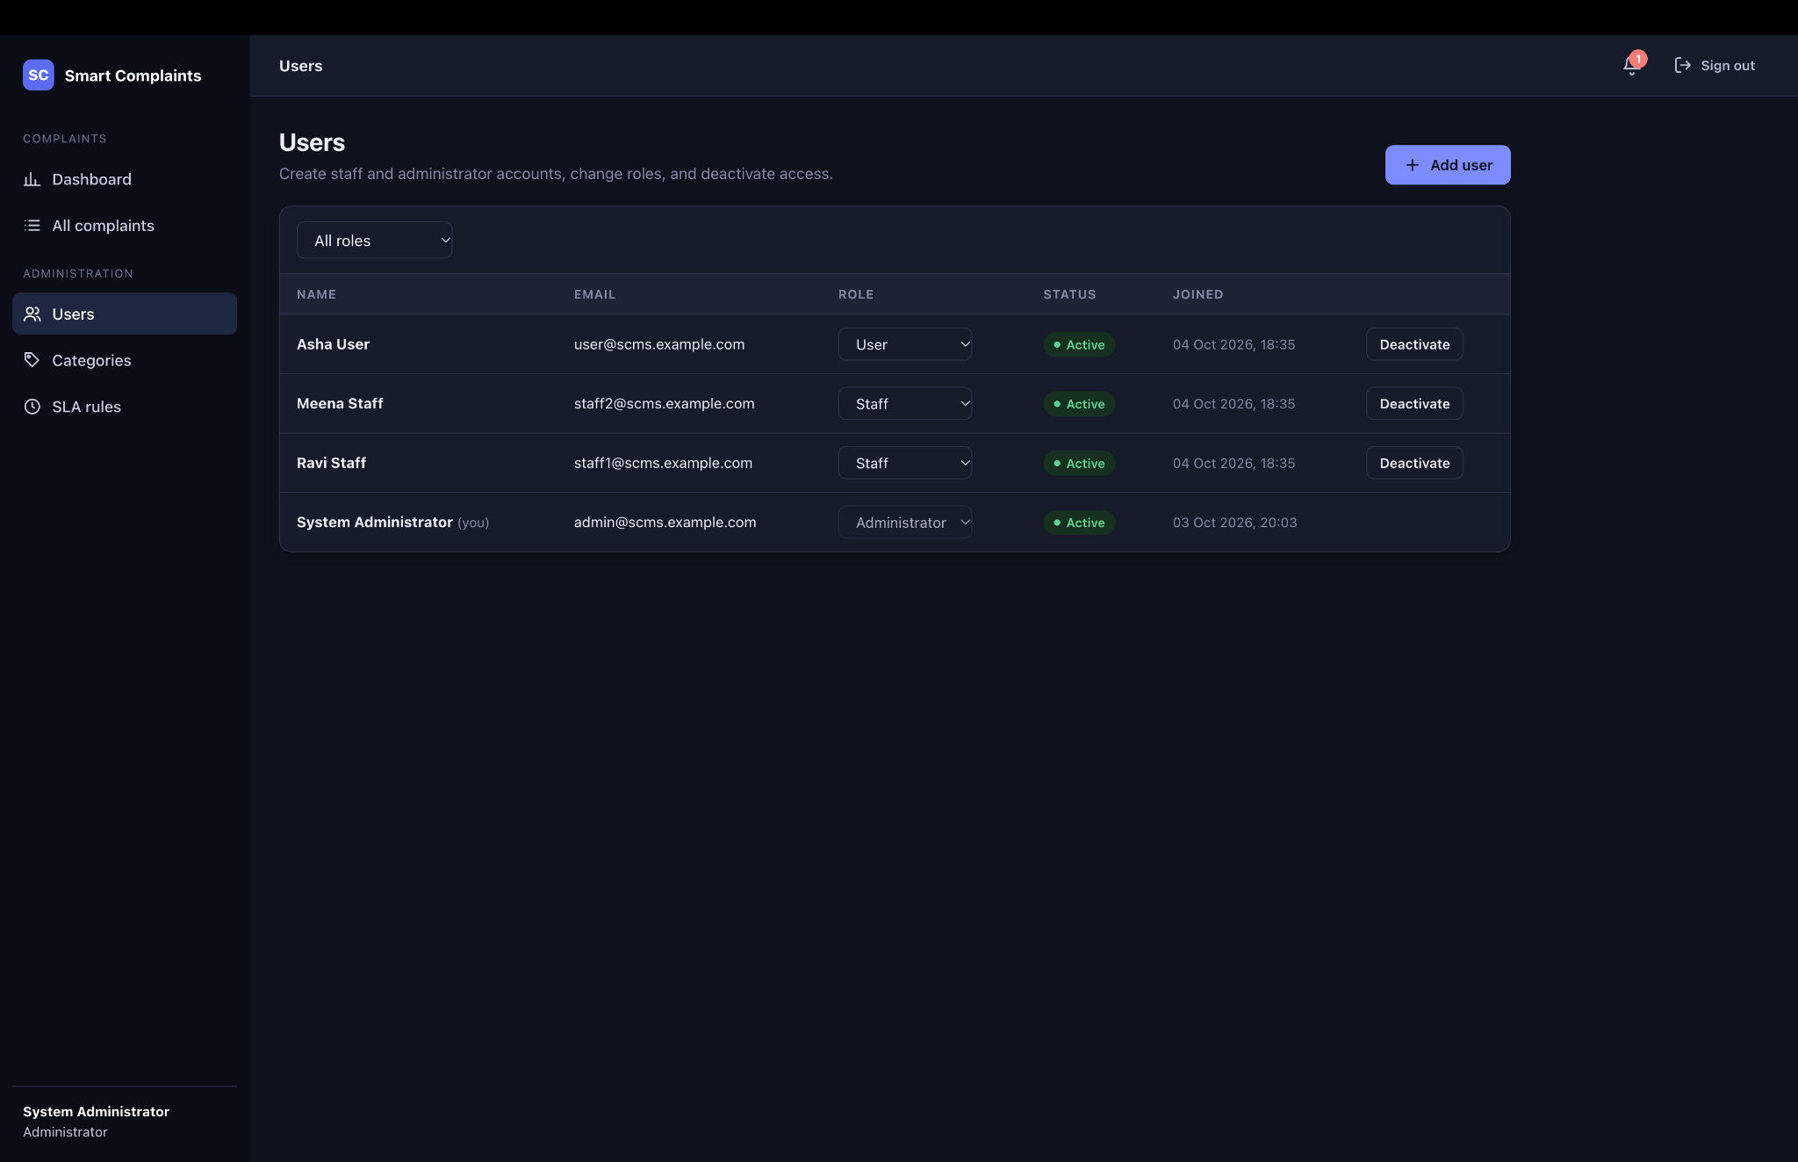
Figure 6.12. Administrator user-management interface with roles and account status.

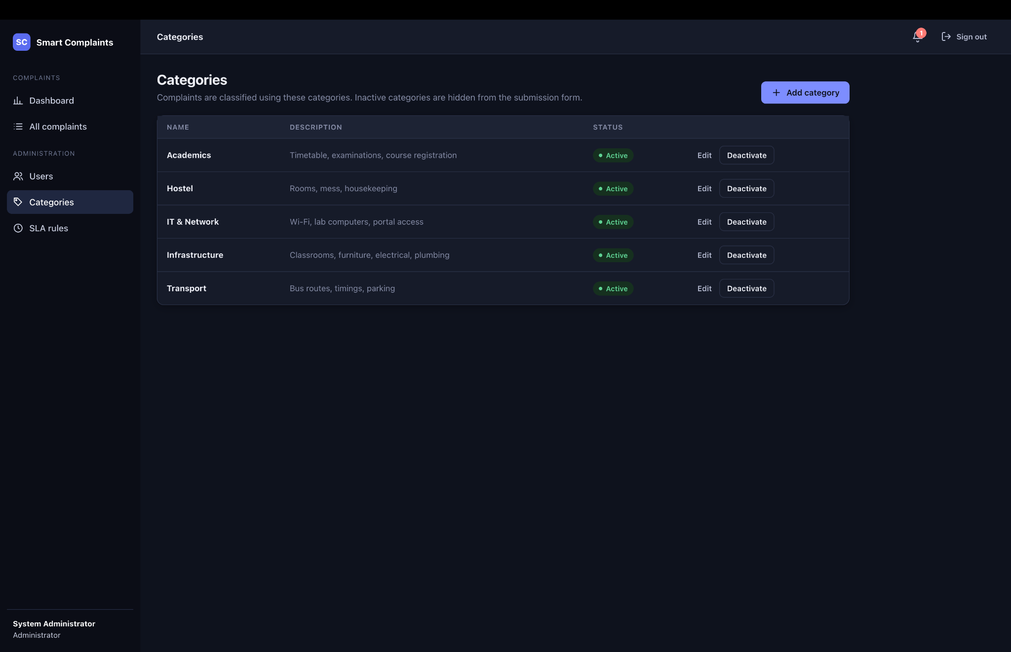
Figure 6.13. Category-management interface with active categories and controls.
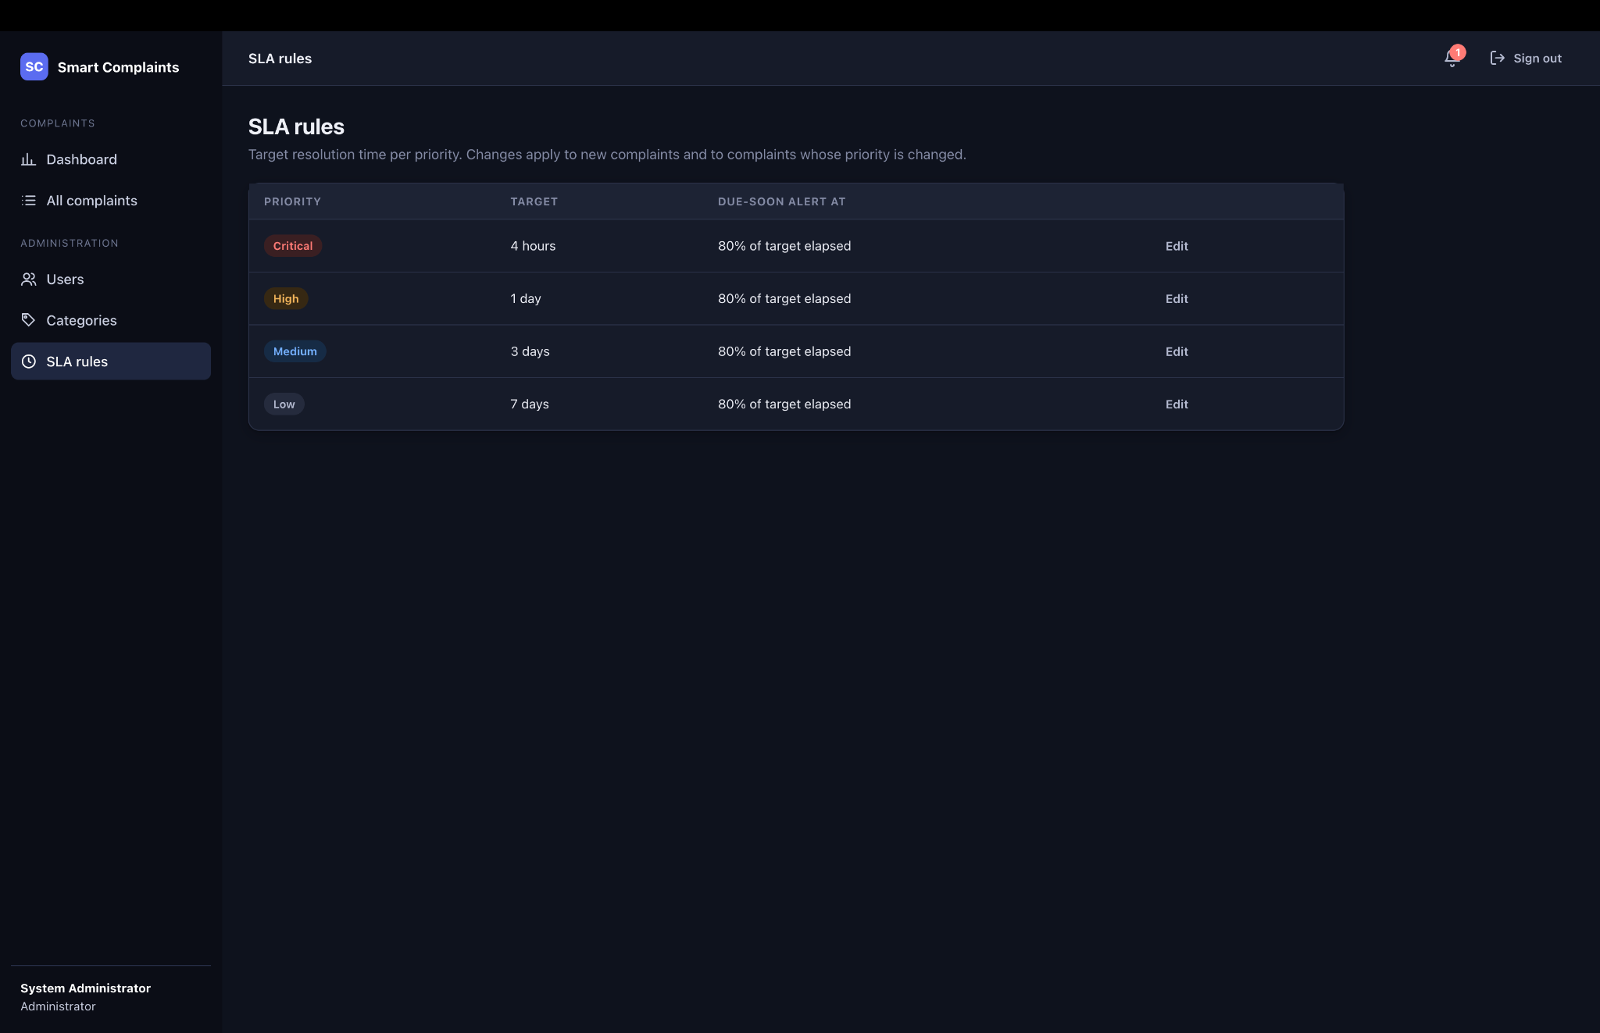
Figure 6.14. SLA rules configuration for Critical, High, Medium, and Low priorities.

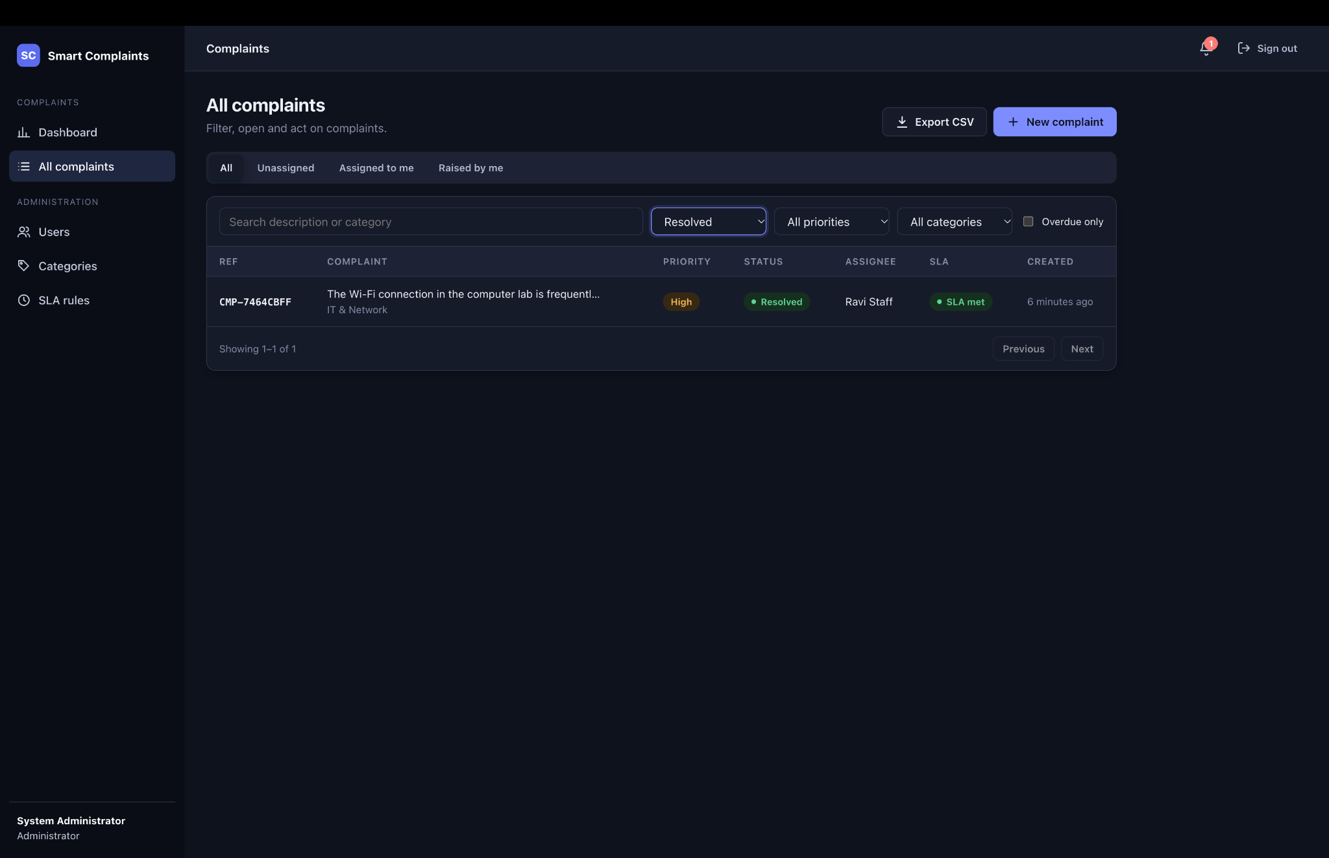
Figure 6.15. All Complaints view filtered to Resolved, including assignee and SLA state.
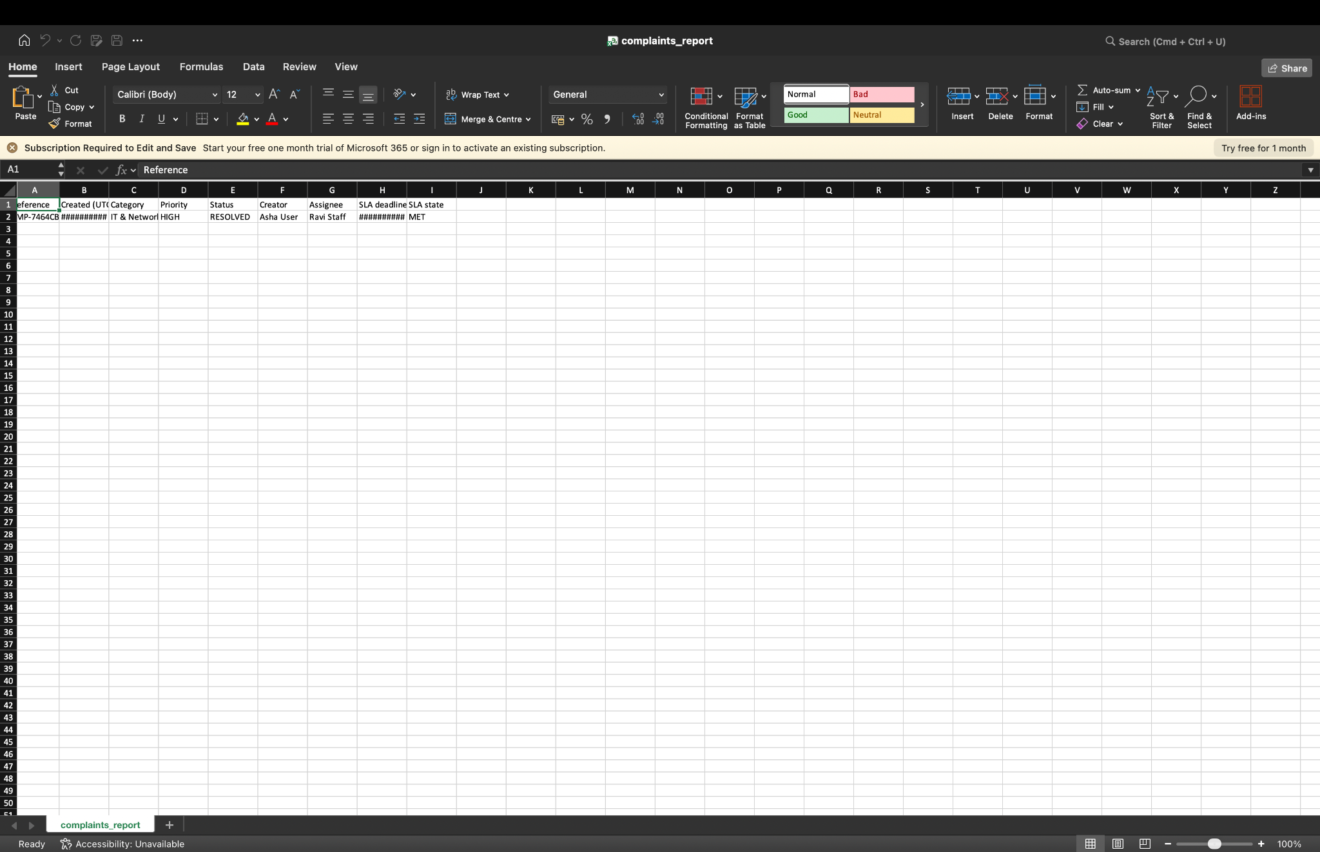
Figure 6.16. Exported complaint CSV report opened in a spreadsheet application.

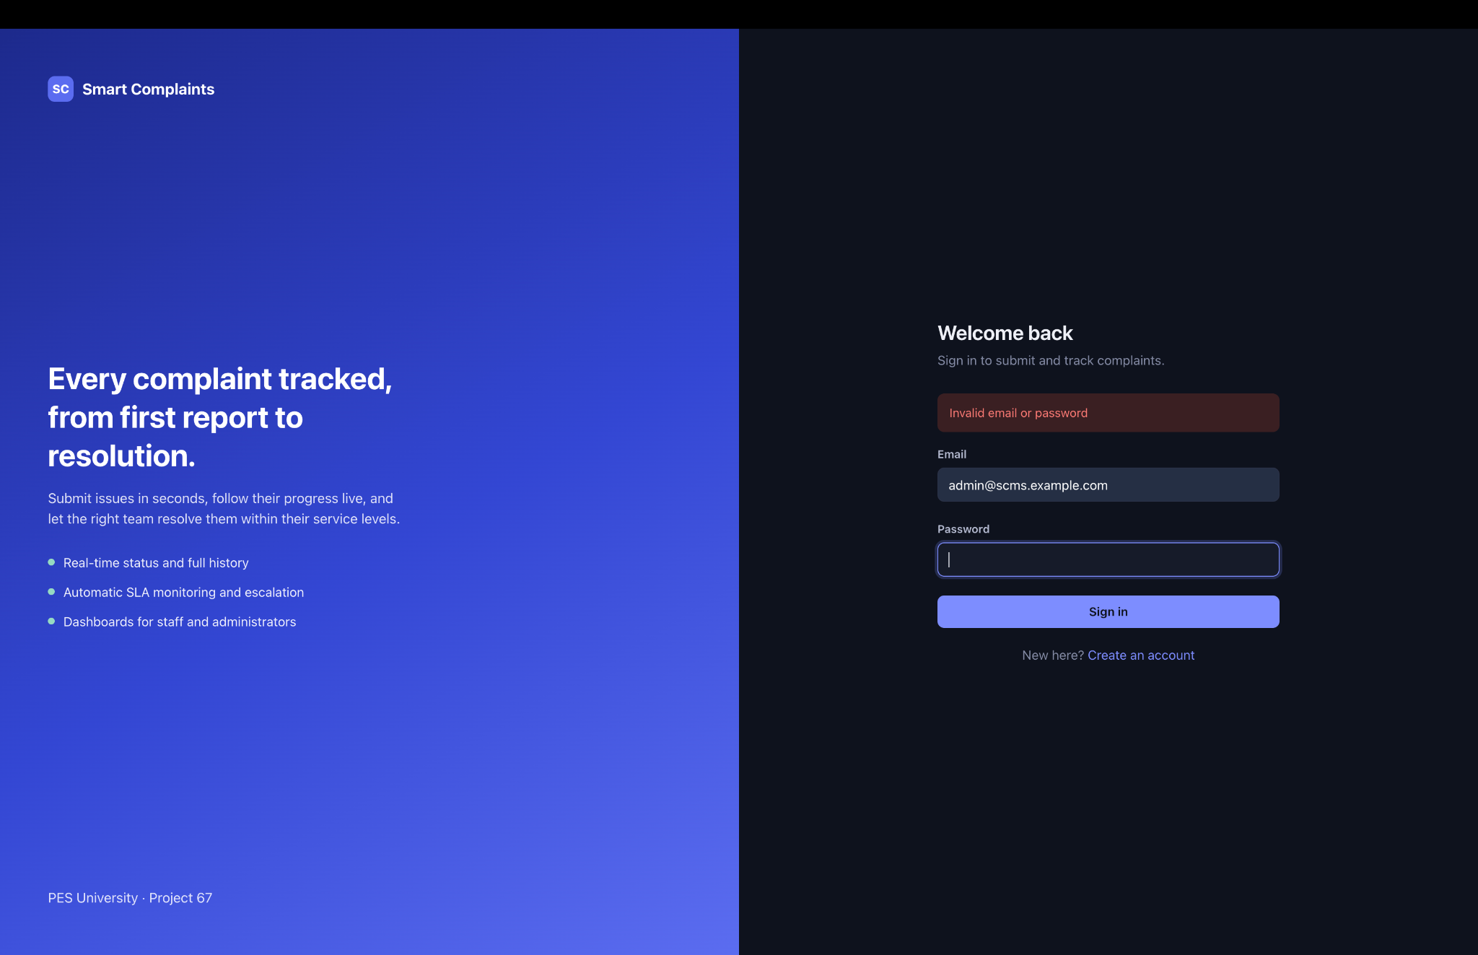
Figure 6.17. Invalid-login error output.
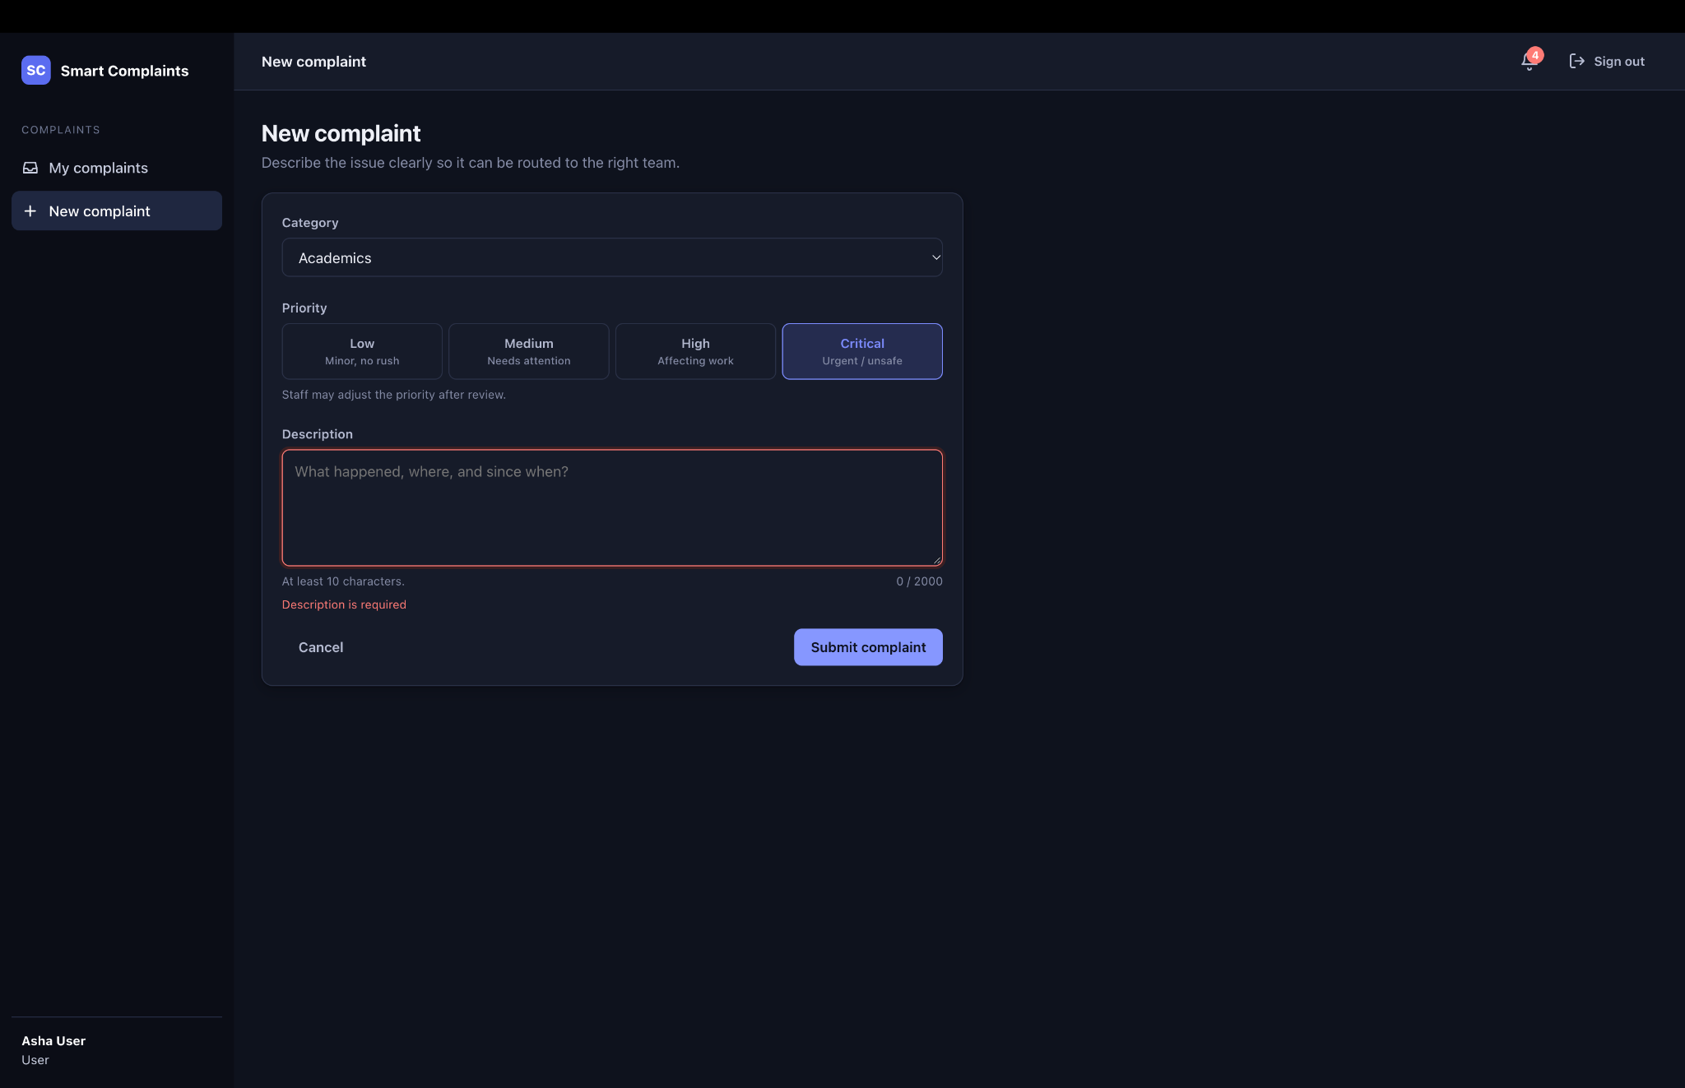
Figure 6.18. Mandatory complaint description validation error.

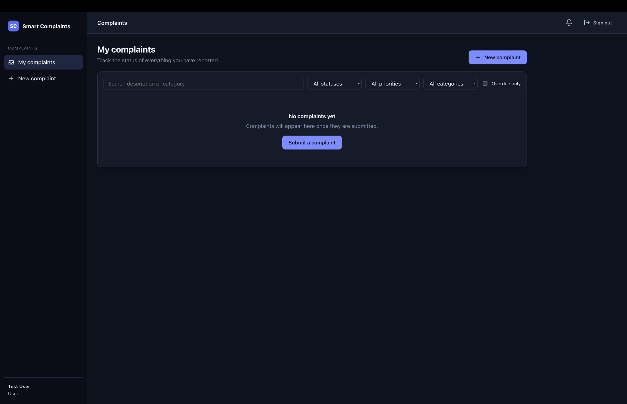
Figure 6.19. Successful registration of a new normal User account.
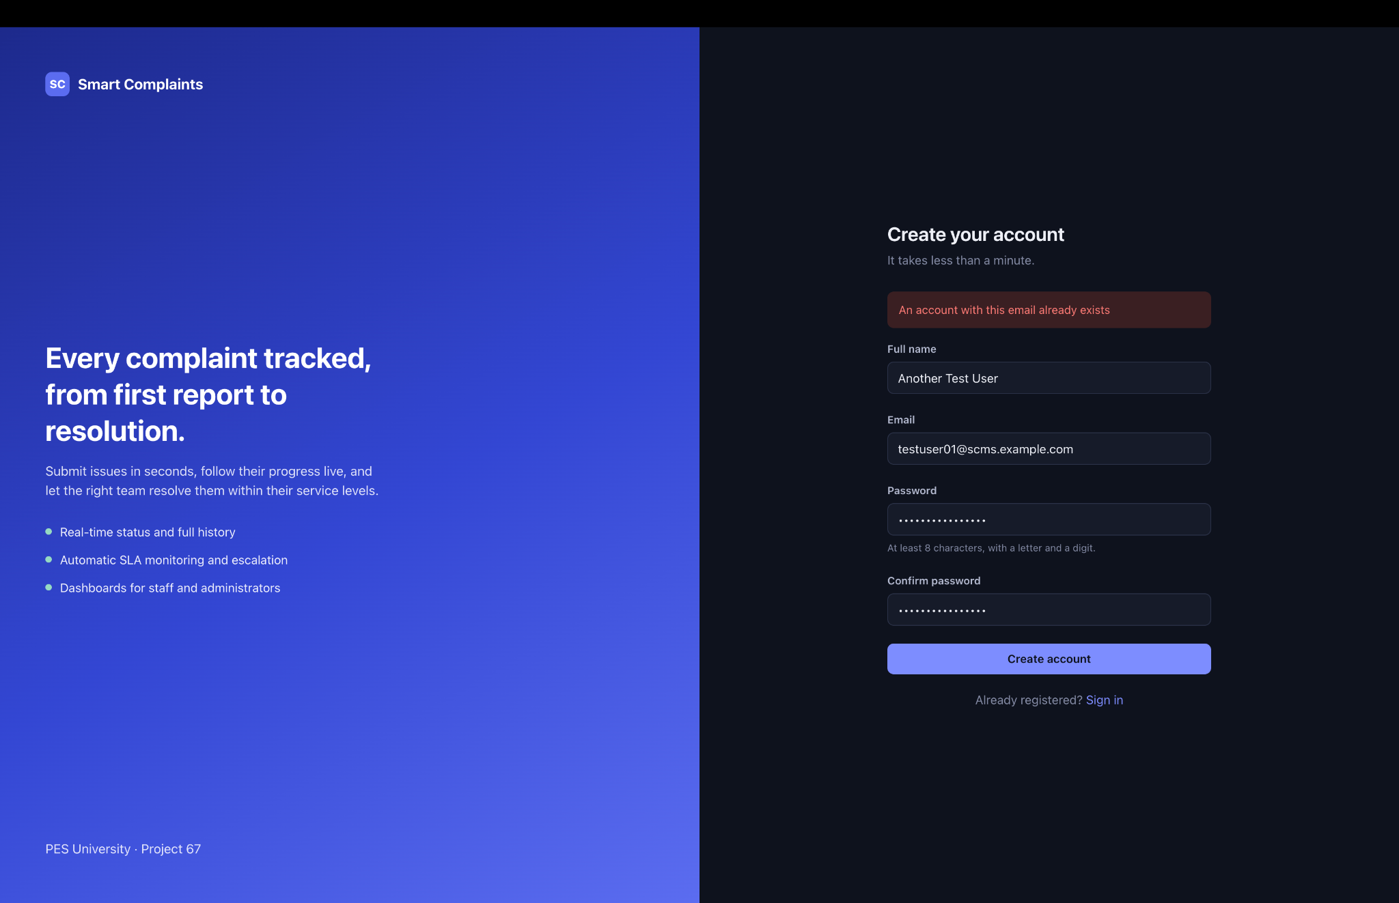
Figure 6.20. Duplicate email registration error.

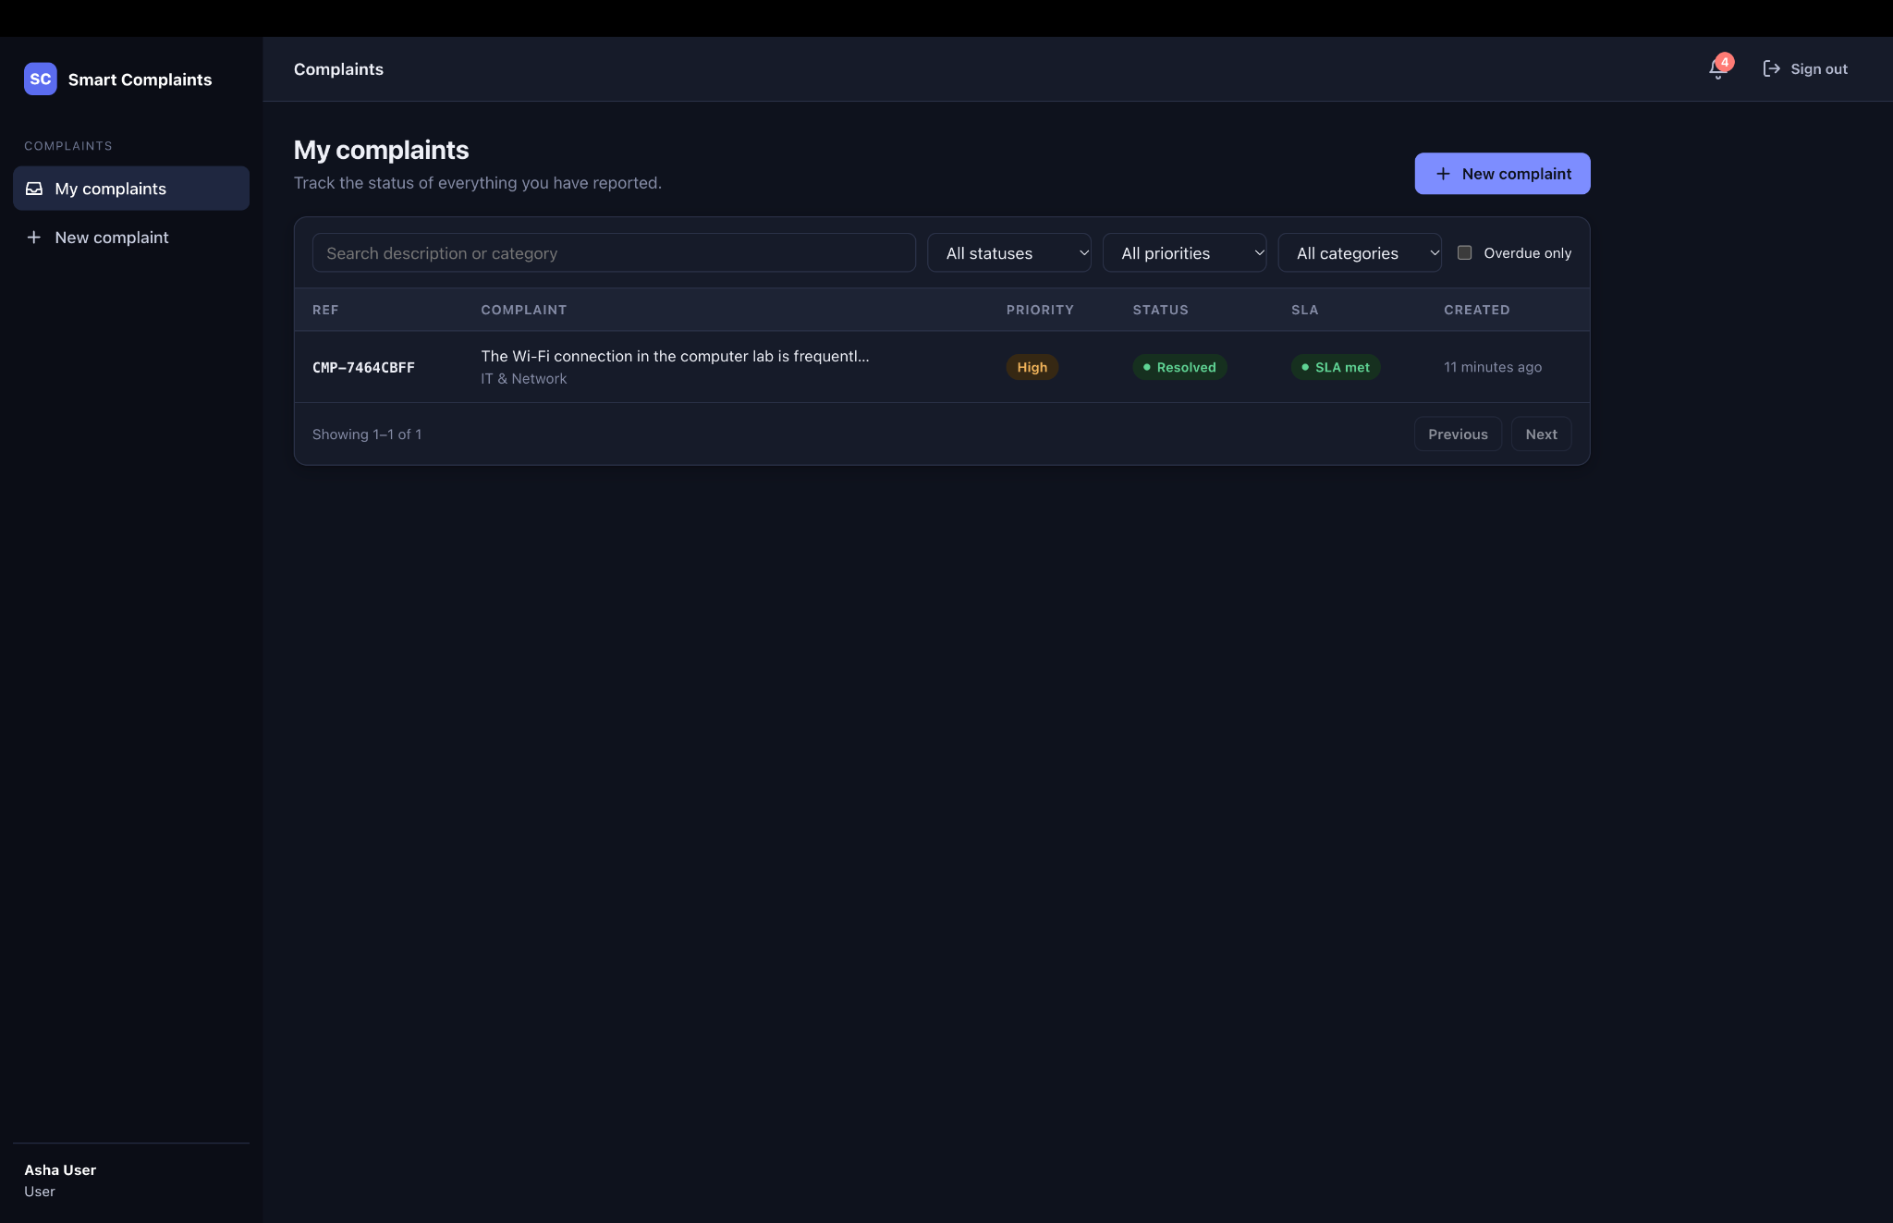
Figure 6.21. Normal User redirected away from the Administrator Users page, demonstrating route protection.
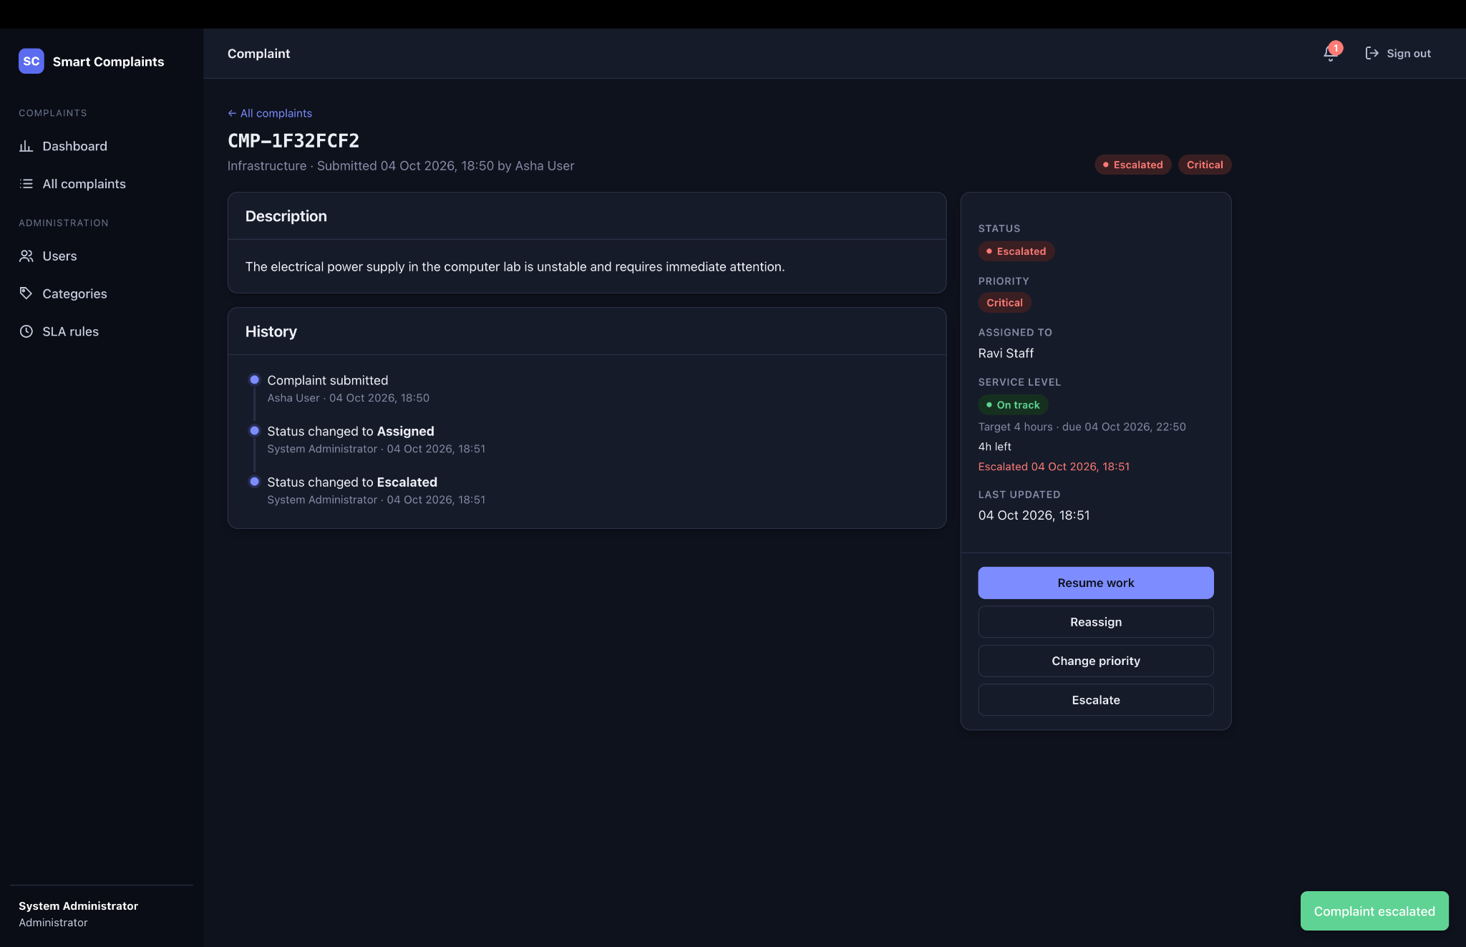
Figure 6.22. Critical complaint escalated by the Administrator with escalation history.

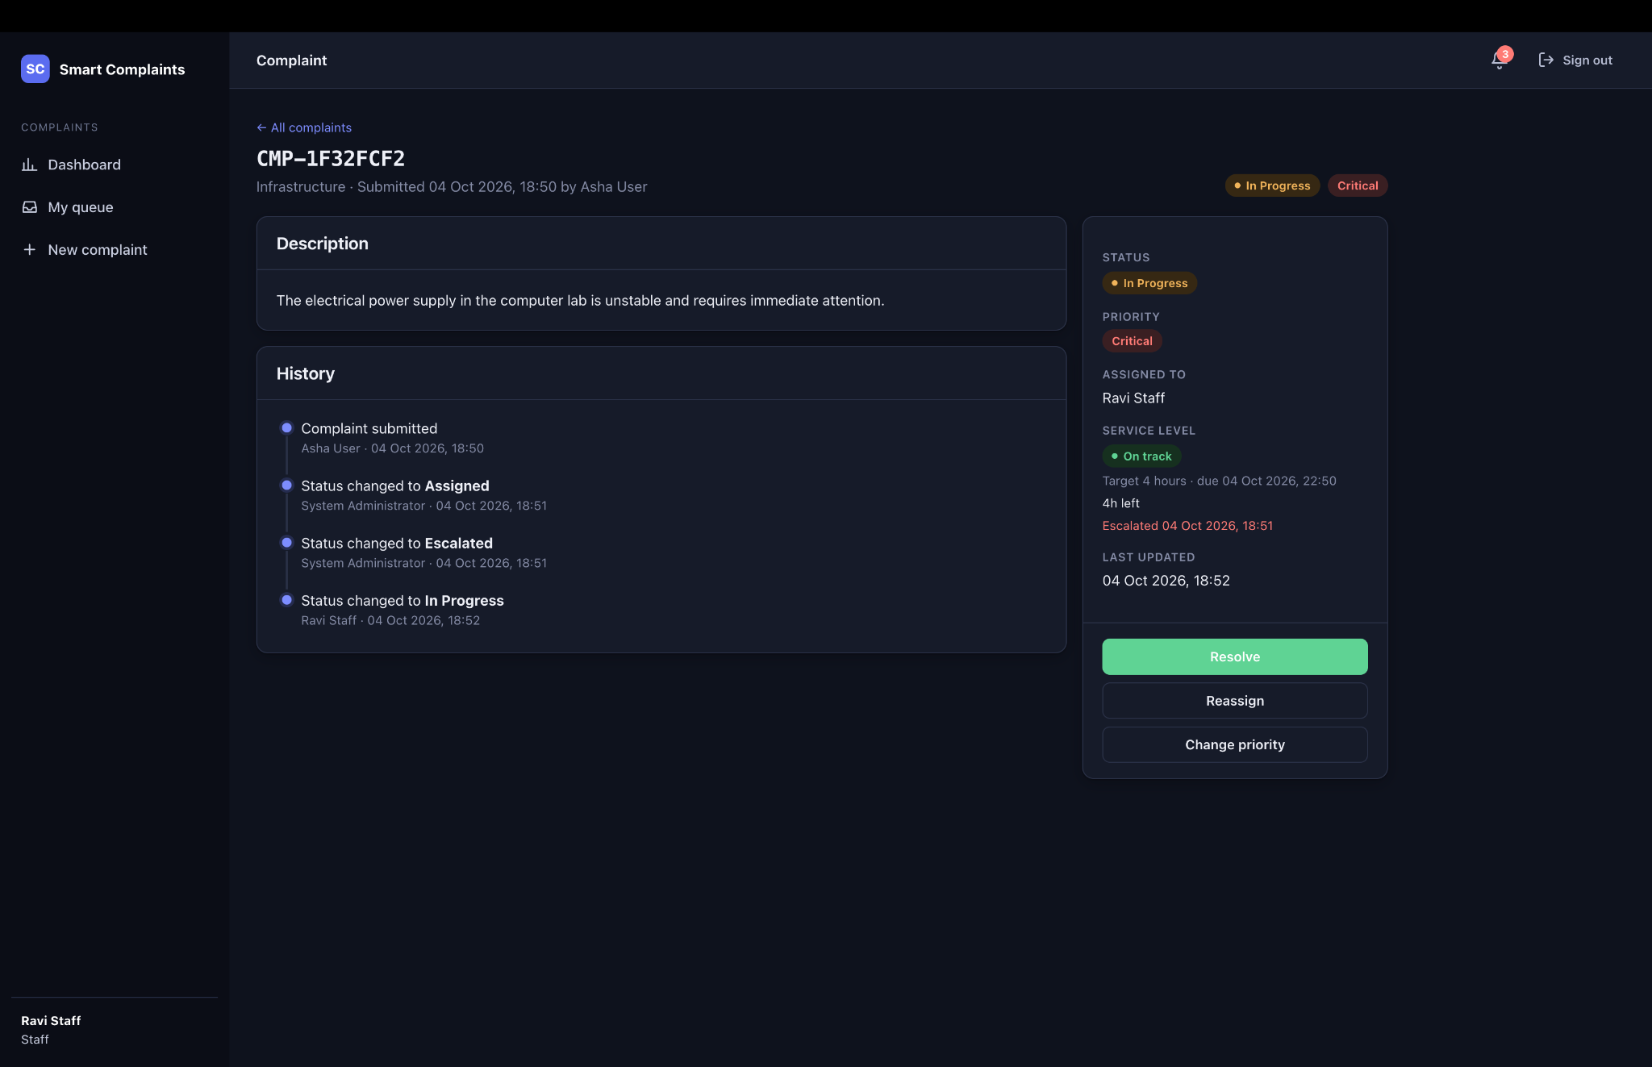
Figure 6.23. Escalated complaint resumed by Ravi Staff and returned to In Progress.
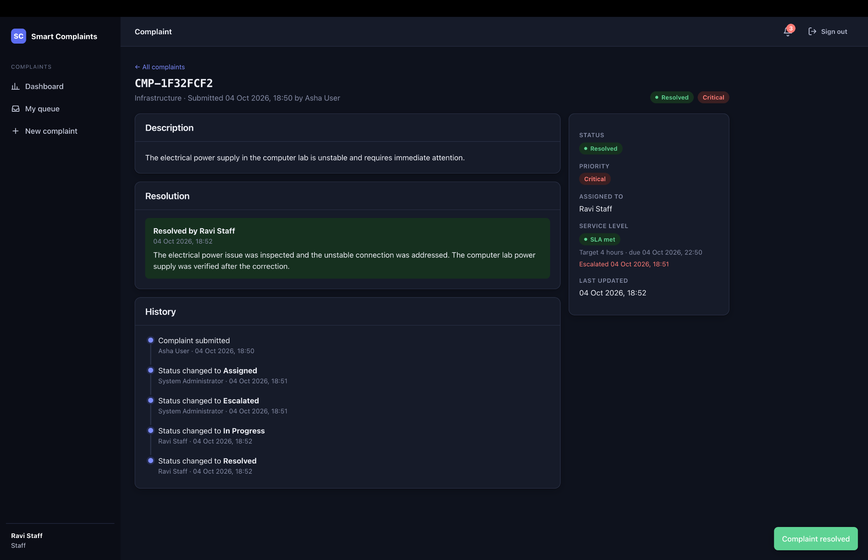
Figure 6.24. Escalation workflow completed with final resolution and SLA met.

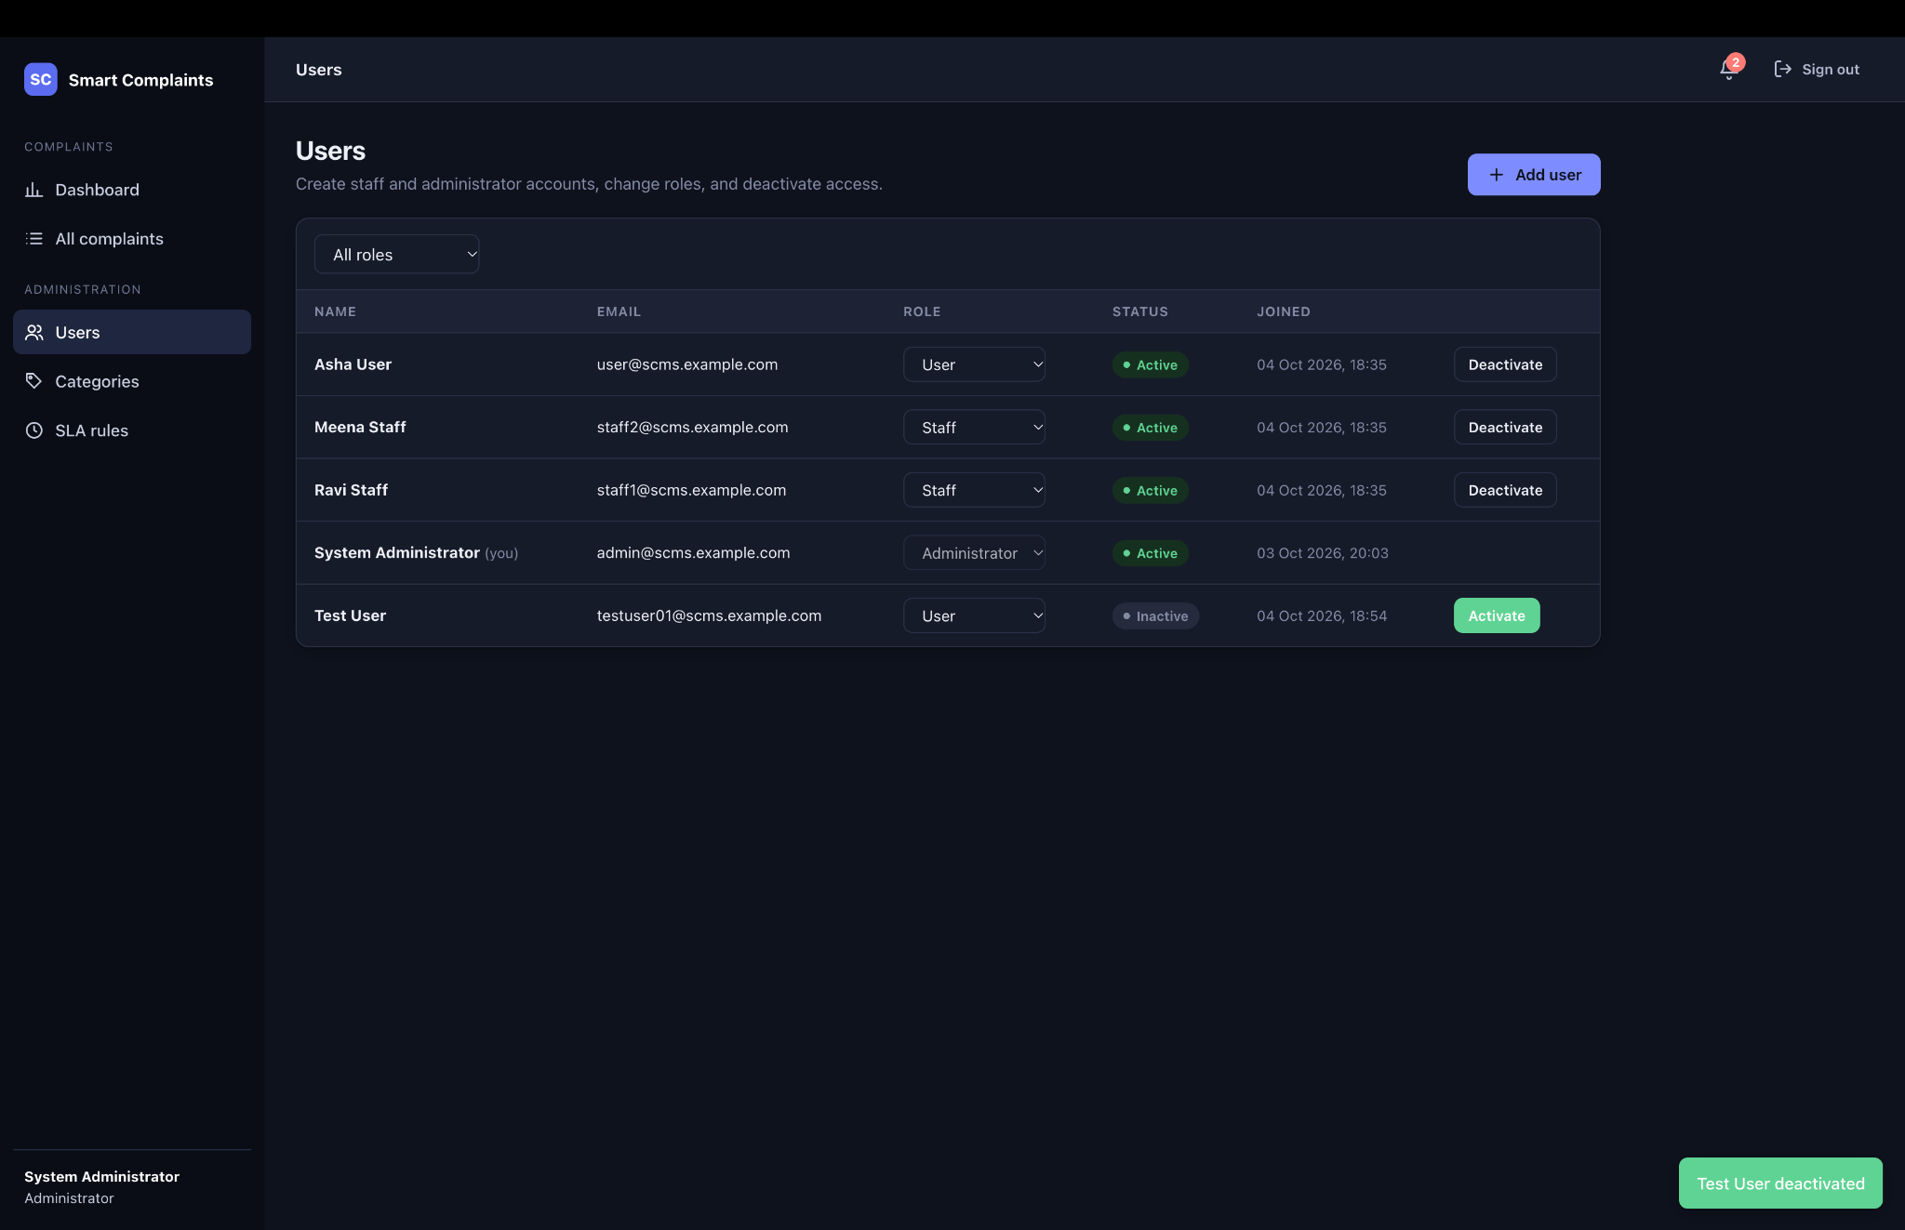
Figure 6.25. Administrator User Management showing a deactivated Test User account.
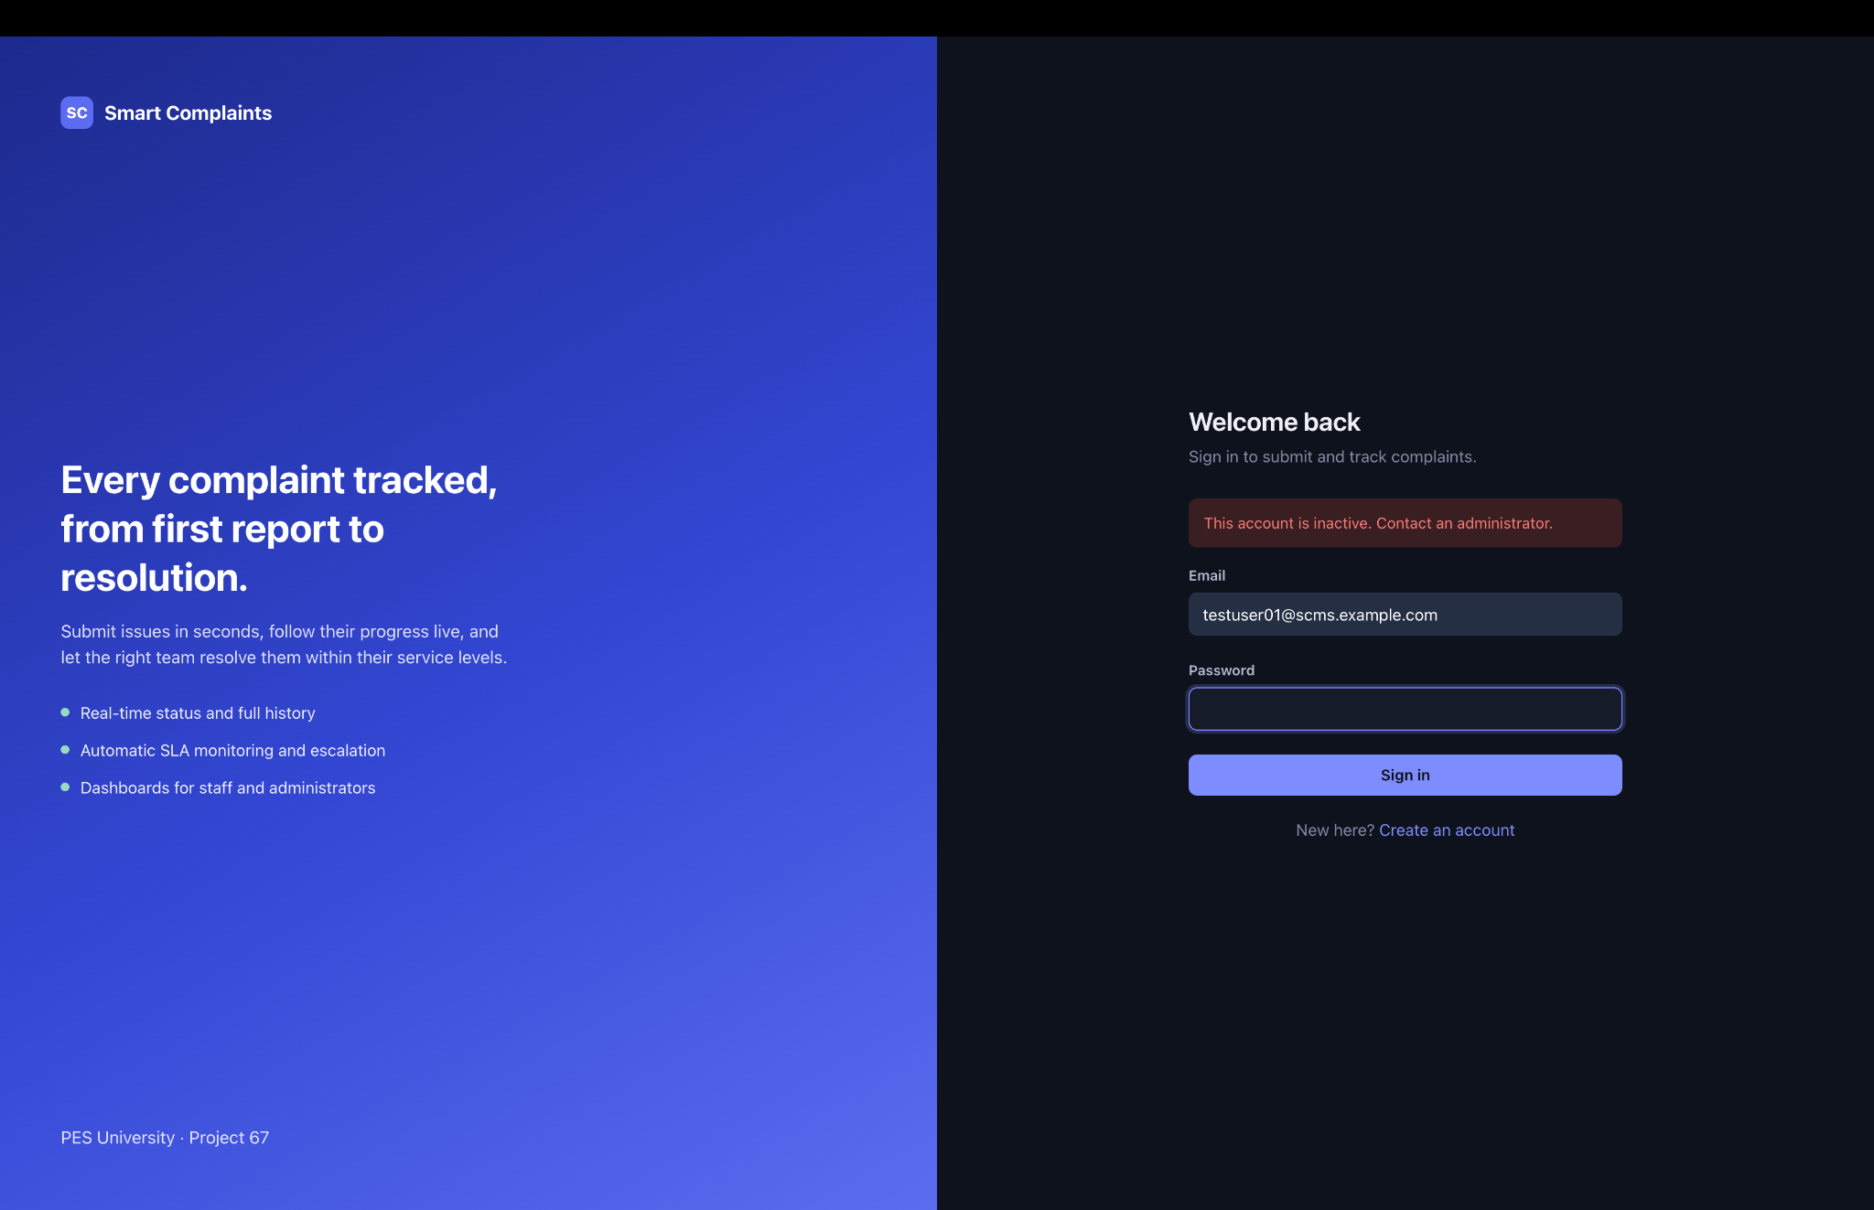
Figure 6.26. Login rejected for the deactivated account.
Evidence note: The screenshots in this section were captured from the same implementation-phase verification session documented in Section 5. They are representative outputs rather than a second execution of the automated test suite.

