HIGH-LEVEL ARCHITECTURE DOCUMENT
Smart Complaint Management System
Project ID: 67
Team Name: Gundu Guru
PES University – Computer Science and Engineering (AI&ML)
Version 1.0
October 2026

1. Architecture Overview
This document defines the high-level architecture of the Smart Complaint Management System. It translates the approved software requirements into major software components, their responsibilities, communication paths, and deployment structure. Detailed class design, database schema, API contracts, and implementation-level decisions will be developed in the subsequent software design phase.

1.1 Architectural Goals
- Provide clear separation of concerns between the user interface, application logic, data access, and external services.
- Support the complaint lifecycle from submission through assignment, SLA monitoring, escalation, and resolution.
- Enforce role-based access and protect administrative and staff operations.
- Allow notification delivery through in-app notifications and configurable external channels.
- Support incremental development by four team members with clear module ownership.
- Support testing, CI/CD, maintainability, and future extension without redesigning the entire system.

2. System Context
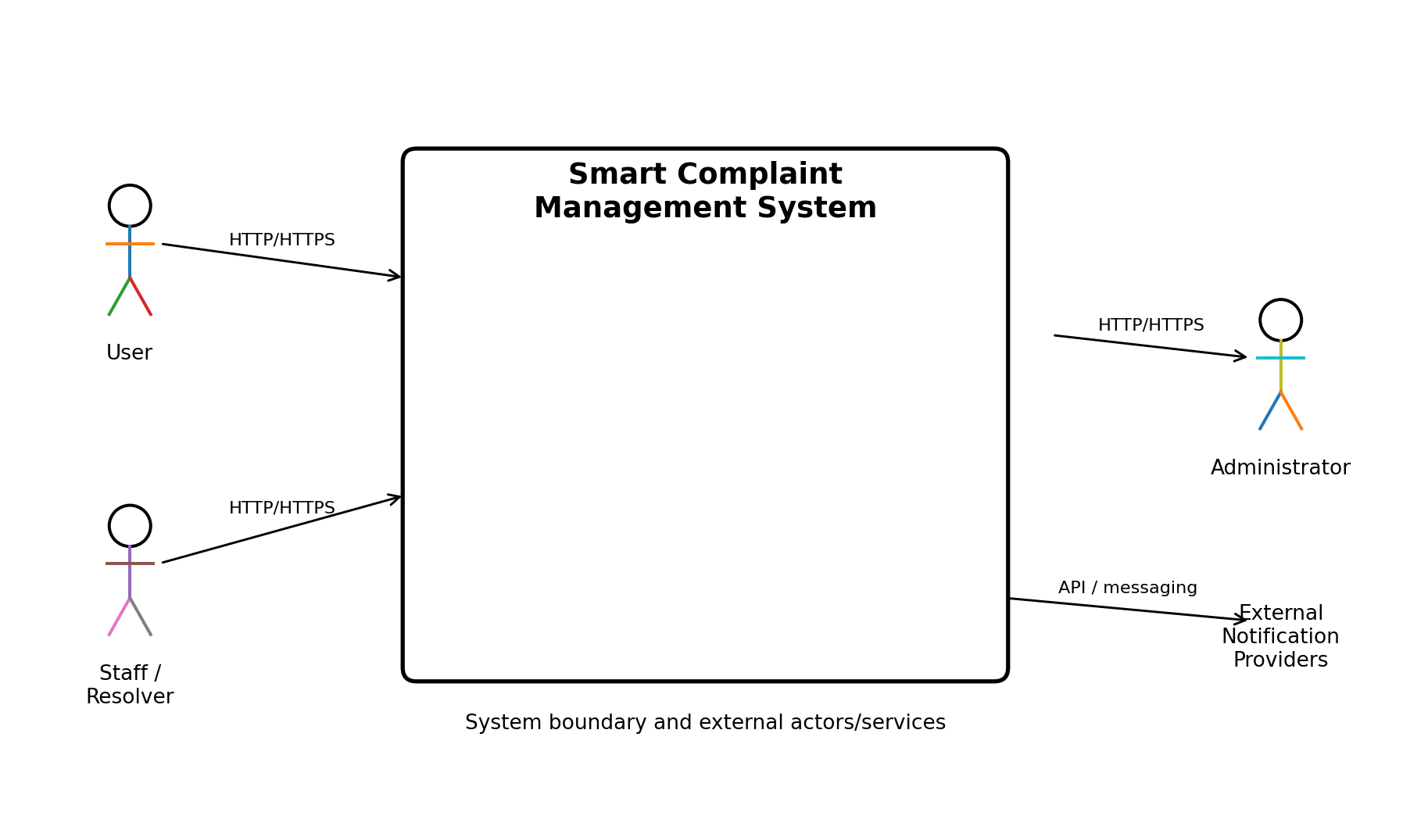
Figure 1. System context diagram
The system is accessed by three primary human roles: User, Staff/Resolver, and Administrator. External notification providers are treated as integrations rather than core complaint-processing components. The web client communicates with the application through HTTP/HTTPS, while the notification service communicates with configured providers through their supported interfaces.

3. Architectural Style

3.1 Selected Style: Layered Modular Web Architecture
The system will use a layered, modular web architecture. A web frontend handles presentation, a backend REST API coordinates application behavior, domain-oriented services implement business functions, a repository/data-access layer isolates persistence concerns, and a relational database stores system data. External messaging providers are accessed through the notification service.

3.2 Why This Style
- It matches the web-based nature of the project described in the SRS.
- It keeps business rules independent from the user interface.
- It allows each functional area to be developed and tested separately.
- It supports role-based authorization at the backend boundary.
- It makes external notification integrations replaceable or configurable.
- It is simple enough for a student mini-project while still demonstrating modular design.

4. Major Components
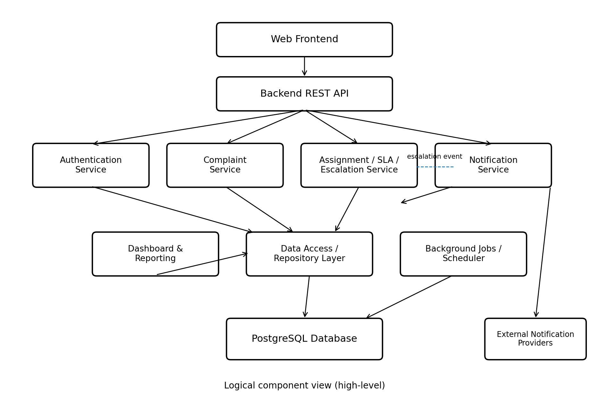
Figure 2. High-level component architecture
Component | Main Responsibility | Primary SRS Functions
Web Frontend | Presentation, forms, dashboards, user interaction. | FR-01–FR-24 user-facing interactions
Backend REST API | Request handling, authentication checks, orchestration, validation. | FR-01–FR-24
Authentication Service | Registration, login, password handling, role checks. | FR-01–FR-04, NFR-04–NFR-06
Complaint Service | Complaint creation, categorization, priority, tracking, status history. | FR-05–FR-11, FR-13–FR-15
Assignment / SLA / Escalation Service | Assignment, deadlines, SLA monitoring, escalation rules. | FR-12, FR-16–FR-19
Notification Service | In-app notifications and adapters for configured external channels. | FR-20–FR-21
Dashboard & Reporting | Administrative summaries, filtering, reporting. | FR-22–FR-24
Data Access / Repository | Persistence abstraction and database access. | Data requirements
Background Jobs / Scheduler | Periodic SLA checks and other non-request processing. | FR-17–FR-18
PostgreSQL Database | Persistent storage of users, complaints, assignments, SLA data, notifications, and resolution data. | Data requirements

5. Component Interaction and Workflow

5.1 Complaint Submission
User → Web Frontend → Backend REST API → Complaint Service → Data Access Layer → PostgreSQL Database. The backend validates the request, applies category/priority rules, stores the complaint, and returns the created complaint record.

5.2 Assignment and Resolution
Administrator/Staff → Web Frontend → Backend REST API → Assignment / Complaint Service → Database. Assignment and status changes are authorized by role and recorded in status history.

5.3 SLA and Escalation
Background Scheduler → SLA/Escalation Service → Data Access Layer → Database. The scheduler checks eligible complaints and applies escalation rules. An escalation event is then passed to the Notification Service when a notification is required.

5.4 Notifications
Application event → Notification Service → In-app notification store and, where configured, external notification providers such as email, SMS, and WhatsApp. The notification service keeps provider-specific integration details separate from complaint-processing logic.

6. Security Architecture
- Authentication is performed before access to protected operations.
- Role-based authorization distinguishes User, Staff/Resolver, and Administrator permissions.
- Passwords are stored using secure password hashing rather than plaintext.
- Input validation occurs at the API boundary and relevant service layer.
- Administrative operations are restricted by authorization checks.
- External notification credentials are kept outside source code and supplied through secure configuration.
Security architecture will be refined during detailed design and security validation; this document defines the high-level control boundaries.

7. Data Architecture – High Level
The system uses a relational database. The high-level logical data groups are User, Complaint, Category, Assignment, Status History, SLA, Notification, and Resolution. These groups correspond to the data requirements established in the SRS. The exact tables, keys, indexes, foreign-key constraints, and normalization decisions will be specified in the Software Design Document.
Data Group | Used By
User / Role | Authentication, authorization, assignment
Complaint | Complaint Service, tracking, reporting
Category / Priority | Complaint Service, administration
Assignment | Assignment/SLA Service, staff dashboard
Status History | Tracking, auditability, reporting
SLA | SLA monitoring and escalation
Notification | Notification Service and in-app notification UI
Resolution | Complaint resolution and reporting

8. Deployment Architecture
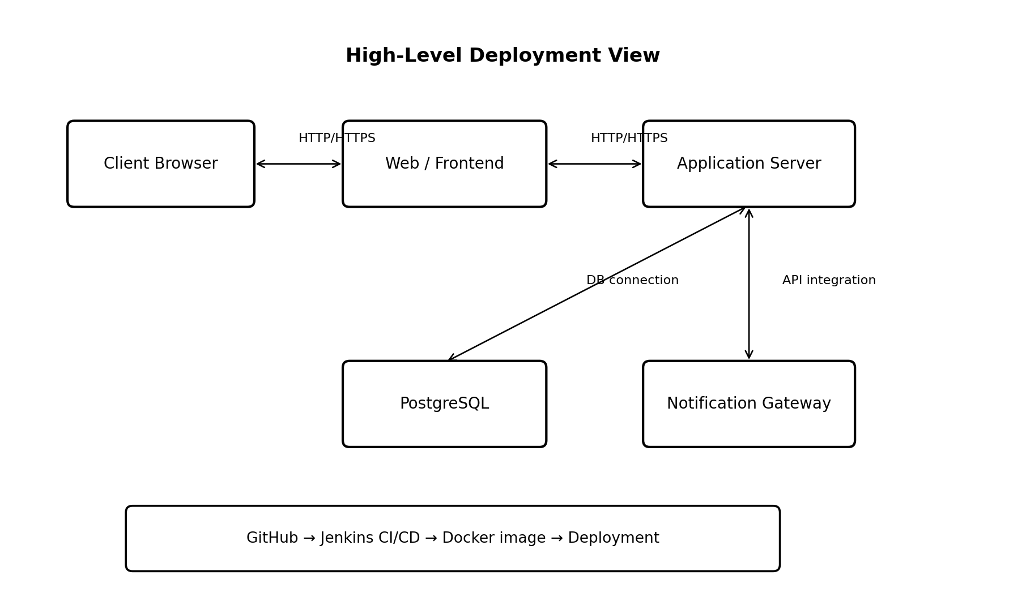
Figure 3. High-level deployment architecture
The deployment model separates the client browser, web/frontend layer, application server, database, and notification gateway/integrations. Docker will be used to provide consistent environments, and Jenkins will automate build/test/deployment activities according to the project plan.

9. Technology Mapping
Layer / Concern | Planned Technology | Reason
Frontend | HTML/CSS/JavaScript or equivalent lightweight web UI | Simple web interface aligned with project scope.
Backend | Python + FastAPI | REST API and modular business logic.
Database | PostgreSQL | Relational persistence for structured complaint data.
Testing | Pytest and API/client testing tools | Unit and integration testing.
CI/CD | Jenkins | Automated build, test, and deployment pipeline.
Containerization | Docker | Consistent development and deployment environment.
Source Control | Git + GitHub | Version control, branches, pull requests, and contribution tracking.
Agile Tracking | GitHub Issues/Projects | Backlog, user stories, tasks, and sprint tracking.
Static Analysis | SonarQube or equivalent | Code-quality and static-analysis checks.

10. Modularity and Team Ownership
Team Member | Primary Architectural Component | Ownership Boundary
Purum Gurudev | Authentication Service | Authentication, authorization, account-related API and tests.
Prashyanth V | Complaint Service | Complaint creation, category/priority, tracking, and history.
Aditya Pradeep | Assignment / SLA / Escalation Service | Assignment, SLA rules, background monitoring, and escalation.
Nihar S Jain | Notification + Dashboard/Reporting | Notifications, external notification adapters, dashboard and reporting.
All members continue to contribute to integration, design reviews, testing, CI/CD, documentation, and code review. The ownership boundaries prevent module overlap while keeping the overall architecture collaborative.

11. Architectural Constraints and Decisions
- The system remains a web-based application as established in the SRS.
- The project uses a relational database and modular backend services.
- External notification channels are integrations and remain configurable; in-app notifications are part of the baseline system.
- Detailed API endpoints, request/response schemas, class structures, database tables, and indexes are deferred to the Software Design Document.
- Architecture decisions must remain traceable to the SRS requirements and be updated through controlled GitHub changes and pull requests.

12. Requirement-to-Component Mapping
Requirement Group | Primary Component(s)
FR-01–FR-04 | Authentication Service + Backend API + Frontend
FR-05–FR-11 | Complaint Service + Frontend + Database
FR-12–FR-15 | Assignment/Complaint Services + Database
FR-16–FR-19 | SLA/Escalation Service + Scheduler + Database
FR-20–FR-21 | Notification Service + Notification Store + External Providers
FR-22–FR-24 | Dashboard/Reporting + Complaint/Data Access
NFR Security | Authentication + API authorization + secure configuration
NFR Performance/Reliability | API + Data Access + Database + Scheduler

13. Next Phase: Software Design
The next deliverable will translate this high-level architecture into implementable design specifications. It will define detailed UML diagrams, database ER design, API endpoints and schemas, component interfaces, sequence flows, and module-level design. The implementation will begin only after the design baseline is established.

