PROJECT PLAN DOCUMENT
Smart Complaint Management System
Project ID: 67
B.Tech. (CSE) – Software Engineering Mini Project
PES University, Bengaluru

Team Name: Gundu Guru
Version 1.0
Prepared: October 2026

Document Control
Field | Value
Project Name | Smart Complaint Management System
Project ID | 67
Team Name | Gundu Guru
Lifecycle | Agile (Scrum-style iterative development)
Planned Duration | 6 weeks
Document Version | 1.0
Prepared | October 2026

Team Profile
Member | SRN | Primary Functional Ownership
Purum Gurudev | PES2UG24AM125 | User Authentication & Account Management
Prashyanth V | PES2UG24AM120 | Complaint Submission, Categorization & Tracking
Aditya Pradeep | PES2UG24AM900 | Assignment, SLA Monitoring & Escalation
Nihar S Jain | PES2UG24AM104 | Notifications, Dashboard & Reporting
All team members are expected to participate in requirements, planning, design, implementation, testing, reviews, and documentation. The functional ownership above identifies the primary end-to-end feature owned by each member.

Table of Contents
1. Project Overview
2. Development Lifecycle
3. Tools and Infrastructure
4. Deliverables and Reuse/Build Classification
5. Team Responsibilities and Product Ownership
6. Work Breakdown Structure (WBS)
7. Effort Estimation
8. Project Schedule and Gantt Chart
9. Sprint Plan
10. Risk and Mitigation Plan
11. Definition of Done
12. Project Tracking and Reporting

1. Project Overview

1.1 Objective
The objective of the Smart Complaint Management System is to provide a centralized web-based platform for lodging, categorizing, prioritizing, assigning, tracking, escalating, and resolving complaints. The project will demonstrate the complete software engineering lifecycle from requirements through validation and final demonstration.

1.2 Scope
The project will implement the functional scope established in the approved SRS: authentication, complaint submission and tracking, categorization and priority management, assignment and resolution, SLA monitoring and escalation, notifications, and administrative dashboard/reporting.

1.3 Key Project Goals
- Deliver a working web application with role-based access.
- Maintain a clear complaint lifecycle with status history.
- Provide SLA-based monitoring and escalation.
- Provide in-app notifications and configurable external notifications through email, SMS, and WhatsApp.
- Provide administrative reporting and filtering.
- Maintain traceability from requirements through implementation and testing.

2. Development Lifecycle

2.1 Selected Lifecycle: Agile
The project will follow an Agile lifecycle using short, iterative sprints. The development process will prioritize a working increment at the end of each sprint, continuous stakeholder/faculty feedback, regular testing, and incremental integration.

2.2 Justification
- The project has several independent functional modules that can be developed and integrated incrementally.
- Requirements can be refined after reviewing early working increments.
- Frequent testing and integration reduce the risk of discovering major defects only at the end of the project.
- Agile supports visible individual contribution through issues, branches, pull requests, commits, and sprint outcomes.
- The PES guidelines explicitly require Agile methodology.

2.3 Agile Working Cycle
Backlog → Sprint Planning → Development → Unit/Integration Testing → Code Review → Integration → Demonstration/Review → Retrospective → Backlog Refinement → Next Sprint.

3. Tools and Infrastructure
Area | Selected Tool | Purpose
Version Control | Git + GitHub | Source control, branching, pull requests, code review, and contribution tracking.
Agile Tracking | GitHub Projects / Issues | User stories, backlog, tasks, sprint tracking, and issue management.
Backend | Python + FastAPI | REST API and business logic.
Frontend | HTML/CSS/JavaScript (or equivalent lightweight web UI) | User-facing application interface.
Database | PostgreSQL | Persistent relational data storage.
Testing | Pytest + API/client testing tools | Unit and integration testing.
CI | Jenkins | Automated build and test execution.
CD | Jenkins | Automated deployment pipeline for the project environment.
Containerization | Docker | Consistent development and deployment environments.
Static Analysis | SonarQube or equivalent | Code quality and static analysis.
Documentation/Design | Draw.io / PlantUML | Architecture, UML, and design diagrams.
The selected tools align with the PES guidelines, which specify Git/GitHub, Jenkins for CI/CD, Docker, testing tools, GitHub/Jira-style tracking, and SonarQube or similar static analysis.

4. Deliverables and Reuse/Build Classification
Deliverable / Component | Type | Purpose / Justification
SRS | Build / Document | Project requirements baseline.
Project Plan | Build / Document | Lifecycle, work breakdown, schedule, effort, and ownership.
High-Level Architecture | Build / Document | Defines major system components and interactions.
Software Design Document | Build / Document | Detailed UML, API, database, interfaces, and modular design.
Authentication | Build | Core project functionality owned by Member 1.
Complaint Management | Build | Core project functionality owned by Member 2.
Assignment/SLA/Escalation | Build | Core project functionality owned by Member 3.
Notification & Reporting | Build | Core project functionality owned by Member 4.
Database Layer | Build | Project-specific schema and persistence layer.
UI Framework / Libraries | Reuse + Configure | Use established framework/library components where appropriate instead of developing low-level UI primitives.
Authentication/Hashing Libraries | Reuse + Configure | Use established, tested security libraries rather than implementing cryptography manually.
Email/SMS/WhatsApp Providers | Reuse + Integrate | External services may be integrated where configured; the project should not implement messaging infrastructure from scratch.
Docker/Jenkins | Reuse + Configure | Use standard infrastructure tooling for build, testing, and deployment automation.

5. Team Responsibilities and Product Ownership
Member | Primary Functionality | Core Responsibilities | Suggested Ownership Measure
Purum Gurudev | Authentication & Account Management | Registration, login, password handling, role-based access, account status. | Working authentication flow; unit/integration tests; PRs and commits.
Prashyanth V | Complaint Submission, Categorization & Tracking | Complaint creation, validation, category, priority, status and history. | Complete complaint lifecycle entry/tracking; tests; PRs and commits.
Aditya Pradeep | Assignment, SLA & Escalation | Assignment workflow, SLA calculation/tracking, overdue detection, escalation. | Working assignment and escalation flow; tests; PRs and commits.
Nihar S Jain | Notifications, Dashboard & Reporting | In-app notification handling, external notification adapters, dashboard and filters. | Working notifications and reporting screens; tests; PRs and commits.

5.1 Shared Responsibilities
- All members participate in requirements refinement and backlog planning.
- All members contribute to architecture/design reviews.
- All members perform code reviews through pull requests.
- All members contribute to integration and system testing.
- All members maintain documentation related to their functionality.
- All members maintain meaningful Git commits linked to project tasks.

6. Work Breakdown Structure (WBS)
WBS ID | Work Package | Major Tasks | Primary Owner
1.0 | Project Initiation | Repository, project board, contribution rules, baseline SRS. | All
2.0 | Planning | Project plan, WBS, effort estimates, Gantt chart. | Purum + All
3.0 | Architecture | High-level architecture, component boundaries, deployment view. | All
4.0 | Detailed Design | UML diagrams, ER model, API definitions, interface design. | All
5.0 | Authentication | Registration, login, roles, protected routes, validation. | Purum
6.0 | Complaint Management | Create complaint, category, priority, tracking, history. | Prashyanth
7.0 | Assignment & SLA | Assignment, resolver workflow, SLA tracking, escalation rules. | Aditya
8.0 | Notifications | In-app notification system and external notification adapters. | Nihar
9.0 | Dashboard & Reporting | Admin dashboard, filters, complaint summaries and reports. | Nihar
10.0 | Integration | Cross-module integration, API consistency, database integration. | All
11.0 | Testing | Unit, integration, system testing, coverage, defect fixing. | All
12.0 | CI/CD & Quality | Jenkins pipeline, Docker, static analysis, code review evidence. | All
13.0 | Validation | Requirements traceability, security validation, system validation. | All
14.0 | Final Documentation | Final report, screenshots, maintenance plan, demo preparation. | All

7. Effort Estimation
The following are rough planning estimates expressed in person-months, as requested by the PES project-plan format. They are intended for scheduling and task allocation rather than as precise productivity measurements.
WBS | Work Package | Estimated Person-Months
1.0 | Project Initiation | 0.20
2.0 | Planning | 0.25
3.0 | Architecture | 0.40
4.0 | Detailed Design | 0.45
5.0 | Authentication | 0.45
6.0 | Complaint Management | 0.60
7.0 | Assignment & SLA | 0.55
8.0 | Notifications | 0.45
9.0 | Dashboard & Reporting | 0.40
10.0 | Integration | 0.45
11.0 | Testing | 0.65
12.0 | CI/CD & Quality | 0.40
13.0 | Validation | 0.35
14.0 | Final Documentation & Demo | 0.35
 | Total Estimated Effort | 5.95
Estimation note: implementation-heavy work packages have been allocated more effort because they include development, debugging, and associated tests. Shared activities are distributed across the team and do not imply that only one member performs them.

8. Project Schedule and Gantt Chart
The planned project duration is six weeks. Work is iterative; therefore, testing, integration, code review, and documentation occur throughout the implementation rather than only at the end.
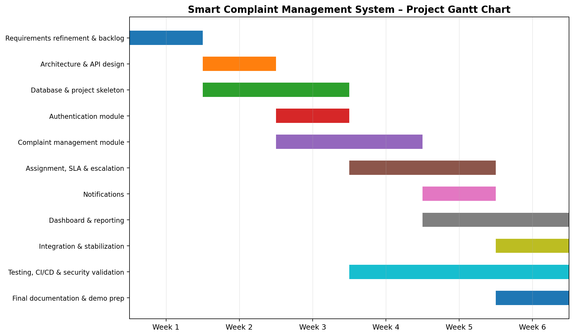
Figure 1. Six-week project Gantt chart

9. Sprint Plan
Sprint | Focus | Expected Increment | Exit Criteria
Sprint 1 – Week 1 | Planning + Requirements Refinement | Final backlog, refined requirements, project setup, repository and CI baseline. | Backlog approved; repo structure established; initial CI job runs.
Sprint 2 – Week 2 | Architecture + Design | Architecture document, API draft, ER model, UML design. | Design reviewed; interfaces and module boundaries agreed.
Sprint 3 – Week 3 | Authentication + Complaint Core | Registration/login plus complaint creation and tracking. | Protected login works; complaint can be created and viewed.
Sprint 4 – Week 4 | Categorization + Assignment + SLA | Category/priority, assignment, status transitions, SLA tracking. | Complaint can move through assigned workflow; SLA rules testable.
Sprint 5 – Week 5 | Escalation + Notifications + Dashboard | Escalation, in-app notifications, external notification adapters, dashboard. | Core notification and reporting flows work; integrated build passes tests.
Sprint 6 – Week 6 | Integration + Validation + Finalization | System validation, coverage, security checks, final report and demo. | Critical defects resolved; validation evidence complete; demo build stable.

10. Risk and Mitigation Plan
Risk | Impact | Mitigation
Integration conflicts between modules | High | Define APIs early; use feature branches and pull requests; integrate incrementally.
Scope expansion | High | Treat SRS as baseline; add new features only through controlled backlog refinement.
External notification service setup | Medium | Use an adapter design; keep in-app notifications as baseline; external channels are configurable.
Insufficient test coverage | High | Write tests alongside feature development and monitor coverage in CI.
Uneven team contribution | High | Assign end-to-end ownership and review GitHub commits, issues, and PRs.
Deployment/CI issues | Medium | Create the Jenkins/Docker pipeline early and test it on every significant integration.
Security defects | High | Use established security libraries, role-based authorization, input validation, and security-focused testing.

11. Definition of Done
- A user story's functional requirements are implemented and linked to the relevant requirement IDs.
- Code is committed to a feature branch and reviewed through a pull request.
- Unit tests exist for new business logic and pass.
- Relevant integration/system tests pass.
- No known critical defect remains for the completed increment.
- Documentation and diagrams are updated when the change affects them.
- The feature is integrated into the main branch and included in the CI pipeline.
- The functionality can be demonstrated in the working application.

12. Project Tracking and Reporting
- Use GitHub Issues or GitHub Projects to maintain the product backlog, user stories, tasks, defects, and sprint status.
- Use one issue for each significant user story or engineering task and link commits/pull requests to the issue.
- Use feature branches for development and pull requests for code review.
- Use GitHub history to demonstrate individual contribution throughout the project.
- Run CI on pull requests and/or main-branch updates.
- Maintain a short sprint review/retrospective record at the end of each sprint.
- Keep requirements, design references, code references, and test references aligned so the final traceability matrix remains current.

References
- PES University, Department of Computer Science and Engineering, JACKFRUIT – Software Engineering Project Guidelines 2026.
- Smart Complaint Management System – Software Requirements Specification, Project ID 67, Version 1.0.

End of Project Plan Document

