SOFTWARE DESIGN DOCUMENT
Smart Complaint Management System
Project ID: 67
B.Tech. (CSE) – Software Engineering Mini Project
PES University, Bengaluru
Department of Computer Science and Engineering (AI&ML)
Team: Gundu Guru
Version 1.0
October 2026

Document Control
Field | Value
Document | Software Design Document
System | Smart Complaint Management System
Project ID | 67
Version | 1.0
Date | October 2026
Status | Design Baseline
Primary Inputs | Approved SRS; High-Level Architecture Document

Table of Contents
1. Design Scope and Objectives
2. Design Principles
3. Detailed Module Design
4. UML Design Models
5. Complaint State Model
6. Sequence Designs
7. Activity and Workflow Design
8. Database Design
9. API Design
10. Validation, Error Handling, and Security
11. Non-Functional Design Considerations
12. Requirement-to-Design Traceability
13. Design Decisions and Trade-offs
14. Implementation Baseline and Next Steps

Design Scope and Objectives
This document converts the approved requirements and high-level architecture into implementable software design specifications. It defines module boundaries, core domain objects, state transitions, sequence flows, database structure, API contracts, validation rules, and security controls. It intentionally stops short of source-code implementation.

1.1 Design Inputs
- Functional requirements FR-01 through FR-24 from the Software Requirements Specification.
- Non-functional requirements NFR-01 through NFR-07 and the related safety, usability, reliability, and maintainability expectations.
- Business rules BR-01 through BR-10.
- The layered modular architecture defined in the High-Level Architecture Document.
- Planned technology mapping: HTML/CSS/JavaScript or equivalent frontend, Python + FastAPI backend, PostgreSQL, Pytest, Jenkins, Docker, Git/GitHub, and static analysis tooling.

1.2 Design Objectives
- Keep presentation, API coordination, domain logic, data access, and external notification integration separated.
- Ensure each functional area has a clear owner and a stable interface.
- Make complaint lifecycle rules explicit and enforceable in one place.
- Preserve complaint status history and resolution records for traceability.
- Provide a database model that supports the required queries, dashboard views, and SLA processing.
- Provide testable service boundaries for unit, integration, and system validation.

Design Principles
Principle | Application in this system
Separation of concerns | Frontend handles presentation; FastAPI routes requests; services implement business rules; repositories handle persistence.
Single responsibility | Each service owns one functional area: authentication, complaints, assignment/SLA, notifications, or dashboard/reporting.
Least privilege | Every protected operation checks authentication and role authorization before changing protected data.
Traceability | Each state change creates a status-history record and important events create notifications.
Validation at boundaries | API payloads are schema-validated before service-level business rules are applied.
Replaceable integrations | External email/SMS/WhatsApp providers are accessed through notification adapters rather than directly from complaint logic.
Testability | Services and repositories expose small interfaces so business rules can be tested independently.
Controlled extensibility | New categories, priorities, notification channels, or reports should be addable without changing unrelated modules.

Detailed Module Design
Module | Responsibilities | Key operations | Depends on
Web Frontend | Screens, forms, dashboards, client-side interaction, presentation of status/history. | login(), submitComplaint(), viewComplaint(), viewAssigned(), updateComplaint(), viewReports() | REST API
Backend REST API | Routing, request/response schemas, authentication dependency, authorization, error mapping. | POST /auth/*, POST /complaints, GET /complaints/*, PATCH /complaints/*, GET /reports/* | Auth + domain services
Authentication Service | Registration, password hashing/verification, token validation, role lookup. | register(), authenticate(), verify_token(), authorize() | User repository
Complaint Service | Create complaint, category/priority validation, status changes, status history, tracking. | create(), get(), list_by_user(), update_status(), add_history() | Complaint/Category/History repositories
Assignment/SLA/Escalation Service | Assignments, SLA deadline calculation, monitoring, escalation decisions. | assign(), calculate_deadline(), check_overdue(), escalate() | Assignment/SLA/Complaint repositories + scheduler
Notification Service | Create in-app events and route external notifications through adapters. | notify(), mark_read(), dispatch_email(), dispatch_sms(), dispatch_whatsapp() | Notification repository + adapters
Dashboard & Reporting | Aggregated counts, filtering, operational summaries. | summary(), filter_complaints(), resolution_metrics() | Read-oriented repository queries
Repository / Data Access | Persistence abstraction and query execution. | create(), get(), update(), list(), aggregate() | PostgreSQL
Background Scheduler | Periodic SLA checks and other non-request work. | run_sla_check() | SLA/Escalation service

3.1 Service Interfaces
Interface | Inputs | Outputs | Failure conditions
AuthService.authenticate | email, password | access token + role | invalid credentials, inactive account
ComplaintService.create | user_id, category_id, priority, description | Complaint record | missing fields, invalid category/priority
ComplaintService.update_status | complaint_id, actor_id, new_status | updated complaint + history | unauthorized actor, invalid transition
AssignmentService.assign | complaint_id, staff_id, actor_id | Assignment record | unauthorized actor, invalid staff
SLAService.calculate_deadline | priority, category, created_at | deadline timestamp | missing SLA configuration
EscalationService.process_due | current_time | escalation result(s) | duplicate escalation prevented by idempotency check
NotificationService.notify | recipient, event, message, channel | Notification record/status | invalid channel/configuration
ReportService.summary | filters/date range | aggregated metrics | invalid filter/date range

UML Design Models

4.1 Use Case Model
The design-level use-case model refines the principal actors and interactions identified in the SRS. It is used to establish clear responsibility boundaries before implementation.
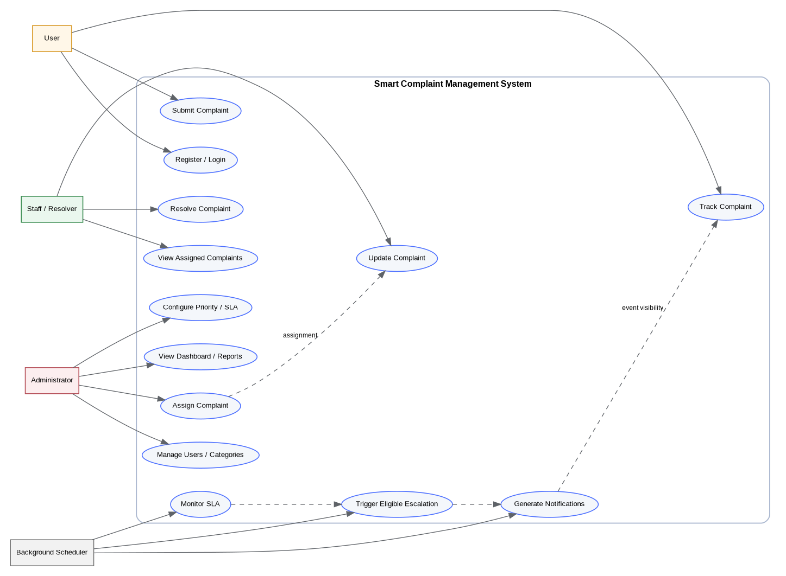
Figure 1. Design-level UML use-case model

4.2 Class and Domain Model
The design-level domain model refines the data groups already identified in the SRS. The model below separates core complaint information from related assignment, SLA, history, notification, and resolution records.
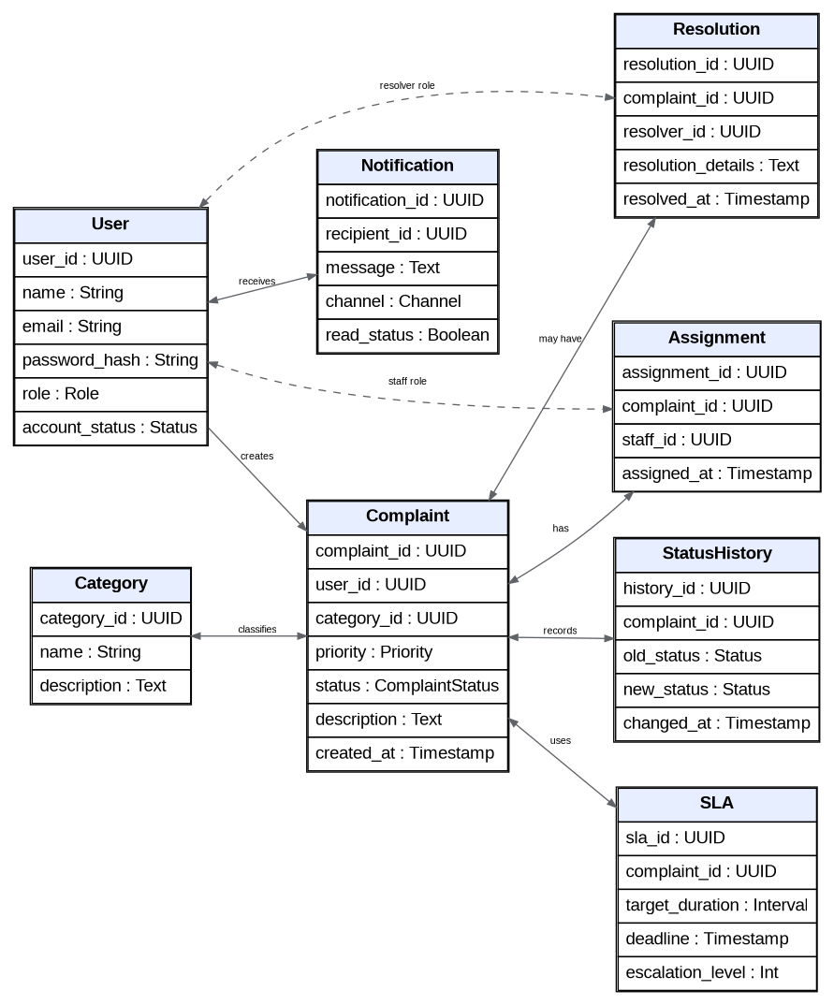
Figure 2. Design-level class/domain model

4.3 Domain Responsibilities
Domain object | Design responsibility
User | Identity, credentials, role, and account status.
Complaint | Current category, priority, status, description, creator, and creation time.
Category | Controlled vocabulary used to classify complaints.
Assignment | Records which staff member is responsible for a complaint and when the assignment occurred.
StatusHistory | Immutable audit-style record of each complaint status transition.
SLA | Stores applicable target duration, deadline, and escalation state needed for monitoring.
Notification | Stores recipient, message, channel, delivery/read state, and event context.
Resolution | Stores the resolver, resolution details, and resolution timestamp.

Complaint State Model
The complaint status model provides the explicit lifecycle needed by FR-06, FR-07, FR-13, FR-15, FR-17, FR-18, FR-19 and BR-05/BR-10.
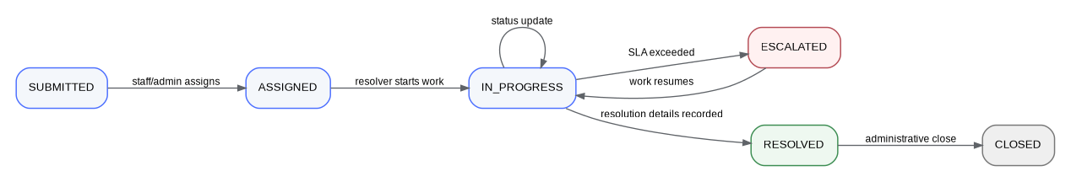
Figure 3. Complaint state transition model

5.1 State Transition Rules
Current state | Allowed transition | Trigger / condition | Required control
SUBMITTED | ASSIGNED | Authorized administrator/staff assigns the complaint | Role check + assignment record
ASSIGNED | IN_PROGRESS | Assigned resolver begins processing | Resolver authorization
IN_PROGRESS | IN_PROGRESS | Status update without leaving processing stage | Valid status + history record
IN_PROGRESS | ESCALATED | Applicable SLA deadline is exceeded | SLA check + escalation rule + notification
ESCALATED | IN_PROGRESS | Resolver resumes work | Authorized resolver action + history
IN_PROGRESS | RESOLVED | Resolution details supplied | BR-05 validation + resolution record
RESOLVED | CLOSED | Administrative close operation | Administrator authorization

Sequence Designs

6.1 Submit Complaint
The submission path follows the architecture flow: Web Frontend -> REST API -> Authentication -> Complaint Service -> Repository -> PostgreSQL, with a notification event created after persistence.
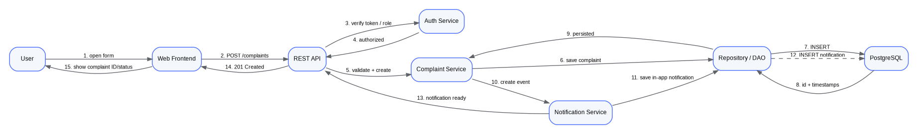
Figure 4. Sequence design for complaint submission

6.2 Assignment and Resolution
1. Administrator or authorized staff opens an eligible complaint.
2. Frontend sends the assignment request with the selected staff identifier.
3. API validates the request and verifies the actor role.
4. Assignment service checks that the target staff account is active and eligible.
5. Assignment record is stored and complaint ownership is updated.
6. A notification event is generated for the assigned resolver.
7. The resolver updates status; the complaint service validates the transition and appends status history.
8. When resolving, the service requires non-empty resolution details before setting RESOLVED.

6.3 SLA Monitoring and Escalation
1. Background scheduler starts an SLA check at the configured interval.
2. SLA repository returns complaints whose deadlines are approaching or exceeded.
3. Escalation service evaluates eligibility against configured priority/category rules and the current escalation state.
4. For an eligible overdue complaint, the service records the escalation and updates the complaint state to ESCALATED.
5. Notification service creates the in-app notification and dispatches configured external notifications.
6. The processing result is logged so the same complaint is not escalated repeatedly by duplicate scheduler runs.

6.4 Notification Event Handling
Event | Default recipient | In-app | External channels
Complaint created / submitted | Creator | Yes | Optional
Complaint assigned | Assigned resolver | Yes | Optional
Status changed | Creator and/or responsible staff | Yes | Optional
SLA approaching | Responsible staff / admin as configured | Yes | Optional
Complaint escalated | Responsible staff / administrator | Yes | Optional
Complaint resolved | Creator | Yes | Optional

Activity and Workflow Design
The activity model shows the end-to-end operational path and where validation loops or escalation branches occur.
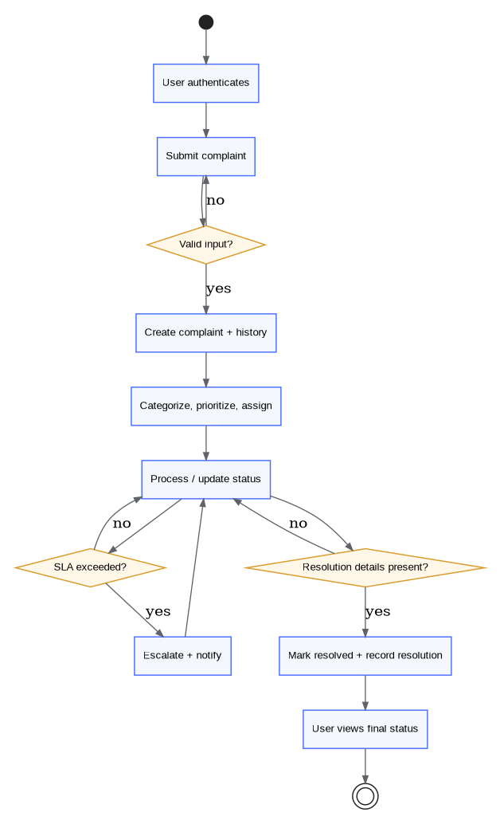
Figure 5. Complaint lifecycle activity design

Database Design
The logical database design uses PostgreSQL. Primary keys are represented as UUIDs in the design to keep entity references globally unique. Timestamps are stored explicitly for auditability and SLA calculations.

8.1 Logical Schema
Table | Primary key | Important fields | Key relationships
users | user_id | name, email, password_hash, role, account_status, created_at | 1:M with complaints; 1:M with notifications; referenced by assignments/resolutions
categories | category_id | name, description, active_flag | 1:M with complaints
complaints | complaint_id | user_id, category_id, priority, status, description, created_at, updated_at | M:1 user; M:1 category; 1:M history; 1:M assignment history; 1:0..1 resolution; 1:0..1 active SLA
assignments | assignment_id | complaint_id, staff_id, assigned_at, ended_at | M:1 complaint; M:1 user(staff role)
status_history | history_id | complaint_id, old_status, new_status, changed_by, changed_at | M:1 complaint
sla | sla_id | complaint_id, target_duration, deadline, escalation_level, escalated_at | 1:1 active SLA per complaint in baseline design
notifications | notification_id | recipient_id, complaint_id, event_type, message, channel, read_status, created_at | M:1 user; optional M:1 complaint
resolutions | resolution_id | complaint_id, resolver_id, resolution_details, resolved_at | 1:1 complaint; M:1 user(resolver)

8.2 Integrity Constraints
- users.email should be unique and indexed for authentication lookup.
- All foreign keys should reference existing parent rows; deletes should be restricted where history or audit records would be lost.
- Complaint status changes should occur through the service layer and create a status_history row in the same database transaction.
- Complaint resolution should be inserted and the complaint marked RESOLVED in a transaction so partial resolution cannot occur.
- SLA records should be indexed on deadline and escalation state to support periodic overdue scans.
- Notifications should be indexed on recipient_id, read_status, and created_at for efficient inbox retrieval.
- Complaint filtering should use indexes on status, priority, category_id, created_at, and assignment-related fields as query patterns are confirmed during implementation.

8.3 Normalization Target
The relational model targets third normal form for the baseline system. Repeated controlled values such as category definitions and user roles are kept out of complaint rows where practical, while event/history records are stored separately to avoid overwriting audit information.

API Design
The backend exposes REST endpoints. The exact URL prefix can be standardized during implementation; this baseline uses /api/v1 for versioning.

9.1 Authentication Endpoints
Method | Endpoint | Purpose | Auth
POST | /api/v1/auth/register | Create user account | Public
POST | /api/v1/auth/login | Authenticate and return token | Public
GET | /api/v1/auth/me | Return authenticated user profile | User
POST | /api/v1/auth/logout | Invalidate client session/token where supported | User

9.2 Complaint Endpoints
Method | Endpoint | Purpose | Auth
POST | /api/v1/complaints | Submit complaint | User
GET | /api/v1/complaints | List complaints according to role/filter | User/Staff/Admin
GET | /api/v1/complaints/{id} | View complaint details and history | Authorized
PATCH | /api/v1/complaints/{id} | Update editable complaint fields | Authorized
PATCH | /api/v1/complaints/{id}/status | Change processing status | Staff/Admin
POST | /api/v1/complaints/{id}/assign | Assign to staff | Staff/Admin as configured
POST | /api/v1/complaints/{id}/resolve | Record resolution and resolve | Staff

9.3 Administration, SLA, Notifications, Reports
Method | Endpoint | Purpose | Auth
GET | /api/v1/categories | List active categories | Authenticated
POST | /api/v1/categories | Create category | Admin
PATCH | /api/v1/categories/{id} | Update category | Admin
GET | /api/v1/sla/rules | View SLA configuration | Admin
PATCH | /api/v1/sla/rules/{id} | Update SLA configuration | Admin
GET | /api/v1/notifications | List current user's notifications | Authenticated
PATCH | /api/v1/notifications/{id}/read | Mark notification as read | Recipient
GET | /api/v1/reports/summary | Dashboard summary metrics | Admin
GET | /api/v1/reports/complaints | Filtered complaint report | Admin

9.4 Core Request / Response Schemas
Schema | Required fields | Notes
RegisterRequest | name, email, password | Password must be validated and hashed before persistence.
LoginRequest | email, password | Invalid credentials must return a generic authentication error.
ComplaintCreateRequest | category_id, priority, description | Supporting information may be optional.
ComplaintUpdateRequest | subset of editable fields | Must not permit unauthorized changes to ownership or audit fields.
StatusUpdateRequest | new_status | Transition checked against current status and actor role.
AssignmentRequest | staff_id | Target user must have Staff/Resolver role and be active.
ResolutionRequest | resolution_details | Required before RESOLVED transition.
NotificationResponse | notification_id, event_type, message, channel, read_status, created_at | Presented in user notification list.

9.5 Standard API Errors
HTTP status | Meaning | Example
400 | Malformed request / business validation | Missing description or invalid status payload
401 | Authentication required or invalid | Missing/expired token
403 | Authenticated but not authorized | User attempts admin-only operation
404 | Resource not found | Complaint ID does not exist or is not accessible
409 | Conflict | Duplicate email or invalid concurrent state change
422 | Schema validation failure | Wrong field type, invalid enum value
500 | Unexpected server error | Unhandled internal exception

Validation, Error Handling, and Security

10.1 Validation Layers
1. Frontend validation provides immediate usability feedback but is not trusted as the security boundary.
2. FastAPI/Pydantic request schemas validate types, required fields, lengths, enumerated values, and basic formatting.
3. Service-layer validation enforces business rules such as authorization, status transitions, valid category/priority, and resolution requirements.
4. Database constraints enforce uniqueness and referential integrity.

10.2 Security Design
- Passwords are stored only as secure password hashes; plaintext passwords are never persisted.
- Protected routes require authentication and role checks.
- Authorization checks are applied to complaint access so users can view only records they are permitted to access.
- Administrative operations are restricted to administrator role permissions.
- Input data is validated and normalized before use in persistence or downstream processing.
- Secrets and notification-provider credentials are supplied through environment-based configuration rather than committed source code.
- HTTP should be used only for local development where appropriate; deployed environments should use HTTPS.
- Operational logs should avoid recording passwords, raw tokens, or sensitive notification credentials.

10.3 Idempotency and Concurrency
SLA escalation processing must tolerate repeated scheduler execution. Before creating an escalation or sending an escalation notification, the service checks the current escalation state so a repeated run does not create duplicate events. Status changes should also be protected against conflicting updates by validating the expected current state inside the transaction.

Non-Functional Design Considerations
NFR | Design response | Validation approach
NFR-01 Performance | Use indexed lookups for authentication and dashboard filters; avoid duplicate queries; paginate complaint lists where needed. | API response-time tests under expected project workload.
NFR-02 Safety | Restrict destructive actions and require authorization/confirmation where applicable. | Negative authorization tests and destructive-operation tests.
NFR-03 Data consistency | Use database transactions for state + history and resolution updates. | Transaction/integrity tests.
NFR-04 Password security | Hash passwords; never persist plaintext. | Security tests and repository inspection.
NFR-05 Authentication | Protect all non-public endpoints with authentication dependencies. | Unauthorized-request tests.
NFR-06 RBAC | Centralize role permission checks. | Role matrix test suite.
NFR-07 Input validation | Schema + service + database validation. | Boundary and invalid-input tests.
Maintainability | Modular services, repositories, schemas, tests, and configuration separation. | Code review + static analysis + module tests.
Reliability | Graceful error handling and explicit transactions. | Failure-path and recovery tests.

Requirement-to-Design Traceability
Requirement(s) | Primary design element | Design artifact
FR-01–FR-04 | Authentication Service + auth API + RBAC | Auth module interfaces; API design; security design
FR-05–FR-08 | Complaint Service + complaint API + Complaint entity | Class model; submission sequence; complaint schema
FR-09–FR-11 | Category/Priority validation | Complaint service rules; category model
FR-12–FR-15 | Assignment Service + Complaint Service + StatusHistory + Resolution | State model; assignment/resolution sequence
FR-16–FR-19 | SLA/Escalation Service + Scheduler | SLA schema; escalation sequence; idempotency design
FR-20–FR-21 | Notification Service + Notification entity | Notification event table; adapter boundary
FR-22–FR-24 | Dashboard/Reporting + repository aggregations | Report API and query design
BR-01–BR-10 | Service-layer business rules + DB constraints | Validation and state-transition rules
NFR-01–NFR-07 | Cross-cutting API/database/security design | Non-functional design table and test approach

Design Decisions and Trade-offs
Decision | Reason | Trade-off / limitation
Layered modular backend | Matches approved high-level architecture and supports independent feature development. | More files/classes than a single monolithic script.
FastAPI REST API | Provides clear API contracts, validation, and modular service integration. | Requires disciplined dependency and schema organization.
PostgreSQL relational model | Fits structured users, complaints, assignments, SLA, history, and reporting requirements. | Schema changes must be managed carefully through migrations.
Repository abstraction | Keeps persistence logic separate from domain rules and improves unit-test isolation. | Adds an abstraction layer that may feel heavy for a small project.
Background scheduler for SLA | Separates periodic work from user-request processing. | Scheduler must handle duplicate runs and failed jobs safely.
Notification adapters | Prevents provider-specific code from leaking into complaint logic. | Requires adapter interfaces even for a small number of channels.
UUID primary keys | Provides stable globally unique identifiers across modules. | Less human-readable than sequential IDs.
In-app baseline notifications | Ensures notifications work without depending on external providers. | External channels remain optional and require separate configuration.

Implementation Baseline and Next Steps
This design is the implementation baseline for the next phase. Implementation should proceed against these interfaces and models, with changes reviewed through GitHub pull requests and traced back to the SRS/architecture baseline.
1. Create the repository/folder structure for frontend, backend, services, repositories, schemas, models, tests, and configuration.
2. Create PostgreSQL migrations for users, categories, complaints, assignments, status history, SLA, notifications, and resolutions.
3. Implement authentication and authorization first because protected operations depend on them.
4. Implement complaint submission, tracking, status history, assignment, and resolution according to the state model.
5. Implement SLA calculation, scheduler-based monitoring, escalation, and notification events.
6. Implement dashboard/report queries and role-specific frontend views.
7. Add Pytest unit/integration coverage, static analysis, Docker configuration, and Jenkins CI/CD according to the project plan.
8. Update this design document through controlled revisions when implementation reveals a required design change.

Appendix A – Role Permission Matrix
Operation | User | Staff / Resolver | Administrator
Register / Login | Yes | Yes | Yes
Submit complaint | Yes | Yes if used as complainant | Yes if used as complainant
View own complaints | Yes | Yes | Yes
View assigned complaints | No | Yes | Yes
Assign complaint | No | Yes if authorized | Yes
Change processing status | No | Yes | Yes if authorized
Resolve complaint | No | Yes | Yes if authorized
Configure categories / SLA | No | No | Yes
Escalation visibility | Own only | Assigned scope | All eligible complaints
Dashboard / reports | No | Limited operational scope | Yes

