System Validation Report
Smart Complaint Management System
Validation of the implemented system against the SRS

Project ID: 67
B.Tech. (CSE) – Software Engineering Mini Project
PES University, Bengaluru

Version 1.0
October 2026

Revision History
Version | Date | Description
1.0 | October 2026 | Validation of the first complete implementation against SRS v1.0.

Contents
1. Purpose
2. Validation Approach
3. Validation Environment
4. Summary of Results
5. Requirement Validation Matrix
6. Non-Functional Validation
7. Use-Case Acceptance Walkthrough
8. Design Refinements Made During Implementation
9. Known Limitations and Open Items
10. Conclusion and Sign-off

1. Purpose
This report records whether the implemented Smart Complaint Management System meets the requirements baseline in the SRS (v1.0): 24 functional requirements, 7 non-functional requirements and 10 business rules. It closes the System Validation phase of the project plan (SRS → Architecture → Design → Implementation → Testing → Validation).

2. Validation Approach
- Requirement traceability: every automated test that checks a requirement is tagged with its ID. A test hook produces the requirement-to-test results used in §5.
- Levels of evidence: unit tests, API integration tests on PostgreSQL, browser end-to-end tests in Chromium, a load test with 50 concurrent users, static analysis, and a manual walkthrough of each use case with screenshots (§7).
- Pass rule: a requirement passes when all of its tests pass and the walkthrough shows the expected behaviour.
- Detailed test cases and the defect log are in the Test Plan and Test Report (docs/Testing).

3. Validation Environment
Item | Detail
Application | Branch feature/frontend-testing-validation: FastAPI backend, HTML/CSS/JavaScript front end, SLA scheduler
Database | PostgreSQL 16; schema created by Alembic migrations bfc7a4ba29c3 and c3a1f0d2e7b4
Server | uvicorn (1–2 workers), Linux, 2 vCPU
Browser | Chromium (Playwright 1.56), desktop 1280×800 and mobile 360–390 px
Data | Seed script: 1 administrator, 2 staff, 1 user, 5 categories; default SLA rules (Critical 4 h, High 24 h, Medium 72 h, Low 7 days)

4. Summary of Results
Measure | Result
Requirements validated | 41 of 41 pass (24 FR, 7 NFR, 10 BR)
Automated tests | 207 executed, 207 passed, 0 failed
Backend statement coverage | 94.6 %
Load test (50 users, 2,050 requests) | 0 errors; overall p95 829 ms
Static analysis (ruff) | No findings
Open defects | 1 accepted (login burst latency, see §9)

Verdict: the system meets the SRS baseline and is ready for the final demonstration, with the limitations listed in §9.

5. Requirement Validation Matrix
Tests = passed / executed tests tagged with the requirement. Evidence lists the test modules (tests/…).
ID | Requirement | How it is met | Evidence | Tests | Result
FR-01 | Register using required details | Registration API + form; validation of name, e-mail, password; duplicate e-mail blocked. | api/test_auth, e2e/test_ui, unit/test_schemas | 14/14 | Pass
FR-02 | Authenticate before protected functions | JWT bearer tokens; every non-public endpoint depends on get_current_user. | api/test_auth, e2e/test_ui | 6/6 | Pass
FR-03 | Role-based access for users, staff, administrators | Roles USER/STAFF/ADMIN; admin manages roles; role-specific navigation. | api/test_admin, e2e/test_ui | 3/3 | Pass
FR-04 | Reject invalid login credentials | Generic 401 for wrong e-mail or password; 403 for inactive accounts; UI shows the error. | api/test_auth, e2e/test_ui | 6/6 | Pass
FR-05 | Authenticated user can submit a complaint | POST /complaints; New complaint form; E2E journey. | api/test_complaints, e2e/test_ui | 2/2 | Pass
FR-06 | Complaint has ID, category, description, priority, creator, date/time, status | All fields returned and shown; reference CMP-XXXXXXXX. | api/test_complaints | 1/1 | Pass
FR-07 | User can view current status and history | Detail page with status badge and timeline; history API. | api/test_complaints, e2e/test_ui | 2/2 | Pass
FR-08 | Prevent submission when mandatory fields are missing | Server 422 naming each field; client-side errors before sending. | api/test_complaints, e2e/test_ui, unit/test_schemas | 10/10 | Pass
FR-09 | Classify complaints using predefined categories | Admin-managed categories; inactive/unknown categories rejected. | api/test_admin, api/test_complaints, e2e/test_ui | 5/5 | Pass
FR-10 | Authorised staff can assign or modify priority | Handler/admin can change priority; SLA recalculated; creator blocked. | api/test_complaints | 1/1 | Pass
FR-11 | Multiple priority levels (Low, Medium, High, Critical) | Enumeration enforced in schema and UI. | unit/test_schemas | 4/4 | Pass
FR-12 | Admins/authorised staff assign complaints | Assign/reassign to active staff only; normal users blocked. | api/test_workflow, e2e/test_ui | 5/5 | Pass
FR-13 | Assigned staff update complaint status | Transitions validated against the state model. | api/test_workflow, e2e/test_ui, unit/test_state_machine | 22/22 | Pass
FR-14 | Resolution details recorded before Resolved | Resolve requires details; resolution record stored with resolver. | api/test_workflow, e2e/test_ui | 4/4 | Pass
FR-15 | Maintain complaint status history | Every transition appends a history row in the same transaction. | api/test_workflow, e2e/test_ui, unit/test_state_machine | 18/18 | Pass
FR-16 | Associate SLA/deadline with complaints | SLA rule per priority; deadline stored per complaint; admin-configurable. | api/test_sla, e2e/test_ui, unit/test_sla_rules | 11/11 | Pass
FR-17 | Identify complaints approaching or exceeding SLA | SLA state (on track / due soon / overdue); one due-soon alert per complaint. | api/test_scheduler_and_adapters, api/test_sla, unit/test_sla_rules | 8/8 | Pass
FR-18 | Escalate eligible overdue complaints | Scheduler escalates once (idempotent); notifies assignee and admins. | api/test_scheduler_and_adapters, api/test_sla | 4/4 | Pass
FR-19 | Escalated complaints visible to administrators | Status filter, dashboard KPI, notifications; manual escalation by admin. | api/test_sla | 2/2 | Pass
FR-20 | Notify users of significant status changes | In-app notifications for submit, assign, status changes, escalation. | api/test_workflow, e2e/test_ui | 3/3 | Pass
FR-21 | Notifications via in-app and configured external channels | In-app baseline; adapter interface for external channels with failure isolation. | api/test_scheduler_and_adapters, api/test_workflow | 2/2 | Pass
FR-22 | Admins view counts by status, category, priority | Dashboard bars and KPI tiles; summary API. | api/test_reports, e2e/test_ui | 3/3 | Pass
FR-23 | Dashboard supports filtering | Status, priority, category, search, overdue and date-range filters. | api/test_complaints, api/test_reports, e2e/test_ui | 4/4 | Pass
FR-24 | Summary information on resolution performance | SLA compliance %, average resolution time, 14-day trend, CSV export. | api/test_reports, e2e/test_ui, unit/test_sla_rules | 4/4 | Pass
NFR-01 | Respond within 3 s under expected workload | p95 tests with 500 complaints; 50-user load test (see §6.1). | api/test_performance | 3/3 | Pass*
NFR-02 | No destructive operations without authorisation | No delete endpoints; deactivate instead of delete; confirmation dialogs. | api/test_security_inputs | 1/1 | Pass
NFR-03 | Data consistency on update/resolve | Transactions for status + history and resolution; expected-status conflict check. | api/test_security_inputs, api/test_workflow | 6/6 | Pass
NFR-04 | Passwords not stored in plain text | bcrypt (cost 12 in production). | api/test_auth, unit/test_security | 8/8 | Pass
NFR-05 | Protected functions require authentication | 401 for missing/invalid/expired tokens across all protected endpoints. | api/test_auth, api/test_complaints, api/test_rbac_matrix, unit/test_security | 64/64 | Pass
NFR-06 | RBAC prevents unauthorised admin access | Permission matrix (52 cases) and browser route guards. | api/test_rbac_matrix, e2e/test_ui | 54/54 | Pass
NFR-07 | Validate user input | Schema, service and database validation; XSS and injection tests. | api/test_admin, api/test_auth, api/test_complaints, api/test_security_inputs, api/test_sla, e2e/test_ui, unit/test_schemas | 37/37 | Pass
BR-01 | Complaint submitted by an authenticated user | Anonymous submission returns 401. | api/test_complaints | 2/2 | Pass
BR-02 | Valid category and priority | Unknown/inactive category and invalid priority rejected. | api/test_complaints, unit/test_schemas | 8/8 | Pass
BR-03 | Only authorised staff/admins assign | Normal users get 403. | api/test_workflow | 1/1 | Pass
BR-04 | Only authorised staff update processing status | Non-assigned staff and users get 403. | api/test_workflow, unit/test_state_machine | 17/17 | Pass
BR-05 | Resolved requires resolution details | Blank details rejected; status unchanged. | api/test_workflow, unit/test_schemas | 2/2 | Pass
BR-06 | SLA from configured priority rules | Deadline = created time + rule target. | api/test_sla, unit/test_sla_rules | 6/6 | Pass
BR-07 | Overdue complaints escalated by configured rule | Escalation on deadline breach, once. | api/test_sla | 1/1 | Pass
BR-08 | Users view only authorised complaints | Own complaints only; others return 404; staff summary limited to assigned. | api/test_complaints, api/test_reports | 2/2 | Pass
BR-09 | Admin functions restricted to administrators | Categories, users, SLA rules, reports, close, manual escalation. | api/test_admin, api/test_rbac_matrix, api/test_reports, api/test_sla, api/test_workflow, e2e/test_ui | 59/59 | Pass
BR-10 | Status history retained | Full ordered history checked through the complete lifecycle. | api/test_workflow | 1/1 | Pass
* NFR-01 passes for normal requests. A burst of 50 simultaneous logins exceeds 3 s on the 2-vCPU test host; see §6.1 and §9.

6. Non-Functional Validation

6.1 Performance (NFR-01)
Two checks were made. (1) In-process: with 500 complaints loaded, the list, search and dashboard endpoints were each called 20 times; p95 was well under 3 s. (2) Load: 50 virtual users each registered, logged in and then ran 10 rounds of submit → open → list → notifications against PostgreSQL with production password hashing.
Operation | Count | Median (ms) | p95 (ms) | Max (ms)
login | 50 | 5953 | 8458 | 8485
submit | 500 | 548 | 885 | 4848
detail | 500 | 394 | 717 | 1128
list | 500 | 437 | 686 | 1304
notifications | 500 | 307 | 522 | 765

All 2,050 requests succeeded. Normal operations stay below 1 s at p95. Logins are the exception: bcrypt (cost 12) is deliberately CPU-heavy, so 50 logins arriving in the same second queue on 2 vCPUs (p95 8.5 s). In normal use, logins are spread out and take about 0.25 s each.

6.2 Security (NFR-02 – NFR-07)
- Passwords are bcrypt hashes; a test asserts production cost ≥ 12 and that the stored value never contains the password.
- All protected endpoints reject missing, malformed, wrongly signed and expired tokens (401). Tokens expire after 30 minutes.
- A 52-case matrix confirms each role reaches only its permitted endpoints. The browser route guards redirect users away from admin pages.
- Complaints that are not accessible return 404 rather than 403, so their existence is not revealed.
- HTML and script payloads are stored as text and rendered with textContent; the browser test confirms no script runs. SQL-injection strings in search are treated as data (parameterised queries).
- There are no delete endpoints; accounts and categories are deactivated, keeping audit history (NFR-02).
- Responses include X-Content-Type-Options, X-Frame-Options and Referrer-Policy headers. Secrets come from environment variables (.env.example).

6.3 Usability and reliability
- Forms show field-level errors before submission, using the same rules as the server (6 front-end tests).
- Layouts were checked at 360 px: no horizontal scrolling, and navigation moves to a slide-out menu.
- Invalid input never crashes the server: validation errors return 400/422 with readable messages, and the browser tests fail on any JavaScript error or stray "null"/"undefined" text.
- The SLA scheduler survives failed runs and is idempotent, so repeated or overlapping runs never double-escalate.

7. Use-Case Acceptance Walkthrough
Each SRS use case was carried out in the browser with the seed data. The screenshots were taken from the running system.

7.1 Register / Login (User)
Expected: user can sign in; invalid credentials are rejected. Result: Accepted.
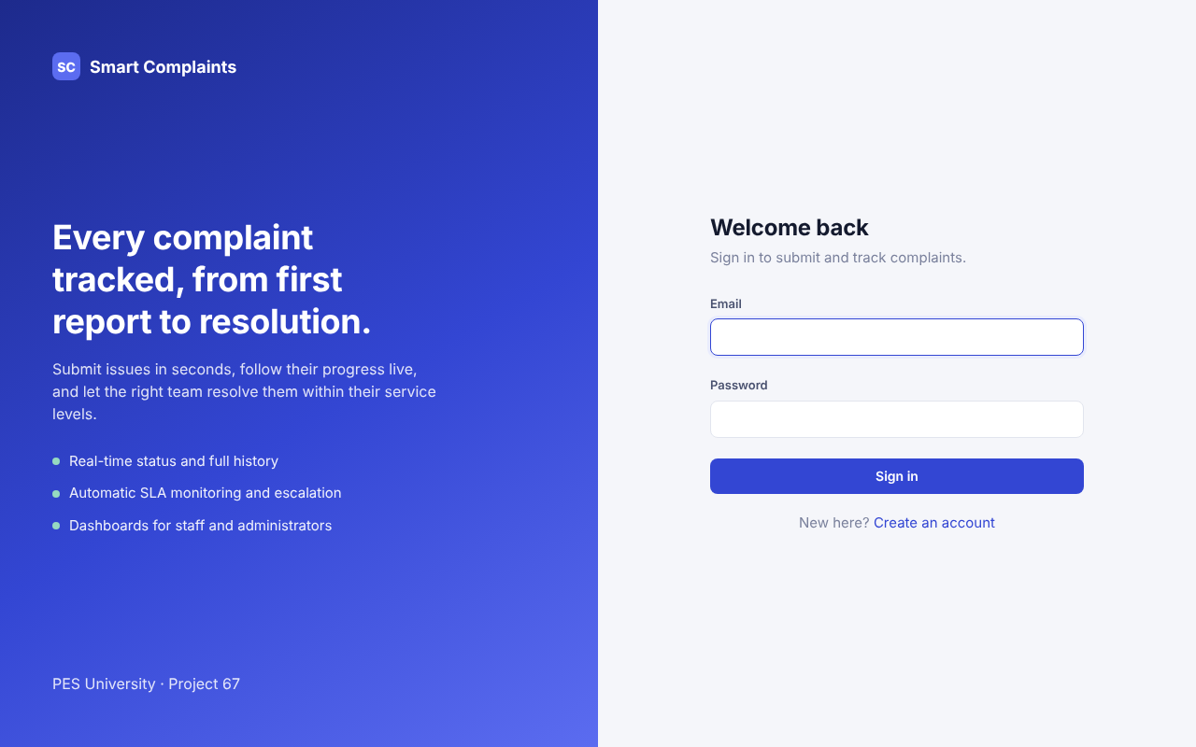
Figure 1. Sign-in page

7.2 Submit Complaint (User)
Expected: mandatory fields enforced; complaint created with reference, SLA and status Submitted. Result: Accepted.
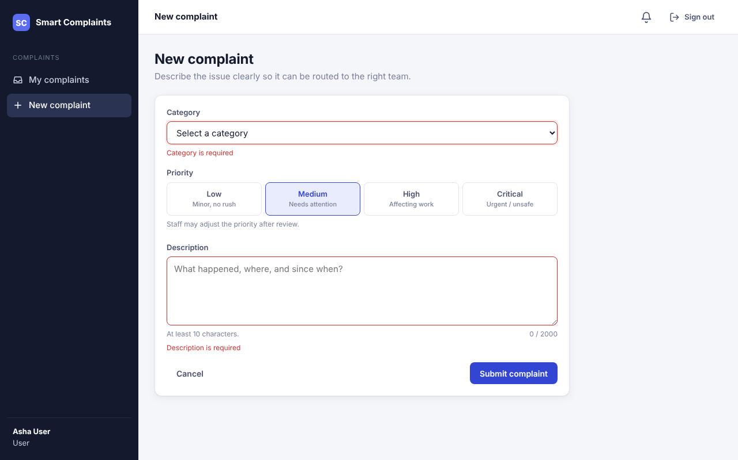
Figure 2. Submission form showing mandatory-field validation

7.3 Track Complaint (User)
Expected: user sees only their own complaints with status, priority and SLA. Result: Accepted.
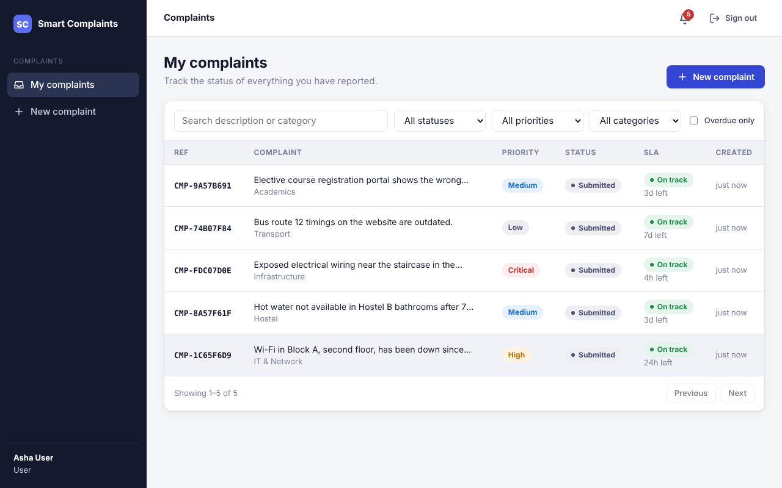
Figure 3. My complaints

7.4 Assign Complaint (Admin/Staff) and Update Complaint (Staff)
Expected: admin assigns to staff; staff sees it in their queue, starts work and resolves with details. Result: Accepted.
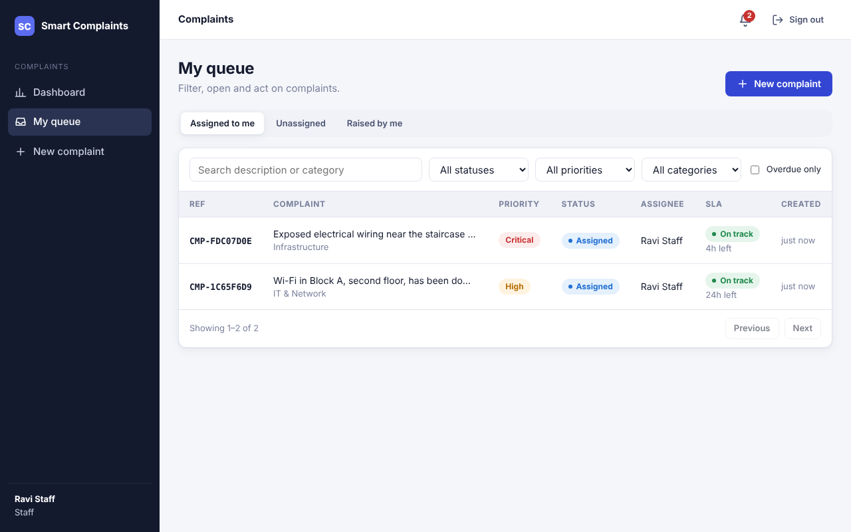
Figure 4. Staff queue (assigned complaints)
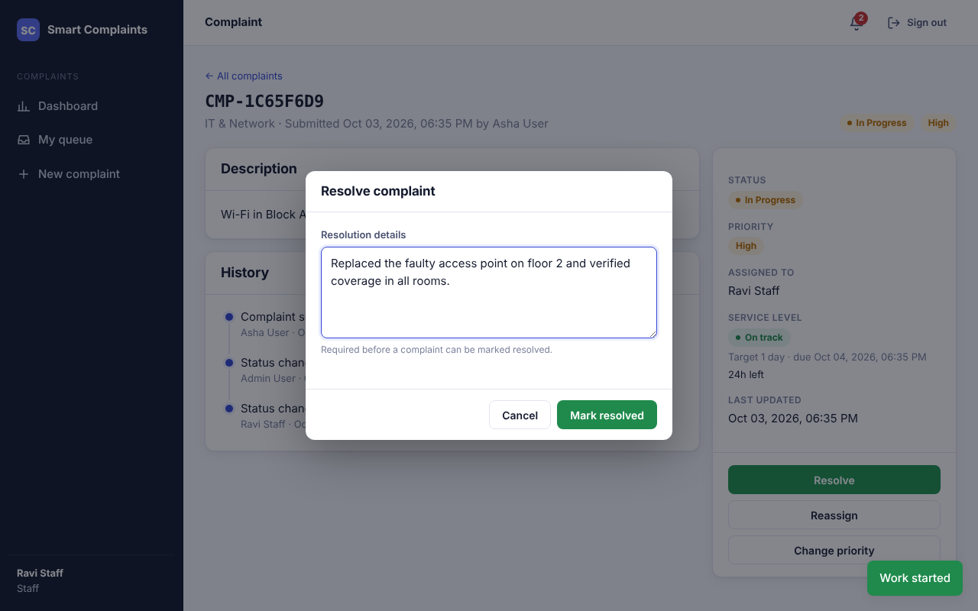
Figure 5. Resolution details are required before resolving
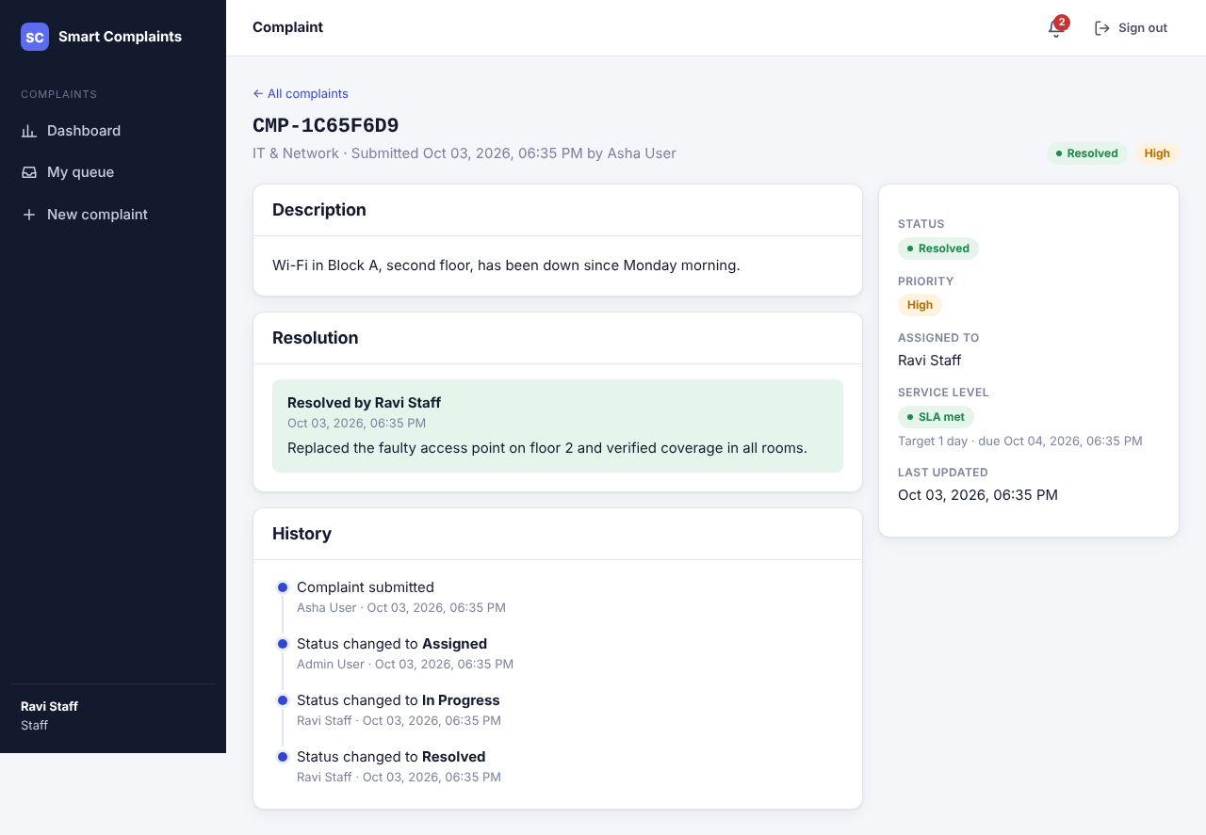
Figure 6. Resolved complaint with resolution and full status history

7.5 Escalate Complaint (System/Admin)
Expected: overdue complaints are escalated once and administrators are notified; administrators can escalate manually. Result: Accepted (verified by the automated SLA tests with simulated time, and with the Run SLA check button on the dashboard).
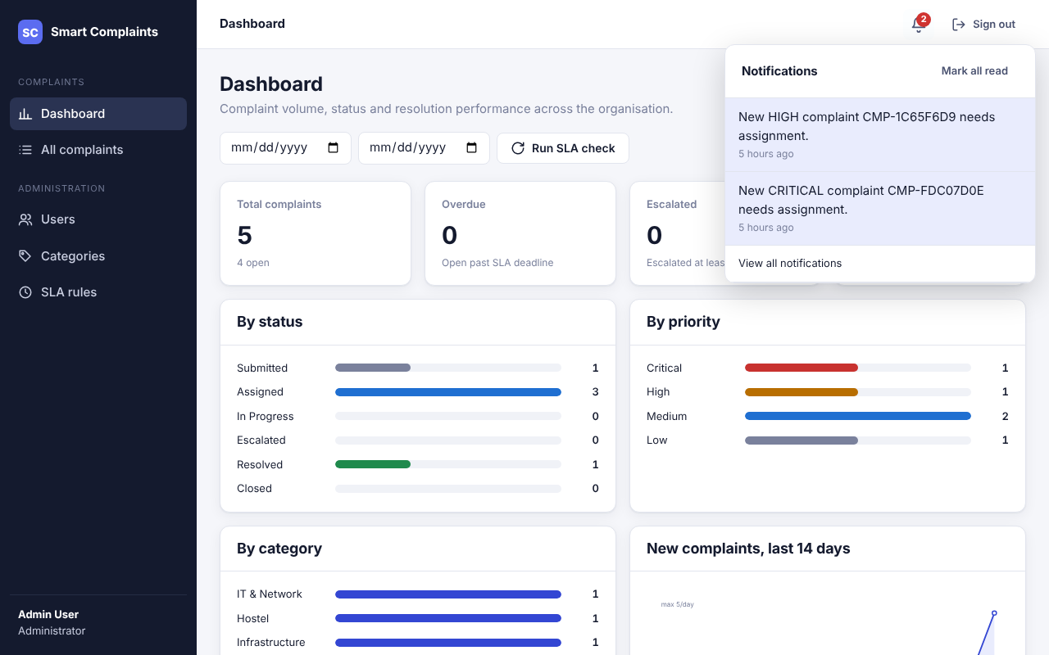
Figure 7. In-app notifications

7.6 View Reports (Admin)
Expected: counts by status, priority and category; resolution performance; filtering and export. Result: Accepted.
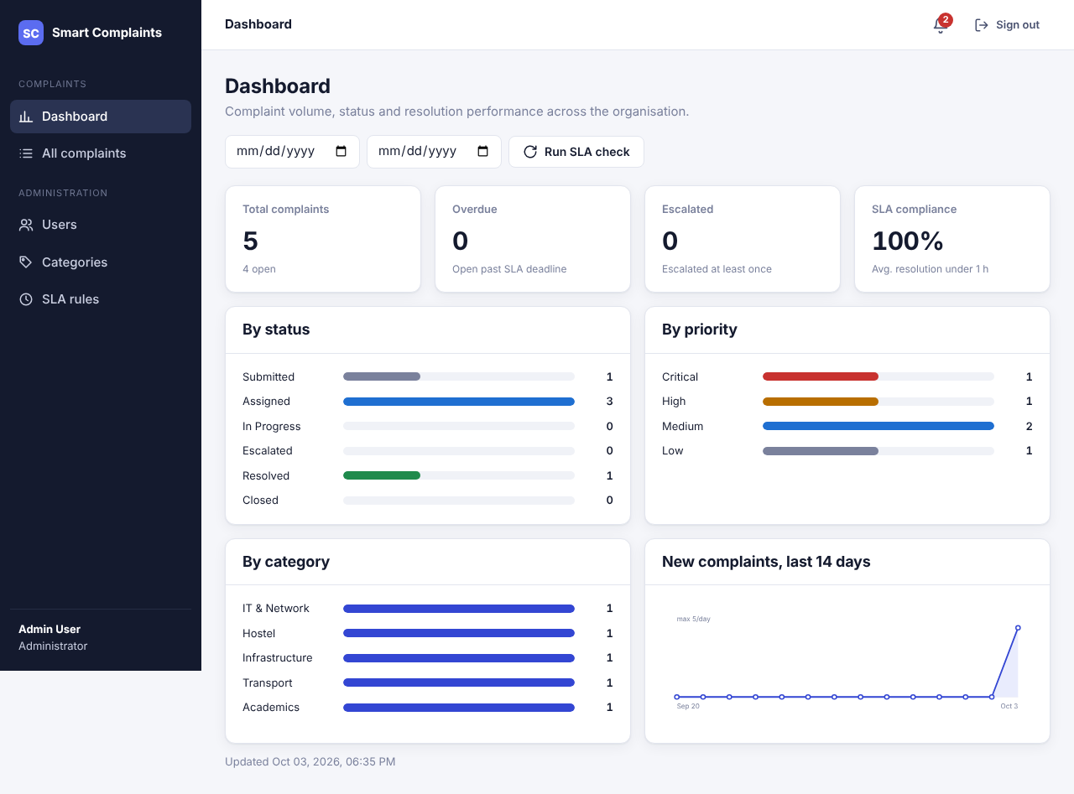
Figure 8. Administrator dashboard
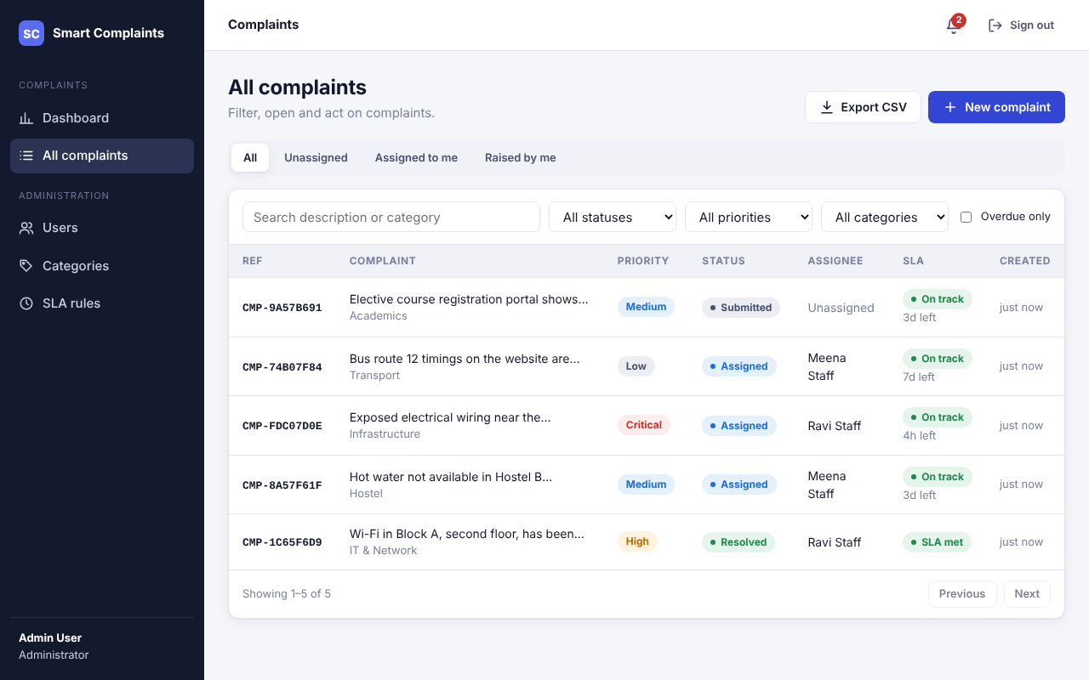
Figure 9. All complaints with filters and CSV export

7.7 Manage Users / Categories and SLA rules (Admin)
Expected: admin creates staff, changes roles, deactivates accounts, manages categories and SLA targets. Result: Accepted.
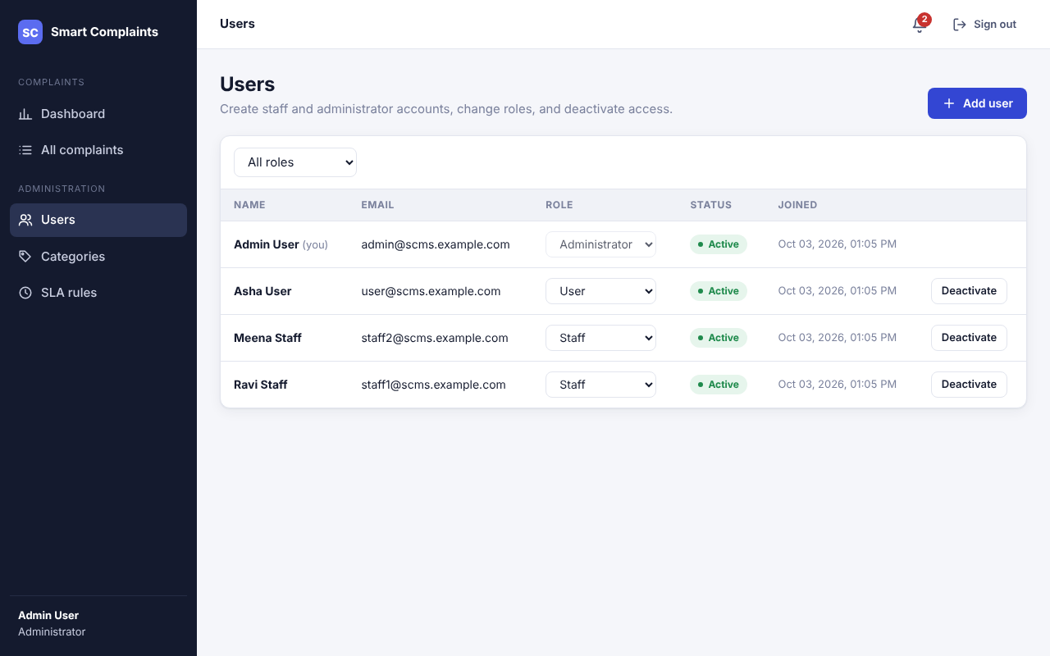
Figure 10. User management
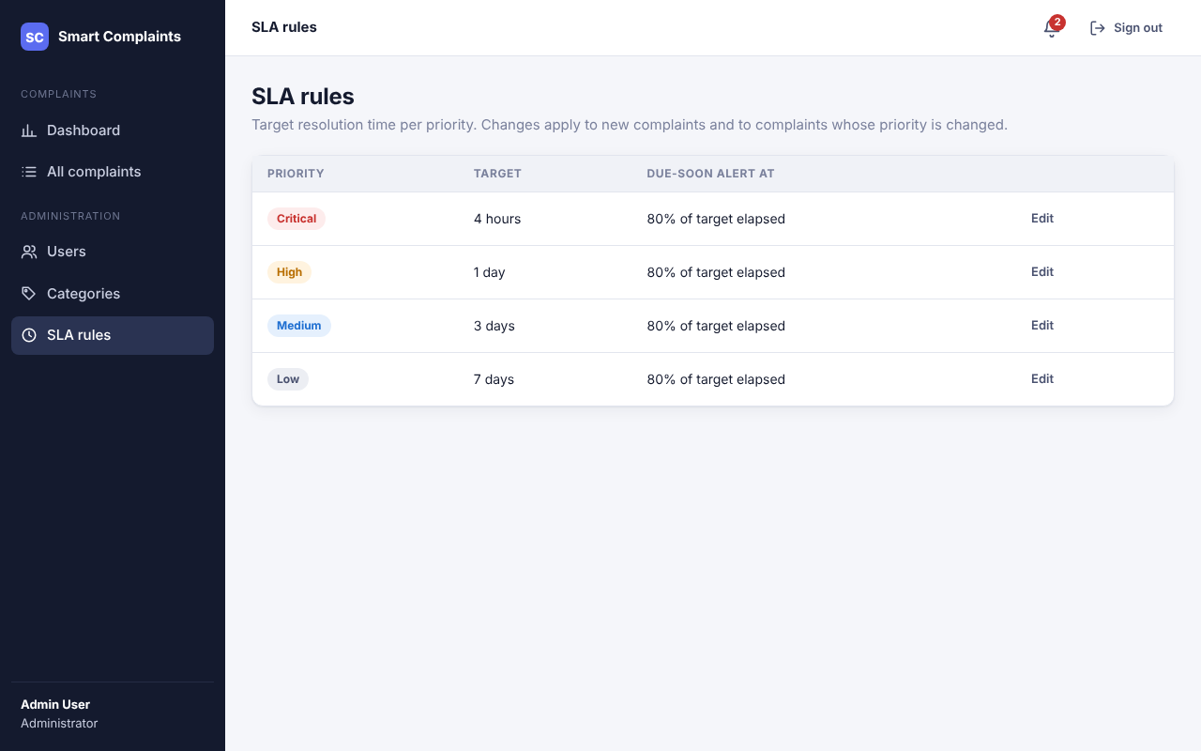
Figure 11. SLA rules

7.8 Mobile layout
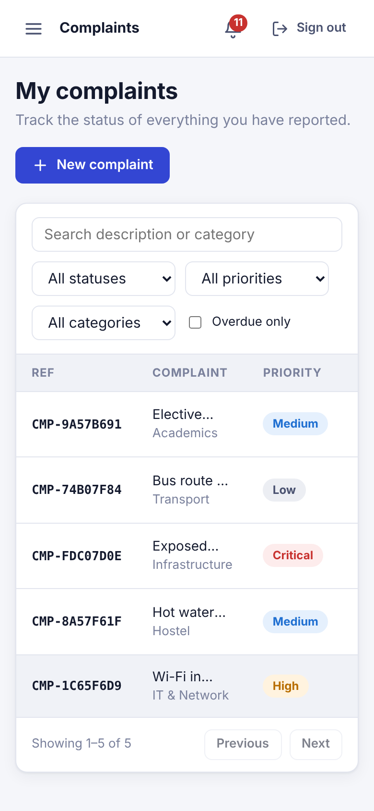
Figure 12. My complaints at 390 px width

8. Design Refinements Made During Implementation
The Software Design allows controlled changes found during implementation (Software Design, Implementation Baseline step 8). These should be added to the next revision of the Software Design Document:
# | Refinement | Reason
1 | New table sla_rules (priority, target minutes, due-soon %), migration c3a1f0d2e7b4, seeded with defaults | GET/PATCH /sla/rules in the API design needed persistent configuration that the schema did not have.
2 | Escalation is also allowed from SUBMITTED and ASSIGNED, not only IN_PROGRESS | A complaint can breach its SLA before anyone starts work; those are the cases most in need of escalation.
3 | ESCALATED → ASSIGNED on reassignment; resuming requires an active assignee | An escalated, unassigned complaint must get an owner before work resumes.
4 | Internal "System" account (cannot log in) records scheduler actions | status_history.changed_by is mandatory; escalations need an actor.
5 | Additional endpoints: /users (admin), /sla/check, /notifications/read-all, /reports/complaints.csv | Needed by the Manage Users use case, the dashboard and report export.
6 | Optional expected_status on status updates (409 on mismatch) | Implements the concurrency protection described in SDD §10.3.
7 | Role values stored as USER / STAFF / ADMIN (model default changed from "User") | Consistent controlled vocabulary for role checks.

9. Known Limitations and Open Items
Item | Impact | Recommendation
50 simultaneous logins exceed 3 s on 2 vCPUs (bcrypt cost 12) | Only at a login spike; normal use unaffected | Run more uvicorn workers or a larger host; or lower BCRYPT_ROUNDS to 11 after review.
External notification channels have no provider configured | Only in-app notifications are delivered | Implement an e-mail adapter using the existing adapter interface when credentials are available.
Docker image and Jenkins pipeline were written but not executed in the validation environment (no Docker daemon or Jenkins server) | Container start sequence was validated without Docker (migrate → start → admin bootstrap) | Run docker compose up and the Jenkins job once on the team's machine.
SRS v1.1 additions are not implemented (feedback/reopen, attachments, departments, login lockout) | None for the v1.0 baseline | Plan as the next increment once v1.1 is adopted by the team.
Only Chromium was tested | Low; standard HTML/CSS/ES modules | Smoke-test in Firefox and Edge before the demonstration.

10. Conclusion and Sign-off
All 41 requirements in the SRS v1.0 baseline were validated, with automated evidence for each, and all 207 automated tests pass. The open items in §9 do not block the baseline. The system is ready for the final report and demonstration.
Role | Name | Signature | Date
Authentication & Accounts | Purum Gurudev
Complaints & Tracking | Prashyanth V
Assignment, SLA & Escalation | Aditya Pradeep
Notifications & Reporting | Nihar S Jain
Faculty evaluator

