Cox Proportional Hazards Regression in IBM SPSS Statistics.

The Hazard Ratio is the most important value.

HR > 1 → higher risk of death

HR < 1 → lower risk (protective effect)

Variable-by-variable interpretation
Sex

p = .655

Not significant.

HR = 0.852

Interpretation:

Females had 14.8% lower hazard, but the difference was not statistically significant.

Diagnosis (overall test)

p < .001

This means:

Tumor diagnosis significantly affects survival.

Now look at each category.

Diagnosis (1) – HG glioma

p = .009

HR = 4.25

Interpretation:

Patients with HG glioma had 4.25 times higher hazard of death compared to the reference group.

This is statistically significant.

Diagnosis (2) – LG glioma

p = .749

HR = 1.265

Not significant.

Diagnosis (3) – Meningioma

p = .231

HR = 0.491

Lower hazard but not significant.

Treatment method

p = .509

HR = 0.700

Interpretation:

SRS patients had 30% lower hazard than SRT, but not statistically significant.

KI (Karnofsky Index)

p = .002

HR = 0.946

This IS significant.

Interpretation:

Each 1-unit increase in KI reduces death hazard by 5.4%.

Meaning:
Better functional status improves survival.
GTV (tumor volume)
p = .108
HR = 1.036
Not significant.

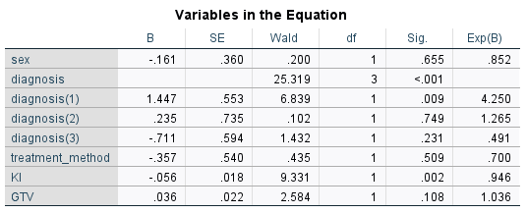

Interpretation

A Cox proportional hazards regression analysis was conducted to examine the effects of sex, diagnosis, treatment method, Karnofsky Index (KI), and gross tumor volume (GTV) on patient survival. The overall effect of diagnosis was significant, Wald χ²(3) = 25.32, p < .001. Patients with high-grade glioma showed a significantly higher risk of mortality compared to the reference group (HR = 4.25, p = .009). KI was also a significant predictor of survival (HR = 0.946, p = .002), indicating that higher functional status was associated with reduced mortality risk. Sex (HR = 0.852, p = .655), treatment method (HR = 0.700, p = .509), and GTV (HR = 1.036, p = .108) were not significant predictors of survival.

