Fire and Smoke Detection using Deep Learning Models

Project progress report submitted to
MANIPAL ACADEMY OF HIGHER EDUCATION

For Partial Fulfillment of the Requirement for the Award of the Degree
of
Bachelor of Technology
in
Computer Science and Engineering
by
Chintakunta Guru Dinesh Reddy Reg. No. 220905438
Under the guidance of
Dr. Sucharitha Shetty Assistant Professor
School of Computer Engineering Manipal Institute of Technology Manipal, India

March 2026

Introduction
Fire accidents are one of the major causes of damage to human life, property, and the environment. Such incidents can occur in forests, industrial areas, residential buildings, and public places. Detecting fire at an early stage is extremely important in order to reduce the damage caused by these accidents. Traditional fire detection systems usually rely on hardware sensors such as smoke detectors, temperature sensors, and flame sensors. Although these systems work well in indoor environments, they often face limitations in large open areas or outdoor environments.
In situations such as forest fires or large industrial spaces, smoke may spread slowly or environmental conditions may delay the response of sensors. Because of this, traditional systems may not detect fire quickly enough, which can increase the risk of severe damage. Therefore, more intelligent and reliable detection systems are required that can work effectively in different environments.
With the rapid growth of Artificial Intelligence (AI) and computer vision technologies, deep learning methods have become powerful tools for analyzing visual data. Deep learn- ing models, especially Convolutional Neural Networks (CNNs), are capable of identifying complex patterns in images. These models can detect important visual characteristics such as flame color, smoke texture, and movement patterns.
Among the various object detection models available today, the YOLO (You Only Look Once) architecture has become very popular because of its ability to perform object detection in real time with high accuracy and speed. YOLO models are widely used in applications such as surveillance systems, safety monitoring, and disaster prevention systems.
However, detecting the presence of fire alone may not always be sufficient for proper emergency response. Fires are classified into different categories depending on the ma- terials involved, such as Class A fires (ordinary combustible materials) and Class B fires (flammable liquids). Using an incorrect fire suppression method can worsen the situation. Therefore, identifying the type of fire is also important.
To address this problem, this project proposes a two-stage computer vision system. In the first stage, different YOLO models such as YOLOv8, YOLOv9, YOLOv10, and YOLOv11 are used to detect fire and smoke using bounding box detection. The per- formance of these models is evaluated using metrics such as precision, recall, and mean average precision (mAP). In the second stage, a classification module is used to categorize the detected fire into specific types such as Class A and Class B using a custom dataset. This approach helps in improving the accuracy of fire detection and provides more useful information for emergency response systems.

Literature Survey
Many researchers have explored the use of computer vision and deep learning techniques for fire and smoke detection. Earlier fire detection systems mainly depended on physical sensors such as smoke detectors, temperature sensors, and flame sensors. These systems are commonly used in buildings and indoor environments, but they often face difficulties in large open areas or outdoor environments where smoke spreads quickly or environmental conditions interfere with sensor readings.

With the advancement of digital image processing and deep learning technologies, computer vision based methods have become more effective for detecting fire and smoke. Convolutional Neural Networks (CNNs) are widely used for image classification tasks because they can learn complex visual patterns from images. These models are capable of identifying important features such as flame color, smoke patterns, and texture variations. However, traditional CNN-based classifiers analyze the entire image and only deter- mine whether fire is present or not. They cannot accurately locate the exact position of fire within the image. To solve this problem, region-based object detection models such as Faster R-CNN were introduced. These models can detect the location of fire by
drawing bounding boxes around the affected region.
Although region-based models improve detection accuracy, they require more com- putational power and may not be suitable for real-time applications. To overcome this limitation, one-stage object detection models such as YOLO (You Only Look Once) were developed. YOLO models are capable of detecting and locating objects simultaneously, which makes them faster and more efficient for real-time detection systems.
Over the years, the YOLO architecture has been improved significantly, leading to several advanced versions such as YOLOX, YOLOv7, YOLOv8, YOLOv9, YOLOv10, and YOLOv11. These models provide better accuracy and faster detection speed, making them suitable for applications such as surveillance systems, forest fire monitoring, and industrial safety systems.

Research Gap and Motivation
Although many studies focus on detecting fire using bounding boxes, most existing sys- tems only identify the presence of fire without analyzing its type. In real-life situations, it is important to understand the type of fire because different fire classes require different extinguishing methods. For example, water can be used for Class A fires but may worsen Class B fires involving flammable liquids.
Most traditional methods used for analyzing fire characteristics rely on basic color space analysis such as HSV (Hue, Saturation, Value). These approaches may not always provide reliable classification results. Therefore, there is a need for an improved system that can both detect fire and classify its type.
To address this gap, this project proposes a two-stage computer vision system that first detects fire and smoke using YOLO models and then classifies the detected fire into specific categories using a custom dataset. This approach aims to improve fire detection systems and support better decision making in emergency situations.

Problem Definition
Fire accidents can cause serious damage to human life, buildings, forests, and industrial environments. Detecting fire and smoke at an early stage is very important in order to prevent disasters and reduce the level of damage. Traditional fire detection systems mainly depend on physical sensors that detect smoke, heat, or flames. Although these systems are useful in indoor environments, they often face limitations in large open areas or outdoor environments where smoke spreads slowly or environmental conditions affect sensor performance.

The use of computer vision and deep learning techniques has helped overcome some of the limitations of traditional sensor-based systems by allowing fire detection through images or video data. However, many existing visual detection systems only provide a simple alert indicating that a fire has been detected. They do not provide additional information about the type or nature of the fire.
In real-world emergency situations, understanding the type of fire is very important because different types of fires require different methods for extinguishing them. For example, using water to extinguish a fire caused by flammable liquids can make the situation worse instead of controlling it. Therefore, emergency responders and automated safety systems need accurate information about the specific class of fire in order to apply the correct safety measures.
The main problem addressed in this project is the development of an intelligent two- stage deep learning system that can detect fire and smoke from images or video frames in real time and also classify the detected fire into different categories such as Class A and Class B fires. By solving both detection and classification problems, the proposed system aims to provide a more effective and practical solution for modern fire monitoring and disaster response systems.

Objective
The main objectives of this project are as follows:
- To study and understand different deep learning models that are commonly used for real-time object detection.
- To train and compare the performance of different YOLO models such as YOLOv8, YOLOv9, YOLOv10, and YOLOv11 in order to determine the most suitable model for detecting fire and smoke.
- To evaluate the trained models using performance metrics such as precision, recall, and mean average precision (mAP) to identify the most effective detection model.
- To collect and prepare a custom dataset consisting of approximately 400 images categorized into Class A fires (ordinary combustible materials) and Class B fires (flammable liquids).
- To develop and train a deep learning based classification module that can accurately classify detected fires into their respective fire classes.
- To integrate the detection and classification components into a two-stage computer vision system that can both detect fire and identify its type, helping to improve fire monitoring and response systems.

Methodology
The proposed system follows a two-stage computer vision pipeline designed to first detect the presence of fire or smoke and then classify the detected fire into specific categories.

The first stage focuses on identifying and locating fire or smoke in images, while the second stage performs classification of the detected fire type.
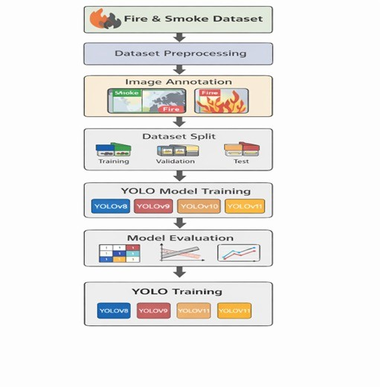
Figure 1: Overall Workflow of the Proposed Fire and Smoke Detection System

Phase 1: Baseline Fire and Smoke Detection
The first phase focuses on detecting the presence of fire and smoke and identifying their exact location within an image or video frame.

Data Collection and Preprocessing:
The dataset used for this project consists of images of fire and smoke collected from publicly available sources. These images represent different real-world scenarios such as forest fires, building fires, and industrial environments. Before training the models, preprocessing steps were performed, including removing corrupted images, organizing the dataset into directories, and resizing all images to a fixed resolution such as 640×640 pixels.

Image Annotation and Dataset Splitting:
After preprocessing, the images were manually annotated by drawing bounding boxes around the regions containing fire or smoke. Each object was labeled into two categories: Smoke and Fire. The dataset was then divided into training, validation, and testing sets to ensure that the model can generalize well to unseen data.

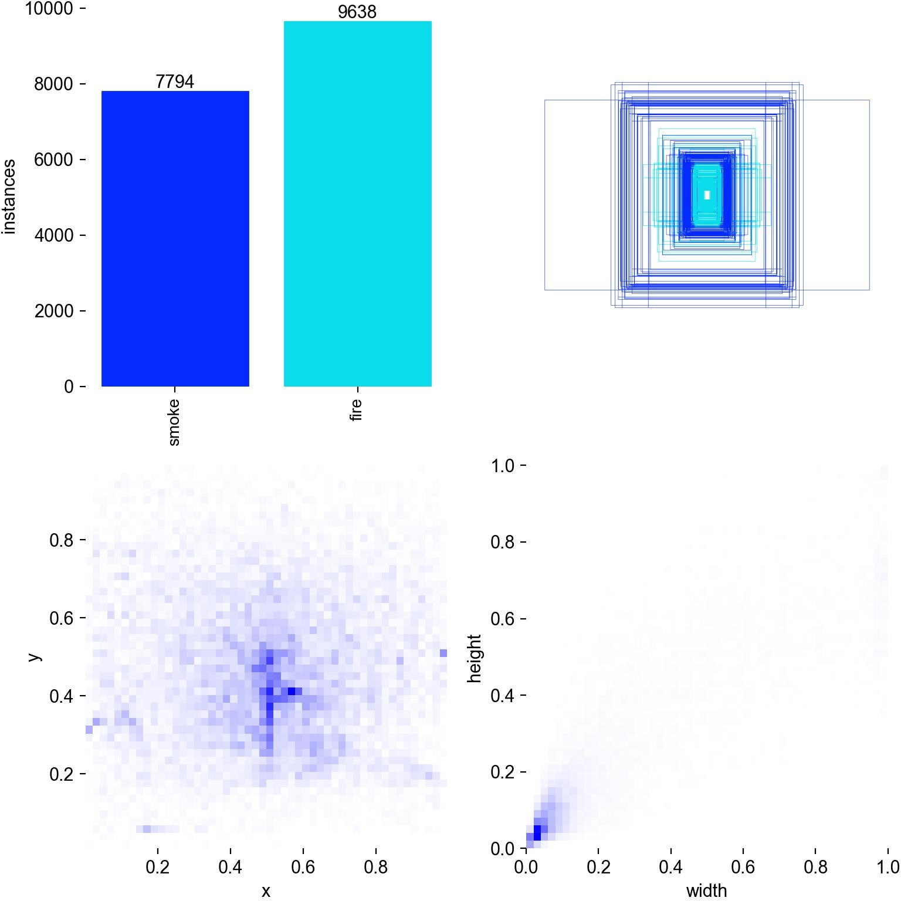

Figure 2: Dataset Label Distribution

Model Training and Evaluation:
Multiple YOLO architectures were trained and evaluated to determine the most effective model for fire and smoke detection. In this project, YOLOv8, YOLOv9, YOLOv10, and YOLOv11 models were trained using the prepared dataset. The models were evaluated using standard object detection metrics such as Precision, Recall, and Mean Average Precision (mAP).

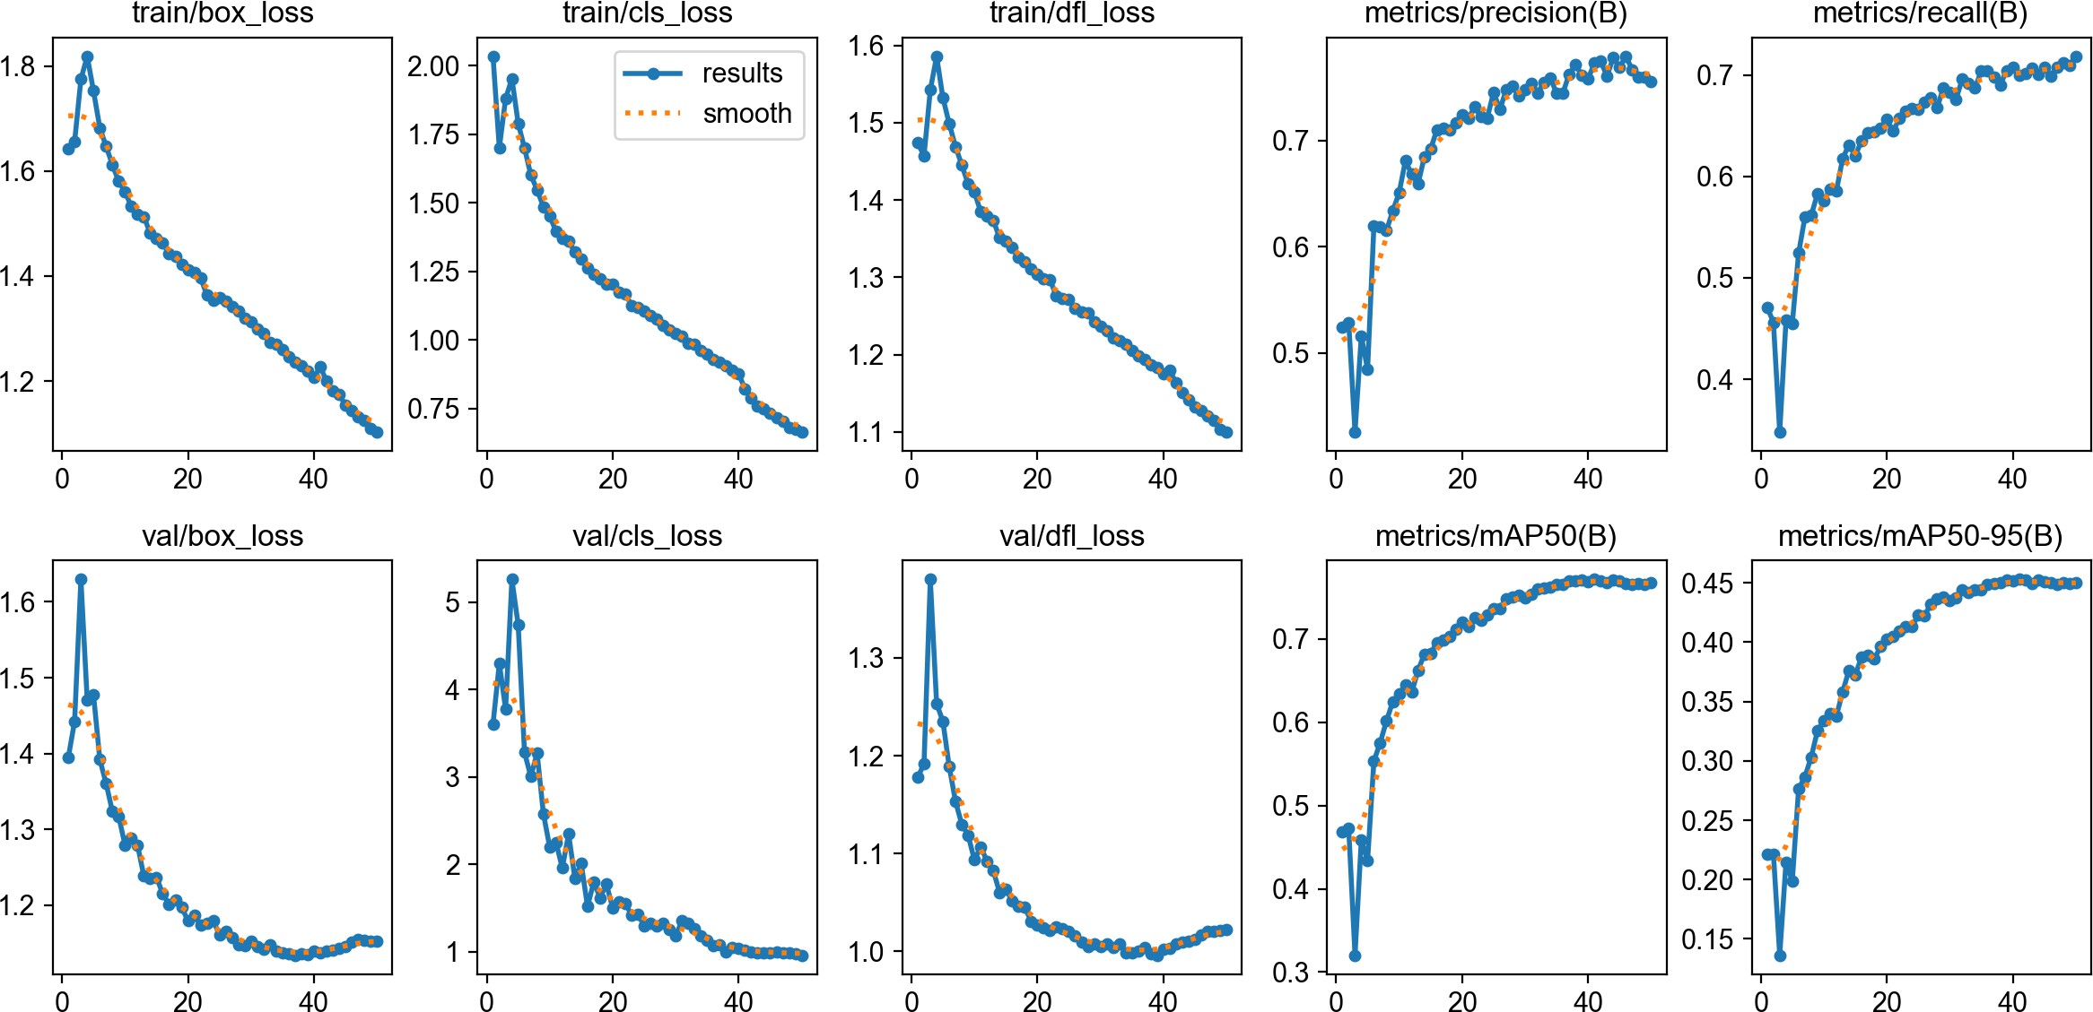

Figure 3: Training Results of YOLO Models

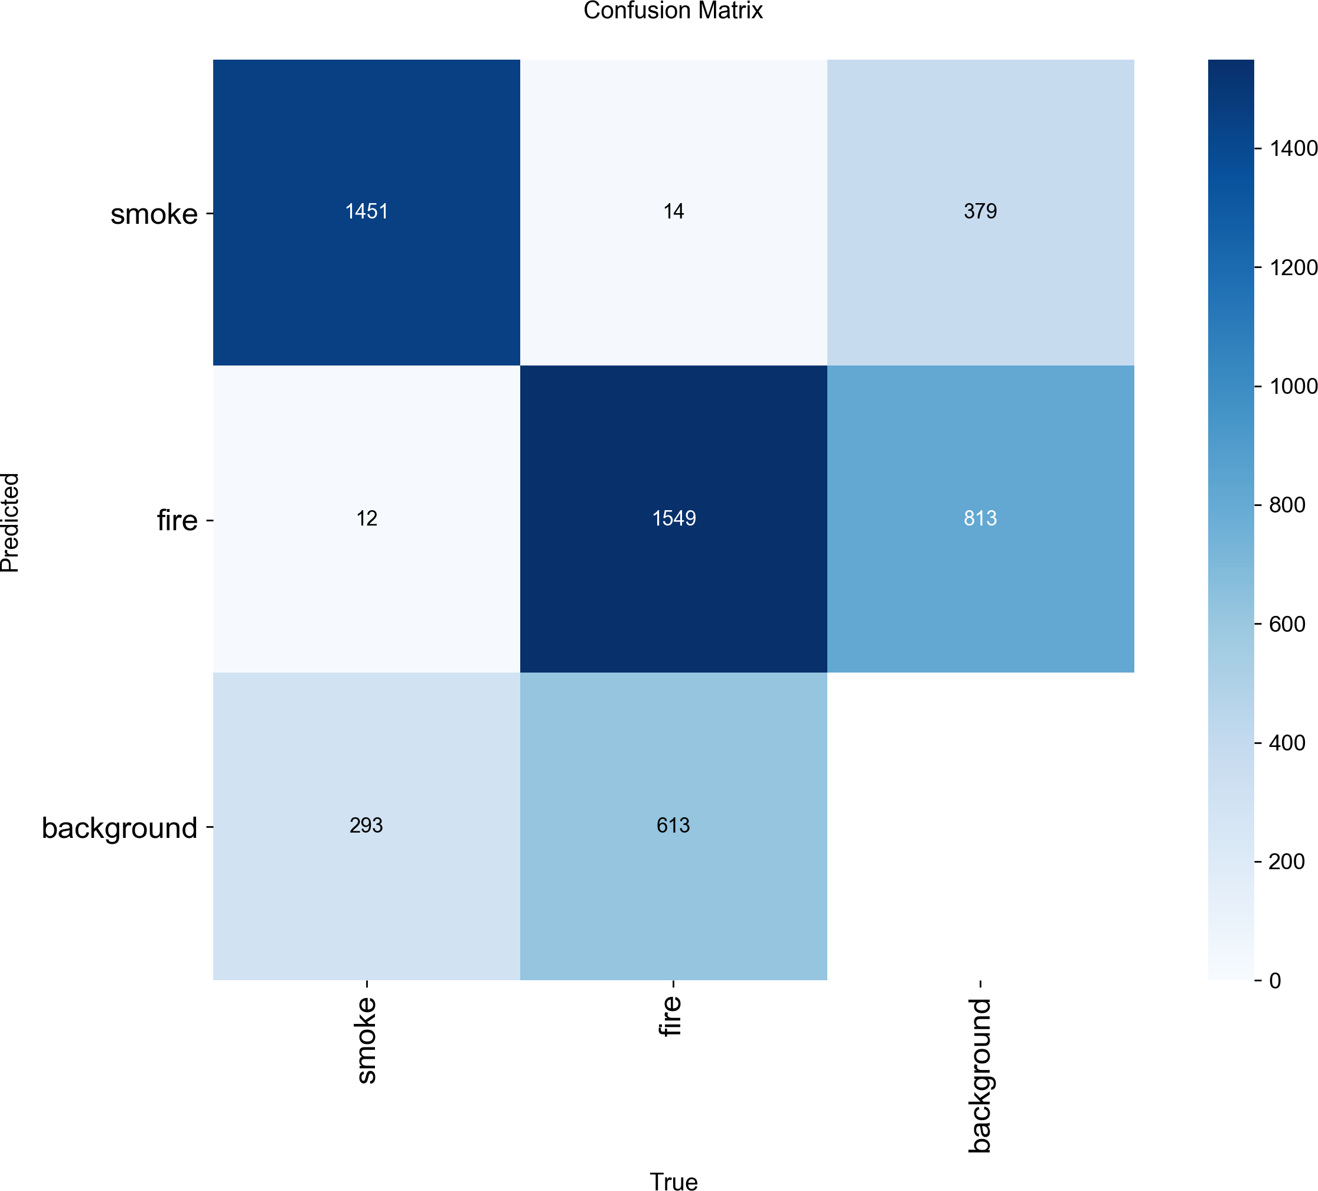

Figure 4: Confusion Matrix of Fire and Smoke Detection

Phase 2: Fire Type Classification (Novel Contribution)
Once the fire is detected in the first stage, the detected bounding box is extracted and passed to the second stage for fire type classification.

Custom Dataset Preparation:
A custom dataset consisting of approximately 400 images was created for the classi- fication task. These images were categorized into two classes: Class A fires (ordinary combustible materials such as wood or paper) and Class B fires (flammable liquids such as oil or fuel).

Classification Model:
A deep learning based classification model was trained using the custom dataset. In this stage, the YOLOv11 classification architecture was used to learn the visual patterns that differentiate Class A fires from Class B fires.

Hybrid Feature Analysis using HSV:
To further improve classification reliability, traditional image processing techniques were also used. The HSV (Hue, Saturation, Value) color space was analyzed to examine flame color characteristics such as red, orange, and yellow intensity. This analysis helps verify the predictions generated by the deep learning model.

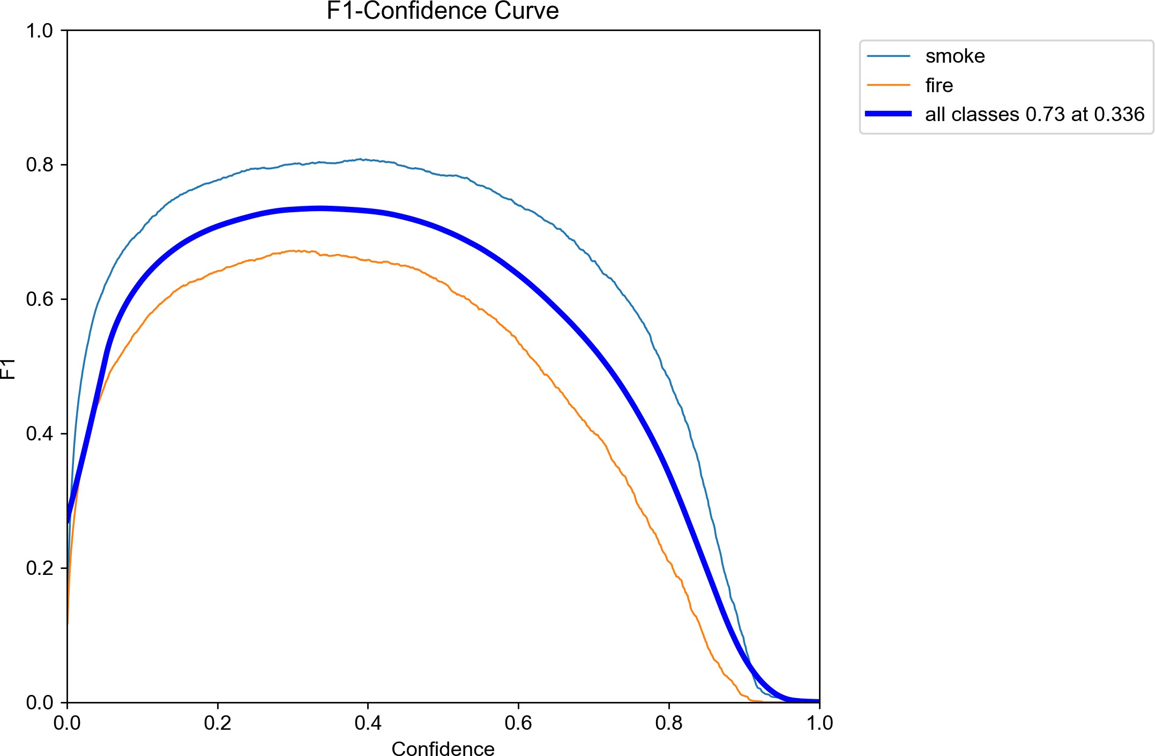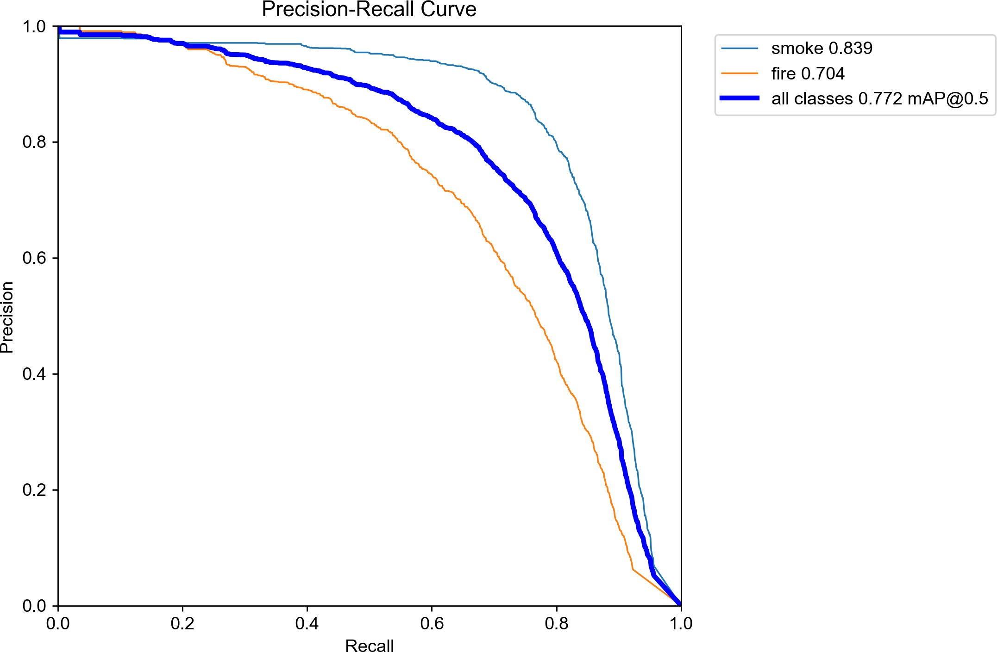
Figure 5: F1 Score vs Confidence Curve Figure 6: Precision-Recall Curve of the
Model
Overall, the proposed methodology integrates deep learning based object detection with fire type classification to create an intelligent fire monitoring system. By detecting the location of fire and identifying its type, the system can provide more meaningful information for safety monitoring and emergency response systems.

Workdone So Far
- The dataset related to web-based network traffic attacks was collected and prepro- cessed to remove inconsistencies and prepare it for analysis.
- Exploratory Data Analysis (EDA) was done to analyze the characteristics of the given data set.
- Various visualizations were created to analyze the distribution of different types of web attacks, the top destination ports for the attacks, and the forward packet size for the attacks.
- A machine learning model was created to classify the network traffic as normal or an attack.
- The model was validated using a threshold value of 0.7 , achieving an accuracy of 99%, with an F1-score of 0.82 for the Attack class and a Macro F1-score of 0.91.

- Cross-validation was also performed to validate the model’s performance to achieve a mean CV Macro F1-score of 0.872.

Workdone So Far
A dataset containing fire and smoke images was collected from publicly available sources to develop the baseline fire detection models. The collected dataset was carefully pre- processed by removing corrupted or unnecessary images and organizing the data into structured folders. The images were then divided into training, validation, and testing sets to ensure proper model evaluation. Each image in the dataset was manually an- notated with bounding boxes to mark the exact location of fire and smoke within the frames.
After preparing the dataset, several YOLO-based object detection models were trained to analyze their effectiveness for fire and smoke detection. In this project, multiple ver- sions of YOLO were considered, including YOLOv8, YOLOv9, YOLOv10, and YOLOv11. The objective of this comparison was to determine which model performs best in terms of detection accuracy and real-time performance.
The performance of these models was evaluated using standard object detection met- rics such as Precision, Recall, and Mean Average Precision (mAP). The results obtained from the experiments are summarized in Table 1.

Model | Precision | Recall | mAP50
YOLOv8 | 0.755 | 0.718 | 0.744
YOLOv9 | 0.765 | 0.704 | 0.767
YOLOv10 | 0.733 | 0.763 | 0.663
YOLOv11 | 0.750 | 0.725 | 0.675

Table 1: Performance Comparison of YOLO Models
From the experimental results, YOLOv8 achieved the best overall performance among the evaluated models, providing the highest mean average precision (mAP). The trained models were further tested on sample images and video streams to verify that the system can successfully detect and localize fire and smoke in different environments.

Classification Module Progress (Novel Contribution)
In addition to the baseline detection system, progress has also been made toward developing the fire type classification module. A custom dataset was created for this purpose, consisting of approximately 400 images. These images were categorized into two classes: 200 images representing Class A fires (ordinary combustible materials) and 200 images representing Class B fires (flammable liquids).
Preliminary experiments were conducted using the YOLOv11 classification architec- ture to evaluate its ability to distinguish between these fire types. The initial results show that the model can learn meaningful visual differences between Class A and Class B fires, and further improvements will be explored in the next phase of the project.

Remaining Work
Although the current system is able to detect fire and smoke using YOLO-based object detection models, there are still several improvements that need to be completed in the next phase of the project. The main focus of the remaining work is to improve the system by adding a reliable fire type classification module. Identifying the type of fire is very important because different types of fires require different extinguishing methods. For example, using water on certain types of fires can make the situation worse instead of controlling it.
To further improve the proposed system, the following tasks will be carried out:

Improving the Classification Model:
The first task is to improve the performance of the fire classification model. Cur- rently, the custom dataset contains around 400 images, which include Class A fires (ordinary combustible materials) and Class B fires (flammable liquids). In the next phase, the dataset will be expanded by adding more images with different environ- ments and lighting conditions. This will help the YOLOv11 classification model learn better patterns and improve its accuracy in distinguishing between different fire types.

HSV-Based Feature Analysis:
To make the classification results more reliable, additional analysis will be per- formed using the HSV (Hue, Saturation, Value) color space. HSV is useful for iden- tifying flame colors such as red, orange, and yellow, which are commonly present in fire images. After the YOLO model detects the fire region in an image or video frame, the HSV color values of that region will be analyzed to extract useful color patterns that help verify the model’s prediction.

Integration of Detection and Classification:
Another important task is to combine the fire detection model and the classification model into a single system. By integrating both modules, the system will not only detect the presence of fire but will also classify the detected fire into categories such as Class A or Class B. This integrated pipeline will make the system more useful for real-world safety monitoring applications.

Testing and Documentation:
Finally, the complete system will be tested on different images and video inputs to evaluate its overall performance. The results will be carefully documented, including accuracy and other performance metrics. These results will help in preparing the final project report and may also support future research work based on this system.

Scope
The proposed two-stage system demonstrates how deep learning and object detection models can be used to analyze visual data for detecting fire and smoke and identifying

their characteristics. By combining fire detection with fire type classification, the system provides more useful information than traditional detection systems. Such intelligent monitoring systems have the potential to be applied in many real-world environments where early fire detection is critical.

Industrial and Maritime Safety:
In industrial plants, warehouses, and maritime environments, early fire detection is extremely important because fires can spread rapidly and cause severe damage. The proposed system can continuously monitor visual feeds and detect the early signs of fire before traditional sensors are triggered. By identifying the type of fire, the system can also assist automated fire suppression systems in selecting the appropriate extinguishing method, such as using chemical foam instead of water for flammable liquid fires.

Forest Fire Monitoring:
In large forest areas, installing and maintaining traditional smoke detectors is often difficult and expensive. The proposed computer vision system can monitor forest regions using cameras or drones and detect fire or smoke at an early stage. This makes it a scalable and practical solution for forest fire monitoring and prevention.

Smart City Integration:
The system can also be integrated into smart city infrastructure by connecting it with existing CCTV camera networks. This allows real-time monitoring of public areas and provides immediate alerts to emergency responders if fire or smoke is de- tected. Such integration can help improve public safety and enable faster emergency response.
Overall, this project contributes to the development of intelligent safety systems by exploring the use of computer vision and deep learning for fire detection and classification. The custom dataset and the proposed hybrid detection-classification approach can also support future research and development in automated hazard monitoring systems.

References
- J. Redmon, S. Divvala, R. Girshick, and A. Farhadi, “You only look once: Unified, real-time object detection,” in Proceedings of the IEEE Conference on Computer Vision and Pattern Recognition (CVPR), 2016.
- Z. Ge, S. Liu, F. Wang, Z. Li, and J. Sun, “Yolox: Exceeding yolo series in 2021,”
arXiv preprint arXiv:2107.08430, 2021.
- C.-Y. Wang, A. Bochkovskiy, and H.-Y. M. Liao, “Yolov7: Trainable bag-of- freebies sets new state-of-the-art for real-time object detectors,” arXiv preprint arXiv:2207.02696, 2022.
- T. Wang et al., “Yolov9: Learning what you want to learn using programmable gradient information,” arXiv preprint, 2024.

- S. Frizzi, R. Kaabi, M. Bouchouicha, and J. Ginoux, “Convolutional neural network for video fire and smoke detection,” in IEEE Conference on Industrial Electronics and Applications, 2016.
- P. Barmpoutis, K. Dimitropoulos, and N. Grammalidis, “Fire detection from images using faster r-cnn and deep learning,” in International Conference on Engineering Applications of Neural Networks, 2019.
- S. Muhammad, A. Ullah, and S. W. Baik, “Vision-based fire detection system using deep learning,” IEEE Access, vol. 6, pp. 18 192–18 202, 2018.
- J. Schmidhuber, “Deep learning in neural networks: An overview,” Neural Networks, vol. 61, pp. 85–117, 2015.
- R. C. Gonzalez and R. E. Woods, Digital Image Processing, 4th ed. Pearson Edu- cation, 2018.
- A. Krizhevsky, I. Sutskever, and G. E. Hinton, “Imagenet classification with deep convolutional neural networks,” in Advances in Neural Information Processing Sys- tems (NeurIPS), 2012.
- G. Jocher, A. Chaurasia, and J. Qiu, “Ultralytics yolo,” https://github.com/ultralytics/ultralytics, 2023.

