**AEM task -5**

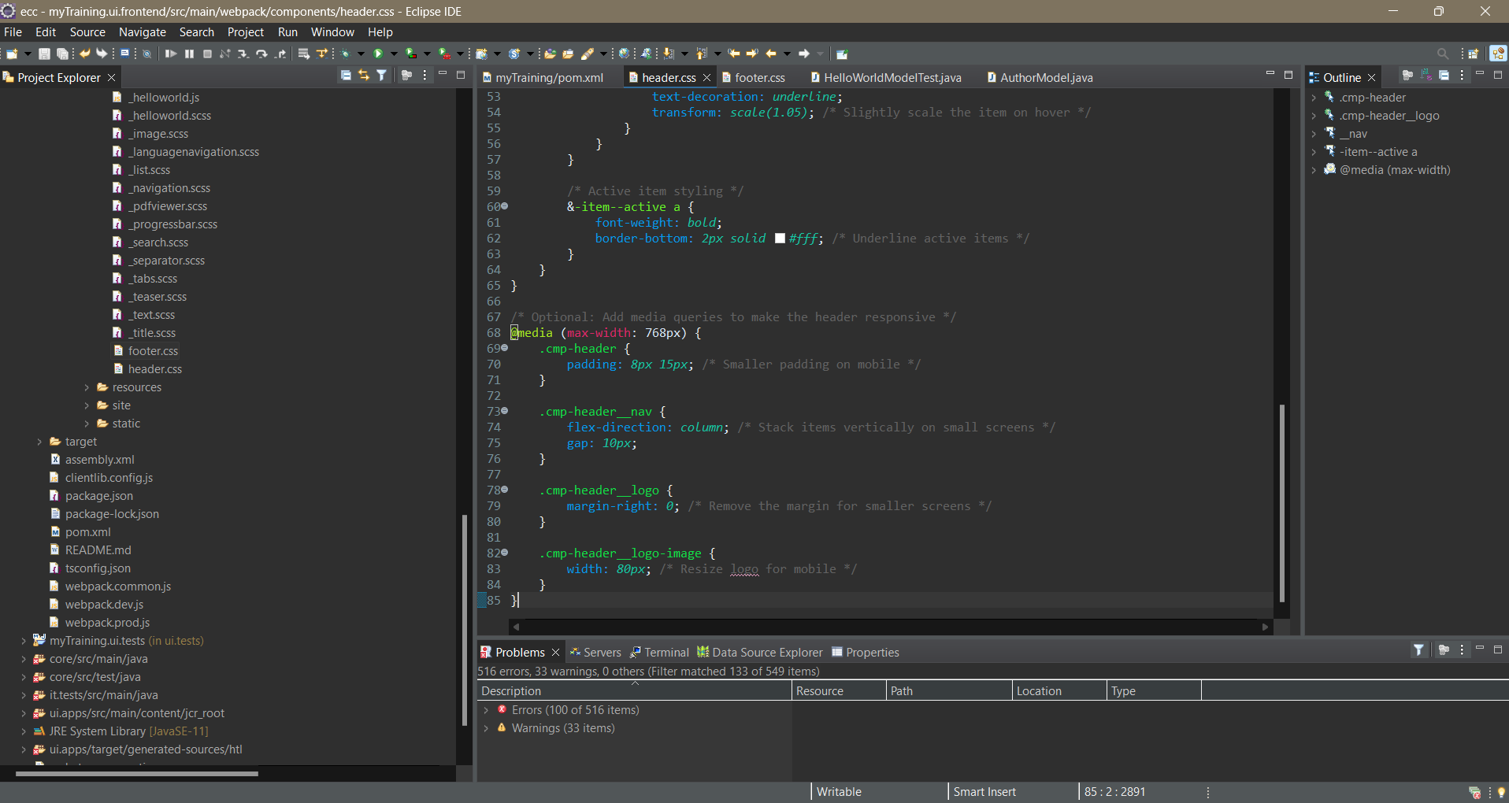**1.Editing the Header:**

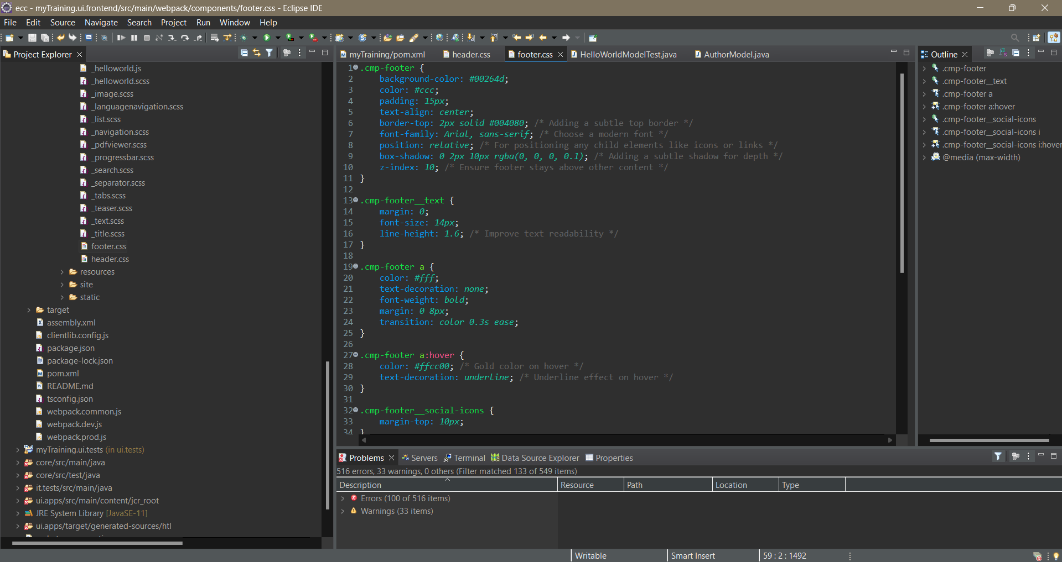**2. Editing the Footer:**

**3.Modifying the Author Component to add nodes addScript , authorDesignation:**

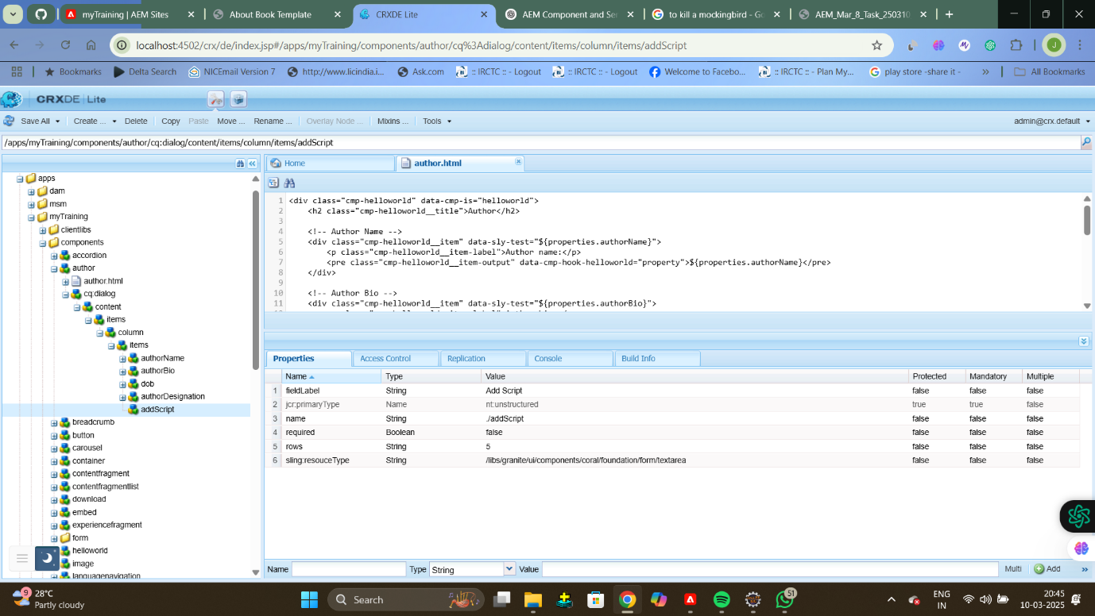

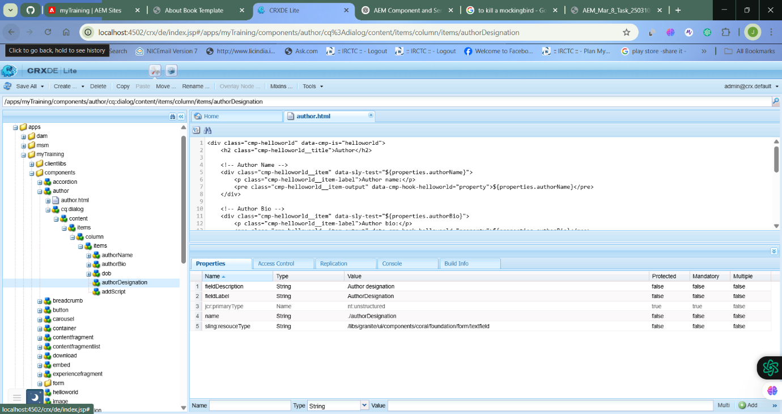

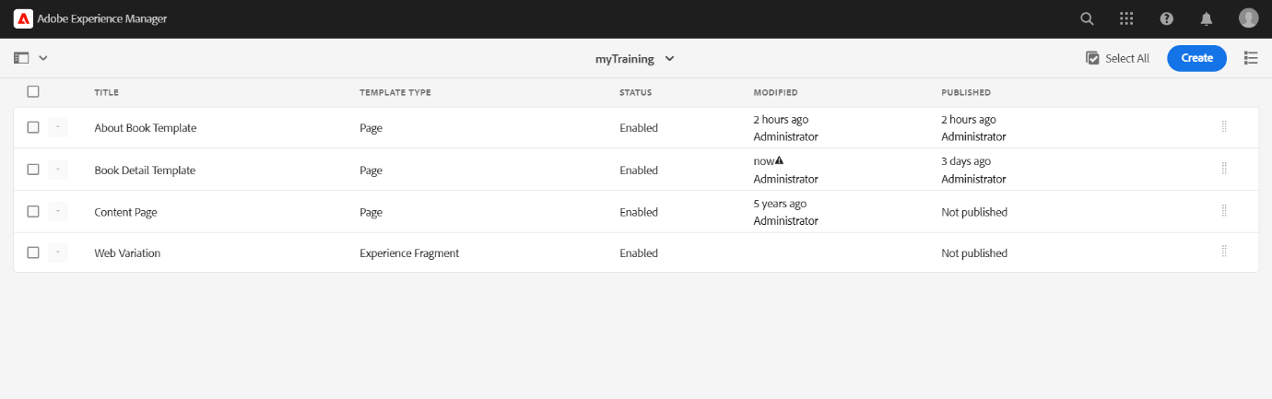**4.Created a About Book Template:**

**5.Using the Author Model fetching data and perform Serverlet functions:**

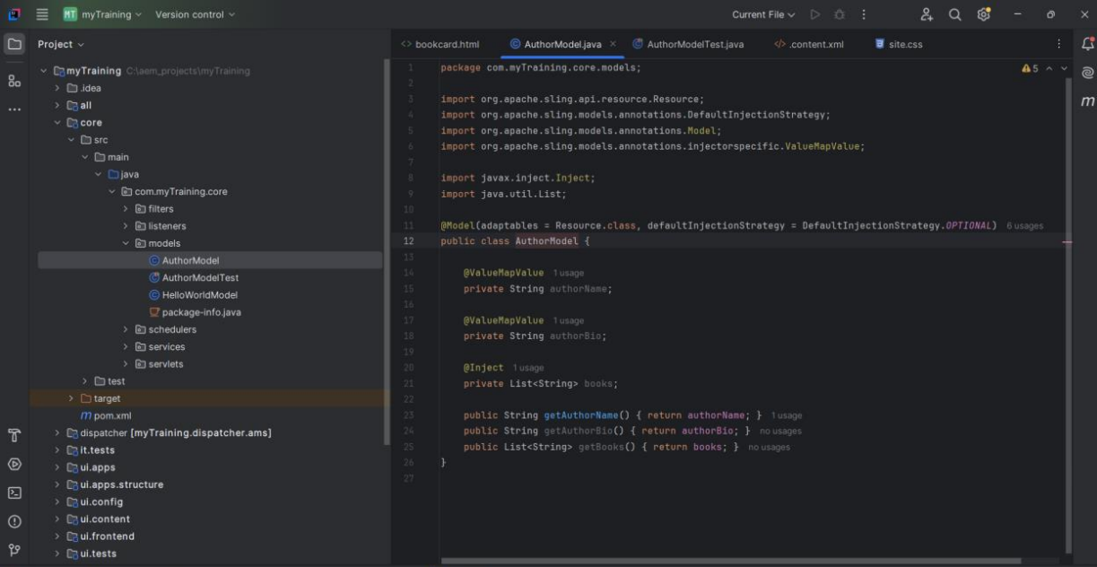

**6.Final Outlook:**

