**AEM task -6**

**1.Modifying the Author Component:**

Modifying the Author Component With added Nodes like fetching more books and authors and also using custom api.

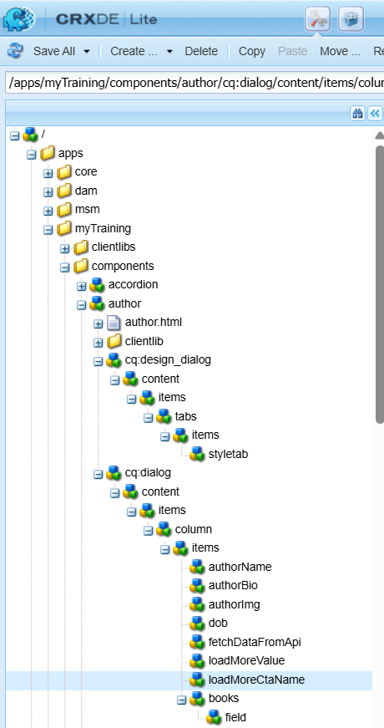

**2. Editing the Footer:**

Adding Site.js file to fetch the date Api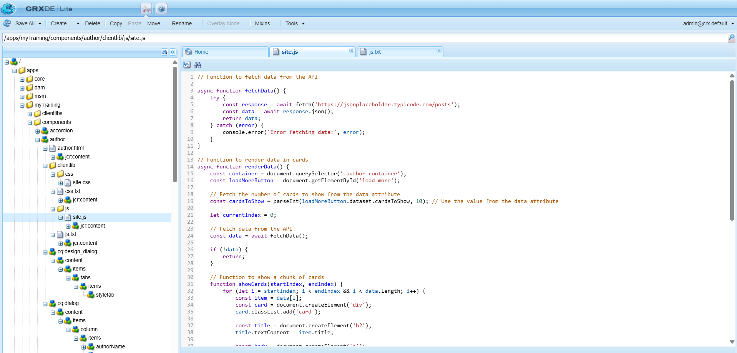

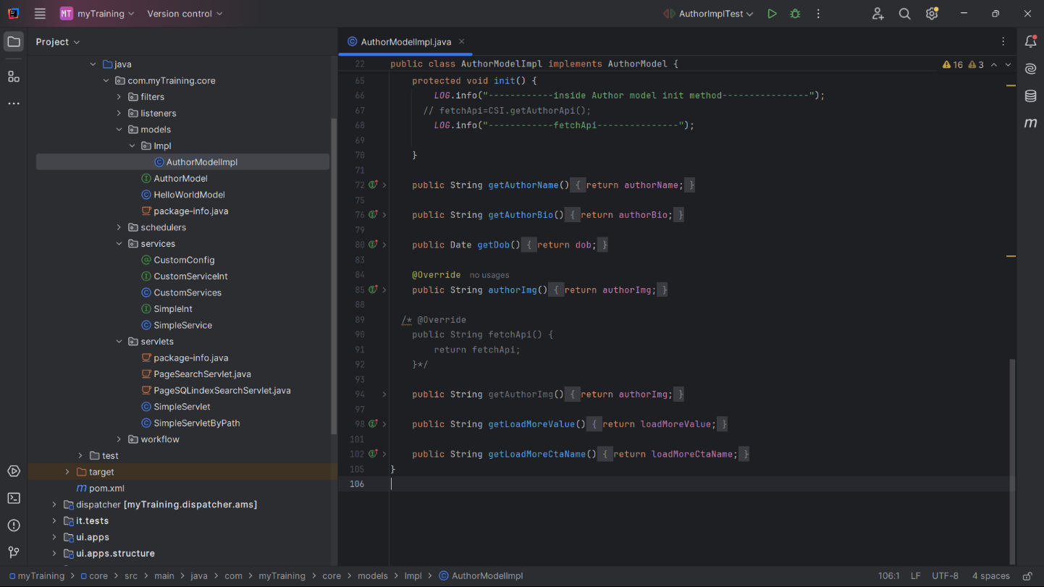**3.Modified Author Model:**

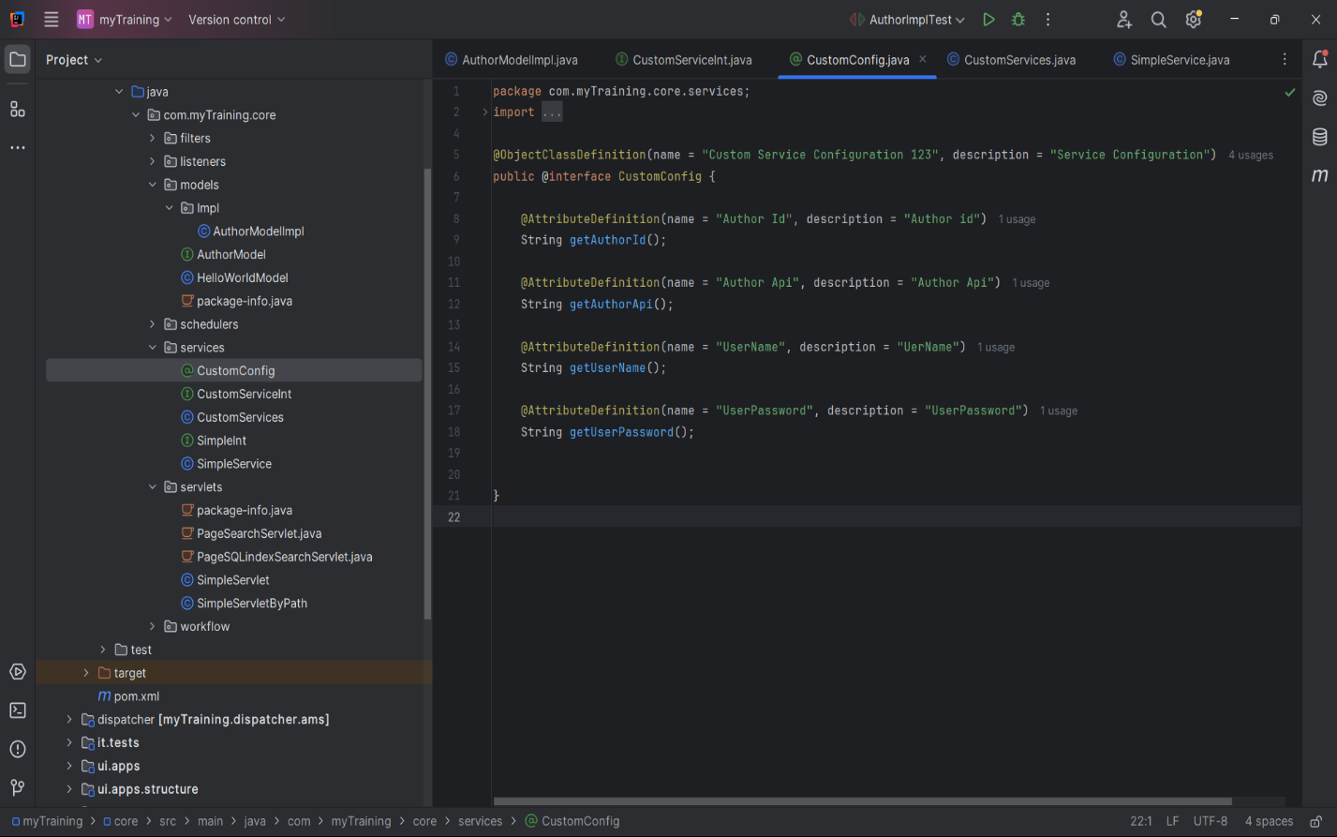**4.Custom Service Configuration:**

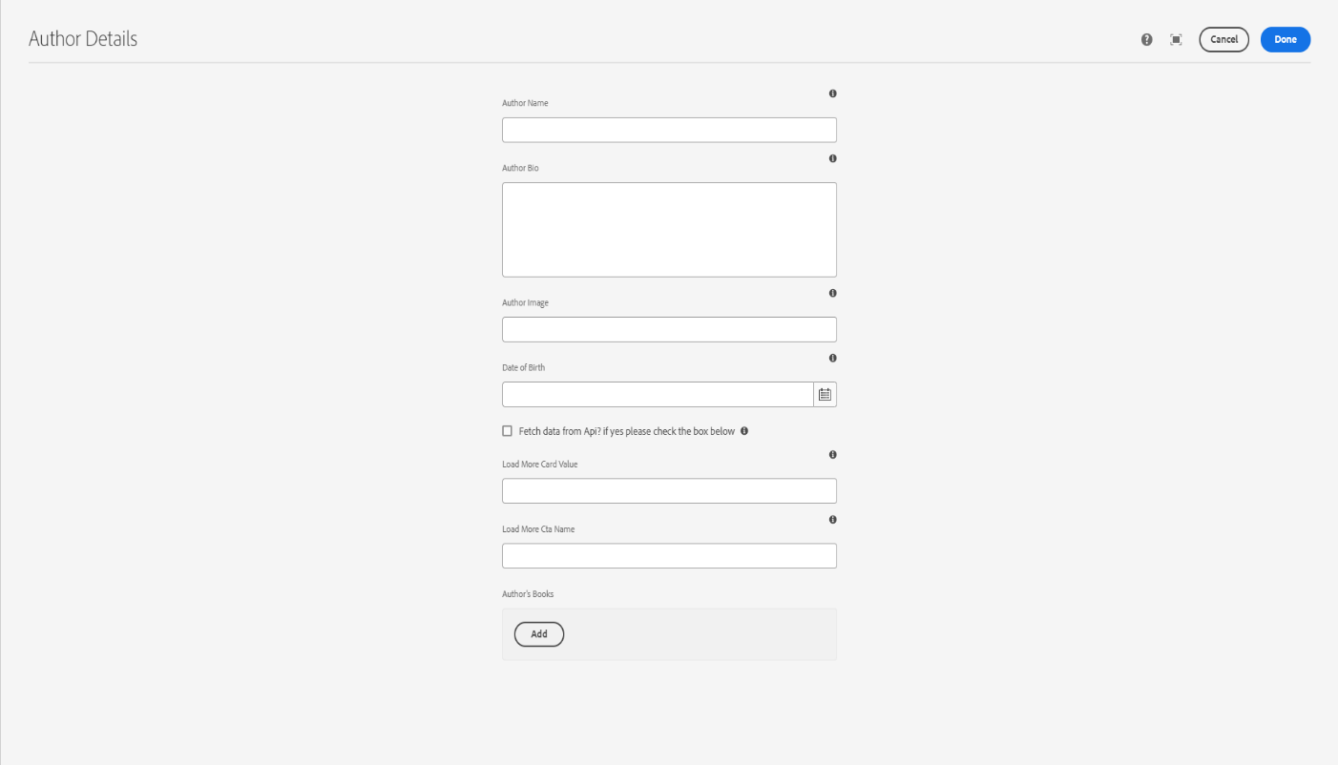**5.Using the Author Component:**

**4.Using custom Api to get the date to AEM:**

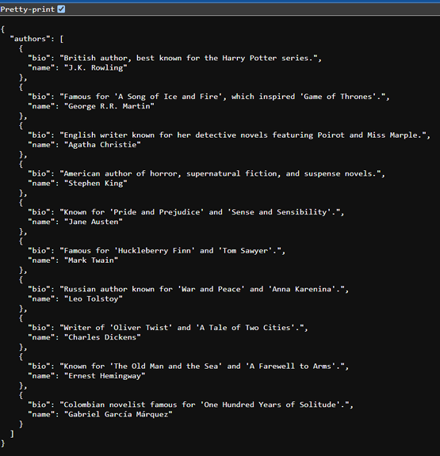

**5.Final Outlook:**

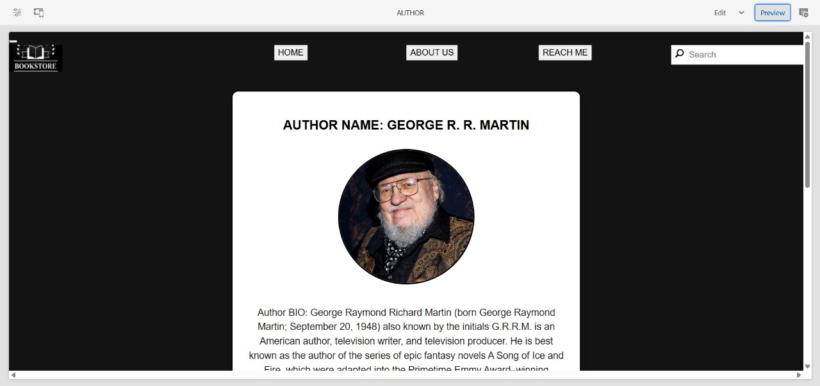

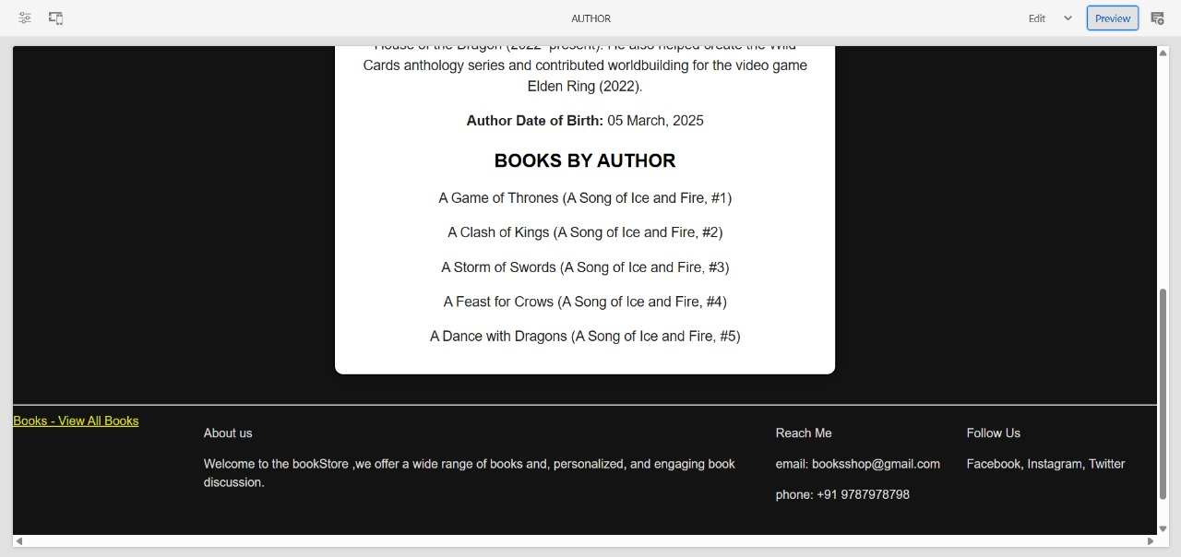

**More Authors:**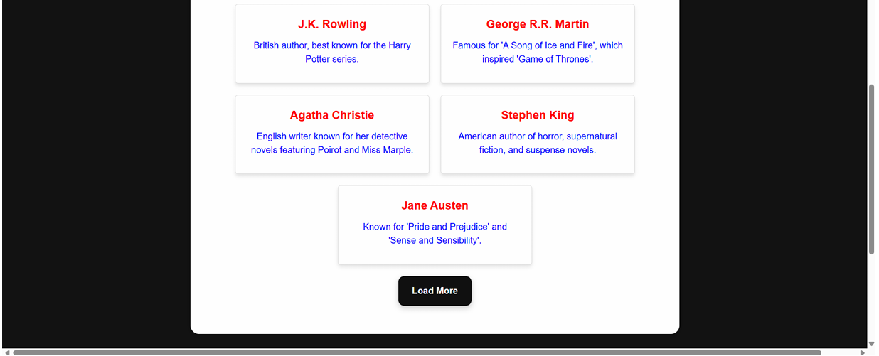

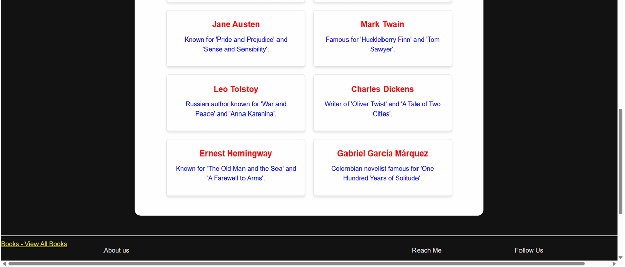**After Clicking Load More:**