**E-COMMERCE-Documentation**

**1. Homepage**

The homepage is the entry point of the platform, where users are welcomed with a clean and engaging interface. It typically features list of products with home and cart menu.

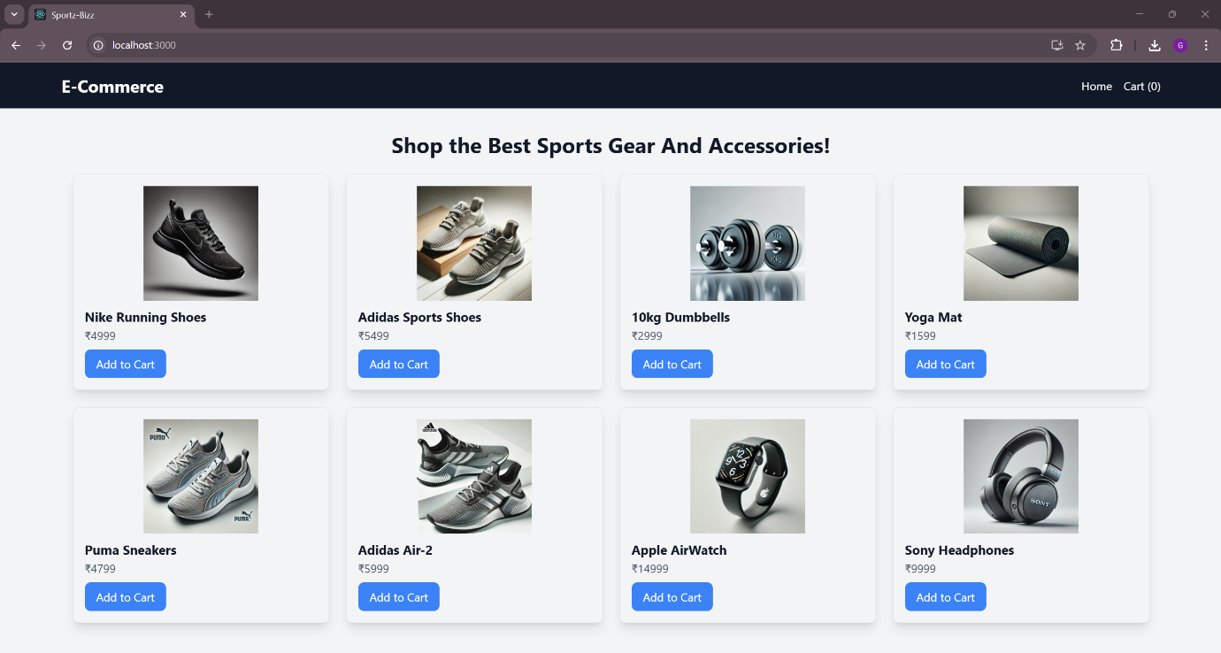

**2. Adding Products To Cart**

In here we are adding the products to our cart which can be either single or multiple items.

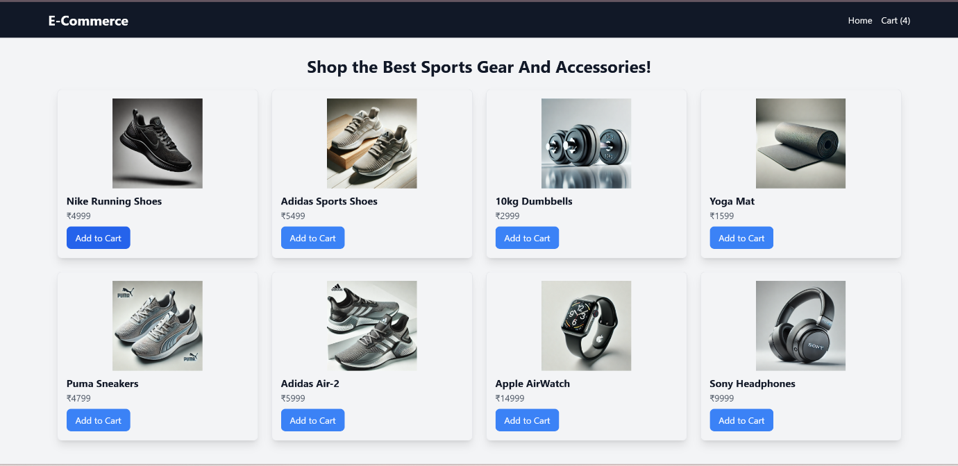

**3. Cart Page**

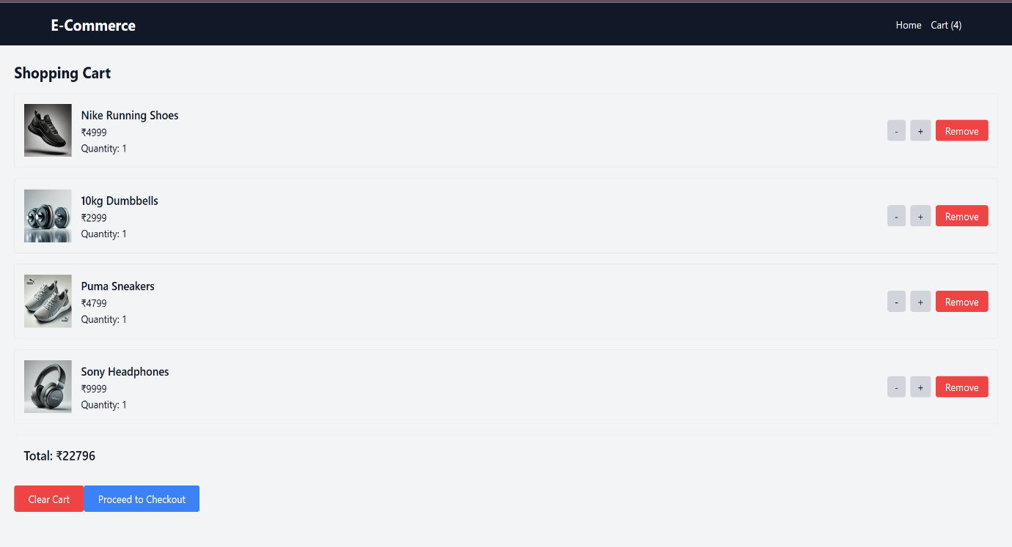In the Cart page we can see the items that we have added to the cart and the total amount of the products . Also in the Cart page we can increase ,decrease and remove the number of quantity or clear the entire cart too.

**Increasing Quantity:**

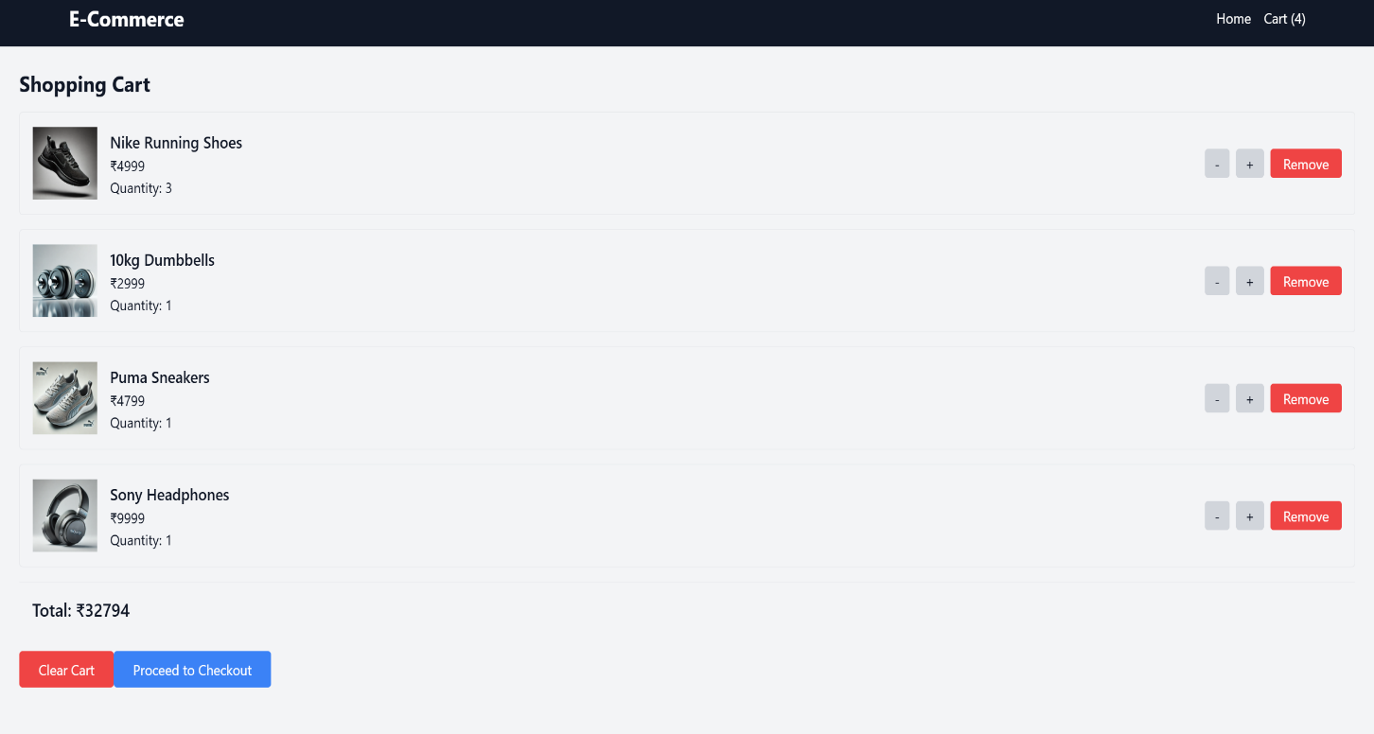

**Clearing Cart:**

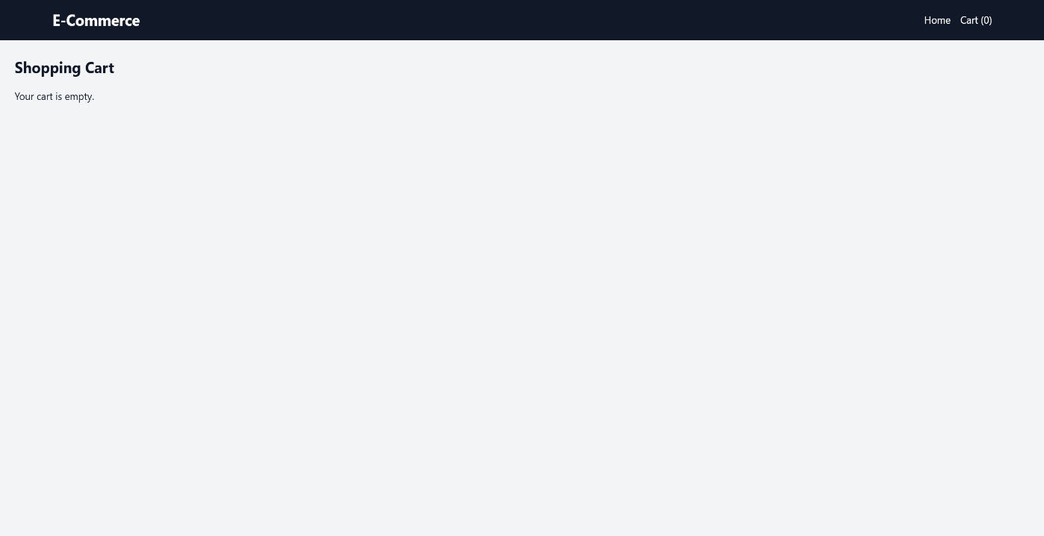

**4. Checkout**

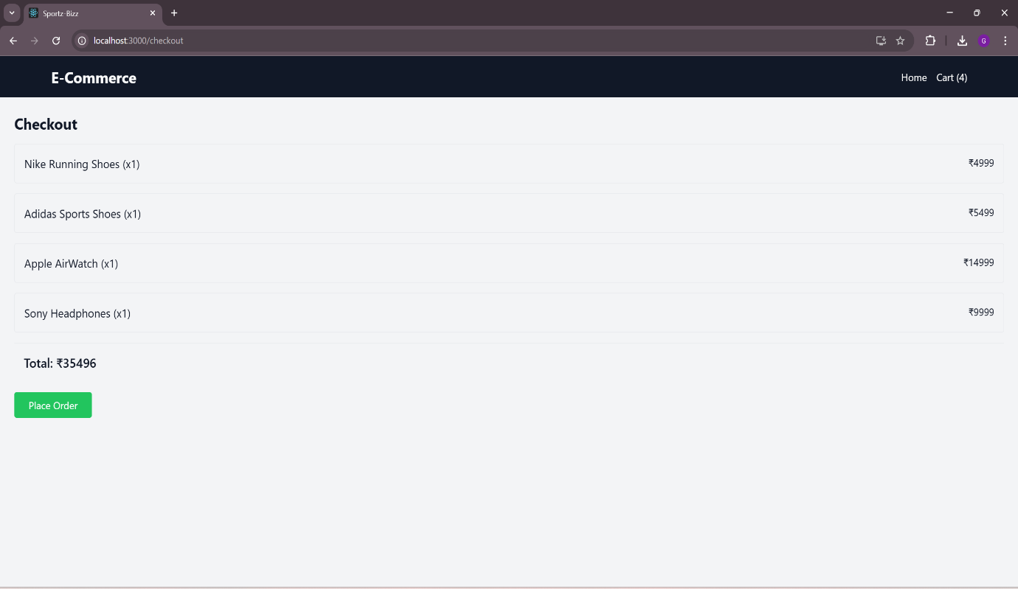This page contains information about the products that we have added to cart and proceeding to checkout where we can review the information and place the order.

**5. Placing Order**

After checking the products in the checkout page we can now proceed to place the order. After placing the order , a prompt showing order placed successfully will be shown.

