7COM1079-0901-2025 - Team Research and Development Project

Final report title: Comparison of Early and Late 2021 COVID-19 Vaccination Rates in U.S. States

Group ID: Group A 209

Dataset number: DS317

Prepared by: Gurunath Kumithi - 24161025
Shalini Solium – 24152576
Sravani Mandalam – 25006236
Kusuma Ummadipoli – 24177473
Arafath Shaik - 24158234

University of Hertfordshire
Hatfield, 2025
Contents

1 Introduction 1
1.1 Problem statement and research motivation 1
1.2 The data set 1
1.3 Research question 1
1.4 Null hypothesis and alternative hypothesis (H0/H1) 1
2 Background Research 1
2.1 Related Work 1
2.2 Why Research Question is of interest 2
3 Visualization 2
3.1 Appropriate graphs 2
3.2 Additional Information Connected with the Understanding of Data 3
3.3 Useful Information for Data Understanding 4
4 Analysis 5
4.1 Statistical test used 5
4.2 Null hypothesis rejected / not rejected 5
5 Evaluation 5
5.1 What went well 5
5.2 Points for improvement 5
5.3 Group’s time management 5
5.4 Project’s overall judgement 5
5.5 Note Any Changes to the Group 5
5.6 Comment on the GitHub Log Output 6
6 Conclusions 6
6.1 Interpreting Results 6
6.2 Interpretation of the results 6
6.3 Future work / limitations 6
7 References 7
8 Appendices 8
8.1 Appendix – A 8
8.2 Appendix – B 21

Introduction

Problem statement and research motivation
It is necessary to analyze the change in vaccination activity during the COVID-19 pandemic to determine the strategies aimed at addressing the problem of increasing people's awareness of their health. The rapid deployment of vaccines took place in early 2021 in the United States, and in later 2021 as a result of behavioral, logistical and policy factors, the uptake declined. According to the previous studies, the availability, the trust of the population, and the eligibility conditions determine the trends of vaccination (Davis et al., 2021). The study of variations in the daily level of vaccination assists in determining when and why the public health campaigns are successful or lag behind. The paper adds further weight by comparing the initial and subsequent 2021 vaccination activity based on real-world aggregated data.

The data set
The dataset consists of the daily rate of vaccination of all the states of the U.S at the time of December 2020-May 2023. It includes the variables such as number of vaccinations per day, number of vaccinations per population, rate of vaccination adjusted to population and number of booster doses. Only observations on 2021 were taken into account in this project. A derived variable, daily_vax, was derived using daily vaccinations (or daily vaccinations/million where available). In order to improve reliability, the dataset was cleaned up by removing missing data, and outliers at the 99 th percentile.

Research question
Do U.S. states administer significantly more daily COVID-19 vaccinations in early 2021 compared with late 2021?
This question assesses whether vaccination rollout intensity differed between the early and later phases of the national campaign and whether the difference is statistically significant.

Null hypothesis and alternative hypothesis (H0/H1)
The research hypothesis was whether there was a difference in median level of daily vaccination in early and late 2021. The null and the alternative hypotheses were; there was no difference and there was a difference, respectively. The skewness of both distributions was very large; therefore, the Wilcoxon rank-sum test was used to compare the two periods. The level of significance taken was 0.05 to indicate whether the differences that are observed are of any significance.

Background Research

Related Work
The latest researches give complementary information about the COVID-19 spread and immunization. Surveying interventions that have been introduced to the world to enhance the vaccine uptake, Andreas et al. (2022) discover that communication strategies are the most prevalent, and massive disparities in low-income settings and access-oriented interventions. Malinzi et al. (2023) use an SEIRV model in South Africa to show that vaccines, NPIs, and high vaccine coverage positively influence the decrease in the number of infections and deaths, which proves that a combination of interventions is necessary. The most predictive and reliable predictor of vaccine uptake in Hong Kong is the lack of vaccine confidence (Yuan et al., 2024), yet at various pandemic phases, demographic variables and preventive behaviors reversed. Karaivanov et al. (2022) demonstrate that the incidence of proof-of-vaccination requirement was significantly more effective and efficient in Canada and Europe compared to incentives and nudges. That is why it is necessary to consider the behavioral reaction of the population to the epidemic, as shown by Juga and Nyabadza (2025), which is interacting with fear and social distancing to obtain the final result of the epidemic, that is, in addition to pharmaceuticals.

Why Research Question is of interest
It is also applicable, as the literature review points to general trends, but in many cases, there are no specific statistical tests of early and late phases of the vaccination campaign. The observed differences in the daily activities of vaccination have not been experimentally proven to be statistically significant at scale across all states, creating a research gap. The comprehension of this disparity assists in measuring the timeliness of the policy, people obedience, and successful implementation. It also gives them a clue on how to implement mass vaccination in the future because governments will learn to predict the behavioral and logistical issues ahead of time.

Visualization

Appropriate graphs
The primary visualization was the boxplot since it was easy to compare the distribution of the daily vaccinations in Early2021 and Late2021 and observe the difference in the medians, spread, and outliers. Histograms of each of the periods and all the data of 2021 were added to determine the level of normality and the type of test that fits best.
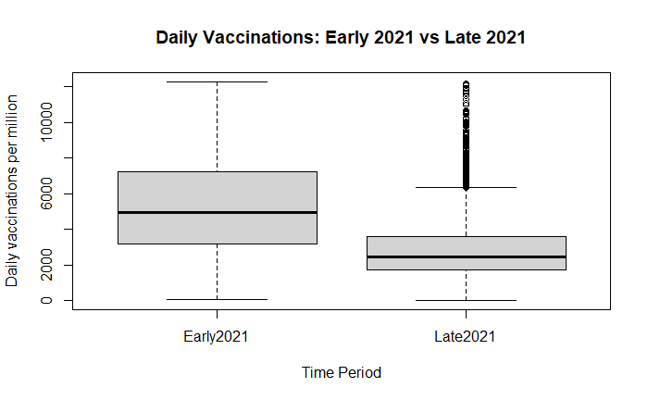

Additional Information Connected with the Understanding of Data
According to the histograms, the data of vaccination in both periods are highly skewed to the right with many smaller counts of the daily vaccinations and the number of data counts of very large values gradually reduces. This non-normality is conducive to an assumption of Wilcoxon rank-sum test. The Early2021 histogram is more dispersed and more of a peak that indicates more intensity of the activity of vaccination.

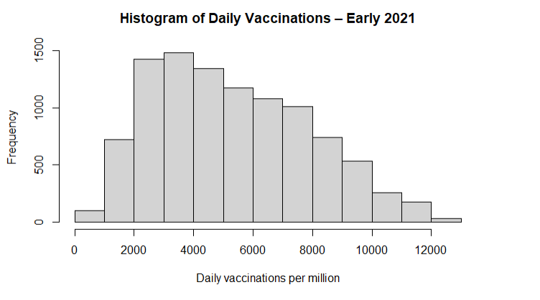
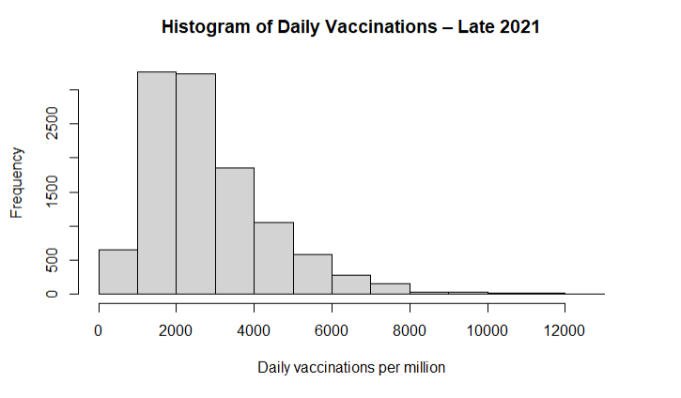
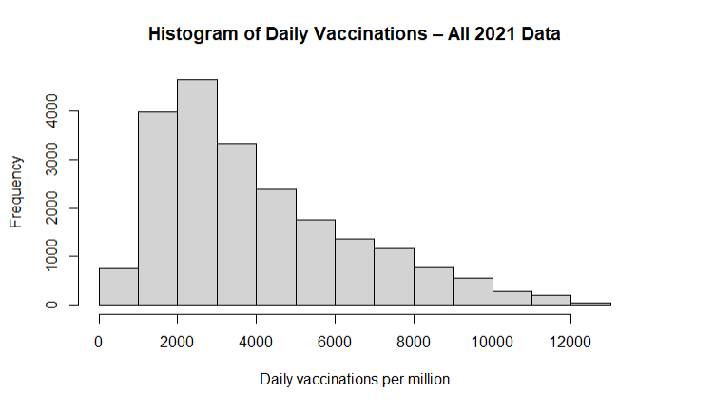

Useful Information for Data Understanding
The boxplot indicates that the median of Early2021 is much higher and has more variability than Late2021. The outliers in both groups are many as there are occasional spikes in the vaccinations but Early2021 clearly outperforms Late2021 throughout the distribution. These visual trends are consistent with the numbers, demonstrating a definite downward trend in the rates of vaccination on a daily basis.

Analysis

Statistical test used
The histograms revealed that the skewness was large on the right and consequently t-test was not applied but Wilcoxon rank-sum test. It is also non-parametric as compared to the medians and it does not presuppose the data to have a normal distribution. The hypothesis testing through the Wilcoxon involved the t -test, which was calculated as the means of comparing too. Group size: Early2021 =11061 data, Late2021 =11875 data.

Null hypothesis rejected / not rejected
The Wilcoxon test produced W = 89351556 and p = less than 2.2e-16 which is far much lower than alpha of 0.05. The null hypothesis is, therefore, not accepted. It demonstrates that the statistical significance of the changes in the number of vaccinations per day in the first and last two weeks of 2021 is statistically significant. It registered a higher median (median = 4963) in the beginning of 2021 than in the end of 2021 (median = 2455). The average values also verify this trend (Early = 5311.824; Late = 2832.744). The data confirms the hypothesis that the vaccination process was more significant in the first half of the year 2021.

Evaluation

What went well
In our group, there was effective teamwork because there was tasks division in terms of coding, research and documenting. Within a short time, we managed to agree on a research question and to clean and analyses a big real-world dataset. Communication was explicit and we utilized the feedbacks constructively to propose our analysis endowed with clarity. There were also smooth integrations of RStudio and GitHub.

Points for improvement
We could improve by starting earlier on the literature review and dedicating more time to interpreting statistical outputs. Additionally, better scheduling could reduce periods where some members had more workload than others. More frequent GitHub commits would also show clearer development progress.

Group’s time management
Managing time was typically high but weekly progress meetings would have helped ensure improved workflow. The majority of duties was done within time.

Project’s overall judgement
We addressed the research question, came up with reproducible R code, and created a clear comparison-of-means study; therefore, the project was successful.

Note Any Changes to the Group
There were no major changes to the group structure after the initial allocation. All members remained active throughout the project and contributed to different parts of the dataset analysis, R coding, and report writing. One update involved ensuring everyone had the correct GitHub access so all contributions were recorded properly in the repository. Aside from this administrative adjustment, the group composition stayed the same, and all members participated consistently in the development process.

Comment on the GitHub Log Output
The GitHub log output, included in Appendix B, shows steady contributions from all members, with commits covering data import, cleaning, descriptive statistics, visualisation, and hypothesis testing. The commit history reflects clear progression and collaborative development. Three of the most important commits from the project are listed below:
- Commit Message: “Add data import, cleaning, and creation of period variable for early vs late 2021”
Impact: Established the foundation of the analysis by preparing the dataset and creating the grouping variable central to the research question.

- Commit Message: “Add descriptive statistics: calculate mean and median daily vaccinations by period”
Impact: Provided essential early insights that guided interpretation and justified further hypothesis testing.

- Commit Message: “Add t-test and Wilcoxon test to compare daily vaccinations between Early and Late 2021”
Impact: Introduced the main statistical procedure used in the final analysis and generated the core evidence supporting the project’s conclusions.

Conclusions

Interpreting Results
The percentage of daily operation of vaccination in early 2021 and late 2021 was significantly different. By the start of 2021, there were many more vaccinations performed per day, having been an initial surge of the rollout. The prices at the end of 2021 are substantially lower because of the decline in the popularity of demand and most of the population has been vaccinated.

Interpretation of the results
The shift in medians demonstrates the actual shift in the vaccination behavior as in 2021. This is consistent with previous studies of fast initial adoption and slow adoption subsequently. The findings will assist the policymakers in continuing with a rollout in its latter stages.

Future work / limitations
The differences between states or the demographic variables (age, population density, or vaccine hesitancy) would be the focus of future studies. A lack of data, the delay in reporting, and the state-level instead of individual-level data related to vaccination will be some of the limitations.

References
Andreas, M., Iannizzi, C., Bohndorf, E., Monsef, I., Piechotta, V., Meerpohl, J. J., & Skoetz, N. (2022). Interventions to increase COVID-19 vaccine uptake: a scoping review. In Cochrane Database of Systematic Reviews (Vol. 2022, Issue 8). John Wiley and Sons Ltd. https://doi.org/10.1002/14651858.CD015270
Juga, M., & Nyabadza, F. (2025). On the dynamics of a COVID-19 model with vaccination and social processes. Scientific Reports, 15(1), 40751. https://doi.org/10.1038/s41598-025-24606-3
Karaivanov, A., Kim, D., Lu, S. E., & Shigeoka, H. (2022). COVID-19 vaccination mandates and vaccine uptake. Nature Human Behaviour, 6(12), 1615–1624. https://doi.org/10.1038/s41562-022-01363-1
Malinzi, J., Juma, V. O., Madubueze, C. E., Mwaonanji, J., Nkem, G. N., Mwakilama, E., Mupedza, T. V., Chiteri, V. N., Bakare, E. A., Moyo, I. L. Z., Campillo-Funollet, E., Nyabadza, F., & Madzvamuse, A. (2023). COVID-19 transmission dynamics and the impact of vaccination: modelling, analysis and simulations. Royal Society Open Science, 10(7). https://doi.org/10.1098/rsos.221656
Yuan, J., Xu, Y., Wong, I. O. L., Lam, W. W. T., Ni, M. Y., Cowling, B. J., & Liao, Q. (2024). Dynamic predictors of COVID-19 vaccination uptake and their interconnections over two years in Hong Kong. Nature Communications, 15(1). https://doi.org/10.1038/s41467-023-44650-9

Appendices

Appendix – A

```{r}
###############
# 1. Setup
###############

# Load libraries
library(readr)
```

```{r}
###############
# 2. Read in data
###############

vacc_data <- read_csv("us_state_vaccinations.csv")

# Have a quick look at the structure of the dataset
names(vacc_data)
summary(vacc_data)

# For convenience, work with a shorter name
df <- vacc_data
```

```{r}
###############
# 3. Choose the numeric variable for comparison
###############
# Different versions of this dataset have slightly different columns.
# We will try to pick daily_vaccinations_per_million if it exists.
# If not, we will fall back to daily_vaccinations.

if ("daily_vaccinations_per_million" %in% names(df)) {
df$daily_vax <- df$daily_vaccinations_per_million
vax_label <- "Daily vaccinations per million"
} else if ("daily_vaccinations" %in% names(df)) {
df$daily_vax <- df$daily_vaccinations
vax_label <- "Daily vaccinations"
} else {
stop("No suitable daily vaccination column found.
Look at names(df) and change the script to use the correct column.")
}

```

```{r}
###############
# 4. Create the grouping variable: early vs late 2021
###############
# Convert date column to Date type (if not already)
# Note: if the date column has a different name, change "date" below.
if (!"date" %in% names(df)) {
stop("No 'date' column found. Check names(df) and update the script.")
}

df$date <- as.Date(df$date)

# Keep only rows from 2021 (to avoid later years messing things up)
df_2021 <- subset(df, format(date, "%Y") == "2021")

# Create a period variable:
# Early2021 = Jan–Jun 2021
# Late2021 = Jul–Dec 2021
df_2021$period <- ifelse(df_2021$date <= as.Date("2021-06-30"),
"Early2021", "Late2021")

# Check how many rows in each group
table(df_2021$period)
```

```{r}
###############
# 5. Clean the data (remove missing and extreme values)
###############

# Remove rows where daily_vax is NA or <= 0
df_2021_clean <- subset(df_2021, !is.na(daily_vax) & daily_vax > 0)

# Remove very extreme outliers (top 1%) to make the distribution more sensible
upper_cutoff <- quantile(df_2021_clean$daily_vax, 0.99, na.rm = TRUE)
df_2021_clean <- subset(df_2021_clean, daily_vax <= upper_cutoff)

summary(df_2021_clean$daily_vax)
table(df_2021_clean$period)

```

```{r}
###############
# 6. Descriptive statistics
###############

# Means by group
aggregate(daily_vax ~ period, df_2021_clean, mean)

# Medians by group
aggregate(daily_vax ~ period, df_2021_clean, median)

```

```{r}
###############
# 7. Check normality with histogram
###############

# Histogram for Early2021
hist(df_2021_clean$daily_vax[df_2021_clean$period == "Early2021"],
main = "Histogram of Daily Vaccinations – Early 2021",
xlab = vax_label)

# Histogram for Late2021
hist(df_2021_clean$daily_vax[df_2021_clean$period == "Late2021"],
main = "Histogram of Daily Vaccinations – Late 2021",
xlab = vax_label)

# Optional: combined basic check of distribution
hist(df_2021_clean$daily_vax,
main = "Histogram of Daily Vaccinations – All 2021 Data",
xlab = vax_label)
```
```{r}

###############
# 8. Comparison of means
###############
# We will run both tests:
# - t.test (for "normal" data)
# - wilcox.test (for non-normal data)
# Then you decide which is more appropriate based on histograms.

# t-test (parametric)
t_test_result <- t.test(daily_vax ~ period, data = df_2021_clean)
t_test_result

# Wilcoxon rank-sum test (non-parametric)
wilcox_result <- wilcox.test(daily_vax ~ period, data = df_2021_clean)
wilcox_result
```
```{r}
###############
# 9. Boxplot for visual comparison
###############

boxplot(daily_vax ~ period,
data = df_2021_clean,
xlab = "Time Period",
ylab = vax_label,
main = "Daily Vaccinations: Early 2021 vs Late 2021")
```

R version 4.4.2 (2024-10-31 ucrt) -- "Pile of Leaves"
Copyright (C) 2024 The R Foundation for Statistical Computing
Platform: x86_64-w64-mingw32/x64

R is free software and comes with ABSOLUTELY NO WARRANTY.
You are welcome to redistribute it under certain conditions.
Type 'license()' or 'licence()' for distribution details.

Natural language support but running in an English locale

R is a collaborative project with many contributors.
Type 'contributors()' for more information and
'citation()' on how to cite R or R packages in publications.

Type 'demo()' for some demos, 'help()' for on-line help, or
'help.start()' for an HTML browser interface to help.
Type 'q()' to quit R.

> ###############
> # 1. Setup
> ###############
>
> # Load libraries
> library(readr)
> ###############
> # 2. Read in data
> ###############
>
> vacc_data <- read_csv("us_state_vaccinations.csv")
Rows: 54628 Columns: 16── Column specification ──────────────────────────────────────────────────────────────────────────────────────────────────────────────────────────────────────────────────────────────────────────────────────────
Delimiter: ","
chr (1): location
dbl (14): total_vaccinations, total_distributed, people_vaccinated, people_fully_vaccinated_per_hundred, total_vaccinations_per_hundred, people_fully_vaccinated, people_vaccinated_per_hundred, distributed_...
date (1): date
ℹ Use `spec()` to retrieve the full column specification for this data.
ℹ Specify the column types or set `show_col_types = FALSE` to quiet this message.
>
> # Have a quick look at the structure of the dataset
> names(vacc_data)
[1] "date" "location" "total_vaccinations" "total_distributed" "people_vaccinated"
[6] "people_fully_vaccinated_per_hundred" "total_vaccinations_per_hundred" "people_fully_vaccinated" "people_vaccinated_per_hundred" "distributed_per_hundred"
[11] "daily_vaccinations_raw" "daily_vaccinations" "daily_vaccinations_per_million" "share_doses_used" "total_boosters"
[16] "total_boosters_per_hundred"
> summary(vacc_data)
date location total_vaccinations total_distributed people_vaccinated people_fully_vaccinated_per_hundred total_vaccinations_per_hundred people_fully_vaccinated
Min. :2020-12-20 Length:54628 Min. : 416 Min. : 6000 Min. : 401 Min. : 0.00 Min. : 0.17 Min. : 1
1st Qu.:2021-08-09 Class :character 1st Qu.: 927731 1st Qu.: 1188560 1st Qu.: 504310 1st Qu.:34.24 1st Qu.: 75.02 1st Qu.: 372328
Median :2022-03-10 Mode :character Median : 3199256 Median : 4051065 Median : 1730820 Median :52.28 Median :116.72 Median : 1349818
Mean :2022-03-10 Mean : 11851991 Mean : 14988322 Mean : 5909278 Mean :47.33 Mean :114.72 Mean : 4891624
3rd Qu.:2022-10-09 3rd Qu.: 7948546 3rd Qu.: 10064899 3rd Qu.: 4023565 3rd Qu.:62.48 3rd Qu.:154.39 3rd Qu.: 3396357
Max. :2023-05-10 Max. :676728782 Max. :984444295 Max. :270227181 Max. :91.26 Max. :302.85 Max. :230637348
NA's :22096 NA's :22356 NA's :22360 NA's :23977 NA's :23878 NA's :22440
people_vaccinated_per_hundred distributed_per_hundred daily_vaccinations_raw daily_vaccinations daily_vaccinations_per_million share_doses_used total_boosters total_boosters_per_hundred
Min. : 0.24 Min. : 6.14 Min. : 0 Min. : 0 Min. : 0 Min. :0.043 Min. : 11 Min. : 0.00
1st Qu.: 42.59 1st Qu.: 95.63 1st Qu.: 1075 1st Qu.: 1036 1st Qu.: 627 1st Qu.:0.742 1st Qu.: 145342 1st Qu.: 10.29
Median : 60.60 Median :141.33 Median : 6846 Median : 4253 Median : 1498 Median :0.797 Median : 605864 Median : 24.78
Mean : 56.57 Mean :144.74 Mean : 37388 Mean : 25118 Mean : 2355 Mean :0.789 Mean : 2581003 Mean : 25.51
3rd Qu.: 72.41 3rd Qu.:196.39 3rd Qu.: 22088 3rd Qu.: 13895 3rd Qu.: 3172 3rd Qu.:0.852 3rd Qu.: 1799718 3rd Qu.: 36.80
Max. :118.55 Max. :414.90 Max. :4629928 Max. :3384387 Max. :27652 Max. :1.276 Max. :192964188 Max. :104.04
NA's :23902 NA's :23898 NA's :26274 NA's :65 NA's :2912 NA's :22356 NA's :36512 NA's :37374
>
> # For convenience, work with a shorter name
> df <- vacc_data
> ###############
> # 3. Choose the numeric variable for comparison
> ###############
> # Different versions of this dataset have slightly different columns.
> # We will try to pick daily_vaccinations_per_million if it exists.
> # If not, we will fall back to daily_vaccinations.
>
> if ("daily_vaccinations_per_million" %in% names(df)) {
+ df$daily_vax <- df$daily_vaccinations_per_million
+ vax_label <- "Daily vaccinations per million"
+ } else if ("daily_vaccinations" %in% names(df)) {
+ df$daily_vax <- df$daily_vaccinations
+ vax_label <- "Daily vaccinations"
+ } else {
+ stop("No suitable daily vaccination column found.
+ Look at names(df) and change the script to use the correct column.")
+ }
>
> ###############
> # 4. Create the grouping variable: early vs late 2021
> ###############
> # Convert date column to Date type (if not already)
> # Note: if the date column has a different name, change "date" below.
> if (!"date" %in% names(df)) {
+ stop("No 'date' column found. Check names(df) and update the script.")
+ }
>
>
> df$date <- as.Date(df$date)
>
> # Keep only rows from 2021 (to avoid later years messing things up)
> df_2021 <- subset(df, format(date, "%Y") == "2021")
>
> # Create a period variable:
> # Early2021 = Jan–Jun 2021
> # Late2021 = Jul–Dec 2021
> df_2021$period <- ifelse(df_2021$date <= as.Date("2021-06-30"),
+ "Early2021", "Late2021")
>
> # Check how many rows in each group
> table(df_2021$period)

Early2021 Late2021
11061 11875
> ###############
> # 5. Clean the data (remove missing and extreme values)
> ###############
>
> # Remove rows where daily_vax is NA or <= 0
> df_2021_clean <- subset(df_2021, !is.na(daily_vax) & daily_vax > 0)
>
> # Remove very extreme outliers (top 1%) to make the distribution more sensible
> upper_cutoff <- quantile(df_2021_clean$daily_vax, 0.99, na.rm = TRUE)
> df_2021_clean <- subset(df_2021_clean, daily_vax <= upper_cutoff)
>
> summary(df_2021_clean$daily_vax)
Min. 1st Qu. Median Mean 3rd Qu. Max.
18 2114 3311 4008 5447 12286
> table(df_2021_clean$period)

Early2021 Late2021
10079 11185
>
> ###############
> # 6. Descriptive statistics
> ###############
>
> # Means by group
> aggregate(daily_vax ~ period, df_2021_clean, mean)
>
> # Medians by group
> aggregate(daily_vax ~ period, df_2021_clean, median)
>
> ###############
> # 7. Check normality with histogram
> ###############
>
> # Histogram for Early2021
> hist(df_2021_clean$daily_vax[df_2021_clean$period == "Early2021"],
+ main = "Histogram of Daily Vaccinations – Early 2021",
+ xlab = vax_label)
>
> # Histogram for Late2021
> hist(df_2021_clean$daily_vax[df_2021_clean$period == "Late2021"],
+ main = "Histogram of Daily Vaccinations – Late 2021",
+ xlab = vax_label)
>
> # Optional: combined basic check of distribution
> hist(df_2021_clean$daily_vax,
+ main = "Histogram of Daily Vaccinations – All 2021 Data",
+ xlab = vax_label)
>
> ###############
> # 8. Comparison of means
> ###############
> # We will run both tests:
> # - t.test (for "normal" data)
> # - wilcox.test (for non-normal data)
> # Then you decide which is more appropriate based on histograms.
>
> # t-test (parametric)
> t_test_result <- t.test(daily_vax ~ period, data = df_2021_clean)
> t_test_result

Welch Two Sample t-test

data: daily_vax by period
t = 82.426, df = 16550, p-value < 2.2e-16
alternative hypothesis: true difference in means between group Early2021 and group Late2021 is not equal to 0
95 percent confidence interval:
2420.127 2538.033
sample estimates:
mean in group Early2021 mean in group Late2021
5311.824 2832.744

>
> # Wilcoxon rank-sum test (non-parametric)
> wilcox_result <- wilcox.test(daily_vax ~ period, data = df_2021_clean)
> wilcox_result

Wilcoxon rank sum test with continuity correction

data: daily_vax by period
W = 89351556, p-value < 2.2e-16
alternative hypothesis: true location shift is not equal to 0

> ###############
> # 9. Boxplot for visual comparison
> ###############
>
> boxplot(daily_vax ~ period,
+ data = df_2021_clean,
+ xlab = "Time Period",
+ ylab = vax_label,
+ main = "Daily Vaccinations: Early 2021 vs Late 2021")
>
>
>

Appendix B – GitHub Log
Repository: github.com/Gurunath-Kumithi/TeamResearch
Branch: main
Commit Hash | Author | Date | Commit Message
21a634f | Gurunath-Kumithi | 2025-12-08 | Updated report document with completed Sections 5.6 and full GitHub Log Output (Appendix B)
4ba4b23 | kusuma7316 | 2025-12-08 | Add boxplot to visually compare daily vaccinations between Early and Late 2021
1ee7b0a | Sravani-mandalam | 2025-12-07 | Add t-test and Wilcoxon test to compare daily vaccinations between Early and Late 2021
214de84 | Shalini3233 | 2025-12-07 | Add histograms to check distribution of daily vaccinations for Early vs Late 2021
45e4503 | Arafath584 | 2025-12-07 | Add descriptive statistics: calculate mean and median daily vaccinations by period
9847df3 | Gurunath-Kumithi | 2025-12-07 | Add data import, cleaning, and creation of period variable for early vs late 2021
6387ffd | Gurunath-Kumithi | 2025-12-07 | Delete code.Rmd
9006a32 | Gurunath-Kumithi | 2025-12-07 | Initial upload of R code and report draft
e467372 | Gurunath-Kumithi | 2025-12-07 | Added raw dataset: us state vaccinations.csv for analysis

