PRACTICAL-2

**Aim : Commands**

1. **Create User**

**Ans :-**

db.createUser({ user: "guru", pwd: "guru007", roles:[{role: "userAdminAnyDatabase" , db:"admin"}] })

**Output**:



1. **Create Database**

**Ans :-**

use emp

**Output :-**

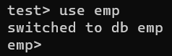

1. **Create Collection**

**Ans :-**

db.createCollection("emp")

**Output :-**

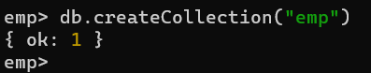

1. **Insert Data into Database**

**Ans :-**

db.emp.insert({"empid":1,"empname":"martin"})

**Output :-**

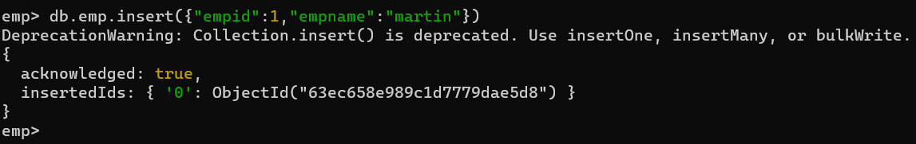

db.emp.insert({"empid":2,"empname":"neha","age":23})

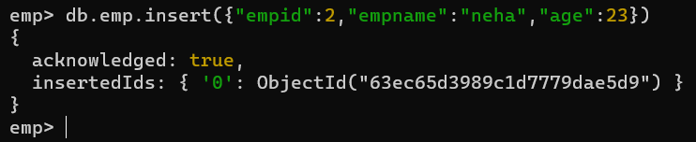

var myemp=[{"empid":3,"empname":"smith"},{"empid":4,"empname":"John"}]

db.emp.insert(myemp)

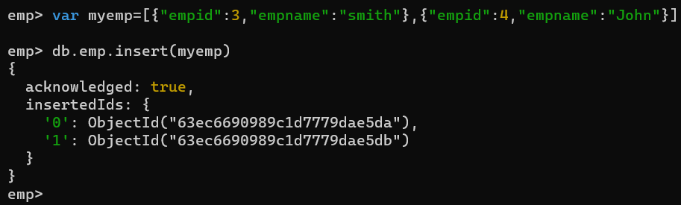

db.emp.find().pretty()

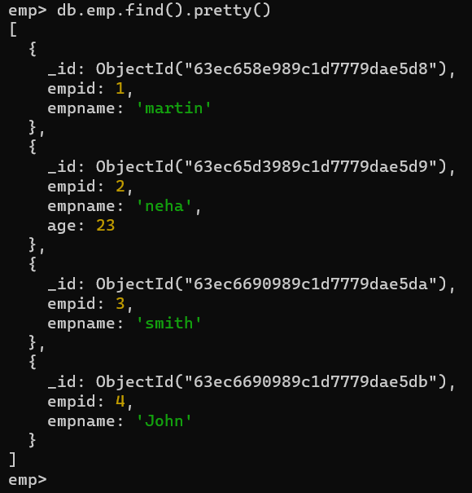

1. **Update and Delete Data**

**Ans :-**

db.emp.update({"empid":1},{$set:{"empname":"xyz"}})

**Output :-**

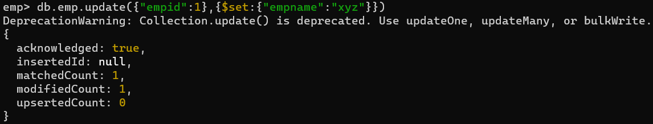

db.emp.update({"empid":1},{$set:{age:40}})

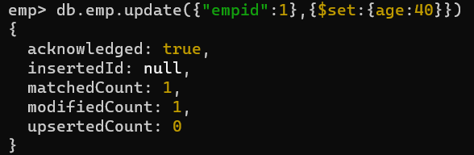

db.emp.find({"empid":1}).pretty()

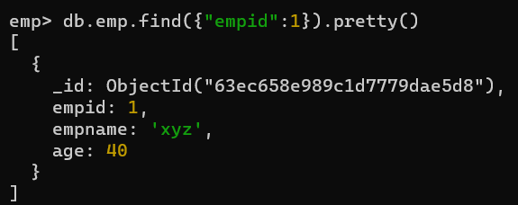

* **Remove Particular Field :-**

**Ans :-**

db.emp.update({"empid":1},{$unset:{age:40}})

**Output :-**

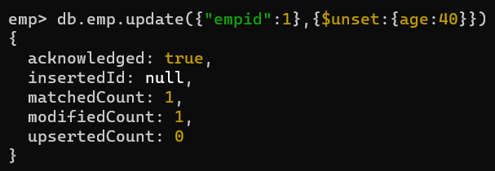

* **Update value of age by 5 :**

**Ans :-**

db.emp.update({"empid":1},{$inc:{age:5}})

**Output :-**

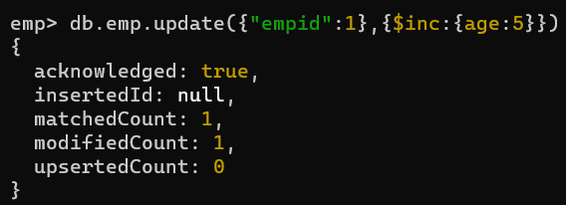

* **Removing whole Document :-**

**Ans :-**

db.emp.remove({empid:2})

**Output :-**



* **If no document matching with particular condition exists, then if we set upsert “true”, then initially it will also create it :-**

**Ans :-**

db.emp.update({empid:3},{empid:5,empname:"heena"},{upset:true});

**Output :-**



* **Renaming any particular field :-**

**Ans :-**

db.emp.update({empid:4},{$rename:{"empname":"nameemp"}});

**Output :-**

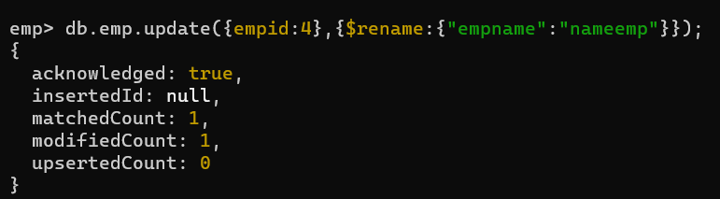

1. **Retrival of Data**

db.emp.find().forEach(printjson)

**Output :-**

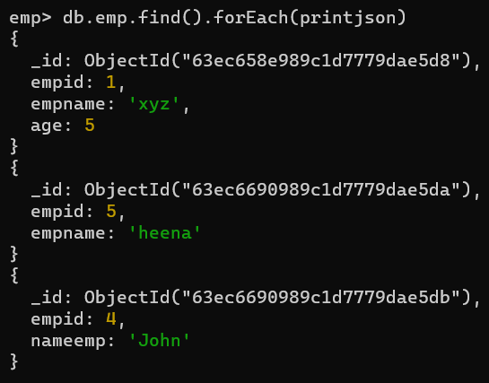

db.emp.find().pretty()

Output :-

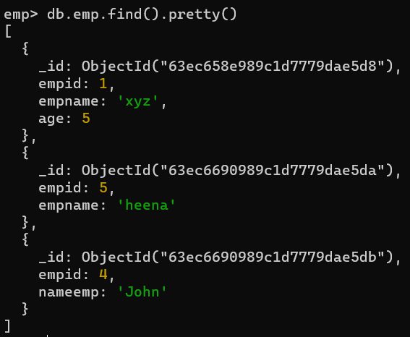

db.emp.find({})

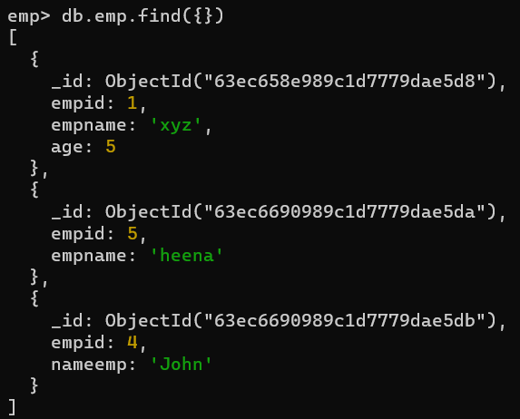

db.emp.find({empname:"xyz"}).forEach(printjson)

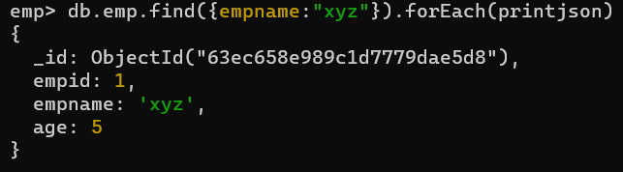

db.emp.find({empid:{$gt:2}})

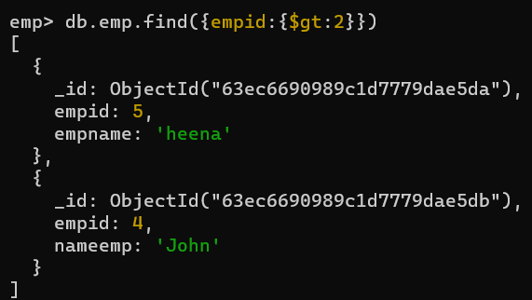

var myemp=db.emp.find({empid:{$gt:2}})

while(myemp.hasNext()){

... print(tojson(myemp.next()));

... }

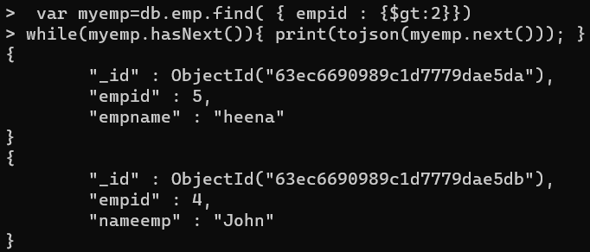

1. **Display Database**

**Ans :-**

show dbs

**Output :-**

