Practical – 2 : Basic Python Programming

1) Write a python program to print “Welcome to UVPCE”.

# CODE :-

*print(21012011074)*

*print("Welcome to UVPCE")*

# OUTPUT :-

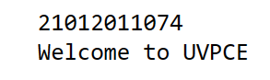

2) Write a python program which takes student information such as Name, Enrollment Number, Branch, Age, Email and Mobile number from user and print as following:

“=======================

====”

Your Name

Your Enrollment No.

Branch: CE/IT

Age:XX years Email:your mail ID Mobile No: your No.

“=======================

====”

# CODE :-

*print(21012011074)*

*name=input("Your Name:")*

*Enroll=int(input("Your Enrollment No."))*

*Branch=input("Branch CE/IT:")*

*Age=int(input("Enter your age:"))*

*Email=input("Enter your Email:")*

*Mob=int(input("Enter your Mobile_No:"))*

*print("\n-----------------------------\n-----------------------------")*

*print("Your Name:",name)*

*print("Your Enrollment No:",Enroll)*

*print("Your Branch:",Branch)*

*print ("Your age:",Age)*

*print ("Your Email:",Email)*

*print ("Your Mobile_No:",Mob)*

*print("-----------------------------\n-----------------------------")*

OUTPUT :-

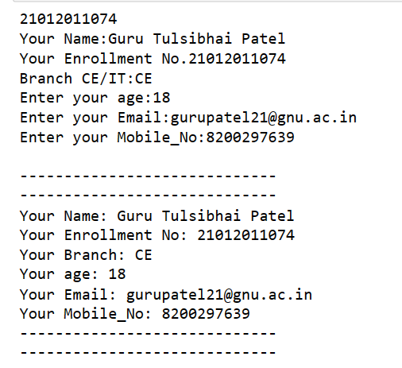

3) Write python programs to evaluate the following expressions to demonstrate the use of operator precedence and associativity.

12 + 3 - 4 / 2 < 3 + 1

X = (10 * 2) % 2 << 4

# CODE :-

*print(21012011074)*

*print(12 + 3 - 4 / 2 < 3 + 1)*

*x= (10 * 2) % 2 << 4*

*print(x)*

OUTPUT:

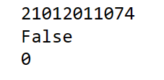

4) Write a python program to display data types of different variables.

# CODE :-

*print(21012011074)*

*a = 1*

*b = True*

*c = "Harry"*

*d = complex(8, 2)*

*e = 3.14*

*f=[1,3.3,5+6]*

*g={1,2.2,3+4}*

*h={1:'guru',2:'patel'}*

*i = ("Geeks", "for", "Geeks")*

*print("The type of a is ", type(a))*

*print("The type of b is ", type(b))*

*print("The type of c is ", type(c))*

*print("The type of d is ", type(d))*

*print("The type of e is ", type(e))*

*print("The type of f is ", type(f))*

*print("The type of g is ", type(g))*

*print("The type of h is ", type(h))*

*print("The type of i is ", type(i))*

# OUTPUT :-

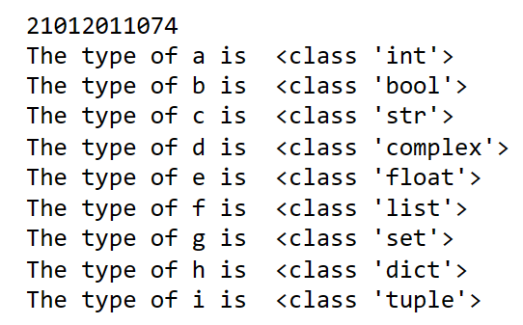

5) Write a python program to check given character is a vowel or not.

# CODE :-

|  |
| --- |
| *print(21012011074)*  *a=input("Enter a character:")*  *if (a=='A' or a=='E' or a=='I' or a=='O' or a=='U' or a=='a' or a=='e' or a=='i' or a=='o' or a=='u') :*  *print("It's a Vowel")*  *else:*  *print("It's a Consonant")* |

OUTPUT:

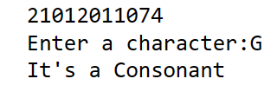

6) Write a python program to for library charges a fine for books returned late. Following are the fines:

First five days: 40 paisa per day. Six to ten day: 65 paisa per day.

Above ten days: 80 paisa per day

# CODE :-

|  |
| --- |
| *print(21012011074)*  *print('''-----Late Submission Charge-----*  *First five days: 40 paisa per day.*  *Six to ten day: 65 paisa per day.*  *Above ten days: 80 paisa per day*  *--------------------------------''')*  *x=int(input("Enter the day of submission:"))*  *y=x-31*  *if(y>0 and y<=5 and x>31):*  *print("Your are",y,"days Late")*  *print("As per Guidelines Your total charge is:",40*y,"paisa")*    *elif(y>5 and y<=10 and x>31):*  *print("Your are",y,"days Late")*  *print("As per Guidelines Your total charge is:",65*y,"paisa")*    *elif(y>10 and x>31):*  *print("Your are",y,"days Late")*  *print("As per Guidelines Your total charge is:",80*y,"paisa")*  *else:*  *print("Your are under timeline So you don't have to pay any charges")* |

# OUTPUT :-

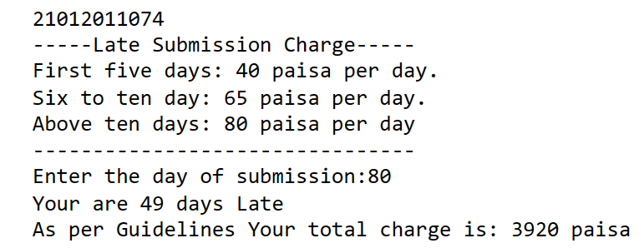

7) Write a python program to count odd numbers from given three numbers and display maximum odd number.

CODE :-

|  |
| --- |
| *print(21012011074)*  *x=[2,63,9,69,98,200,49,78,79,11]*  *count=0*  *max=x[0]*  *for i in range(10):*  *if(x[i]%2!=0):*  *count=count+1*  *if(max<x[i]):*  *max=x[i]*  *print("No of odd numbers :",count)*  *print("Maximum Number :",max)* |

OUTPUT:

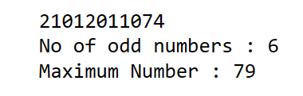

8) Enter the following statements into the interpreter and note which ones produce an error, give reason for error:

1. str1 = “welcome” print (str1*2)

# CODE :-

*print*('21012011074')

str1 = "welcome"

print (str1*2)

# OUTPUT :-

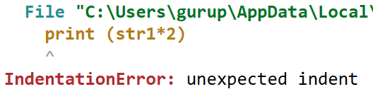

2. 15 % 12

CODE :-

*print*('2101201 1074') *print*(15%12)

# OUTPUT :-



3. print (18.0 // 4)

# CODE :-

*print*('21012011074')

*print*(18.0 // 4)

OUTPUT:

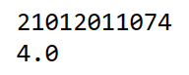

4. 7<=7

# CODE :-

*print*('21012011074')

*print*(7 <= 7)

OUTPUT:

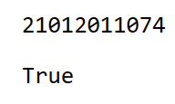

5. -1<>-1.0

# CODE :-

*print*('21012011074') *print*(-1 <> -1.0)

# OUTPUT :-

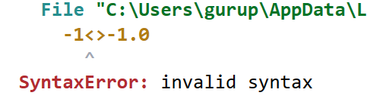

6. -5 is -5.0

# CODE :-

*print*('21012011074') *print*(-5 *is* -5.0)

OUTPUT:

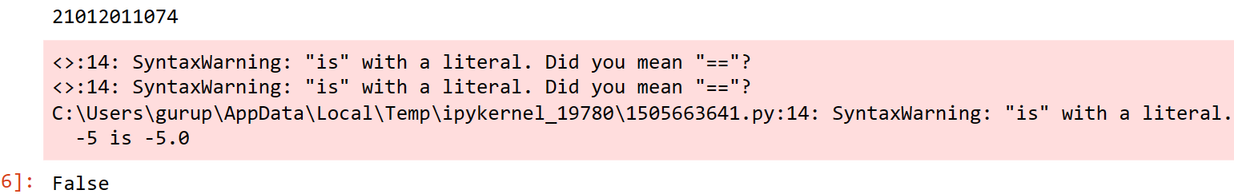

7. print( ‘Steve's “ Laptop”’)

# CODE :-

*print*(21012011074)

*print*('Steve's "Laptop"')

OUTPUT:

