**Practical-3: Iterative Statements and Strings**

1. Write a program to check if number is Armstrong.

**CODE:**

print(21012011074)

n=int(input("enter the number:"))

temp=n

x=len(str(n))

sum=0

while(n>0):

y=n%10

sum+=y**x

n=n//10

if temp==sum:

print("it's armstrong")

else:

print("it's not armstrong")

**OUTPUT:**

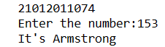

1. WRITE A PROGRAM TO CHECK SPECIAL NUMBER. (NUMBER IS EQUAL TO THE SUM OF ITS DIVISORS).

CODE:

print(21012011074)

n=int(input("Enter the number: "))

sum=0

for i in range(1,n):

if n%i==0:

sum+=i

if sum==n:

print(n,"is special")

else:

print(n,"is not special")

OUTPUT:

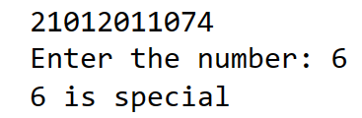

1. WRITE CREATE A PROGRAM THAT WILL PRINT OUT WORDS THAT START WITH 'S' FROM THE BELOW GIVEN STATEMENT.

CODE:

print(21012011074)

st='Print only the words that start with s in this sentence'

res=[]

for s in st.split():

if s[0] == 's':

res.append(s)

print(res)

OUTPUT:

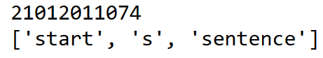

1. WRITE A PROGRAM TO GIVE OUTPUT OF ENTERED NUMBER MULTIPLICATION TABLE.

CODE:

print(21012011074)

n=int(input("Enter the number: "))

for i in range(1,11):

print(n,' * ',i,' = ',n*i)

OUTPUT:

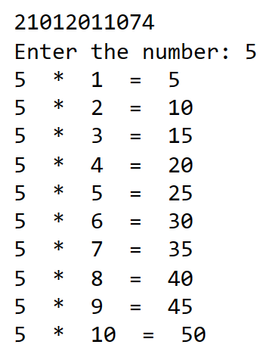

1. WRITE A PROGRAM TO FIND THE SUM OF DIGIT OF AN INPUT NUMBER USING WHILE LOOP.

CODE:

print(21012011074)

n=int(input("Enter the number: "))

sum=0

while(n!=0):

sum+=n%10

n=n//10

print("Sum of digits = ",sum)

OUTPUT:

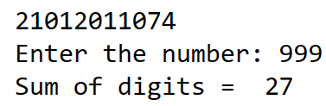

1. GO TO STRING BELOW AND IF THE LENGTH OF A WORD IS EVEN PRINT "EVEN!".

CODE:

print(21012011074)

str='I love doing python programming in spyder'

def even(str):

str = str.split()

for a in str:

if len(a)%2 == 0:

a += ' = even!'

print (a)

even(str)

OUTPUT:

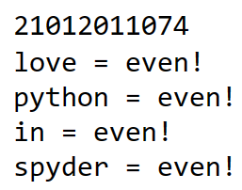

1. WRITE A PROGRAM TO CALCULATE FREQUENCY OF DIGIT, UPPER CASE CHARACTER AND LOWER CASE CHARACTER FROM THE STRING.

CODE:

print(21012011074)

count1=0

count2=0

count3=0

st='I Love Doing Python Programming In Spyder 8200297639'

for i in st:

if i.isupper():

count1+=1

elif i.islower():

count2+=1

elif i.isdigit():

count3+=1

print("Number of digits :",count3)

print("Number of lowercase :",count2)

print("Number of uppercase :",count1)

OUTPUT:

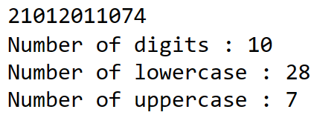

1. WRITE A PYTHON PROGRAM TO CHECK IF A STRING IS A PALINDROME OR NOT.

CODE:

print(21012011074)

st=input("Enter the string :")

rev="".join(reversed(st))

if(rev==st):

print("It's palindrome")

else:

print("It's not palindrome")

OUTPUT:

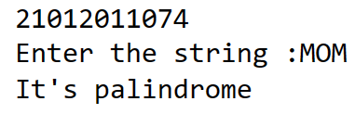

1. WRITE A PYTHON PROGRAM TO REMOVE I’TH CHARACTER FROM STRING.

CODE:

print(21012011074)

st='I love doing python programming in spyder'

n=int(input("Enter the index :"))

str=" "

for i in range(len(st)):

if i!=n:

str+=st[i]

print(str)

OUTPUT:

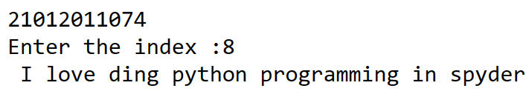

1. WRITE A PYTHON PROGRAM TO CHECK IF THE SUBSTRING IS PRESENT IN A GIVEN STRING.

CODE:

print(21012011074)

st='I love doing python programming in spyder'

sstr=(input("Enter the substring :"))

def string_check(st,sstr):

if(st.find(sstr)==-1):

print(sstr,"is not present")

else:

print(sstr,"is present")

string_check(st,sstr)

OUTPUT:

