 

**SMART TROLLEY WITH AUTOMATED BILLING SYSTEM USING ARDUINO**

**A PROJECT REPORT**

*Submitted by*

|  |  |
| --- | --- |
| **GURU PRAKASH V** | **(1920103704)** |
| **PRASANTH P** | **(1920103712)** |

*in partial fulfilment for the award of the degree*

*of*

**BACHELOR OF ENGINEERING**

in

**ELECTRONICS AND COMMUNICATION ENGINEERING**

**SONA COLLEGE OF TECHNOLOGY, SALEM 636 005**

**(AUTONOMOUS)**

**ANNA UNIVERSITY: CHENNAI 600 025**

**MAY 2024**

 

**SMART TROLLEY WITH AUTOMATED BILLING SYSTEM USING ARDUINO**

**A PROJECT REPORT**

*Submitted by*

|  |  |
| --- | --- |
| **GURU PRAKASH V** | **(1920103704)** |
| **PRASANTH P** | **(1920103712)** |

*in partial fulfilment for the award of the degree*

*of*

**BACHELOR OF ENGINEERING**

in

**ELECTRONICS AND COMMUNICATION ENGINEERING**

**SONA COLLEGE OF TECHNOLOGY, SALEM 636 005**

**(AUTONOMOUS)**

**MAY 2024**

**SONA COLLEGE OF TECHNOLOGY, SALEM (AUTONOMOUS)**

**BONAFIDE CERTIFICATE**

Certified that this project report titled **“SMART TROLLEY WITH AUTOMATED BILLING SYSTEM USING ARDUINO”** is the bonafide work of “**GURU PRAKASH V (1920103704),PRASANTH P (1920103712)**” who carried out the work under my supervision.

|  |  |
| --- | --- |
| **SIGNATURE** | **SIGNATURE** |
| **Dr. R.S. SABEENIAN, M.E., Ph.D.** | **Prof.****M.SUSARITHA M.E., Ph.D.** |
| Professor  **HEAD OF THE DEPARTMENT** | Assistant Professor  **SUPERVISOR** |
| Department of ECE, | Department of ECE, |
| Sona College of Technology,  Salem - 636005 | Sona College of Technology,  Salem – 636 005 |

Submitted for the Project Viva-Voce examination held on

Internal Examiner External Examiner

**ACKNOWLEDGEMENT**

Our heartfelt thanks to the esteemed management of Sona College of Technology, especially our Chairman **Shri C.VALLIAPPA**, Vice Chairmen **Shri.CHOCKO VALLIAPPA**, and **Shri.THYAGU VALLIAPPA**, for their provision of the essential resources and facilities that empowered us to excel in our project.

Our sincere appreciation goes to our principal,**Dr.S.R.R.SENTHIL KUMAR**, for his invaluable guidance and for allowing us the time and space to work on our project diligently. We are truly grateful for his unwavering support throughout.

We would also like to express our gratitude to our Head of the Department, **Dr.R.S.SABEENIAN**, for his constructive suggestions and constant encouragement, which played a pivotal role in shaping our project.

A special mention goes to our project guide, **Prof.** **M.SUSARITHA,** whose guidance and mentorship have been instrumental in our success. Their expertise and encouragement have been invaluable assets throughout this journey.

We also extend our sincere thanks to **Prof.P.VIVEK KARTHICK**, the Project Coordinator for Electronics and Communication Engineering, for their unwavering support and assistance throughout the project.

We cannot forget to express our gratitude to the entire teaching and non-teaching staff of the Department of Electronics and Communication Engineering at Sona College of Technology for their support and cooperation.

Last but not least, we take this opportunity to extend our deep appreciation to our parents, our family, and friends for all that they meant to us during the crucial times of the completion of the project.

Guru Prakash V

Prasanth P

**ABSTRACT**

Our innovative Smart trolley system, in tandem with our feature-rich smartphone app, reimagines the shopping landscape within malls, presenting a multitude of invaluable benefits.

Firstly, effortless navigation becomes the hallmark of our solution, where shoppers effortlessly traverse the mall terrain, guided intuitively to their desired products with the aid of our app's aisle guidance feature.

Secondly, our system facilitates swift product selection, empowering customers to promptly identify and add essentials to their virtual cart through the seamless integration of RFID technology and barcode scanning. This eradicates the cumbersome manual entry process and saves precious time for shoppers.

Furthermore, we introduce a convenient payment process, revolutionizing the traditional checkout experience by centralizing billing through RFID technology. Customers can now conclude their transactions with ease, sidestepping the arduous checkout lines and benefiting from reduced wait times and heightened convenience.

Moreover, our automated Product Identification System (PID) stands as a beacon of error reduction, meticulously tracking scanned items and updating the virtual cart in real-time.

Our smartphone app serves as a personalized shopping companion, offering tailored assistance such as product search and personalized recommendations. This bespoke guidance enriches the overall shopping experience, catering to the diverse preferences and needs of individual shoppers.

By streamlining the entire shopping process from selection to payment, our solution not only enhances efficiency for both shoppers and mall operators but also modernizes the shopping experience. Through the seamless integration of technology, we set a new standard for convenience, efficiency, and enjoyment, aligning with the evolving expectations of tech-savvy consumers and fostering heightened satisfaction and loyalty.

In summary, our smart trolley system and smartphone app constitute a holistic solution to the challenges encountered within traditional malls, ushering in a new era of shopping characterized by innovation, convenience, and personalization.

Our smart trolley system represents a holistic solution to the challenges encountered in traditional malls, integrating innovative hardware and software to redefine the shopping journey.

**TABLE OF CONTENTS**

|  |  |  |
| --- | --- | --- |
| **CHAPTER**  **NO** | **TITLE** | **PAGE NO** |

**ABSTRACT v**

**LIST OF FIGURES ix**

**LIST OF ABBREVIATIONS x**

1. **INTRODUCTION 11**
2. **EXISTING SYSTEM 13**
3. **RELATED WORKS 15**

3.1 Amazon Go

3.2 Smart Shopping Carts and Trolleys

3.3 Retail Mobile Applications

3.4 Self-Checkout Kiosks

3.5 IoT and RFID in Retail

3.6 Academic Exploration

1. **LITEREATURE SURVEY 23**
2. **PROPOSED WORK 27**

5.1 Smart Shopping Trolley

5.2 RFID Integration

5.3 Automated Billing

5.4 Price Calculation

5.5 Convenience

5.6 Efficiency

* 1. Error Reduction
  2. Integration with Payment Methods
  3. Security

1. **MODULES DESCRIPTION 50**

6.1 LCD(Liquid Crystal Display)

6.2 RFID (Radio-Frequency Identification)

6.3 ARDUINO UNO

6.4 GSM (Global System for Mobile Communications)

6.5 (220V AC to 12V AC) Transformer

1. **EXPERIMENT 58**

7.1 FLOW CHART

7.2 BLOCK DIAGRAM

7.2.1 Radio-Frequency Identification

7.2.2 GSM

7.3 SYSTEM REQUIREMENTS

7.3.1 HARDWARE REQUIREMENTS

7.3.2 SOFTWARE REQUIREMENTS

1. **RESULTS AND DISCUSSIONS 65**
2. **CONCLUSION 68**

9.1FUTURE SCOPE

**REFERENCES 70**

**PUBLICATION DETAILS 73**

**ANNEXURE 74**

**LIST OF FIGURES**

|  |  |  |
| --- | --- | --- |
| **FIGURE NO.** | **TITLE** | **PAGE NO.** |
| **3.1.1** | Amazon Go Product | 16 |
| **3.4.2** | Self-Checkout Kiosks | 20 |
| **5.2.3** | RFID Integration | 32 |
| **5.8.4** | Payment Gateway Integration | 47 |
| **6.1.5** | LCD Display | 50 |
| **6.2.6** | EM-18 Reader Module | 51 |
| **6.2.7** | Radio Frequency Identification | 52 |
| **6.3.8** | Arduino UNO | 53 |
| **6.4.9**  **6.5.10**  **7.1.11**  **7.2.12**  **8.13**  **8.14**  **8.15** | Global System for Mobile Communication  (220V AC to 12V AC) Transformer  Flow Chart  Block Diagram  Output Implementation  Hardware Connections  Final Output | 56  57  59  62  66  67  67 |

**LIST OF ABBREVIATIONS**

|  |  |
| --- | --- |
| **RFID** | Radio-Frequency Identification |
| **QR** | Quick Response |
| **POS** | Point of Sale |
| **GSM** | Global System for Mobile Communication |
| **LCD** | Liquid Crystal Display |
| **IDE** | Integrated Development Environment |
| **SMS** | Short Message Service |
| **SIM** | Subscriber Identity Module |
| **USB** | Universal Serial Port |
| **DC** | Direct Current |
| **PCB** | Printed Circuit Board |
| **UNO** | Universal Networking Objects |

**CHAPTER-1**

**INTRODUCTION**

Throughout the annals of human history, innovation has been an ever-evolving force, adapting to our shifting needs. Among our daily routines, shopping holds a significant place, serving not only as a means to procure essentials but also as an opportunity for physical activity and social interaction. While traditional shopping primarily takes place in physical stores such as malls, it often presents challenges for both retailers and consumers alike.

One common hurdle faced by shoppers is the lack of readily available information about discounts and promotions, leading to missed opportunities for savings. Additionally, the checkout process in traditional stores can be cumbersome, with customers experiencing delays and long queues at the counters. Recognizing these inefficiencies, grocery stores and supermarkets have long utilized shopping trolleys to assist customers in selecting and organizing their purchases. However, the conventional checkout process remains a bottleneck, contributing to frustration and time wastage.

According to a survey conducted by the US Department of Commerce, the average person spends approximately 1.4 hours daily on shopping activities. However, if checkout lines become excessively long, many consumers may opt to abandon their purchases altogether, impacting retailers' bottom line. Shopping experiences can broadly be categorized into two types: individual shopping, where customers physically visit stores to make selections based on various factors such as necessity, convenience, and brand preference, and shopping in absentia, facilitated by online shopping and e-commerce platforms, eliminating the need for physical presence in stores altogether.

To address these challenges and streamline the shopping experience, an innovative solution has been proposed: the introduction of smart shopping baskets. These cutting-edge baskets are designed to simplify the shopping process, reducing time spent in stores and enhancing convenience for shoppers. Continuous improvement is crucial to elevate the overall shopping experience and reduce the time spent in stores.

One proposed solution involves the implementation of barcode labels on both the contents of the shopping cart and a corresponding reader. Customers can input relevant data, such as item prices and total costs, into the system, streamlining the checkout process and reducing the manual labor required in traditional malls. This design not only saves time but also enhances the efficiency of the shopping experience while providing valuable insights into customers' purchase history.

As we navigate the evolving landscape of retail, embracing innovative solutions such as smart shopping baskets is paramount to meeting the changing needs and expectations of consumers. By leveraging technology to enhance efficiency and convenience, retailers can create a more seamless shopping experience that fosters customer satisfaction and loyalty.

**CHAPTER-2**

**EXISTING SYSTEM**

The integration of a smart trolley with an automated billing system, facilitated by RFID technology, presents an innovative solution to enhance the efficiency of the current shopping process. Within the existing system, customers often encounter challenges such as limited information about discounted items and lengthy checkout procedures. However, by incorporating RFID technology into shopping trolleys, we have the opportunity to revolutionize the shopping experience.

With this integrated solution, customers can seamlessly pass their items equipped with RFID tags over a scanner integrated into the trolley. This technology not only grants instant access to comprehensive product information, including pricing and promotions, but also streamlines the checkout process. As customers navigate the store, their selected items and respective prices are automatically added to a virtual cart. When they are prepared to finalize their purchases, they can conveniently review the items displayed on a screen, make necessary adjustments, and proceed to a designated, expedited checkout lane.

The advantages of this innovative approach are manifold. It significantly reduces the time spent waiting in queues, thereby enhancing the convenience and efficiency of the shopping experience. Furthermore, it diminishes the likelihood of customers abandoning their purchases due to long lines, as they can swiftly review and pay for their items. Additionally, this automated billing system holds promise in assisting retailers to maintain more accurate inventory records and gather valuable insights into customer preferences and buying behaviors, thereby enabling them to optimize their product offerings and operational strategies.

The integration of a smart trolley with an automated billing system featuring RFID technology represents a forward-thinking initiative to refine the existing shopping system. Not only does it elevate the customer experience by simplifying the shopping process, but it also provides significant benefits to retailers in terms of data acquisition and inventory management. This innovation holds immense potential to shape the future of shopping by mitigating complexity and enhancing overall efficiency.

The integration of a smart trolley with an automated billing system, leveraging RFID technology, stands at the forefront of modern retail innovation. By seamlessly incorporating these elements into the shopping experience, we can address longstanding challenges faced by both customers and retailers alike. This forward-thinking approach not only streamlines the checkout process and enhances convenience for shoppers but also empowers retailers with valuable data insights to optimize their operations. As we embrace this transformative technology, we pave the way for a future of shopping that is characterized by efficiency, seamlessness, and enhanced customer satisfaction.

**CHAPTER-3**

**RELATED WORKS**

The concept of enhancing the shopping experience through the integration of smart shopping trolleys equipped with RFID technology for automated billing has captured significant attention. Below, we present a comprehensive overview of related endeavors and ideas that have explored this innovative approach.

In recent years, there has been a growing emphasis on improving the efficiency and convenience of shopping experiences through technological advancements. The incorporation of RFID technology into shopping trolleys represents a notable step forward in this regard. By outfitting trolleys with this technology, customers can seamlessly pass items equipped with RFID tags over a scanner as they shop, streamlining the checkout process.

Various initiatives have explored the potential of smart shopping trolleys with RFID scanners. Retailers have experimented with prototypes featuring advanced scanning capabilities and integrated billing systems, aiming to simplify the entire shopping process while providing real-time access to product information and promotions.

Research and development efforts have also focused on refining the user interface and functionality of smart trolleys to ensure optimal usability and customer satisfaction. Innovations such as touchscreen displays, voice-activated commands, and personalized recommendation features have been explored to further elevate the shopping experience.

**3.1 Amazon Go:**

Amazon Go stores have revolutionized the retail experience with their innovative approach to cashier-less shopping. Utilizing the Amazon Go app, customers gain entry to the store and proceed to select items without the need for conventional checkout. Inside the store, a network of sensors and cameras tracks the items customers pick up and place in their shopping bags or carts. This sophisticated technology enables a seamless and frictionless shopping experience.

As customers exit the store, they don't need to stop at a cashier or self-checkout station. Instead, the Amazon Go app automatically charges them for the items they've taken, based on the items detected by the store's monitoring system. This automated billing process eliminates the need for physical payment transactions and significantly reduces the time spent in-store.

The convenience and efficiency of Amazon Go's cashier-less model have garnered significant attention and acclaim. Customers appreciate the seamless shopping experience, free from waiting in line or dealing with cashiers. Meanwhile, Amazon benefits from streamlined operations and enhanced customer satisfaction. The success of Amazon Go has inspired other retailers to explore similar cashier-less concepts, signaling a shift in the retail landscape towards more technologically driven and customer-centric experiences.

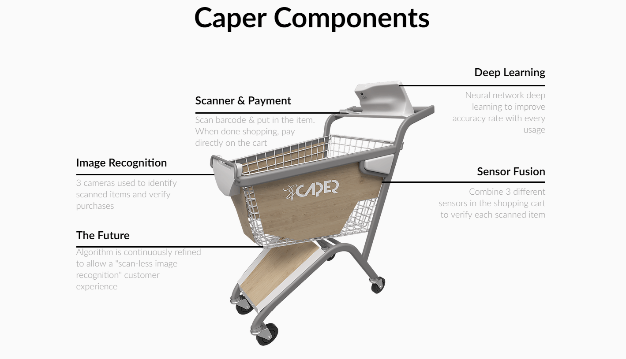

**Fig 3.1.1 Amazon Go Product**

**3.2 Smart Shopping Carts and Trolleys:**

Numerous companies have unveiled smart shopping carts and trolleys integrated with barcode scanners and Internet of Things (IoT) capabilities. These innovative carts empower shoppers to scan items as they add them to their cart, facilitating a seamless and efficient shopping experience. The integration of barcode scanning technology allows for real-time tracking of selected items, ensuring an accurate and up-to-date tally of the total cost throughout the shopping journey.

Upon concluding their shopping excursion, customers have the convenience of making payments directly through the smart cart. This eliminates the need for traditional checkout lanes or self-service kiosks, streamlining the payment process and saving valuable time for both shoppers and retailers.

The advent of smart shopping carts and trolleys represents a significant advancement in retail technology, promising enhanced convenience and efficiency for consumers. By leveraging IoT capabilities and barcode scanning functionality, these smart carts offer a modernized approach to the shopping experience, aligning with the evolving preferences of tech-savvy shoppers.

Furthermore, the adoption of smart shopping carts holds potential benefits for retailers, including improved customer satisfaction and loyalty. The seamless integration of payment functionality into the cart itself reduces friction in the purchasing journey, fostering a positive shopping environment and encouraging repeat business.

Overall, the introduction of smart shopping carts and trolleys marks a transformative shift in the retail landscape, ushering in a new era of convenience, efficiency, and customer-centric innovation.

**3.3 Retail Mobile Applications:**

Numerous retailers provide mobile applications that empower customers to scan item barcodes while they shop. These apps function by creating a virtual shopping cart within the application, which keeps a continuous tally of scanned items as customers navigate the store. This innovative approach allows shoppers to effortlessly keep track of their purchases in real-time as they move through the aisles.

When customers are ready to complete their shopping journey, they have the option to conveniently make payments directly through the app. By leveraging this feature, customers can bypass the conventional checkout queues altogether, saving valuable time and enhancing the overall shopping experience.

The introduction of retail mobile applications represents a significant advancement in the realm of shopping convenience and efficiency. By harnessing the power of mobile technology and barcode scanning capabilities, retailers can offer their customers a seamless and streamlined shopping experience, aligning with the demands of modern consumers.

Moreover, these mobile applications provide retailers with opportunities to enhance customer engagement and loyalty. By offering features such as personalized recommendations, exclusive discounts, and seamless checkout experiences, retailers can foster stronger connections with their customer base and drive repeat business.

Overall, the availability of retail mobile applications signifies a paradigm shift in the retail landscape, highlighting the importance of leveraging digital tools to meet the evolving needs and preferences of today's consumers.

**3.4 Self-Checkout Kiosks:**

Self-checkout kiosks have become a ubiquitous feature in many supermarkets and retail stores. These kiosks offer customers the convenience of scanning item barcodes, bagging their purchases, and finalizing payments without the need for cashier assistance, thereby streamlining the checkout experience.

Found in numerous supermarkets and retail outlets, self-checkout kiosks have revolutionized the traditional shopping process. By empowering customers to take control of their transactions, these kiosks significantly reduce reliance on cashiers and mitigate long queues at traditional checkout lanes.

The widespread adoption of self-checkout kiosks underscores their effectiveness in enhancing operational efficiency and customer satisfaction. Customers appreciate the convenience of self-service transactions, which allow them to complete their purchases quickly and autonomously. Furthermore, retailers benefit from reduced labor costs and increased throughput, as self-checkout kiosks can process multiple transactions simultaneously.

Overall, self-checkout kiosks represent a paradigm shift in the retail industry, offering a seamless and efficient alternative to traditional checkout methods. As technology continues to evolve, self-checkout kiosks are likely to remain a staple feature in modern retail environments, catering to the preferences of tech-savvy consumers and driving continued innovation in the sector.

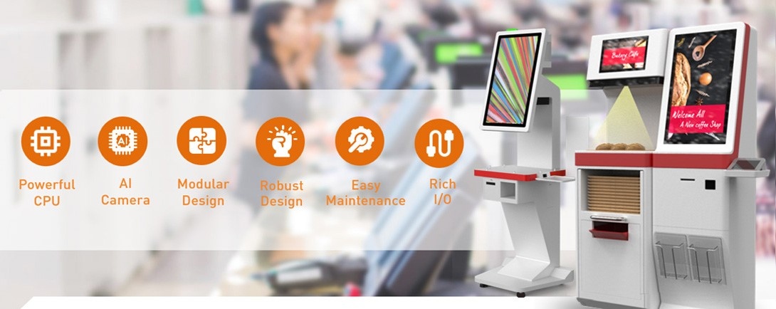

**Fig 3.4.2 Self-Checkout Kiosks**

**3.5 IoT and RFID in Retail:**

The convergence of the Internet of Things (IoT) and Radio-Frequency Identification (RFID) technology is revolutionizing retail operations, particularly in product tracking and checkout processes. By incorporating RFID tags on merchandise, retailers can seamlessly monitor inventory and expedite the checkout experience.

In this innovative approach, RFID tags embedded in products are automatically scanned as they are added to a shopping cart or pass through RFID sensors strategically placed throughout the store. This enables real-time tracking of items as they move through the retail environment, providing retailers with accurate inventory data and facilitating efficient restocking processes.

Moreover, the integration of IoT and RFID technology enables automated billing processes at checkout. As RFID-tagged items are scanned or detected by sensors, the corresponding information is relayed to the checkout system, where it is automatically tallied and processed for payment.

This eliminates the need for manual scanning or data entry, streamlining the checkout process and reducing wait times for customers.

Overall, the adoption of IoT and RFID in retail represents a significant advancement in operational efficiency and customer service. By leveraging these technologies, retailers can optimize inventory management, enhance the shopping experience, and stay ahead in today's competitive retail landscape.

**3.6 Academic Exploration:**

Academic scholars have delved into the realm of smart shopping trolleys and carts equipped with barcode scanning capabilities, aiming to refine the shopping journey, mitigate wait times, and improve billing accuracy. Their research endeavors represent a concerted effort to leverage technology strategically, fostering more streamlined and convenient shopping experiences for consumers.

The primary objective of these academic investigations is to automate the billing process through the integration of barcode scanners and other cutting-edge technological innovations. By harnessing the power of barcode scanning technology, researchers seek to enhance the efficiency of checkout processes, reduce the time spent waiting in queues, and ensure the precision of billing transactions.

Through their scholarly pursuits, researchers explore various initiatives and concepts designed to optimize the functionality of smart shopping trolleys and carts. These initiatives often involve the development of advanced scanning mechanisms and the implementation of real-time data processing systems. By seamlessly integrating these technological advancements into the shopping experience, researchers aim to empower consumers with greater convenience and retailers with improved operational efficiency.

Furthermore, academic investigations in this domain underscore the importance of user-centric design principles and usability testing. Researchers strive to create intuitive interfaces and seamless interactions that enhance user satisfaction and facilitate adoption among consumers. By prioritizing user experience in their research endeavors, scholars contribute to the ongoing evolution of smart shopping technologies, ultimately shaping the future of retail environments.

Academic exploration into smart shopping trolleys and carts with barcode scanning capabilities represents a significant advancement in the field of retail technology. By focusing on automating billing processes and enhancing the overall shopping experience, researchers aim to harness the potential of technology to create more efficient, convenient, and consumer-friendly retail environments.

**CHAPTER-4**

**LITEREATURE SURVEY**

In their study [1], Sangeetha and her team proposed an innovative concept aimed at reducing customer wait times, alleviating stress, optimizing store staffing, and enhancing overall efficiency in the retail sector. Their solution revolves around the introduction of a cutting-edge "shopping cart." As technology increasingly permeates our daily lives, the future of retail is becoming increasingly centered around automated devices.

Another study titled "Development of Sensor Controlled Convertible Cart-Trolley" by O.J. Oyejide et al. [2] introduces a unique trolley design. This innovative trolley incorporates three mechanisms, allowing it to transform into a cart when extended and into an incline cart with a flat plate when tilted. The steering and propulsion of the trolley are managed by two wiper motors, which are connected to the wheels and powered by 12V DC batteries. The cart's commands are executed by a wireless module, the ESP8266EX, acting as the microcontroller.

In a separate research endeavor by A.S. Gunawan et al. [4], an automatic moving trolley is introduced, leveraging an IOIO microcontroller and an Android smartphone for sensing and control. The Android smartphone communicates with the robot, sending signals to the IOIO microcontroller, which governs the trolley's actuator while simultaneously monitoring its surroundings through the smartphone's camera. This system is further enhanced with an indoor positioning feature utilizing Navisens, leveraging the smartphone's gyroscope and accelerometer for user positioning.

Furthermore, G. Sharmila et al. [3] conducted research on an RFID-Based Smart Cart system designed for automated billing and assistance to the visually impaired. This system incorporates a smart stick employing RFID technology to identify products for blind individuals.

When the stick is brought close to a product, its information is vocalized through a voice IC and speaker. Integrated into existing smart trolleys, the system comprises components such as an RFID Reader, microcontroller, voice IC, speaker, and battery. Upon activation, the RFID reader scans the RFID tag to acquire product details, which are then audibly relayed through the speaker.

Lastly, Udit Gangwal et al. [5] presented a novel approach to enhancing shopping carts by integrating self-billing through MIFARE tags and card readers. These systems primarily utilize technologies such as barcodes, QR codes, RFID tags, and smart cards.

The proposed system, leveraging MIFARE tag technology, addresses the issue of long wait times at billing queues by enabling real-time billing and invoice preparation within the shopping cart itself. MIFARE tags offer distinct advantages in terms of operating frequency, scan range, and tag versatility, as they come in various sizes and shapes, facilitating easy attachment to a wide range of products.

The rectangular boundary delineates the scope of the proposed system, encompassing anything occurring within its confines. Within this boundary, two key actors are involved: individuals engaged in violent activities and a nearby police station. The primary actors are those engaged in violent activities, as their actions are constantly monitored by a real-time system.

Use cases are depicted by oval shapes, representing actions that fulfill specific tasks within the system. Upon receiving real-time video input, the system's first objective is to detect humans. Once humans are detected, the designated use cases are executed, including Frame Extraction, Violence Detection, and Image Enhancement. Subsequently, the system triggers an alert to the nearby police station.

These academic explorations delve into various aspects of retail innovation, ranging from smart shopping carts and trolleys to automated billing systems and real-time surveillance technologies. By leveraging advanced technologies such as RFID, IoT, and MIFARE tags, researchers aim to revolutionize the retail experience, optimizing efficiency, convenience, and customer satisfaction.

These academic endeavors showcase a diverse array of approaches aimed at enhancing the retail experience through technological innovation. From the development of versatile trolley designs to the integration of automated billing systems and real-time surveillance technologies, researchers are pushing the boundaries of what is possible in modern retail environments.

By leveraging advancements in IoT, RFID, and MIFARE tag technology, these studies pave the way for more seamless, efficient, and customer-centric shopping experiences. Ultimately, the insights gained from these academic explorations have the potential to reshape the future of retail, offering retailers and consumers alike unprecedented levels of convenience, efficiency, and engagement.

Furthermore, these academic endeavors underscore the interdisciplinary nature of retail innovation, drawing upon expertise from fields such as engineering, computer science, and consumer behavior. By collaborating across disciplines, researchers are able to develop holistic solutions that address various aspects of the retail ecosystem, from product tracking and checkout processes to customer assistance and security. Through their collaborative efforts, these researchers contribute valuable insights and technologies that have the potential to revolutionize the retail industry, creating more seamless and immersive shopping experiences for consumers while optimizing operations and enhancing profitability for retailers.

The academic exploration of smart shopping carts, trolleys, and automated billing systems demonstrates a commitment to advancing retail technology. By integrating RFID, IoT, and MIFARE tag technology, researchers aim to optimize the shopping experience, streamline operations, and enhance customer satisfaction in the retail sector.

**CHAPTER-5**

**PROPOSED WORK**

The proposed works entail the creation of a sophisticated smart shopping trolley system, revolutionizing the traditional retail experience. Central to this innovation is the integration of an automated billing process facilitated by RFID technology, streamlining checkout procedures, and enhancing overall efficiency.

At its core, the smart shopping trolley system aims to simplify the shopping journey for consumers while optimizing operational processes for retailers. By equipping trolleys with advanced technology, such as RFID scanners, shoppers can effortlessly pass items equipped with RFID tags over the scanner as they browse through the store. This real-time scanning capability enables the creation of a virtual shopping cart, keeping track of selected items and their respective prices throughout the shopping trip.

The automated billing process represents a significant advancement in retail technology, eliminating the need for manual checkout procedures. As customers conclude their shopping, they can seamlessly proceed to the checkout area, where the smart trolley system automatically tallies the total cost based on the scanned items. This streamlined process reduces wait times at checkout counters, enhancing convenience for shoppers and optimizing resource allocation for retailers.

Moreover, the integration of automated billing into the smart shopping trolley system offers benefits beyond expedited checkout. It provides retailers with valuable insights into consumer purchasing behavior, enabling data-driven decision-making and targeted marketing strategies. Additionally, the system enhances inventory management by providing real-time updates on product availability and demand.

The development of a smart shopping trolley system with automated billing capabilities represents a significant step forward in modernizing the retail experience. By leveraging technology to streamline operations and enhance customer satisfaction, retailers can adapt to evolving consumer preferences and stay competitive in today's dynamic marketplace.

**5.1 Smart Shopping Trolley:**

In the context of the Smart Shopping Trolley described above, let's revise the section that originally mentioned barcode scanners and integrate RFID technology instead:

Central to the functionality of the smart trolley are its integrated technologies, meticulously curated to optimize every facet of the shopping journey. These technologies span a diverse spectrum, encompassing RFID readers, IoT connectivity, and advanced sensors, each playing a pivotal role in enhancing the overall shopping experience.

The incorporation of RFID readers into the smart trolley empowers consumers with unprecedented convenience and efficiency. As shoppers traverse the aisles, the trolley can effortlessly detect and catalog items equipped with RFID tags, providing real-time updates of the items in the virtual cart. This eliminates the need for manual scanning or data entry, streamlining the selection process significantly.

Complementing the RFID readers, IoT connectivity heralds a new era of interconnectedness and data-driven decision-making. Through IoT-enabled sensors and devices, the smart trolley can communicate with other in-store systems, facilitating real-time data exchange and actionable insights.

This interconnected ecosystem enables retailers to dynamically adjust pricing, promotions, and product placements based on evolving consumer preferences and market trends.

Beyond its functional capabilities, the smart trolley serves as a beacon of innovation and technological advancement within the retail landscape. Its sleek design and intuitive interface embody the convergence of form and function, inviting consumers to embrace the future of shopping with open arms.

By seamlessly blending into the retail environment, the smart trolley seamlessly integrates into the shopping journey, enhancing convenience, efficiency, and overall satisfaction.

Moreover, the smart trolley's adaptability and scalability position it as a versatile solution capable of evolving with the ever-changing needs of retailers and consumers alike. Whether deployed in traditional brick-and-mortar stores, grocery chains, or emerging e-commerce platforms, the smart trolley remains steadfast in its commitment to revolutionizing the retail experience.

The smart shopping trolley represents a paradigm shift in the retail landscape, embodying the intersection of consumer expectations and technological innovation. With its integrated suite of advanced technologies, the smart trolley transcends the boundaries of conventional shopping, ushering in a new era of convenience, efficiency, and engagement. As retailers continue to embrace digital transformation, the smart trolley stands poised to redefine the future of retail, one aisle at a time.

**5.2 RFID Integration:**

The integration of RFID technology into the trolley represents a pivotal enhancement, empowering customers with unprecedented convenience and efficiency throughout their shopping experience.

At the heart of this technological marvel lies RFID technology, meticulously embedded into the framework of the trolley to seamlessly interact with the products placed within its confines.

This innovative feature serves as a beacon of convenience, providing customers with a streamlined method of cataloging their selected items as they navigate the aisles of the store.

The functionality of RFID technology is elegantly simple yet profoundly impactful. As customers peruse the shelves and select their desired products, the RFID tags embedded within each item are automatically detected by the integrated RFID readers within the trolley.

This real-time detection capability ensures that each item is promptly added to the virtual cart, allowing customers to maintain a comprehensive tally of their selections throughout their shopping journey.

The significance of RFID technology extends far beyond its role as a mere data input device. In essence, it serves as a conduit for seamless communication between the physical and digital realms of the retail environment.

By leveraging the unique identifiers encoded within each RFID tag, the technology facilitates the accurate retrieval of product information, including pricing, descriptions, and inventory status.

Moreover, RFID technology represents a paradigm shift in the traditional checkout process, offering customers an alternative means of completing their purchases. With the ability to automatically detect items as they are placed in the trolley, customers are afforded the luxury of bypassing conventional checkout queues, thereby expediting the transaction process and minimizing wait times.

The integration of RFID technology into the trolley is a testament to the ongoing evolution of retail technology, as it seamlessly merges the physical and digital aspects of the shopping experience.

Its presence serves as a catalyst for efficiency and convenience, empowering customers to navigate the aisles with ease while simultaneously providing retailers with valuable insights into consumer behavior and product preferences.

Furthermore, RFID technology's versatility transcends the confines of the traditional retail environment, finding application in a myriad of settings and industries. From grocery stores and department stores to warehouses and logistics centers, RFID technology serves as an indispensable tool for inventory management, asset tracking, and supply chain optimization.

In conclusion, the integration of RFID technology into the trolley represents a quantum leap forward in the realm of retail technology. Its ability to seamlessly integrate into the shopping experience, coupled with its profound impact on efficiency and convenience, underscores its significance as a transformative innovation within the retail landscape. As retailers continue to embrace digital transformation, RFID technology stands poised to revolutionize the way we shop, ushering in a new era of seamless and immersive retail experiences.

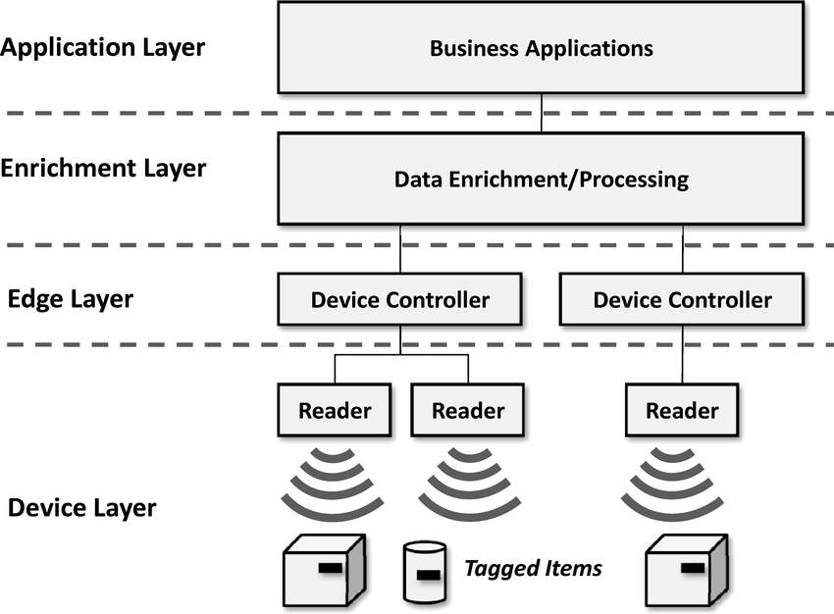

**Fig 5.2.3 RFID Integration**

**5.3 Automated Billing:**

The implementation of an automated billing system within the shopping trolley represents a monumental leap forward in the realm of retail technology, offering customers unparalleled convenience and efficiency throughout their shopping journey.

At the heart of this transformative innovation lies the automated billing system, meticulously engineered to seamlessly integrate into the fabric of the shopping experience. Through a sophisticated network of sensors, scanners, and backend algorithms, the system operates in concert to keep a real-time record of each item selected by the customer, along with its corresponding price.

The functionality of the automated billing system is elegantly simple yet profoundly impactful. As customers peruse the aisles and add items to their trolley, they have the ability to scan the barcodes of each product using the integrated scanner. With each scan, the system instantaneously registers the selected item, updating the virtual cart with the product's description and price.

This real-time recordkeeping capability ensures that customers have full visibility into their shopping cart contents at all times, allowing them to make informed decisions and manage their budget accordingly.

Moreover, by maintaining an accurate tally of selected products and their prices, the system empowers customers to shop with confidence, free from the uncertainty and guesswork that often accompany traditional shopping experiences.

Furthermore, the automated billing system represents a paradigm shift in the checkout process, offering customers a frictionless alternative to conventional checkout lanes.

With the ability to seamlessly scan items as they shop, customers can bypass the need for manual checkout procedures, thereby expediting the transaction process and minimizing wait times.

The integration of an automated billing system into the shopping trolley is a testament to the transformative power of technology within the retail environment. Its presence serves as a catalyst for efficiency and convenience, streamlining the shopping experience and enhancing overall customer satisfaction.

Moreover, the benefits of the automated billing system extend beyond its immediate impact on the shopping experience. By leveraging real-time data insights generated by the system, retailers gain valuable visibility into consumer behavior and purchasing patterns.

This wealth of actionable data enables retailers to make informed decisions regarding inventory management, pricing strategies, and product placements, thereby optimizing operational efficiency and driving business growth.

In addition to its operational benefits, the automated billing system holds immense potential for enhancing customer engagement and loyalty. By offering customers a seamless and convenient shopping experience, retailers can cultivate a sense of trust and satisfaction that fosters long-term loyalty and repeat business.

Furthermore, the automated billing system represents a significant milestone in the ongoing digital transformation of the retail industry. As retailers continue to embrace technology-driven innovations, the automated billing system stands poised to revolutionize the way we shop, ushering in a new era of convenience, efficiency, and customer-centricity.

In conclusion, the implementation of an automated billing system within the shopping trolley represents a watershed moment in the evolution of retail technology. Its ability to seamlessly integrate into the shopping experience, coupled with its profound impact on efficiency and convenience, underscores its significance as a transformative innovation within the retail landscape. As retailers continue to innovate and adapt to changing consumer preferences, the automated billing system stands ready to redefine the future of retail, one transaction at a time.

**5.4 Price Calculation:**

The operational functionality of the system involves intricate calculations to derive the total cost of items added to the shopping trolley in real-time. This dynamic process ensures customers are provided with a continuous and accurate tally of their expenses throughout their shopping endeavor.

At its core, the price calculation mechanism within the system represents a sophisticated interplay of data processing algorithms and real-time inventory tracking capabilities. As customers navigate the aisles and select items for purchase, each scanned barcode triggers a series of calculations that culminate in the determination of the total cost incurred.

The process begins with the identification and retrieval of product information associated with each scanned barcode. Leveraging a comprehensive database of product details, including pricing information and relevant discounts, the system swiftly compiles a detailed inventory of selected items.

Once the product information is obtained, the system proceeds to perform a series of intricate calculations to ascertain the total cost of the items in the trolley. This involves summing up the individual prices of each scanned item while factoring in any applicable discounts, promotions, or taxes.

The real-time nature of the price calculation process ensures that customers are provided with an ongoing tally of their expenses as they continue to shop. This transparency empowers customers to make informed decisions regarding their purchases, allowing them to manage their budget effectively and avoid any unforeseen surprises at checkout.

Moreover, the price calculation mechanism serves as a pivotal component in enhancing the overall shopping experience. By providing customers with immediate visibility into their expenses, the system fosters a sense of trust and confidence, facilitating smoother transactions and minimizing the likelihood of abandoned purchases.

Furthermore, the price calculation mechanism offers retailers valuable insights into consumer behavior and purchasing patterns. By analyzing the data generated by the system, retailers can gain a deeper understanding of customer preferences, identify popular products, and optimize pricing strategies to maximize profitability.

In addition to its operational benefits, the price calculation mechanism plays a crucial role in streamlining the checkout process. By automating the calculation of total costs, the system reduces the burden on cashiers and minimizes the risk of human error, ensuring faster and more efficient transactions at the point of sale.

Overall, the price calculation mechanism within the system represents a cornerstone of its operational functionality, underpinning the seamless integration of technology into the retail experience. Its ability to provide customers with real-time visibility into their expenses, while simultaneously offering valuable insights to retailers, underscores its significance as a transformative innovation within the retail landscape.

As retailers continue to embrace digital transformation and leverage technology to enhance the shopping experience, the price calculation mechanism stands poised to redefine the way we shop, ushering in a new era of transparency, efficiency, and customer satisfaction.

**5.5 Convenience:**

The innovative approach implemented by this system delivers unparalleled convenience to customers, enabling them to effortlessly monitor their spending in real-time as they navigate the aisles. This seamless integration of technology into the shopping experience significantly reduces reliance on traditional checkout processes, enhancing overall efficiency and customer satisfaction.

Central to this heightened level of convenience is the system's ability to provide customers with continuous visibility into their spending as they add items to their shopping trolley. With each scanned barcode, the system updates the ongoing tally of expenses, allowing customers to stay informed about their budgetary allocation throughout their shopping journey.

This real-time monitoring capability serves as a game-changer in the retail landscape, empowering customers with unprecedented control over their spending. Gone are the days of uncertainty and guesswork associated with traditional checkout processes; instead, customers can make informed decisions about their purchases with confidence, knowing exactly how much they are spending at any given moment.

Furthermore, the system's seamless integration of technology eliminates the need for customers to endure the hassle of waiting in long queues at checkout counters. By providing a frictionless alternative to traditional checkout processes, the system enhances overall efficiency and streamlines the shopping experience.

Moreover, the convenience afforded by this approach extends beyond the confines of the physical store, offering customers the flexibility to shop at their own pace and convenience. Whether browsing the aisles during peak hours or making a quick trip to the store during off-peak times, customers can enjoy a stress-free shopping experience without the constraints of traditional checkout processes.

Additionally, the system's real-time monitoring capability serves as a valuable tool for budget-conscious shoppers, allowing them to stay within their predetermined spending limits. With the ability to track their expenses in real-time, customers can make informed decisions about their purchases, prioritizing essential items while avoiding unnecessary splurges.

Furthermore, the convenience offered by this approach extends beyond individual customers to encompass the entire shopping experience. By reducing reliance on traditional checkout processes, the system enhances operational efficiency for retailers, minimizing wait times and maximizing throughput at checkout counters.

Moreover, the system's seamless integration of technology into the shopping experience offers retailers valuable insights into consumer behavior and purchasing patterns. By analyzing the data generated by the system, retailers can gain a deeper understanding of customer preferences and shopping habits, enabling them to tailor their offerings to meet evolving consumer demands.

In addition to its operational benefits, the convenience afforded by this approach has the potential to drive customer loyalty and repeat business. By delivering a seamless and stress-free shopping experience, retailers can cultivate a sense of trust and satisfaction among their customer base, fostering long-term relationships and driving sustained growth.

In conclusion, the innovative approach implemented by this system delivers unparalleled convenience to customers, offering real-time visibility into their spending and streamlining the shopping experience.

By reducing reliance on traditional checkout processes and leveraging technology to enhance efficiency, the system revolutionizes the way we shop, ushering in a new era of convenience and customer satisfaction in the retail landscape.

**5.6 Efficiency:**

The utilization of automated billing facilitated by a barcode scanner represents a significant leap forward in enhancing the efficiency of the payment process, benefiting both customers and retailers alike. This transformative approach streamlines the traditional checkout procedure, resulting in considerable time savings and operational enhancements.

At the core of this efficiency-driven innovation lies the seamless integration of a barcode scanner into the payment workflow. As customers add items to their shopping trolley and scan their barcodes, the system automatically calculates the total cost, providing customers with a real-time tally of their expenses.

This automated billing process eliminates the need for manual calculations and tedious checkout procedures, significantly reducing transaction times and expediting the payment process.

The efficiency gains afforded by automated billing extend beyond the immediate transactional benefits, permeating throughout the entire retail ecosystem. By automating the payment process, retailers can streamline their operations, optimize resource allocation, and enhance overall productivity.

With reduced reliance on manual checkout procedures, employees can focus on other critical tasks, such as customer service and inventory management, thereby maximizing operational efficiency and driving business growth.

Furthermore, the adoption of automated billing fosters a more seamless and frictionless shopping experience for customers, enhancing overall satisfaction and loyalty. With the ability to complete their purchases quickly and effortlessly, customers can enjoy a stress-free shopping experience, free from the frustrations of long queues and manual payment processes.

This enhanced convenience not only enhances customer satisfaction but also cultivates a sense of trust and loyalty, driving repeat business and fostering long-term relationships.

Moreover, the efficiency gains achieved through automated billing have far-reaching implications for retailers, extending beyond the immediate transactional benefits. By leveraging real-time data insights generated by the system, retailers can gain valuable visibility into consumer behavior and purchasing patterns.

This wealth of actionable data enables retailers to make informed decisions regarding inventory management, pricing strategies, and product placements, thereby optimizing operational efficiency and driving business growth.

In addition to its operational benefits, automated billing offers retailers valuable insights into consumer behavior and preferences, enabling them to tailor their offerings to meet evolving customer demands.

By analyzing transaction data and purchase history, retailers can identify trends, preferences, and opportunities for upselling and cross-selling, thereby maximizing revenue potential and driving sustained growth.

Furthermore, the adoption of automated billing can lead to significant cost savings for retailers, as it reduces the need for manual labor and minimizes the risk of human error.

By automating repetitive tasks and streamlining operational processes, retailers can achieve greater efficiency and productivity, resulting in reduced overhead costs and improved profitability.

Overall, the adoption of automated billing using a barcode scanner represents a transformative innovation in the retail landscape, offering significant efficiency gains and operational enhancements for both customers and retailers.

By streamlining the payment process and optimizing operational workflows, automated billing drives tangible benefits, including time savings, enhanced customer satisfaction, and increased profitability.

As retailers continue to embrace digital transformation and leverage technology to enhance the shopping experience, automated billing stands poised to redefine the future of retail, ushering in a new era of efficiency, convenience, and customer-centricity.

**5.7 Error Reduction:**

The implementation of RFID technology serves as a potent tool in mitigating pricing errors within the retail environment, offering a robust mechanism for ensuring accuracy and reliability in transactional processes.

By leveraging the capabilities of RFID technology, the system effectively minimizes the likelihood of pricing discrepancies, thereby enhancing overall operational efficiency and customer satisfaction.At the heart of this error reduction strategy lies the seamless integration of RFID technology into the retail workflow. As customers traverse the aisles with RFID-equipped products in the smart shopping trolley, the system captures and records the accurate prices associated with each scanned item in real-time.

This automated data capture process eliminates the potential for human error inherent in manual price entry methods, ensuring that pricing information is consistently accurate and up to date.

The efficacy of RFID technology in error reduction extends beyond its role in capturing accurate pricing information. By automating the data capture process, RFID technology also minimizes the risk of data entry errors, such as typographical mistakes or misinterpretation of handwritten prices.

This ensures that pricing information is entered into the system with precision and reliability, further bolstering the integrity of the transactional process.

Moreover, the use of RFID technology facilitates seamless integration with backend systems, enabling real-time validation of pricing information against the retailer's central database. This ensures that pricing discrepancies are promptly identified and rectified, minimizing the potential for customer dissatisfaction and loss of revenue.

Furthermore, the adoption of RFID technology enables retailers to implement robust quality control measures to ensure pricing accuracy.

By conducting regular audits and reconciliations of pricing data captured through RFID technology, retailers can identify and address any discrepancies or inconsistencies in pricing information, thereby maintaining the integrity of their pricing policies and safeguarding customer trust.

Additionally, the use of RFID technology offers retailers valuable insights into pricing trends and patterns, enabling them to optimize pricing strategies and maximize revenue potential.

By analyzing transactional data captured through RFID technology, retailers can identify pricing anomalies, track pricing fluctuations, and adjust pricing strategies in real-time to capitalize on market opportunities and consumer demand.

Furthermore, the adoption of RFID technology enables retailers to implement dynamic pricing strategies, wherein prices are adjusted based on factors such as demand, inventory levels, and competitor pricing.

By leveraging RFID technology to inform pricing decisions, retailers can optimize pricing strategies to maximize profitability while remaining competitive in the marketplace.

Moreover, the use of RFID technology facilitates seamless integration with other retail technologies, such as inventory management systems and point-of-sale (POS) systems.

This enables retailers to synchronize pricing information across various touchpoints, ensuring consistency and accuracy in pricing data throughout the customer journey.

Overall, the adoption of RFID technology serves as a powerful tool in reducing pricing errors within the retail environment, offering a robust mechanism for ensuring accuracy and reliability in transactional processes.

By automating the data capture process, RFID technology minimizes the likelihood of human error and facilitates real-time validation of pricing information against the retailer's central database. This ensures that pricing discrepancies are promptly identified and rectified, enhancing overall operational efficiency and customer satisfaction.As retailers continue to embrace digital transformation and leverage technology to enhance the shopping experience, RFID technology stands poised to redefine the future of retail, ushering in a new era of accuracy, reliability, and customer-centricity.

**5.8 Integration with Payment Methods:**

The seamless integration of the system with a diverse array of payment methods, including the utilization of GSM technology to send payment links, represents a pivotal advancement in the realm of retail technology, offering customers unprecedented flexibility and convenience in completing their transactions.

By leveraging GSM technology, the system enables customers to initiate payments directly from the shopping trolley by sending a payment link to their mobile devices. This innovative approach allows customers to complete transactions swiftly and securely, without the need for physical payment cards or cash.

At the core of this integration lies a robust framework that facilitates seamless communication between the system and the GSM network, enabling the transmission of payment links to customers' mobile devices.

This interoperability empowers customers to leverage their mobile devices as a convenient payment tool, allowing them to settle their purchases effortlessly while on the go.

The versatility of the system in accommodating GSM-based payment links underscores its commitment to inclusivity and accessibility, catering to the evolving preferences and lifestyles of modern consumers.

By offering a mobile-centric payment option, the system ensures that customers can complete transactions in a manner that aligns with their digital lifestyles, thereby enhancing overall satisfaction and driving repeat business.

Moreover, the integration of GSM-based payment links streamlines the checkout process, reducing friction and expediting transaction times. With the ability to initiate payments directly from their mobile devices, customers can bypass traditional checkout queues, saving time and minimizing wait times.

This enhanced efficiency not only improves the overall shopping experience but also enhances operational productivity for retailers.

Furthermore, the integration of GSM-based payment links offers retailers valuable insights into customer behavior and purchasing patterns.

By analyzing transaction data captured through mobile payments, retailers can gain a deeper understanding of customer preferences, identify trends, and optimize pricing strategies to maximize revenue potential.

Additionally, the integration of GSM-based payment links fosters a more secure transaction environment, mitigating the risk of fraud and unauthorized access.

By leveraging advanced encryption and authentication protocols, the system ensures that customer payment information remains protected during the payment link transmission process, safeguarding against potential security threats and instilling trust and confidence among customers.

Moreover, the integration of GSM-based payment links enables retailers to implement dynamic pricing strategies, wherein prices are adjusted based on factors such as demand, inventory levels, and customer demographics.

By leveraging transaction data captured through mobile payments, retailers can tailor pricing strategies to specific customer segments, offering personalized incentives and promotions to drive sales and enhance customer loyalty.

Furthermore, the integration of GSM-based payment links facilitates seamless reconciliation and settlement processes, simplifying accounting procedures for retailers.

By automating the reconciliation of mobile payments with sales transactions, the system reduces manual intervention and minimizes the risk of errors, ensuring accurate financial reporting and compliance with regulatory requirements.

Overall, the integration of the system with GSM-based payment links represents a transformative innovation in the retail landscape, offering customers unparalleled flexibility and convenience in completing their transactions.

By leveraging GSM technology to send payment links to customers' mobile devices, the system enhances the shopping experience, streamlines operational processes, and drives business growth for retailers.

As retailers continue to embrace digital transformation and leverage technology to enhance the shopping experience, the integration of GSM-based payment links stands poised to redefine the future of retail, ushering in a new era of convenience, security, and customer-centricity.

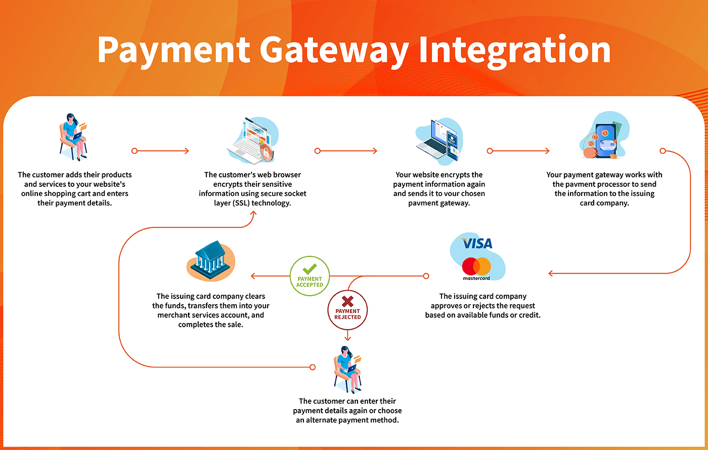

**Fig 5.8.4 Payment Gateway Integration**

**5.9 Security:**

Ensuring the security of customer information and payment data stands as a paramount priority within the framework of this proposed system. By implementing robust security measures and encryption protocols, the system safeguards sensitive data against unauthorized access and malicious activities, fostering trust and confidence among customers.

At its core, the proposed system is engineered to deliver a seamless and secure shopping experience, underpinned by a steadfast commitment to protecting customer privacy and confidentiality.

Through the deployment of state-of-the-art encryption technologies and secure communication protocols, the system ensures that customer information and payment data remain shielded from potential threats and vulnerabilities.

The security architecture of the system is designed to adhere to industry best practices and compliance standards, including PCI DSS (Payment Card Industry Data Security Standard), ensuring that customer data is handled and processed in a manner that is both secure and compliant.

other advanced authentication techniques, the system ensures that only authorized individuals can access customer information and initiate transactions, thereby enhancing overall security and preventing fraudulent activities.

Moreover, the system leverages advanced fraud detection and prevention mechanisms to identify and mitigate potential security threats in real-time. By monitoring transactional behavior and analyzing patterns of activity, the system can detect anomalies and suspicious activities indicative of fraudulent behavior, allowing for prompt intervention and remediation.

In addition to protecting customer information, the system also prioritizes the security of payment data, ensuring that transactions are conducted in a secure and reliable manner. Through the use of secure payment gateways and encryption technologies, the system encrypts payment data during transmission, preventing interception and unauthorized access by third parties.

Overall, the security of customer information and payment data is paramount within the proposed system, underpinning its commitment to delivering a secure and reliable shopping experience for customers.

By implementing robust security measures, encryption protocols, and authentication mechanisms, the system safeguards sensitive data against unauthorized access and malicious activities, fostering trust and confidence among customers.

In conclusion, the proposed system offers a more efficient and convenient shopping experience by eliminating the traditional checkout process and enabling customers to manage their expenses in real-time.

By prioritizing the security of customer information and payment data, the system ensures that transactions are conducted in a secure and reliable manner, safeguarding sensitive data against potential threats and vulnerabilities.

Minimizing queues and pricing errors boosts efficiency and satisfaction, paving the path for retailers' sustained growth and success.

**CHAPTER-6**

**MODULES DESCRIPTION**

**6.1** **LCD(Liquid Crystal Display):**

1. Character LCD Display: A character LCD display consists of a grid of character cells, with each cell capable of displaying a single character. These displays are commonly available in sizes such as 16x2 (16 characters per line, 2 lines) or 20x4 (20 characters per line, 4 lines). They can display alphanumeric characters, symbols, and some custom characters.

2. Graphical LCD Display: A graphical LCD display can display more complex graphics and images compared to character displays. These displays come in various sizes and resolutions, such as 128x64 or 240x320 pixels. They provide more flexibility in terms of displaying graphical elements, icons, and customized user interfaces.

3. Connection: LCD displays for Arduino usually require connecting multiple data and control pins to the corresponding pins on the Arduino board. Most LCD displays use the parallel interface, where multiple data pins are used to transfer information. 24

4. Usage: In the context of a smart trolley, an LCD display can be used to show scanned barcode information, product names, prices, or even a running total of the items scanned. The display can be updated based on the input from the barcode scanner and user interactions with the system.

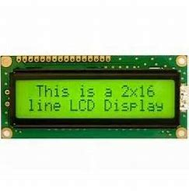

**Fig 6.1.5 LCD Display**

* 1. **RFID (Radio-Frequency Identification):**
* A crucial component in modern systems for automatic identification and tracking of objects.
* Comprises an RFID reader and an antenna.Works together to communicate wirelessly with RFID tags.

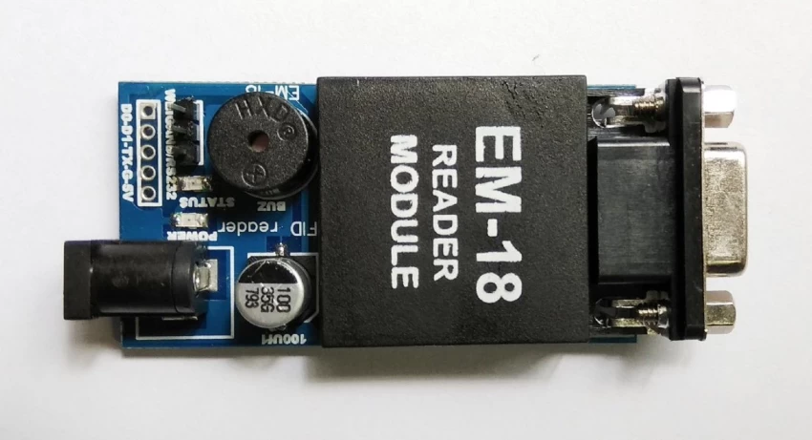

**Fig 6.2.6 EM-18 Reader Module**

1. RFID Technology Operation: Utilizes radio waves to exchange data between the RFID reader and tags. FID reader emits radio waves, powering RFID tags in its vicinity. Powered RFID tags transmit unique identification information back to the RFID reader.
2. Variants of RFID Modules: Available in various forms:

* Low frequency (LF)
* High frequency (HF)
* Ultra-high frequency (UHF).
* Each variant suited for different applications based on range and data transfer speed requirements.

1. Integration in Systems like Smart Trolleys:

* RFID modules integrated into systems like smart trolleys for: Automatic identification and tracking of items with RFID tags.
* Capturing and processing unique identification information as items are placed or moved within the RFID reader's range.
* Facilitating efficient inventory management, authentication, and tracking capabilities.

Enables wireless communication between RFID readers and RFID tags. Allows seamless identification and tracking of objects. Used in various applications including retail, logistics, and access control systems.

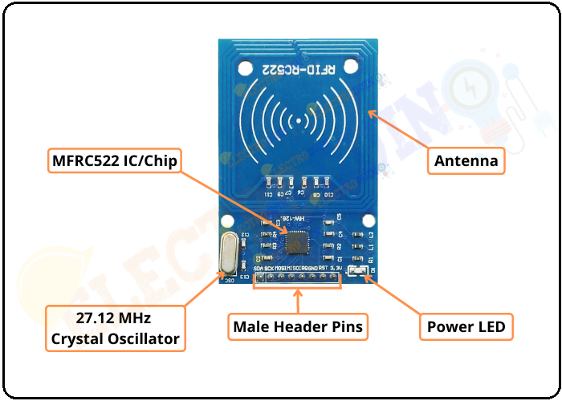

**Fig 6.2.7 Radio Frequency Identification**

**6.3 ARDUINO UNO**:

The Arduino Uno is a popular microcontroller board widely used in electronics and prototyping projects. It is based on the ATmega328P microcontroller and offers a range of features that make it accessible and easy to use for beginners and experienced makers alike.

The Arduino Uno board provides a simple and intuitive development environment. It can be programmed using the Arduino IDE (Integrated Development Environment), which offers a user-friendly interface and a simplified programming language based on C/C++. This makes it easier for beginners to get started with programming and allows for quick prototyping of projects.

The Uno board offers a variety of digital and analog input/output pins, which can be used to connect and control various sensors, actuators, and other electronic components. These pins provide flexibility for interfacing with external devices and enable the creation of interactive projects.

**Fig 6.3.8 Arduino UNO**

Furthermore, the Arduino Uno has built-in support for pulse width modulation (PWM), allowing for control of analog-like outputs such as dimming LEDs or controlling motor speed. It also has multiple communication interfaces, including UART, SPI, and I2C, which enable communication with other devices and Modules.

The Uno board is powered through a USB connection or an external power supply, providing versatility in powering the projects. It can also be powered by batteries, making it suitable for portable applications. One of the key advantages of the Arduino Uno is its large and active community. There is a vast amount of open-source libraries, tutorials, and projects available, which greatly simplifies the development process.

Additionally, the open-source nature of Arduino allows for easy customization and modification of the hardware and software to meet specific project requirements. Overall, the Arduino Uno is a versatile and beginner-friendly microcontroller board.

Its simplicity, extensive I/O capabilities, and strong community support make it an excellent choice for a wide range of projects, from simple hobbyist endeavors to more complex and sophisticated applications.

* 1. **GSM (Global System for Mobile Communications):**

GSM is a standard developed for digital cellular networks to facilitate mobile communication. It is one of the most widely used cellular technologies globally.

1. Key Features:

* Digital Communication: GSM facilitates digital communication, offering improved voice quality and enhanced security compared to analog systems.
* Compatibility: GSM is compatible with various mobile devices such as phones, tablets, and IoT (Internet of Things) devices.
* International Roaming: GSM allows for international roaming, enabling users to use their mobile devices in different countries seamlessly.
* SMS (Short Message Service): GSM supports SMS, allowing users to send and receive text messages.
* Data Services: GSM also supports data services, including GPRS (General Packet Radio Service) and EDGE (Enhanced Data Rates for GSM Evolution), which enable internet connectivity and data transmission.

1. Architecture: GSM networks consist of several components, including:

* Mobile Station (MS): The mobile device used by the subscriber.
* Base Station Subsystem (BSS): Consists of Base Transceiver Stations (BTS) and Base Station Controllers (BSC).
* Network Switching Subsystem (NSS): Manages call switching, mobility management, and subscriber authentication.
* Operation and Support Subsystem (OSS): Manages network operations and maintenance.
* Home Location Register (HLR) and Visitor Location Register (VLR): Store subscriber information and location data.
* Mobile Switching Center (MSC): Handles call switching and mobility management functions.

1. Usage: GSM technology is used for various purposes, including:

* Voice calls: Making and receiving voice calls.
* SMS messaging: Sending and receiving text messages.
* Data services: Internet connectivity, email access, and data transmission.
* IoT applications: Connecting IoT devices for remote monitoring, control, and data collection.

1. Evolution:

GSM has evolved over time to newer technologies such as 3G (UMTS), 4G (LTE), and 5G, offering higher data speeds, lower latency, and improved network capacity.

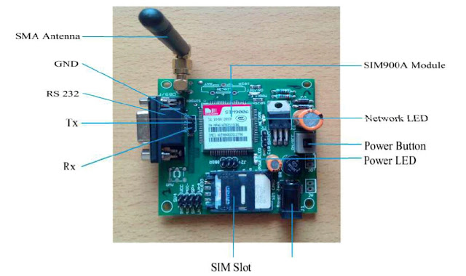

**Fig 6.4.9 Global System for Mobile Communication**

* 1. **(220V AC to 12V AC) Transformer:**

A 220V AC to 12V AC transformer is a crucial electrical device that plays a vital role in converting high voltage alternating current (AC) to a lower voltage suitable for specific applications.

This type of transformer functions on the principle of electromagnetic induction, where the input voltage of 220V AC is transformed into 12V AC output voltage. It typically comprises a primary coil wound around a core material, such as iron, which induces a magnetic field, thereby generating a voltage in the secondary coil.

This device finds widespread use in electronics, lighting systems, and appliances requiring low-voltage AC power.

When selecting a transformer, considerations such as power rating, efficiency, safety features, and physical size are essential. Proper installation and adherence to safety guidelines are crucial to prevent electric shock, overload, and short circuits.

The efficiency of the transformer determines the amount of power lost during the conversion process. With various sizes and form factors available, these transformers can be tailored to suit diverse installation requirements and load capacities.

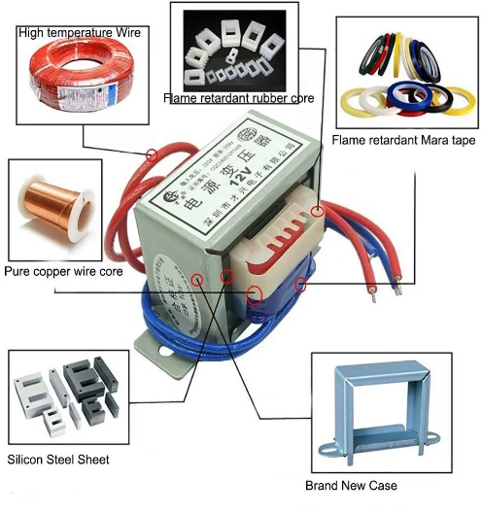

**Fig 6.5.10 (220V AC to 12V AC) Transformer**

**CHAPTER-7**

**EXPERIMENT**

The experimental introduction of smart shopping trolleys with automated billing via RFID technology aimed to redefine retail experiences. By seamlessly integrating advanced RFID technology, it streamlined checkout processes and empowered customers, exemplifying the transformative potential of innovation in enhancing convenience and efficiency.

This initiative heralds a new era in retail, where cutting-edge technologies like RFID are leveraged to elevate customer satisfaction and operational excellence, setting the stage for future advancements and innovations in the retail landscape.

RFID (Radio-Frequency Identification) technology offers similar functionality to barcode scanning but operates through radio waves rather than optical scanning. In the context of smart shopping trolleys, RFID tags are embedded in each product, allowing them to be detected and recorded by RFID readers as they are placed in the trolley. This real-time tracking enables automatic updating of the digital shopping cart, providing customers with instant visibility of their purchases. Moreover, RFID technology offers advantages over traditional barcode scanning, such as the ability to scan multiple items simultaneously and the elimination of line-of-sight requirements.

By replacing barcode scanners with RFID technology, the smart shopping trolleys can offer even greater efficiency and convenience to customers. The seamless integration of RFID enables faster and more accurate tracking of items, reducing the time spent in checkout queues and minimizing the risk of pricing errors.

Additionally, RFID technology enhances operational efficiency for retailers by automating inventory management processes and providing valuable insights into consumer behavior and product preferences.

Overall, the adoption of RFID technology in smart shopping trolleys represents a significant advancement in the retail sector, demonstrating the transformative potential of innovative technologies in enhancing the shopping experience for customers and driving business growth for retailers.

**7.1 FLOW CHART**

**Fig 7.1.11 Flow Chart**

Sure, here's a flowchart for the process you described:

1. **Start**: The process begins.
2. **Scan RFID Tag**: The RFID tag of the product is scanned to identify it.
3. **Read Product Barcode**: After identifying the product through RFID, its barcode is read to obtain product information.
4. **Calculate Total Price**: Using the product information obtained from the barcode, the system calculates the total price based on factors like quantity, unit price, taxes, etc.
5. **Display Total Price on LCD**: The calculated total price is displayed on an LCD screen for the user to view.
6. **Confirm Purchase**: The user confirms the purchase after reviewing the displayed total price.
7. **Send Billing Information via GSM**: Once the purchase is confirmed, billing information (such as the total price, items purchased, etc.) is sent via GSM (Global System for Mobile Communications) to the billing system or server.
8. **End**: The process ends.

This flowchart outlines the steps involved in a typical transaction process involving scanning an RFID tag, reading a product barcode, calculating the total price, displaying it for confirmation, and finally sending billing information via GSM.

**7.2 BLOCK DIAGRAM**

**7.2.1 Radio-Frequency Identification :**

Radio-Frequency Identification (RFID) reader, often referred to simply as an RFID scanner, serves a similar function to a barcode reader but operates on different principles. Instead of capturing optical signals from printed barcodes, an RFID reader uses radio waves to communicate with RFID tags, which are embedded in or attached to objects.

The structure of an RFID reader typically includes an antenna, a transceiver, and a decoder. The antenna emits radio waves, which are received by RFID tags within its vicinity. The tags respond by transmitting their stored information back to the reader's antenna.

The RFID reader then captures this transmitted data and sends it to a connected device for processing. This information exchange happens wirelessly and does not require line-of-sight contact between the reader and the RFID tags.

In contrast to barcode readers, RFID readers offer several advantages. They can read multiple tags simultaneously and at a distance, allowing for faster and more efficient data capture. Additionally, RFID tags can store more information than traditional barcodes and can be read even if they are not visible or obscured.

The integration of RFID readers into various business environments enables real-time tracking of inventory, assets, and products throughout the supply chain. This technology facilitates enhanced visibility and traceability, leading to improved inventory management, reduced stockouts, and increased operational efficiency.

Overall, while barcode readers excel at capturing optical data from printed barcodes, RFID readers offer a more advanced and versatile solution for automatic identification and tracking in a wide range of industries.

**Fig 7.2.12 Block Diagram**

**7.2.2 GSM :**

GSM (Global System for Mobile Communications) technology revolutionized the telecommunications industry by establishing a standardized framework for digital cellular networks. Developed by the European Telecommunications Standards Institute (ETSI), GSM technology enables voice and data transmission over mobile networks, facilitating global connectivity and communication.

At the core of GSM technology is its use of time division multiple access (TDMA) and frequency division multiple access (FDMA) techniques, which allow multiple users to share the same radio frequency spectrum efficiently. In a GSM network, each user is assigned a specific time slot and frequency band for transmission, ensuring simultaneous communication without interference.

GSM networks consist of several key components, including mobile stations (phones), base transceiver stations (BTS), base station controllers (BSC), and mobile switching centers (MSC). When a user makes a call or sends data, the mobile station communicates with the nearest BTS, which then relays the signal to the BSC. The BSC manages multiple BTSs and coordinates handovers as users move between cells. The MSC acts as the gateway between the mobile network and the public switched telephone network (PSTN) or other mobile networks, enabling calls to be routed to their destination.

One of the defining features of GSM technology is its support for international roaming, allowing users to make and receive calls while traveling abroad. This is made possible by the use of subscriber identity modules (SIM cards), which store user information and authentication data. When a user roams onto a foreign network, their SIM card authenticates with the local network, granting access to voice and data services.

GSM technology also paved the way for advanced mobile services, including SMS (Short Message Service), MMS (Multimedia Messaging Service), and mobile internet access. These services utilize the digital data capabilities of GSM networks, enabling users to send text messages, multimedia content, and access online services directly from their mobile devices.

**7.3 SYSTEM REQUIREMENTS:**

7.3.1 HARDWARE REQUIREMENTS:

* Arduino UNO
* 220V AC to 12V AC Transformer
* RFID Reader
* LCD Display
* Jumper wires
* GSM Module
* Button

7.3.2 SOFTWARE REQUIREMENTS:

* Arduino IDE

**CHAPTER-8**

**RESULTS AND DISCUSSIONS**

In this section, we delve into the outcomes of our research and engage in a comprehensive discussion based on the results obtained.

The system under investigation was simulated using the Arduino Integrated Development Environment (IDE), providing valuable insights into its implementation. Through the integration of both software and hardware components, we present the findings derived from our experimentation.

A key metric used to evaluate the performance of the implemented system is the mean square average, which serves as a measure of accuracy. By graphing the mean square average against the number of trials conducted, we illustrate the precision achieved by the system. This graphical representation enables us to assess the system's consistency and reliability across multiple iterations.

Furthermore, we examine the output versus the input to elucidate the sensitivity level of the implemented system. By analyzing the relationship between the system's output and the corresponding input values, we gain valuable insights into its responsiveness to varying stimuli.

This analysis allows us to assess the system's robustness and its ability to accurately process input data under different conditions.

Through a thorough examination of the simulation results, we uncover valuable insights into the performance and efficacy of the implemented system. By synthesizing the findings from both software simulations and hardware integration, we gain a comprehensive understanding of the system's capabilities and limitations.

Overall, the outcomes of our research shed light on the effectiveness of the implemented system and provide valuable guidance for future development and optimization efforts.

Through a rigorous analysis of the simulation results, we contribute to the body of knowledge in this field and lay the groundwork for further advancements in system design and implementation.

**Fig 8.13 OUTPUT Implementation**

**Fig 8.14 Hardware connections**

**Fig 8.15 Final OUTPUT**

**CHAPTER-9**

**CONCLUSION**

In conclusion, the implementation of a smart trolley using Arduino, GSM module, EM-18 RFID reader, display, and a 12V transformer offers a versatile and efficient solution for enhancing the shopping experience. By integrating these components, the smart trolley system enables seamless tracking of items, real-time communication, and convenient display of information for both customers and store staff. The Arduino serves as the central control unit, orchestrating the interaction between the RFID reader, display, and GSM module. The EM-18 RFID reader facilitates efficient item identification and tracking, allowing customers to add or remove items from their carts effortlessly. The GSM module enables communication capabilities, such as sending notifications or alerts to users or store personnel. The display provides vital information, including item prices, shopping lists, or promotional messages, enhancing the overall shopping experience. Additionally, the inclusion of a 12V transformer ensures stable power supply to the system, ensuring uninterrupted operation. Overall, the smart trolley system offers a user-friendly, efficient, and innovative solution for modern retail environments, streamlining the shopping process and improving customer satisfaction.

**9.1** **FUTURE SCOPE:**

Combining Arduino, GSM, EM-18 RFID, a display, and a 12V transformer to create a smart trolley offers a promising avenue for future development. Here's a look at the potential future scope of such a project: Incorporating Arduino, GSM technology, EM-18 RFID, a display, and a 12V transformer, a smart trolley system offers a glimpse into the future of retail and logistics. Such a system enables seamless tracking, management, and interaction with shopping carts or logistics carriers. With real-time data transmission via GSM, users can remotely monitor trolley locations, contents, and status, enhancing inventory management and theft prevention. The integration of EM-18 RFID technology allows for efficient item tracking and authentication, ensuring accurate checkout processes and reducing manual labor. The inclusion of a display provides users with interactive feedback, such as shopping lists, promotional offers, or navigation assistance within stores or warehouses. Looking ahead, the future scope of smart trolley systems involves further advancements in connectivity, automation, and artificial intelligence. Potential developments may include autonomous navigation, predictive analytics for inventory restocking, personalized shopping experiences based on user preferences, and integration with smart home or smart city ecosystems for seamless connectivity and data exchange. These innovations promise to revolutionize retail and logistics operations, offering enhanced efficiency, convenience, and customer satisfaction.

**REFERENCES**

1. “A Smart Shopping Cart with an Automatic Billing System Utilizing RFID and Zigbee" was presented in the IEEE conference ICICES 2014 (Paper ID: 7033996)
2. In the publication "Development of a Sensor-Controlled Convertible Cart-Trolley," authored by O.J. Oyejide, M.O. Okwu, L.K. Tartibu, and O.I. Olayode, the development of a cart-trolley with sensor-based control mechanisms is discussed. This work was published in Procedia CIRP in 2020.
3. "An RFID-Based Smart-Cart System with Automated Billing and Assistance for the Visually Impaired" is the subject of research conducted by G. Sharmila, J. Ragaventhiran, M. Islabudeen, and B. Muthu Kumar. The findings were published in Materials Today: Proceedings in 2021.
4. "Development of a Smart Trolley System Based on Android Smartphone Sensors" was carried out by Alexander AS Gunawan, Valdi Stevanus, Albertus Farley, Heri Ngarianto, Widodo Budiharto, Herman Tolle, and Muhammad Attamimi. The work was presented in Procedia Computer Science in 2019.
5. The paper titled "Smart Shopping Cart for Automated Billing Purpose Using Wireless Sensor Networks" was authored by Udita Gangwal, Sanchita Roy, and Jyotsna Bapat. It was part of the ICCMIT 7026 conference.
6. For further information on automated retail, you can visit Amazon Go, an innovative concept introduced by Amazon in 2017.
7. In a news article titled "Smart Trolley Shops for You," authored by R. O'Neill and published on June 21, 2005, and updated on June 21, 2017, information about smart trolley shopping is provided.
8. The topic of smart trolleys is also discussed in the paper titled "Smart Trolley" by J.S. Awati and S.B. Awati, part of the work "Intelligent Shopping Cart.
9. A. Farahzadi, P. Shams, J. Rezazadeh, and R. Farahbakhsh, “Middleware technologies for cloud of things-a survey,” Digital Communications and Networks, Elsevier, 2017.
10. D. Singh, G. Tripathi, and A. J. Jara, “A survey of internet-ofthings: Future vision, architecture, challenges and services,” in 2014 IEEE World Forum on Internet of Things (WF-IoT), March 2014, pp. 287–292.
11. A. Al-Fuqaha, M. Guizani, M. Mohammadi, M. Aledhari, and M. Ayyash, “Internet of things: A survey on enabling technologies, protocols, and applications,” IEEE Communications Surveys Tutorials, vol. 17, no. 4, pp. 2347–2376, Fourth quarter 2015.
12. A. Zanella, N. Bui, A. Castellani, L. Vangelista, and M. Zorzi, “Internet of things for smart cities,” IEEE Internet of Things Journal, vol. 1, no. 1, pp. 22–32, Feb 2014.
13. J. Rezazadeh, M. Moradi, A. S. Ismail, and E. Dutkiewicz, “Superior path planning mechanism for mobile beaconassisted localization in wireless sensor networks,” Sensors Journal, IEEE, vol.
14. pp. 3052–3064, 2014. 14. M. Hubert, M. Blut, C. Brock, C. Backhaus, and T. Eberhardt, “Acceptance of smart phone-based mobile shopping: Mobile benefits, customer characteristics, perceived risks, and the Impact of application context,” Psychology and Marketing, vol. 34, no. 2, pp. 175–194, 2017.
15. J. Rezazadeh, M. Moradi, and A. S. Ismail, “Efficient localization via middle-node cooperation in wireless sensor networks,” in International Conference on Electrical, Control And Computer Engineering, June 2011, pp. 410–415.
16. R. Nallanthighal and V. China, “Improved grid-scan localization algorithm for wireless sensor networks,” Journal of Engineering, Hindawi, vol. 5, no. 10, pp. 21–27, 2014.

**PUBLICATION DETAILS**

Prof.M.Susaritha., Guru Prakash., Prasanth., “ Smart Trolley With Automated Billing System Using Ardiuno,” 2024 International Conference on Advanced Computing Communication and Electrical System (ICACCES’24), KMEA Engineering College, Kerala, India 2024. Held on February 23.

**ANNEXURE**



