AWS VPC Implementation Documentation
1. Overview
This document describes the setup and configuration of a Virtual Private Cloud (VPC) in AWS, including subnets, route tables, and Internet Gateway (IGW) integration. The VPC is designed to support both public and private workloads with proper network segmentation.
VPC Name: gps-vpc
VPC CIDR: 10.0.0.0/16
Region: us-east-1

2. VPC Creation
- A new VPC was created in AWS with the specified CIDR block.
- An Internet Gateway (IGW) was attached to allow internet access for public subnets.
Screenshot: VPC Creation
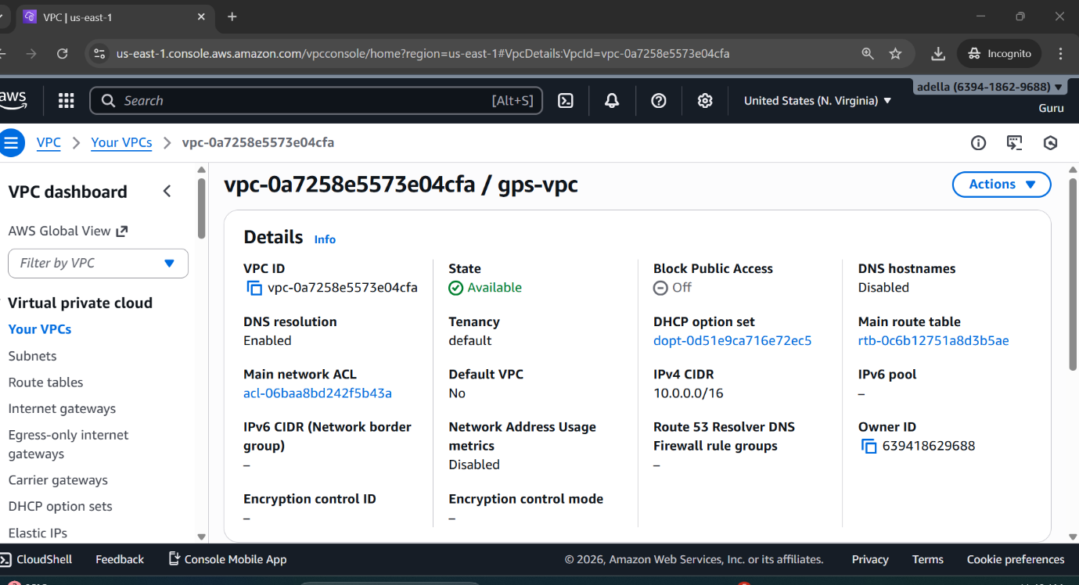

3. Subnet Configuration
Six subnets were created in the VPC to logically separate resources based on their function.
Subnet Name | CIDR Block | Type | Availability Zone
shared01 | 10.0.0.0/19 | Private/Public | <AZ>
platform02 | 10.0.32.0/20 | Private/Public | <AZ>
app03 | 10.0.48.0/21 | Private | <AZ>
web04 | 10.0.56.0/22 | Public | <AZ>
edge05 | 10.0.60.0/23 | Public | <AZ>
admin06 | 10.0.62.0/24 | Private | <AZ>
Subnet Naming Convention:
- shared01 – Shared services and utilities
- platform02 – Platform services
- app03 – Application layer
- web04 – Web-facing servers
- edge05 – Edge services
- admin06 – Administrative or management servers
Screenshot: Subnet Configuration
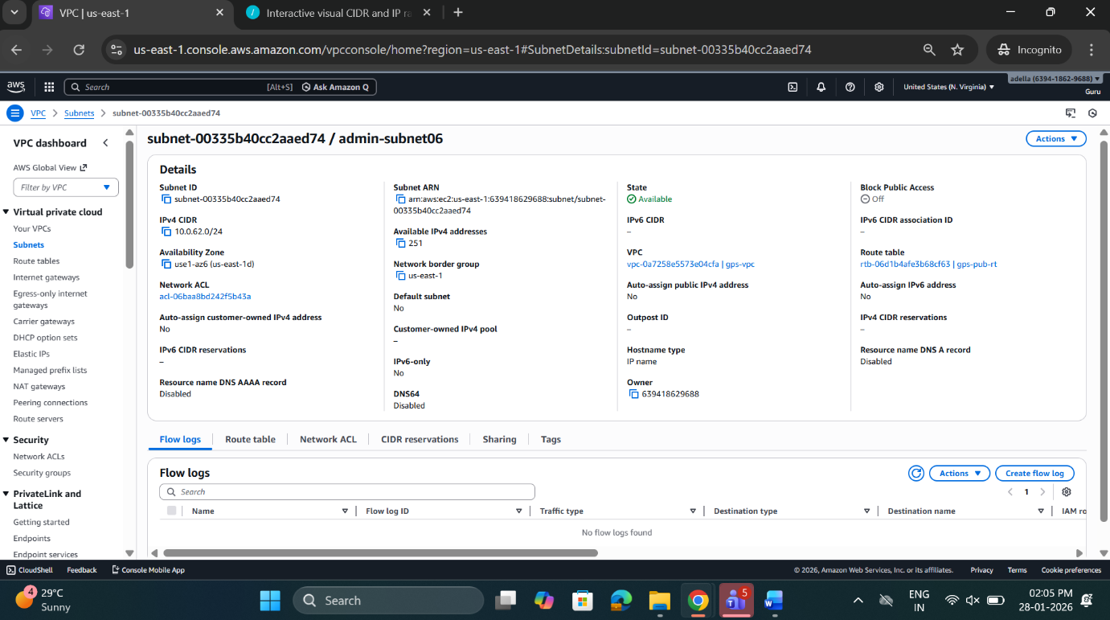
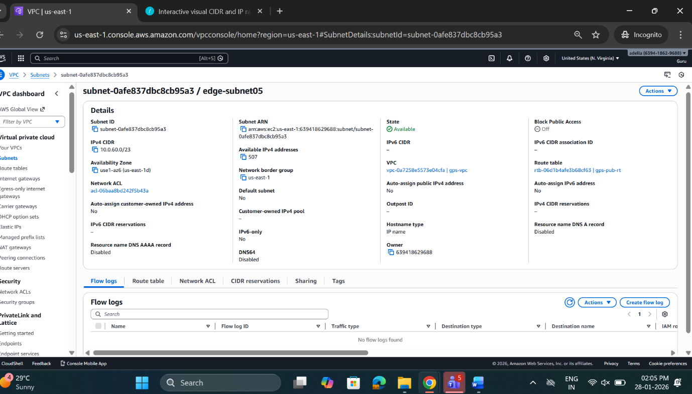
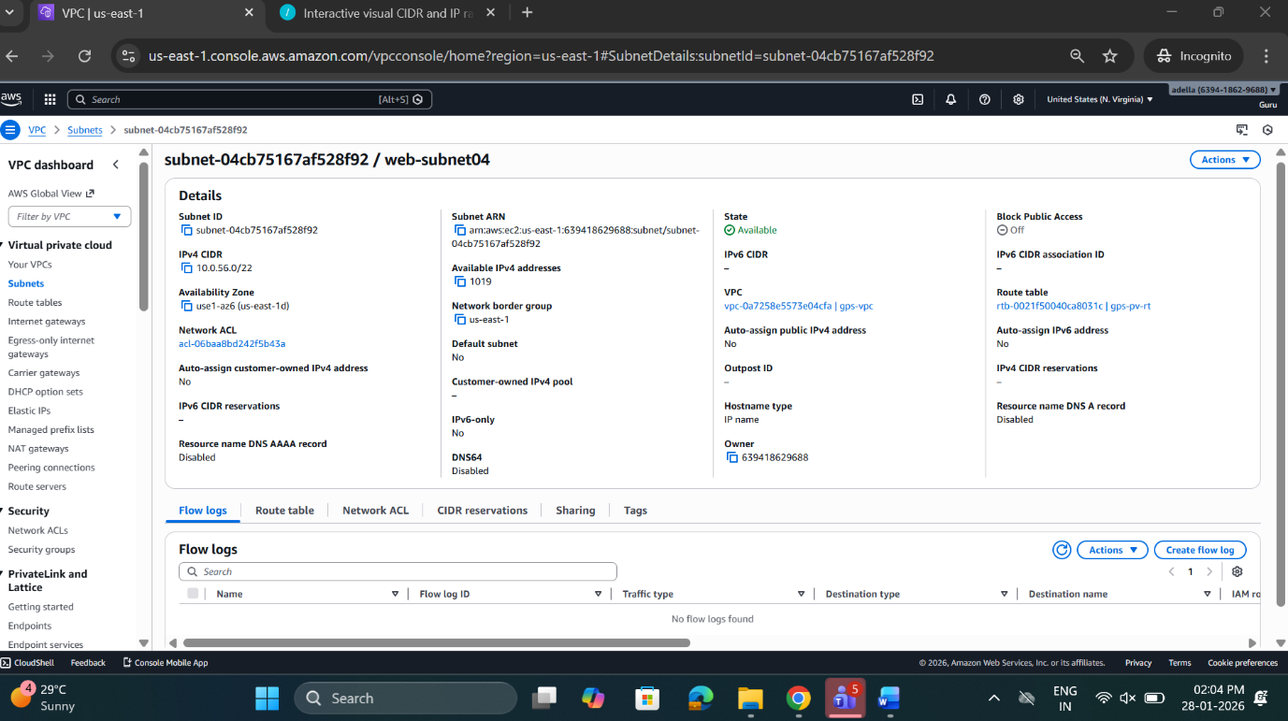
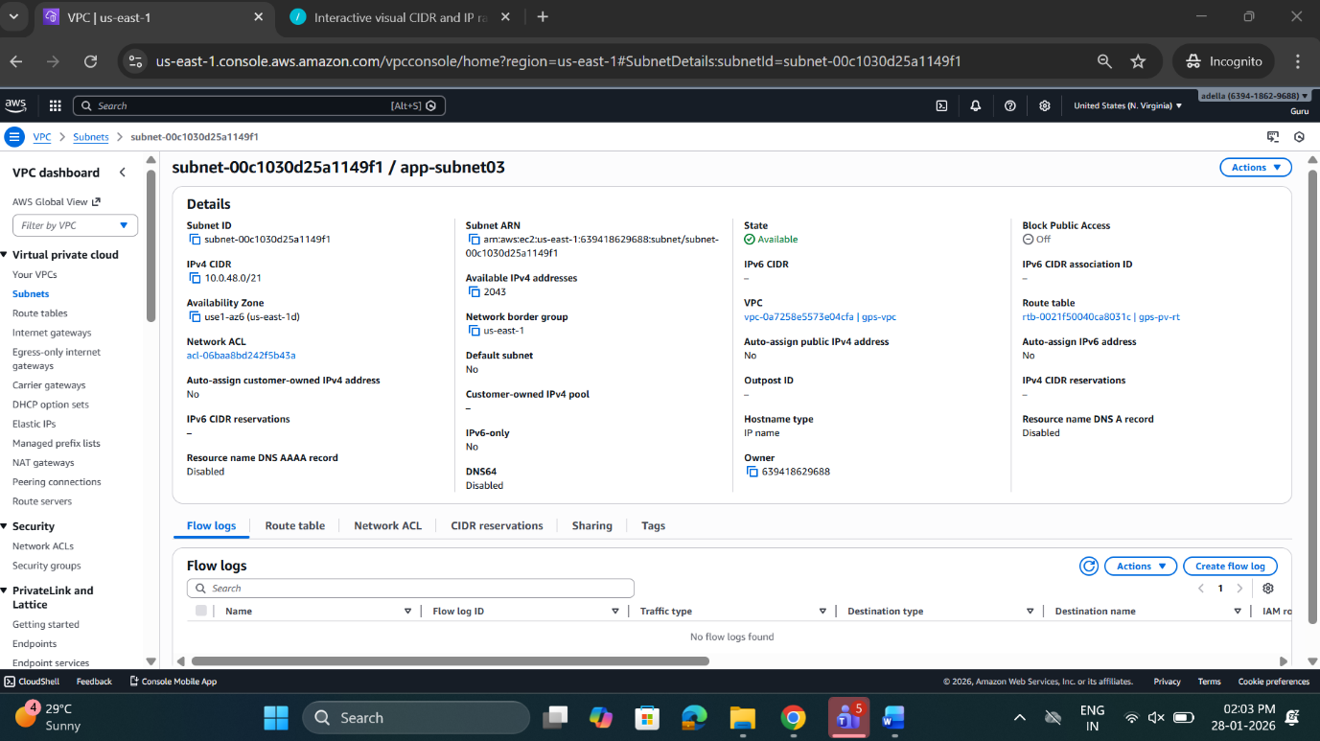
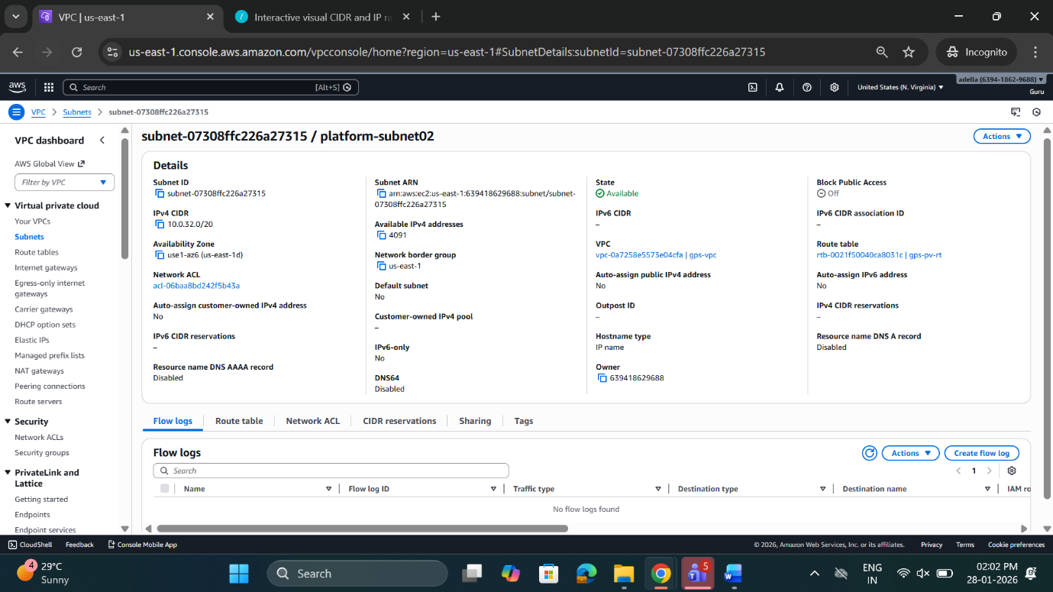
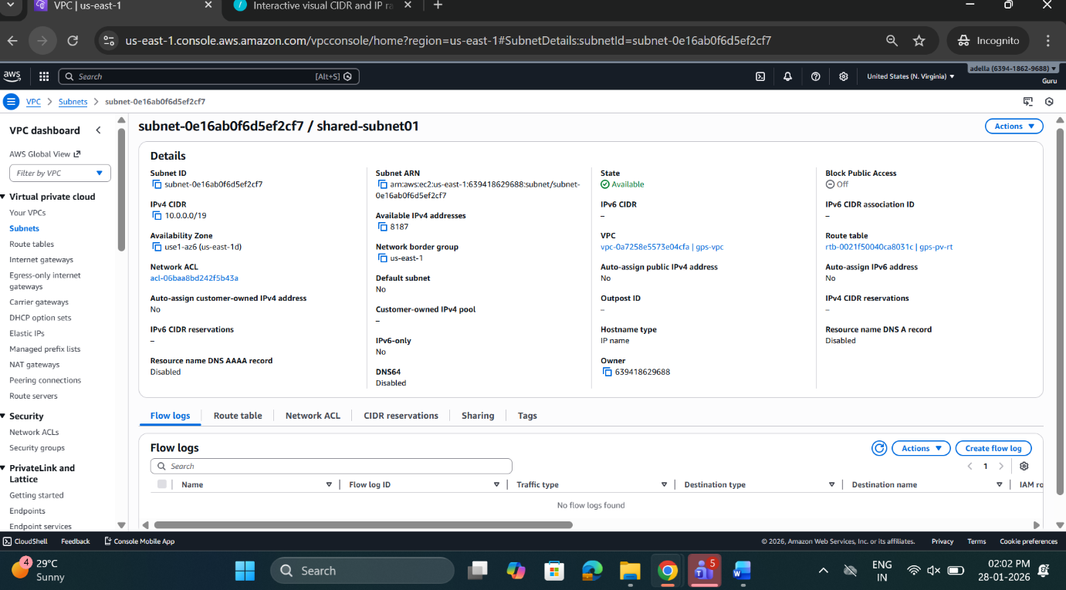

4. Route Tables
Two route tables were created to control traffic routing for public and private subnets.
4.1 Public Route Table
- Associated Subnets: web04, edge05
- Routes:
  - 0.0.0.0/0 → IGW (Internet Gateway)
- Purpose: Provides internet access for public-facing resources.
Screenshot: Public Route Table
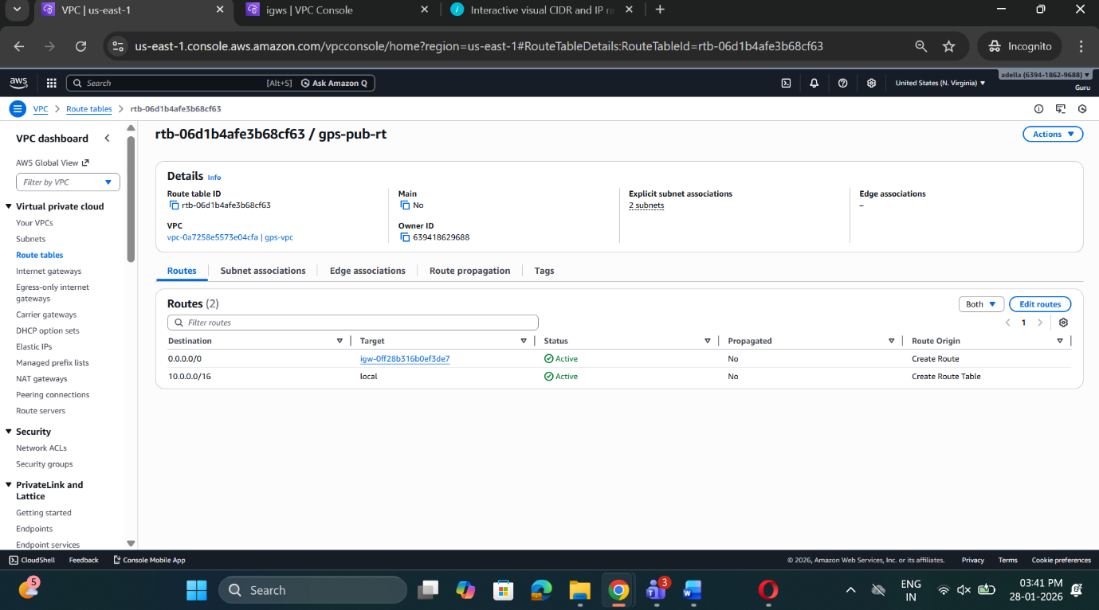

4.2 Private Route Table
- Associated Subnets: shared01, platform02, app03, admin06
- Routes:
  - 0.0.0.0/0 → NAT Gateway (if applicable)
- Purpose: Keeps workloads private, without direct internet access, while allowing outgoing internet traffic via NAT (if configured).
Screenshot: Private Route Table
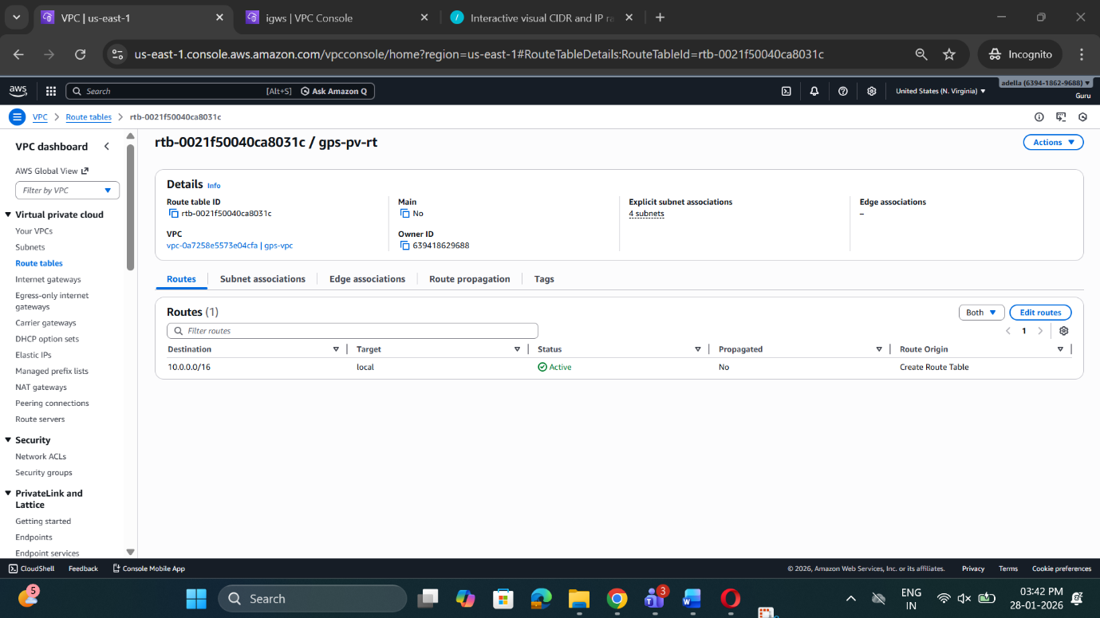

5. Internet Gateway (IGW)
- Name: gps-internetgateway
- Attached to VPC: gps-vpc
- Purpose: Enables internet access for public subnets.
Screenshot: IGW Attachment
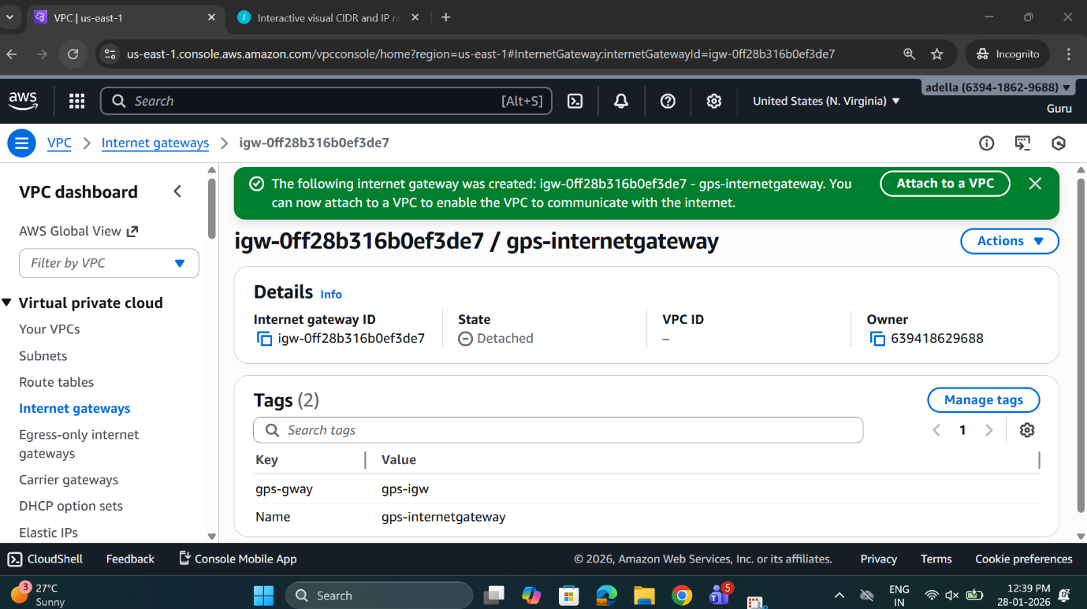

6. Security Considerations
- Ensure that public subnets are protected using Security Groups and Network ACLs.
- Private subnets should not have direct internet exposure. Use NAT Gateway or Bastion host for controlled access.
- Proper tagging and naming conventions are followed for ease of management.

7. Summary
The VPC design provides:
- Segregation of workloads into public and private subnets.
- Controlled internet access via IGW and route tables.
- Clear network hierarchy for shared, application, platform, web, edge, and administrative layers.
This setup can be extended with additional services such as NAT Gateway, VPN, or Transit Gateway as needed.
Screenshot: VPC Architecture Diagram (Optional)
