**B3:  Sub-pixel Resolution particle detection**

*B3.1: Creating a synthetic image from particles detected from B2.4*

Summary:

The synthetic image is created by using the detected particles that are detected in B2.4. These particles are set to 1 and the background is set to zero. This raw image is convolved with a Gaussian kernel chosen to approximate the PSF, in order to create a synthetic image. White noise is generated by choosing random values from a normal distribution with mean equal to the average background noise and standard deviation is set to be 0.25 times the average intensity of the detected particles. White noise is generated from the aforementioned noise distribution to create an image I\_noise of the same size as that of the original image (I). The noisy image is now added to the synthetic image to simulate an actual noisy image of signal to noise ratio of 4. This process is repeated with different standard deviations in the noise distributions thereby resulting in images with different SNR ratios. The results are shown below, the image looks less sharper(more fuzzy) with a higher SNR as should be expected.

Code Execution Instructions:

In order to generate the synthetic image run the “Creation of synthetic Image” section in the Main. m file. This will generate the synthetic image I\_synthetic.

* The image is obtained by calling the createSynthetic.m function that requires as input the following :
  + *finalMaxima*: The x and y co-ordinates of the detected particles along with their intensity values.
  + *I* : original image.
  + *bkgdMean/noise\_mean*: average background noise previously calculated.
  + *noise* : 10-25% of the average intensity that is assigned as the level of noise , Eg: 0.25 ( indicates a noise level of 25% of the mean intensity of the detected particles).

Results: Set of synthetic images for different SNR ratios.

1. 25% Noise (SNR :4)

C:\Users\priyanka raja\Desktop\CMU\Spring_2016\Bioimage_Informatics\Assignments\Programming Assignment 3\25_noise.tif

1. 15% Noise (SNR : ~ 7)

C:\Users\priyanka raja\Desktop\CMU\Spring_2016\Bioimage_Informatics\Assignments\Programming Assignment 3\15_noise.tif

1. C:\Users\priyanka raja\Desktop\CMU\Spring_2016\Bioimage_Informatics\Assignments\Programming Assignment 3\10_noise.tif10% Noise (SNR : 10)

B3.2 Sub-pixel detection algorithm using oversampling

Summary: In order to perform subpixel detection on the original image (first frame of the video). We implement the Gaussian fitting algorithm as described by Cheezum et al. The co-ordinates of the particles that were previously detected are obtained from the detectMaxima.mat file. Only the pixel co-ordinates of the detected particles and their neighbors (3x3 neighborhood) are oversampled. Gaussian fitting is carried out in this oversampled image space. The

Gaussian kernel sigma = (PSF radius /3)/13nm. This Gaussian kernel is swiped across the oversampled image space and the pixel co-ordinates that minimizes the least square fit with the Gaussian are returned as sub pixel co-ordinates of the detected particles.

Code Execution Instructions:

In order to generate the synthetic image run the “Subpixel Detection” section in the Main. m file. This will generate the finalsubPixelMaxima variable that contain the pixel co-ordinates in the oversampled image(co-ordinates corresponding to when the whole image is resized) as well as the co-ordinates of the detected particles in the oversampled version of the image that only contained the detected particle pixel and its neighbors in a 3x3 neighborhood.

* The co-ordinates are obtained by running the subPixelDetection.m function which will execute when the aforementioned section is run in the main program. This function requires as input the following :
  + *finalMaxima*: Load detectMaxima.mat which contains contains the x, y co-ordinate of detected particles and the corresponding intensity value
  + *I* : Original Image
  + *I\_syntheticNoNoise*: This is an optional parameter used in the extra credit section run in the Main.m function. This parameter is an image which contains only the detected particle intensities with no added noise (raw image).

The outputs generated:

* subPixelDetect : Detected sub-pixel co-ordinates that is returned by

using gaussian fitting.

* realSubPixelMaxima : The actual sub-pixel co-ordinates obtained from the
* raw image.

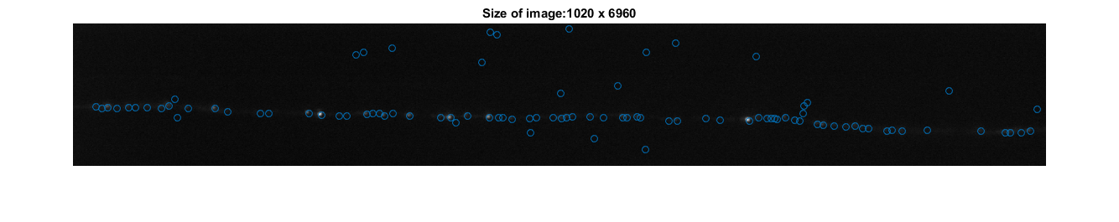  
Results:

B3.3 :  Benchmarking subpixel detection algorithm (Extra Credit)

Summary:

Code Execution Instructions:

Results:

|  |  |  |
| --- | --- | --- |
| **Synthetic Image: Noise Level** | **Accuracy (Mean of detection error)** | **Precision (Std dev of detection error)** |
| 10% | 0.17 | 0.38 |
| 15% | 0.44 | 0.54 |
| 20% | 0.67 | 0.62 |
| 25% | 0.98 | 0.60 |

References :

1) A. Ponti, P. Vallotton, W. C. Salmon, C. M. Waterman-Storer, and G. Danuser, Computational analysis of F-actin turnover in cortical actin meshworks using fluorescent speckle microscopy, *Biophysical Journal*,

84:3336-3352, 2003.

2) M. K. Cheezum, W. F. Walker, and W. H Guilford, Quantitative comparison of algorithms for tracking single fluororescent particles, *Biophysical Journal*, 81:2378-2388, 2001.