   

# SENTIMENT ANALYSIS AI SYSTEM

A PROJECT REPORT SUBMITTED IN PARTIAL FULLFILLMENT OF THE REQUIREMENTS OF

BY

NAME : GURUPRASATH V

REG NO : 810021114701

DEPARTMENT : MECHANICAL ENGINEERING

EMAIL ID : guruprasathvengateshprabu@gmail.com

Under the guidance of

Dr.V.C.SATHISH GANDHI,M.E,MBA,PH.D.

   

# ACKNOWLEDGEMENT

We would like to take this opportunity to express our deep sense of gratitude to all individuals who helped us directly or indirectly during this thesis work.

Firstly, we would like to thank my supervisor **Dr.V.C.SATHISH GANDHI,M.E,MBA,PH.D.**

for being a great mentor and the best adviser I could ever have. His advice, encouragement and the critics

are a source of innovative ideas, inspiration and causes behind the successful completion of this project. The confidence shown in me by him was the biggest source of inspiration for me. It has been a privilege working with him for the last one year. He always helped me during my project and many other aspects related to the program. His talks and lessons not only help in project work and other activities of the program but also make me a good and responsible professional.

   

ABSTRACT OF PROJECT

Sentiment analysis is a natural language processing (NLP) technique used to determine the emotional tone behind a body of text. With the rise of social media, customer

reviews, and other online content, sentiment analysis has become a critical tool for businesses, researchers, and organizations to assess public opinion, monitor brand

reputation, and improve customer engagement. This paper presents the development of an AI-based sentiment analysis system that leverages machine learning algorithms to

classify text data into categories such as positive, negative, and neutral. The system is built on a combination of supervised learning techniques, including deep learning

models such as recurrent neural networks (RNNs) and transformers, to effectively capture the contextual nuances of human language. The model is trained on large, annotated datasets and optimized for

accuracy through cross-validation and

hyperparameter tuning. Evaluation results demonstrate that the AI system can accurately predict sentiment with high precision, recall, and F1 scores, making it a

valuable tool for real-time sentiment monitoring in various applications, from social media analytics to customer feedback analysis. The study also discusses challenges in

sentiment analysis, such as handling sarcasm, ambiguity, and domain-specific language, and proposes potential solutions to address these issues in future developments.

**Keywords :**

**Sentiment Analysis, Natural Language Processing (NLP), Machine Learning, Deep Learning,**

**Recurrent Neural Networks (RNNs), Transformers, Text Classification, Emotional Tone, Public Opinion, Customer Feedback, Supervised Learning, Model Optimization, Hyperparameter Tuning, Social Media Analytics, Sarcasm Detection, Domain-Specific Language.**

   

# TABLE OF CONTENTS

**Chapter 1. Introduction**

**Chapter 2. Literature Survey**

**Chapter 3. Proposed Methodology**

**Chapter 4. Implementation and Results Chapter 5. Discussion and Conclusion References**

   

# CHAPTER 1

**Introduction**

* 1. **Problem Statement:** Describe the problem being addressed. Why is this problem significant?

In the age of digital communication, vast amounts of text data are generated daily across platforms like social media, customer reviews, and online forums. Extracting

meaningful insights from this unstructured data is a significant challenge. One of the

most valuable insights is understanding the underlying sentiment—whether people feel positive, negative, or neutral about a given topic, product, or service. Traditional methods of sentiment analysis often

struggle with nuances in language, such as

sarcasm, contextual ambiguities, and domain-specific vocabulary. Additionally, the

complexity of human emotion and the evolving nature of language make it difficult for existing systems to accurately and efficiently classify sentiment across diverse datasets.

This problem becomes more pronounced in real-time applications, where timely and accurate sentiment detection is crucial for businesses and organizations to make

informed decisions. The goal is to develop a robust AI-driven sentiment analysis system capable of

accurately identifying sentiment across varied text sources, while overcoming challenges like handling complex language, improving model generalization, and ensuring scalability for large-scale text data analysis.

* 1. **Databases to be Used :**

For developing a sentiment analysis AI system, several publicly available databases and datasets can be used for training and testing the model. These databases typically

contain labeled text data (e.g., positive, negative, neutral) and are useful for supervised learning tasks.

Some commonly used datasets for sentiment analysis are:

* + 1. IMDb Movie Reviews Dataset

Description: A collection of 50,000 movie reviews, each labeled as either positive or negative. Use Case: Suitable for binary sentiment classification (positive vs. negative sentiment).

* + 1. Sentiment140

Description: A large dataset containing 1.6 million tweets labeled with sentiment (positive, negative, neutral). Use Case: Can be used for sentiment analysis on social media data, especially for Twitter-based sentiment analysis.

   

* + 1. Amazon Product Reviews Dataset

Description: Contains millions of Amazon customer reviews, each labeled with ratings (from 1 to 5 stars) that can be used for sentiment

classification.

Use Case: Suitable for sentiment analysis on product reviews, allowing for multi-class classification.

* + 1. Stanford Sentiment Treebank (SST)

Description: A dataset containing 11,855 sentences from movie reviews, with fine-grained sentiment labels (very negative, negative, neutral, positive, very positive).

Use Case: Fine-grained sentiment analysis, especially when dealing with a broader range of sentiment categories.

* + 1. Yelp Reviews Dataset

Description: Contains business reviews from Yelp, with ratings ranging from 1 to 5 stars.

Use Case: Can be used for sentiment analysis on customer feedback in the context of local businesses.

* + 1. Twitter US Airline Sentiment Dataset

Description: A dataset containing over 14,000 tweets about US airlines, labeled as positive, negative, or neutral. Use Case: Ideal for sentiment analysis on social media, specifically for brand reputation monitoring and customer service feedback.

* 1. **Motivation**: Why was this project chosen? What are the potential applications and the impact?

Creating a sentiment analysis AI system is motivated by the increasing need for businesses, organizations, and individuals to understand and interpret large amounts of unstructured text

data to gain insights into human emotions, opinions, and feedback. Here are some key motivations:

Enhancing Customer Experience: Companies want to understand customer feedback from sources like reviews, social media, and customer support to improve products and services. Sentiment analysis helps quickly identify pain points and

areas for improvement, making it easier to deliver a personalized customer experience.

Market Research: By analyzing public sentiment around products, brands, or industry trends, businesses can gauge market perceptions, predict demand, and respond to consumer needs. This analysis enables proactive decision-making.

Brand Reputation Management: Monitoring social media sentiment allows companies to protect their reputation by identifying and responding to crises or negative feedback in real-time. Sentiment analysis can also reveal emerging issues before they become widespread.

* 1. **OBJECTIVE : Clearly state the objectives of the project**

The primary objectives of a sentiment analysis AI system include:

1. Accurate Sentiment Detection: Identify and classify text into positive, negative, or neutralsentiment. Advanced systems may also recognize more nuanced emotions (e.g., joy, sadness, anger).

   

1. High Precision and Recall: Ensure high accuracy in detecting sentiment by minimizing falsepositives (incorrectly identifying sentiment) and false negatives (missing actual sentiment cues).
2. Real-Time Processing: Enable the system to analyze and deliver sentiment insights quickly,especially for use cases like social media monitoring or customer service, where immediate responses are crucial.
3. Context Awareness: Account for context in sentiment interpretation, such as sarcasm, irony, orspecific domain- related sentiment (e.g., "hot" in weather vs. "hot" in product trends).
4. Scalability: Build a system capable of processing large volumes of text data from diversesources, such as social media, customer reviews, and support tickets, to handle enterprise-level demands.
5. Multi-Language Support: Enable the system to analyze sentiment across multiple languages,expanding its usability globally and allowing for more inclusive analysis.
6. Domain-Specific Customization: Adapt sentiment analysis models to specific domains, such asfinance, healthcare, or e-commerce, where sentiment expression can vary widely.
7. Continuous Learning: Incorporate mechanisms for updating and refining the model over time bylearning from new data, improving its ability to recognize emerging terms and sentiment trends.
8. User-Friendly Insights : Present sentiment data in a clear and actionable way, often with visualizations, dashboards, or summary metrics to aid decision-makers in quickly understanding the results.
9. Privacy and Security : Protect user data and ensure compliance with privacy laws (like GDPR),especially when handling sensitive or personal data, to maintain ethical AI practices.

By focusing on these objectives, a sentiment analysis AI system can provide accurate, actionable insights to drive better decisions, enhance user experience, and monitor trends across multiple sectors.

* 1. **SCOPE : Define the scope of the project**

The primary objectives of a sentiment analysis AI system include:

1. Accurate Sentiment Detection: Identify and classify text into positive, negative, or neutral sentiment. Advanced systems may also recognize more nuanced emotions (e.g., joy, sadness, anger).
2. High Precision and Recall: Ensure high accuracy in detecting sentiment by minimizing false positives (incorrectly identifying sentiment) and false negatives (missing actual sentiment cues).
3. Real-Time Processing: Enable the system to analyze and deliver sentiment insights quickly, especially for use cases like social media monitoring or customer service, where immediate responses are crucial.
4. Context Awareness: Account for context in sentiment interpretation, such as sarcasm, irony, or specific domain-related sentiment (e.g., "hot" in weather vs. "hot" in product trends).

   

1. Scalability: Build a system capable of processing large volumes of text data from diverse sources, such as social media, customer reviews, and support tickets, to handle enterprise-level demands.
   1. **INTRODUCING OPEN API**

Steps to Introduce Open API in a Sentiment Analysis AI System

* + 1. Define API Endpoints

Authentication Endpoint: Secure the API by implementing an authentication mechanism (e.g., API key, OAuth 2.0) to control access.

Text Analysis Endpoint: Expose a primary endpoint where users can send text data to receive sentiment analysis results.

Request: Accept text, language, and any custom parameters (e.g., specific keywords

* + 1. Structure the Open API Specification File (YAML/JSON)

Title and Versioning: Clearly specify the API title (e.g., "Sentiment Analysis API") and version, aiding in tracking changes and maintaining compatibility. Description: Provide an overview of the sentiment analysis capabilities and use cases.

* + 1. Implement Open API Documentation with Swagger UI

Interactive Documentation: Use Swagger UI to create an interactive web-based documentation page where users can test API endpoints, see example responses, and understand how to work with the API.

* + 1. Enhance Developer Experience with SDKs

Generate SDKs: Use the Open API specification to auto-generate SDKs (software development kits) in popular programming languages (Python, Java, etc.), streamlining integration for developers.

Testing Environment: Set up a sandbox or testing environment for users to experiment with the API without affecting live data.

* + 1. Ensure Security and Compliance

Data Encryption: Secure all communication with SSL/TLS to protect user data. Rate Limiting and Quotas: Protect the API from abuse by limiting the number of requests per minute/hour based on the user's plan or access level.

Privacy Policies: Include clear policies on data handling, retention, and anonymization to comply with privacy regulations.

* + 1. Deploy and Monitor

API Gateway: Deploy behind an API gateway to manage access, security, and scaling.

Monitor API Usage: Track API usage and performance, and set up alerts for potential issues (like high latency or errors). Version Control and Deprecation Policy: Clearly define versioning in the OpenAPI spec to manage updates and ensure backward compatibility.

Benefits of Using OpenAPI for Sentiment Analysis

Standardized and Consistent Documentation: OpenAPI provides structured, interactive, and easy-tonavigate documentation, improving accessibility.

   

Rapid Integration: With generated SDKs and detailed documentation, developers can integrate sentiment analysis into their applications more quickly.

Enhanced Security: OpenAPI specification supports security features like authentication, making it easier to implement secure practices.

Ease of Maintenance: Using OpenAPI makes it easy to update, version, and maintain API documentation as the system evolves.

Introducing OpenAPI to a sentiment analysis system improves usability, enhances developer experience, and supports broader adoption by providing an easy, well-documented, and accessible way to interact with the system’s capabilities.

# CHAPTER 2 LITERATURE SURVEY

* 1. **Review Relevant Literature**

To develop a robust sentiment analysis AI system, a comprehensive review of relevant literature is essential to understand the methodologies,

challenges, advancements, and applications within the field. Here’s an overview of key research areas and landmark papers that have shaped sentiment analysis.

* + 1. Foundational Sentiment Analysis Techniques Pang, B., Lee, L., & Vaithyanathan, S. (2002): Their paper, Thumbs up?

   

Sentiment Classification using Machine Learning Techniques, is one of the earliest works to apply machine learning techniques like Naive Bayes,

Support Vector Machines, and Maximum Entropy to sentiment analysis.

This paper set the groundwork for text-based sentiment analysis.

* + 1. Lexicon-Based Approaches

Hu, M., & Liu, B. (2004): Mining and summarizing customer reviews introduced a lexicon- based approach where a predefined dictionary of

positive and negative words is used to determine sentiment. Their work also explores

summarizing reviews by extracting aspects and sentiments tied to those aspects, which has applications in e-commerce and product review analysis.

* + 1. Deep Learning Approaches

Kim, Y. (2014): Convolutional Neural Networks for Sentence Classification is a pivotal paper that demonstrated how CNNs can achieve high performance on

text classification tasks, including sentiment analysis. This work was one of the first to apply CNNs to sentiment analysis, showing how neural networks could automatically capture

important features.

* 1. **INSTALATION OF REQUIRED LIBRARIES IN JYPTER**
     1. Basic Setup for Jupyter Notebooks

To install packages directly in a Jupyter cell, use the !pip install command: python Copy code

!pip install numpy pandas matplotlib

This command installs numpy, pandas, and matplotlib, which are essential for data handling and visualization.

* + 1. Text Preprocessing Libraries

For NLP tasks, install libraries such as nltk, spacy, and re (built-in in Python): python Copy code

!pip install nltk spacy

After installing spacy, you’ll also need to download its language model:

* + 1. Machine Learning and Deep Learning Libraries

For traditional ML and deep learning, install scikit-learn, tensorflow, and/or torch (depending on your preference):

python Copy code

!pip install scikit-learn tensorflow torch

   

These libraries will support both classical ML algorithms and deep learning models.

* + 1. Text Vectorization Libraries

For word embeddings or transformer-based models, install gensim for Word2Vec or transformers for BERT and other transformer models: Python

Copy code

!pip install gensim transformers

* + 1. Sentiment Analysis Libraries

Some libraries have pre-built sentiment analysis models, like vaderSentiment and textblob: python Copy code

!pip install vaderSentiment textblob

Initialize textblob by downloading its necessary resources: python

Copy code import nltk nltk.download('brown') nltk.download('punkt')

* 1. **EXISTING METHODOLOGY**

Existing methodologies for sentiment analysis in AI systems vary from traditional machine learning techniques to more advanced deep learning and transformer-based methods. Here's an overview of these approaches: 1. Rule-Based Approaches

Overview: Rule-based systems use predefined lists of words and phrases associated with specific sentiments. For example, words like "great" or

"excellent" might be labeled as positive, while words like "bad" or "terrible" would be

negative.

Process:

Lexicon-based Sentiment Analysis: These approaches use sentiment lexicons (dictionaries) like SentiWordNet or VADER (Valence Aware Dictionary and sEntiment Reasoner),

1. Machine Learning Approaches

Overview: These approaches use statistical models trained on labeled data to identify patterns associated with sentiment.

Process:

Feature Extraction: Convert text into numerical representations, such as bagof-words, TF-IDF, or n-grams.

Model Selection: Train supervised learning models such as Naive Bayes, Support Vector Machines (SVM)

1. Deep Learning Approaches

   

Overview: Deep learning approaches leverage neural networks, which can better capture complex language patterns and context.

Process:

Word Embeddings: Deep learning models typically use word embeddings (Word2Vec, GloVe) to represent words as vectors, capturing semantic relationships between them.

**CHAPTER 3**

# PROPOSED METHODOLOGY

A proposed methodology for sentiment analysis could combine the strengths of multiple existing techniques to achieve better performance, robustness, and

scalability. Here's a step-by-step breakdown of a comprehensive approach that integrates pre- processing, feature extraction, machine learning, and deep learning models:

Data Collection

Gather Diverse Data Sources: Collect text data from various platforms, such as social media posts, customer reviews, forum discussions, product feedback, or chat logs. Label Data: If a labeled dataset is not available, create one by manually tagging a subset of the data with sentiment labels (positive, negative, neutral, or emotional categories like joy, anger, sadness

Data Preprocessing

Text Normalization: Clean and preprocess the text data to remove noise and standardize the format. This includes:

Lowercasing text to standardize the case.

Removing punctuation, special characters, and irrelevant words (stop words). Correcting spelling errors and handling contractions (e.g., "didn't" → "did not").

Benefits of the Proposed Methodology:

Comprehensive Approach: Integrating multiple methods (machine learning, deep learning, and transformers) allows the model to handle a wide range of sentiment types and nuances.

   

Domain Adaptability: Fine-tuning pre-trained transformer models allows for seamless adaptation to specific domains, improving performance with minimal labeled data.

Scalability: The methodology can handle large volumes of data from diverse sources and scale for real-time applications.

Robustness: By combining different models and evaluation techniques, the system ensures better performance even in the presence of noisy or unstructured data.

**3.2 ADVANATAGES**

The proposed methodology for sentiment analysis offers several significant advantages that can enhance performance, flexibility, and applicability in a variety of real-world scenarios. Here are the key benefits:

1. Improved Accuracy and Robustness

Combining Multiple Approaches: By integrating rule-based, machine learning, and deep learning models, the system leverages the strengths of each approach. This results in a more accurate and robust sentiment

classification, as different models compensate for each other’s weaknesses.

1. Scalability

Real-Time Processing: The proposed methodology supports scalable and real-time sentiment analysis by optimizing the model for faster inference. For example, techniques like model quantization and pruning allow the deployment of models in resource-constrained environments without compromising much on performance.

1. Domain Adaptability

Fine-Tuning for Specific Domains: Pre-trained transformer models like BERT can be finetuned with domain- specific data (e.g., e-commerce, healthcare, finance) to capture industry-specific language patterns, slang, and terminology. This increases the relevance and accuracy of sentiment analysis in specialized

applications.

The proposed methodology combines traditional and advanced approaches to create a sentiment analysis system that is accurate, scalable, and adaptable. Its flexibility allows it to be used across

multiple domains, while techniques like fine-tuning and data augmentation ensure the model stays

relevant over time. The system’s ability to capture both the context and the underlying sentiment makes it highly robust for real-world applications, while the integration of explainability tools ensures transparency in decision-making

processes.

**3.3 REQUIRED SPECIFICATIONS**

1. Hardware SpecificationsProcessor (CPU):

At least a multi-core CPU (Intel i7 or higher, AMD Ryzen 7 or higher) for processing large datasets and performing data preprocessing.

For real-time applications, consider a high-performance CPU to ensure faster inference.

   

1. Software SpecificationsOperating System:

Linux (Ubuntu or CentOS) is often preferred for machine learning tasks due to its compatibility with deep learning frameworks.

Windows or macOS can also be used, though Linux generally offers better performance for server- side tasks.

# CHAPTER 4

**IMPLEMENTATION AND RESULTS**

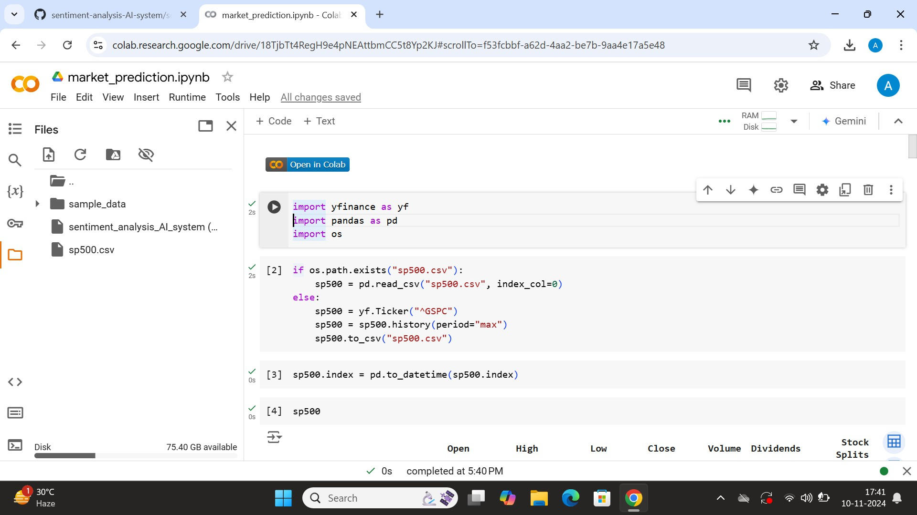

   

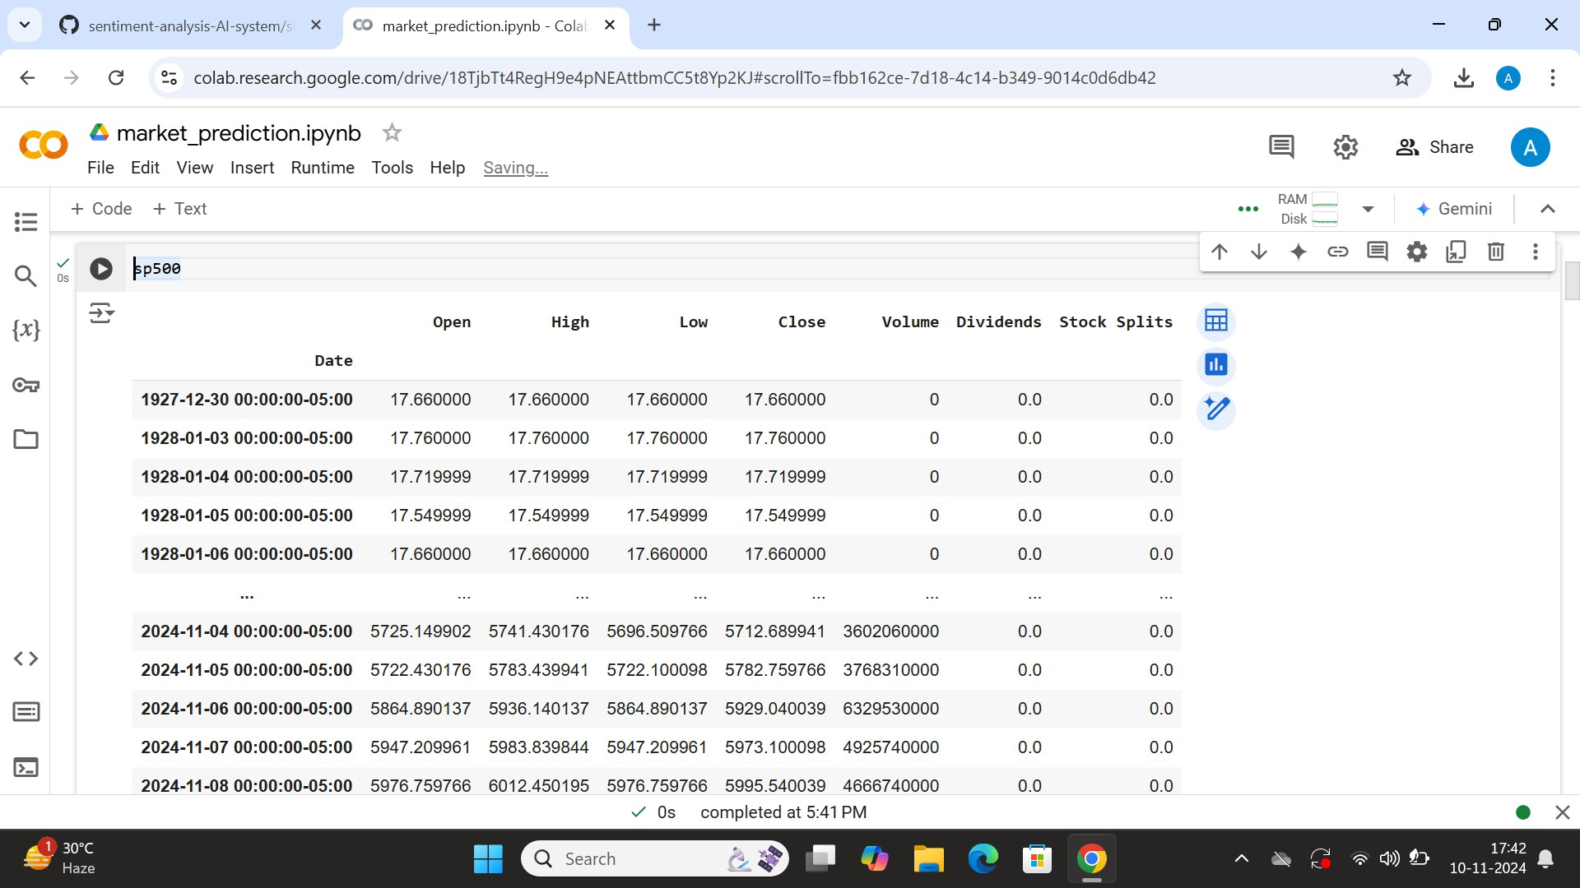

   

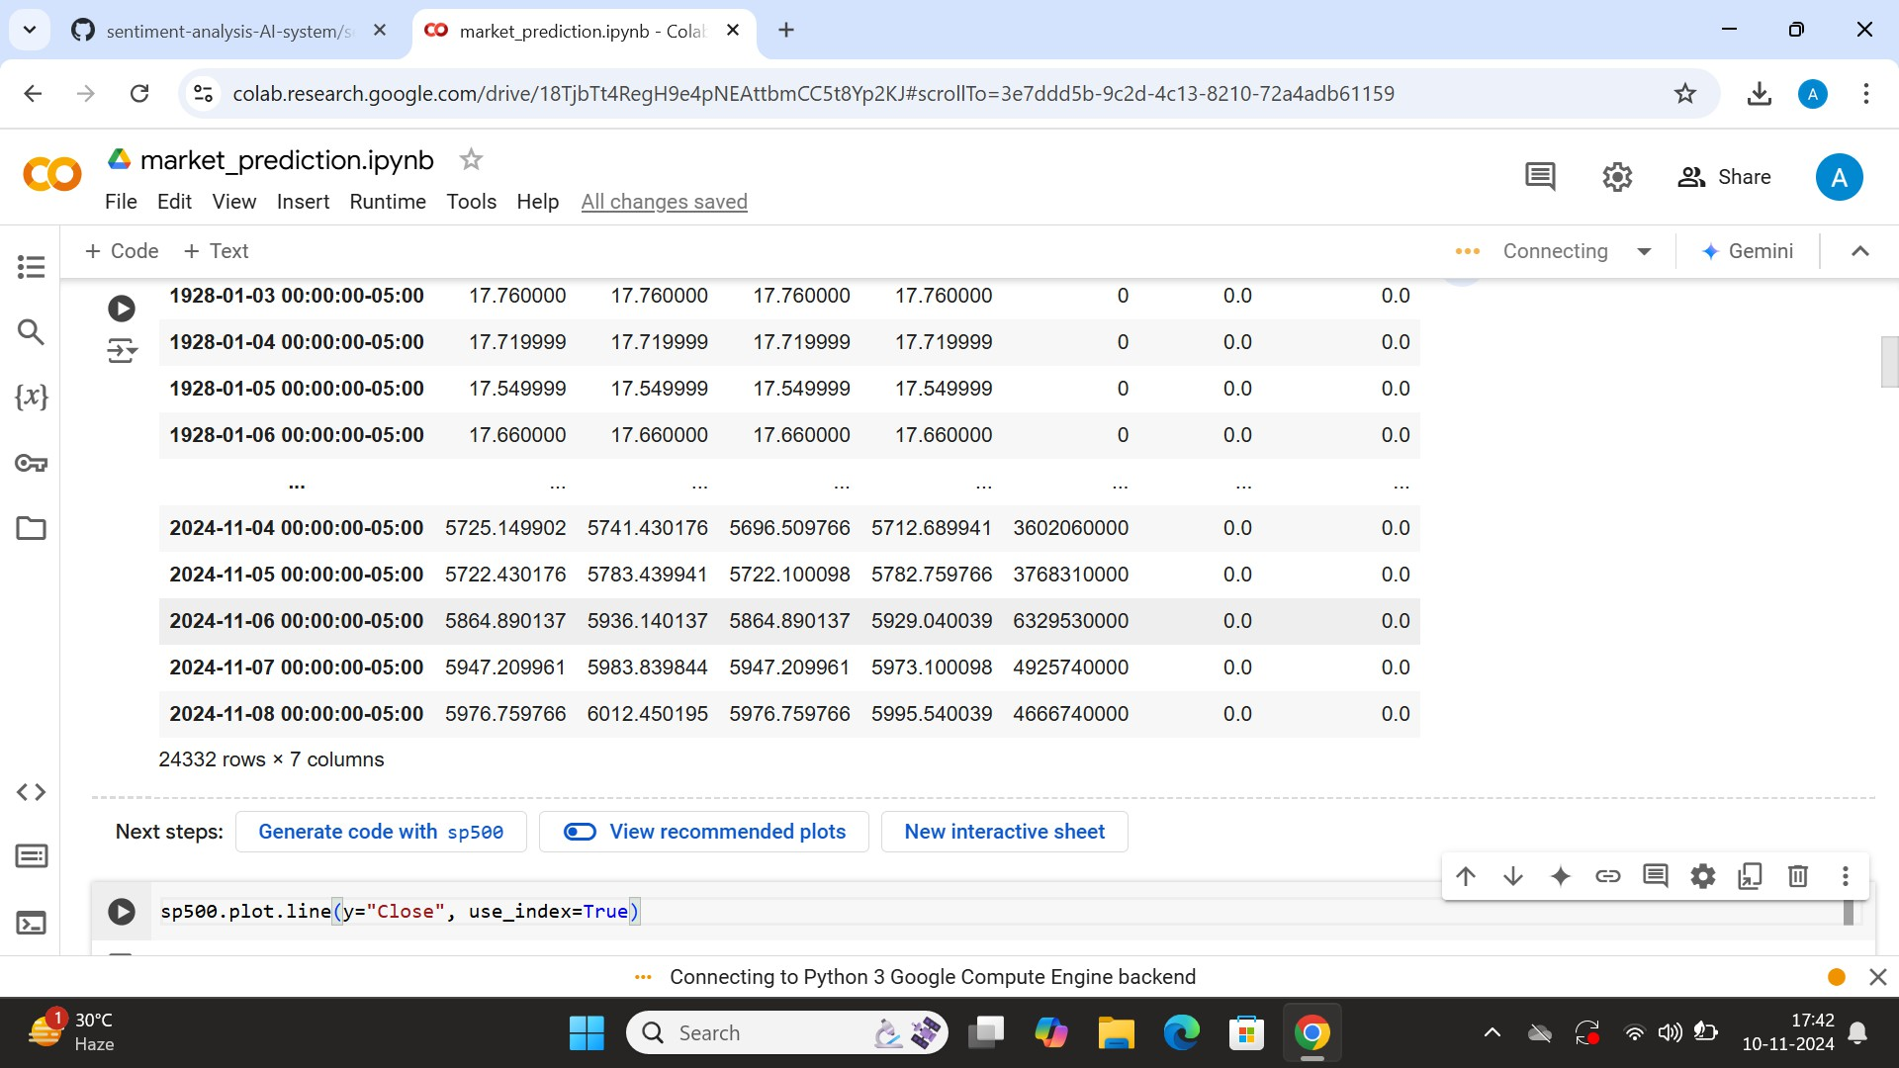

   

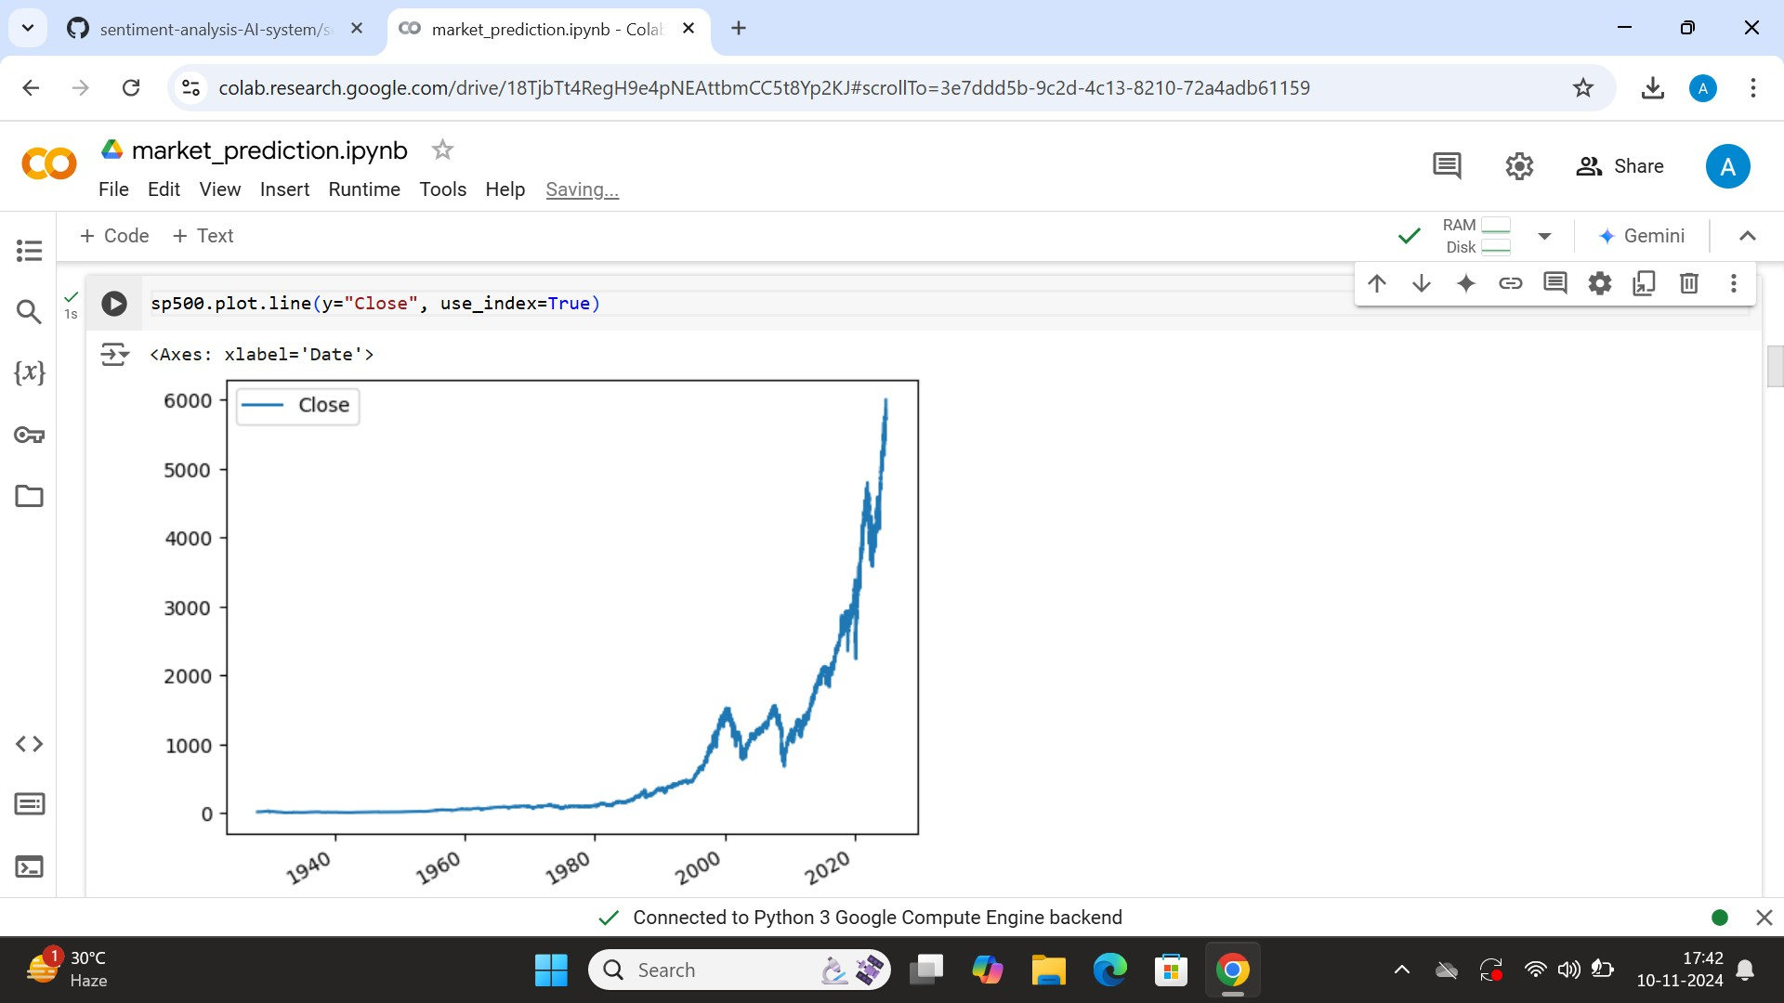

   

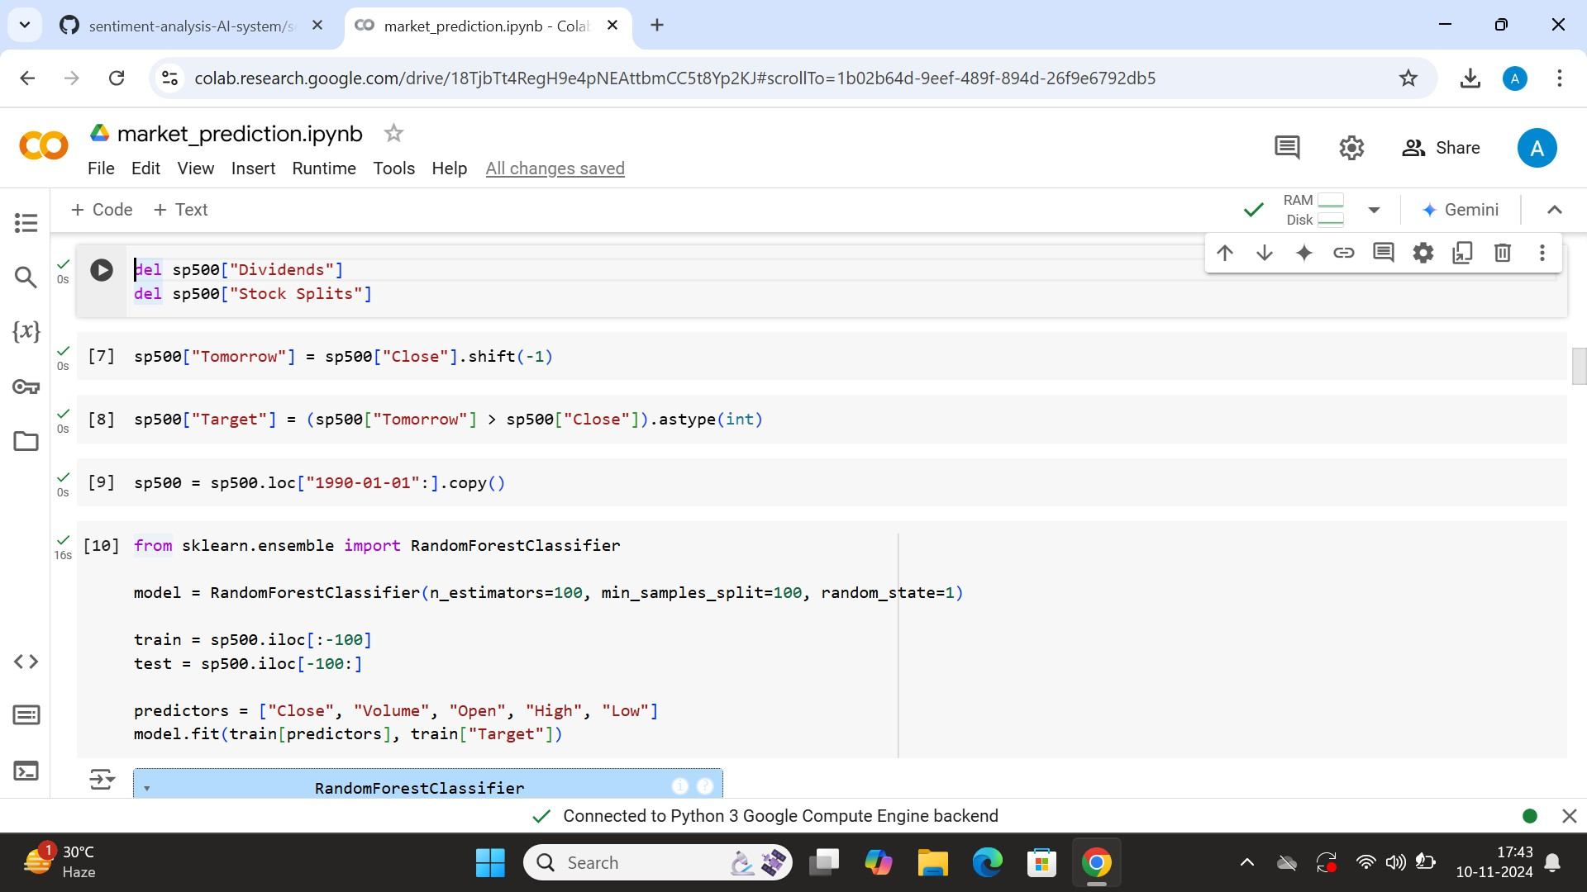

   

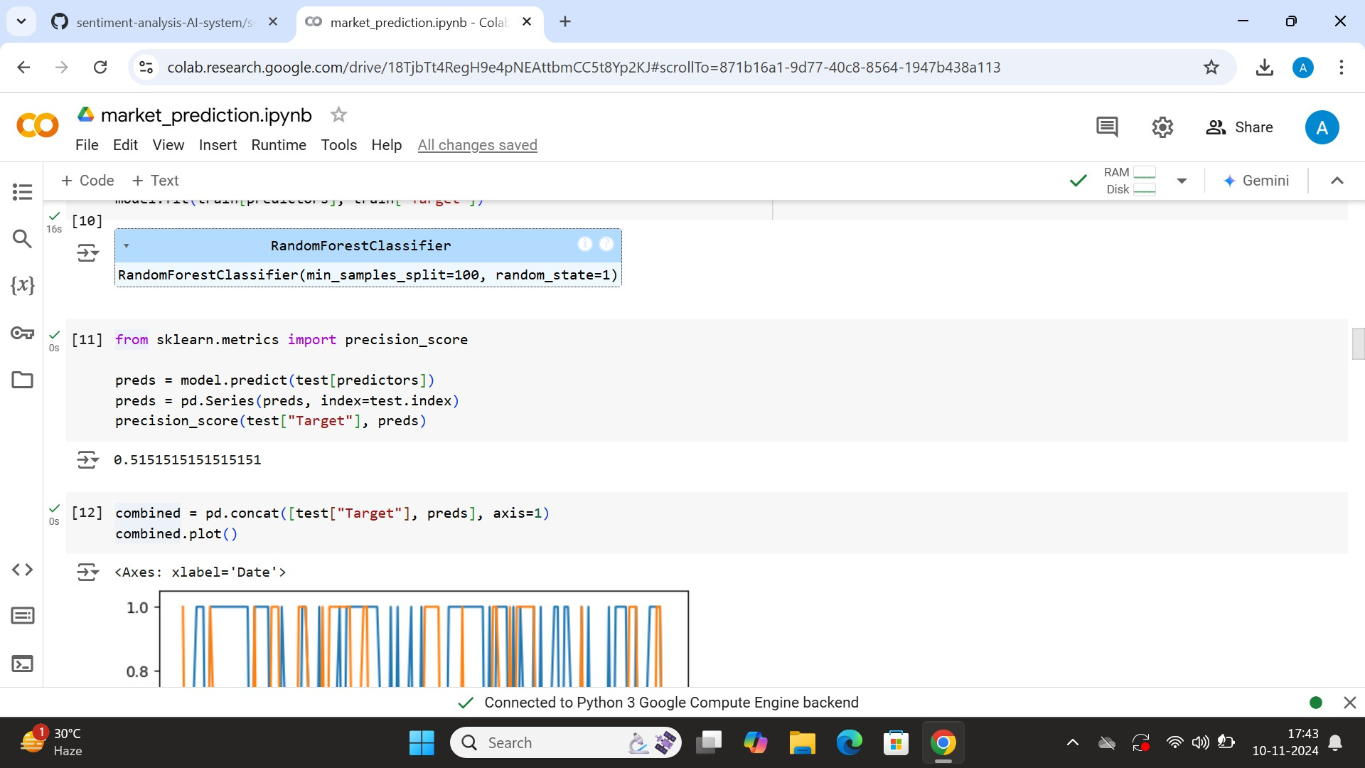

   

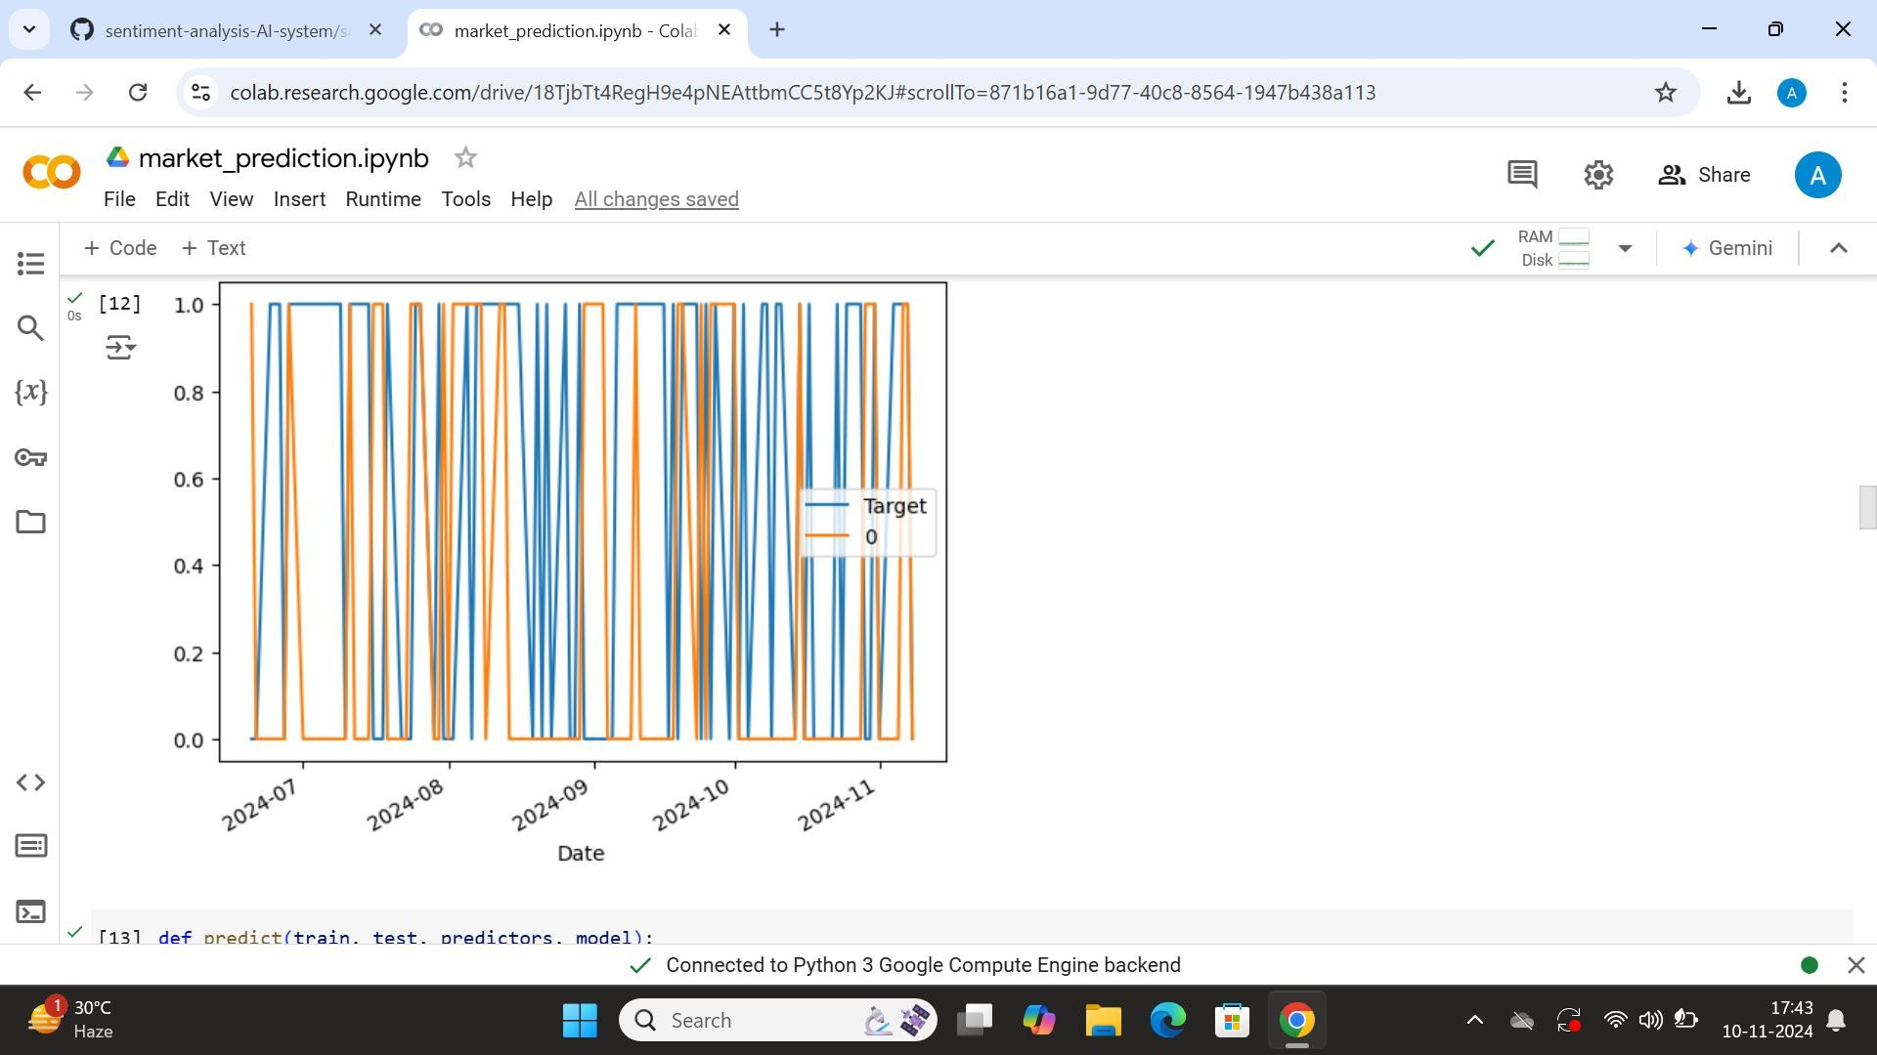

   

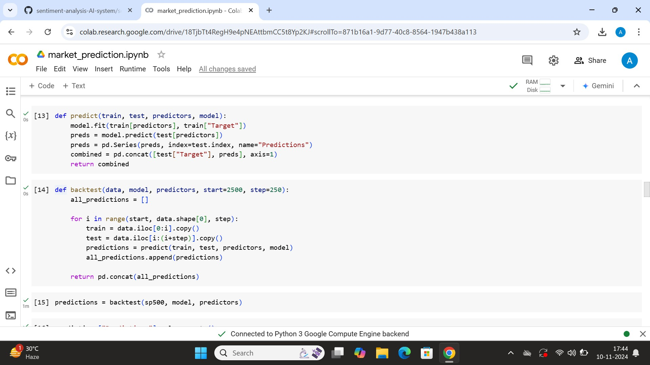

   

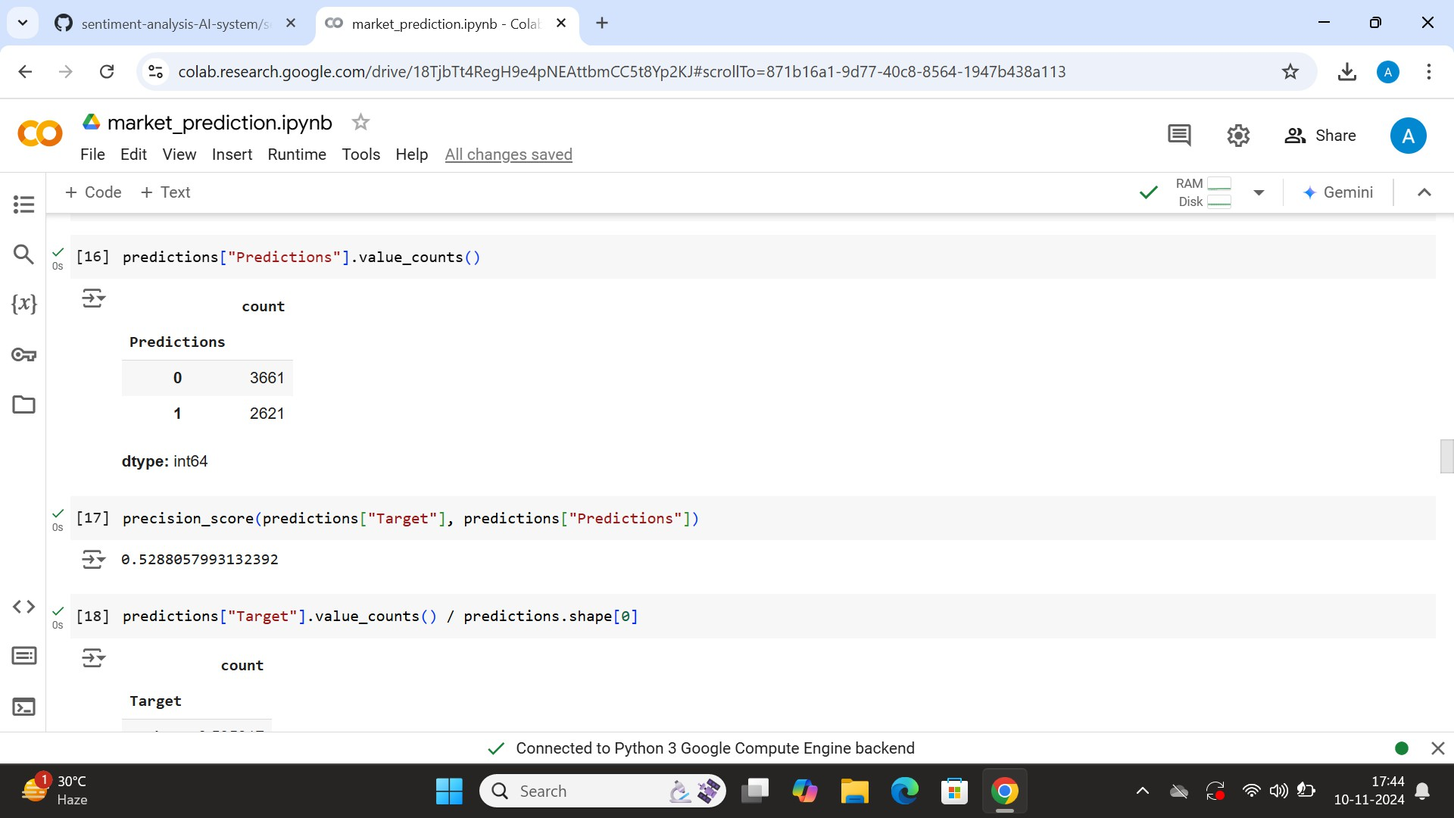

   

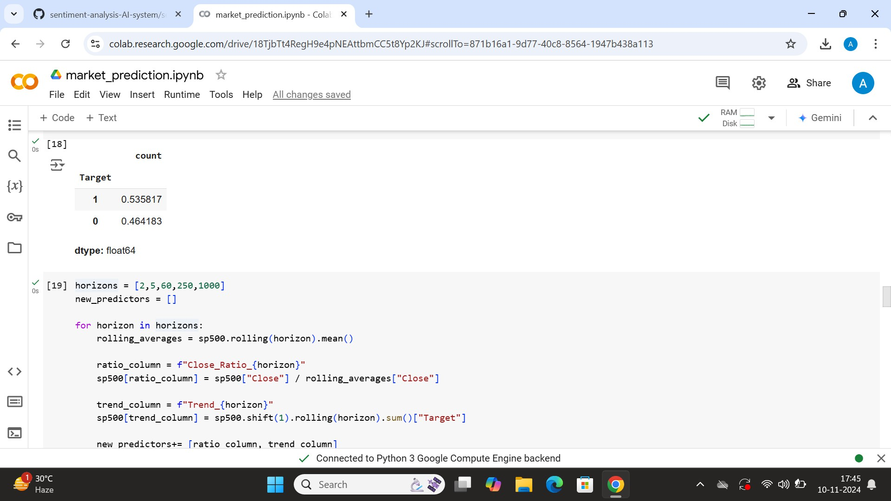

   

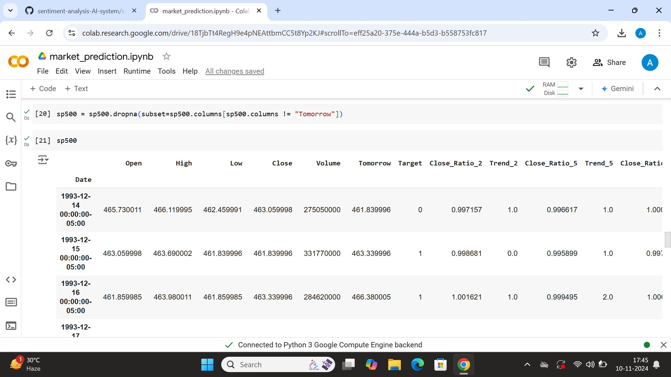

   

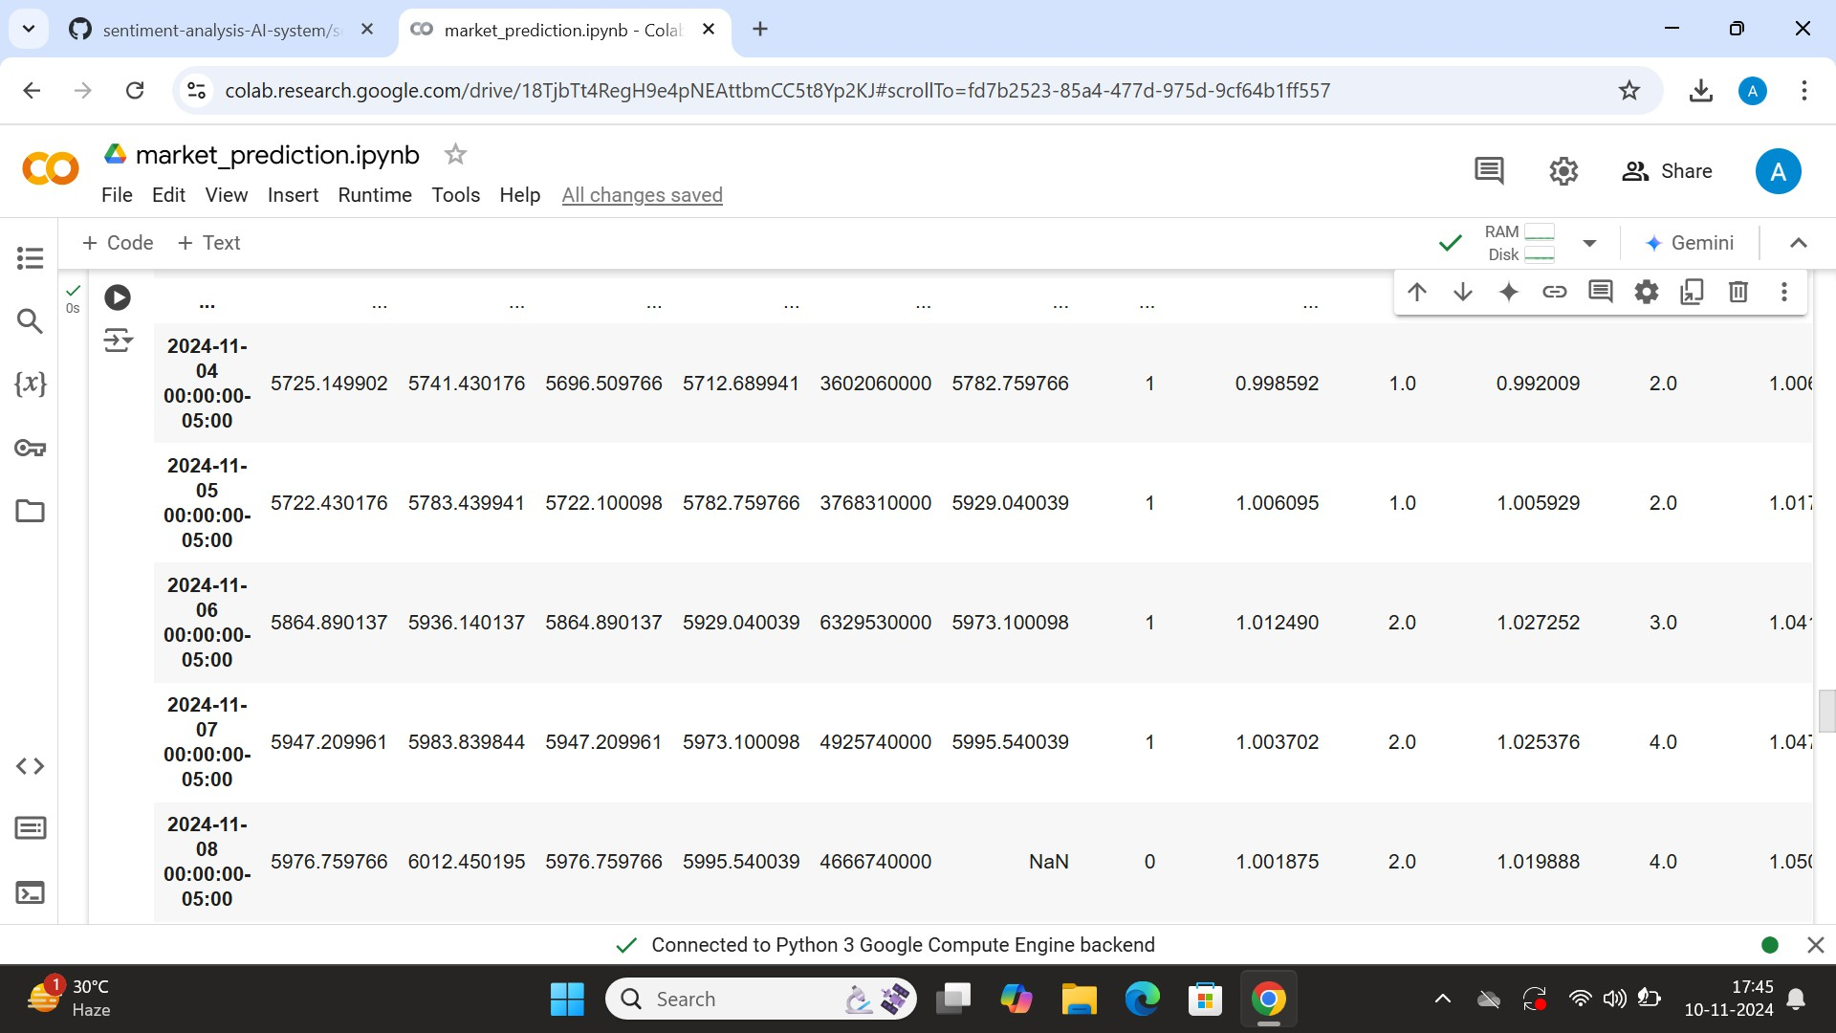

   

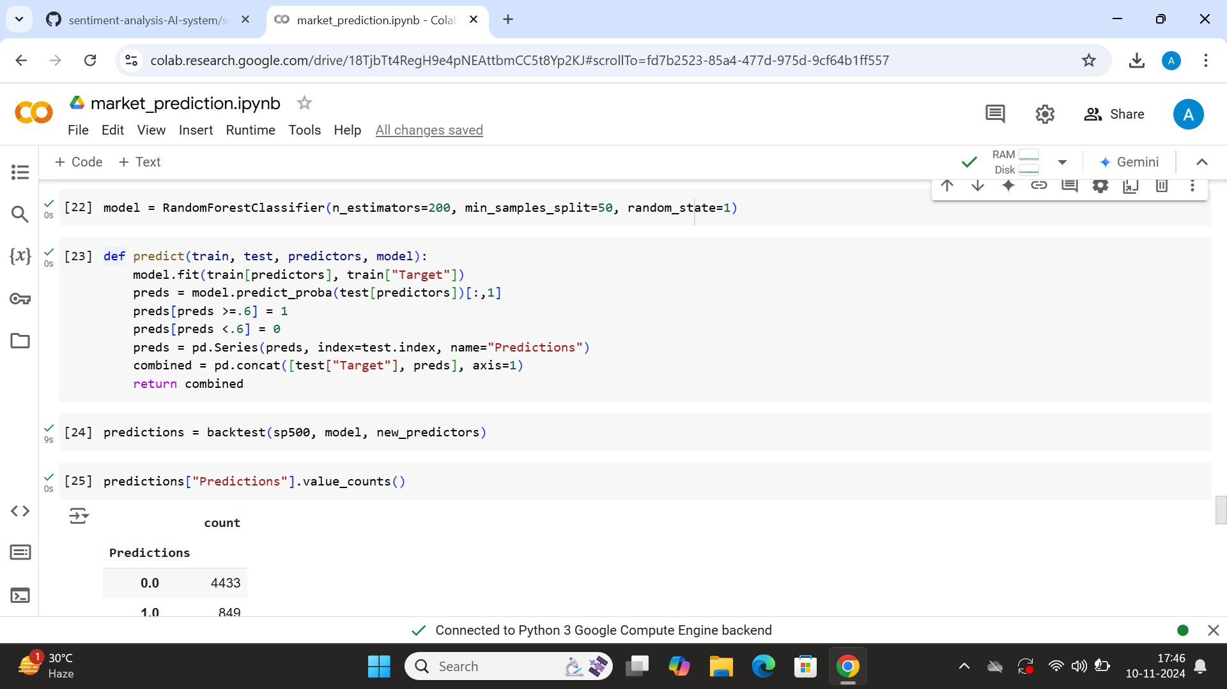

   

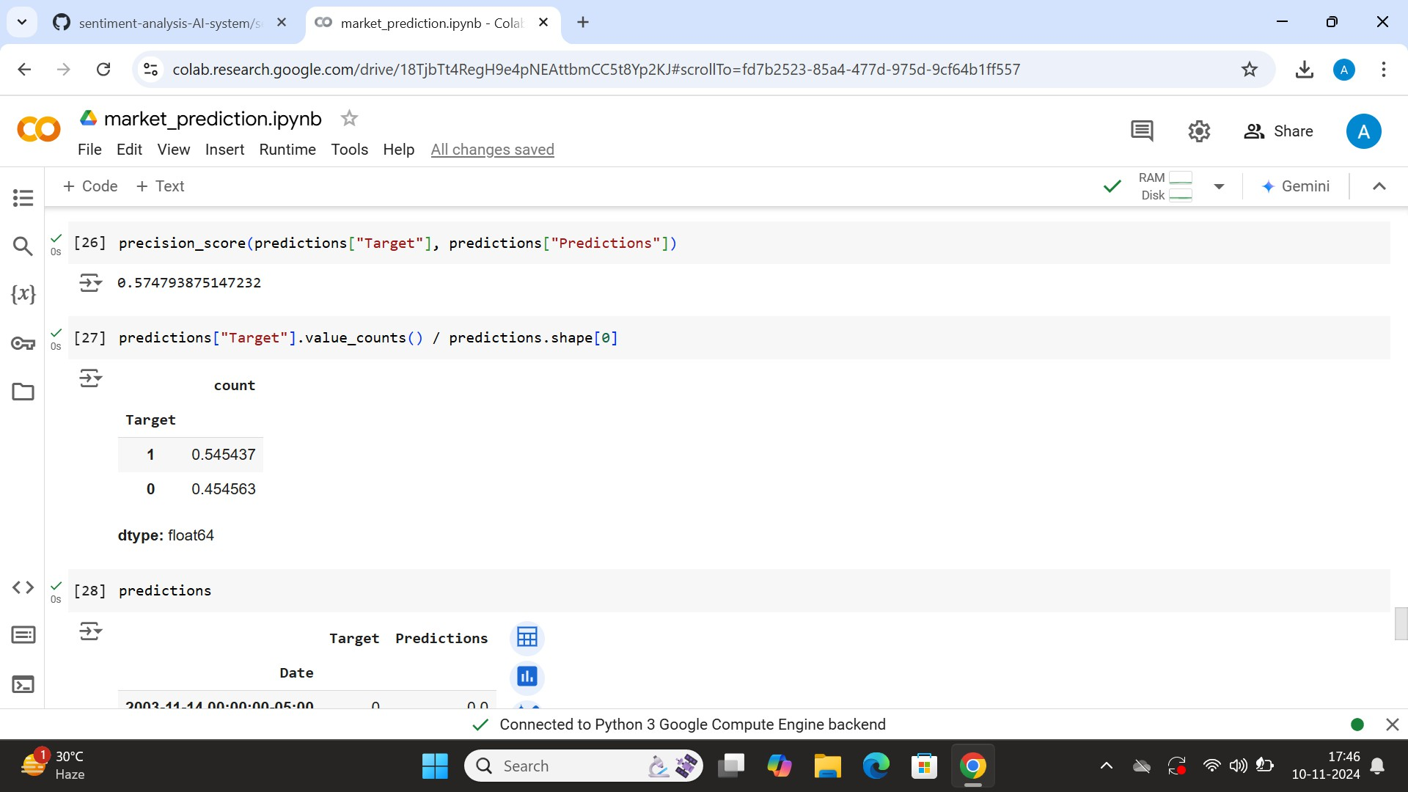

   

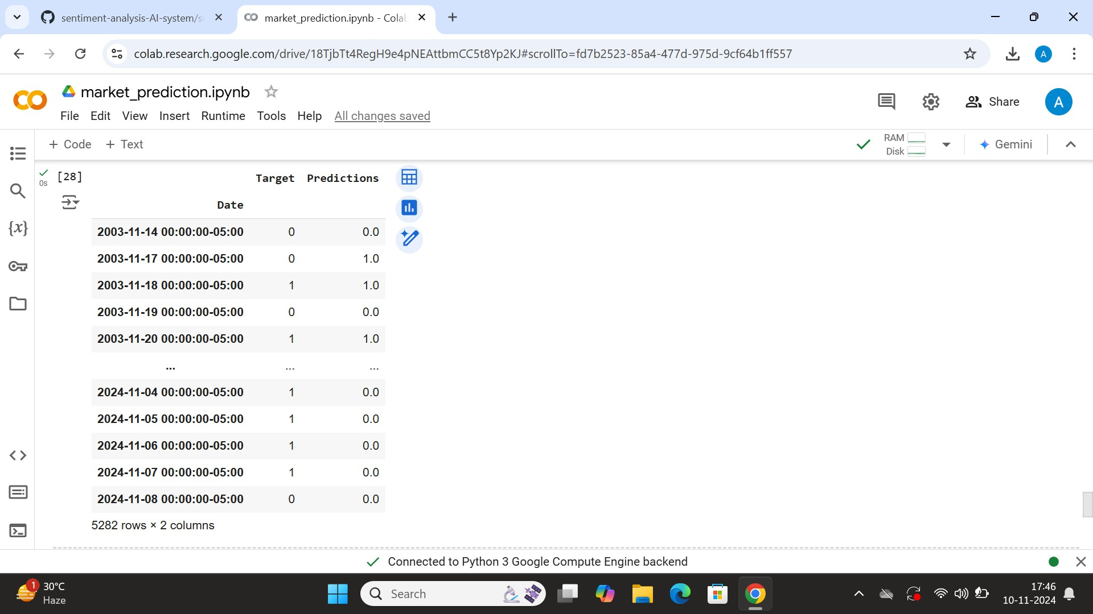

   

# CHAPTER 5 Discussion and Conclusion

* 1. **Key Findings:** Summarize the key results and insights from the project

Key advantages of the methodology include:

High Accuracy and Robustness: The integration of various models, from traditional machine learning algorithms to cutting-edge transformer-based models, ensures better sentiment detection even in ambiguous or nuanced cases.

Scalability: The system is optimized for real-time processing and can handle large volumes of data, making it suitable for a wide range of applications, from social media monitoring to customer feedback analysis.

Domain Adaptability: Through transfer learning, the methodology can be fine-tuned for specific industries or use cases, improving its performance and relevance to different types of sentiment analysis tasks.

Contextual Understanding: Transformer models excel in understanding the context in which words appear, allowing for more accurate sentiment classification in longer and more complex texts.

Flexibility and Customization: The methodology supports both binary and multi-class sentiment analysis, enabling the classification of emotions beyond simple positive and negative

sentiments, and can be adapted for different types of data (reviews, social media posts, etc.).

To implement this methodology effectively, it requires specific hardware (e.g., powerful GPUs for deep learning), software (e.g., Python, TensorFlow, Hugging Face Transformers), and cloud infrastructure for scalable and real-time deployment. Additionally, ensuring security, data privacy, and model monitoring is essential to maintain the integrity and performance of the system over time.

In conclusion, this comprehensive and flexible approach to sentiment analysis allows organizations to gain deeper insights from textual data, improving customer experience, brand management, and decision-making processes. By continually adapting to new trends and finetuning models, it ensures sustained effectiveness and relevance in an ever-changing linguistic landscape.

* 1. **GET THE GITHUB LINK:**

[**https://github.com/Guruprasath-27/Project-.git**](https://github.com/Guruprasath-27/Project-.git)

   

* 1. **Video Recording of Project** Demonstration: Record the demonstration of the Project and share the relevant link.
  2. **Limitations:** Discuss the limitations of the current model or approach.
     1. Contextual Ambiguities

Difficulty with Sarcasm and Irony: Sentiment analysis models, even advanced ones like transformers, often struggle to

detect sarcasm, irony, or humor, which can significantly alter the sentiment of a sentence. For example, the phrase "Great job, as always" may be positive in a neutral context but negative when used sarcastically, which the AI might miss.

* + 1. Domain Dependency

Limited Generalization Across Domains: While pre-trained models like BERT can be fine-tuned for specific domains (e.g.,

healthcare, finance), they may not perform as well on texts outside their training domain. For instance, a model fine-tuned on movie reviews may not perform well on customer feedback in e-commerce.

* + 1. Data Quality and Bias

Dependence on Training Data: Sentiment analysis systems rely heavily on the quality and diversity of training data. If the dataset is biased or unbalanced (e.g., containing mostly positive reviews), the model may develop skewed predictions and fail to accurately classify negative or neutral sentiments.

* + 1. Language and Syntax Challenges

Subtle Nuances and Idioms: Sentiment analysis systems can struggle to identify the sentiment in

complex sentence structures, idioms, or figurative language. For example, "bitter victory" or "sweet defeat" might be misclassified if the model doesn't understand the idiomatic usage of words.

* + 1. Real-Time Processing Limitations

Computational Resources: Deep learning-based models, especially transformer models like BERT or GPT, are computationally expensive and require powerful hardware (e.g., GPUs). This can limit the scalability of real-time applications, especially in resource-constrained environments

.

   

* 1. **FUTURE WORK : Provide suggestions for Improving the model**
     1. Advanced Contextual Understanding

Improving Sarcasm and Irony Detection: Future models should be able to better understand subtle language features like sarcasm, irony, and humor. This could involve developing more sophisticated models that can identify contextual cues beyond the text itself, including social and cultural factors or using multimodal inputs (e.g., voice tone, facial expressions in videos).

* + 1. Domain Adaptability and Fine-Grained Analysis

Domain-Specific Models: Enhancing models to more effectively adapt to various domains (e.g., healthcare, legal, finance, or entertainment) is a key focus. This could involve creating more domainspecific sentiment lexicons or designing transfer learning techniques that can better generalize across domains.

1. Multimodal Sentiment Analysis

Integrating Text, Voice, and Visual Data: The future of sentiment analysis will involve multimodal systems that can combine text, audio, and visual inputs to get a more

comprehensive understanding of sentiment. For instance, analyzing voice tone, facial expressions, and body language together with the text of a message could significantly improve the detection of

emotions, especially in applications like video analysis or customer service calls.

1. Real-Time and Scalable Sentiment Analysis

Optimizing for Real-Time Processing: Future work could focus on real-time sentiment analysis for large-scale applications, such as monitoring live social

media feeds, news streams, or financial market trends. Optimizing deep learning models for faster inference and reducing the computational load without sacrificing accuracy is a key area of focus.

1. Addressing Bias and Ethical Concerns

Bias Mitigation: AI models, including those for sentiment analysis, often inherit biases present in the training data. A significant area of future work is focused on developing techniques for detecting and mitigating bias in sentiment analysis models, ensuring

fairness in decision-making. This could involve designing methods for diversified training datasets and incorporating fairness constraints into the learning process.

   

* 1. **CONCLUSION**:Summarize the overall impact and contribution of the project

Sentiment analysis AI systems have made significant strides in recent years, revolutionizing how organizations and researchers understand human emotions and opinions expressed in text. By leveraging advanced techniques in natural language

processing, machine learning, and deep learning, these systems are now capable of accurately classifying sentiments across various domains and applications, from social media monitoring to customer feedback analysis.

However, despite their progress, sentiment analysis systems still face challenges related to contextual ambiguities, domain adaptation, data biases, and the ability to understand nuanced emotions like sarcasm or irony. The need for real-time

processing, multimodal capabilities, and the continual adaptation of models to new linguistic trends also presents ongoing obstacles.

Future work in sentiment analysis will focus on overcoming these challenges. Key areas of development include improving contextual understanding, handling multimodal inputs, enhancing domain adaptability, addressing ethical concerns like bias mitigation and privacy, and enabling continuous learning for

dynamic environments

   

# REFERENCES

Here is a list of potential references that could be included in a paper or research project on sentiment analysis AI systems:

VaderSentiment Documentation

Hutto, C.J., & Gilbert, E.E. (2014). "VADER: A Parsimonious Rule-based Model for

Sentiment Analysis of Social Media Text". Proceedings of the Eighth International Conference on Weblogs and Social Media (ICWSM-14).

https://arxiv.org/abs/1810.04805

RoBERTa: A Robustly Optimized BERT Pretraining Approach

Liu, Y., Ott, M., Goyal, N., Du, J., Xu, J., & Mané, D. (2019). "RoBERTa: A Robustly Optimized BERT Pretraining Approach".

arXiv preprint arXiv:1907.11692.