**CREATE TABLE CLIENT MASTER AND INSERT THE DATA**

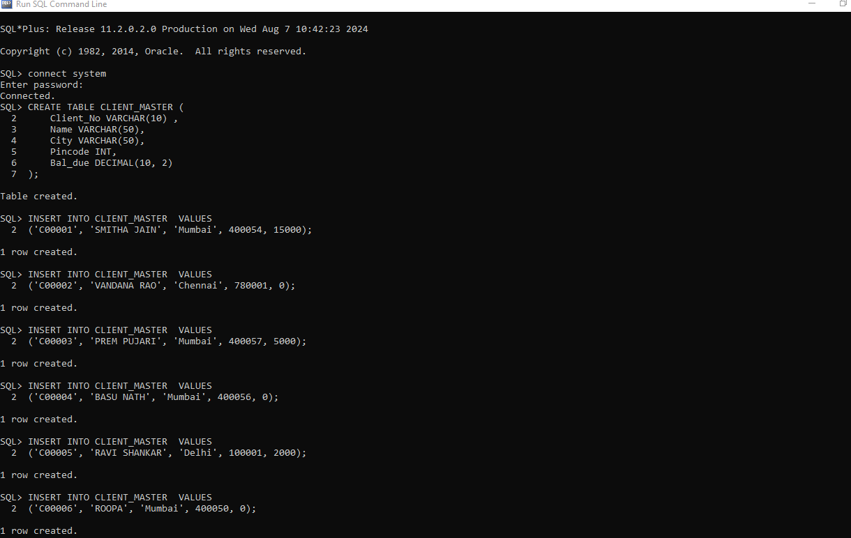

**CREATE TABLE SALE_ORDER AND INSERT THE DATA**

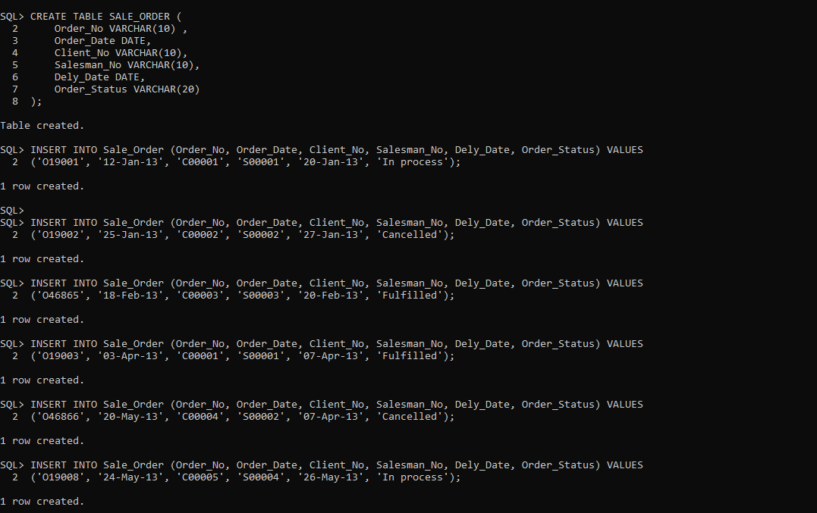

1. **List all details from the client_master table for clients whose Bal_due = 0.**

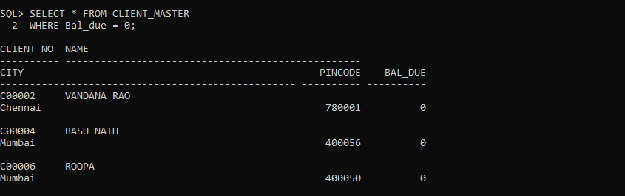

1. **Update table client_master, Change city of Client_no C00004 to Jaipur.**

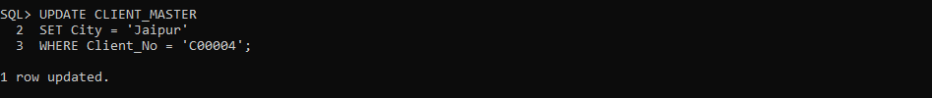

1. **Retrieve records of clients residing in Mumbai.**

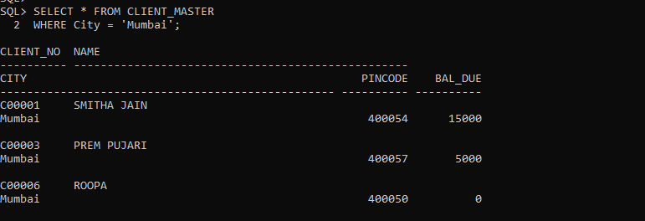

1. **Find the name and address of customer who has placed Order_no 'O19003' and 'O19002' respectively.**

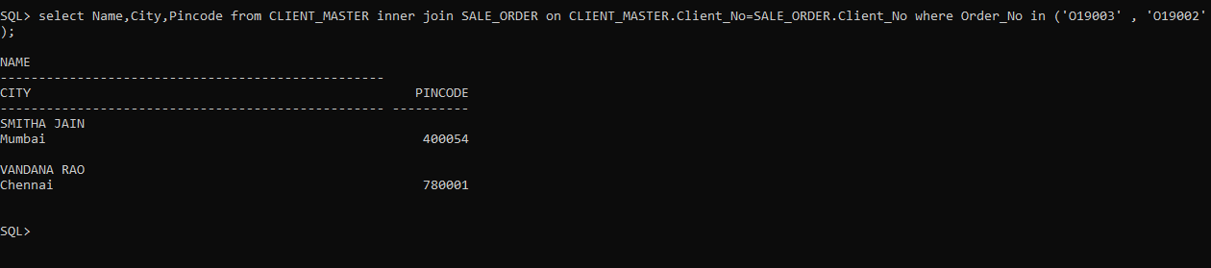

1. **Construct English like sentence from the table client_master ({Customer name} live in the city of {city}).**

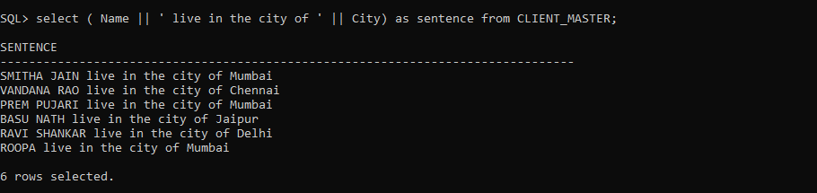

1. **List the client_no, name, city and pincode of clients whose Order_status is "In process".**

