Week 5 Report: Strategic Recommendation and Operational Planning in Agribusiness
Name: Guru priya D.
Task: Week 5 – Strategic Recommendation and Operational Planning
Dataset: crops.csv.csv (1997–2015)
Tools Used: R, RStudio, ggplot2, dplyr
1. Introduction
This report converts the findings from previous weeks' data analysis into practical strategies for improving agribusiness operations. Earlier analyses of the crops.csv dataset identified production trends, seasonal variations, and key risks affecting agricultural performance. The objective of this task is to recommend actionable strategies that improve productivity, reduce operational risks, and support sustainable growth. The recommendations are supported by production trends, crop performance, and operational planning with measurable outcomes.
2. Analysis Summary
The analysis of Indian crop production data from 1997 to 2015 revealed several important patterns. Production levels fluctuated across different years, indicating the influence of environmental and operational factors. The analysis also showed that certain crops contribute significantly more to total production than others, suggesting opportunities for targeted investment. Previous risk assessment identified climate variability, market price fluctuations, and seasonal dependence as major challenges affecting agribusiness performance.

Figure 1: Top 10 Crops by Total Production
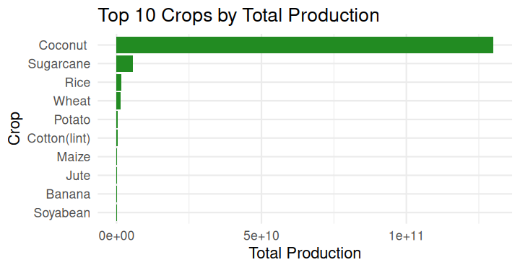
Figure 1 identifies the ten crops contributing the highest total production, helping prioritize resource allocation and investment decisions.
3. Strategic Recommendations
Strategy 1: Prioritize High-Producing Crops
Invest more resources in crops that consistently contribute higher production through improved seeds, irrigation, and technical support.
Strategy 2: Strengthen Seasonal Planning
Use seasonal production patterns to schedule planting, harvesting, and resource allocation more effectively.
Strategy 3: Improve Market and Supply Chain Efficiency
Expand storage facilities, encourage digital marketplaces, and improve transportation to reduce post-harvest losses and stabilize farmer income.

4. Operational Planning
Figure 2: Average Production by Season
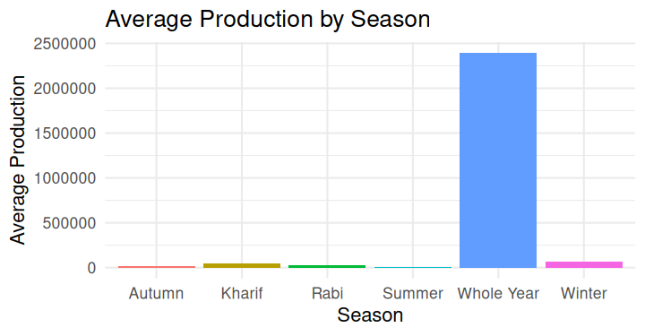
Figure 2 highlights production differences across agricultural seasons, supporting better seasonal planning and resource management.
Implementation Plan
Phase | Timeline | Activities
Planning | Month 1 | Review production data and identify priority crops
Preparation | Month 2 | Arrange training, irrigation support, and storage planning
Implementation | Months 3–5 | Apply improved farming and marketing practices
Monitoring | Month 6 | Measure results and evaluate performance
Required Resources
- Agricultural extension officers
- Weather forecasting information
- Irrigation facilities
- Storage infrastructure
- Digital market platforms
- Farmer training programs
5. Key Performance Indicators (KPIs)
KPI | Target
Production improvement | 10–15% increase
Reduction in post-harvest losses | 15% decrease
Farmer participation | Above 80%
Market access improvement | Increased digital marketplace participation
Seasonal planning efficiency | Better resource allocation across seasons
Figure 3: Forecasted Crop Production (2016–2020)

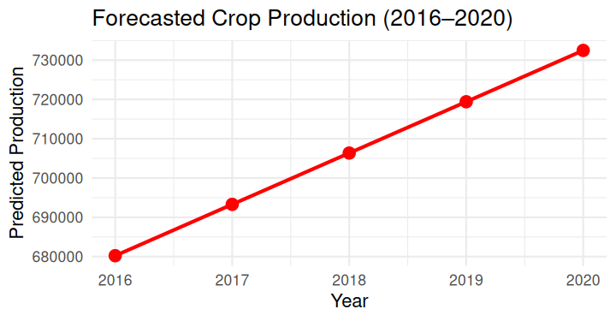
Figure 3 presents projected production trends, supporting long-term planning and strategic decision-making.
6. Potential Challenges
Implementation may face several challenges, including unpredictable weather conditions, limited financial resources, infrastructure constraints, and varying levels of farmer adoption. Market competition and transportation limitations may also affect operational efficiency.
7. Expected Outcomes
The recommended strategies are expected to improve productivity, strengthen climate resilience, reduce operational risks, and increase farmer profitability. Better planning based on production trends and seasonal insights can support more efficient resource management and long-term agricultural sustainability.
8. Conclusion
The strategic recommendations presented in this report build directly on the production analysis and risk assessment completed in previous weeks. By focusing on high-producing crops, improving seasonal planning, and strengthening market access, agribusiness operations can become more efficient and resilient. Continuous monitoring through performance indicators and data-driven decision-making will support sustainable agricultural growth and improved operational performance over time.

