Week 3: Statistical Analysis and Agribusiness Forecasting
Dataset: crops.csv.csv
Tool Used: R (Posit Cloud)
Student: Guru priya D
Introduction
This report analyzes an Indian crop production dataset containing 246,091 records across 33 states, 646 districts, and 124 crops from 1997–2015. Descriptive statistics, correlation analysis, linear regression, and a forecasting model were used to study production patterns and estimate future trends.
Dataset Description
Item | Value
Rows | 246,091
Columns | 7
States | 33
Districts | 646
Crops | 124
Years | 1997–2015
Missing values after cleaning | 0
Methodology
The dataset was cleaned using na.omit(), Crop_Year was converted to numeric, descriptive statistics were generated with summary(), Pearson correlation measured the relationship between Area and Production, simple linear regression modeled Production from Area, and a forecasting model used yearly average production.
Descriptive Statistics
Measure | Area | Production
Minimum | 0.1 | 0
1st Quartile | 87 | 88
Median | 603 | 729
Mean | 12,167.4 | 582,500
3rd Quartile | 4,545 | 7,023
Maximum | 8,580,100 | 1,251,000,000
Correlation Analysis
Pearson correlation coefficient (Area vs Production): 0.04058748
Interpretation: The relationship is very weak but positive, indicating cultivated area alone does not strongly explain production across the complete dataset.
Regression Analysis
Model: Production = 416,800 + 13.62 × Area
Statistic | Value
Intercept | 416,800
Area Coefficient | 13.62
t-value | 20.0
Residual Standard Error | 17,050,000
Multiple R² | 0.001647
Adjusted R² | 0.001643
F-statistic | 399.9
p-value | <2.2 × 10⁻¹⁶
Interpretation: The Area coefficient is statistically significant, but Area alone explains only about 0.16% of the variation in production.
Hypothesis Testing
H₀: Cultivated area has no significant effect on crop production.
H₁: Cultivated area has a significant effect on crop production.
Decision: Since p < 0.05, the null hypothesis is rejected.
Forecast Model
Yearly average production (1997–2015) was used to build a linear forecast model.
Statistic | Value
Year Coefficient | 13,062
Multiple R² | 0.09661
Adjusted R² | 0.04347
F-statistic | 1.818
p-value | 0.1952
Interpretation: The yearly trend is not statistically significant, but it provides a simple demonstration of forecasting.
Forecast (2016–2020):
Year | Forecast
2016 | 680,227.9
2017 | 693,289.5
2018 | 706,351.1
2019 | 719,412.6
2020 | 732,474.2
Visualizations
Figure 1: Area vs Production

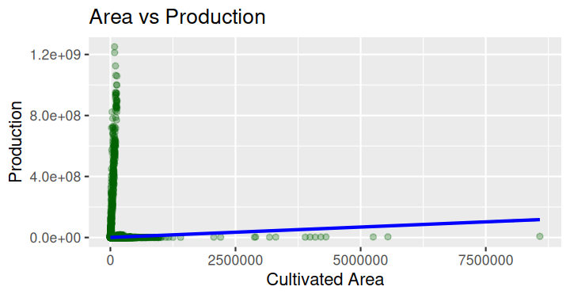

Figure 2: Average Production by Year

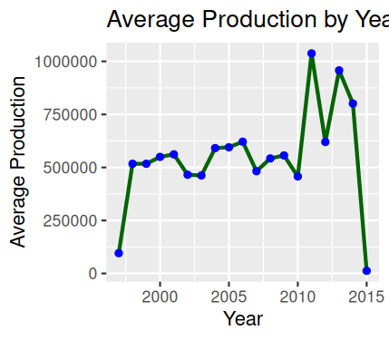

Figure 3: Forecasted Crop Production

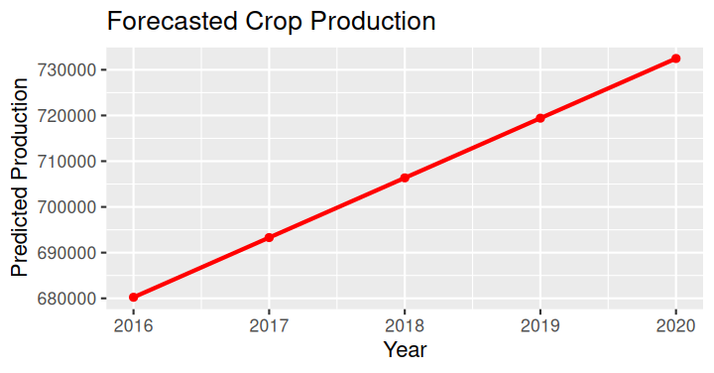

Conclusion
The statistical analysis showed that cultivated area has a statistically significant but weak relationship with production. The forecasting model demonstrated how historical yearly averages can be used to estimate future production, while visualizations helped interpret production patterns over time.

