Week 6 Report: Reflective Analysis and Future Forecasting in Agribusiness
Name: Guru priya D.
Internship: Agribusiness Data Analysis Virtual Internship
Task: Week 6 – Reflective Analysis and Future Forecasting
Dataset Used: crops.csv (Indian Crop Production Data, 1997–2015)
Tools Used: Python, Pandas, Matplotlib, R, RStudio (Posit Cloud), ggplot2, dplyr, Microsoft Word
Table of Contents
- Introduction
- Internship Project Review
- Methodologies Used Throughout the Internship
- Key Findings from Previous Weeks
- Reflective Analysis
- Future Forecasting
- Emerging Trends in Agribusiness
- Recommendations for Future Projects
- Future Action Plan
- Conclusion
1. Introduction
This report presents a comprehensive reflection on my six-week Agribusiness Data Analysis Virtual Internship. Throughout the internship, I learned how data analysis can support agricultural decision-making by transforming raw crop production data into meaningful insights. The project involved data collection, cleaning, visualization, statistical analysis, scenario planning, risk assessment, strategic recommendation development, and forecasting.
Each week's activities contributed to building a complete analytical workflow. Beginning with data preprocessing and ending with strategic planning and forecasting, the internship demonstrated how data-driven approaches can improve productivity, reduce operational risks, and support sustainable agricultural development. This final report summarizes the entire project, reflects on the learning experience, evaluates the methods used, and provides future-oriented recommendations for improving agribusiness through technology and analytics.
2. Internship Project Review
The internship was completed over six structured weeks, with each week focusing on a different stage of the data analysis process.
Week 1: Data Collection, Cleaning, and Initial Analysis
The first week focused on collecting agricultural data from public sources such as FAOSTAT, Data.gov.in, and Kaggle. The dataset was cleaned using Python by removing duplicates, handling missing values, validating data types, and performing exploratory data analysis through descriptive statistics and visualizations.
Week 1 Report.docx
Week 1 Report.docx
Week 2: Data Visualization and Insight Generation
The second week introduced data visualization techniques using RStudio. Bar charts, histograms, scatter plots, and line graphs helped identify production patterns, relationships between cultivated area and production, and yearly production trends.
Week2_Data_Visualization_Report.docx
Week2_Data_Visualization_Report.docx
Week 3: Statistical Analysis
Statistical analysis was performed to better understand production behavior. Correlation analysis, summary statistics, and trend analysis provided deeper insights into agricultural production and helped prepare the dataset for forecasting and strategic planning.
Week 4: Scenario Analysis and Risk Assessment
Three realistic agribusiness scenarios were developed based on previous analyses. Major risks such as climate variability, seasonal dependence, market price fluctuations, and uneven cultivated area were identified and prioritized through a risk assessment matrix.
Week 5: Strategic Recommendation and Operational Planning
The fifth week converted analytical findings into practical business strategies. Operational plans, implementation timelines, measurable Key Performance Indicators (KPIs), and resource requirements were proposed to improve agricultural efficiency and long-term sustainability.
Week 6: Reflection and Future Forecasting
The final week consolidates all previous learning while exploring future opportunities for technology-driven agricultural development.
3. Methodologies Used Throughout the Internship
Several analytical methods were applied throughout the internship.
Data Collection
Agricultural production data was obtained from publicly available datasets containing crop production records across Indian states and districts.
Data Cleaning
The preprocessing stage included:
- Removing duplicate records.
- Handling missing values.
- Verifying data types.
- Validating dataset quality.
- Preparing the data for analysis.
Exploratory Data Analysis (EDA)
EDA was performed using:
- Summary statistics
- Histograms
- Box plots
- Correlation analysis
- Trend evaluation
Data Visualization
Visualizations were created using:
- Bar charts
- Scatter plots
- Line graphs
- Risk analysis charts
Forecasting
Simple trend forecasting techniques were applied using historical production data to estimate future production patterns.
4. Key Findings from Previous Weeks
The internship produced several valuable insights.
Production Trend Analysis
Agricultural production varied considerably across different years, indicating that environmental and operational factors strongly influence output.
Figure 1: Average Production by Year (1997–2015)

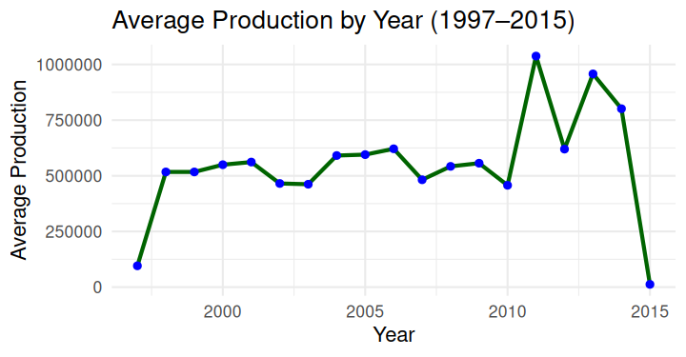
The yearly production trend illustrates fluctuations in agricultural output, highlighting the importance of long-term planning and forecasting.
Cultivated Area and Production
The relationship between cultivated area and production revealed that larger cultivated areas generally contribute to higher production, although other factors such as irrigation, rainfall, and crop type also play important roles.

Figure 2: Area vs Production in Indian Agriculture

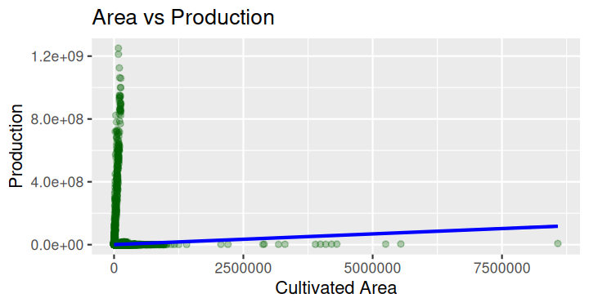
The scatter plot demonstrates a positive relationship between cultivated area and production while showing the influence of additional agricultural factors.
High-Producing Crops
Analysis identified crops contributing significantly to total production, providing useful information for future resource allocation and investment decisions.
Figure 3: Top 10 Crops by Total Production
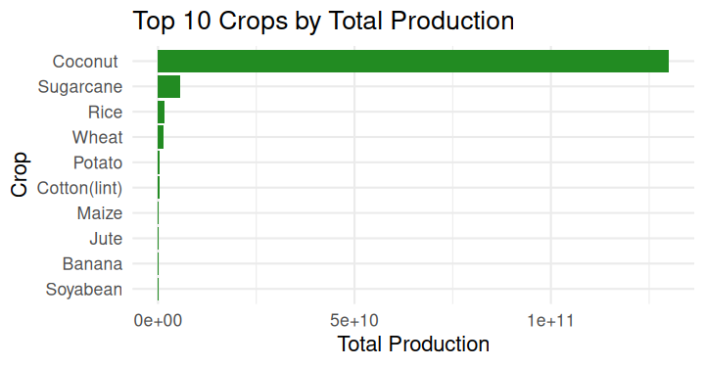

High-producing crops can be prioritized for future planning and productivity improvement initiatives.
Major Risks Identified
The risk assessment highlighted four primary challenges:
- Climate variability
- Market price fluctuations
- Seasonal dependence
- Uneven cultivated area
These risks formed the basis for strategic recommendations developed during Week 5.
5. Reflective Analysis
This internship significantly improved my understanding of practical data analysis. Initially, learning new tools such as RStudio and handling coding errors required patience and continuous practice. Working with large agricultural datasets also emphasized the importance of proper data cleaning before performing meaningful analysis.
One of the most valuable lessons was understanding how visualizations simplify complex information. Charts made production trends, crop comparisons, and seasonal variations much easier to interpret than raw numerical tables alone.
Another important learning outcome was recognizing how different analytical stages connect together. Data collection, cleaning, visualization, statistical analysis, risk assessment, and forecasting are not separate activities but parts of one continuous decision-making process.
The internship also strengthened my problem-solving skills while debugging R code, handling missing data, and organizing professional reports.
6. Future Forecasting
Based on historical production trends, future agricultural production is expected to continue changing due to technological advancements, climate conditions, and evolving market demands.
Several developments are likely to shape future agribusiness.
- Increased adoption of precision agriculture.
- Wider use of weather forecasting systems.
- Expansion of digital marketplaces.
- Improved irrigation technologies.
- Greater reliance on predictive analytics.
Future forecasting models can become more accurate by incorporating rainfall, temperature, soil quality, and satellite monitoring data alongside production records.
7. Emerging Trends in Agribusiness
Modern agriculture is becoming increasingly technology-driven.
Artificial Intelligence
AI can improve crop disease detection, yield prediction, and farm management.
Internet of Things (IoT)
Sensors can monitor:
- Soil moisture
- Temperature
- Irrigation requirements
Remote Sensing
Satellite imagery and drones can help monitor crop health across large agricultural areas.
Digital Agriculture
Online marketplaces allow farmers to access buyers more efficiently while improving price transparency.
Predictive Analytics
Machine learning models can forecast production, market demand, and potential risks more accurately than traditional methods.
8. Recommendations for Future Projects
Future agribusiness projects can be improved through several enhancements.
Data Improvements
- Use more recent datasets.
- Integrate rainfall and weather data.
- Include soil quality information.
Analytical Improvements
- Apply machine learning for yield prediction.
- Use advanced forecasting models.
- Perform district-level comparative analysis.
Visualization Improvements
- Build interactive dashboards using Power BI or Tableau.
- Create real-time agricultural monitoring systems.
- Develop automated reporting dashboards.
Operational Improvements
- Expand farmer training programs.
- Improve irrigation infrastructure.
- Increase adoption of digital agricultural platforms.
9. Future Action Plan
Objective | Action | Expected Outcome
Improve forecasting | Apply machine learning models | Better yield prediction
Enhance monitoring | Integrate weather data | Improved planning
Increase productivity | Promote precision agriculture | Higher crop yields
Strengthen decision-making | Develop interactive dashboards | Faster analysis
Reduce operational risks | Improve irrigation and storage | Greater resilience
These actions can help agribusiness organizations become more efficient while improving long-term sustainability.
10. Conclusion
The Agribusiness Data Analysis Virtual Internship provided valuable practical experience in working with real-world agricultural datasets and applying analytical techniques across the complete project lifecycle. Beginning with data collection and cleaning, progressing through visualization, statistical analysis, risk assessment, strategic planning, and finally forecasting, the internship demonstrated how data-driven methods can improve agricultural decision-making.
The project strengthened both technical and analytical skills while improving confidence in using Python, R, and visualization tools. More importantly, it highlighted the growing role of technology, predictive analytics, and sustainable planning in the future of agriculture. The knowledge gained throughout these six weeks provides a strong foundation for future data analysis projects and supports continued learning in agribusiness and data science.

