Week 4 Report: Scenario Analysis and Risk Assessment in Agribusiness
Name: Guru priya D.
Course: Agribusiness Data Analysis Internship
Task: Week 4 – Scenario Analysis and Risk Assessment
Dataset: crops.csv.csv (1997–2015)
1. Introduction
Agribusiness is exposed to numerous uncertainties that affect crop production, market stability, and farmer profitability. Factors such as changing weather patterns, seasonal dependence, market price fluctuations, and regional differences in cultivation can significantly influence agricultural output. This report performs a scenario analysis using the crops.csv dataset containing crop production records across India from 1997 to 2015. By analyzing production trends and cultivated area, the report identifies major risks, evaluates possible future scenarios, and recommends practical mitigation strategies. The analysis is supported by graphical representations that help explain production patterns and risk priorities.
2. Methodology
The analysis was conducted using the cleaned crops.csv.csv dataset in R. Missing values were removed during previous analysis, and the dataset contained information on state, district, crop year, season, crop type, cultivated area, and production.
The methodology included:
- Analyzing yearly production trends.
- Examining the relationship between cultivated area and production.
- Identifying major agribusiness risks.
- Developing realistic future scenarios.
- Evaluating risks through a risk assessment matrix.
3. Production Trend Analysis
The yearly production trend provides an overview of how agricultural output changed between 1997 and 2015. The graph shows noticeable fluctuations across different years, indicating that production is influenced by multiple external factors such as rainfall, cultivation practices, and seasonal conditions.
Figure 1: Average Production by Year (1997–2015)

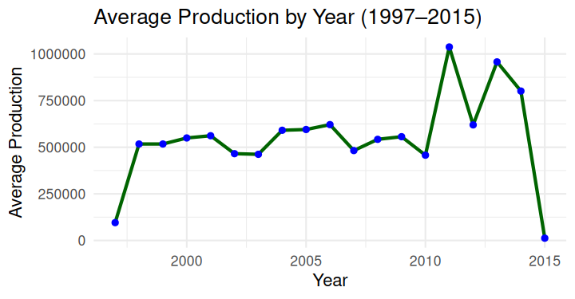

Figure 1 illustrates the annual average crop production from 1997 to 2015. The changing production levels indicate that agricultural output is not constant and is influenced by environmental and operational conditions.
4. Relationship Between Area and Production
The scatter plot compares cultivated area with crop production across different observations. Although larger cultivation areas generally contribute to higher production, the distribution of data points suggests that land area alone does not determine agricultural output.

Figure 2: Area vs Production in Indian Agriculture

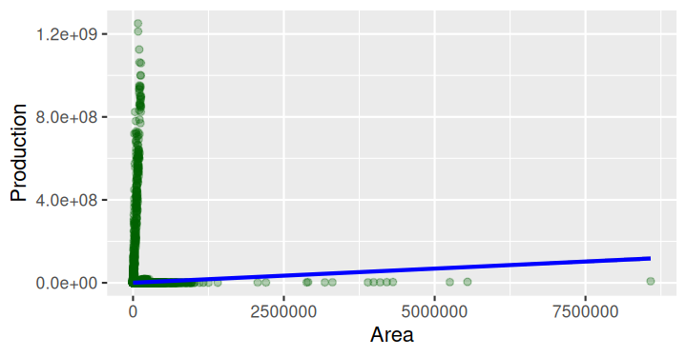

Figure 2 shows the relationship between cultivated area and crop production. The positive trend line indicates a general increase in production with larger cultivated areas, while the scattered points highlight the influence of additional factors such as irrigation, weather, and crop type.
5. Key Risk Factors
The analysis identified four major risks that could affect agribusiness operations.
Risk Factor | Description | Impact
Climate Variability | Droughts, floods, and irregular rainfall reduce crop yields. | High
Market Price Fluctuation | Changes in supply and demand reduce farmer income. | High
Seasonal Dependence | Certain crops rely heavily on specific growing seasons. | High
Uneven Cultivated Area | Regional differences create production imbalance. | Medium

6. Risk Analysis

The identified risks were prioritized according to their potential impact on agricultural production and business stability. Climate variability, market price fluctuation, and seasonal dependence were classified as high-risk factors, while uneven cultivated area was classified as a medium-risk factor.
Figure 3: Risk Analysis of Agribusiness Factors

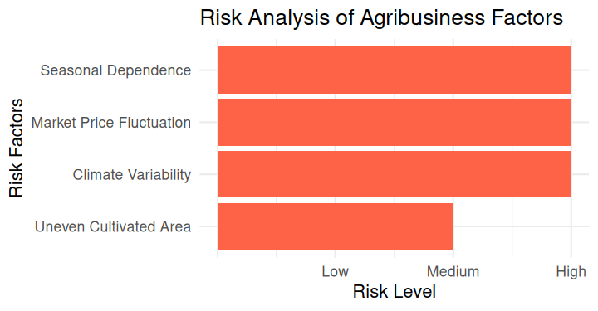
Figure 3 summarizes the major agribusiness risks identified during the analysis. The chart helps prioritize mitigation strategies by highlighting the most significant risk factors.

7. Scenario Analysis
Scenario 1: Climate Stress Scenario
A severe drought during the Kharif season reduces rainfall, leading to lower crop production despite maintaining similar cultivated areas.
Expected Impact:
- Reduced agricultural output
- Higher food prices
- Lower farmer income
- Increased production uncertainty
Scenario 2: Market Oversupply Scenario
Improved production results in excess supply, causing market prices to decline.
Expected Impact:
- Reduced profit margins
- Increased storage costs
- Financial pressure on small farmers
Scenario 3: Agricultural Expansion Scenario
Farmers increase cultivated area through improved farming practices and better irrigation.
Expected Impact:
- Higher production potential
- Increased investment requirements
- Greater need for efficient resource management
8. Risk Assessment Matrix
Scenario | Probability | Impact | Overall Risk
Climate Stress | High | High | Very High
Market Oversupply | Medium | High | High
Agricultural Expansion | Medium | Medium | Moderate
The matrix shows that climate-related risks require the highest priority because they directly affect production and market stability.
9. Risk Mitigation Strategies
To improve agribusiness resilience, the following strategies are recommended:
- Adopt drought-resistant crop varieties.
- Improve irrigation infrastructure.
- Encourage crop diversification.
- Strengthen crop insurance programs.
- Expand warehouse and cold-storage facilities.
- Improve weather forecasting systems.
- Increase access to digital agricultural marketplaces.
- Promote sustainable farming practices.
These measures can reduce production uncertainty and improve long-term agricultural sustainability.
10. Conclusion
The scenario analysis demonstrates that agribusiness faces significant risks from climate variability, market price fluctuations, and seasonal dependence. The production trend analysis and cultivated area relationship provide valuable insights into how agricultural output changes under different conditions. The three developed scenarios illustrate realistic challenges that farmers and agribusiness organizations may encounter. Implementing proactive risk mitigation strategies, including improved irrigation, crop diversification, weather forecasting, and better market access, can strengthen agricultural resilience and support more stable production outcomes.

