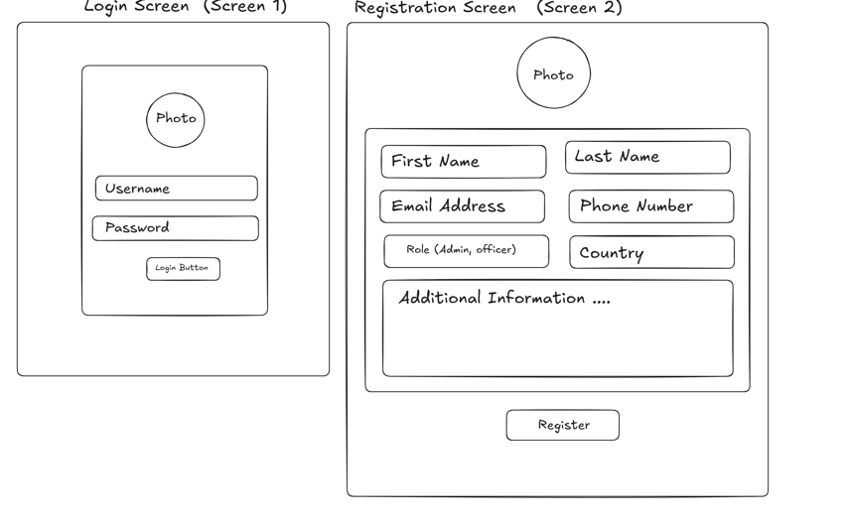
login screen(screen 1)
-> username
-> password
-> login button

registration screen(screen 2)
->first name
->last name
->email
->phone no.
->role
->country
->additional information
->register button
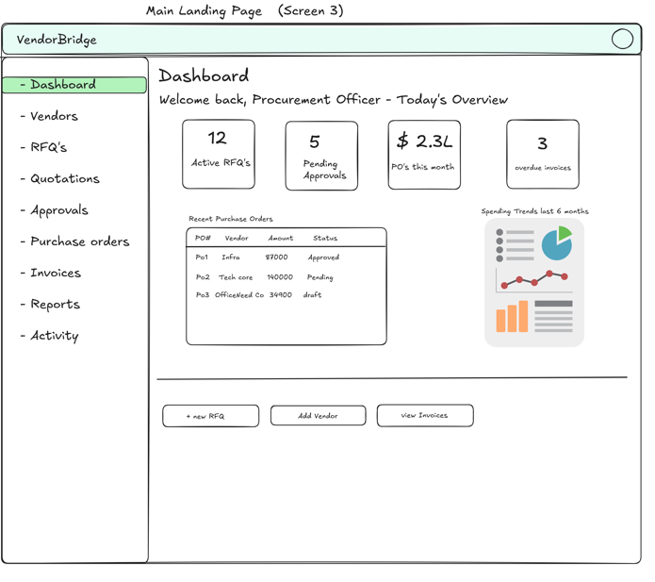
main loading page(screen 3)
Dashboard
->welcome back, procurement officer-today's overview
->active RFQ's , pending approvals , PO's this month , overdue invoices

->recent purchase orders ->spending trends last 6 months
PO's Vender Amount Status charts
ex:-PO1 infra 87000 approved

->+new RFQ , Add Vender , View Invoices

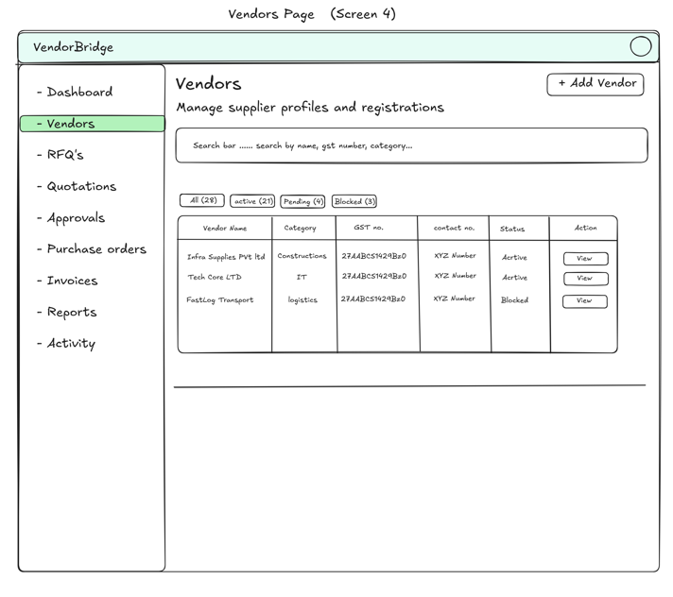Vendors page(screen 4)
vendors ->=add vendor
->manage supplier profiles and registrations
->search bar...search by name, gst no., category..

->all(ex-28) , active() ,pending(),blocked()

-> vendor name , category, gst no. contact no. ,status , action
ex-tech core Ltd , IT , 27AABCS1429Bz0 ,8583896838 , active , view
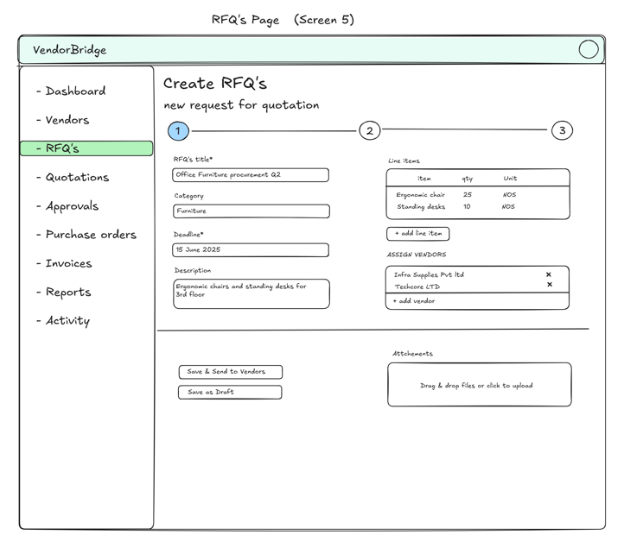
RFQ's Page(screen 5)
-> create RFQ's
->new request for quotation

->RFQ's title ->line Items
->category item ,qty ,unit
->deadline ->+add line item
->descrption -> assign vendors

->save & send to vendors ->attchments
->save as draft drag & drop files or click to upload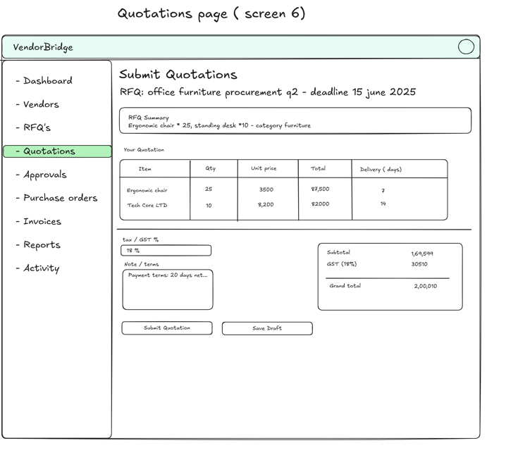
Quotations page(screen 6)
submit quotations
->RFQ: office furniture procuremet q2 - deadline date

->RFQ summary

->Your Quotation
item ,qty , unit price, total ,delivery(days)

->tax/GST% ->subtotal
->note/terms ->gst
->grand total
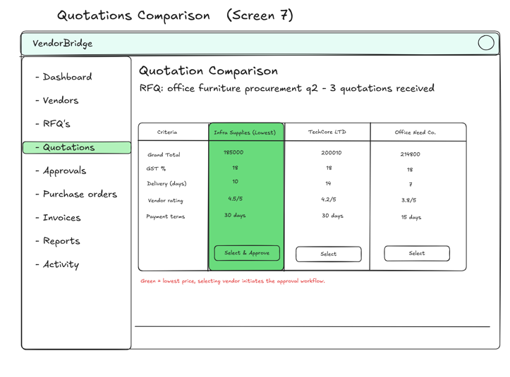
Quotations comparsion(screen 7)
Quotations comparsion
->RFQ: office furniture procurement q2 - 3 quotations received

->criteria,infra supplies ,techcore ltd , office need co.
(green=lowest price ,selecting vendor initiates the approval workflow)
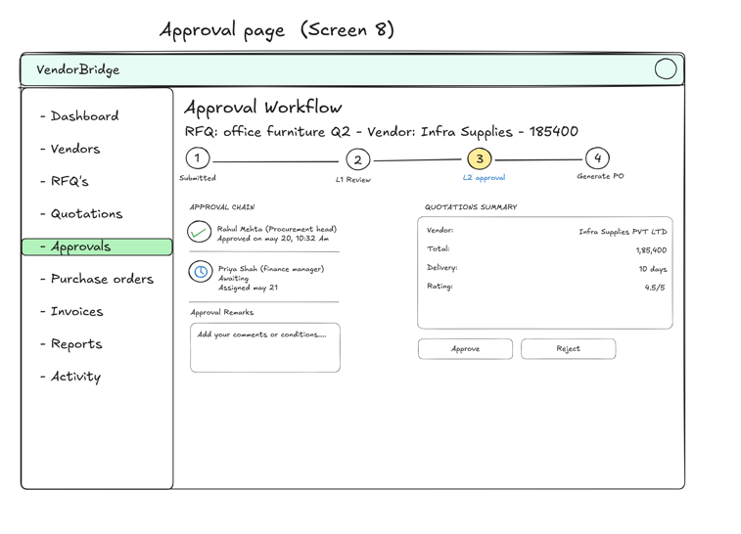
approval page(scrren 8)
->approval workflow
->RFQ: office furniture q2 - vendor:infra supplies - 185400
1(submitted)--2(l1 review)--3(l2 approved)--4(generate po)

->approval chain ->quotations summary
vendor:
total:
delivery:
->approval remarks rating: 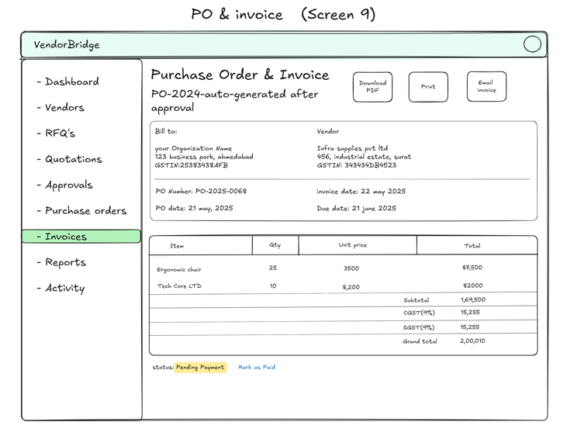
->approve ,rejectPO & Invoice(screen 9)
purchase order & invoice ->dashboard pdf , pront , email invoice

->bill to: vendor
->PO number ->invoive date:
->po date: ->due date:

->item ,qty , unit price , total

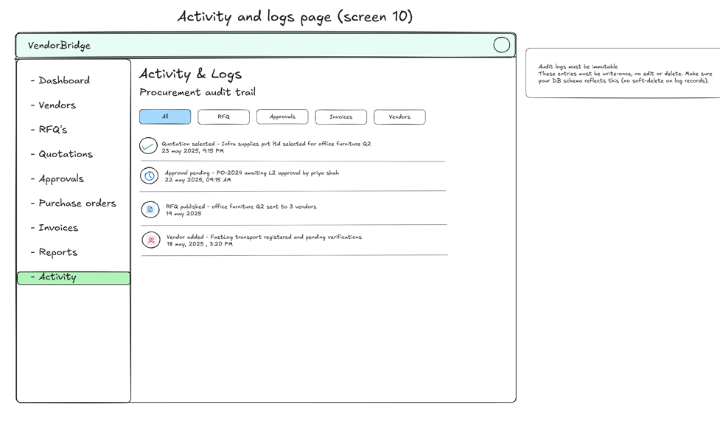
activity and logs page(screen 10)
activity & logs
->procurement audit trail
->all ,rfq , approvals , invoices , vendors
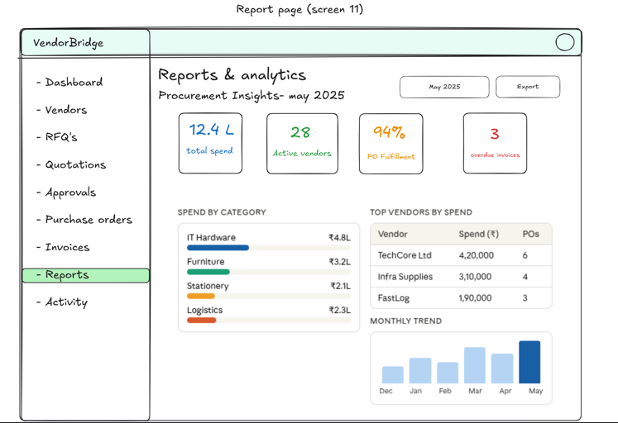

report page(screen 11)
report & analytics
->procurement insights - may 2025 -> may 2025 ,report

->total spend , active vendors ,PO fulfillment , overdue invoices

->spend by category ->top vendors by spend
->monthly trend

