Student Performance Analysis
Project Report
IBM SkillsBuild Data Analytics with AI
Academic Internship Program
BharatCares in association with AICTE
Submitted by: Gururaj Khale

1. Introduction
Exam results depend on many things apart from a student's ability. Daily habits such as how long a student studies, how regularly they attend class and how well they sleep can all make a difference. This project uses basic data analytics in Python to find out which of these factors are linked most strongly to exam scores.

2. Objectives
- Load, inspect and clean a student performance dataset.
- Find how study hours, attendance, sleep, parental support and tutoring relate to exam scores.
- Compare performance across Maths, Science and English.
- Build a simple prediction line for score based on study hours.

3. Dataset Description
The dataset (student_performance.csv) has 505 rows and 10 columns. It is a sample dataset generated for learning purposes and is not real student data. A few missing values and duplicate rows were included on purpose so that data cleaning could be practised.
Column | Description
student_id | Unique number for each student
gender | Male or Female
study_hours | Hours studied per day
attendance_pct | Class attendance in percent
sleep_hours | Hours of sleep per night
parental_support | Low, Medium or High
tutoring | Whether the student takes tutoring (Yes/No)
math_score, science_score, english_score | Marks out of 100 in each subject

4. Tools and Technologies
- Python 3
- Pandas and NumPy for data handling and calculations
- Matplotlib for charts
- Jupyter Notebook for writing and running the code

5. Methodology

5.1 Data Quality Check
The data had 16 missing values in attendance_pct, 10 missing values in sleep_hours and 5 duplicate rows.

5.2 Data Cleaning
- The 5 duplicate rows were removed, leaving 500 students.
- Missing attendance and sleep values were filled with the median of each column. The median was chosen because extreme values do not affect it much.

5.3 New Columns
An average_score column was created from the three subject scores. A grade column was then added: A for 75 and above, B for 60 to 74, C for 45 to 59 and D below 45.

6. Analysis and Results

6.1 Score Distribution
The mean average score is 69.6 and the median is 69.7, so the scores are spread fairly evenly around the middle. Out of 500 students, 152 got grade A, 254 got grade B, 90 got grade C and 4 got grade D.
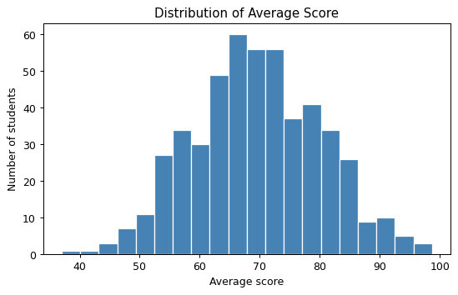
Figure 1: Distribution of average score

6.2 Subject-wise Performance
English has the highest average (71.7), followed by Science (69.7) and Maths (67.4).
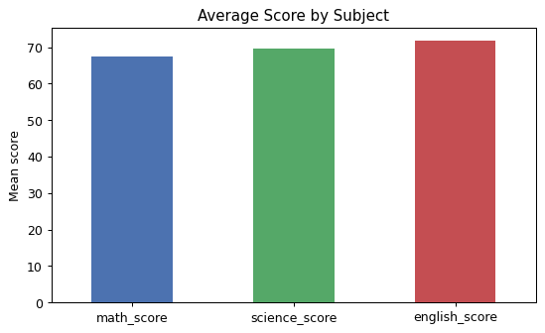
Figure 2: Average score by subject

6.3 Study Hours
Study hours has a strong positive correlation of 0.85 with the average score. Students who study more tend to score clearly higher.
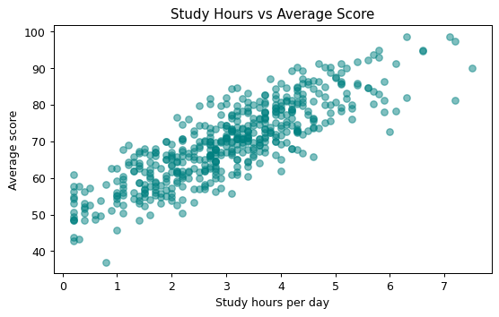
Figure 3: Study hours vs average score

6.4 Attendance
Attendance has a moderate positive correlation of 0.30 with the average score.
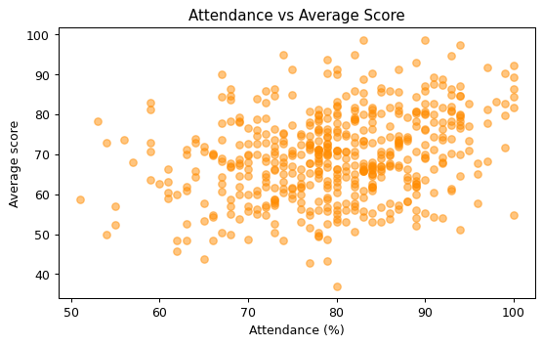
Figure 4: Attendance vs average score

6.5 Parental Support and Tutoring
Group | Category | Average score
Parental support | Low | 66.5
Parental support | Medium | 69.6
Parental support | High | 72.2
Tutoring | No | 68.4
Tutoring | Yes | 72.2
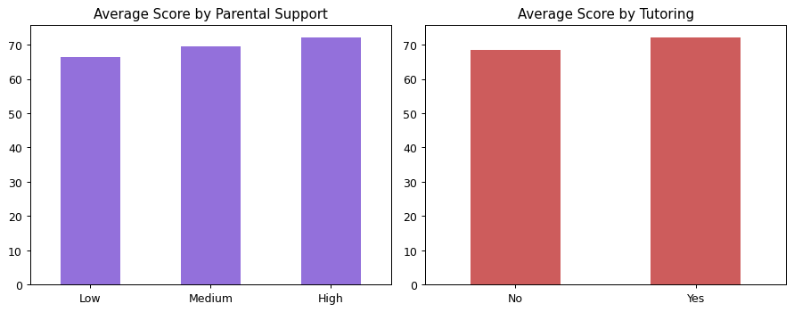
Figure 5: Average score by parental support and tutoring

6.6 Gender
Female students averaged 70.7 and male students averaged 68.6. The gap is only about 2 marks, so it may simply be due to chance.

6.7 Correlation Heatmap
The heatmap confirms that study hours is the strongest factor (0.85), then attendance (0.30), then sleep (0.12).
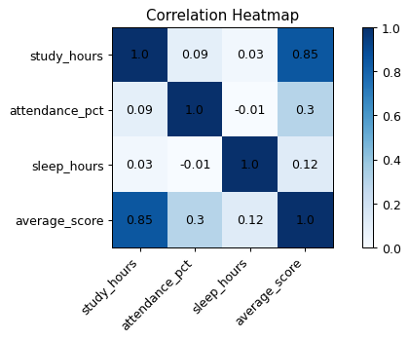
Figure 6: Correlation heatmap

6.8 Simple Linear Regression
A straight line was fitted between study hours and average score using NumPy. The slope was 6.49, which means each extra hour of daily study is linked to about 6.5 more marks. The intercept was 49.88 and R-squared was 0.71, so study hours alone explains about 71 percent of the variation in scores.
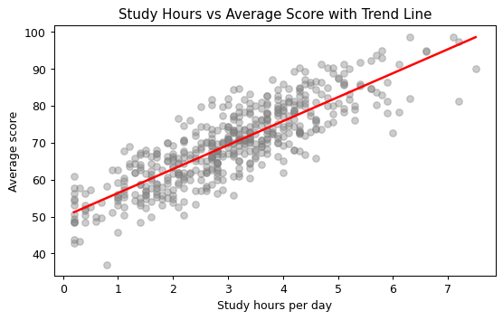
Figure 7: Trend line for study hours vs average score
Study hours per day | Predicted average score
2 | 62.9
4 | 75.9
6 | 88.8

7. Conclusions
- Study hours is the biggest factor linked to exam scores in this data.
- Attendance, parental support and tutoring also show a positive link with scores.
- Sleep has only a weak link with scores here.
- English scores are highest and Maths scores are lowest on average.

8. Limitations
- The dataset is a generated sample, so the results show how the analysis works rather than real-world facts.
- Correlation does not prove that one thing causes another.
- Only a simple one-variable regression was used.

9. Future Scope
- Repeat the analysis on a real student dataset.
- Use multiple regression or other machine learning models with several factors together.
- Build a dashboard to show the results interactively.

10. Files Submitted
- Gururaj_Khale_StudentPerformanceAnalysis.ipynb - full project code
- requirements.txt - list of Python libraries
- Gururaj_Khale_ProjectReport.docx - this report
- README.md - project overview and run instructions
- student_performance.csv - dataset

