Standard Operating Procedure (SOP)
SOP for Extracting County, Title Owner, and Lien Data for given ForRentByOwner_Contact_2025-09-02_withID_Guru.csv

1. Purpose
This SOP provides detailed, step-by-step instructions for extracting County, Title Owner, and Lien information from public data sources and entering this data into the project spreadsheet. A dedicated Python script (`county_extractor.py`) is used to automate the County lookup step.

2. Spreadsheet Data Entry Instructions
1. Open the file: ForRentByOwner_Contact_2025-09-02_withID_Guru.csv
2. Locate and prepare to fill the following columns:
- County
- Title Owner
- Lien (Y/N)
3. Save the working copy as:
ForRentByOwner_Contact_2025-09-02_withID_Guru_WORKING.xlsx

3. County Extraction Script (county_extractor.py)
The script `county_extractor.py` reads the spreadsheet, calls the U.S. Census Geocoder API for each property, and fills in the County column where it is blank or marked as UNKNOWN.
High-level version of the script:
import time
import requests
import pandas as pd
INPUT_FILE = 'ForRentByOwner_Contact_2025-09-02_withID_Guru.csv'
OUTPUT_FILE = 'ForRentByOwner_Contact_2025_with_county.csv'
CENSUS_URL = 'https://geocoding.geo.census.gov/geocoder/geographies/address'
def get_county_from_census(street, city, state, zipcode, retries=3):
params = {
'street': street,
'city': city or '',
'state': state or '',
'zip': str(zipcode) if zipcode else '',
'benchmark': 'Public_AR_Current',
'vintage': 'Current_Current',
'format': 'json',
}
for attempt in range(1, retries + 1):
try:
resp = requests.get(CENSUS_URL, params=params, timeout=10)
resp.raise_for_status()
data = resp.json()
matches = data.get('result', {}).get('addressMatches', [])
if not matches:
return 'UNKNOWN'
geos = matches[0].get('geographies', {})
counties = geos.get('Counties', [])
if not counties:
return 'UNKNOWN'
return counties[0].get('NAME', 'UNKNOWN')
except Exception:
if attempt == retries:
return 'UNKNOWN'
time.sleep(1.5)
def main():
df = pd.read_csv(INPUT_FILE, encoding='latin1')
if 'County' not in df.columns:
df['County'] = ''
for idx, row in df.iterrows():
county = str(row.get('County', '')).strip()
if county:
continue
street = row.get('StreetAddress', '')
city = row.get('City', '')
state = row.get('State', 'GA')
zipcode = row.get('Zipcode', '')
new_county = get_county_from_census(street, city, state, zipcode)
df.at[idx, 'County'] = new_county
time.sleep(0.25)
df.to_csv(OUTPUT_FILE, index=False, encoding='latin1')
if __name__ == '__main__':
main()
To run the script:
1. Ensure Python 3 and the `requests` and `pandas` libraries are installed.
2. Place `county_extractor.py` in the same folder as the CSV file.
3. Run from a terminal: python county_extractor.py
4. After completion, open the output file 'ForRentByOwner_Contact_2025_with_county.csv' to verify County values.

4. Manual County Lookup (Fallback)
If the script returns UNKNOWN for a row, use the Census Geocoder website manually:
https://geocoding.geo.census.gov/geocoder/geographies/address
Enter: Street, City, State, and ZIP, then read the County value.
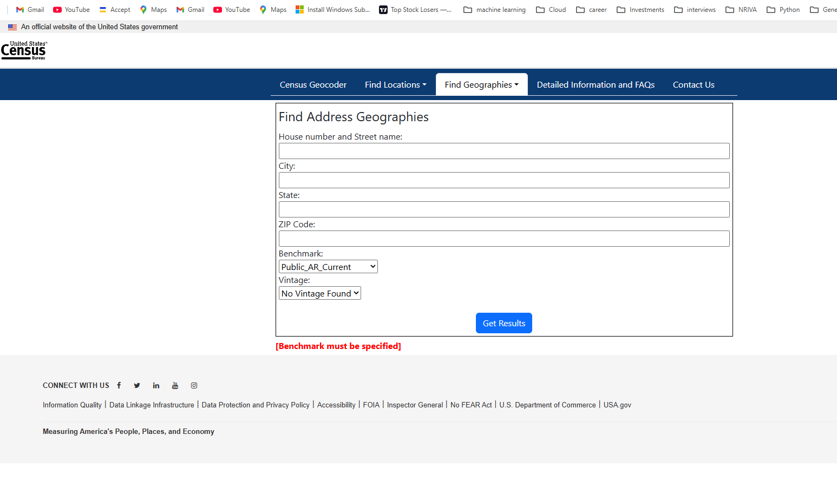

5. Title Owner Lookup Instructions
A. Fulton County Lookup:
https://qpublic.schneidercorp.com/Application.aspx?App=FultonCountyGA&PageType=Search

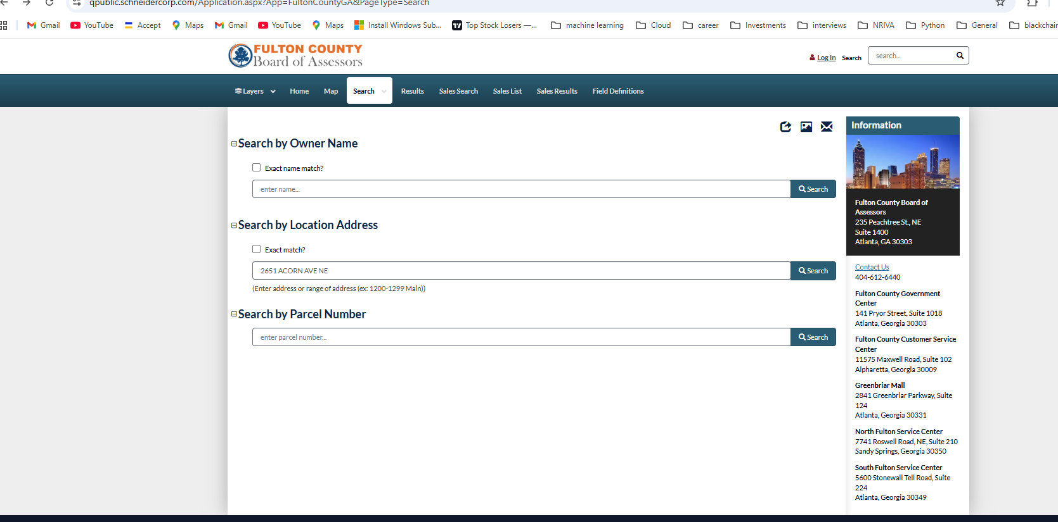

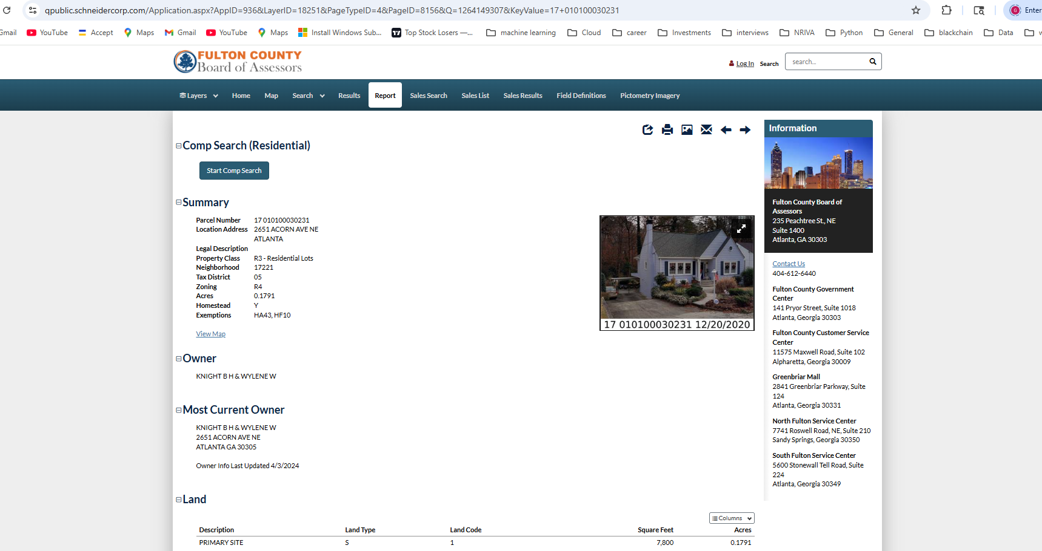
B. DeKalb County Lookup:
https://qpublic.schneidercorp.com/Application.aspx?AppID=994&PageTypeID=2&pageID=8822
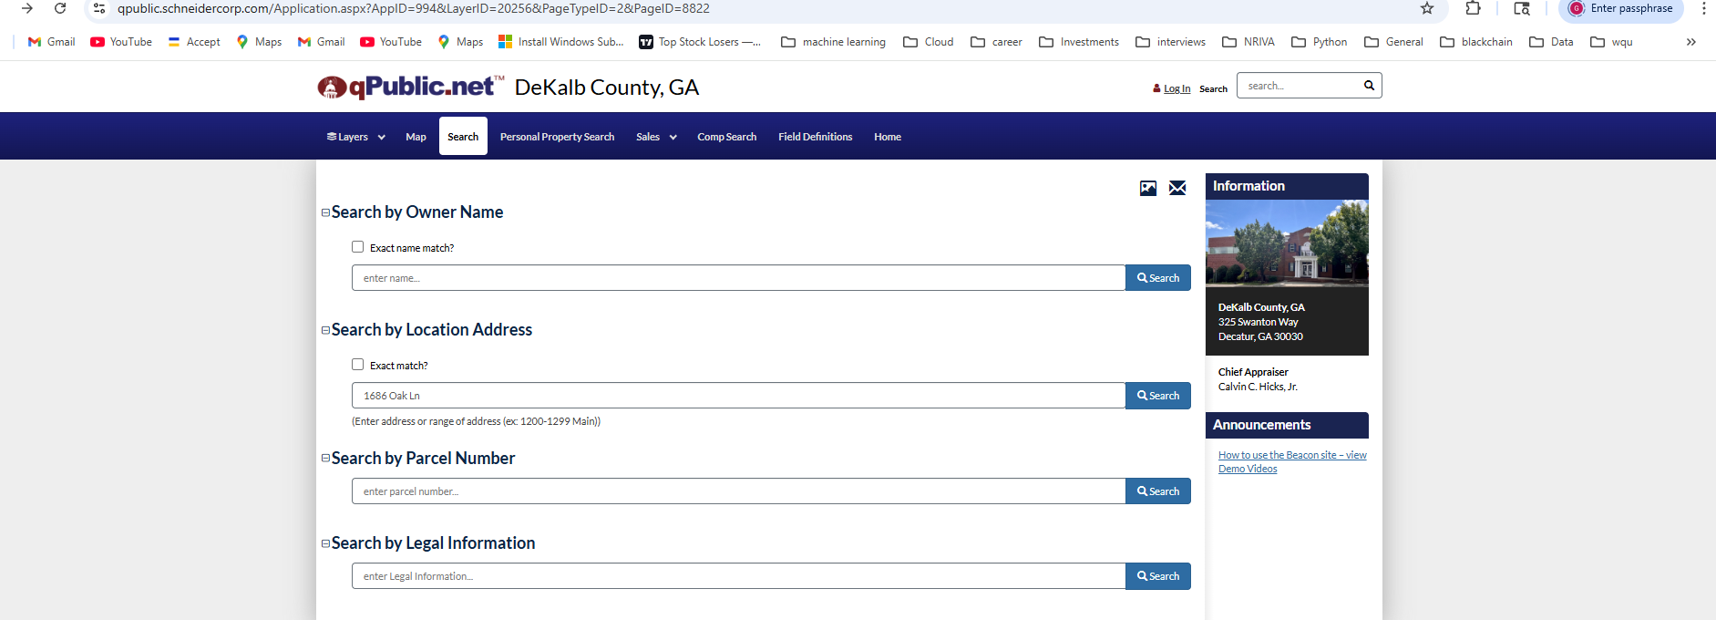
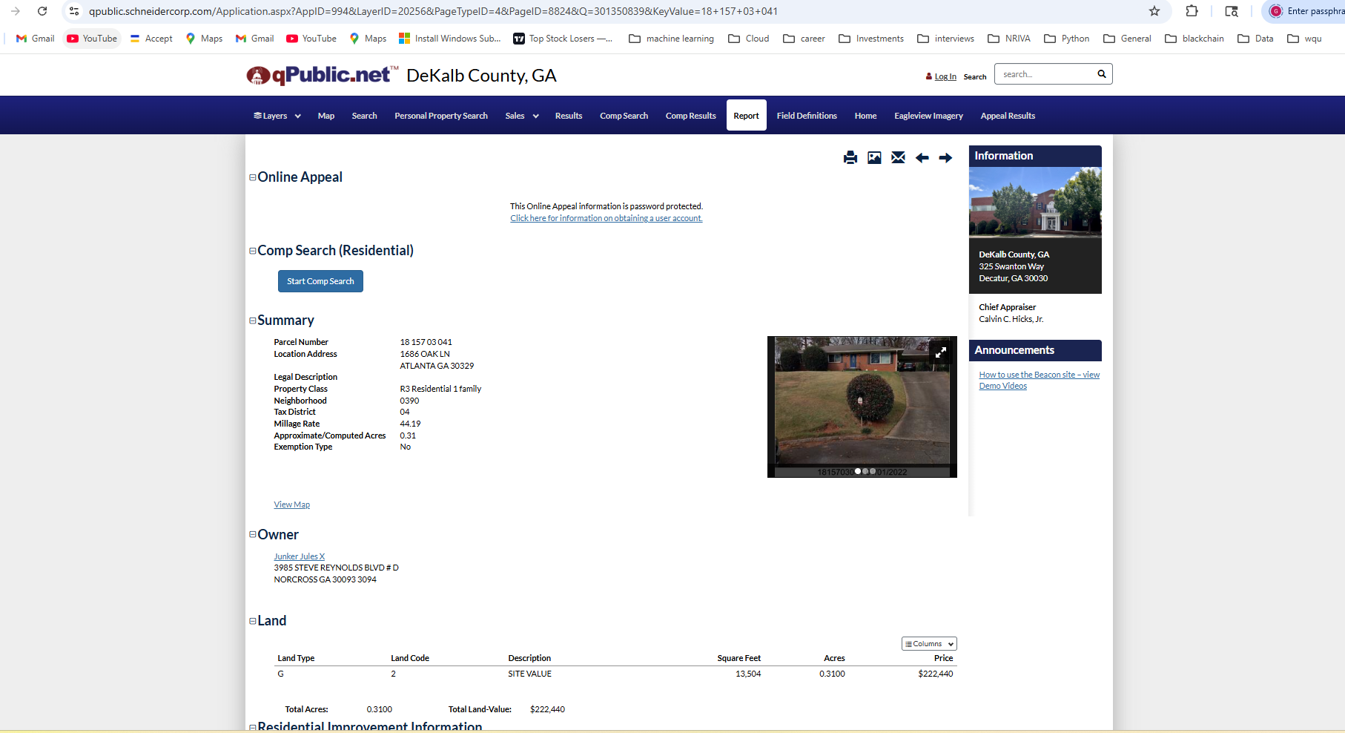
In each case:
1. Search by property address.
2. Open the matching record.
3. Copy the Owner name into the 'Title Owner' column.

6. Lien Lookup Instructions
Use GSCCCA Lien Search:
https://search.gsccca.org/Lien/namesearch.asp
Steps:
1. Create a free account and log in.
URL : GSCCCA.org - Account Management
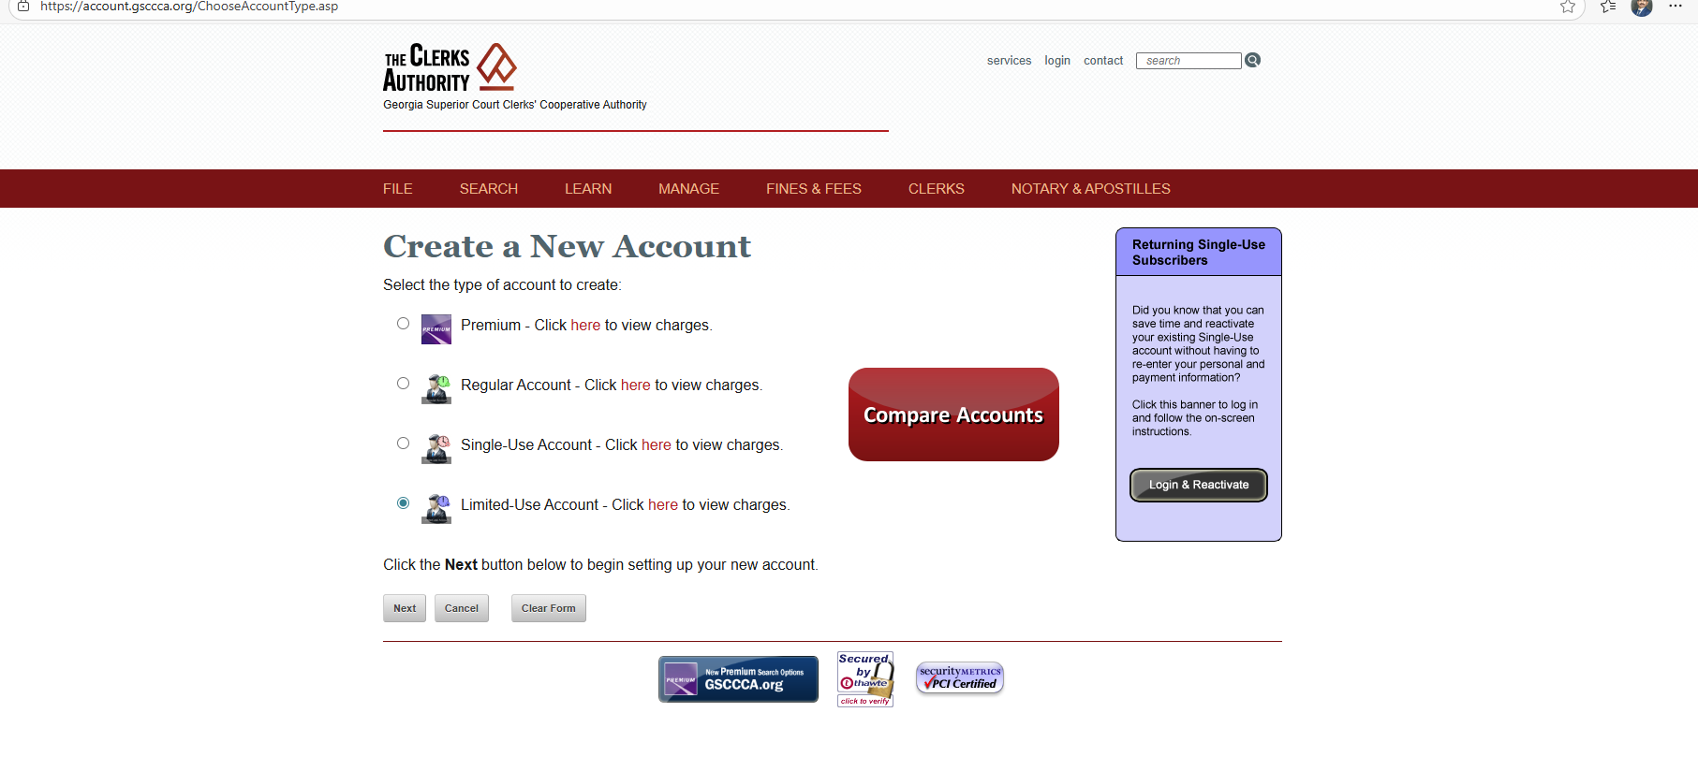
And Login
https://search.gsccca.org/Lien/namesearch.asp
2. Set Party Type = 'All Parties'.
3. Set Instrument Type = 'Lien'.
4. Enter the Title Owner name in Search Name.
5. If records are found, mark 'Y' in the Lien column; otherwise, mark 'N'.

  - Searching lien Info if no Lien – If no lien on Property
    - Fill the Following Fields:
    - Party type: All Parties
    - Instrument type: Lien
    - Search Name: AUDEN HOLDINGS LLC
    - Click Search Button and display next Page.
    - If there is no lien on Property: No Records in found in your Search Criteria

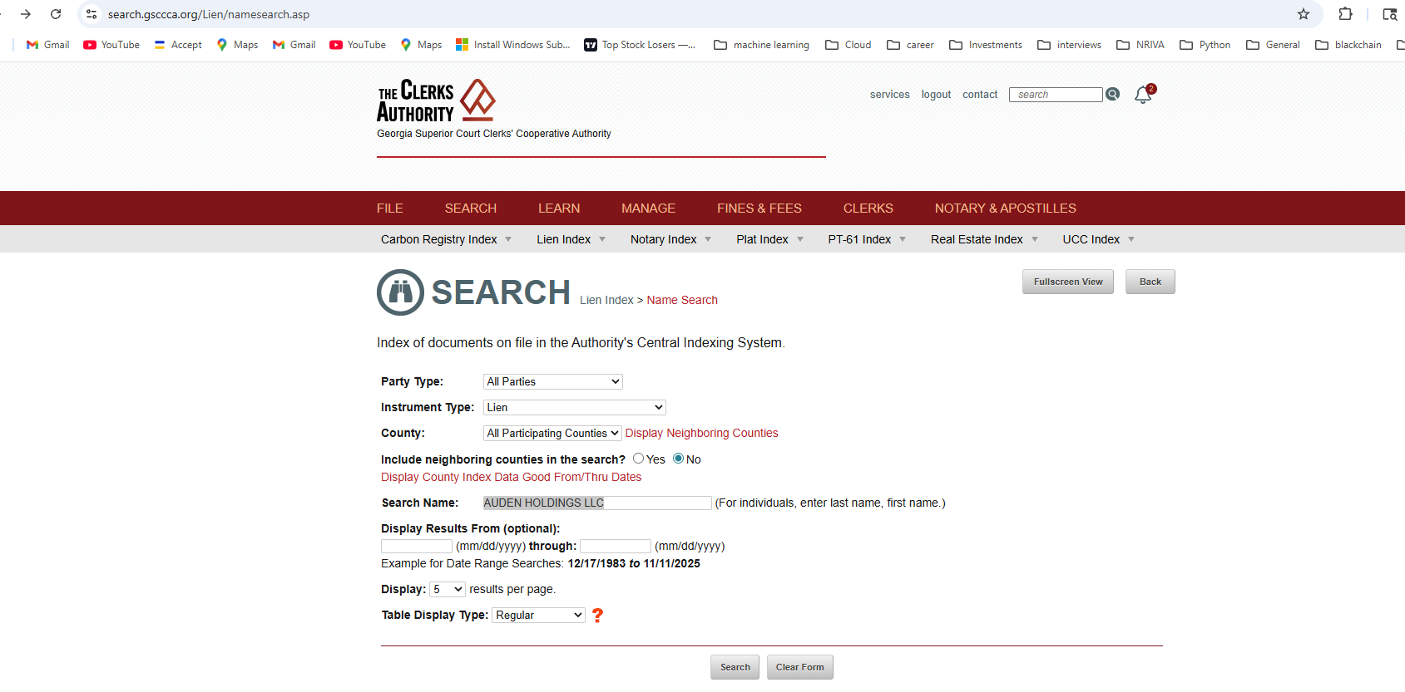
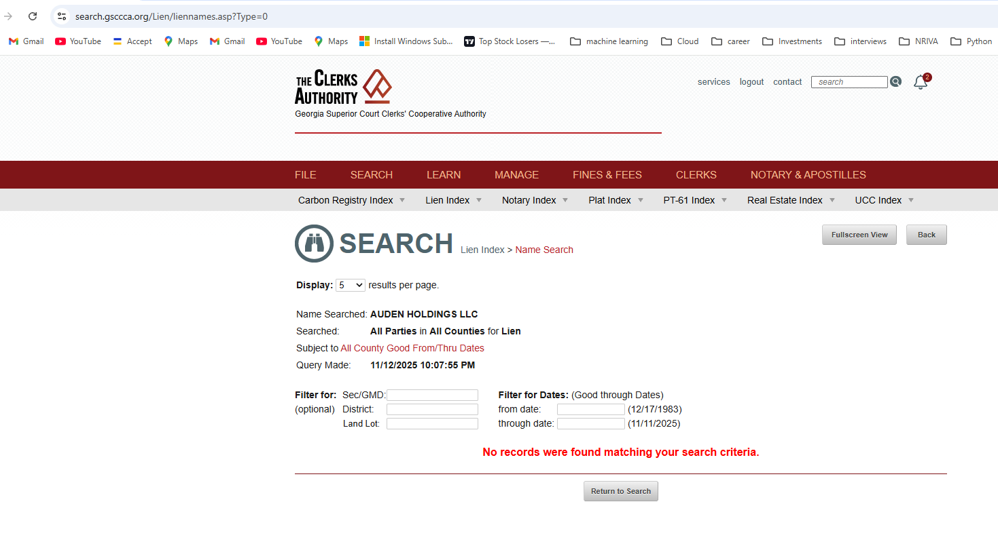
  - Searching lien Info if no Lien – If lien on Property
    - https://search.gsccca.org/Lien/namesearch.asp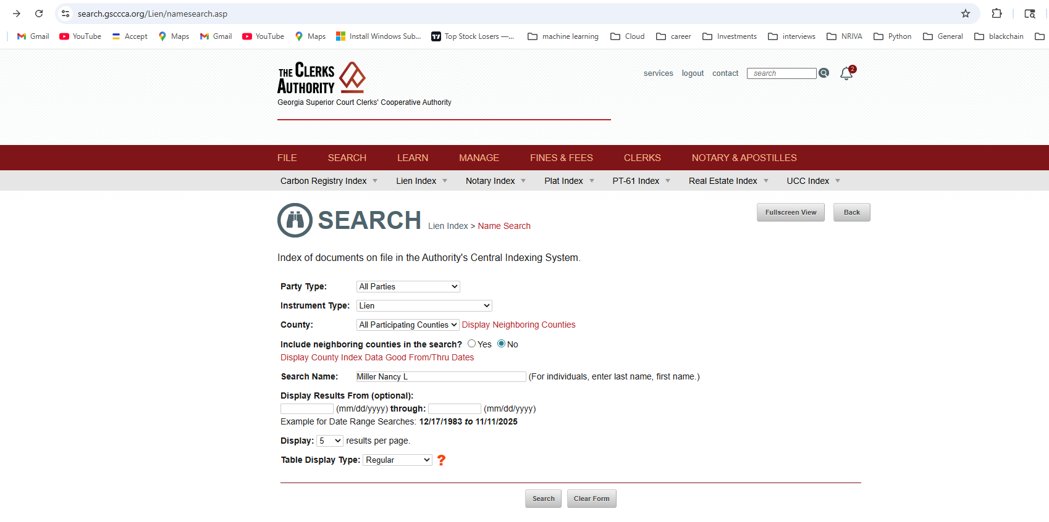
    - Fill the Following Fields:
    - Party type: All Parties
    - Instrument type: Lien
    - Search Name: Miller Nancy L
    - Click Search Button and display next Page.
    - If there is lien on Property: Display the which type of lien info as shown in Picture

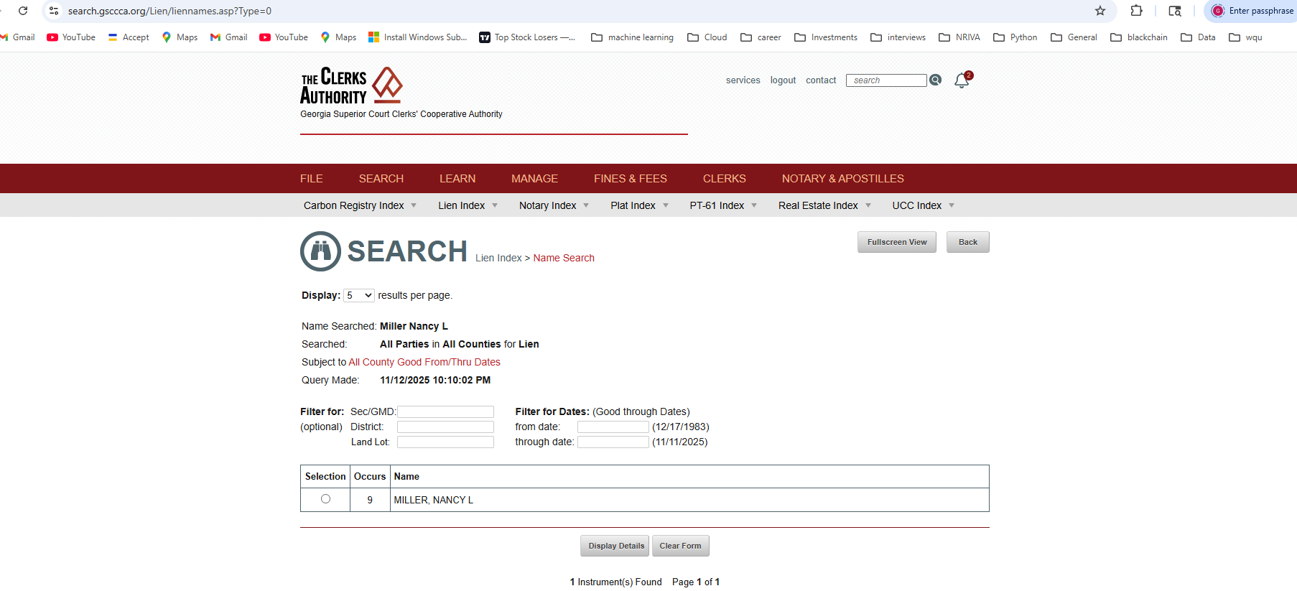

Final spreadsheet with County, Title Owner, and Lien filled

7. Process Flowchart
The following flowchart summarizes the end-to-end process:
