23CSE461 FULLSTACK FRAMEWORKS
B. Guru Sai Prasad Reddy CSE-B
Scientific Calculator
OUTPUTS:
INITALLY
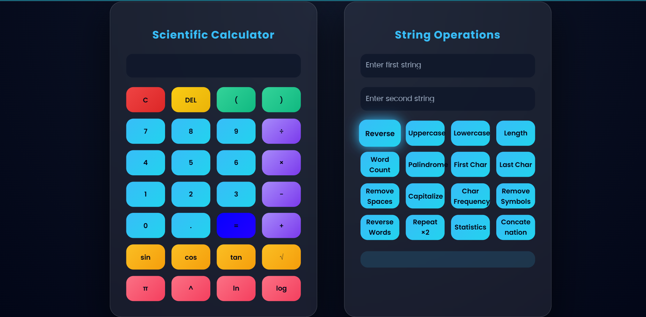
INPUT IN BOTH CALCULATER AND STRING OPERATIONS
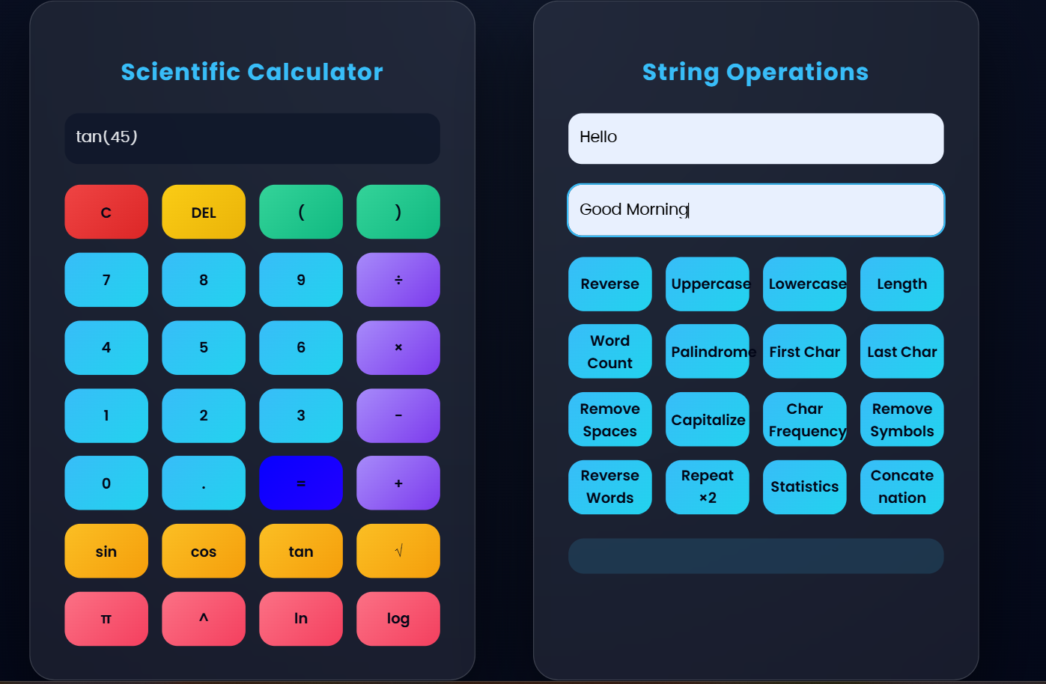
OUTPUT
