Project Title:
SkillForge – AI-Driven Adaptive Learning & Exam Generator

Project Statement:
SkillForge is a smart e-learning platform that leverages AI to personalize student learning paths and dynamically generate exams tailored to each user’s skill level. By analyzing student progress, emotional feedback (optional), and performance trends, the system recommends learning resources and auto-generates custom quizzes using AI (e.g., LLM or GPT API). Built with Angular 19 on the frontend, Node.js (Express) backend, and a MySQL database, SkillForge redefines modern, adaptive education.

1. User Authentication & Role-Based Dashboard
Roles: Student, Instructor, Admin
Services:
- Registration/Login
- JWT-based session management
- Role-based dashboard redirection
Expected Output Screenshot:
- Login/Register screen
- Dashboards with role-specific menus (e.g., Student → Learning; Instructor → Course Upload)

2. Course & Content Management (Instructor Panel)
Services:
- Add/edit/delete subjects, topics, and materials
- Upload videos, PDFs, links
- Tag content with difficulty level
Expected Output Screenshot:
- Form to create a course with upload buttons
- Course table with action buttons
3. Adaptive Learning Engine (Student Panel)
Services:
- System suggests content based on scores & activity
- Adaptive quiz difficulty based on performance
- Color-coded progress tracker
AI Integration:
- Simple ML model or heuristic logic in Node.js to score difficulty
Optional: Use GPT API to adjust quiz level
Expected Output Screenshot:
- Progress bar + personalized suggestions
- "Next Suggested Lesson" card

4. AI-Generated Quiz Module
Services:
- Instructor enters a topic
- System generates questions using GPT API (MCQ, short answer)
- Store quiz in DB and assign to students
AI Integration:
- Node.js server calls OpenAI GPT for question generation
Expected Output Screenshot:
- Quiz generation form
- Auto-filled questions with option to review/edit

5. Quiz Attempt & Scoring (Student Panel)
Services:
- Students take quizzes
- Auto scoring for MCQs, manual scoring option for long answers
- Timed quizzes, score feedback
Expected Output Screenshot:
- Timer + Quiz interface with questions
- Result summary after submit

6. Analytics & Adaptive Report System
Services:
- Show topic-wise performance
- Adaptive level trend (Beginner → Advanced)
- Instructor views student strengths/weaknesses
Expected Output Screenshot:
- Pie chart of topics
- Line graph: Skill progression over time
- Table: Student vs Quiz scores

Tech Stack Summary
Layer | Technology
Frontend | Angular 19, Angular Material, Chart.js
Backend | Node.js (Express), JWT Auth, REST APIs
Database | MySQL with Sequelize ORM
AI Services | OpenAI API / GPT-4 for quiz generation
Charts | ngx-charts / Chart.js

Expected output:
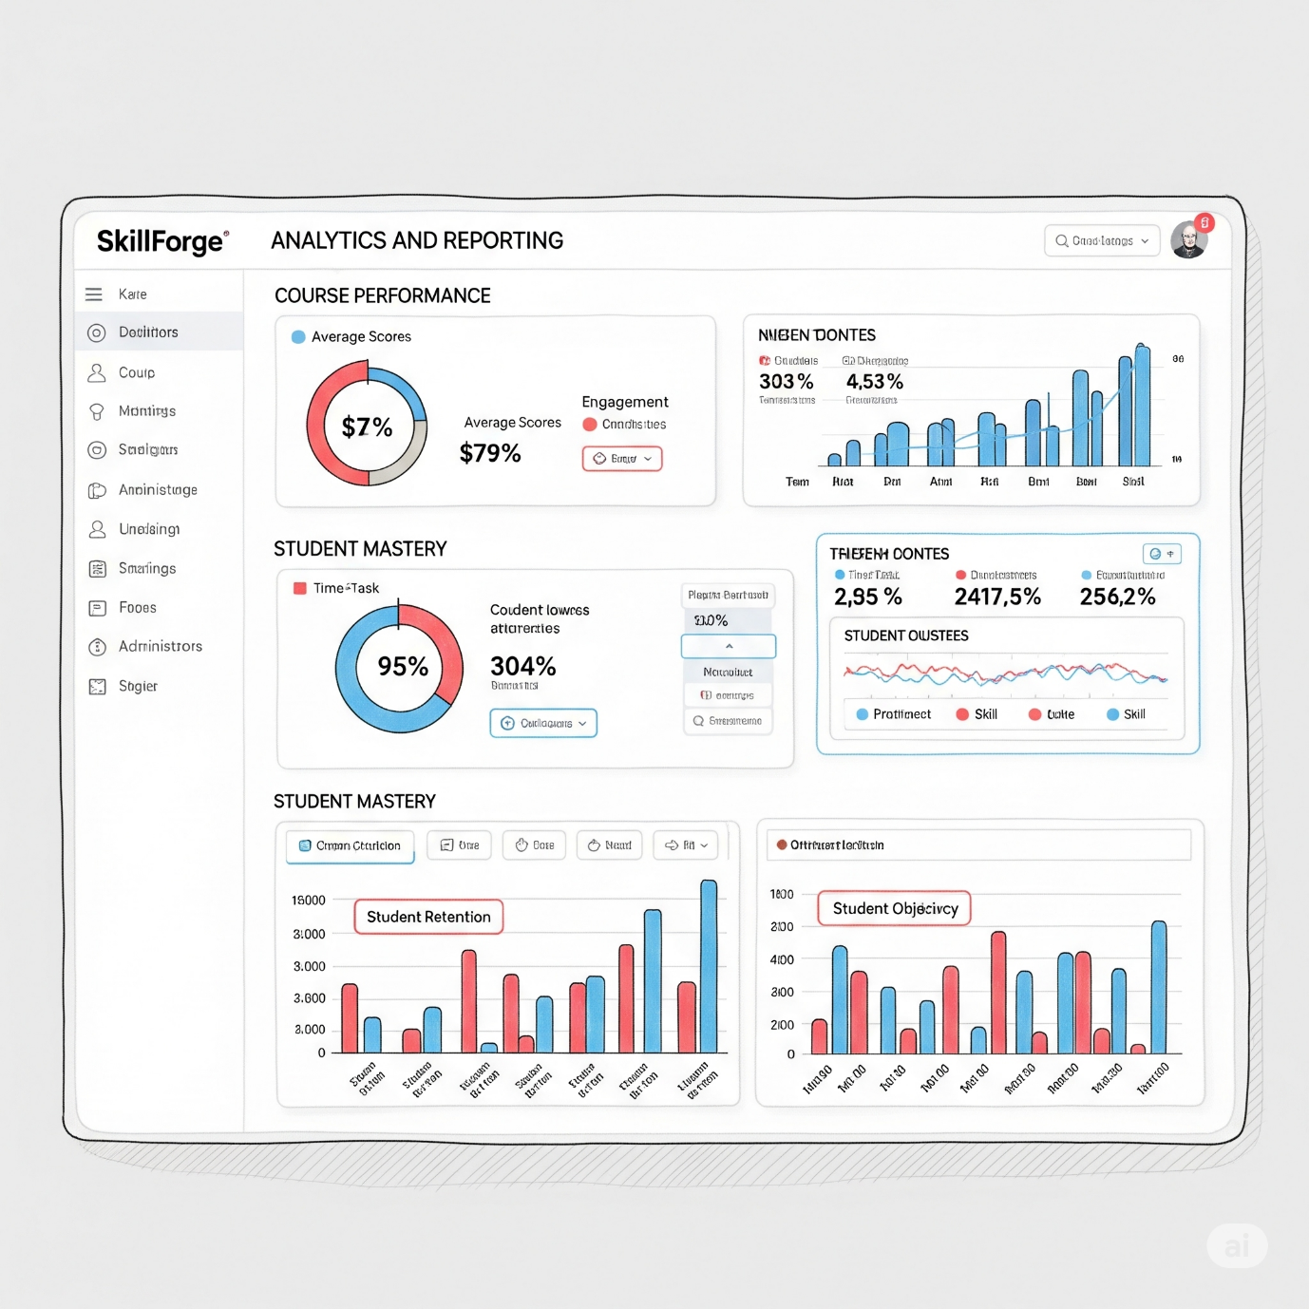
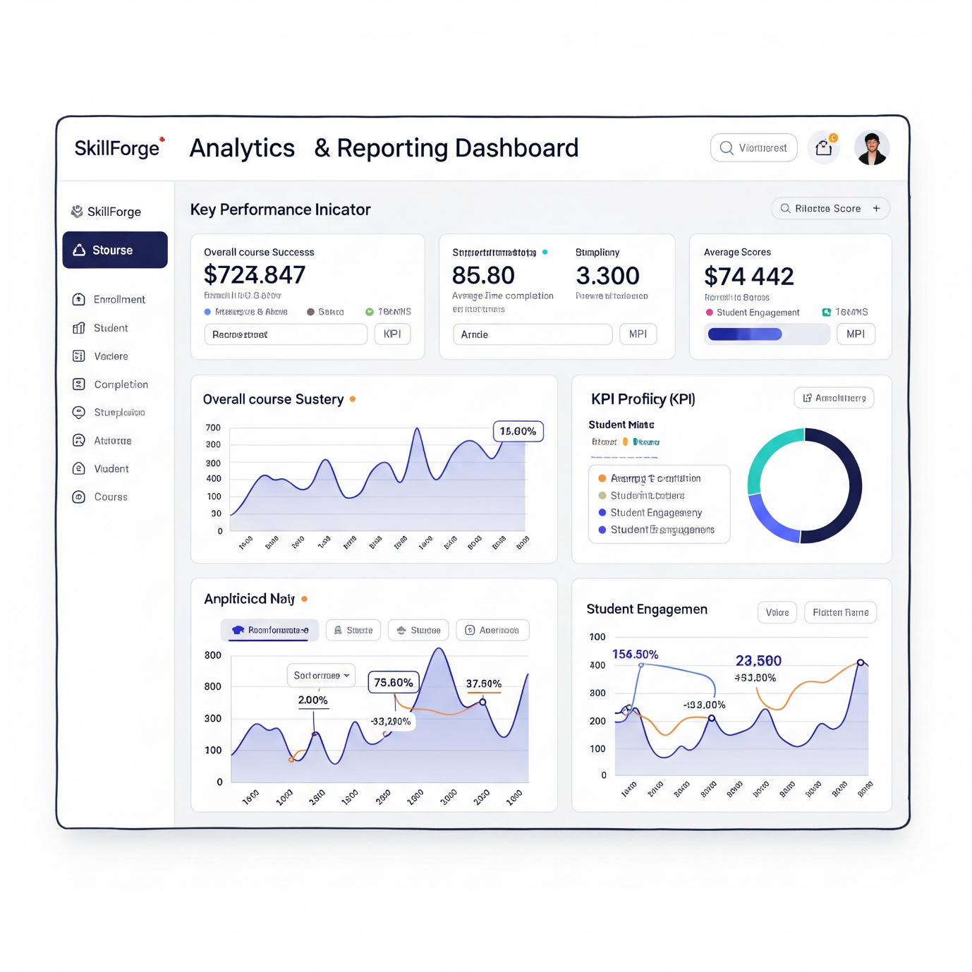
Database Schema (MySQL Sample)
CREATE TABLE users (
id BIGINT AUTO_INCREMENT PRIMARY KEY,
name VARCHAR(100),
email VARCHAR(100),
password VARCHAR(255),
role ENUM('STUDENT', 'INSTRUCTOR', 'ADMIN')
);
CREATE TABLE courses (
id BIGINT AUTO_INCREMENT PRIMARY KEY,
title VARCHAR(100),
instructor_id BIGINT,
difficulty_level ENUM('BEGINNER','INTERMEDIATE','ADVANCED'),
FOREIGN KEY (instructor_id) REFERENCES users(id)
);
CREATE TABLE quizzes (
id BIGINT AUTO_INCREMENT PRIMARY KEY,
course_id BIGINT,
title VARCHAR(100),
generated_by_ai BOOLEAN,
FOREIGN KEY (course_id) REFERENCES courses(id)
);
CREATE TABLE questions (
id BIGINT AUTO_INCREMENT PRIMARY KEY,
quiz_id BIGINT,
question_text TEXT,
options JSON,
correct_answer VARCHAR(100),
FOREIGN KEY (quiz_id) REFERENCES quizzes(id)
);
CREATE TABLE quiz_attempts (
id BIGINT AUTO_INCREMENT PRIMARY KEY,
quiz_id BIGINT,
student_id BIGINT,
score DECIMAL(5,2),
attempt_time DATETIME,
FOREIGN KEY (quiz_id) REFERENCES quizzes(id),
FOREIGN KEY (student_id) REFERENCES users(id)
);

