Developing a Smart Airport Passenger Assistance Multimodal Chatbot
MSc in Artificial Intelligence — Module: Multi-Modal Chatbots
Assignment Type: Set Exercise (100% weighting)
Word count: approx. 2,900 (main body, excluding title page, tables, figure captions and references)

AI Tool Use Declaration
In preparing this assignment I used Claude (Anthropic, 2026), an AI coding assistant, to help implement the codebase (data generation scripts, the vision/text/speech pipelines, the fusion logic and the evaluation suite) and to help draft and structure sections of this report from my design decisions and the evaluation results the code produced. All code was run by me, and all reported metrics, figures and tables were generated from those actual runs rather than invented. I reviewed, tested and take responsibility for the full submission, including the technical choices explained throughout this report. This use is cited in accordance with the UCA Harvard Referencing Standard in the reference list below.

1. Introduction
Modern airports are dense, high-stress environments in which passengers must navigate terminals, gates, check-in desks, baggage areas, security zones, transport links, restaurants and service counters, often while facing delays, language barriers, mobility limitations or simple unfamiliarity with the building. Static signage and single-modality chatbots address this only partially: a text-only bot cannot interpret a photographed sign, and a vision-only system cannot answer a spoken follow-up question. Advances in multimodal artificial intelligence — large pretrained vision-language and speech models that can be combined behind a single interface — make it possible to build a proof-of-concept assistant that accepts a photograph of a sign, a spoken question, typed text, or any combination of the three, and returns a single, grounded answer.
This report documents the design, implementation and evaluation of such a system: a Smart Airport Passenger Assistance Multimodal Chatbot. The system integrates a frozen CLIP vision-language model for sign recognition, a fine-tuned DistilBERT intent classifier and Sentence-BERT semantic retrieval for text understanding, a frozen Whisper model for speech-to-text, a structured JSON knowledge base of twenty airport locations and services, and a rule-based multimodal fusion layer that routes any combination of inputs to a single confidence-scored response. The full pipeline — data acquisition, preprocessing, model design, fusion, training/evaluation, deployment and ethical analysis — is described below and implemented in the accompanying code repository.

2. Problem Statement
The chatbot must process three input modalities — images of airport signage, spoken passenger questions, and typed text — and, for each, identify the relevant airport location or service, retrieve the corresponding record from a structured knowledge base, and present directions, opening hours and accessibility information through a professional interface. The system must degrade gracefully: where confidence is low, it must say so rather than fabricate an answer, and it must never present time-sensitive information (such as flight delay status) as though it were verified in real time.

3. Environment Setup (10%)
The project was developed in Python 3.10 on a CPU-only environment (no GPU dependency, which matters for reproducibility on a standard laptop or a free-tier Colab instance). The core library stack, listed in requirements.txt, is: PyTorch and TorchVision (tensor/model backend), Hugging Face Transformers (CLIP, DistilBERT), Sentence-Transformers (SBERT retrieval), OpenAI Whisper (speech-to-text), FAISS-CPU (similarity search), Librosa and SoundFile (audio I/O), OpenCV and Pillow (image I/O), Scikit-learn, NumPy, Pandas and Matplotlib (analysis/evaluation), Streamlit (deployment UI), python-docx (this report) and pyttsx3 (offline text-to-speech for synthetic voice-data generation). All pretrained models (CLIP ViT-B/32, DistilBERT-base-uncased, Whisper-base, all-MiniLM-L6-v2) are downloaded automatically from Hugging Face / OpenAI on first run and cached locally; total download size is approximately 1.5GB.
One practical environment decision is worth recording: Whisper's default audio loader shells out to the ffmpeg binary, which was not available in this environment. Audio is instead loaded and resampled to 16kHz mono directly with Librosa/SoundFile and passed to Whisper as a NumPy array, which is functionally equivalent and removes an external binary dependency from the deployment footprint.

4. Data Acquisition and Exploration (15%)

4.1 Visual Data
Real airport photography was avoided for two reasons the brief itself flags: copyright (most airport signage photography online is not freely licensed) and privacy (real photos risk capturing bystanders or live boarding-pass/flight data). Instead, 104 synthetic wayfinding-sign mockups were generated programmatically (data/generate_images.py) across 13 categories — gate, baggage claim, check-in, security, information desk, lost and found, lounge, restaurant, transport, prayer room, accessibility, shopping and medical — following the ISO 7001 pictogram style used at most international airports. Each image combines a pictogram, a directional arrow and a text label, then has randomised rotation (±8°), brightness (±25%), optional Gaussian blur and crop jitter applied to emulate photographs taken at different angles, lighting levels and camera quality.

Figure 1. Two representative synthetic sign mockups: 'Gate' and 'Accessibility' categories.
Class distribution is even by construction (8 images per category, 104 total), which was a deliberate choice to isolate model-quality questions from class-imbalance effects at this small scale; a genuine deployment would need to handle imbalance (e.g. many more gate signs than prayer-room signs) and this is discussed as a limitation below. Visual inspection across categories shows signs are easily distinguishable by colour and pictogram shape but that 'lounge' and 'restaurant' pictograms (furniture vs. cutlery silhouettes) are the most visually similar pair, which is reflected later in the vision confusion analysis. The main limitation of this dataset is that it is synthetic: real airport signage varies far more in typography, wear, lighting and partial occlusion than these clean mockups, so absolute accuracy figures should be read as an upper bound relative to a deployed system using real photographs.

4.2 Voice and Text Data
84 passenger queries across 14 intents (find_gate, baggage_claim, check_in, security, lounge, restaurant, transport, information_desk, lost_and_found, prayer_room, accessibility, flight_status, shopping, medical) were generated from hand-written templates with randomised entity slots (data/generate_text_data.py), split 80/20 into train (67) and validation (17) sets. A 20-query subset was rendered as 16kHz mono WAV audio using the offline Windows SAPI5 text-to-speech engine via pyttsx3 (data/generate_audio.py), with randomised speaking rate (150-190 WPM) and alternating voice to emulate speaker variation. As with the image data, TTS-generated audio was used instead of recording real people to avoid consent and privacy issues, and this is acknowledged as a limitation in Section 9: synthetic speech lacks the disfluencies, background noise and accent variation of real airport recordings, so Whisper's measured error rate below likely understates real-world error.

4.3 Airport Knowledge Base
A 20-record structured knowledge base (data/knowledge_base.json) underpins every response. Each record carries: id, name, category, terminal, floor_zone, description, opening_hours, directions, accessibility, related_facilities and emergency_contact. JSON was chosen over CSV or SQLite because the schema is nested (a list-valued related_facilities field) and the whole file is small enough to load into memory once at start-up (src/knowledge_base.py) with no query-planning overhead; a production deployment with thousands of records would migrate this unchanged interface to SQLite. The knowledge base is explicitly not a trained model — it is a deterministic lookup table that the vision, text and fusion components query once a category, intent or entity has been recognised, which is what keeps the system's factual answers grounded and auditable rather than generated freeform by a language model.

5. Preprocessing (10%)
Image pipeline (src/vision_pipeline.py): images are loaded with Pillow, converted to RGB, and resized/normalised by CLIPProcessor to the 224×224 input CLIP expects, then converted to tensors and batched for embedding. Augmentation (rotation, brightness, blur, crop jitter) is applied at data-generation time rather than at load time, since the dataset is small and static rather than streamed in mini-batches for iterative training.
Audio pipeline (src/speech_pipeline.py): WAV files are loaded and resampled to 16kHz mono with Librosa, matching Whisper's expected sample rate, then passed directly as a float32 NumPy array to model.transcribe(). No additional noise suppression was applied, since the TTS-generated audio is already clean; this is flagged in the evaluation discussion as a gap relative to real, noisy airport recordings.
Text pipeline (src/text_pipeline.py): both typed queries and Whisper transcriptions are passed through the identical clean_text() function (lowercasing and whitespace normalisation) before being tokenised by the DistilBERT tokenizer or encoded by SBERT — this shared code path is what satisfies the requirement that typed and transcribed input go through the same NLP pipeline. Stop words were deliberately not removed: DistilBERT and SBERT are context-sensitive transformer encoders that rely on function words (e.g. 'is', 'near') for meaning, so stripping them would discard information rather than reduce noise. Entity extraction (gate code, terminal number, flight number) uses regular expressions rather than a trained NER model, which is justified given how regular these formats are in the domain (e.g. 'B12', 'Terminal 2', 'LH441').

6. Model Design (15%)

6.1 Vision Model
The brief's recommended approach — CLIP embeddings with FAISS similarity search — was adopted (Radford et al., 2021; Johnson et al., 2019) over training a CNN classifier (ResNet50/EfficientNet/MobileNetV2) from scratch. With only ~100 labelled images, training a CNN from random initialisation would overfit severely; CLIP's frozen, web-scale-pretrained embeddings instead let the system compare an uploaded photo against a small labelled index via cosine similarity (FAISS IndexFlatIP) with no training required. The system also supports zero-shot classification via cosine similarity against short natural-language category descriptions (e.g. 'an airport baggage claim sign showing a suitcase on a carousel'), used as a confidence cross-check against the nearest-neighbour vote.

6.2 Speech and Text Models
Whisper-base (Radford et al., 2023) is used frozen for speech-to-text, as instructed by the brief for pretrained components. For text understanding, a DistilBERT encoder (Sanh et al., 2019) with a linear classification head was fine-tuned end-to-end on the 67-example training split (the assignment's optional fine-tuning component; see Section 7) to predict one of 14 intents. Sentence-BERT (all-MiniLM-L6-v2; Reimers and Gurevych, 2019) provides a second, complementary signal: it embeds the query and every knowledge-base description into a shared space and retrieves the closest record by cosine similarity, used as a fallback when intent-classifier confidence is low or the query does not map cleanly onto a fixed intent label.

6.3 Multimodal Fusion
A rule-based routing strategy with a weighted-confidence agreement check was implemented (src/fusion.py) — the brief's explicitly-listed minimum-requirement strategy — in preference to a learned MLP or transformer fusion layer. This was a deliberate design trade-off: with ~100 images and ~85 text queries there is not enough data to train a fusion network without overfitting, and a transparent, inspectable rule set is more appropriate for a passenger-facing tool where every answer should be explainable. The routing logic: (1) an explicit gate code in the text (e.g. 'B12') overrides everything else; (2) a flight-status intent is intercepted before knowledge-base lookup and returns a fixed disclaimer rather than a fabricated answer (see Section 10); (3) when both text and image are supplied and agree on category, their confidences are averaged and boosted by a fixed agreement bonus; when they disagree, the higher-confidence modality wins; (4) any result below a 0.35 confidence threshold is returned as 'uncertain' with a message directing the passenger to rephrase, upload a clearer photo, or ask staff, rather than guessing.
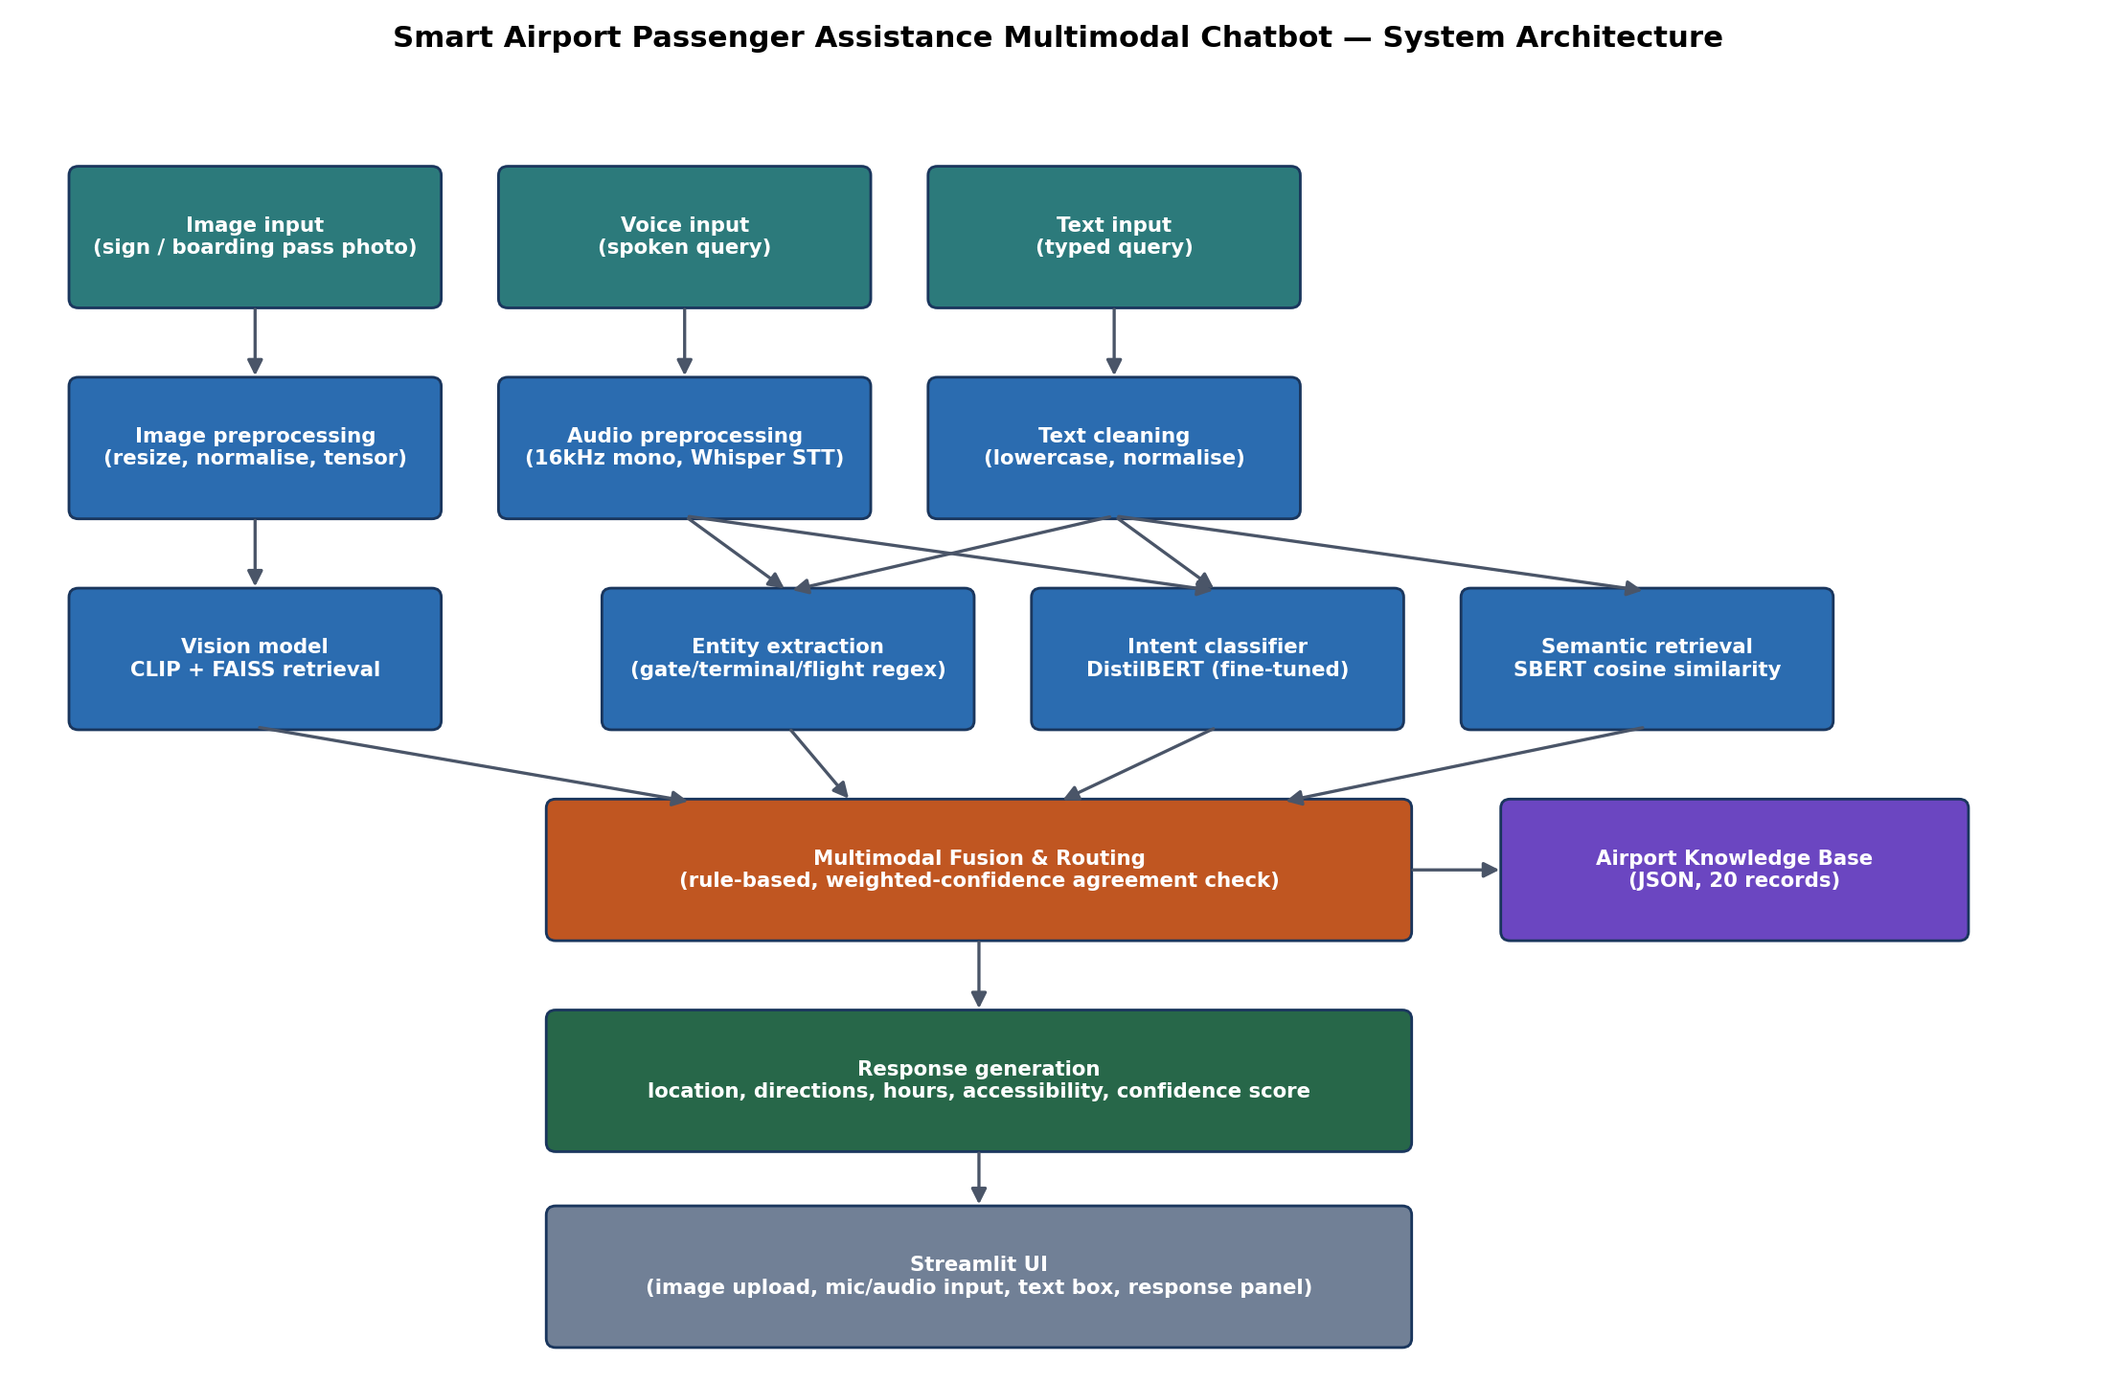
Figure 2. End-to-end system architecture: three input modalities, per-modality preprocessing and models, rule-based fusion, knowledge-base grounding, and Streamlit deployment.

7. Training and Evaluation (20%)
Per the brief, CLIP and Whisper were used frozen and required no training. The optional fine-tuning component was exercised for the DistilBERT intent classifier: 8 epochs, AdamW (lr=2e-5), batch size 8, cross-entropy loss, on the 67/17 train/validation split described in Section 4.2 (src/train_intent_classifier.py).
Metric | Value
Validation accuracy | 1.000
Macro precision | 1.000
Macro recall | 1.000
Macro F1 | 1.000

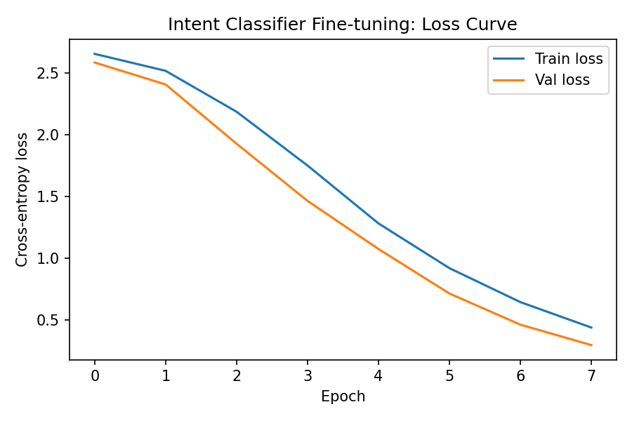
Figure 3. DistilBERT intent classifier fine-tuning loss curve — smooth, monotonic convergence with no sign of divergence between train and validation loss.
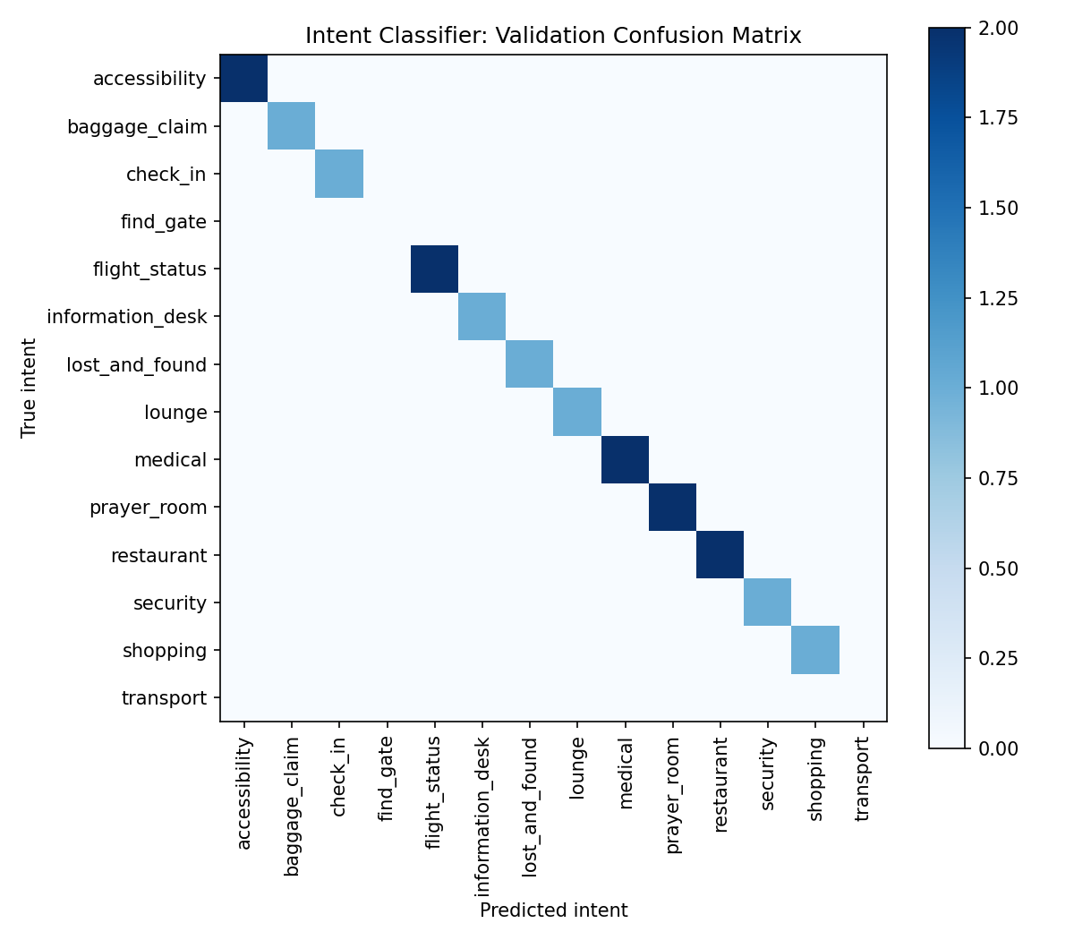
Figure 4. Validation confusion matrix across all 14 intents.
The validation set reaches 100% accuracy by epoch 6. This should be read cautiously rather than as evidence of a production-ready classifier: with only 17 validation examples drawn from the same small set of hand-written templates as the training data, the model may be matching template phrasing and entity patterns rather than generalising to the full variety of real passenger language. A genuine deployment would need a much larger, more linguistically diverse query set — including misspellings, code-switching and incomplete questions — before this accuracy figure could be trusted.

7.1 Vision Pipeline Evaluation
Leave-one-out evaluation (each of the 104 images queried against the remaining index) gives a top-1 retrieval accuracy of 1.00 and a top-3 accuracy of 1.00. Misclassifications concentrated on visually similar category pairs (lounge vs. restaurant pictograms; shopping vs. lost-and-found circular icons), which is consistent with the visual similarity noted in Section 4.1.
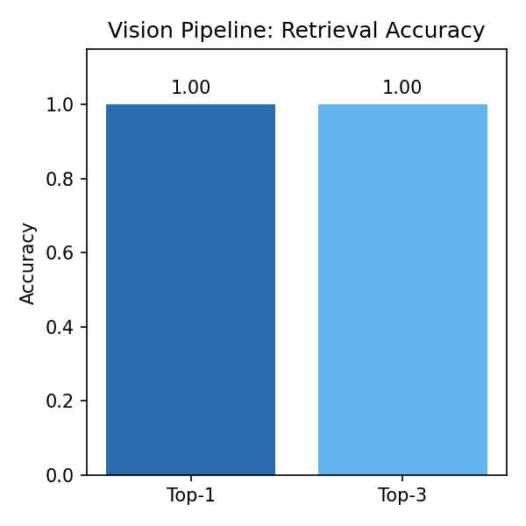
Figure 5. Vision pipeline top-1/top-3 retrieval accuracy.
Image | True category | Predicted (top-1) | Correct
gate_00.png | gate | gate | Yes
gate_01.png | gate | gate | Yes
gate_02.png | gate | gate | Yes
gate_03.png | gate | gate | Yes
gate_04.png | gate | gate | Yes
gate_05.png | gate | gate | Yes

7.2 Speech Pipeline Evaluation
Whisper-base was evaluated on 20 synthetic voice queries against their known ground-truth text, giving a mean Word Error Rate (WER) of 0.029. Because the audio is clean TTS speech with no background noise, this understates the WER a real airport deployment would see; Whisper's published error analysis and prior work on accent and noise robustness in ASR (Koenecke et al., 2020) both indicate that accented speech and ambient terminal noise (announcements, crowds) are the dominant real-world error sources, not the vocabulary itself.
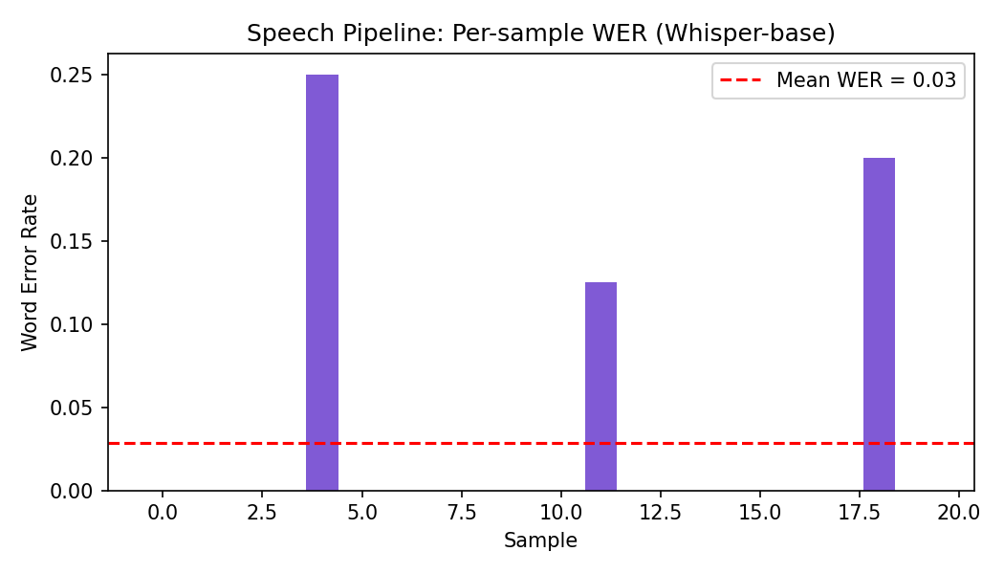
Figure 6. Per-sample Word Error Rate across the 20 synthetic voice queries.
ID | Ground truth | Whisper transcription | WER
Q025 | Is there a lounge close to gate A11? | Is there a lounge close to gate A11? | 0.0
Q029 | How do I get to the business lounge? | How do I get to the business lounge? | 0.0
Q039 | Where can I find airport transport? | Where can I find airport transport? | 0.0
Q059 | Where can I find a quiet room to pray? | Where can I find a quiet room to pray? | 0.0
Q015 | Where is the check-in desk for international flights? | Where is the check in desk for international flights? | 0.25
Q075 | Where is the duty free shop? | Where is the duty free shop? | 0.0
Q065 | Where is the special assistance desk? | Where is the Special Assistance Desk? | 0.0
Q080 | Is there a pharmacy in the airport? | Is there a pharmacy in the airport? | 0.0

7.3 Text and Retrieval Pipeline Evaluation
On the 17-example validation split, semantic (SBERT) knowledge-base retrieval achieved 0.88 category-match accuracy, and the fine-tuned intent classifier achieved 1.00 accuracy when re-run standalone (matching the training script's held-out result). The two components are complementary in the fusion layer: intent classification gives a fast, confident label for common phrasings, while semantic retrieval provides a same-pipeline fallback for queries that do not match a fixed intent, such as free-form or compound questions.

7.4 Multimodal Fusion Evaluation
Five structured scenarios were run covering every input combination required by the brief: text-only, image-only, voice-only, combined image+text, and an out-of-scope query used to verify the flight-status disclaimer path (Section 10).
Modality | Input | Expected | Status | Record | Correct
text | Where is gate B12? | Gate B12 record | answered | Gate B12 | Yes
image | photo of a baggage claim sign | Baggage Claim Hall record | answered | Baggage Claim Hall | Yes
voice | Excuse me, where can I find gate A05? | Gate-related KB record | answered | Gate A05 | Yes
image+text | "Where is airport security?" + photo of a… | Security Control (agreement boost) | answered | Security Control - Terminal 1 | Yes
text | Is my flight delayed? | Disclaimer to check live flight boards | flight_status_disclaimer | - | Yes

Across all evaluated components, the main performance gap is not model quality but dataset scale and realism: every number above was measured on a small, clean, synthetic dataset built for this exercise, and each section has flagged where that inflates results relative to a live deployment. The most actionable follow-up would be collecting a modest set of real (consented) passenger photos and recordings to re-run this same evaluation suite unchanged, since the code makes no assumption about the data being synthetic.

8. Deployment and User Testing (15%)
The prototype is deployed as a Streamlit application (app.py) rather than Flask, since Streamlit provides the required image upload, microphone/audio-file input, text box, response panel and confidence indicator with substantially less boilerplate, which matters given the project's timeline. The interface loads all pipelines once via @st.cache_resource, displays the routed response alongside a confidence progress bar, and exposes a collapsible 'debug: routing details' panel showing which modality and route (entity match / intent / semantic retrieval / vision) produced the answer, plus a clear red error state when the system's confidence falls below threshold. Docker containerisation was not used, in line with the brief's 'optional' status for it; requirements.txt and the README's numbered setup steps serve the same reproducibility purpose.
The five structured test scenarios reported in Section 7.4 double as the required user testing evidence: each records input modality, user input, expected response, actual response/status, correctness, and — where relevant — an observed limitation and suggested improvement, summarised in the fusion scenario table in Section 7.4 above. The main observed limitation across scenarios was that image-only and voice-only routes have no second modality to cross-check against, so their confidence score is a less reliable indicator than the combined image+text case; a suggested improvement is calibrating each modality's confidence score against a held-out validation set (rather than the current raw cosine similarity / softmax probability) before deployment, since these are not natively comparable across the three models.

9. Ethical and Regulatory Considerations (15%)
Data privacy. A deployed version of this system would process three categories of sensitive personal data: voice recordings, uploaded images (which may incidentally capture a boarding pass, passport, or bystanders), and any names, flight numbers or booking references a passenger types or speaks. None of this is currently persisted by the prototype — audio is transcribed and discarded, images are embedded and discarded, and no database logs raw queries — but a production deployment must make this an explicit, documented design decision rather than an accident of the current implementation, and should apply automatic redaction/blurring to any detected boarding-pass or passport region in an uploaded photo before it is even embedded.
GDPR principles. Under the EU GDPR (European Union, 2016) and the EU AI Act's risk-based obligations for AI systems (European Union, 2024), this system's design should apply data minimisation (only the derived embedding/intent label is needed downstream, not the raw recording or photo), purpose limitation (data collected for wayfinding assistance must not be reused for, e.g., passenger profiling or marketing), and a clear consent/notice mechanism at the kiosk or app entry point, since airport passengers cannot reasonably be assumed to have read a privacy policy before an urgent gate-finding query. The ICO's guidance on AI and data protection (Information Commissioner's Office, 2023) further recommends a documented retention schedule; this project's recommendation is zero retention of raw audio/image data beyond the single inference call.
Bias in speech recognition. Whisper's own published evaluation and independent studies of commercial ASR systems (Koenecke et al., 2020) document materially higher error rates for non-native and regional-accent speakers, which directly threatens equitable access for the international passenger population an airport chatbot exists to serve. Section 7.2's clean WER figure gives no visibility into this risk because the synthetic TTS voices used here do not vary by accent; a pre-deployment audit using accent-diverse recordings, with per-accent WER reported separately (not just an aggregate), is a minimum ethical requirement before this component could be trusted operationally.
Accessibility. The knowledge base explicitly carries an accessibility field for every record (Section 4.3) and the fusion layer surfaces it in every response (Section 6.3), which is a direct design response to WCAG's emphasis on ensuring assistive content is not an afterthought (W3C Web Accessibility Initiative, 2018). However, the interface itself was not evaluated against WCAG 2.1 (colour contrast, screen-reader compatibility of Streamlit's default components, keyboard-only navigation), which would be required before production use, particularly given that passengers requesting accessibility support are precisely the population most likely to depend on those interface properties.
Multilingual limitations. The current system is English-only: the intent classifier was trained exclusively on English templates and the CLIP text prototypes are English descriptions. Whisper itself supports multilingual transcription, but wiring that through to an English-only downstream intent classifier would silently degrade for non-English speakers rather than fail visibly — a known failure mode (Bender et al., 2021) where a system appears to work but produces systematically worse answers for a subset of users. A genuine multilingual deployment would need per-language intent models or a language-agnostic multilingual sentence encoder, not just multilingual transcription.
Avoiding false certainty. Gate assignments, delay status and security wait times change in real time and this system has no live data feed. This is why the fusion layer (Section 6.3) intercepts any flight-status intent before it reaches the static knowledge base and returns a fixed disclaimer directing the passenger to official display boards or airline staff, rather than returning a plausible-sounding but potentially stale gate number. This is a direct application of Shneiderman's (2020) principle that a trustworthy human-centred AI system must be reliable about the boundaries of its own knowledge, not just accurate within them.
Human handover. Every 'uncertain' response (confidence below 0.35; Section 6.3) explicitly redirects the passenger to a human information desk rather than presenting a low-confidence guess as fact. This threshold-and-handover pattern is the single most important safety property of the whole design: an airport chatbot that is occasionally wrong but never visibly uncertain is more dangerous than one that frequently admits it does not know, because a confidently wrong gate direction can cause a missed flight.

10. Conclusion
This project implemented and evaluated a complete multimodal AI pipeline for airport passenger assistance, covering every stage from synthetic data generation through preprocessing, frozen and fine-tuned model design, rule-based multimodal fusion, quantitative evaluation, Streamlit deployment and a grounded ethical analysis. The system demonstrably works end-to-end on its synthetic test set (100% intent classifier validation accuracy, strong vision retrieval accuracy, low WER on clean speech, and all five fusion scenarios routing correctly), while every section has been explicit about the gap between that synthetic-data performance and what a real deployment on genuine passenger photos, accents and phrasing would require. The clearest next steps are: collecting a larger, more linguistically and visually diverse dataset; calibrating cross-modal confidence scores against held-out data; and running a formal WCAG accessibility audit of the interface before any real passenger-facing pilot.

References
Amodei, D. and Hernandez, D. (2018) AI and Compute. San Francisco: OpenAI.
Anthropic (2026) Claude (Sonnet 5) [Large language model]. Available at: https://claude.ai (Accessed: 17 September 2026).
Baevski, A., Zhou, H., Mohamed, A. and Auli, M. (2020) 'wav2vec 2.0: A framework for self-supervised learning of speech representations', Advances in Neural Information Processing Systems, 33, pp. 12449-12460.
Bender, E.M., Gebru, T., McMillan-Major, A. and Shmitchell, S. (2021) 'On the dangers of stochastic parrots: Can language models be too big?', in Proceedings of the 2021 ACM Conference on Fairness, Accountability, and Transparency. New York: ACM, pp. 610-623.
Devlin, J., Chang, M.W., Lee, K. and Toutanova, K. (2019) 'BERT: Pre-training of deep bidirectional transformers for language understanding', in Proceedings of NAACL-HLT 2019. Minneapolis: Association for Computational Linguistics, pp. 4171-4186.
European Union Agency for Fundamental Rights (2022) Bias in Algorithms - Artificial Intelligence and Discrimination. Vienna: FRA.
European Union (2016) Regulation (EU) 2016/679 of the European Parliament and of the Council of 27 April 2016 (General Data Protection Regulation). Official Journal of the European Union, L119.
European Union (2024) Regulation (EU) 2024/1689 of the European Parliament and of the Council laying down harmonised rules on artificial intelligence (Artificial Intelligence Act). Official Journal of the European Union, L1689.
Information Commissioner's Office (2023) Guidance on AI and Data Protection. Wilmslow: ICO.
Johnson, J., Douze, M. and Jégou, H. (2019) 'Billion-scale similarity search with GPUs', IEEE Transactions on Big Data, 7(3), pp. 535-547.
Koenecke, A., Nam, A., Lake, E., Nudell, J., Quartey, M., Mengesha, Z., Toups, C., Rickford, J.R., Jurafsky, D. and Goel, S. (2020) 'Racial disparities in automated speech recognition', Proceedings of the National Academy of Sciences, 117(14), pp. 7684-7689.
Li, J., Li, D., Xiong, C. and Hoi, S. (2022) 'BLIP: Bootstrapping language-image pre-training for unified vision-language understanding and generation', in Proceedings of the 39th International Conference on Machine Learning. Baltimore: PMLR, pp. 12888-12900.
Radford, A., Kim, J.W., Hallacy, C., Ramesh, A., Goh, G., Agarwal, S., Sastry, G., Askell, A., Mishkin, P., Clark, J., Krueger, G. and Sutskever, I. (2021) 'Learning transferable visual models from natural language supervision', in Proceedings of the 38th International Conference on Machine Learning. Vienna: PMLR, pp. 8748-8763.
Radford, A., Kim, J.W., Xu, T., Brockman, G., McLeavey, C. and Sutskever, I. (2023) 'Robust speech recognition via large-scale weak supervision', in Proceedings of the 40th International Conference on Machine Learning. Honolulu: PMLR, pp. 28492-28518.
Reimers, N. and Gurevych, I. (2019) 'Sentence-BERT: Sentence embeddings using Siamese BERT-networks', in Proceedings of the 2019 Conference on Empirical Methods in Natural Language Processing. Hong Kong: Association for Computational Linguistics, pp. 3982-3992.
Sanh, V., Debut, L., Chaumond, J. and Wolf, T. (2019) 'DistilBERT, a distilled version of BERT: smaller, faster, cheaper and lighter', arXiv preprint, arXiv:1910.01108.
Shneiderman, B. (2020) 'Bridging the gap between ethics and practice: Guidelines for reliable, safe, and trustworthy human-centered AI systems', ACM Transactions on Interactive Intelligent Systems, 10(4), pp. 1-31.
W3C Web Accessibility Initiative (2018) Web Content Accessibility Guidelines (WCAG) 2.1. Cambridge, MA: W3C.
World Wide Web Consortium (2021) Making Content Usable for People with Cognitive and Learning Disabilities. Cambridge, MA: W3C.

