₹ MiniKhata

Project Submission Report

A Multi-User Digital Ledger Application for Small Businesses

Developed by:
Gurutej Hegde

GitHub: github.com/GurutejHegde/minikhata

Report Generated: 02 June 2026

📋 1. Project Overview
MiniKhata is a full-stack web application that serves as a digital udhar khata (credit ledger) for small business owners and individuals. It enables users to manage customer accounts, record credit and payment transactions, track installment-based payments, generate analytics reports, and receive smart overdue notifications — all through a modern, dark-themed web interface.

The name "MiniKhata" comes from the Hindi word "Khata" (खाता), meaning account book or ledger. The "Mini" prefix reflects its lightweight, accessible nature — a digital equivalent of the traditional physical ledger book used by small Indian shopkeepers.

🛠️ 2. Technology Stack
The application is built using a clean and modern stack optimized for rapid development, maintainability, and performance:

Layer | Technology | Purpose
Backend | Node.js + Express.js | REST API, session auth, routing
Database | MySQL (via XAMPP) | Relational storage, FK constraints, FIFO engine
Frontend | HTML5, CSS3, Vanilla JS | Dynamic SPA dashboard, dark-mode UI
Auth | bcrypt + express-session | Secure password hashing, session management
PDF Export | Browser Print API | Customer statement generation
Backup/Restore | JSON file (API) | Portable data export & restore
Version Control | Git + GitHub | Source code, CI deployment ready

⭐ 3. Key Features

3.1 Authentication & Multi-User Support
- Secure registration and login with bcrypt password hashing
- Session-based authentication using express-session
- Two account modes: Business (Customers & Dues) and Personal (People & Lendings)
- Dynamic UI terminology that switches based on selected account type

3.2 Customer Management
- Add, view, search, and delete customers with name, phone, and address
- Real-time outstanding balance calculated per customer
- Interactive side drawer for full transaction history per customer
- PDF statement export for individual customer ledger

3.3 Transaction Management
- Record Credit Given and Payment Received transactions with notes and dates
- Full edit history with edit reason tracking and timestamps
- Reverse transactions with mandatory reason entry (audit trail)
- Paginated table view with multi-filter support (customer, type, date, keyword)

3.4 FIFO Settlement Engine
- Automatically allocates each payment to the oldest outstanding credit first
- Tracks exactly what percentage of each credit is settled vs. remaining
- Visual progress bars in the customer drawer showing settlement status
- Recalculates on every transaction add, edit, or reversal

3.5 Installment & Due Date Tracking
- Attach due dates to credit transactions for installment tracking
- Overdue Alerts page flags accounts with no payment in 30+ days
- Shows exact "days idle" count per overdue account
- Upcoming dues widget on Dashboard for next-7-day reminders

3.6 Analytics & Reports
- Monthly bar chart showing Credit Given vs. Payment Received
- Summary cards for Total Given, Total Collected, and Total Outstanding
- Custom date range filter for report generation

3.7 Notifications & Alerts
- Smart notification engine evaluates ledger state on each login
- Alerts generated for: overdue payments, large balances, unsettled credits
- Notification badge count displayed in the top navigation bar

3.8 Backup & Data Safety
- Export entire ledger database as a structured JSON backup file
- One-click restore from any previous JSON backup
- Full account deletion with cascade removal of all associated data

🗄️ 4. Database Architecture
The database follows a normalized relational design with six tables, connected via foreign keys and equipped with cascade delete rules to maintain data integrity.

Table | Primary Key | Key Columns | Purpose
users | user_id | username, password, user_type | Login credentials & account type
customers | customer_id | user_id (FK), name, phone | Customer profiles per user
transactions | transaction_id | customer_id (FK), type, amount | Credit & payment records
settlements | id | payment_txn_id, credit_txn_id | FIFO payment allocations
installments | id | transaction_id (FK), due_date | Installment schedules
notifications | id | user_id (FK), type, message | Smart alert system

4.1 Entity-Relationship Diagram
The diagram below illustrates the relationships between all six database entities:

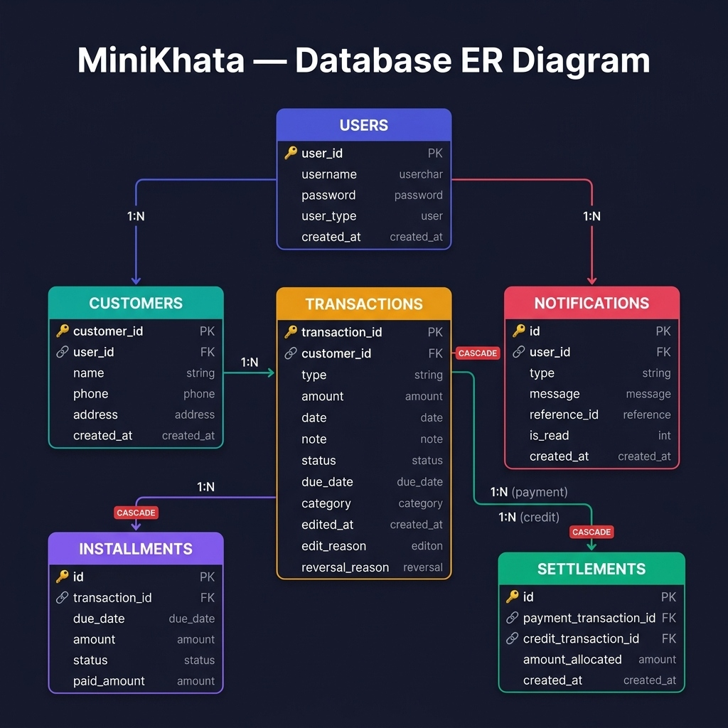
Figure 1 — MiniKhata Database ER Diagram showing all 6 tables with primary keys, foreign keys, and cardinality

🔌 5. API Routes
All API endpoints follow RESTful conventions and are protected by session-based authentication middleware:

Method | Route | Description
POST | /api/auth/login | Authenticate user
POST | /api/auth/register | Register new account
POST | /api/auth/logout | End session
GET | /api/customers | List all customers
POST | /api/customers | Add new customer
DELETE | /api/customers/:id | Remove customer + cascade
GET | /api/transactions | Paginated transaction list
POST | /api/transactions | Add credit or payment
PATCH | /api/transactions/:id | Edit transaction
POST | /api/transactions/:id/reverse | Reverse with audit reason
GET | /api/reports | Monthly analytics data
GET | /api/notifications | User notifications
GET | /api/backup/export | Export DB as JSON
POST | /api/backup/import | Restore DB from JSON

🖥️ 6. User Interface Walkthrough
The following screenshots capture the live system running with realistic demo data seeded across 6 customers and 24 transactions.

6.1 Dashboard
The Dashboard provides an immediate overview of the entire ledger. Four metric cards show Total Customers, Total Pending Amount, Today's Activity, and Overdue Account count. Below these, two panels list customers with outstanding balances and the five most recent transactions.

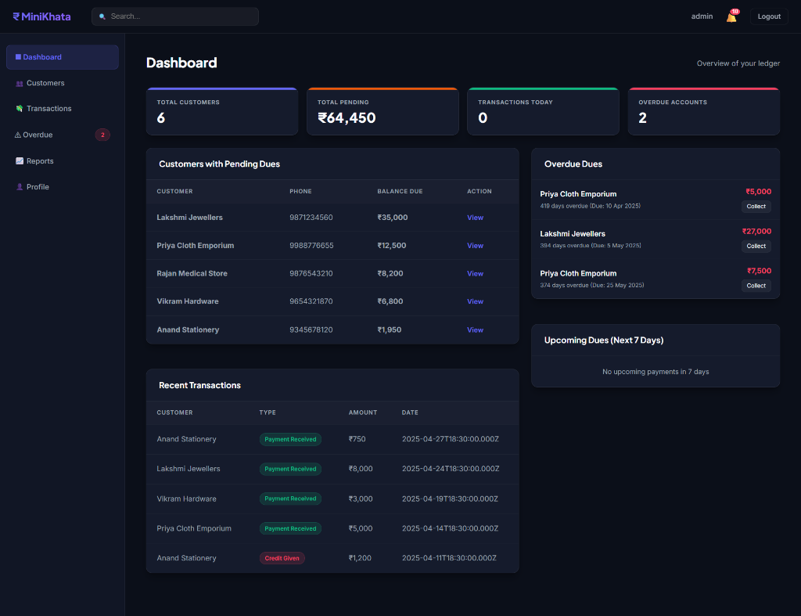
Figure 2 — Dashboard overview showing 6 customers, ₹64,450 total outstanding, and 2 overdue accounts

6.2 Transaction Ledger
The Transactions page shows all 24 records with smart filters. Green "Payment Received" badges with + amounts and red "Credit Given" badges with − amounts make cash flow immediately visible. Each row has Edit, Reverse, and Installments action buttons.

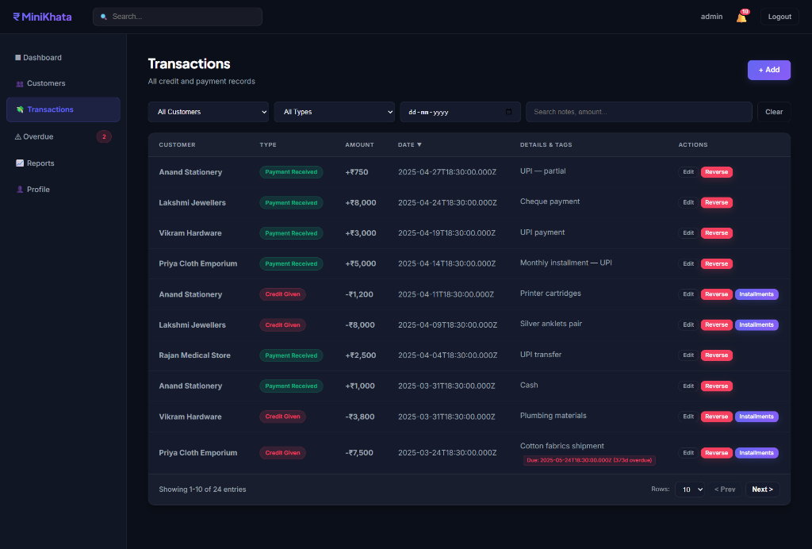
Figure 3 — Transactions page showing paginated ledger with filters, type badges, and action buttons

6.3 Customer Side Drawer
Clicking any customer opens a smooth slide-in drawer showing their live balance, all transactions in reverse chronological order, FIFO settlement progress bars per credit, and quick-action buttons to add credits or payments, or export a PDF statement.

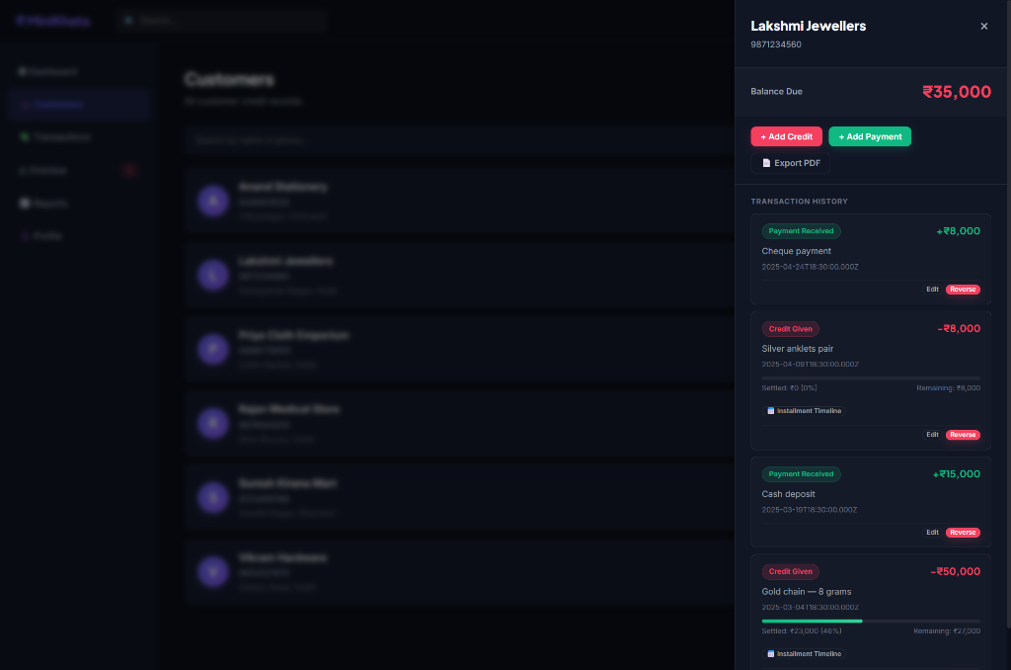
Figure 4 — Lakshmi Jewellers drawer showing ₹35,000 balance, FIFO settlement tracking, and transaction history

6.4 Overdue Alerts
The Overdue Alerts page surfaces customers who have outstanding balances with no incoming payment for more than 30 days. The "Days Idle" counter turns red to indicate urgency, and a direct "Open Drawer" button allows immediate collection action.

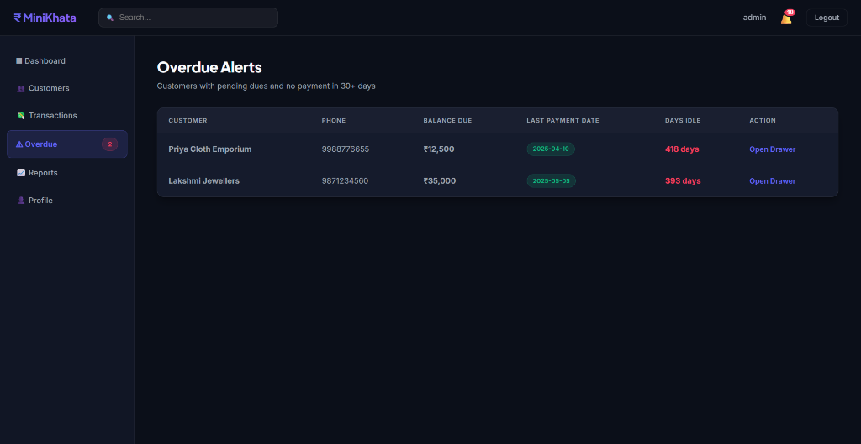
Figure 5 — Overdue Alerts showing Priya Cloth Emporium (418 days) and Lakshmi Jewellers (393 days)

6.5 Ledger Reports
The Reports tab generates a monthly bar chart comparing Credit Given (red bars) vs. Payment Received (green bars). Three summary cards show total figures for the selected period. Date range filters allow custom analysis.

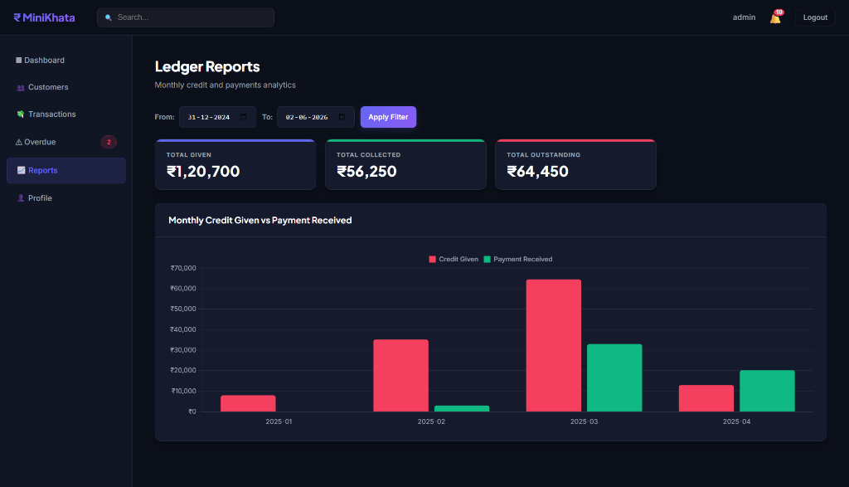
Figure 6 — Ledger Reports showing ₹1,20,700 total given, ₹56,250 collected, ₹64,450 outstanding

6.6 Profile Settings
The Profile page allows users to change account type (Business ↔ Personal), which dynamically updates all UI labels across the application. It also provides a one-click Backup & Restore system for data safety, and an Account Deletion option with cascade removal.

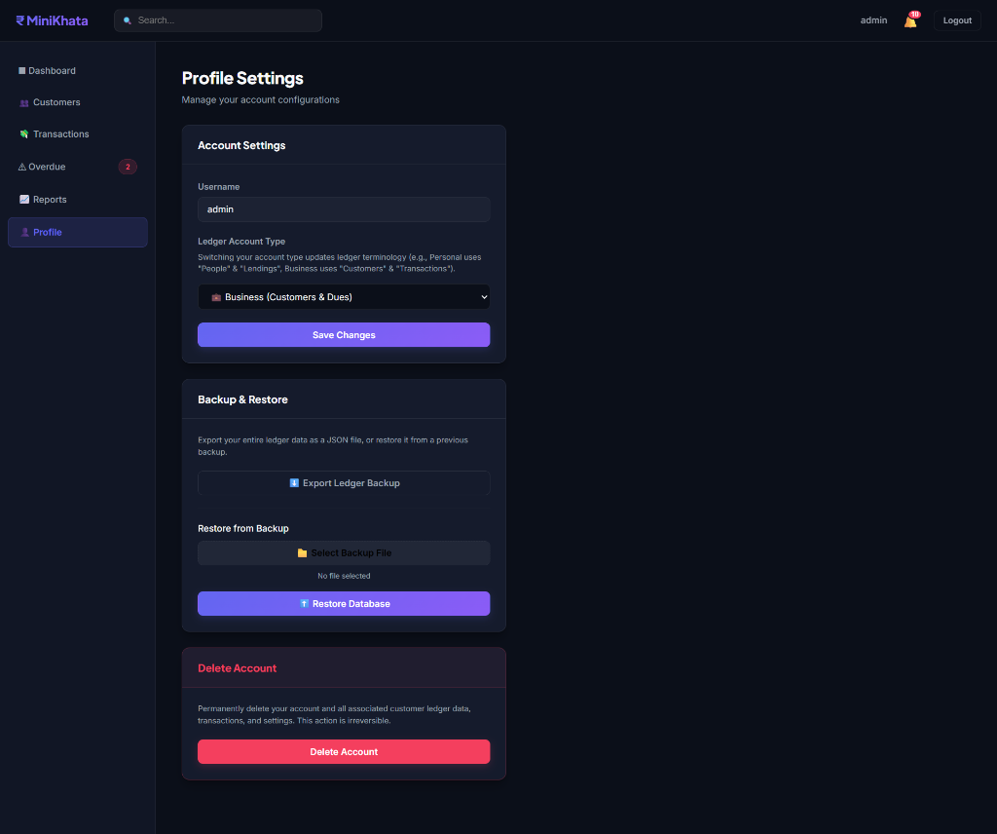
Figure 7 — Profile Settings showing Account Type switcher, Backup & Restore, and Account Deletion

📁 7. Project File Structure
The project follows a clear MVC-like separation with routes handling API logic, services encapsulating business engines, and public containing all front-end assets:

minikhata/
├── server.js # Express app entry point
├── db.js # MySQL connection pool
├── database.sql # Schema + default seed
├── seed-demo.js # Demo data seeder
├── .env # DB credentials (gitignored)
├── routes/
│ ├── auth.js # Login, register, logout
│ ├── customers.js # Customer CRUD
│ ├── transactions.js # Transactions + FIFO trigger
│ ├── reports.js # Monthly analytics
│ ├── notifications.js # Alert system
│ ├── backup.js # Export / Import
│ ├── installments.js # Due date tracking
│ └── search.js # Global search
├── services/
│ ├── settlementEngine.js # FIFO algorithm
│ └── notificationRules.js # Alert rules
└── public/
├── index.html # Login page
├── js/app.js # Core frontend logic
└── pages/
├── dashboard.html
├── customers.html
├── transactions.html
├── overdue.html
├── reports.html
└── profile.html

✅ 8. Conclusion
MiniKhata demonstrates a complete, production-quality web application built from scratch. It solves a real-world problem faced by millions of small business owners in India who still rely on physical ledger books — by digitizing the entire process with modern engineering practices.

The system applies several core engineering concepts including:
- Relational database normalization with proper FK constraints and cascade rules
- FIFO algorithmic design for accurate financial settlement tracking
- RESTful API architecture with clean separation of concerns
- Session-based authentication with bcrypt security
- Event-driven notification system that evaluates business rules on login

Future improvements could include: SMS/WhatsApp payment reminders, multi-branch support, cloud deployment (Railway / Render), and a React Native mobile app.

₹ MiniKhata | github.com/GurutejHegde/minikhata | localhost:3000

