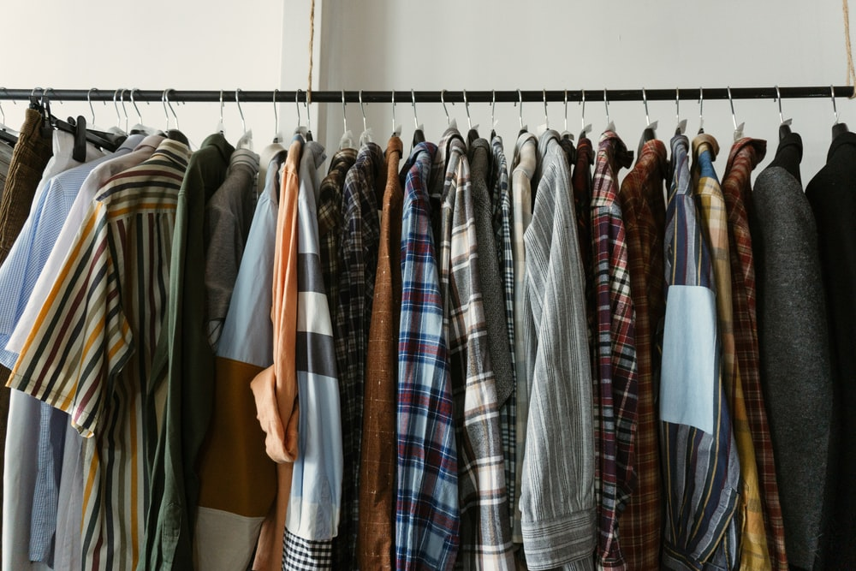

|  |  |  |  |  |
| --- | --- | --- | --- | --- |
| SAMPLE NEWSLETTER  Sustainable apparel for a better world. Discover all the brands that you could switch to for your wardrobe! | | |  | 27th JANUARY 2021 | ISSUE #3 |
|  | | |  | In this issue  The brands and their styles  Add description text here to get your subscribers interested in your topic.  UK based brand just around the corner  Add description text here to get your subscribers interested in your topic.  Design, sustainability and more  Add description text here to get your subscribers interested in your topic |
| The brands and their styles By Linfang Wang |  | Newsletters are periodicals used to advertise or update your subscribers with information about your product or blog. They can be printed or emailed and are an excellent way to maintain regular contact with your subscribers and drive traffic to your site. Type the content of your newsletter here.  Newsletters are periodicals used to advertise or update your subscribers with information about your product or blog. They can be printed or emailed and are an excellent way to maintain regular contact with your subscribers and drive traffic to your site. Type the content of your newsletter here.  Newsletters are periodicals used to advertise or update your subscribers with information about your product or blog. They can be printed or emailed and are an excellent way to maintain regular contact with your subscribers and drive traffic to your site. Type your content here. | | |

|  |  |  |
| --- | --- | --- |
|  |  | SAMPLE NEWSLETTER |
| person pushing wheel barrel of plants Design, sustainability and more By Linfang Wang  Newsletters are periodicals used to advertise or update your subscribers with information about your product or blog. They can be printed or emailed and are an excellent way to maintain regular contact with your subscribers and drive traffic to your site. Type the content of your newsletter here.  Newsletters are periodicals used to advertise or update your subscribers with information about your product or blog. Type the content of your newsletter here.  Newsletters are periodicals used to advertise or update your subscribers with information about your product or blog. They can be printed or emailed and are an excellent way to maintain regular contact with your subscribers and drive traffic to your site. Type the content of your newsletter here.  Newsletters are periodicals used to advertise or update your subscribers with information about your product or blog. They can be printed or emailed and are an excellent way to maintain regular contact with your subscribers and drive traffic to your site. Type the content of your newsletter here.  Newsletters are periodicals used to advertise or update your subscribers. |  | UK based brand just around the corner By Riya Kapoor |
| Newsletters are periodicals used to advertise or update your subscribers with information about your product or blog. They can be printed or emailed and are an excellent way to maintain regular contact with your subscribers and drive traffic to your site. Type the content of your newsletter here.  Newsletters are periodicals used to advertise or update your subscribers with information about your product or blog. Type the content of your newsletter here.  Newsletters are periodicals used to advertise or update your subscribers with information about your product or blog. They can be printed or emailed and are an excellent way to maintain regular contact with your subscribers and drive traffic to your site. Type the content of your newsletter here.  Newsletters are periodicals used to advertise or update your subscribers with information about your product or blog. Type the content of your newsletter here. |