|  |  |
| --- | --- |
| **Exno: 2 b)** | **Portfolio Creation** |
| **Date:** |

**AIM:**

To create a portfolio using HTML and CSS.

**DESCRIPTION:**

This portfolio is created to demonstrate the achievements and skills of me. Each section of the portfolio webpage is created using basic HTML tags and CSS styles.

**PROCEDURE:**

**Step1:Structure:**The HTML file includes various sections such as "About Me", "Education", "Skills", "Projects", "Certificates", and "Achievements".It also has navigation links to quickly jump to different sections of the page.The layout appears to be organized using the Bootstrap framework, as indicated by the class names like "container" and "row".**Step2:Sections:**"About Me": Contains a brief introduction and an image."Education": Lists educational qualifications with details about the institution, duration, and performance."Skills": Divided into categories like "Programming Languages", "Frontend Development", "Backend Development", and "Database Management", each displaying specific skills."Projects": Likely showcases personal or professional projects undertaken by the developer."Certificates" and "Achievements": Highlight certifications and noteworthy accomplishments.**Step3:Styling and Assets:**The stylesheet "styles.css" is linked to the HTML file for styling purposes.Various images/icons are referenced within the HTML for visual elements.Inline styles are used within HTML elements for specific styling instructions.**Step4:Links and Icons:**Links to external profiles like GitHub, LinkedIn, and Google Mail are embedded using anchor tags.Icons for these links are displayed using image tags with appropriate alt text.

**HTML tags:**

|  |  |
| --- | --- |
| **Tags used** | **Description & its Attributes used** |
| <html> | Represents the root of an HTML document. |
| <head> | It is the container for metadata |
| <title> | Defines a title in the browser toolbar. |
| <body> | It contains all the contents of an HTML document. |
| <img> | Defines an image in an HTML page.  **Attributes Used:**   * **src** - Specifies the path to the image * **alt** - Specifies an alternate text for the image, if the image for some reason cannot be displayed * **height** - Specifies the height of an image. * **width** - specifies the width of an image. |
| <div> | The <div> tag represents a generic container that divides the content into sections. It's often used to group together elements for styling purposes, layout structuring, or applying JavaScript functionality. |
| <input> | The <input> tag creates an interactive control in an HTML form, enabling users to enter data or make selections.  **Attributes:**   * **type:** Specifies the type of input control to be created (e.g., text, password, checkbox, radio, etc.). * **name:** Assigns a name to the input control, which is used to identify it when the form is submitted. * **value:** Sets the initial value of the input control. * **placeholder:** Provides a hint or example of the expected input for the user. * **id:** Specifies a unique identifier for the input control.class: Assigns one or more classes to the input control for styling purposes. * **required:** Indicates that the input field must be filled out before submitting the form. * **disabled**: Disables the input control, preventing user interaction. * **readonly:** Specifies that the input control is read-only and cannot be edited by the user. * **maxlength:** Sets the maximum number of characters that can be entered into a text input field. * **minlength:** Sets the minimum number of characters required in a text input field. * **pattern:** Defines a regular expression pattern that the input's value must match to be considered valid. * **autofocus:** Specifies that the input control should automatically have focus when the page loads. * **autocomplete:** Specifies whether the browser should automatically complete the input value based on the user's past entries. |
| <li> | The <li> tag represents a single item in a list.  **Attributes:**  The <li> tag generally does not have specific attributes of its own. However, it's important to note that it's commonly used within <ul> (unordered lists) and <ol> (ordered lists) elements. |
| <h1> to <h6> | Used to define the HTML headings. |
| <p> | Used to define a paragraph. |

**Code:**

**Index.html:**

<html><head> <link rel="stylesheet" href="styles.css"/> <title>Portfolio</title></head><body> <div class="iconsbottom"> <div class="cicon"> <a href="mailto:guruprinting2003@gmail.com"> <img src="google-icon.png" alt="Google"> </a> </div> <div class="cicon"> <a href="https://github.com/Guruvarshini" target="_blank"> <img src="github-icon.png" alt="GitHub"> </a> </div> <div class="cicon"> <a href="https://www.linkedin.com/in/guru-varshini-882b82251/" target="_blank"> <img src="linkedin-icon.png" alt="LinkedIn"> </a> </div> </div> <section id="navbar"> <div class="navbar-con"> <div class="container"> <img class="image" src="./V (3).png"/> <a class="navbar-brand" href="#">Guru Varshini B</a> <div class="collapse" id="navbarResponsive"> <ul class="navbar-nav"> <li class="nav-item"> <a class="nav-link" href="#aboutme">About Me</a> </li> <li class="nav-item"> <a class="nav-link" href="#education">Education</a> </li> <li class="nav-item"> <a class="nav-link" href="#skill">Skills</a> </li> <li class="nav-item"> <a class="nav-link" href="#projects">Projects</a> </li> <li class="nav-item"> <a class="nav-link" href="#certificates">Certificates</a> </li> <li class="nav-item"> <a class="nav-link" href="#achievements">Achievements</a> </li> </ul> </div> </div> </div> </section> <section id="header"> <div class="masthead"> <div class="container1"> <div class="row1"> <div class="col1"> <h1 style="font-family: Sacramento,cursive;" class="h11">I'm Guru Varshini B</h1> <h2 style="font-family: Courgette,cursive;" class="h21">A Web Developer</h2> <p class="lead">"Crafting digital dreams with lines of code"</p> </div> </div> </div> </div> </section> <section id="aboutme"> <div class="container2"> <div class="row2"> <img class="imaged" src="Guru Varshini_2112059.jpg" alt="" width="100" height="100"> <p class="display" style="color: #fafafc;">Hello there👋</p> <div class="col2"> <p class="lead1" style="color: #fcfbfb;">I'm a passionate programmer, delving into the realms of code and innovation. My journey revolves around transforming ideas into reality through elegant solutions and meticulous coding. Iam into exploring the endless possibilities of technology.</p> </div> </div> </div> </section> <section id="education"> <h2 class="section-heading">Education</h2> <div class="contain"> <div class="qualification"> <img src="./school.png" /> <h2>2018-2019</h2> <p class="institution">VSKD Matriculation Higher Sec School, Sivakasi</p> <p class="details">SSLC</p> <p class="percentage">Percentage: 94.6%</p> </div> <div class="qualification"> <img src="./hsc.png" /> <h2>2020-2021</h2> <p class="institution">Kamaraj Matriculation Higher Sec School, Kovilpatti</p> <p class="details">HSC</p> <p class="percentage">Percentage: 95.23%</p> </div> <div class="qualification"> <img src="./coll.png" /> <h2>Present</h2> <p class="institution">National Engineering College, Kovilpatti</p> <p class="details">BE-CSE</p> <p class="cgpa">CGPA: 9.21</p> </div> </div> </section> <section id="skill"> <div class="container1"> <h2 class="section-heading">Skills</h2> <div class="skills"> <div class="skill-card"> <div class="front"> <h2>Programming Languages</h2> </div> <div class="back"> <ul> <li><svg xmlns="http://www.w3.org/2000/svg" width="16" height="16" fill="currentColor" class="bi bi-filetype-java" viewBox="0 0 16 16"> <path fill-rule="evenodd" d="M14 4.5V11h-1V4.5h-2A1.5 1.5 0 0 1 9.5 3V1H4a1 1 0 0 0-1 1v9H2V2a2 2 0 0 1 2-2h5.5zM1.521 15.175a1.3 1.3 0 0 1-.082-.466h.765a.6.6 0 0 0 .073.27.5.5 0 0 0 .454.246q.285 0 .422-.164.138-.165.138-.466V11.85h.79v2.725q0 .66-.357 1.005-.354.345-.984.345a1.6 1.6 0 0 1-.568-.094 1.1 1.1 0 0 1-.408-.266 1.1 1.1 0 0 1-.243-.39m3.972-.354-.314 1.028h-.8l1.342-3.999h.926l1.336 3.999h-.84l-.314-1.028zm1.178-.59-.49-1.616h-.035l-.49 1.617zm2.342 1.618h.952l1.327-3.999h-.878l-.888 3.138h-.038L8.59 11.85h-.917zm3.087-1.028-.314 1.028h-.8l1.342-3.999h.926l1.336 3.999h-.84l-.314-1.028zm1.178-.59-.49-1.616h-.035l-.49 1.617z"/> </svg>Java</li> <li><svg xmlns="http://www.w3.org/2000/svg" width="16" height="16" fill="currentColor" class="bi bi-c-circle" viewBox="0 0 16 16"> <path d="M1 8a7 7 0 1 0 14 0A7 7 0 0 0 1 8m15 0A8 8 0 1 1 0 8a8 8 0 0 1 16 0M8.146 4.992c-1.212 0-1.927.92-1.927 2.502v1.06c0 1.571.703 2.462 1.927 2.462.979 0 1.641-.586 1.729-1.418h1.295v.093c-.1 1.448-1.354 2.467-3.03 2.467-2.091 0-3.269-1.336-3.269-3.603V7.482c0-2.261 1.201-3.638 3.27-3.638 1.681 0 2.935 1.054 3.029 2.572v.088H9.875c-.088-.879-.768-1.512-1.729-1.512"/> </svg>C</li> <li><svg xmlns="http://www.w3.org/2000/svg" width="16" height="16" fill="currentColor" class="bi bi-filetype-py" viewBox="0 0 16 16"> <path fill-rule="evenodd" d="M14 4.5V14a2 2 0 0 1-2 2H7v-1h5a1 1 0 0 0 1-1V4.5h-2A1.5 1.5 0 0 1 9.5 3V1H4a1 1 0 0 0-1 1v9H2V2a2 2 0 0 1 2-2h5.5zM0 11.85h1.6q.434 0 .732.179.302.175.46.477t.158.677-.16.677q-.158.299-.464.474a1.45 1.45 0 0 1-.732.173H.79v1.342H0zm2.06 1.714a.8.8 0 0 0 .085-.381q0-.34-.185-.521-.185-.182-.513-.182H.788v1.406h.66a.8.8 0 0 0 .374-.082.57.57 0 0 0 .238-.24m2.963.75v1.535H4.23v-1.52L2.89 11.85h.876l.853 1.696h.032l.856-1.696h.855z"/> </svg>Python</li> </ul> </div> </div> <div class="skill-card"> <div class="front"> <h2>Frontend Development</h2> </div> <div class="back"> <ul> <li><svg xmlns="http://www.w3.org/2000/svg" width="16" height="16" fill="currentColor" class="bi bi-filetype-html" viewBox="0 0 16 16"> <path fill-rule="evenodd" d="M14 4.5V11h-1V4.5h-2A1.5 1.5 0 0 1 9.5 3V1H4a1 1 0 0 0-1 1v9H2V2a2 2 0 0 1 2-2h5.5zm-9.736 7.35v3.999h-.791v-1.714H1.79v1.714H1V11.85h.791v1.626h1.682V11.85h.79Zm2.251.662v3.337h-.794v-3.337H4.588v-.662h3.064v.662zm2.176 3.337v-2.66h.038l.952 2.159h.516l.946-2.16h.038v2.661h.715V11.85h-.8l-1.14 2.596H9.93L8.79 11.85h-.805v3.999zm4.71-.674h1.696v.674H12.61V11.85h.79v3.325Z"/> </svg>HTML</li> <li><svg xmlns="http://www.w3.org/2000/svg" width="16" height="16" fill="currentColor" class="bi bi-filetype-css" viewBox="0 0 16 16"> <path fill-rule="evenodd" d="M14 4.5V14a2 2 0 0 1-2 2h-1v-1h1a1 1 0 0 0 1-1V4.5h-2A1.5 1.5 0 0 1 9.5 3V1H4a1 1 0 0 0-1 1v9H2V2a2 2 0 0 1 2-2h5.5zM3.397 14.841a1.13 1.13 0 0 0 .401.823q.195.162.478.252.284.091.665.091.507 0 .859-.158.354-.158.539-.44.187-.284.187-.656 0-.336-.134-.56a1 1 0 0 0-.375-.357 2 2 0 0 0-.566-.21l-.621-.144a1 1 0 0 1-.404-.176.37.37 0 0 1-.144-.299q0-.234.185-.384.188-.152.512-.152.214 0 .37.068a.6.6 0 0 1 .246.181.56.56 0 0 1 .12.258h.75a1.1 1.1 0 0 0-.2-.566 1.2 1.2 0 0 0-.5-.41 1.8 1.8 0 0 0-.78-.152q-.439 0-.776.15-.337.149-.527.421-.19.273-.19.639 0 .302.122.524.124.223.352.367.228.143.539.213l.618.144q.31.073.463.193a.39.39 0 0 1 .152.326.5.5 0 0 1-.085.29.56.56 0 0 1-.255.193q-.167.07-.413.07-.175 0-.32-.04a.8.8 0 0 1-.248-.115.58.58 0 0 1-.255-.384zM.806 13.693q0-.373.102-.633a.87.87 0 0 1 .302-.399.8.8 0 0 1 .475-.137q.225 0 .398.097a.7.7 0 0 1 .272.26.85.85 0 0 1 .12.381h.765v-.072a1.33 1.33 0 0 0-.466-.964 1.4 1.4 0 0 0-.489-.272 1.8 1.8 0 0 0-.606-.097q-.534 0-.911.223-.375.222-.572.632-.195.41-.196.979v.498q0 .568.193.976.197.407.572.626.375.217.914.217.439 0 .785-.164t.55-.454a1.27 1.27 0 0 0 .226-.674v-.076h-.764a.8.8 0 0 1-.118.363.7.7 0 0 1-.272.25.9.9 0 0 1-.401.087.85.85 0 0 1-.478-.132.83.83 0 0 1-.299-.392 1.7 1.7 0 0 1-.102-.627zM6.78 15.29a1.2 1.2 0 0 1-.111-.449h.764a.58.58 0 0 0 .255.384q.106.073.25.114.142.041.319.041.245 0 .413-.07a.56.56 0 0 0 .255-.193.5.5 0 0 0 .085-.29.39.39 0 0 0-.153-.326q-.152-.12-.463-.193l-.618-.143a1.7 1.7 0 0 1-.539-.214 1 1 0 0 1-.351-.367 1.1 1.1 0 0 1-.123-.524q0-.366.19-.639.19-.272.527-.422t.777-.149q.456 0 .779.152.326.153.5.41.18.255.2.566h-.75a.56.56 0 0 0-.12-.258.6.6 0 0 0-.246-.181.9.9 0 0 0-.37-.068q-.324 0-.512.152a.47.47 0 0 0-.184.384q0 .18.143.3a1 1 0 0 0 .404.175l.621.143q.326.075.566.211t.375.358.135.56q0 .37-.188.656a1.2 1.2 0 0 1-.539.439q-.351.158-.858.158-.381 0-.665-.09a1.4 1.4 0 0 1-.478-.252 1.1 1.1 0 0 1-.29-.375"/> </svg> CSS</li> <li><svg xmlns="http://www.w3.org/2000/svg" width="16" height="16" fill="currentColor" class="bi bi-filetype-jsx" viewBox="0 0 16 16"> <path fill-rule="evenodd" d="M14 4.5V14a2 2 0 0 1-2 2h-1v-1h1a1 1 0 0 0 1-1V4.5h-2A1.5 1.5 0 0 1 9.5 3V1H4a1 1 0 0 0-1 1v9H2V2a2 2 0 0 1 2-2h5.5zM3.075 14.841a1.13 1.13 0 0 0 .401.823q.194.162.478.252.284.091.665.091.507 0 .858-.158.355-.158.54-.44a1.17 1.17 0 0 0 .187-.656q0-.336-.135-.56a1 1 0 0 0-.375-.357 2 2 0 0 0-.565-.21l-.621-.144a1 1 0 0 1-.405-.176.37.37 0 0 1-.143-.299q0-.234.184-.384.188-.152.513-.152.214 0 .37.068a.6.6 0 0 1 .245.181.56.56 0 0 1 .12.258h.75a1.1 1.1 0 0 0-.199-.566 1.2 1.2 0 0 0-.5-.41 1.8 1.8 0 0 0-.78-.152q-.44 0-.776.15-.337.149-.528.421-.19.273-.19.639 0 .302.123.524t.351.367q.229.143.54.213l.618.144q.31.073.462.193a.39.39 0 0 1 .153.326.5.5 0 0 1-.085.29.56.56 0 0 1-.255.193q-.167.07-.413.07-.176 0-.32-.04a.8.8 0 0 1-.248-.115.58.58 0 0 1-.255-.384zM0 14.791q0 .247.082.466.083.22.243.39.165.17.407.267.246.093.569.093.63 0 .984-.346.357-.345.358-1.004v-2.725h-.791v2.745q0 .302-.138.466t-.422.164a.5.5 0 0 1-.454-.246.6.6 0 0 1-.073-.27zm8.907-2.859H9.8l-1.274 2.007L9.78 15.93h-.908l-.85-1.415h-.035l-.853 1.415h-.861l1.24-2.016-1.228-1.983h.931l.832 1.438h.036l.823-1.438Z"/> </svg> React.js</li> </ul> </div> </div> <div class="skill-card"> <div class="front"> <h2>Backend Development</h2> </div> <div class="back"> <ul> <li><svg xmlns="http://www.w3.org/2000/svg" width="16" height="16" fill="currentColor" class="bi bi-filetype-js" viewBox="0 0 16 16"> <path fill-rule="evenodd" d="M14 4.5V14a2 2 0 0 1-2 2H8v-1h4a1 1 0 0 0 1-1V4.5h-2A1.5 1.5 0 0 1 9.5 3V1H4a1 1 0 0 0-1 1v9H2V2a2 2 0 0 1 2-2h5.5zM3.186 15.29a1.2 1.2 0 0 1-.111-.449h.765a.58.58 0 0 0 .255.384q.105.073.249.114.143.041.319.041.246 0 .413-.07a.56.56 0 0 0 .255-.193.5.5 0 0 0 .085-.29.39.39 0 0 0-.153-.326q-.151-.12-.462-.193l-.619-.143a1.7 1.7 0 0 1-.539-.214 1 1 0 0 1-.351-.367 1.1 1.1 0 0 1-.123-.524q0-.366.19-.639.19-.272.528-.422.336-.15.776-.149.457 0 .78.152.324.153.5.41.18.255.2.566h-.75a.56.56 0 0 0-.12-.258.6.6 0 0 0-.247-.181.9.9 0 0 0-.369-.068q-.325 0-.513.152a.47.47 0 0 0-.184.384q0 .18.143.3a1 1 0 0 0 .405.175l.62.143q.327.075.566.211.24.136.375.358t.135.56q0 .37-.188.656a1.2 1.2 0 0 1-.539.439q-.351.158-.858.158-.381 0-.665-.09a1.4 1.4 0 0 1-.478-.252 1.1 1.1 0 0 1-.29-.375m-3.104-.033A1.3 1.3 0 0 1 0 14.791h.765a.6.6 0 0 0 .073.27.5.5 0 0 0 .454.246q.285 0 .422-.164.138-.165.138-.466v-2.745h.79v2.725q0 .66-.357 1.005-.354.345-.984.345a1.6 1.6 0 0 1-.569-.094 1.15 1.15 0 0 1-.407-.266 1.1 1.1 0 0 1-.243-.39"/> </svg>Node js</li> <li><svg xmlns="http://www.w3.org/2000/svg" width="16" height="16" fill="currentColor" class="bi bi-filetype-js" viewBox="0 0 16 16"> <path fill-rule="evenodd" d="M14 4.5V14a2 2 0 0 1-2 2H8v-1h4a1 1 0 0 0 1-1V4.5h-2A1.5 1.5 0 0 1 9.5 3V1H4a1 1 0 0 0-1 1v9H2V2a2 2 0 0 1 2-2h5.5zM3.186 15.29a1.2 1.2 0 0 1-.111-.449h.765a.58.58 0 0 0 .255.384q.105.073.249.114.143.041.319.041.246 0 .413-.07a.56.56 0 0 0 .255-.193.5.5 0 0 0 .085-.29.39.39 0 0 0-.153-.326q-.151-.12-.462-.193l-.619-.143a1.7 1.7 0 0 1-.539-.214 1 1 0 0 1-.351-.367 1.1 1.1 0 0 1-.123-.524q0-.366.19-.639.19-.272.528-.422.336-.15.776-.149.457 0 .78.152.324.153.5.41.18.255.2.566h-.75a.56.56 0 0 0-.12-.258.6.6 0 0 0-.247-.181.9.9 0 0 0-.369-.068q-.325 0-.513.152a.47.47 0 0 0-.184.384q0 .18.143.3a1 1 0 0 0 .405.175l.62.143q.327.075.566.211.24.136.375.358t.135.56q0 .37-.188.656a1.2 1.2 0 0 1-.539.439q-.351.158-.858.158-.381 0-.665-.09a1.4 1.4 0 0 1-.478-.252 1.1 1.1 0 0 1-.29-.375m-3.104-.033A1.3 1.3 0 0 1 0 14.791h.765a.6.6 0 0 0 .073.27.5.5 0 0 0 .454.246q.285 0 .422-.164.138-.165.138-.466v-2.745h.79v2.725q0 .66-.357 1.005-.354.345-.984.345a1.6 1.6 0 0 1-.569-.094 1.15 1.15 0 0 1-.407-.266 1.1 1.1 0 0 1-.243-.39"/> </svg>Express js</li> </ul> </div> </div> <div class="skill-card"> <div class="front"> <h2>Database Management</h2> </div> <div class="back"> <ul> <li><svg xmlns="http://www.w3.org/2000/svg" width="16" height="16" fill="currentColor" class="bi bi-filetype-sql" viewBox="0 0 16 16"> <path fill-rule="evenodd" d="M14 4.5V14a2 2 0 0 1-2 2v-1a1 1 0 0 0 1-1V4.5h-2A1.5 1.5 0 0 1 9.5 3V1H4a1 1 0 0 0-1 1v9H2V2a2 2 0 0 1 2-2h5.5zM0 14.841a1.13 1.13 0 0 0 .401.823q.194.162.478.252c.284.09.411.091.665.091q.507 0 .858-.158.355-.159.54-.44a1.17 1.17 0 0 0 .187-.656q0-.336-.135-.56a1 1 0 0 0-.375-.357 2 2 0 0 0-.565-.21l-.621-.144a1 1 0 0 1-.405-.176.37.37 0 0 1-.143-.299q0-.234.184-.384.187-.152.513-.152.214 0 .37.068a.6.6 0 0 1 .245.181.56.56 0 0 1 .12.258h.75a1.1 1.1 0 0 0-.199-.566 1.2 1.2 0 0 0-.5-.41 1.8 1.8 0 0 0-.78-.152q-.44 0-.776.15-.337.149-.528.421-.19.273-.19.639 0 .302.123.524t.351.367q.229.143.54.213l.618.144q.31.073.462.193a.39.39 0 0 1 .153.325q0 .165-.085.29A.56.56 0 0 1 2 15.31q-.167.07-.413.07-.176 0-.32-.04a.8.8 0 0 1-.248-.115.58.58 0 0 1-.255-.384zm6.878 1.489-.507-.739q.264-.243.401-.6.138-.358.138-.806v-.501q0-.556-.208-.967a1.5 1.5 0 0 0-.589-.636q-.383-.225-.917-.225-.527 0-.914.225-.384.223-.592.636a2.14 2.14 0 0 0-.205.967v.5q0 .554.205.965.208.41.592.636a1.8 1.8 0 0 0 .914.222 1.8 1.8 0 0 0 .6-.1l.294.422h.788ZM4.262 14.2v-.522q0-.369.114-.63a.9.9 0 0 1 .325-.398.9.9 0 0 1 .495-.138q.288 0 .495.138a.9.9 0 0 1 .325.398q.115.261.115.63v.522q0 .246-.053.445-.053.196-.155.34l-.106-.14-.105-.147h-.733l.451.65a.6.6 0 0 1-.251.047.87.87 0 0 1-.487-.147.9.9 0 0 1-.32-.404 1.7 1.7 0 0 1-.11-.644m3.986 1.057h1.696v.674H7.457v-3.999h.79z"/> </svg> MySQL</li> <li><svg xmlns="http://www.w3.org/2000/svg" width="16" height="16" fill="currentColor" class="bi bi-filetype-sql" viewBox="0 0 16 16"> <path fill-rule="evenodd" d="M14 4.5V14a2 2 0 0 1-2 2v-1a1 1 0 0 0 1-1V4.5h-2A1.5 1.5 0 0 1 9.5 3V1H4a1 1 0 0 0-1 1v9H2V2a2 2 0 0 1 2-2h5.5zM0 14.841a1.13 1.13 0 0 0 .401.823q.194.162.478.252c.284.09.411.091.665.091q.507 0 .858-.158.355-.159.54-.44a1.17 1.17 0 0 0 .187-.656q0-.336-.135-.56a1 1 0 0 0-.375-.357 2 2 0 0 0-.565-.21l-.621-.144a1 1 0 0 1-.405-.176.37.37 0 0 1-.143-.299q0-.234.184-.384.187-.152.513-.152.214 0 .37.068a.6.6 0 0 1 .245.181.56.56 0 0 1 .12.258h.75a1.1 1.1 0 0 0-.199-.566 1.2 1.2 0 0 0-.5-.41 1.8 1.8 0 0 0-.78-.152q-.44 0-.776.15-.337.149-.528.421-.19.273-.19.639 0 .302.123.524t.351.367q.229.143.54.213l.618.144q.31.073.462.193a.39.39 0 0 1 .153.325q0 .165-.085.29A.56.56 0 0 1 2 15.31q-.167.07-.413.07-.176 0-.32-.04a.8.8 0 0 1-.248-.115.58.58 0 0 1-.255-.384zm6.878 1.489-.507-.739q.264-.243.401-.6.138-.358.138-.806v-.501q0-.556-.208-.967a1.5 1.5 0 0 0-.589-.636q-.383-.225-.917-.225-.527 0-.914.225-.384.223-.592.636a2.14 2.14 0 0 0-.205.967v.5q0 .554.205.965.208.41.592.636a1.8 1.8 0 0 0 .914.222 1.8 1.8 0 0 0 .6-.1l.294.422h.788ZM4.262 14.2v-.522q0-.369.114-.63a.9.9 0 0 1 .325-.398.9.9 0 0 1 .495-.138q.288 0 .495.138a.9.9 0 0 1 .325.398q.115.261.115.63v.522q0 .246-.053.445-.053.196-.155.34l-.106-.14-.105-.147h-.733l.451.65a.6.6 0 0 1-.251.047.87.87 0 0 1-.487-.147.9.9 0 0 1-.32-.404 1.7 1.7 0 0 1-.11-.644m3.986 1.057h1.696v.674H7.457v-3.999h.79z"/> </svg> PostgreSQL</li> </ul> </div> </div> <div class="skill-card"> <div class="front"> <h2>Critical Thinking</h2> </div> <div class="back"> <p><svg xmlns="http://www.w3.org/2000/svg" width="16" height="16" fill="currentColor" class="bi bi-file-earmark-person" viewBox="0 0 16 16"> <path d="M11 8a3 3 0 1 1-6 0 3 3 0 0 1 6 0"/> <path d="M14 14V4.5L9.5 0H4a2 2 0 0 0-2 2v12a2 2 0 0 0 2 2h8a2 2 0 0 0 2-2M9.5 3A1.5 1.5 0 0 0 11 4.5h2v9.255S12 12 8 12s-5 1.755-5 1.755V2a1 1 0 0 1 1-1h5.5z"/> </svg>Ability to analyze problems and devise effective solutions</p> </div> </div> <div class="skill-card"> <div class="front"> <h2>Logical Reasoning</h2> </div> <div class="back"> <p><svg xmlns="http://www.w3.org/2000/svg" width="16" height="16" fill="currentColor" class="bi bi-person-arms-up" viewBox="0 0 16 16"> <path d="M8 3a1.5 1.5 0 1 0 0-3 1.5 1.5 0 0 0 0 3"/> <path d="m5.93 6.704-.846 8.451a.768.768 0 0 0 1.523.203l.81-4.865a.59.59 0 0 1 1.165 0l.81 4.865a.768.768 0 0 0 1.523-.203l-.845-8.451A1.5 1.5 0 0 1 10.5 5.5L13 2.284a.796.796 0 0 0-1.239-.998L9.634 3.84a.7.7 0 0 1-.33.235c-.23.074-.665.176-1.304.176-.64 0-1.074-.102-1.305-.176a.7.7 0 0 1-.329-.235L4.239 1.286a.796.796 0 0 0-1.24.998l2.5 3.216c.317.316.475.758.43 1.204Z"/> </svg>Applying structured thinking to break down complex issues</p> </div> </div> </section> <section id="projects"> <h2 class="section-heading">Projects</h2> <div class="containerx"> <div class="card-container"> <div id="project-card1" class="carded"> <img src="./projects/chatbot.jpg" alt="ChatBot Image"> <a href="https://github.com/Guruvarshini/first-chatgpt"><h3>ChatBot</h3></a> <p class="content">A general chatbot to answer user questions related to any topic.It uses the OpenAI API.</p> <p class="sub-content">React JS,Node JS</p>` </div> <div id="project-card2" class="carded"> <img src="./projects/code genrator.jpg" alt="Code generator Image"> <a href="https://github.com/Guruvarshini/Code-Generator-openai-API"><h3>Code Generator</h3></a> <p class="content">The application gives the complete code for the provided code in any language.It uses OpenAI API.</p> <p class="sub-content">HTML,CSS,Node JS</p> </div> <div id="project-card3" class="carded"> <img src="./projects/blogeek.jpg" alt="Blogeek Image"> <a href="https://github.com/Guruvarshini/Blogeek"><h3>Blogeek</h3></a> <p class="content">A blog website designed for coders who can add, update and delete posts and also add books and their description with the front page through a form.</p> <p class="sub-content">Node JS,Express JS,PostgreSQL</p> </div> <div id="project-card4" class="carded"> <img src="./projects/todo.jpg" alt="To_Do List Image"> <a href="https://github.com/Guruvarshini/To-Do-List"><h3>To_Do List</h3></a> <p class="content">A daily planner to save the to_do list of an individual which allows to keeps track of daily planner through a PostgreSQL table.</p> <p class="sub-content">Node JS,Express JS,PostgreSQL</p> </div> </div> </div> </div> </section> <section id="certificates"> <h2 class="section-heading" style="margin: 20px;">Certificates</h2> <div class="row"> <div class="column"> <img src="./certificate/2112059-Guru Varshini B-1.png"> <img src="./certificate/certificate-deshbhaktigeet-1.png"> <img src="./certificate/code debugging-1.png"> <img src="./certificate/guru certificate-1.png"> <img src="./certificate/iisf science fiction.png"> </div> <div class="column"> <img src="./certificate/kpr-1.png"> <img src="./certificate/managerial olymbiad-1.png"> <img src="./certificate/NEWTON SCHOOL CODING CONTEST (2).png"> <img src="./certificate/paper-1.png"> <img src="./certificate/techquiz-1.png"> <img src="./certificate/techlearn-uber-1.png"> </div> <div class="column"> <img src="./certificate/skilllync-webinar.jpg"> <img src="./certificate/source code-1.png"> <img src="./certificate/ppt-1.png"> <img src="./certificate/techlearn-material iu-1.png"> <img src="./certificate/techlearn-tesla car-1.png"> </div> </div> </section> <section id="achievements"> <h2 class="section-heading">Achievements</h2> <div class="divisions"> <div class="certificate" title="Nptel course for software testing got elite silver"> <img src="./certificate/Software Testing Certificate_Guru.jpg" alt="Software Testing Certificate"> </div> <div class="certificate" title="Teachnook internship on artificial intelligence 12 weeks training completed"> <img src="./certificate/Teachnook COURSE Completion Certificate _ Guru Varshini B-1.png" alt="AI Internship Certificate"> </div> <div class="certificate" title="Teachnook internship on artificial intelligence submitted all the assignments internship completed"> <img src="./certificate/TEACHNOOK Internship Completion Certificate _ Guru Varshini B (2)-1.png" alt="AI Internship Certificate"> </div> <div class="certificate" title="Value added course for AIML with sentiment analysis project completed with best presenter award"> <img src="./certificate/aiml value added course certificate-1.png" alt="AIML Certificate"> </div> <div class="certificate" title="NPTEL course on cloud computing elite"> <img src="./certificate/cloud computing.jfif" alt="Cloud Computing Certificate"> </div> <div class="certificate" title="Internshala internship on android app development completed"> <img src="./certificate/android internship.png" alt="Android Internship Certificate"> </div> </div> </section> <section id="contactme"> <footer> <h2 class="section-heading" style="margin: 20px;">Contact me through:</h2> <div class="icons"> <div class="contact-icon"> <a href="mailto:guruprinting2003@gmail.com"> <img src="google-icon.png" alt="Google"> </a> </div> <div class="contact-icon"> <a href="https://github.com/Guruvarshini" target="_blank"> <img src="github-icon.png" alt="GitHub"> </a> </div> <div class="contact-icon"> <a href="https://www.linkedin.com/in/guru-varshini-882b82251/" target="_blank"> <img src="linkedin-icon.png" alt="LinkedIn"> </a> </div> </div> <br/> <div style="text-align: center;"> <p> Copyright @ 2024</p> </div> </footer> </section></body></html>

**Styles.css:**

body, h1, h2, h3, p, ul { margin: 0; padding: 0; } .navbar-con { background: black; height: 80px; width: 100%; position: fixed; top: 0; left: 0; z-index: 1000; box-shadow: 0 2px 4px rgba(0, 0, 0, 0.1); } .container { display: flex; justify-content: space-between; align-items: center; height: 100%; padding: 0 20px; } .image { height: 70px; width: 70px; border-radius: 50%; } .navbar-brand { font-size: 1.5rem; font-weight: bold; color: #fff; text-decoration: none; } .navbar-brand:hover{ font-size: 2rem; } .navbar-nav { display: flex; list-style: none; margin: 0; padding: 0; } .nav-item { margin-right: 20px; } .nav-link { font-size: 1rem; color: #fff; text-decoration: none; } .nav-link:hover { border-bottom: 2px solid white; } body { margin-top: 100px; } #header { height: 100vh; position: relative; overflow: hidden; background: url('tech.gif'); background-size: cover; background-position: center; background-repeat: no-repeat; } .masthead { width: 100%; height: 100%; display: flex; align-items: center; justify-content: center; text-align: center; color: #fff; background: rgba(0, 0, 0, 0.7); } .h11, .h21, .lead { font-family: 'Sacramento', cursive; color: #fff; } .h11 { font-size: 2.5rem; margin-bottom: 10px; } .h21 { font-family: 'Courgette', cursive; font-size: 1.5rem; margin-bottom: 10px; } .lead { font-size: 1rem; }body, h1, h2, h3, p, ul { margin: 0; padding: 0; } #aboutme { width: 100%; height: 650px; background-color: #08080a; opacity: 1; background-repeat: no-repeat; background-image: linear-gradient(30deg, #f5f5f8 12%, transparent 12.5%, transparent 87%, #f9f9fc 87.5%, #f9f9fa), linear-gradient(60deg, #f2f2f5 25%, transparent 25.5%, transparent 75%, #f5f5f8 75%, #f5f5f8), linear-gradient(60deg, #f5f5fa 25%, transparent 25.5%, transparent 75%, #f1f1f1 75%, #f5f5f8); background-position: 0 0, 0 0, 10px 16px, 10px 17px, 0 0, 10px 16px; } .container2 { width: 100%; height: 550px; display: flex; flex-direction: column; align-items: center; justify-content: center; height: 100%; } .row2 { display: flex; flex-direction: column; align-items: center; } .imaged { opacity: 1; border-radius: 50%; border: 2px solid white; margin-bottom: 20px; } .display { font-size: 1.5rem; font-weight: bold; color: #112D4E; margin-bottom: 10px; } .col2 { flex: 1; order: 2; width: 40%; text-align: center; margin: 0 auto; } .lead1 { flex: 1; text-align: center; font-size: 1.2rem; color: #112D4E; line-height: 1.5; } #skill{ background-color: #08080a;display: flex;justify-content: center;flex-direction: column;align-items: center;height: 100vh; }.skills { display: flex;justify-content: center;align-items: center;}.back svg{ margin-right: 10px;}.skill-card { margin-top: 20px; perspective: 1000px; width: 200px; height: 300px; transform-style: preserve-3d; transition: transform 0.5s; cursor: pointer;}.skill-card:hover { transform: rotateY(180deg);}.front,.back { position: absolute; width: 100%; height: 100%; backface-visibility: hidden; display: flex; justify-content: center; align-items: center; text-align: center; border: 2px solid black; box-shadow: 0 4px 8px rgba(0, 0, 0, 0.1);}.front { background-color: #f4f7f8; color: #050505;}.back { background-color: #f4f7f8; color: #050505; transform: rotateY(180deg);}.back ul { list-style: none; padding: 0;}.back li { margin-bottom: 10px;}.containers { max-width: 1200px; margin: 0 auto; padding: 20px;}#projects { background-color: #08080a; padding-top: 70px; padding-bottom: 30px; min-height: 100vh;}.containerx{ padding: 20px;}.section-heading { color: white; border-bottom: 2px solid #ffffff; text-align: center; margin: 50px;}.card-container { display: flex; flex-wrap: wrap; justify-content: center; align-items: center; position: relative;}.carded { display: block; width: 500px; height: 350px; padding: 15px; background-color: #fff; box-shadow: 0 0 10px rgba(0, 0, 0, 0.1); text-align: center; margin: 10px; border: 2px solid rgb(117, 117, 117);}.carded img { width: 480px; height: 250px; border-radius: 8px;}.carded a { color: black; text-decoration: none;}.carded a:hover { color: darkcyan;}.carded h3 { margin-top: 5px; margin-bottom: 5px;}.content { margin-bottom: 5px;}.sub-content { color: #666;}#certificates { padding: 20px; padding-top: 70px; background-color: #08080a; }.row { display: flex; flex-wrap: wrap; justify-content: space-around; }.column { flex: 30%; max-width: 300px; margin: 20px; }.column img { width: 100%; height: auto; border-radius: 8px; box-shadow: 0 0 10px rgba(0, 0, 0, 0.1); transition: transform 0.3s ease;}.column img:hover { transform: scale(1.1); border: 2px solid black;}#achievements { padding-top: 50px; padding-bottom: 50px; background-color: #08080a;}.divisions{ display: flex; justify-content: space-around; flex-wrap: wrap;}.section-heading { color: white; border-bottom: 2px solid #ffffff; text-align: center; margin: 50px;}.certificate { position: relative; margin: 10px; display: inline; width: 400px; height: 200px;}.certificate img { width: 100%; height: 100%; border-radius: 8px; border: 2px solid white; box-shadow: 0 0 10px rgba(0, 0, 0, 0.1); }.certificate:hover img { opacity: 0; }.certificate::before { content: attr(title); position: absolute; width: 100%; height: 100%; top: 0; left: 0; display: flex; align-items: center; justify-content: center; text-align: center; border-radius: 8px; border: 2px solid black; background: linear-gradient(45deg, #939394, #080808); /* Adjust colors as needed */ color: white; opacity: 0; transition: opacity 0.3s ease-in-out;}.certificate:hover::before { opacity: 1;}#contactme { background-color: #000000; padding: 20px; color: #fff;}footer { height:200px;}.icons{ display:flex; justify-content: center;}.contact-icon { margin: 0 15px; transition: transform 0.3s ease-in-out;}.contact-icon img { width: 50px; height: 50px;}.contact-icon:hover { transform: scale(1.2);}#education { position: relative; padding: 50px; height: 100vh; background-color: #08080a;}#education .section-heading { margin: 50px; color: white; border-bottom: 2px solid white;}.contain { display: flex; padding-top: 50px; align-items: center; justify-content: space-between;}.qualification { text-align: center; padding: 20px; background-color: rgb(252, 251, 251); border: 2px solid black; border-radius: 10px;}.qualification img { border-radius: 50%; width: 100px; height: 100px; margin-bottom: 20px; border: 2px solid rgb(14, 13, 13);}.qualification h2 { font-size: 1.5em; color: rgb(12, 12, 12);}.institution { font-style: italic; color: #080808;}.details { font-weight: bold; margin-top: 10px; color: rgb(10, 10, 10);}.percentage,.cgpa { margin-top: 5px; font-weight: bold; color: #007bff;}.iconsbottom { position: fixed; bottom: 0; right: 0; z-index: 1000; display: flex; flex-direction: column; gap: 10px; }.cicon { margin: 10px;}.cicon img { width: 30px; height: 30px; border-radius: 50%;}

**Output:**

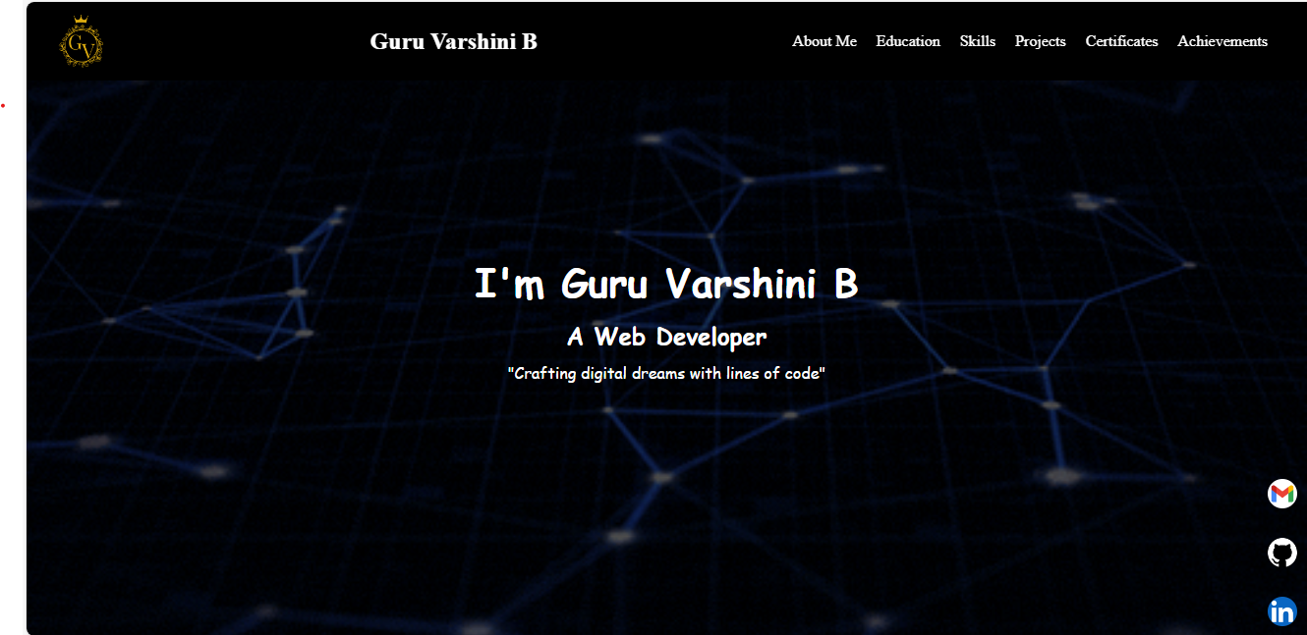



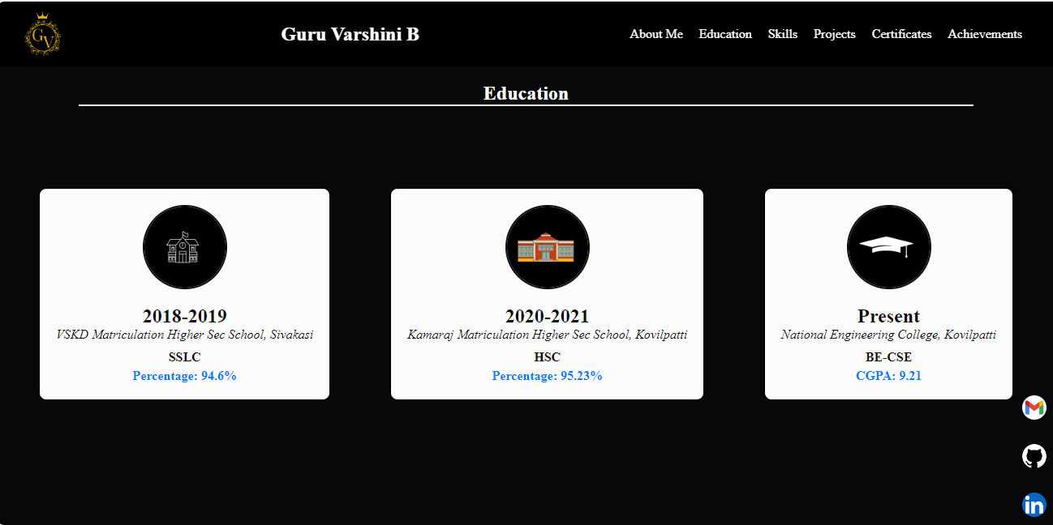

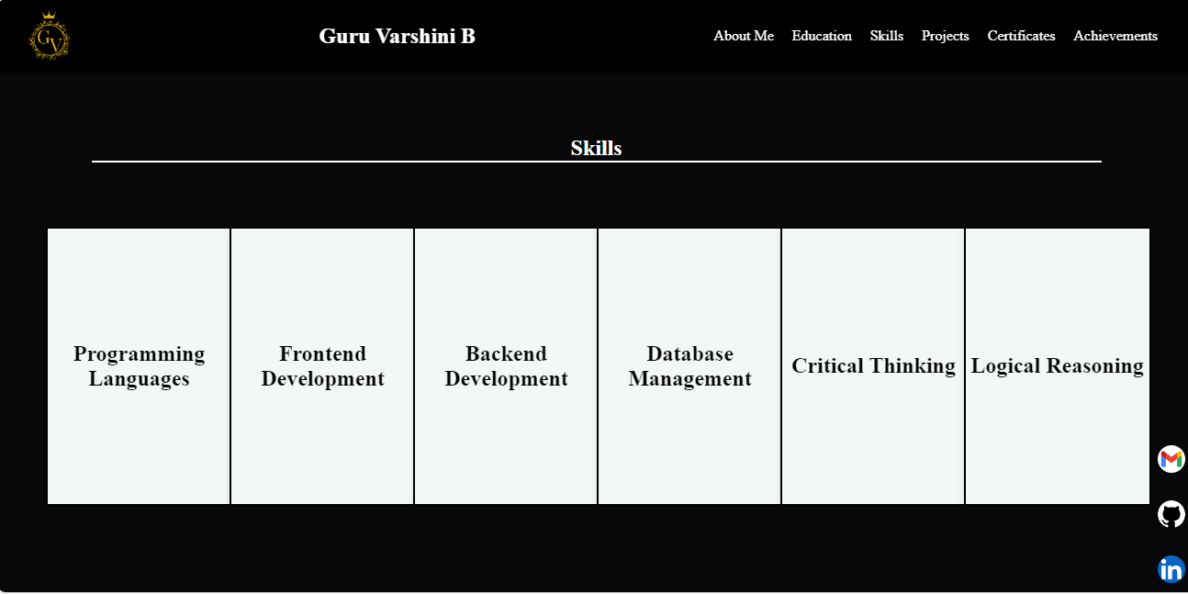

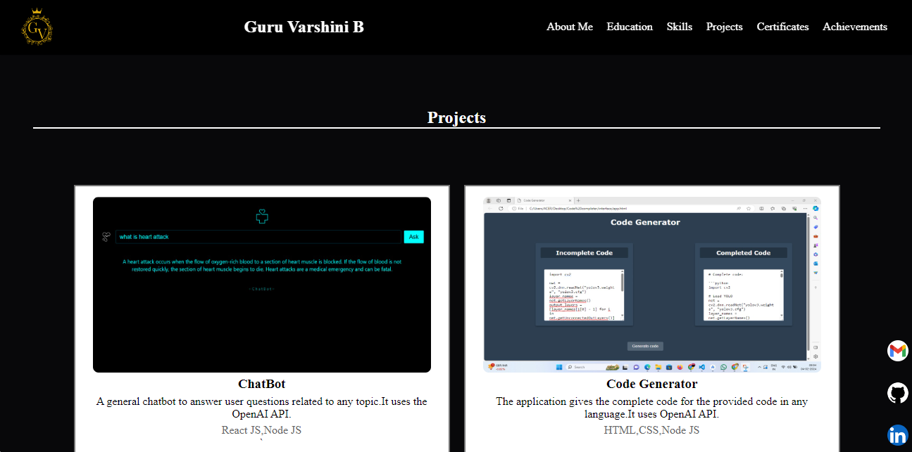



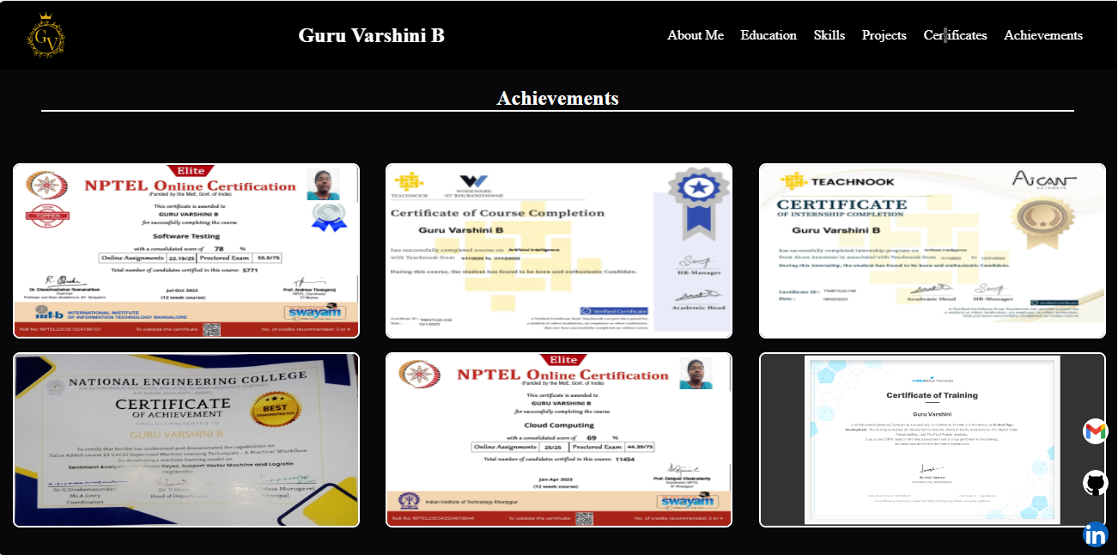



|  |  |  |  |  |
| --- | --- | --- | --- | --- |
| **Problem Understanding**  **(5)** | **Implementation & Output**  **(5)** | **Time Management**  **(5)** | **Viva**  **(5)** | **Total**  **(20)** |
|  |  |  |  |  |

**RESULT :**

Thus the portfolio was created successfully and verified.