Networking Training Program (Module 1 & 2)

- Copying a Folder with Multiple Files (scp, cp)
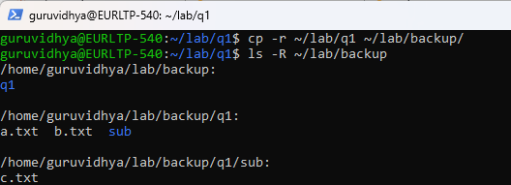

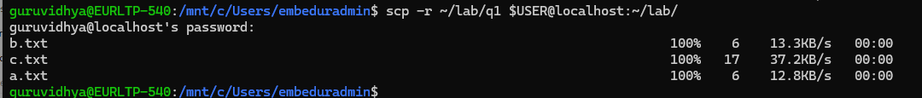
- Hosting an FTP and SFTP Server; Performing PUT and GET Operations
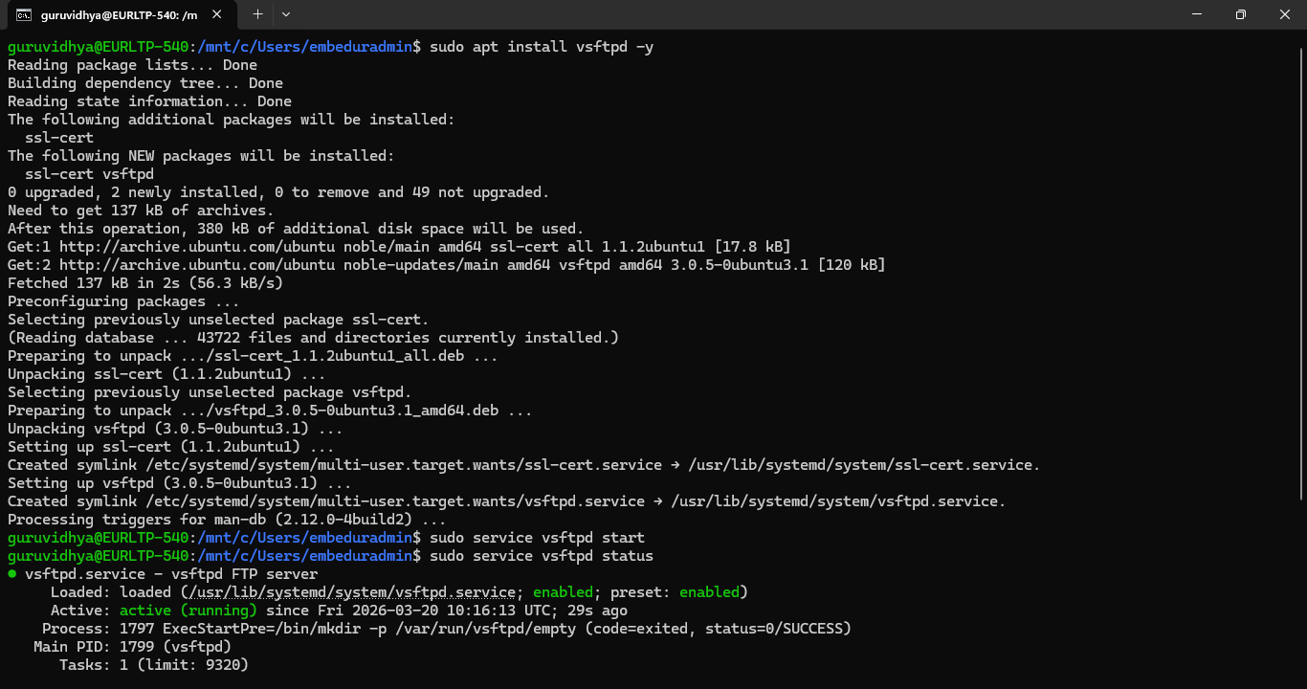
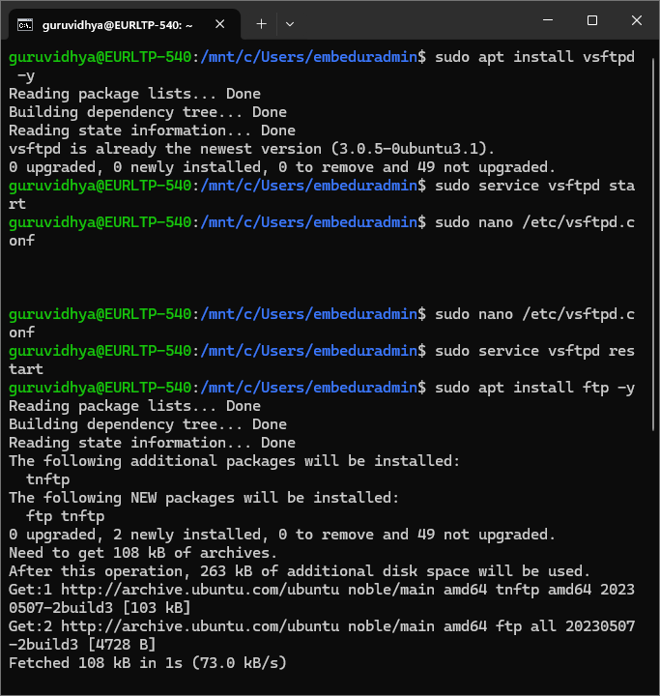
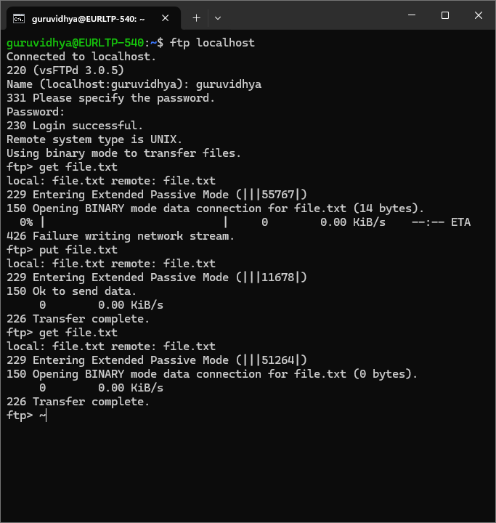
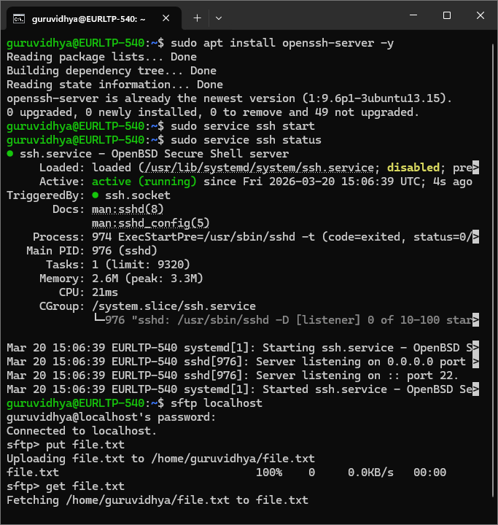

3. Exploring Wireshark, TCPdump, and Cisco Packet Tracer
- Wireshark Filter Example:
- tcp port 80
- Capture Packets using tcpdump:
sudo tcpdump -i eth0
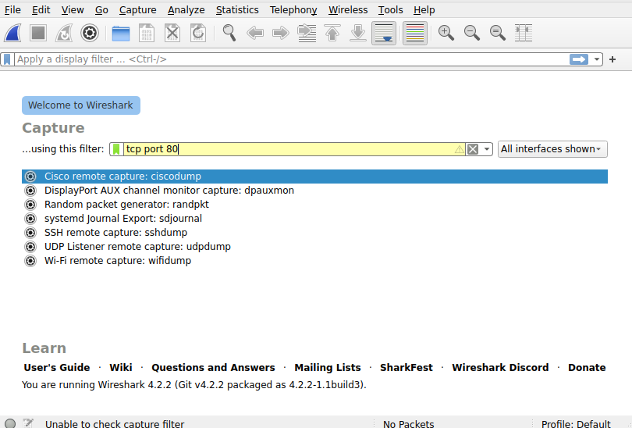
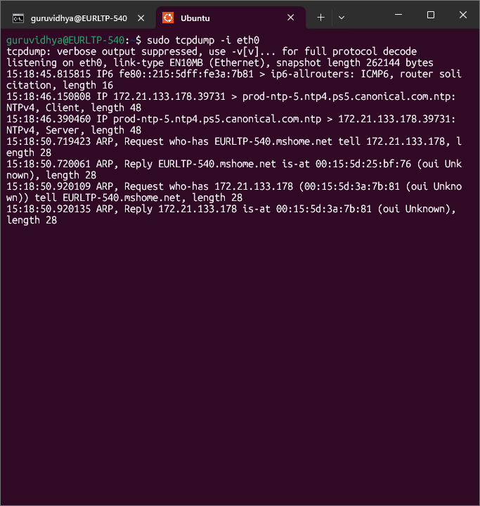

4) Understanding Linux Utility Commands (ping, arp)
- Ping a Host (Router at 192.168.1.1):
ping 192.168.1.1
- Check ARP Table:
arp -a
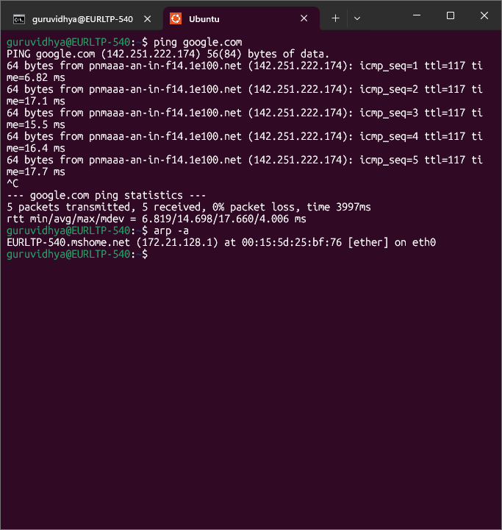

5 ) IP Address Conflict in a Network
When two devices are configured with the same IP address on a network, an IP address conflict occurs.
The network uses ARP (Address Resolution Protocol) to map IP addresses to MAC addresses. When two devices share the same IP, both respond to ARP requests with different MAC addresses, causing the network to get confused about which device to send packets to.
What happens:

Packets are delivered randomly between the two conflicting devices
Both devices experience intermittent or no connectivity
The operating system throws a warning like "IP address conflict detected"
Network performance becomes unstable and unpredictable
Whichever device sent the last ARP reply temporarily wins the traffic

Example: If PC0 and PC1 both have IP 192.168.1.10, a server trying to reach that IP may reach PC0 sometimes and PC1 other times — making communication completely unreliable.
Fix: Assign a unique IP to one of the conflicting devices, or use DHCP to automatically manage IP assignment and prevent conflicts.

6) Accessing Remote Systems
Remote access tools allow you to connect to and control another computer over a network as if you were physically sitting in front of it. They capture the remote screen and send your keyboard/mouse inputs back to that machine. Popular tools include VNC Viewer, AnyDesk, TeamViewer, and Windows Remote Desktop (RDP). Among these, AnyDesk is the easiest — no account needed, just an ID and password.

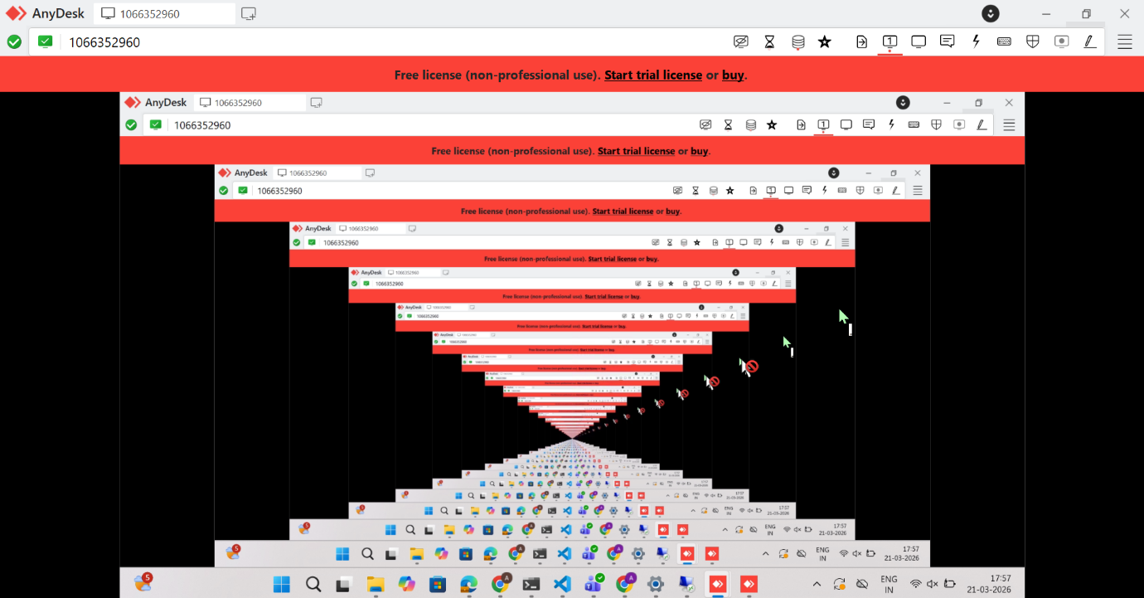

7)
Default Gateway
A default gateway is the IP address of the router that connects your local network to the outside world.
When a device wants to communicate with something outside its own network, it forwards the packet to the default gateway which then routes it to the correct destination. It is called "default" because it is the fallback route — when a device has no specific route to a destination, it uses this default path automatically.
Example: If a device in the local network has IP 192.168.1.10 and wants to reach Google 8.8.8.8, it realizes Google is not within the local network range 192.168.1.x, so it forwards the packet to the default gateway (router at 192.168.1.1) which handles the routing from there.
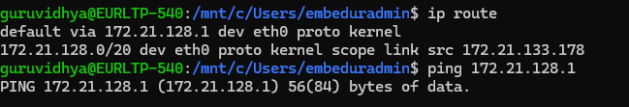

8. Checking Network Interfaces (ifconfig, ip addr)
- ifconfig Command:
ifconfig
- Modern equivalent (ip addr):
ip addr show
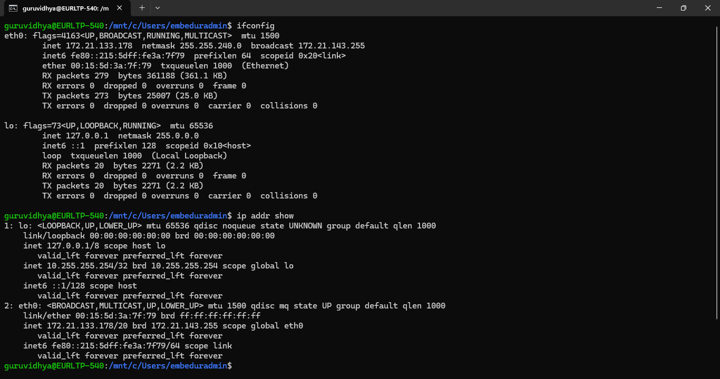
9)
Logging into Home Router Web Interface
Every home router has a built-in web page where you can manage all settings — connected devices, WiFi password, DHCP settings and more.
Step 1 — Find Router IP in Windows CMD:
ipconfig
Look for Default Gateway under WiFi section:
Wireless LAN adapter Wi-Fi:
IPv4 Address : 192.168.x.x
Default Gateway : 192.168.x.1
Step 2 — Open Browser and type:
http://192.168.x.1
Step 3 — If you see a security warning:
Click Advanced → Proceed to 192.168.x.1 (unsafe)
This warning appears because the router uses a self-signed certificate. It is safe since you are on your own local network.
Step 4 — Login:
Router login page appeared — Jio AirFiber Home Gateway IDU
Login using credentials

Connected Devices List
Once logged in look for Connected Devices or DHCP Client List in the router menu to see all devices connected to the network with their IP and MAC addresses.

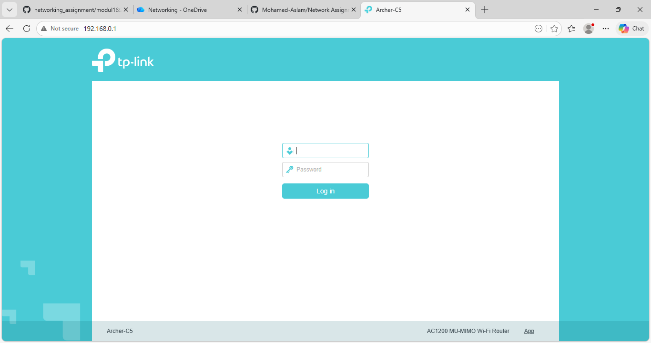

10 ) How a DHCP Server Assigns IP Addresses
DHCP (Dynamic Host Configuration Protocol) is a network protocol that automatically assigns IP addresses to devices in a network so that manual configuration is not needed.

The DORA Process
The entire IP assignment happens in 4 steps called the DORA process — Discover, Offer, Request and Acknowledgement.
1. DISCOVER — When a device joins a network with no IP, it broadcasts a message to the entire network saying it needs an IP address.
2. OFFER — The DHCP server responds with an available IP address along with subnet mask, gateway, DNS and lease time.
3. REQUEST — The device accepts the offer and sends a request back to confirm it wants that IP.
4. ACK — The DHCP server officially assigns the IP and confirms how long the device can use it (lease time).

What DHCP Assigns
Along with the IP address, DHCP also automatically provides:
- Subnet Mask
- Default Gateway
- DNS Server
- Lease Time (how long the IP is valid)

Lease Time
DHCP does not assign IPs permanently. It assigns them for a limited period called lease time. When 50% of the lease time is over, the device automatically tries to renew it. If renewal fails, the IP is released back to the pool and a new one is assigned on reconnection.
11)
guruvidhya@EURLTP-540:/mnt/c/Users/embeduradmin$ sudo apt update
sudo apt install openssh-server -y
[sudo] password for guruvidhya:
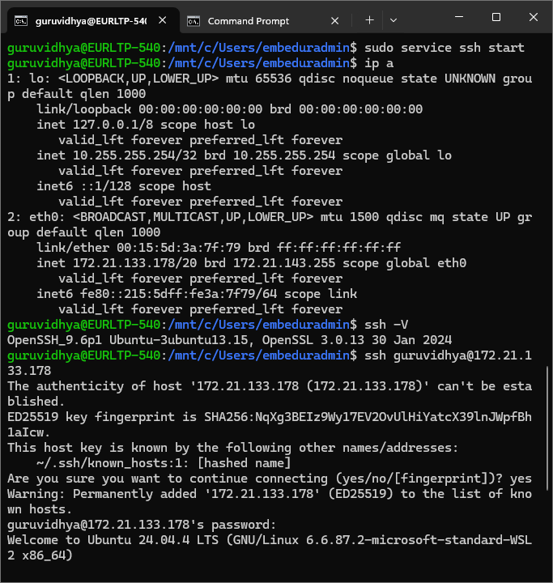
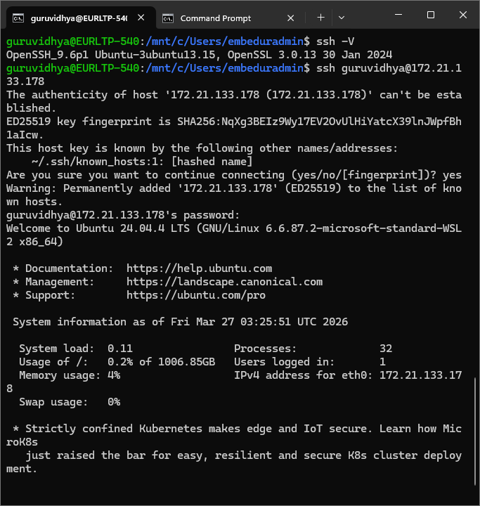

TELNET :
sudo apt update
sudo apt install telnetd -y
