Networking Training Program (Module 3 & 4)

1. Simulation of Small Network with Multiple devices
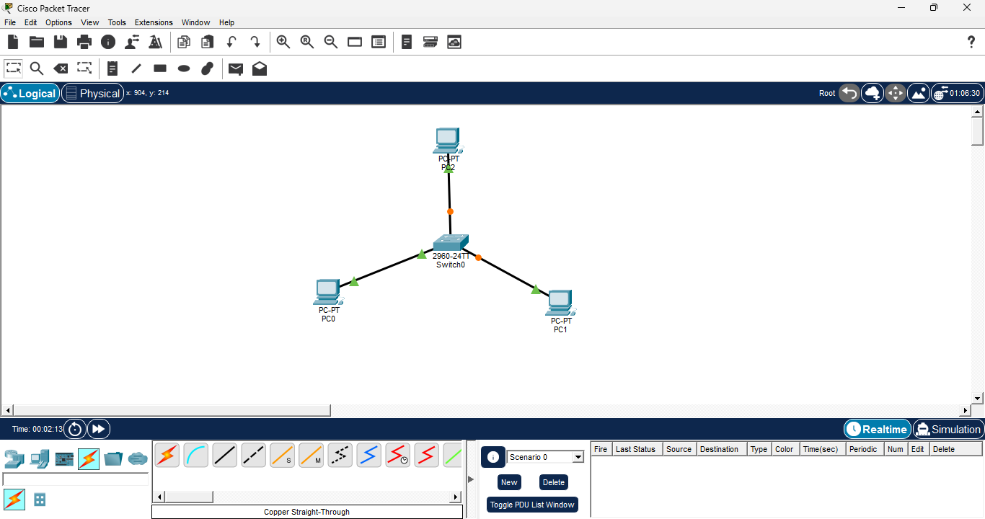
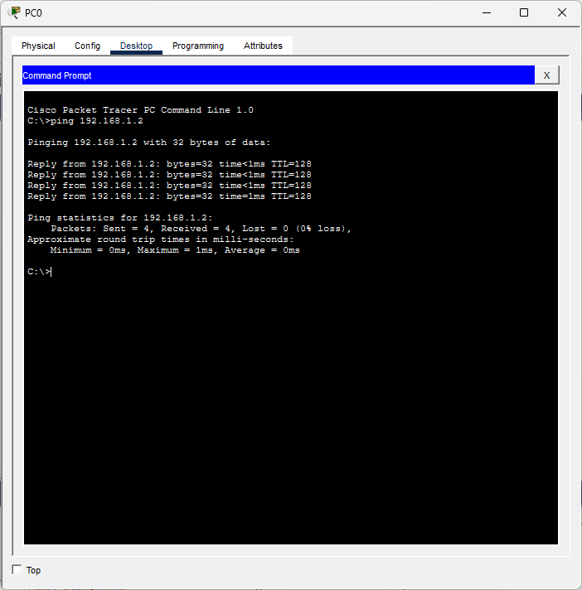
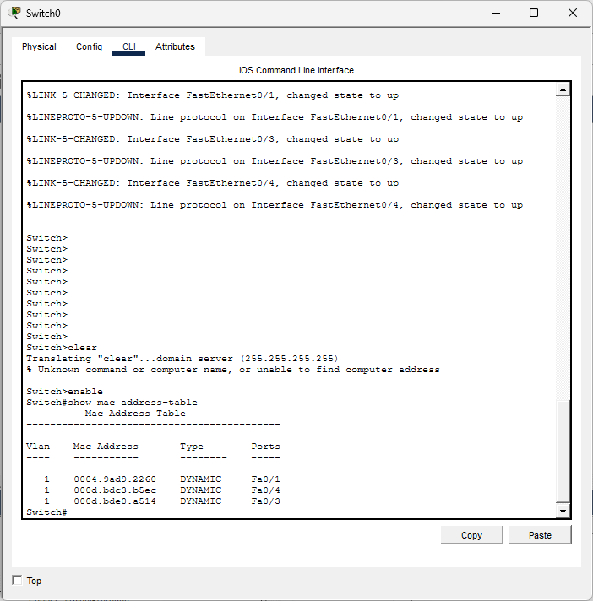
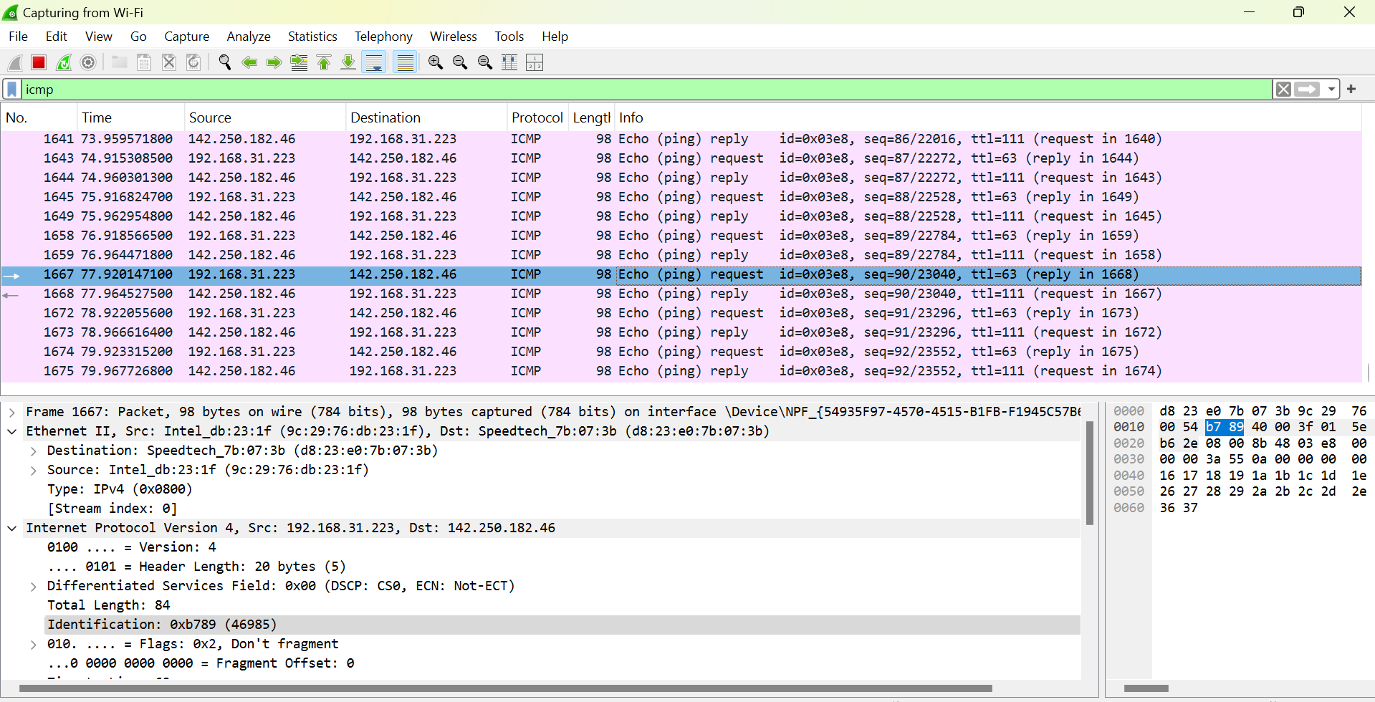

2. Capturing and Analyzing Ethernet Frames using Packet Tracer and wireshark
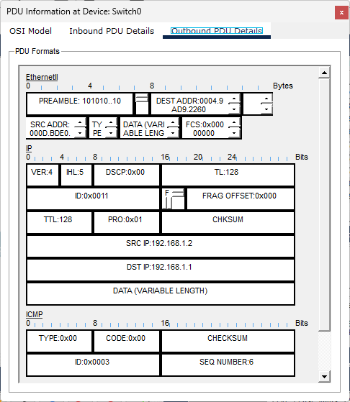
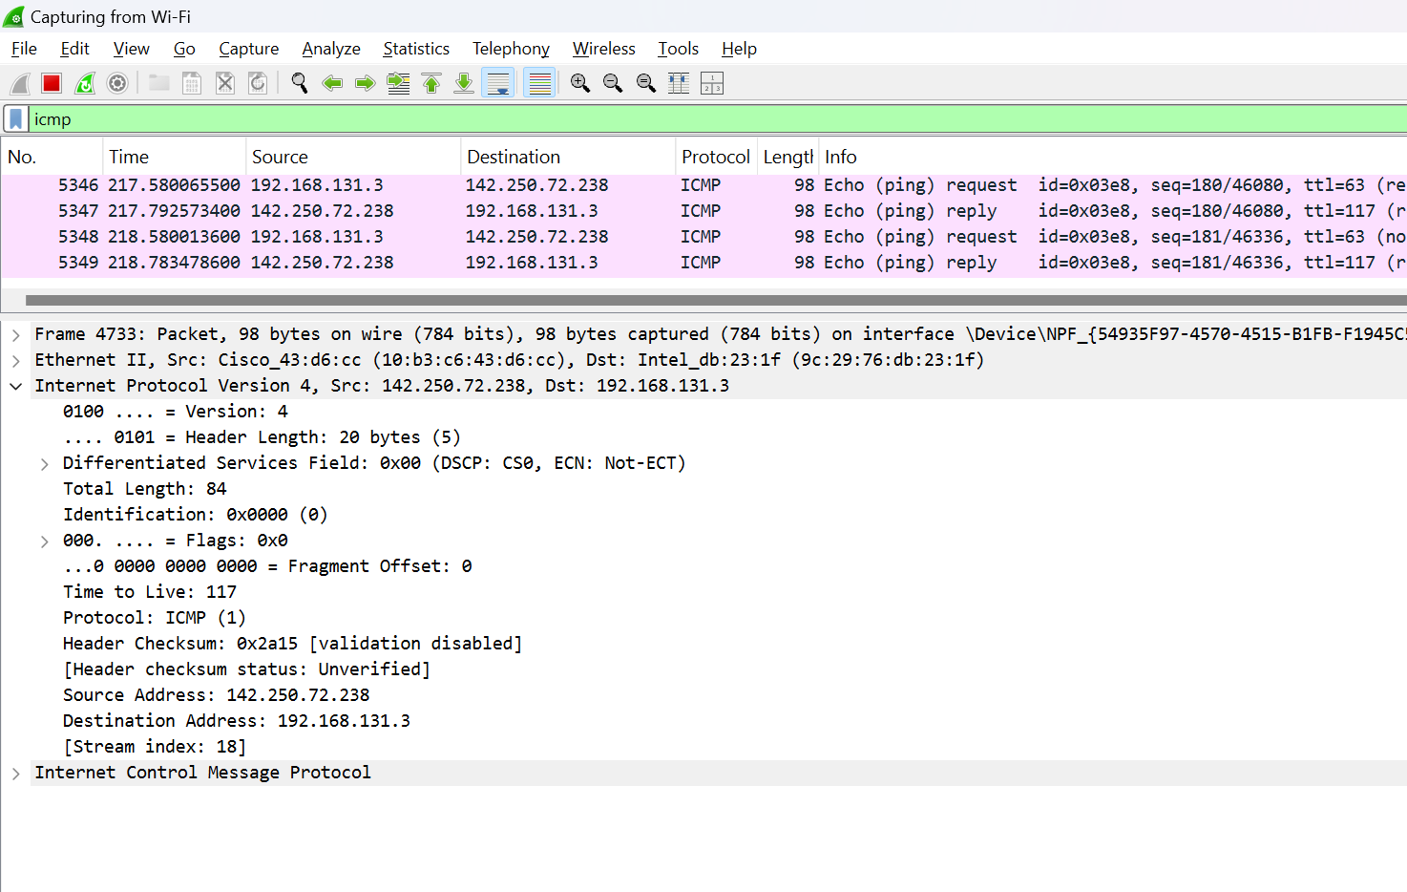

3. Configuring Static IP Address
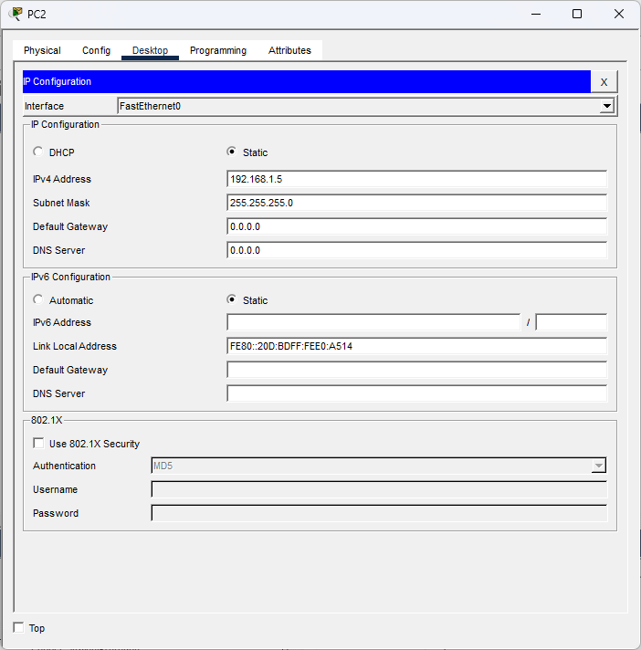
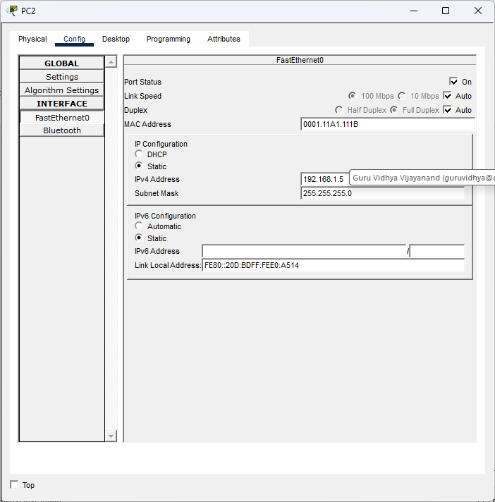

4. Troubleshooting Ethernet Communication
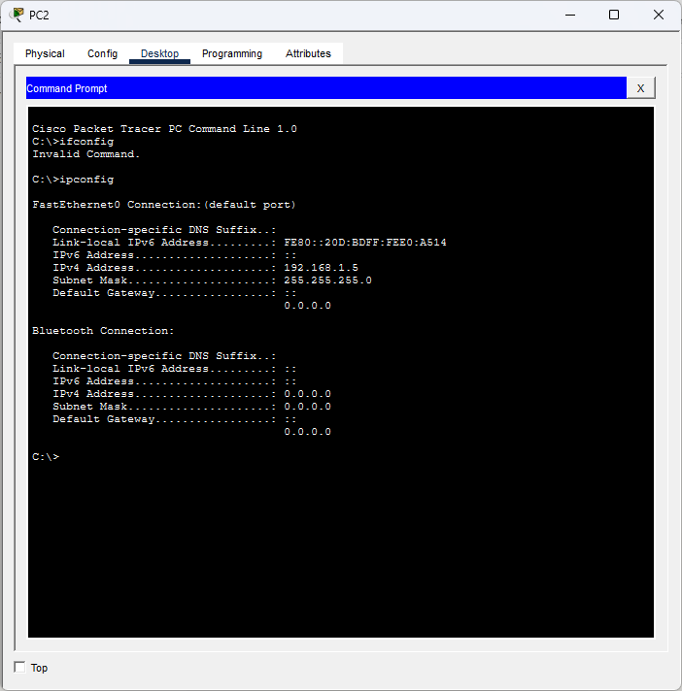

5. Simple LAN Setup with Switches
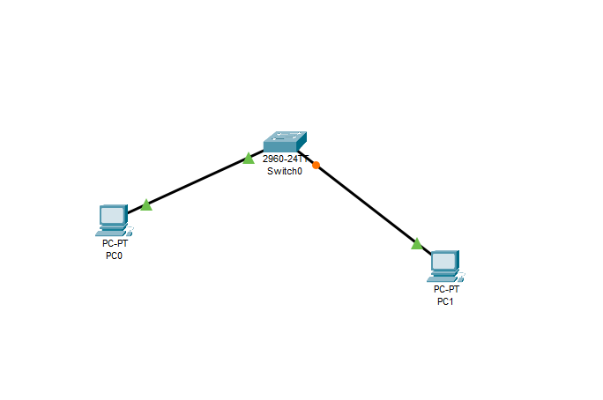
6. Ensuring with Ping command
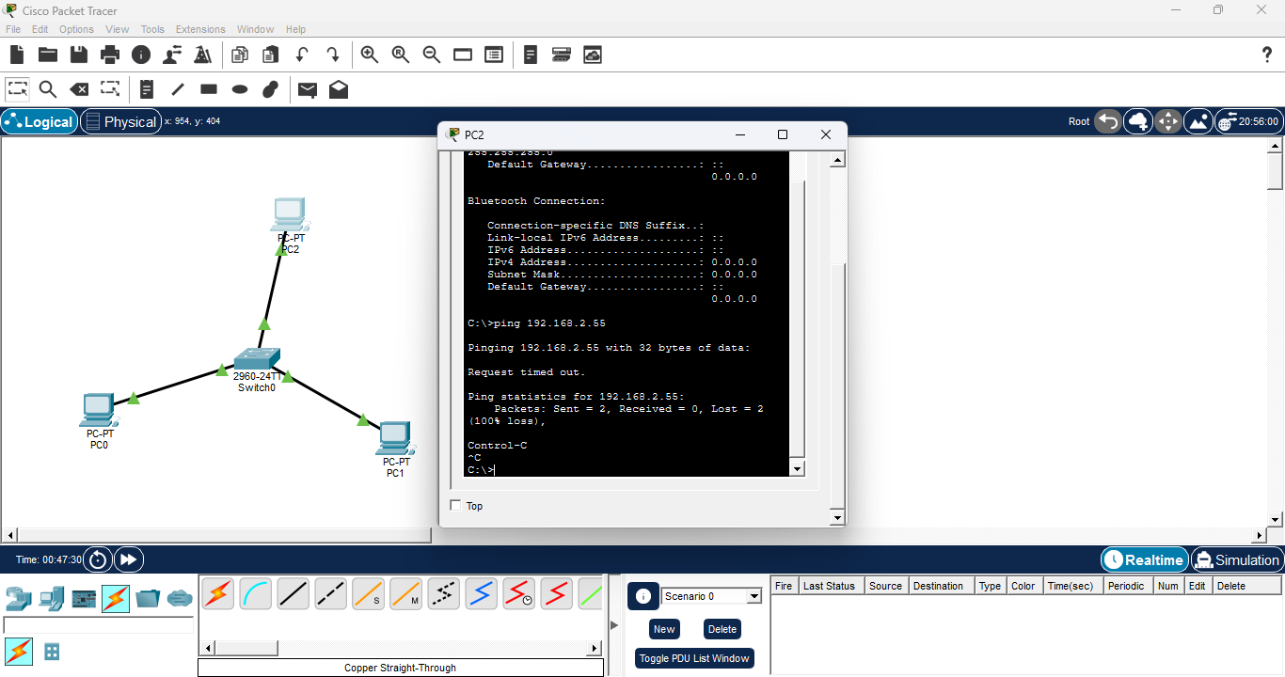
Ping from one machine to the other. If it fails, use ifconfig to ensure the IP addresses are configured correctly. Use traceroute to identify where the packets are being dropped if the ping fails

7. Checking with Traceroute
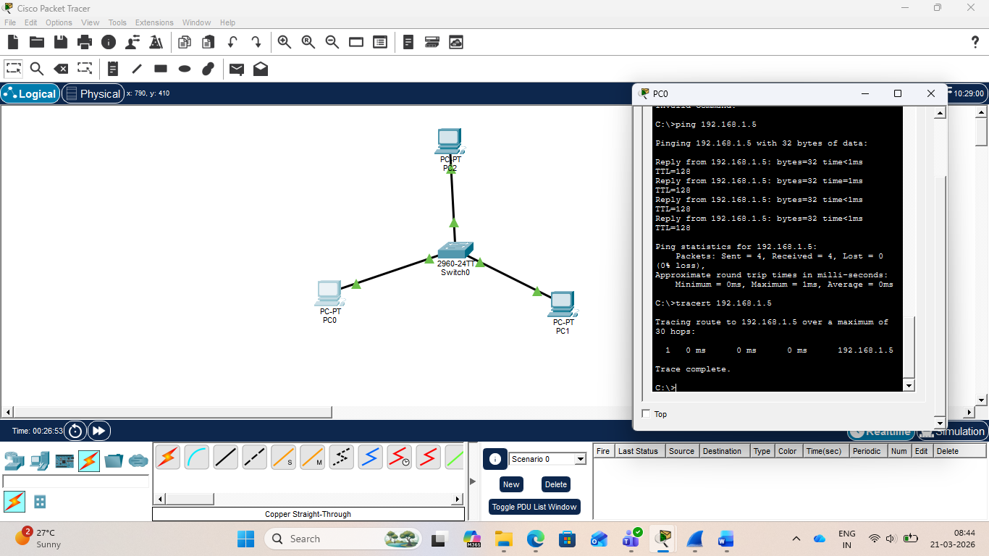
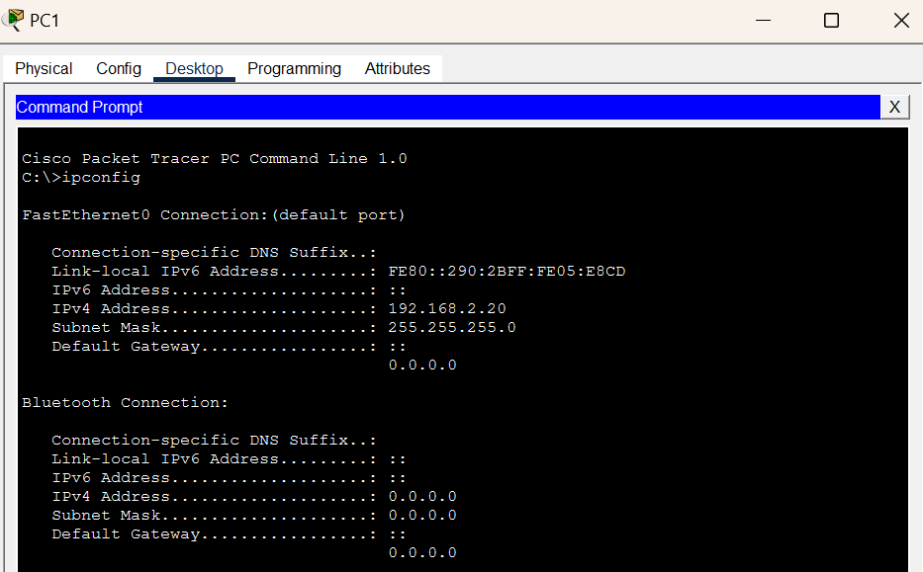
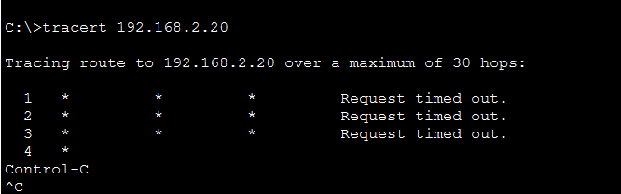
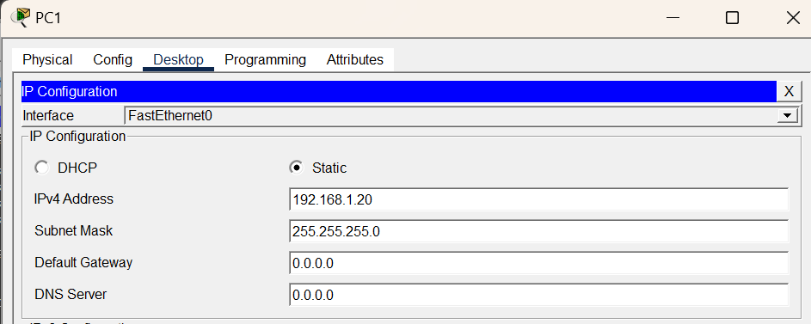
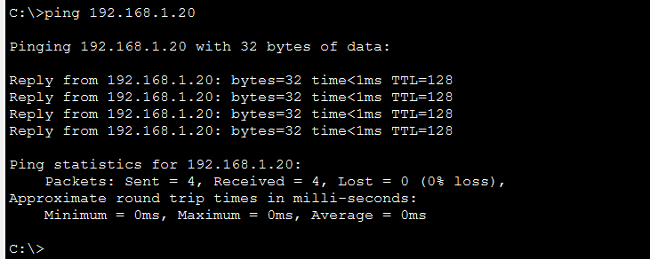

8. Linux Kernel's Handling of Ethernet Devices and Network Interfaces
1. Network Device Drivers The Linux kernel uses device drivers to communicate with Ethernet hardware (NIC). These drivers handle sending and receiving raw Ethernet frames between the hardware and the kernel.

2. Network Interface Representation Every Ethernet device appears as a named interface (e.g., eth0) in Linux. The kernel manages each interface's IP address, MAC address, and MTU settings through the net_device structure.

3. Ethernet Frame Processing When data is received, the kernel checks frames for errors, removes Ethernet headers, and passes data up the stack. When sending, it wraps data into Ethernet frames before transmitting through the NIC.

4. TCP/IP Protocol Stack The kernel implements a full networking stack — IP at Layer 3 handles routing and addressing, while TCP/UDP at Layer 4 handles reliable data delivery — allowing communication between devices across networks.

9. Configuring a Basic LAN Interface Using the ip Command in Linux
Task | Command
List interfaces | ip link show
Bring interface up | sudo ip link set eth0 up
Assign IP address | sudo ip addr add 192.168.1.10/24 dev eth0
Add default gateway | sudo ip route add default via 192.168.1.1
View assigned addresses | ip addr show eth0
View routing table | ip route show
Remove IP address | sudo ip addr del 192.168.1.10/24 dev eth0

10.Viewing the MAC Address Table in a Switch (Cisco & Linux-Based)
In Cisco switches, the MAC address table is displayed using show mac address-table, as seen below:
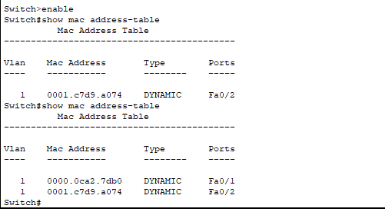

On a Linux-based network switch, use bridge fdb show or ip link show to inspect the MAC table and monitor switch operations dynamically.
Task | Command
View MAC table | bridge fdb show br0
Flush MAC table | bridge fdb flush dev br0
View bridge ports | ip link show master br0

.

