Networking Training Program (Module 5)

1. ARP Analysis

ARP request is broadcasted to all devices in the network to find the MAC address of a given IP.
The sender includes:
- Its own IP address
- Its own MAC address
The target MAC is unknown at this stage.
ARP reply is unicast:
- The device with the requested IP sends back its MAC address.
- This helps the sender store the mapping in ARP cache.
- 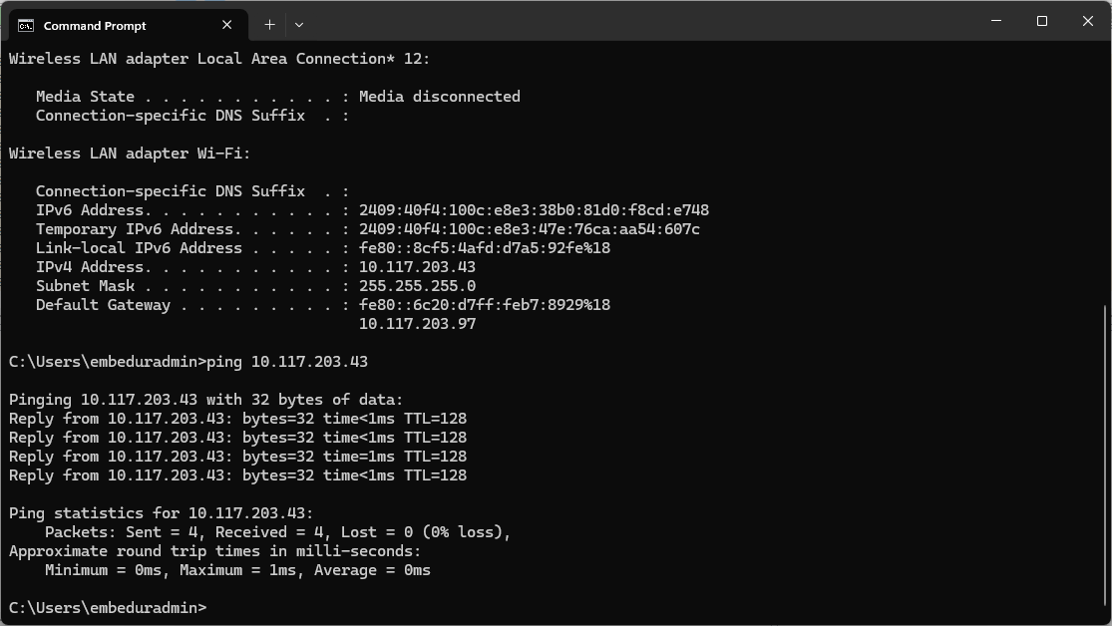

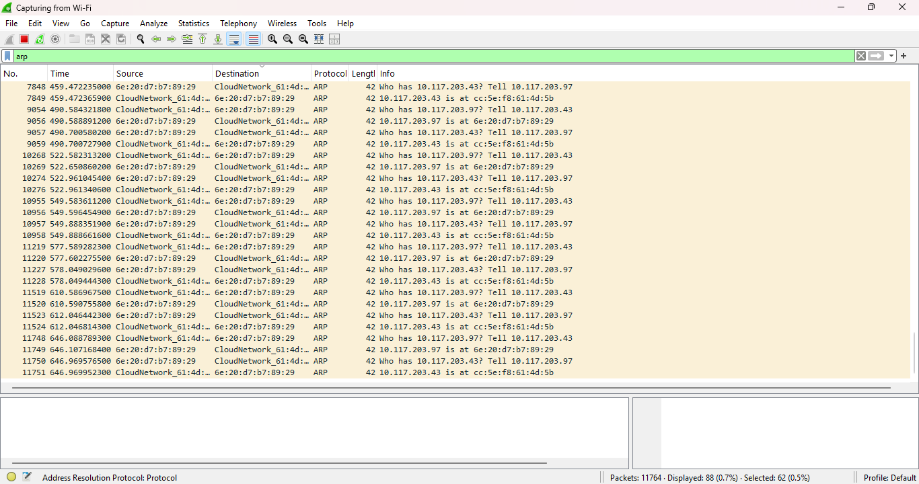
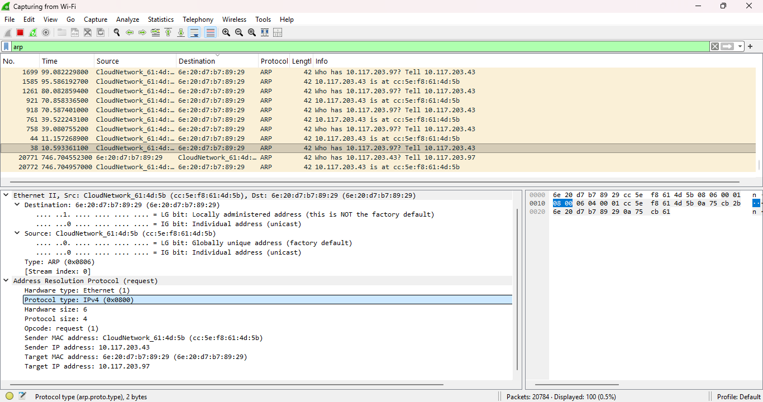

2. ARP Spoofing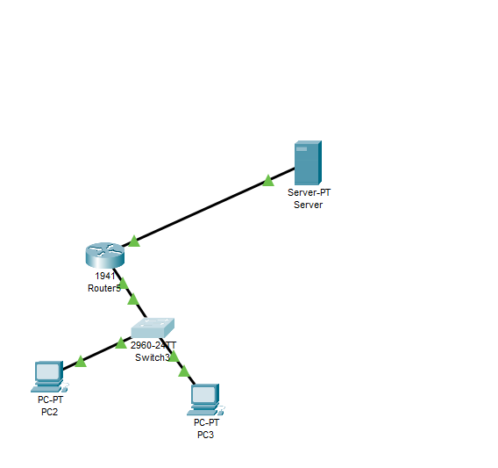
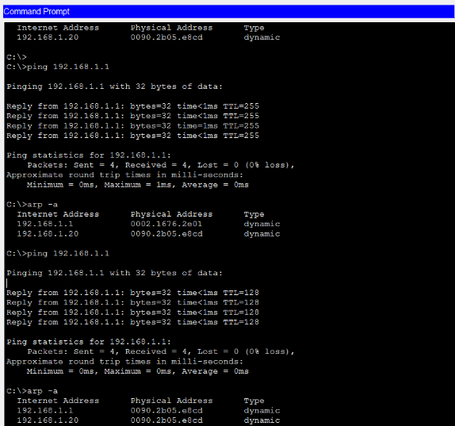Can

3. Manual Changing of IP Address
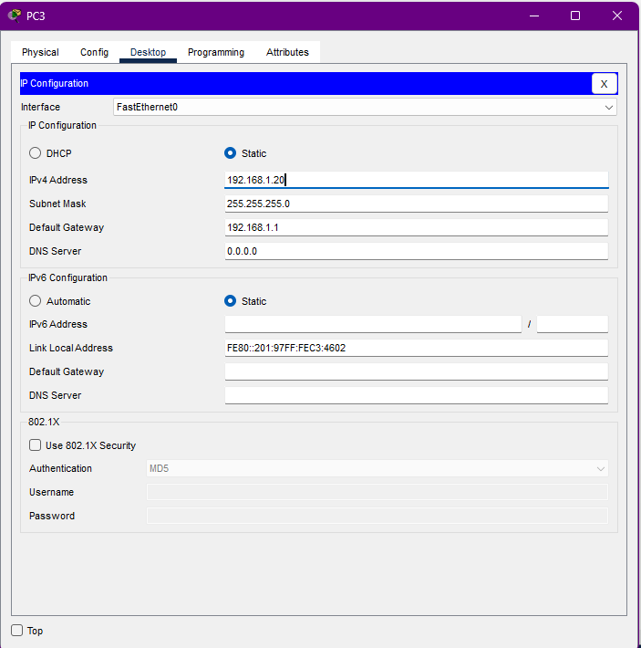

4 ) DHCP follows a four-step process called DORA:
- Discover: The client broadcasts a request to locate DHCP servers.
- Offer: The DHCP server responds with an available IP address.
- Request: The client requests the offered IP address.
- Acknowledge: The server confirms and assigns the IP address.
The process ensures automatic IP configuration without manual intervention.
DHCP uses broadcast communication initially because the client does not have an IP address.

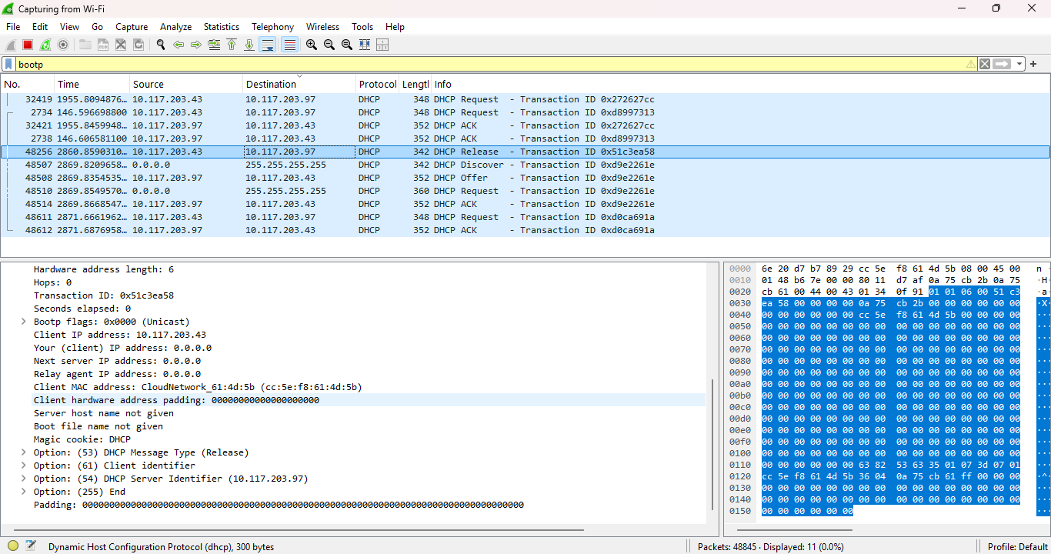

5. Subnetting Task for 192.168.1.0/24 divided into 4 subnets
Subnet Mask Calculation
To divide a /24 network into 4 equal subnets:
- Original network: 192.168.1.0/24
- Number of subnets needed: 4
- Bits required for 4 subnets: 2 bits (2² = 4)
- New prefix length: 24 + 2 = /26
- New subnet mask: 255.255.255.192
Subnet Ranges
Subnet | Network Address | First Usable IP | Last Usable IP | Broadcast Address
1 | 192.168.1.0 | 192.168.1.1 | 192.168.1.62 | 192.168.1.63
2 | 192.168.1.64 | 192.168.1.65 | 192.168.1.126 | 192.168.1.127
3 | 192.168.1.128 | 192.168.1.129 | 192.168.1.190 | 192.168.1.191
4 | 192.168.1.192 | 192.168.1.193 | 192.168.1.254 | 192.168.1.255
Calculation Details
- Subnet mask in binary: 11111111.11111111.11111111.11000000
- Subnet mask in decimal: 255.255.255.192
- Number of hosts per subnet: 2^6 - 2 = 62 hosts
- Subnet increment: 64 (256 ÷ 4)
Each subnet provides 62 usable addresses (excluding the network and broadcast addresses).
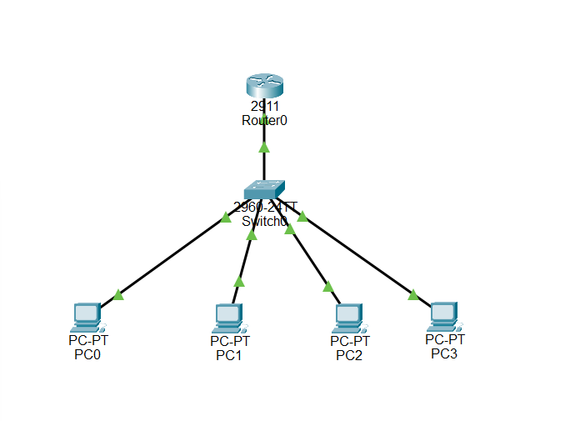
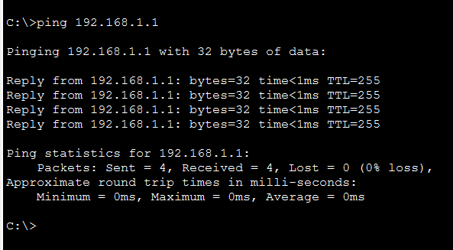
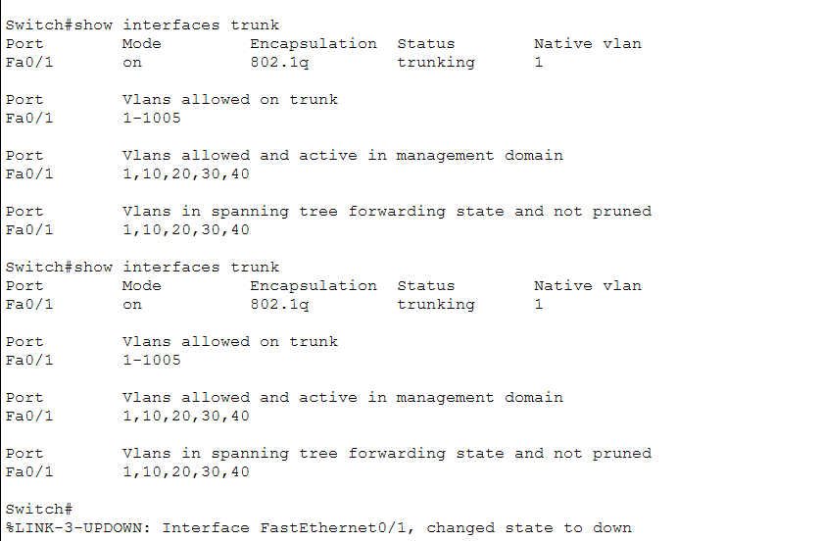
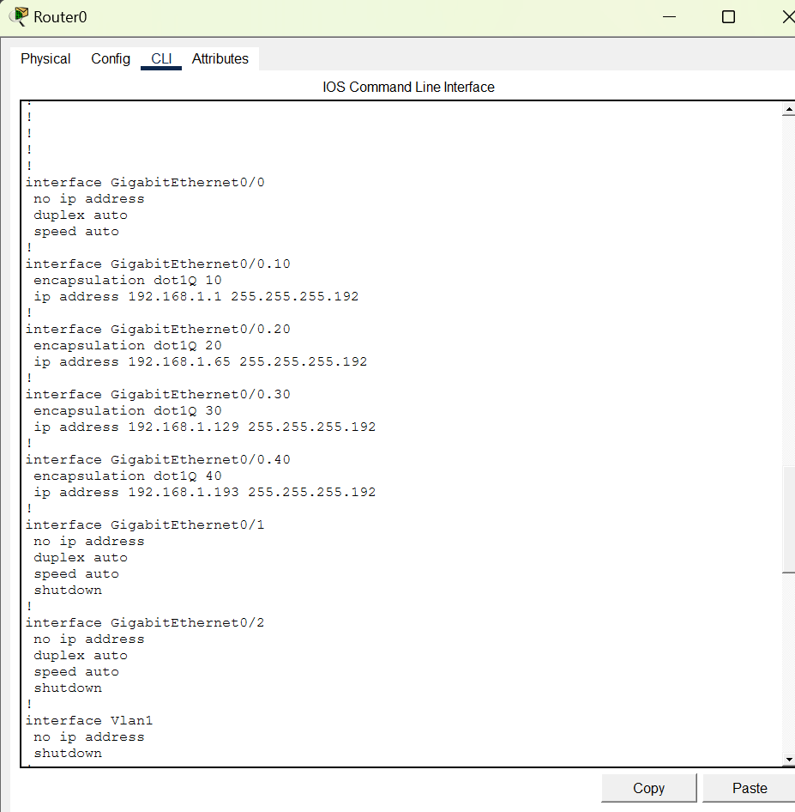

6. IP Address Classification
IP Address Classes for Given Addresses
IP Address | Class | Default Subnet Mask
10.1.1.1 | Class A | 255.0.0.0 (/8)
172.16.5.10 | Class B | 255.255.0.0 (/16)
192.168.1.5 | Class C | 255.255.255.0 (/24)
IP Address Ranges by Class
- Class A: 1.0.0.0 - 126.255.255.255
- Class B: 128.0.0.0 - 191.255.255.255
- Class C: 192.0.0.0 - 223.255.255.255

7. NAT
