Networking Training Program (Module 6)

1. ARP
- ARP resolves IP addresses to MAC addresses, enabling devices to communicate within a local network.
- It allows routers to determine the next-hop MAC address for packet forwarding.
- ARP caching improves efficiency by reducing repeated address lookups.
- Without ARP, network devices wouldn’t know where to send packets, disrupting communication.
Screenshot:
Find the Ip to ping using ipconfig
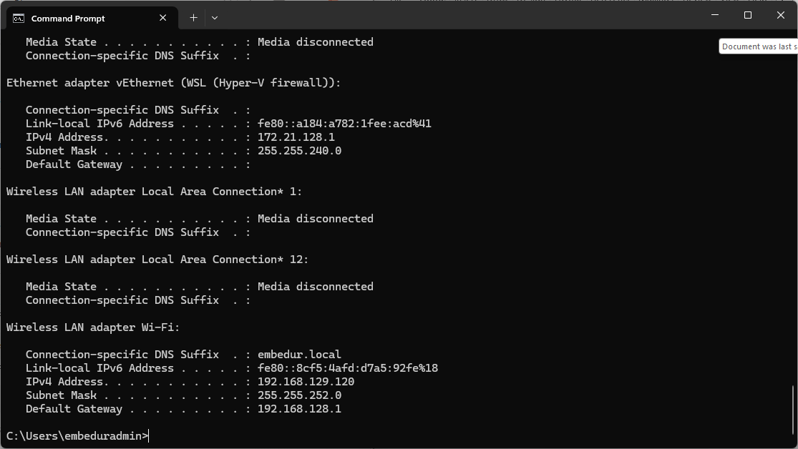

Ping the ip to generate traffic :
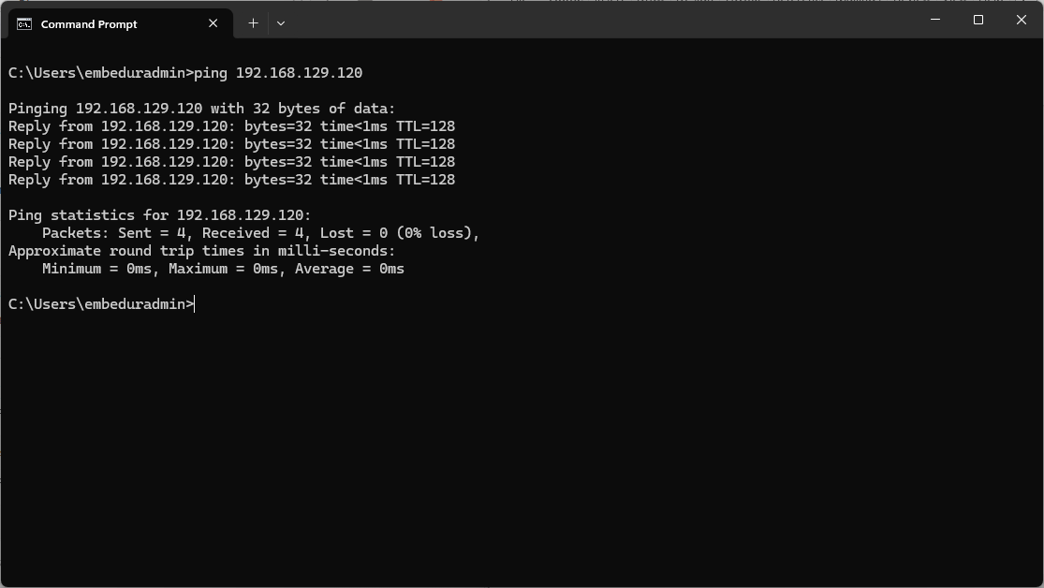

ARP request and response in Wireshark:
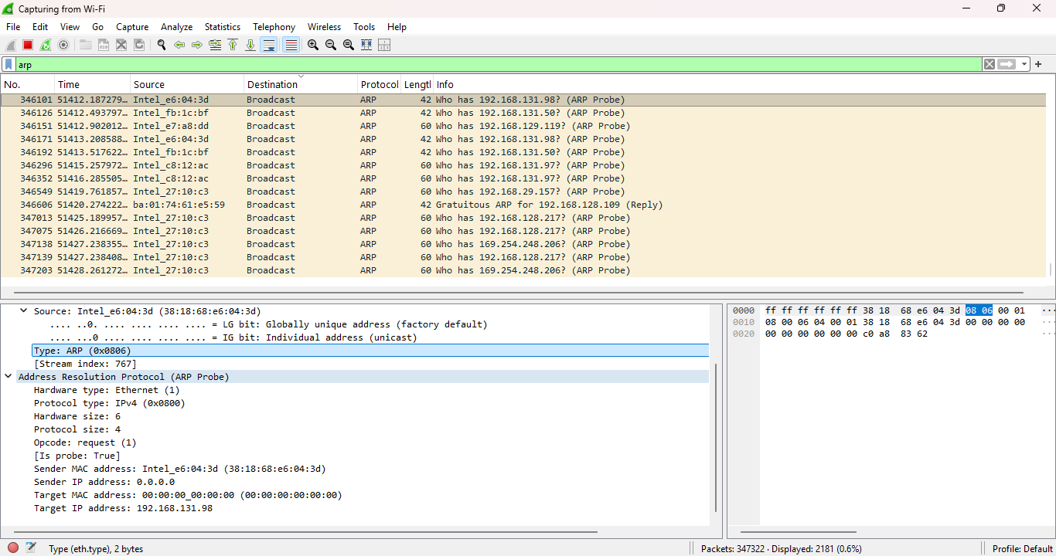

2. Manually configure and Traceroute Tracking
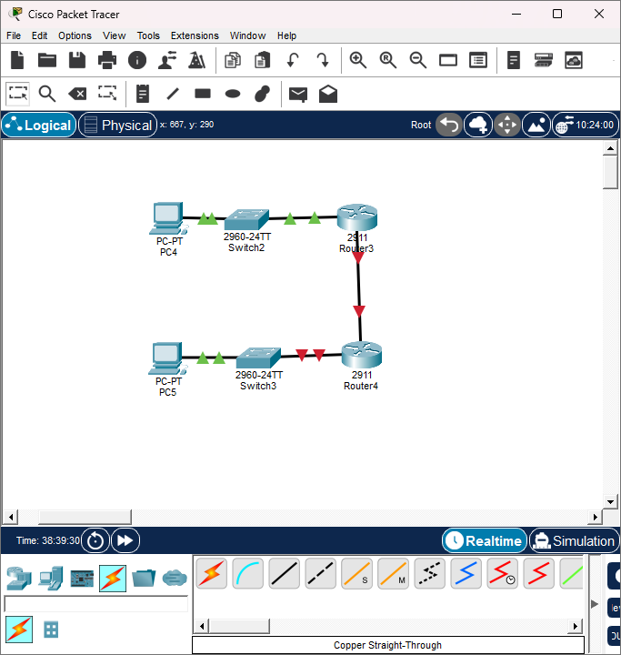
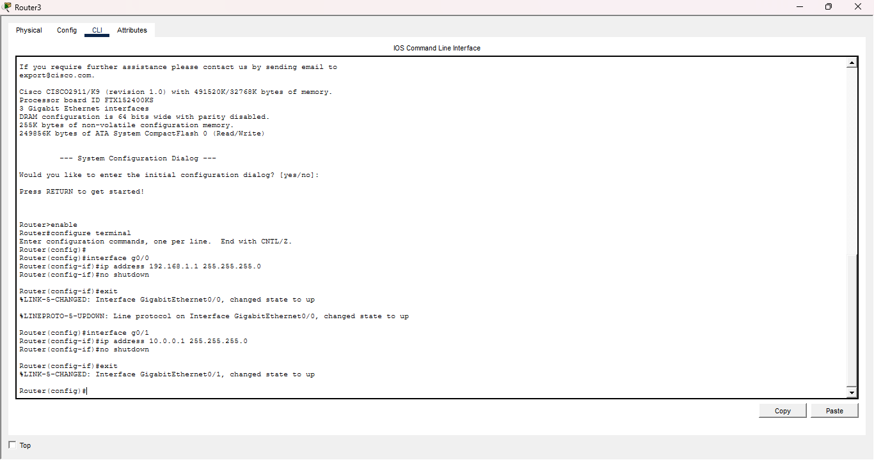

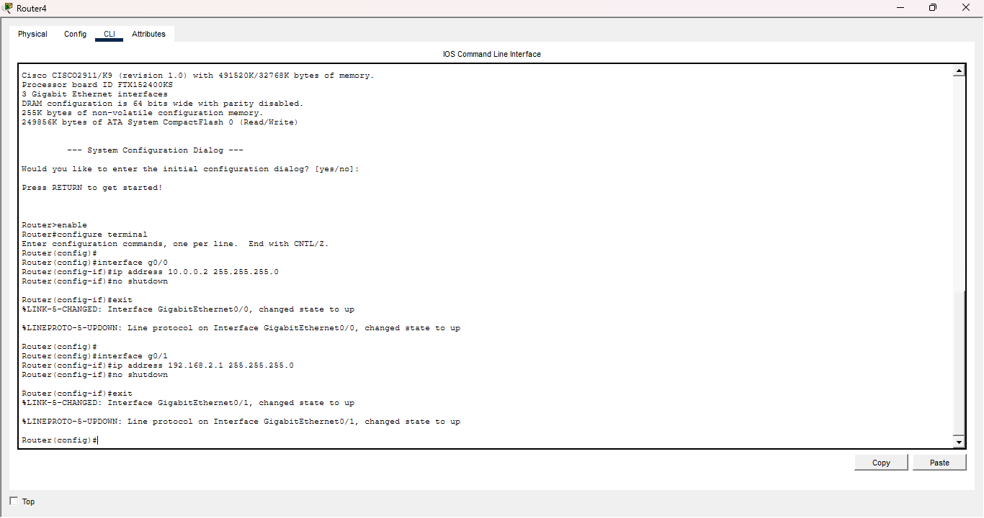

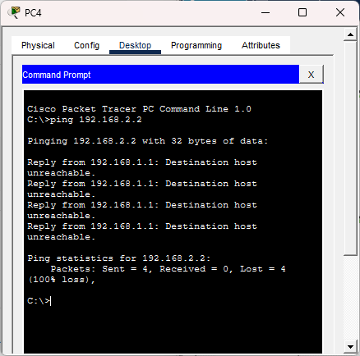
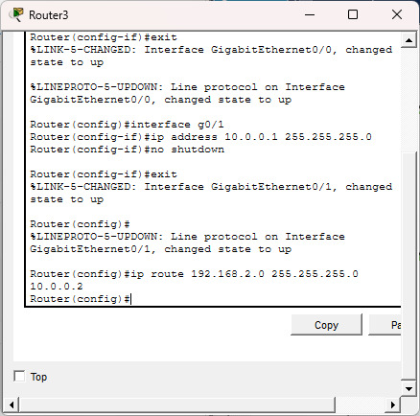
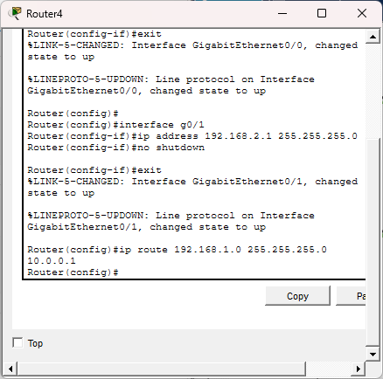
PING TO THE PC3 IT REACHES AFTER SETTING THE STATIC ROUTING :
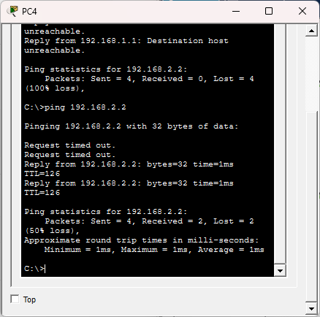

Using tracert :
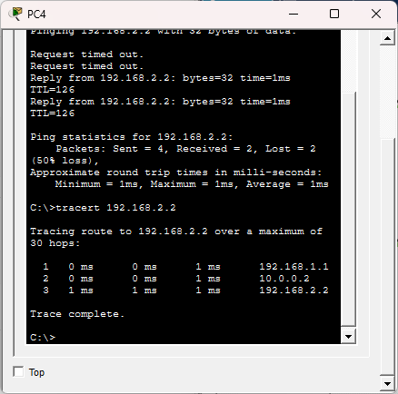

3. Network Subnetting
Subnetting 10.0.0.0/24 into 4 Equal Subnets
1. Given Network Information
- Network Address: 10.0.0.0/24
- Subnet Mask: 255.255.255.0
- Total Hosts in /24: 2⁸ - 2 = 254 hosts
- Requirement: Divide into 4 equal subnets
2. Calculate the New Subnet Mask
- To divide into 4 subnets, we need 2 extra bits (2² = 4).
- The new subnet mask becomes /26 (255.255.255.192).
- Each subnet has 2⁶ - 2 = 62 usable hosts.
3. Subnet Allocation and Host Ranges
Subnet | Network Address | First Usable IP | Last Usable IP | Broadcast Address
1 | 10.0.0.0/26 | 10.0.0.1 | 10.0.0.62 | 10.0.0.63
2 | 10.0.0.64/26 | 10.0.0.65 | 10.0.0.126 | 10.0.0.127
3 | 10.0.0.128/26 | 10.0.0.129 | 10.0.0.190 | 10.0.0.191
4 | 10.0.0.192/26 | 10.0.0.193 | 10.0.0.254 | 10.0.0.255

4. Assign IP Addresses to Devices in Packet Tracer
- Router (Default Gateway): Assign first usable IP from each subnet.
- PCs, Switches: Assign IPs within the valid host range.
Example Device IP Assignments
Device | Assigned IP | Subnet Mask | Gateway
Router | 10.0.0.1 | 255.255.255.192 | N/A
PC1 | 10.0.0.2 | 255.255.255.192 | 10.0.0.1
PC2 | 10.0.0.65 | 255.255.255.192 | 10.0.0.64
PC3 | 10.0.0.129 | 255.255.255.192 | 10.0.0.128
PC4 | 10.0.0.193 | 255.255.255.192 | 10.0.0.192

5. Verify Connectivity
- Ping Test:
  - Use the ping command to check connectivity between devices in the same and different subnets.
  - Example:
ping 10.0.0.65
- Traceroute Test:
  - Use tracert or traceroute to check packet paths between different subnets.
  - Example:
tracert 10.0.0.129
- Check Routing Table (On Router):
show ip route

4. IP Address Classification and NAT Explanation
1. Identifying the Class of Each IP Address
IP addresses are categorized into different classes based on their first octet.
IP Address | First Octet Range | Class
192.168.10.5 | 192 - 223 | Class C
172.20.15.1 | 128 - 191 | Class B
8.8.8.8 | 1 - 126 | Class A
2. Determining if the IP is Private or Public
Some IP ranges are reserved for private networks, while others are public and routable on the internet.
IP Address | Private/Public | Reason
192.168.10.5 | Private | Falls in 192.168.0.0 - 192.168.255.255 (Private Class C)
172.20.15.1 | Private | Falls in 172.16.0.0 - 172.31.255.255 (Private Class B)
8.8.8.8 | Public | Google DNS, routable on the internet

5. NAT Translation
- NAT translates private IP addresses into a public IP address.
- The router replaces the source IP of outgoing packets.
- Inside the network, packets use private IP addresses.
- Outside the network, packets use the router’s public IP.
- This allows multiple devices to share a single public IP.
- Wireshark captures show different source IPs before and after NAT.
