- The ping command is used to test connectivity between a host and a remote server.
- It uses ICMP packets to measure response time and packet loss.
- The nslookup command is used to resolve domain names into IP addresses using DNS.
- The results show successful communication and correct DNS resolution for all tested websites.
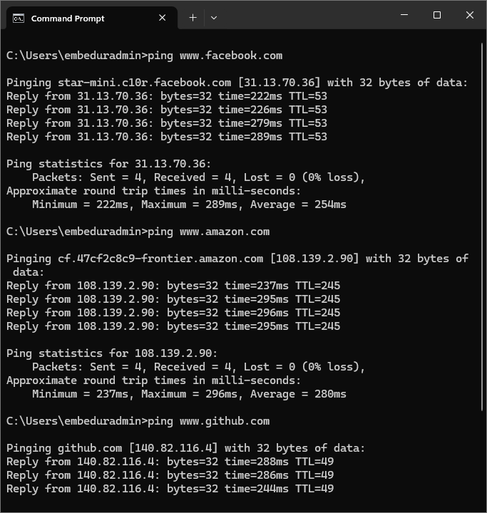

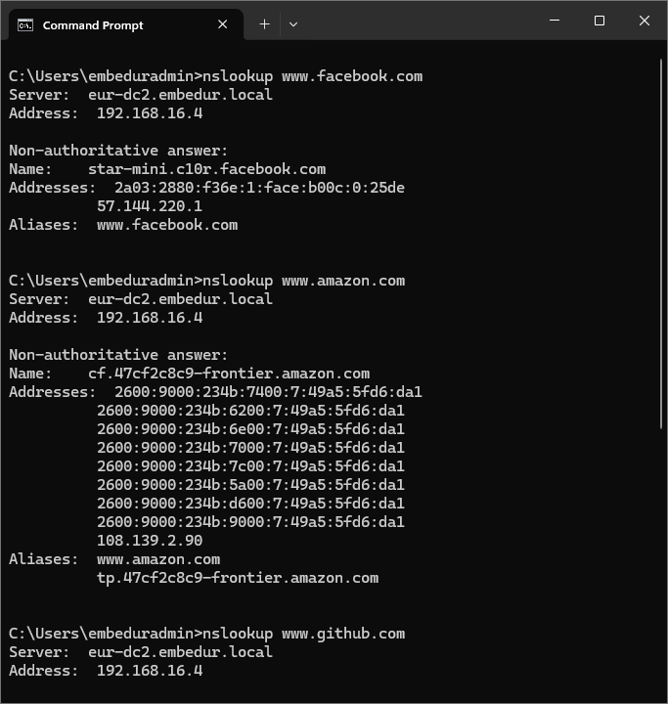

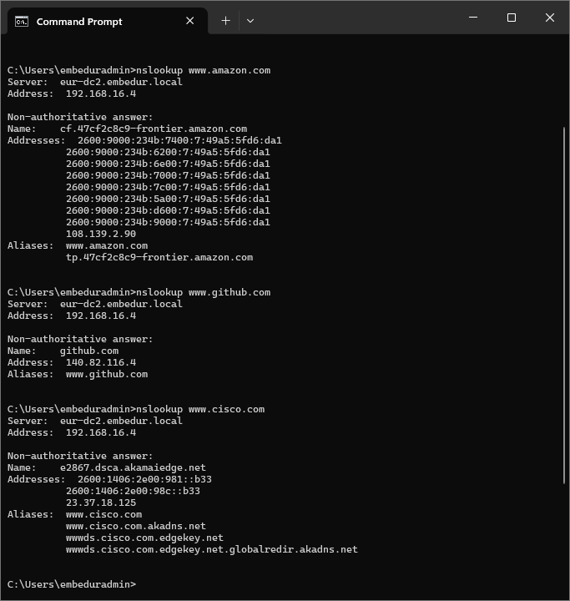

2) Capture & Analyze DNS, TCP, UDP using Wireshark :

3)
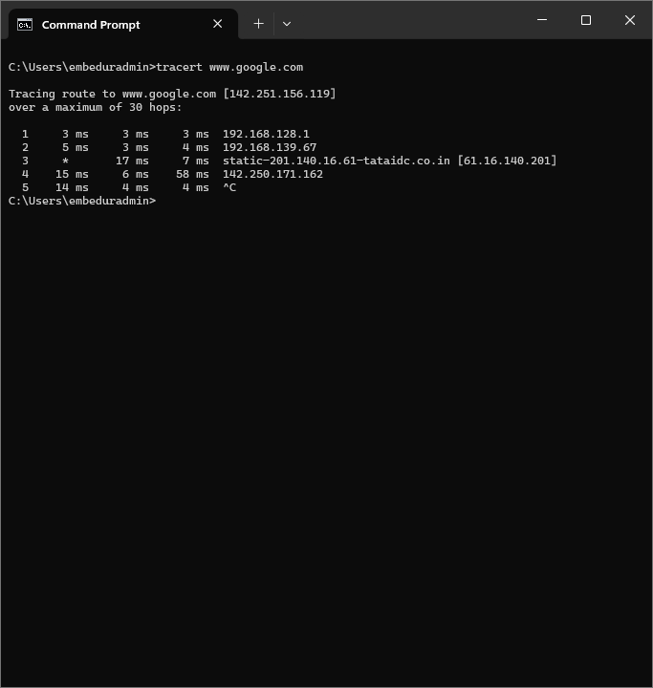
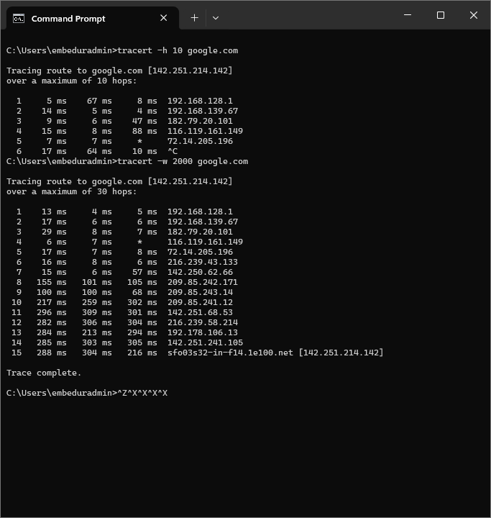

5)
- VLAN (Virtual LAN) is used to logically divide a physical network into multiple smaller networks.
- It improves security, reduces broadcast traffic, and enhances performance.
- Devices in the same VLAN can communicate directly.
- Devices in different VLANs require a router for communication.
- Access ports connect end devices and carry a single VLAN.
- Trunk ports carry multiple VLANs between switches using VLAN tagging.
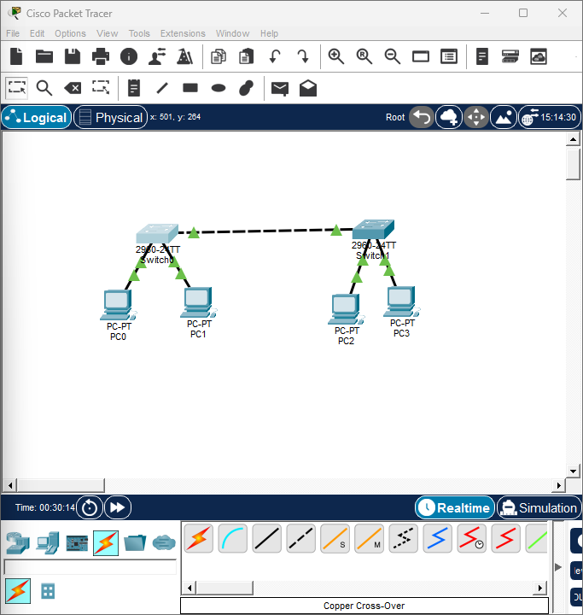

While we ping the devices connected via same switch :
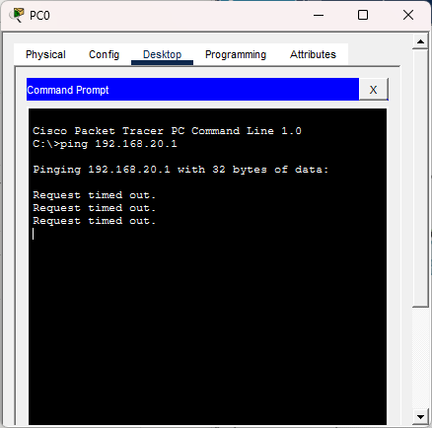
Switch 1 configuration :
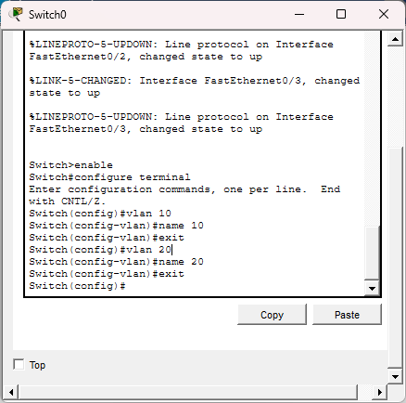
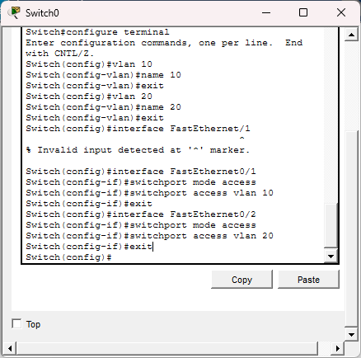
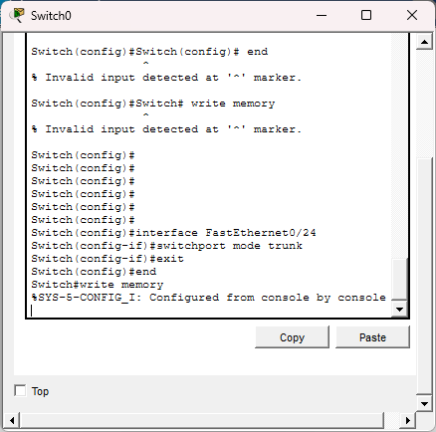

Switch 2 configuration :
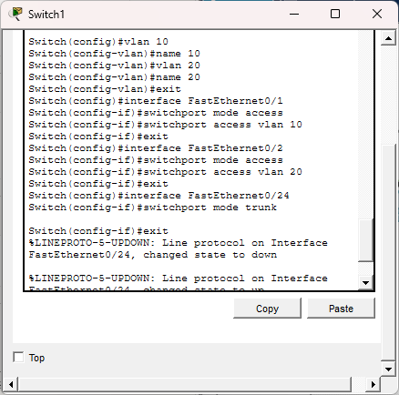
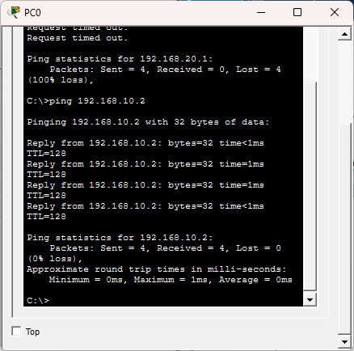
7) Configuration of Native VLAN on a Trunk Port

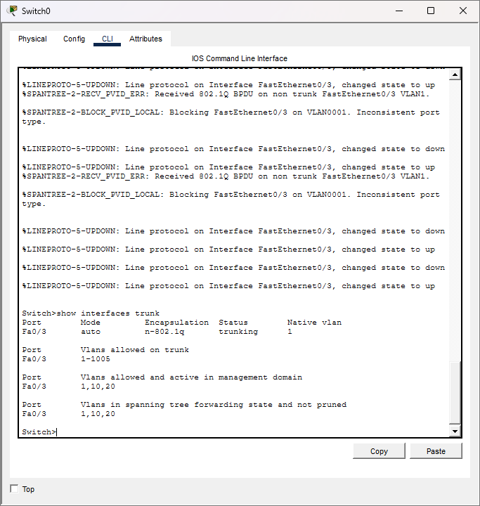
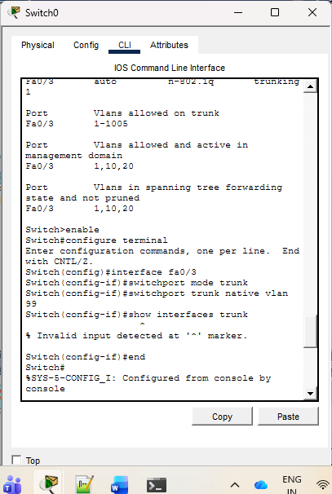

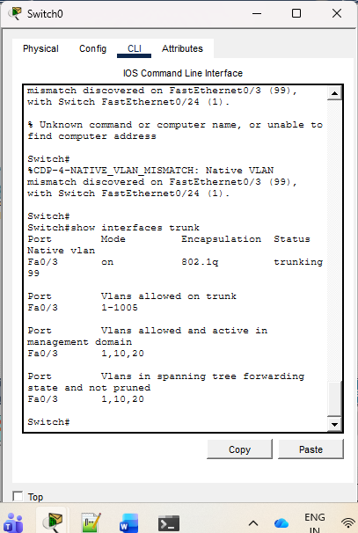

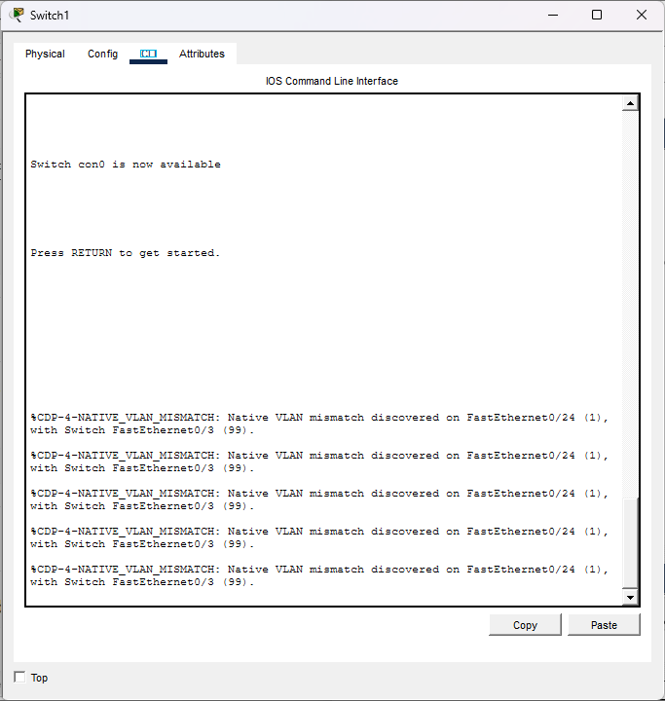

7) Configuration of Management VLAN and Remote Access (SSH/Telnet) :
A management VLAN is a VLAN used specifically for managing a network device (like a switch) remotely. Instead of configuring the switch only through the console, we assign an IP address to a VLAN interface so that we can access the switch over the network using SSH or Telnet.
- Management VLAN = VLAN used for remote administration
- IP address is assigned to a virtual interface called SVI (Switch Virtual Interface)
- Remote access is done using SSH (secure) or Telnet (not secure)

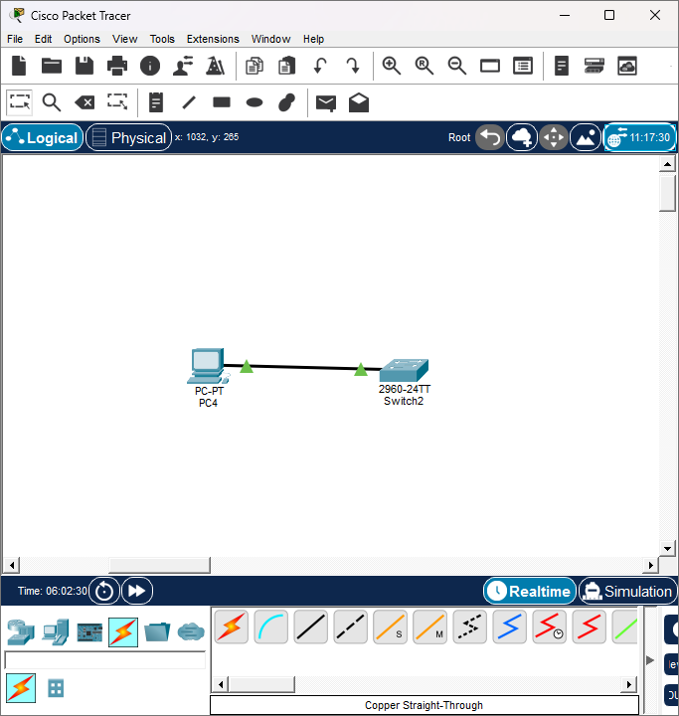

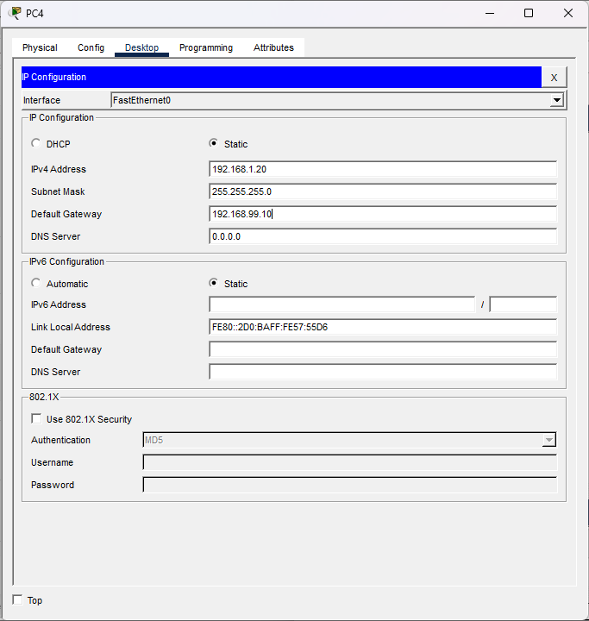
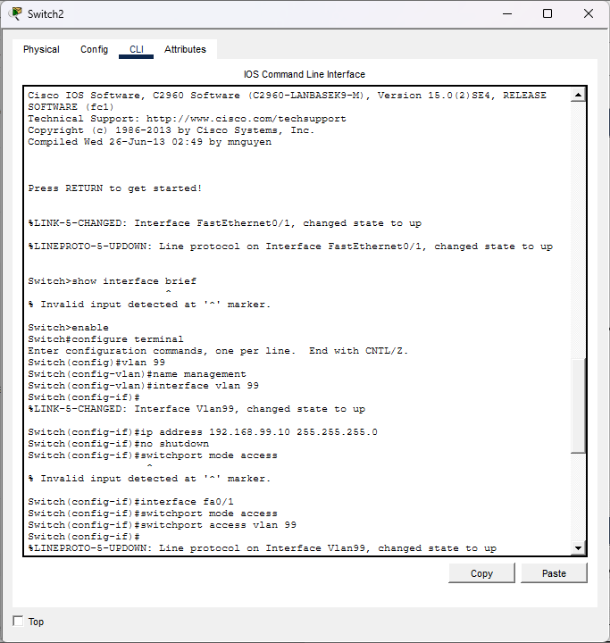
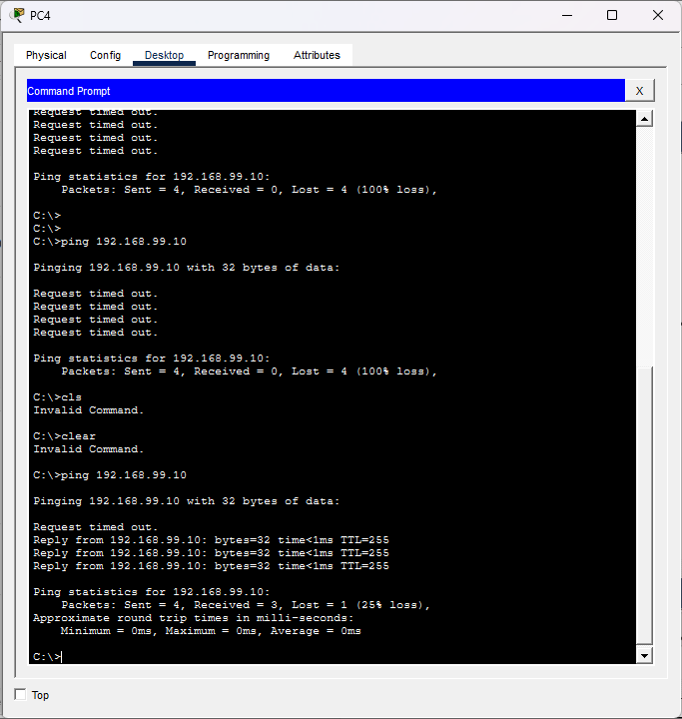
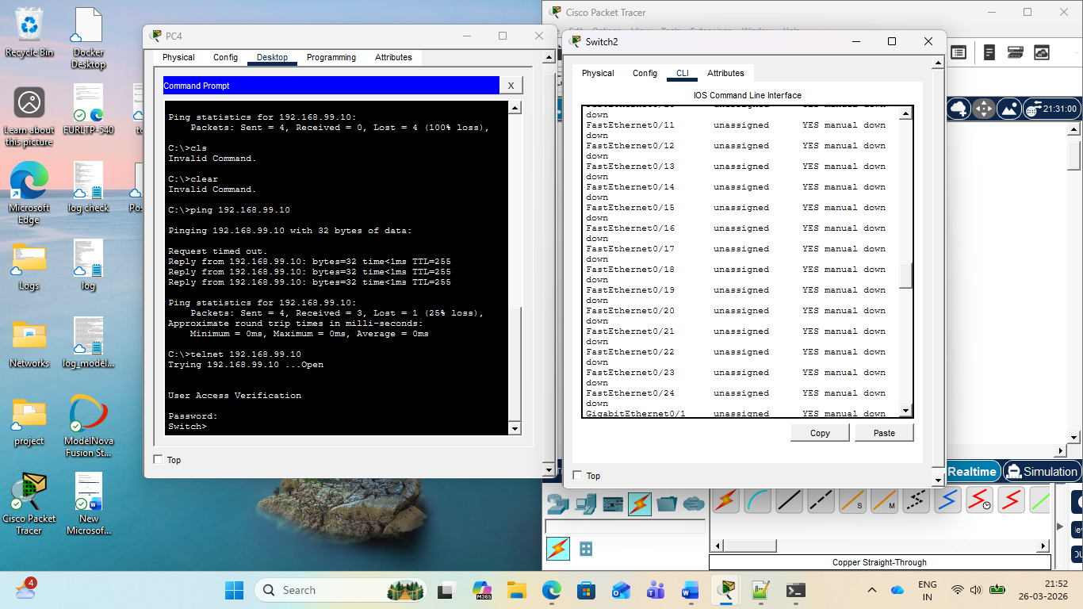
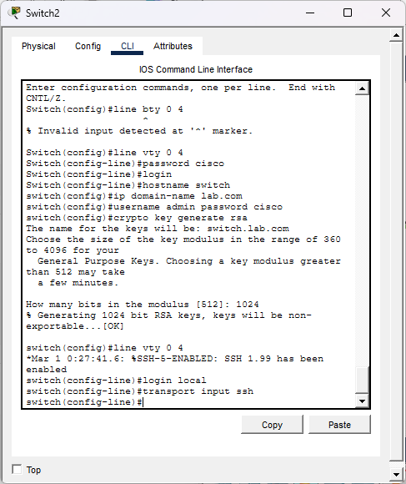
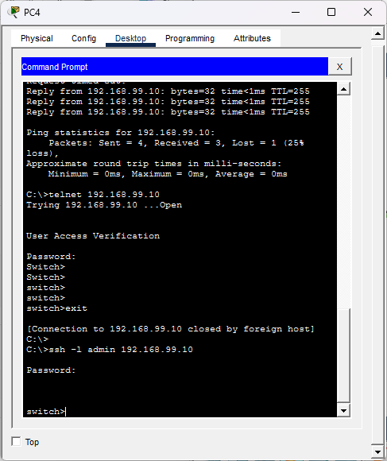

10) Troubleshooting VLAN 10 and VLAN 20 Communication Issue
Devices in VLAN 10 are unable to communicate with devices in VLAN 20 because VLANs operate as separate Layer 2 broadcast domains. A standard Layer 2 switch (like Cisco 2960) can forward traffic within the same VLAN but cannot route traffic between different VLANs.
Root Cause:
- VLAN 10 and VLAN 20 are logically isolated.
- No Layer 3 device is present to perform routing between VLANs.
- Hence, packets cannot move from one VLAN to another.
Solution (Inter-VLAN Routing):
To enable communication, configure Router-on-a-Stick:
- Connect the switch to a router.
- Configure the switch port connected to the router as a trunk port.
- On the router, create subinterfaces for each VLAN:
  - One for VLAN 10
  - One for VLAN 20
- Assign IP addresses to each subinterface (these act as default gateways).
- Ensure devices in each VLAN use the correct gateway IP.
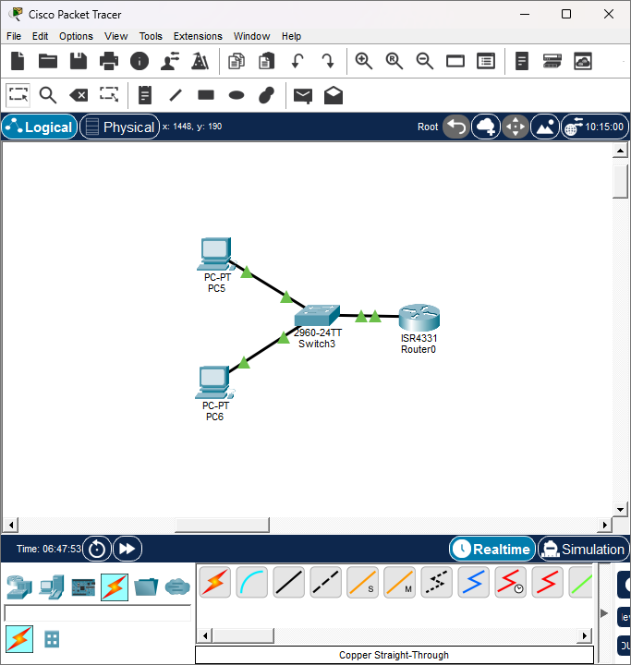
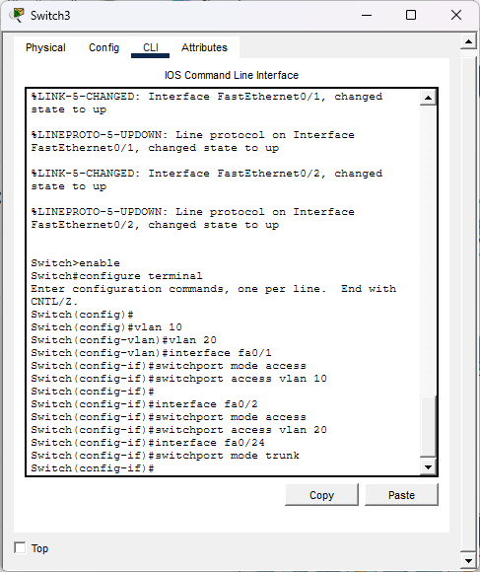
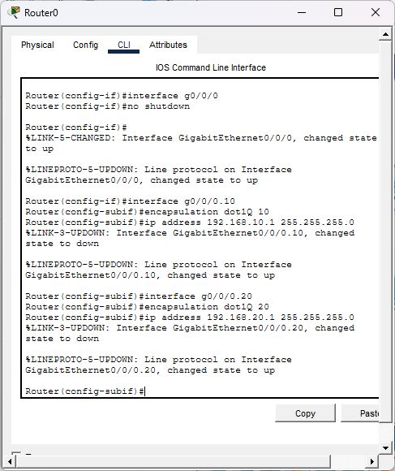

ss

