Project Report: Mechanic Shop Management System

1. Project Overview
The Mechanic Shop Management System is a web-based application designed to streamline and digitize the operations of a mechanic shop. The system provides functionality to manage mechanics, vehicles, and work orders in an efficient and organized manner. The project aims to reduce manual record-keeping, improve data accessibility, and provide a user-friendly interface for daily operations.

2. Team Members
1. Kritish Soni
2. Gurvansh Singh

3. Project Phases

Phase 1: Project Planning and Setup
• Finalized the project idea and scope.
• Selected the technology stack (Spring Boot, Thymeleaf, Bootstrap, H2 Database, Lombok).
• Initialized the project structure and repository.
• Installed and configured all required dependencies.

Phase 2: Homepage Development & Basic CRUD
• Developed the homepage UI using Thymeleaf and Bootstrap.
• Implemented routing and controller setup.
• Completed Create and Read functionality for Mechanics, Vehicles, and Work Orders.
• Styled the interface to make it visually appealing.

Phase 3: Update & Delete Functionality
• Implement Update and Delete functionalities for all modules.
• Improve form validation and error handling.
• Enhance table display for better readability.

Phase 4: Integration of Advanced Features
• Add image upload functionality for vehicles and mechanics.
• Integrate external APIs (e.g., OpenWeatherMap for weather info).
• Add reporting and export functionality using Apache POI.
• Optional: Add notification features like Twilio SMS integration.

Phase 5: Deployment & Final Testing
• Test the complete application for functionality and performance.
• Deploy the application to the cloud.
• Prepare project documentation and user manual.
• Final presentation and demonstration.

4. Work Done Till Now
• Successfully created the project structure and setup.
• Developed homepage and routing.
• Implemented Create and Read functionalities for core modules (Mechanics, Vehicles, Work Orders).
• Styled the UI with Bootstrap and Thymeleaf.
• Tested initial CRUD operations with in-memory H2 database.

5. Future Plans
The upcoming phases will focus on adding Update and Delete features, integrating external APIs, enhancing UI/UX, and deploying the application on a cloud platform. The project will also aim to include advanced functionalities like report generation and notifications.

HomePage
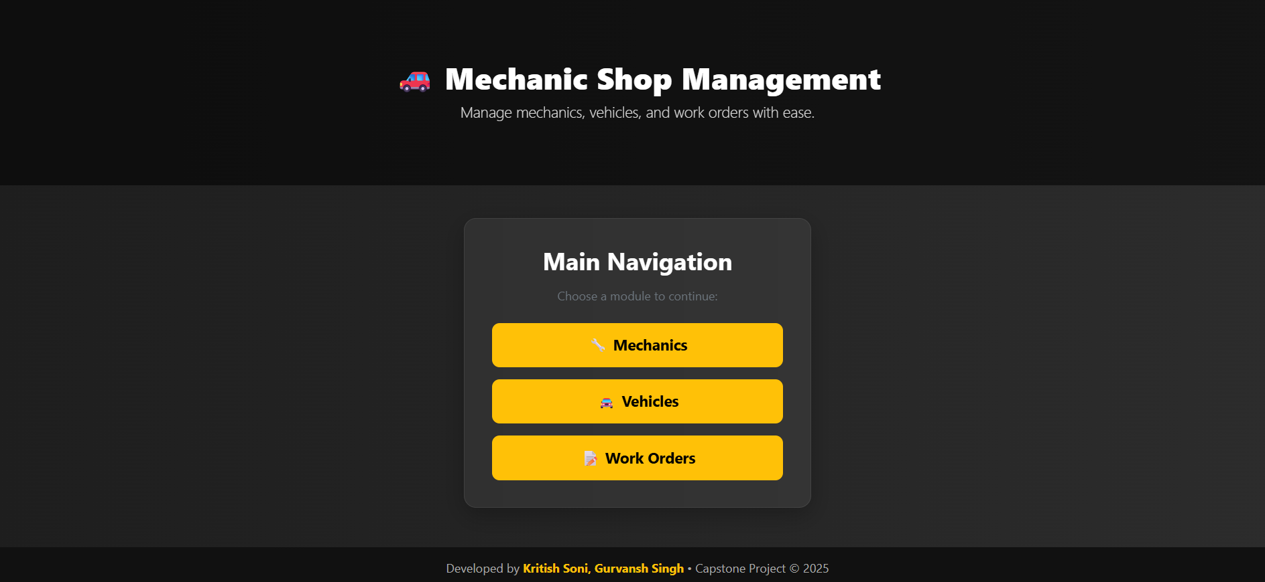

Mechanic Page
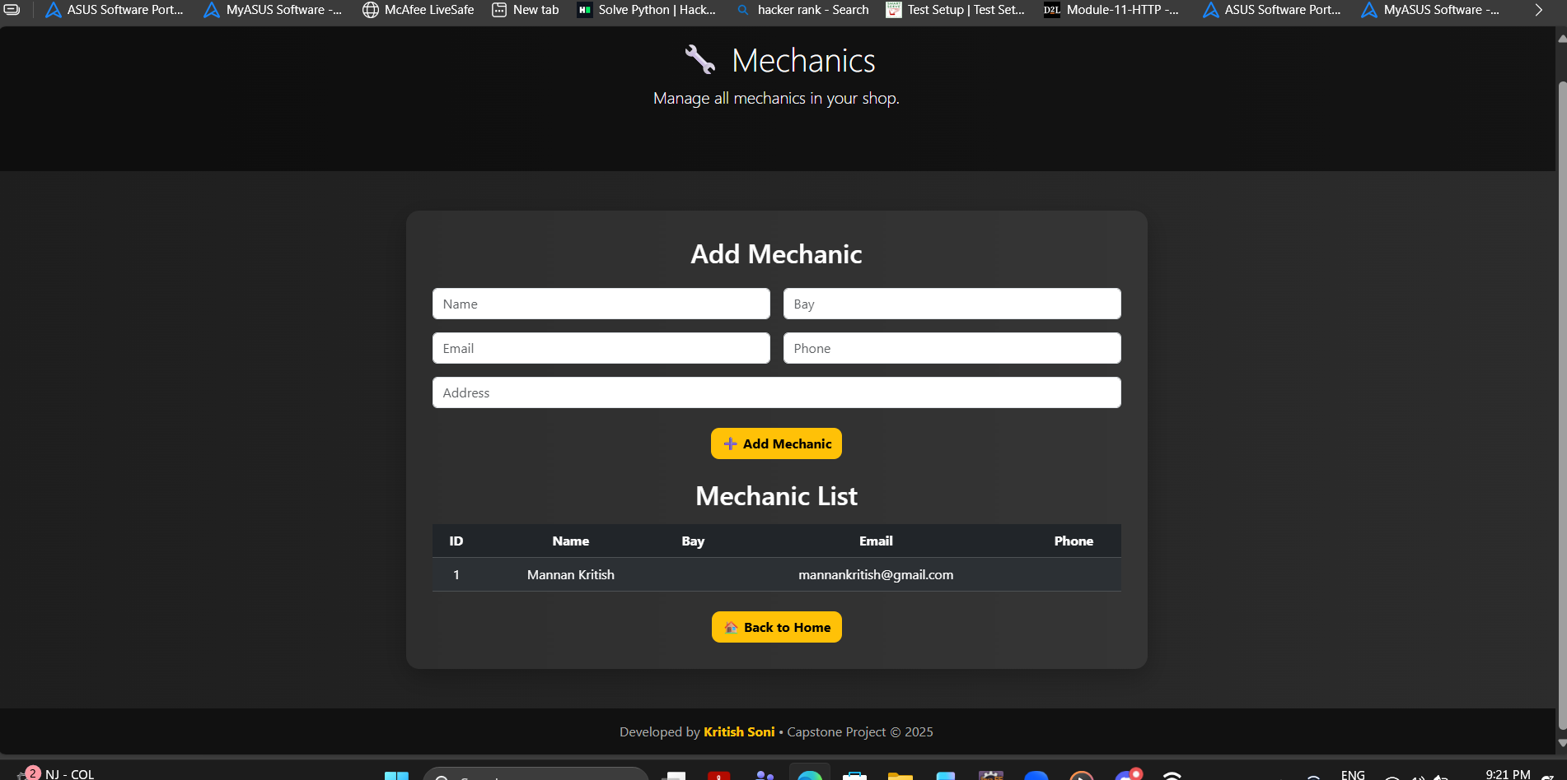

Vehicle page
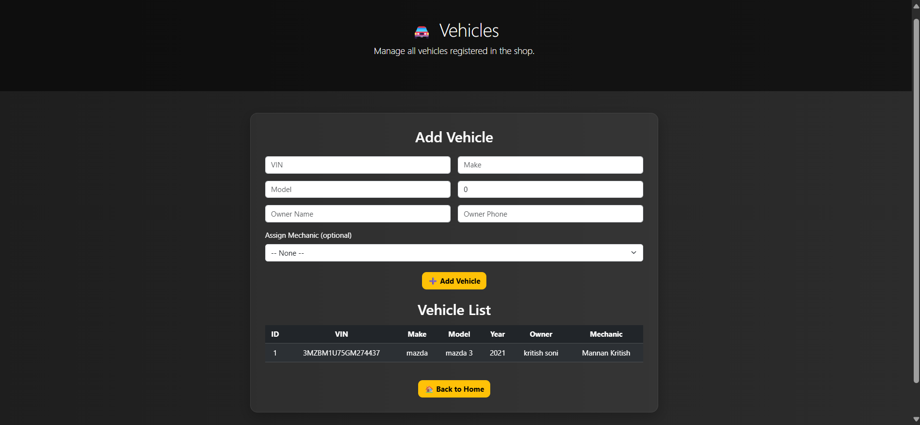

Work page /workorders page

