Prerequisite:

System should have .Net framework (Check **C\Windows\Microsoft.NET\Framework**).

Follow the below steps for the use:

1. Extract the attached zip file (Screenshot Utility.zip).
2. Run the TakeScreenshot.exe file
3. Give a logical document name in the textbox and click on Start button.

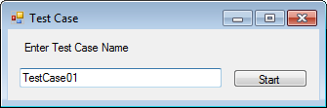

1. A small window will appear with “Print Screen” button on bottom right corner of the screen.

User has to navigate on the desired steps and click on “Print Screen” button at the screen which needs to capture.

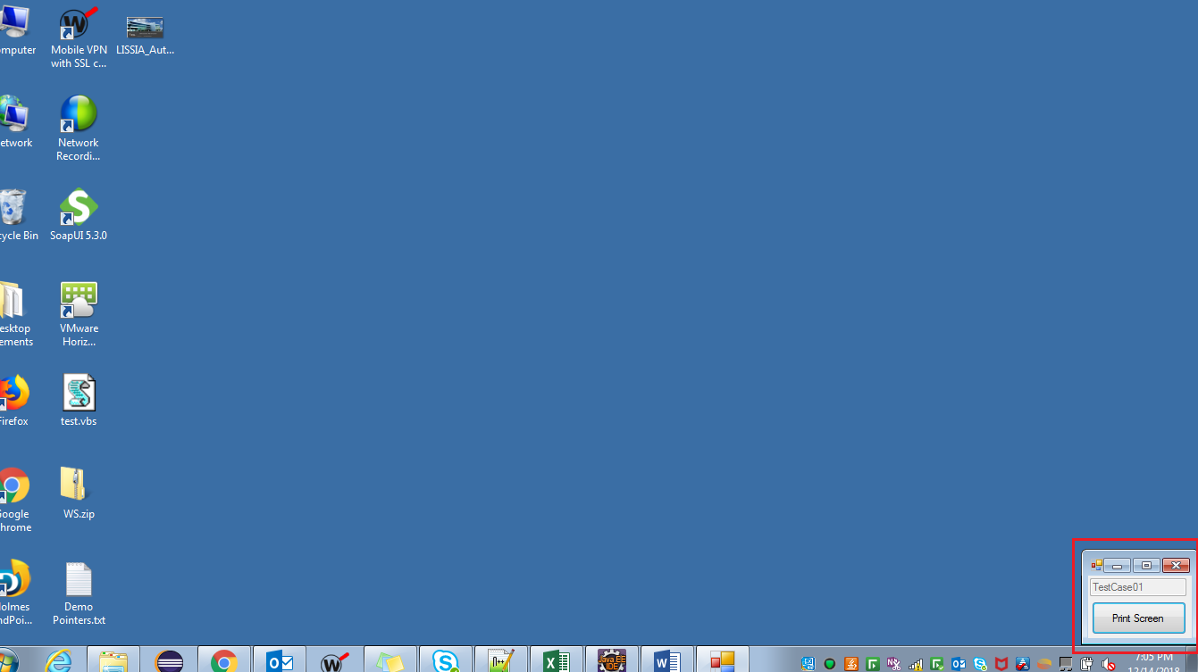

After completion of the flow click on close button, a doc file with given name, with screenshots embedded in it will get generated at location “C:\TestScript_Screenshot”.

