**CHAPTER-8-USER MANUAL (SCREENSHOTS)**

**8.1 User Manual:**

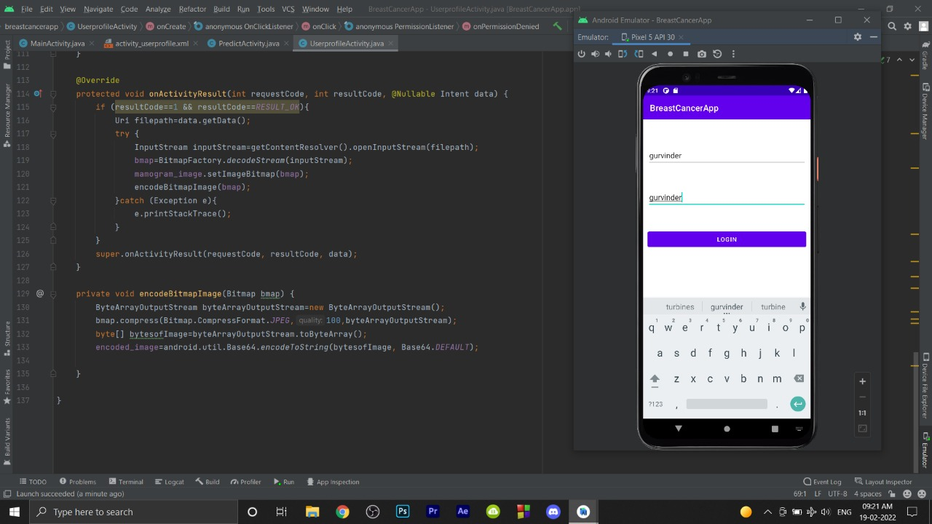

Figure8.1

**Description**: This is the Login page for customer users. Users can enter username and password here.

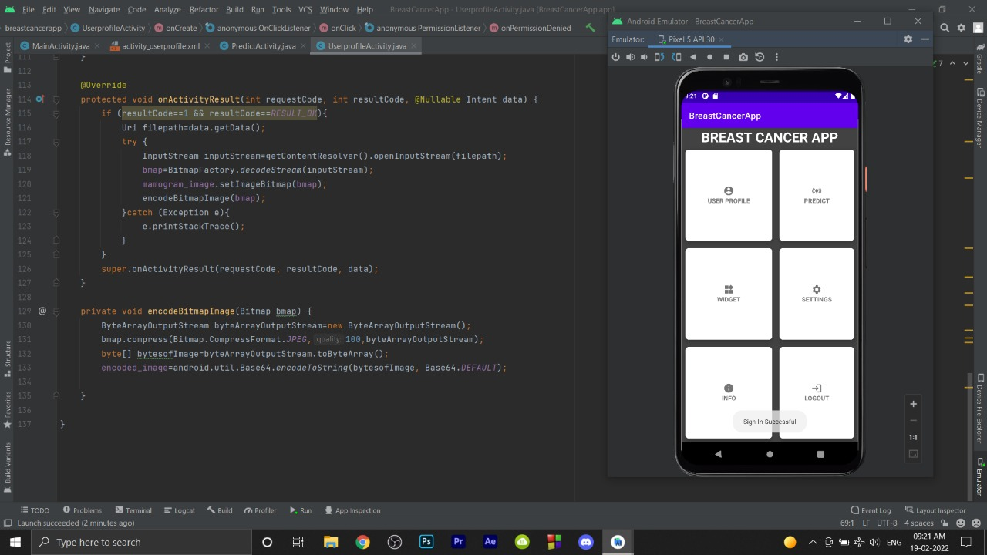

Figure 8.2

**Description:** This is the home page where user can access all the functionalities of the app.

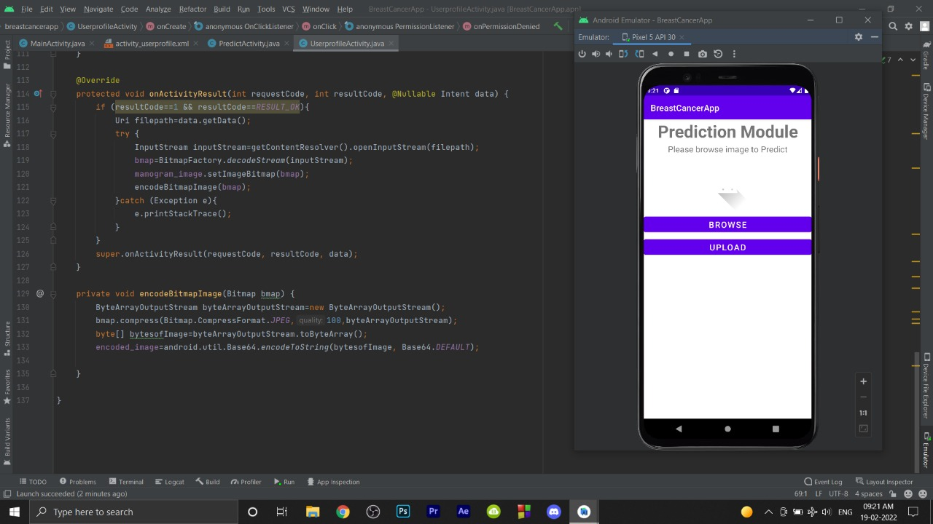

Figure 8.3

**Description**: This is the Prediction Module where user can upload image from local gallery by clicking browse button.

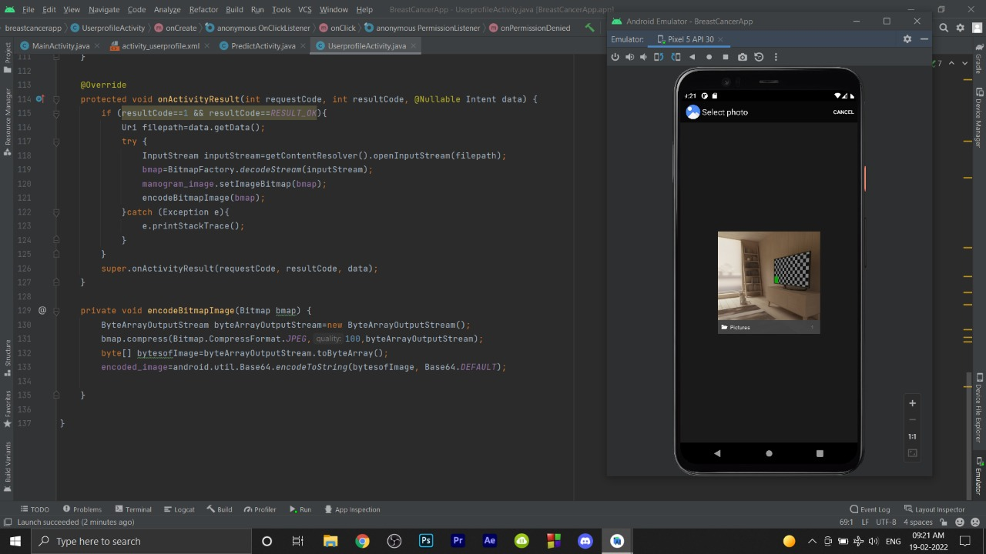

Figure 8.4

**Description:** This is the screen after pressing browse button to select photo from gallery or directly from camera.