Lab Report 9

ESE – 3014

EMBEDDED SYSTEMS COMMUNICATION PROTOCOLS AND SECURITY

Submitted to :

Linchan Wang

Submitted by:

Gurvinder Singh(748418)

1. **Using Beaglebone as master and ADXL345 Accelerometer as slave, achieve I2C interfacing communication to get output by varying the value of x,y and z axis by rotating accelerometer. Each step has to be recorded. Output has to be achieved by varying the value of x, y and z axis by changing position of accelerometer.**

**Solution-**

**Step-1:** This step first shows that no connection is done. As when 53 UU UU appears which indicates that connection is done.

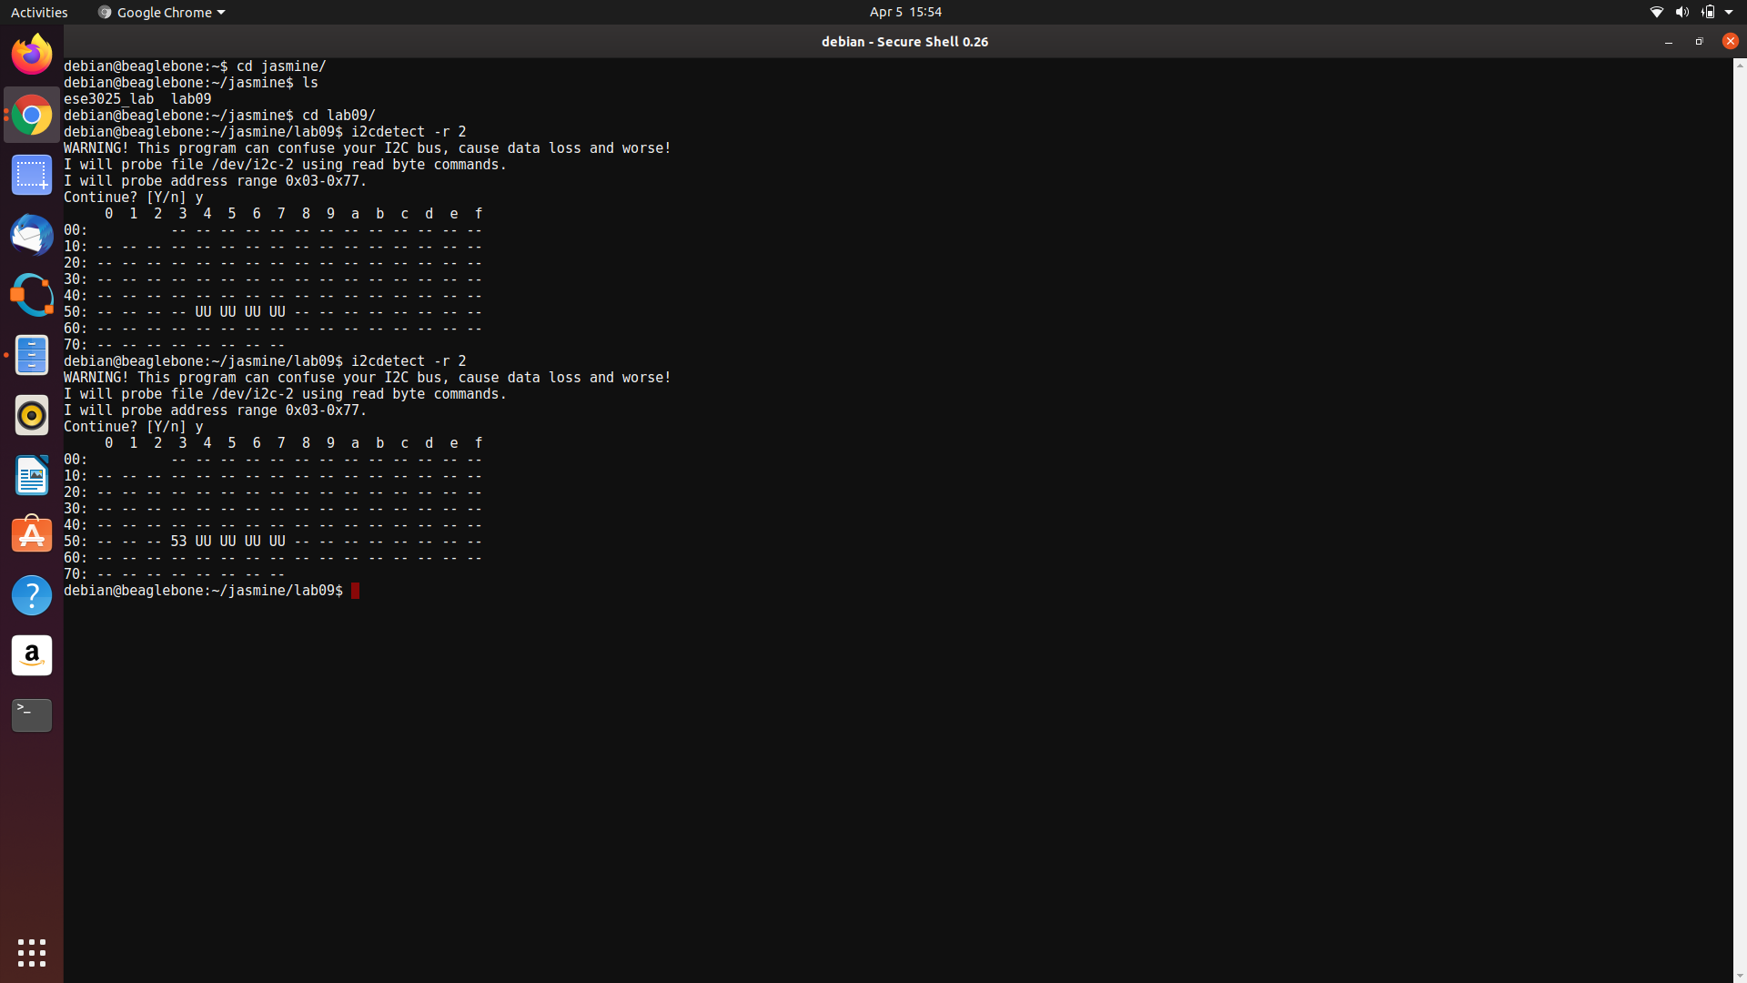

**Step-2:** Step 2 shows the pin configurations of the connection done.

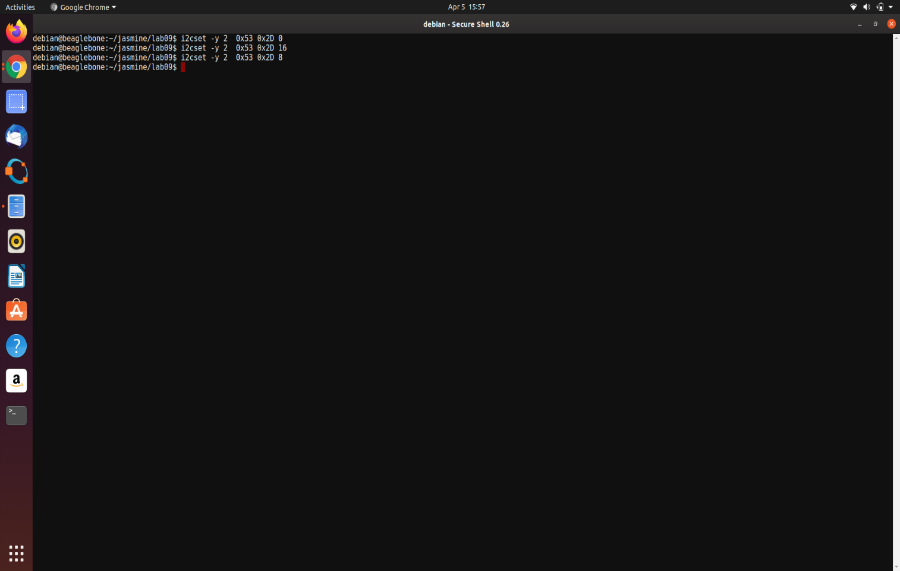

**Step-3:**

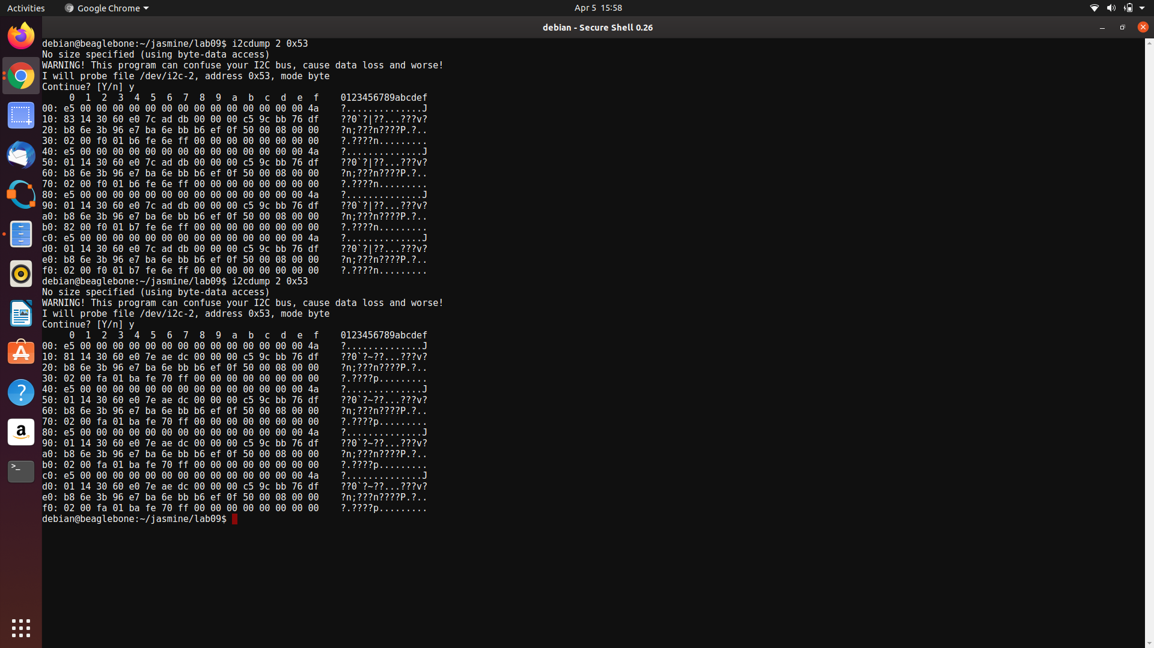

**Step-4:** Output is obtained as follows.

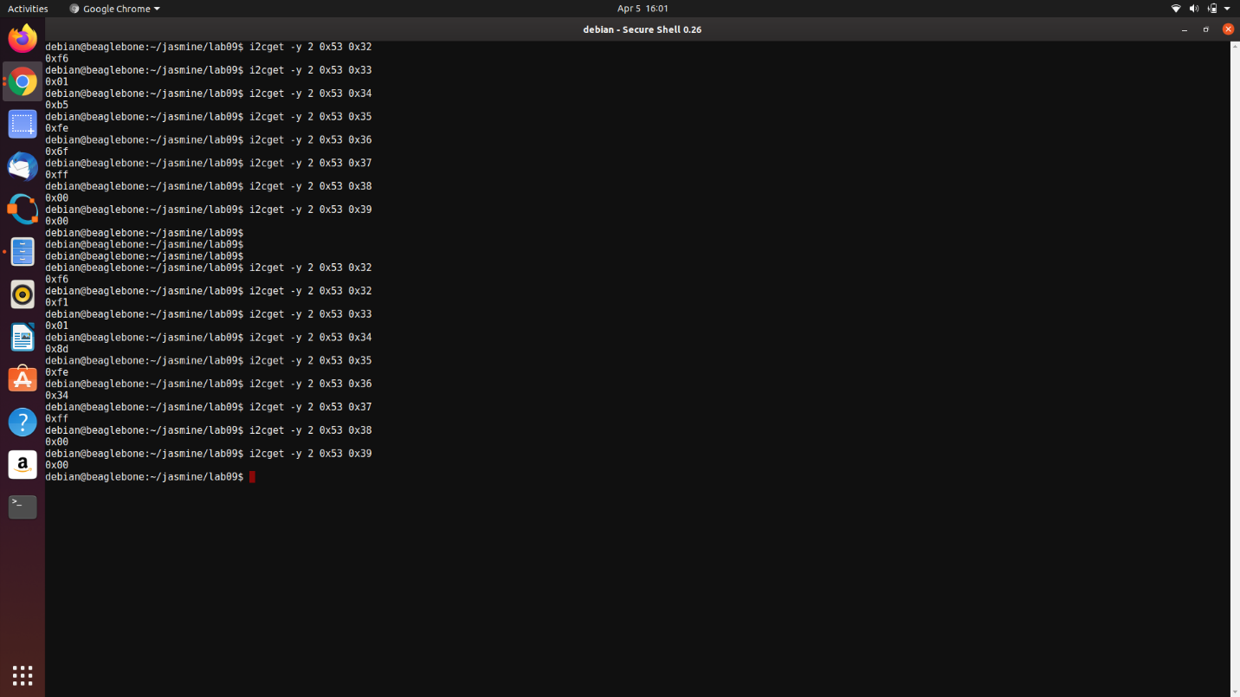

Images showing connections-

During performing this lab, ADXL345 is connected with the beaglebone black to obtain the desired output which is clearly shown in the images below:

Image-1:

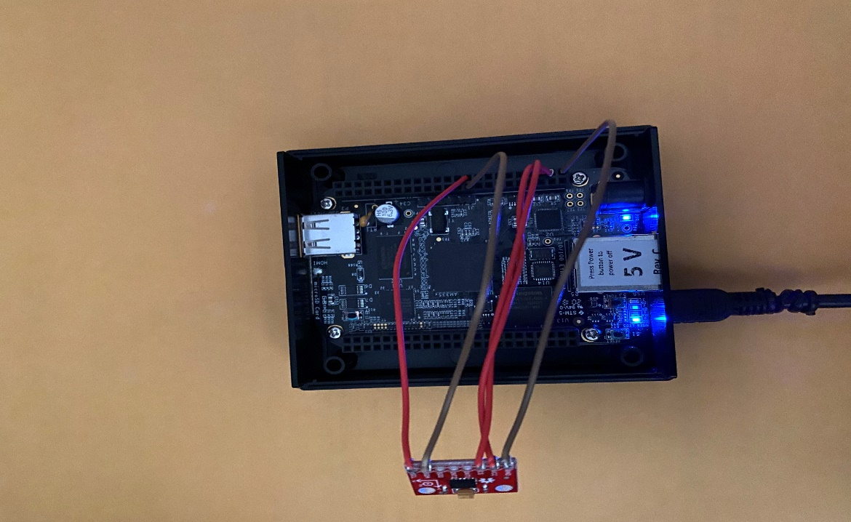

Image-2:

