Lab Report 3

ESE – 3014

EMBEDDED SYSTEMS COMMUNICATION PROTOCOLS AND SECURITY

Submitted to :

Linchan Wang

Submitted by:

Gurvinder Singh(748418)

1.Simulate Code Division multiplexing to achieve multiple access in a shared medium.

2.Follow the process on today’s course, you can use our Walsh matrix. Cre-ate three data sequences for three users, encode and decode with the codeyou chose for all of them from matrix. You don’t have to use pn sequence,m sequence, and gold sequence.

Solution:

>>

%message to be sent "hi"

A1 = [ 0 1 1 0 1 0 0 0 ]; %01101000 binary code for H

A2 = [ 0 1 1 0 1 0 0 1 ]; %01101001 binary code for I

B1 = [ -1 -1 -1 -1 ];%walsh 1

B2 = [ -1 1 1 -1 ];%walsh 2

B3 = [ 1 1 1 1 ];%walsh 3

'vector of message sent: A

'code for vector: B

P = zeros(I,L);

for n = 1:SenStr

Z = zeros(I,L);

for i = 1:I

for m = 1:L

Z(i,m) = [A(n,i)\*B(n,m)];

end

end

P = P + Z;

end

%dimensions

L= length(B); %code length

S = size(A); SenStr = S(1);

I = S(2); % number of bits

T = []; % total data on channel

Output = []; %output at receiver

% decoding at reciever end

for n = 1:SenStr

Reg = zeros(1,I);

R = zeros(I,L);

for i = 1:I

for m = 1:L

R(i,m) = P(i,m) \* B (n,m);

Reg(i) = Reg(i) + R (i,m);

end

end

Output = [ Output ; Reg / L];

end

% Determining channel traffic

for i = 1:I

T = [ T P(i,:) ];

end

'traffic:', T

Output

In octave:

%message to be sent "hi"

A1 = [ 0 1 1 0 1 0 0 0 ]; %01101000 binary code for H

A2 = [ 0 1 1 0 1 0 0 1 ]; %01101001 binary code for I

B1 = [ -1 -1 -1 -1 ];%walsh 1

B2 = [ -1 1 1 -1 ];%walsh 2

B3 = [ 1 1 1 1 ];%walsh 3

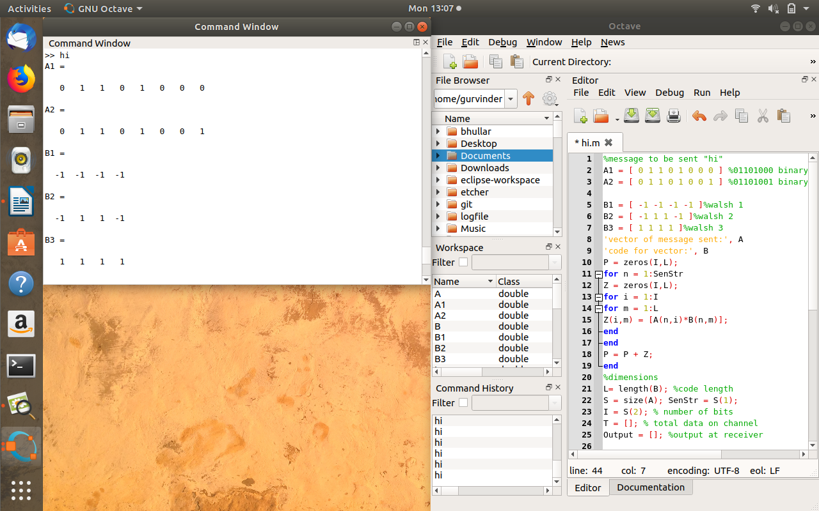

In octave

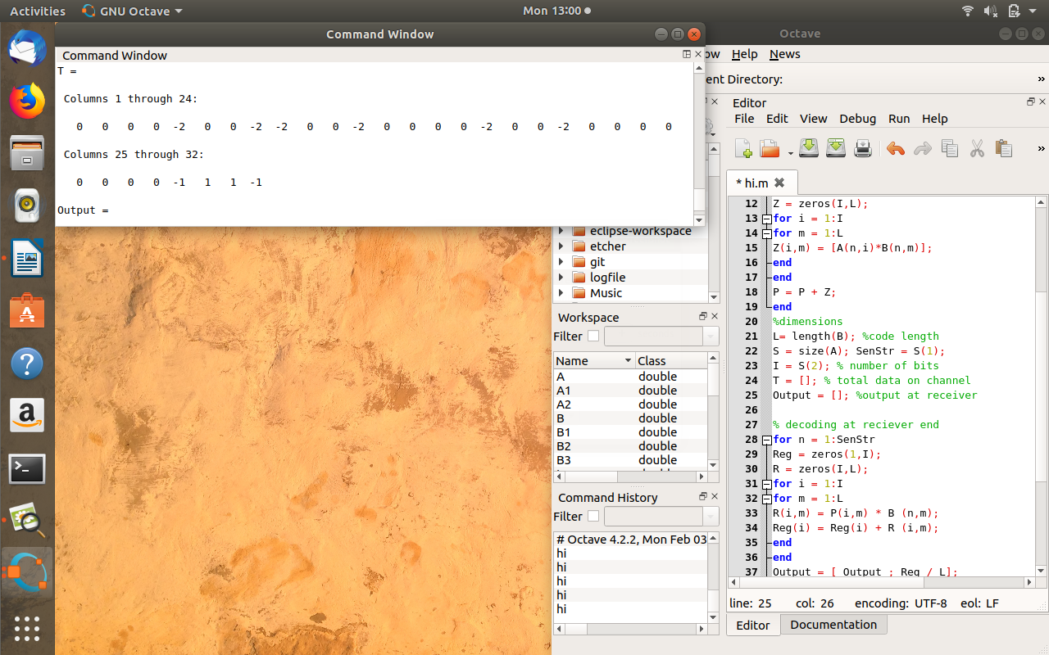

In octave

% transmitted message(”hi”) for B1 user

