EMBEDDED SYSTEMS

COMMUNICATION

PROTOCOL AND SECURITY

ESE 3014(Lab Report 1)

Gurvinder Singh (748418)

Note- Sir we did first 4 questions and get the desired results. Unfortunately in question 5 we have some issues with code and didn’t get the desired results. So instead of copying someone’s code we are adding the code best to our knowledge.

1. Create a 5\*1 vector of zeroes.

>>zeros(5,1)

ans =

0

0

0

0

0

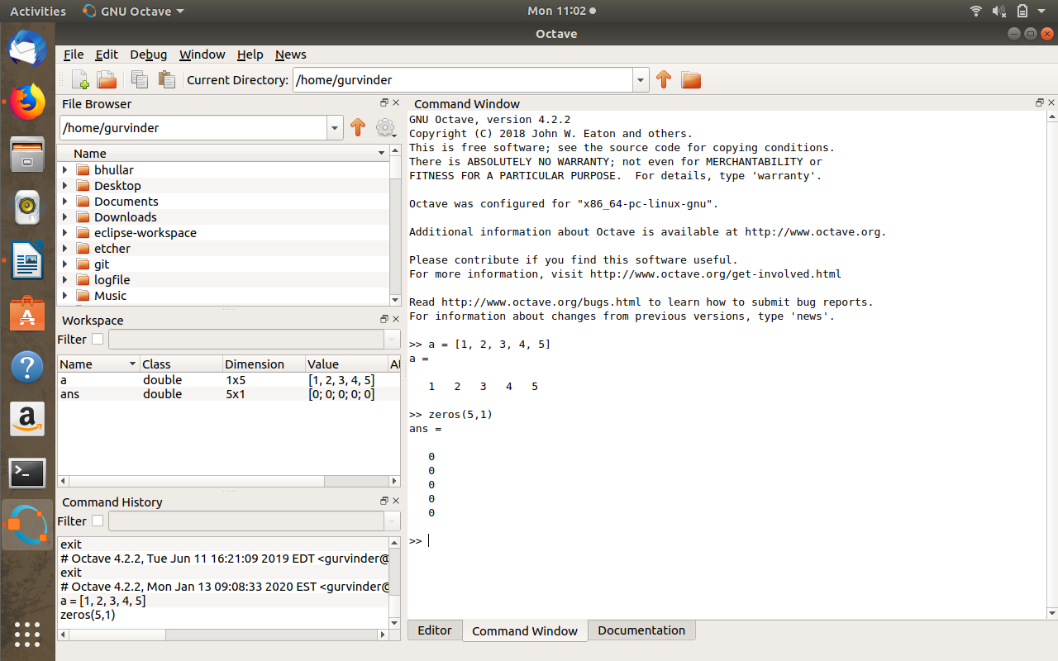in Octave

\* Create a 2\*5 matrix of random numbers.

>> rand(2,5)

ans =

0.91664 0.18566 0.96680 0.69888 0.49963

0.39870 0.21506 0.19923 0.18929 0.15457

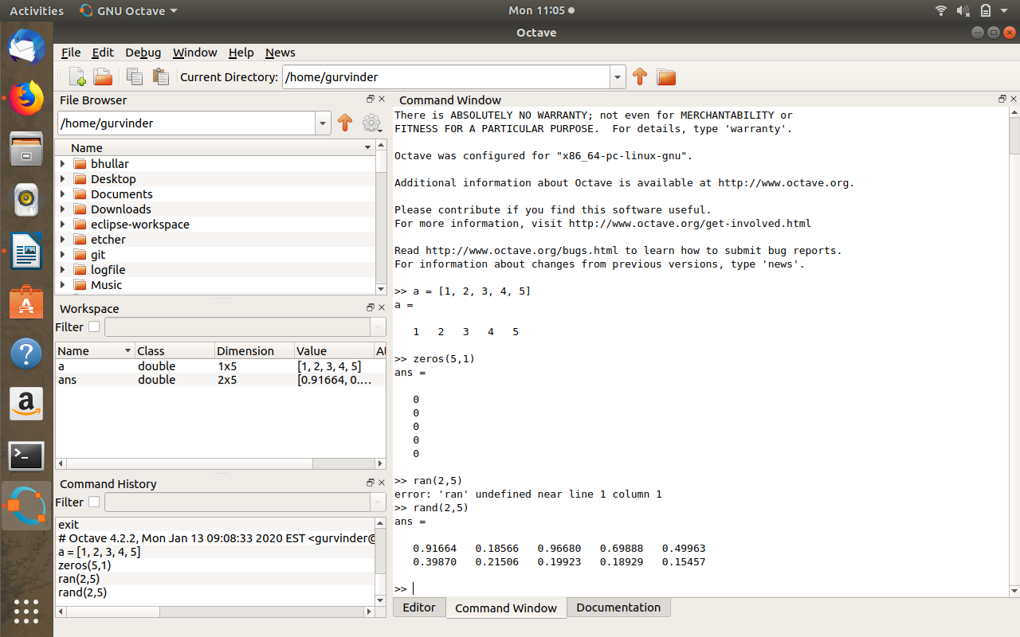in Octave

2. Multiply a column of a matrix with an element of this same matrix.

>> a = [1, 2, 3, 4, 5, 6]

a =

1 2 3 4 5 6

>> X = a .\*a

X =

1 4 9 16 25 36

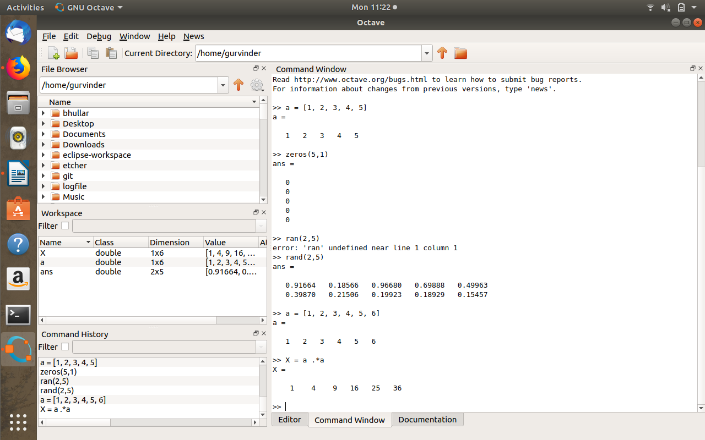in octave

3.Create a plot of the sin function between 0 and 6π.

>> a=0:0.1:6\*pi;

>> b=sin(a)

>>plot(a,(sin))

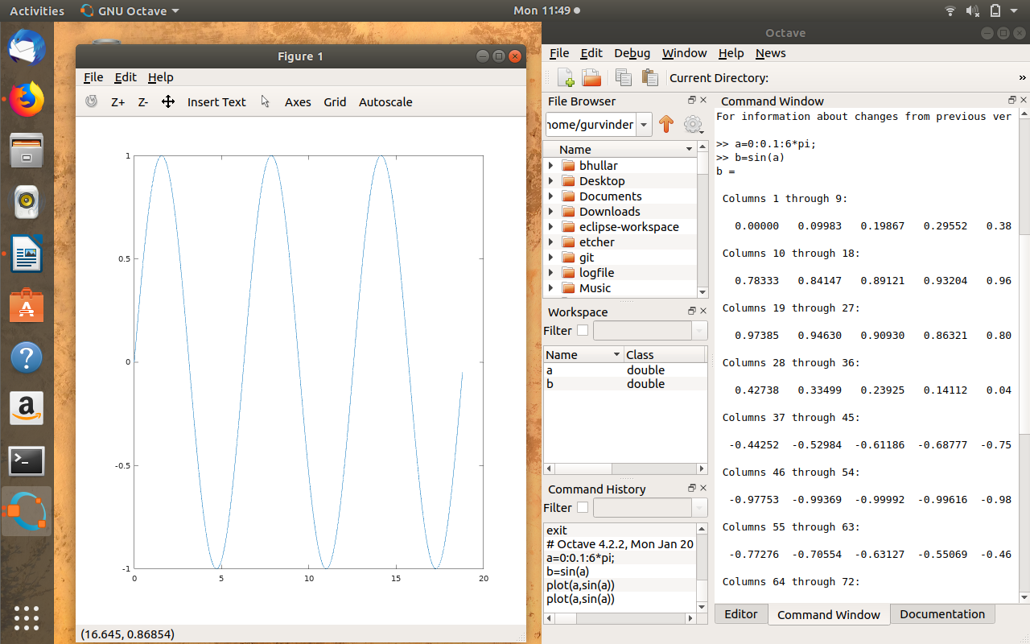in octave

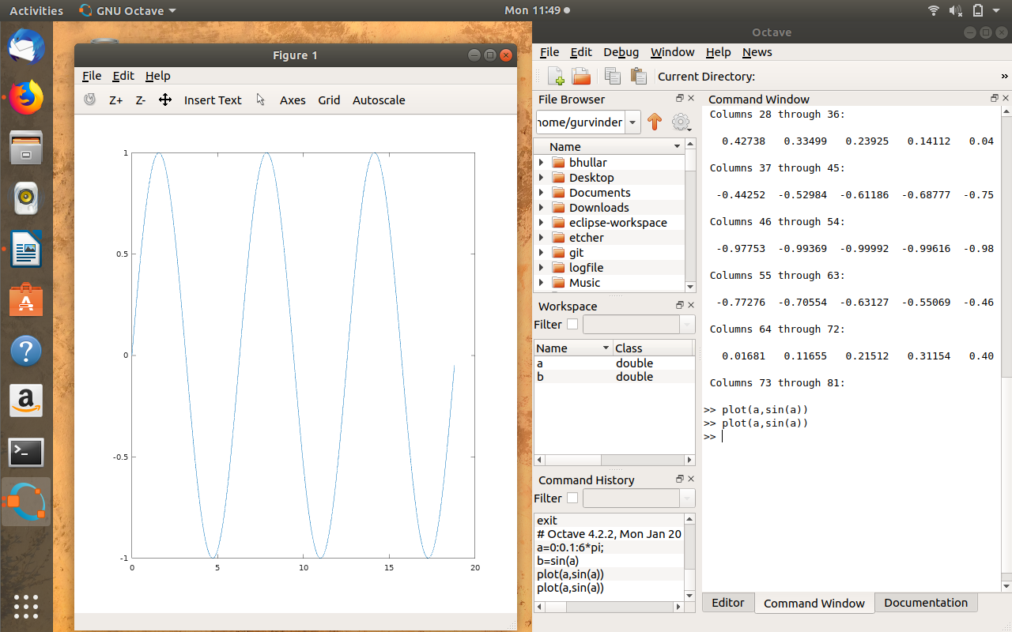

4.Simulate an amplitude modulation (AM) system with all input, carrier and output signals. Say the input signal is a cosine wave with amplitude as 2V and frequency as 1000Hz. The carrier signal is also a cosine wave with amplitude as 5V and frequency as 10KHz. The modulation degree is 0.5, and the initial phases of all cosine wave are 0. (Recall Nyquist sampling theorem to avoid distortion i.e. under sampling).

Disp ('m=1');

%m=input('Enter data (m) =');

m=1; %modulation data

%modulating signal

subplot(3,1,1);

plot(t, ym), grid on;% Graphical representation of Modulating signal

title ('Modulating Signal');

xlabel ('time'); ylabel ('Amplitude');

Am=5; % Amplitude of modulating signal

fa=2000; % Frequency of modulating signal

Ta=1/fa; % Time period of modulating signal

t=0:Ta/999:6\*Ta; % simulation

ym=Am\*cos(2\*pi\*fa\*t); % Equation of modulating signal

%carrier signal

subplot(3,1,2);

plot(t,yc), grid on;% Graphical representation of carrier signal

title ('Carrier Signal');

xlabel ('time'); ylabel ('Amplitude');

Ac=Am/m;% Amplitude of carrier signal

fc=fa\*10;% Frequency of carrier signal

Tc=1/fc; % Time period of carrier signal

yc=Ac\*cos(2\*pi\*fc\*t); % Equation of carrier signal

%AM Modulation

subplot(3,1,3);

plot(t,y);% Graphical representation of AM signal

title ('Amplitude Modulated signal');

xlabel ('time'); ylabel ('Amplitude');

y=Ac\*(1+m\*cos(2\*pi\*fa\*t)).\*cos(2\*pi\* fc\*t); % Equation of Amplitude

grid on;

if (0>m||m>1)

error('m may be less than or equal to one and greater than to zero');

end

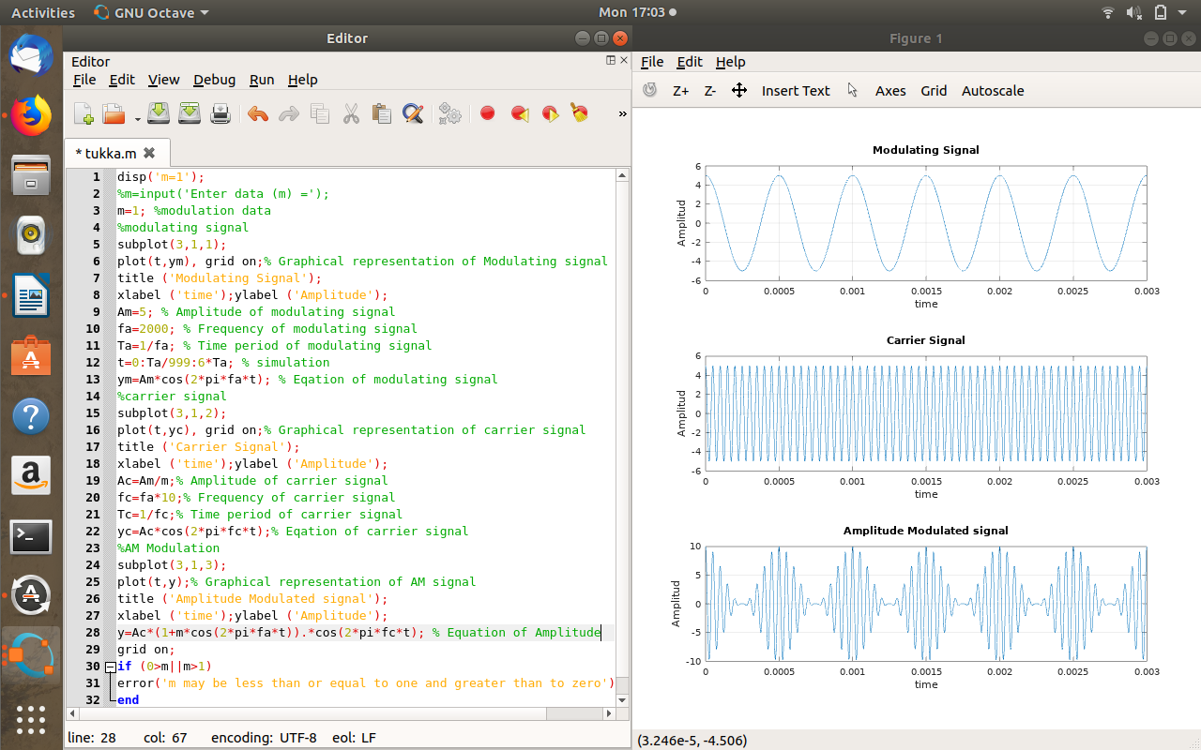in octave

5.Use the signals above, consider a actual vivid simulation mode, and add random noise in output signal. In this simulation, we divide time domain into several duration, and call each duration as frame. The scanning cycle of an oscilloscope is equal to frame period, that means each time we simulate a frame of signal, and the display will be refreshed once. Therefore, we can get a constantly sliding input signal, a carrier signal with phase jitter, and output signal with noise.

Ac=10;Am=1;

fc=1500;fm=250;

m=.10;t=100;

t1=linespace(0,t,1000);

y1=cos(2\*pi\*fm\*t1); % m(t)

y2=Ac\*cos(2\*pi\*fc\*t1); % c(t)

eq=(1+m.\*cos(2\*pi\*fm\*t1)).\*(Ac.\*cos(2\*pi\*fc\*t1));

for framedata=0:550 %total frames

%movement of signal

set(gcf,"movement","on");

drawnow;

time=framedata\*T+(0:fm:t); %sampling in farmes

input=2\*cos(2\*pi\*1500\*time);

carrier=5\*cos(2\*pi\*1e4\*time+0.2\*randn);

output=(2+.10\*input).\*carrier;

distortion=randn(size(time));

a=output+distortion; %output with noise

%input signal plot

subplot(3,1,1);

plot([0:dt:T],input);

xlabel("time");ylabel("input signal");

text(T\*2/3,1.5,["frame Number=" , num2str(framedata)]);

%carrier signal plot

subplot(3,1,2);

plot([0:dt:T],carrier);

xlabel("time");ylabel("carrier signal");

%output signal plot

subplot(3,1,3);

plot([0:dt:T],a);

xlabel("time");ylabel("output signal");

end