**CERTIFICATE**

This is to certify that YOUR NAME, of class XII-C, has prepared the Project File as per the prescribed syllabus of Computer Science (083) under the supervision of TEACHER NAME.

Academic Year: 2023-24

Internal Examiner External Examiner

**ACKNOWLEDGEMENT**

I would like to express my special thanks of gratitude to my teacher TEACHER NAME who gave me a golden opportunity to do this project of Computer Science, which also helped me in doing a lot of research and I came to know new things about it. Without their help, guidance and support it would be impossible to complete this project. Secondly, I would also like to thank my parents and friends who helped me a lot in finishing this project within a limited time. I am making this project not only for marks but also to increase my knowledge.

Once again thanks to all who helped me in doing this project.

**INDEX**

|  |  |
| --- | --- |
| Content | Pg No. |
| * Project Title | 4 |
| * Project Introduction * Needs * Benefits | 5 |
| * Project Objective * Features | 6 |
| * Technology Used | 7 |
| * Hardware & Software Requirements | 9 |
| * Project Code | 10 |
| * Table Structure | 22 |
| * Project Output | 23 |
| * Future Scope | 33 |

TITLE OF THE PROJECT:

**STAFF MANAGEMENT**

BY:

**YOUR NAME**

**PROJECT INTRODUCTION**

**Need:**

1. It is an overhead to keep the records related to staff on the papers and the chances of mistakes are high.

2. It is a burden to take out the register and view the records. It is a time-consuming process.

3. Most importantly, we should minimize paperwork so that there is no need to cut down more and more trees.

**Benefits:**

1. Keeps records related to the staff.

2. Easy to use and available at an affordable cost.

**PROJECT OBJECTIVES**

All the details regarding Staffs will be stored in one place safely. Chances of data redundancy are close to none.

**Key features:**

- Add Staff Record

- Remove Staff Record

- Update Staff Data

- View All Staff Data

- View Staff Data with some conditions

**Purposes:**

i) Quick and easy way to access staff data.

ii) One can search for staff details.

iii) HR can assign a unique identification number to the staff.

iv) HR can delete Staff's record.

v) HR can update Staff's record.

**TECHNOLOGY USED**

**Python:**

Python is an interpreted, object-oriented, high level programming language with dynamic semantics. Its high-level

built in data structures, combined with dynamic typing and dynamic binding. It is used for web development (server-side), software development, machine learning & system scripting.



Application used-

Python IDLE 3.12.0 64-bit

**MySQL:**

SQL stands for Structured Query Language

It is a domain-specific language used in programming and designed for managing data held in a relational database (RDBMS), or for stream processing in a relational data stream management system (RDSMS). It provides many different types of commands used for different purposes. These commands can be divided into:

(i). Data Definition Language (DDL)

(ii). Data Manipulation Language (DML)

(iii). Transaction Control Language (TCL)

Application used-

MySQL 8.2.0

**MS Office:**

Microsoft Word is a widely used word processor developed by Microsoft. It allows users to create, edit, and format text documents, and comes with features for inserting tables, images, and other elements. It’s commonly used for creating professional documents like letters, reports, and resumes. The files are typically saved with a .docx extension.

Application Used-

Microsoft Office 365

**HARDWARE & SOFTWARE REQUIREMENTS**

**Hardware:**

Processor: Intel or AMD Multi-core Processor, 1.5 GHz or higher

Memory: 2 GB (minimum)

Architecture: x86 or x64

GPU: Integrated Intel or Radeon Graphics

Storage: 5 GB free disk space (HDD or SSD)

Mouse & Keyboard: Integrated Mouse & Keyboard

**Software:**

OS: Windows 7, MacOS X 10.11, or any compatible Linux distribution

Apps: MySQL 8.0 & Python IDLE 3.9

DirectX: DX9 (minimum)

**PROJECT CODE**

Source Code:

import mysql.connector as sqltor

print('Enter MySQL Credentials below:')

hst = input('Enter hostname: ')

usr = input('Enter username: ')

pwd = input('Enter password: ')

mycon = sqltor.connect(host=hst, user=usr, passwd=pwd)

cursor = mycon.cursor()

if mycon.is_connected():

print('Connected to MSQL Successfully')

else:

print('Not Connected, Please rerun the program')

def createdb():

gendetails = """

CREATE TABLE IF NOT EXISTS GeneralDetails

(SID INT PRIMARY KEY,

FName VARCHAR(20),

LName VARCHAR(20),

Email VARCHAR(100),

MobNo BIGINT,

Gender VARCHAR(2),

Department VARCHAR(50),

Title VARCHAR(50))

"""

perdetails = """

CREATE TABLE IF NOT EXISTS PersonalDetails

(SID INT PRIMARY KEY,

Address varchar(200),

DOB DATE,

Adhaar VARCHAR(12),

PAN VARCHAR(10))

"""

empdetails = """

CREATE TABLE IF NOT EXISTS StaffingDetails

(SID INT PRIMARY KEY,

DOJ DATE,

HoursWorkSD INT,

HourlyRate INT)

"""

notes = """

CREATE TABLE IF NOT EXISTS Notes

(SID INT,

NID INT PRIMARY KEY,

Notes TEXT)

"""

emergencyinfo = """

CREATE TABLE IF NOT EXISTS EmergencyContactInfo

(SID INT PRIMARY KEY,

EmergencyContactName VARCHAR(50),

EmergencyContactNumber BIGINT)

"""

cursor.execute('CREATE DATABASE IF NOT EXISTS SMS')

cursor.execute('USE SMS')

cursor.execute(gendetails)

cursor.execute(perdetails)

cursor.execute(empdetails)

cursor.execute(notes)

cursor.execute(emergencyinfo)

print('Created Database and Tables successfully')

print('Run (3) to insert test records if you want')

def deldb():

cursor.execute('DROP DATABASE IF EXISTS SMS')

print('Removed sucessfully')

def regendb():

deldb()

createdb()

def testrec():

cursor.execute('USE SMS')

grec1 = "INSERT INTO GeneralDetails VALUES(001, 'Ramesh', 'Patel', 'rameshpatel1@gmail.com', 9845634724, 'M', 'Marketing', 'Marketing Manager')"

grec2 = "INSERT INTO GeneralDetails VALUES(002, 'Ujwal', 'Ahuja', 'ujwalahuja4@gmail.com', 9845734724, 'M', 'Accounting', 'Accounting Manager')"

grec3 = "INSERT INTO GeneralDetails VALUES(003, 'Yuvi', 'Garg', 'gargyuvi1@gmail.com', 9823634724, 'M', 'Accounting', 'Intern')"

prec1 = "INSERT INTO PersonalDetails VALUES(001, '285 Suchieta Niwas, 11 Shahid Bhagat Singh R, Fort, Mumbai', '1998-12-30', '662223509284', 'ALWPG5809L')"

prec2 = "INSERT INTO PersonalDetails VALUES(002, '2a, Shakespeare Sarani, Middleton Row, Kolkata', '1994-03-17', '226035064188', 'OKYZ3261NH')"

prec3 = "INSERT INTO PersonalDetails VALUES(003, 'J-1/52/f, Beriwala Bagh, Back Side Almariah Factor, Hari Nagar, Delhi', '1999-05-21', '817870326834', 'MOZKF016NB')"

erec1 = "INSERT INTO StaffingDetails VALUES(001, '2017-02-21', 5636, 475)"

erec2 = "INSERT INTO StaffingDetails VALUES(002, '2017-03-16', 5484, 450)"

erec3 = "INSERT INTO StaffingDetails VALUES(003, '2021-10-23', 2037, 120)"

nrec1 = "INSERT INTO Notes VALUES(001, 001, 'Straight forward')"

nrec2 = "INSERT INTO Notes VALUES(001, 002, 'Good behaviour')"

nrec3 = "INSERT INTO Notes VALUES(002, 003, 'Lazy')"

nrec4 = "INSERT INTO Notes VALUES(003, 004, 'Newly joined')"

nrec5 = "INSERT INTO Notes VALUES(003, 005, 'Will work up the ranks')"

ecrec1 = "INSERT INTO EmergencyContactInfo VALUES(001, 'Aditya Patel', 7423101168)"

ecrec2 = "INSERT INTO EmergencyContactInfo VALUES(002, 'Sahil Ahuja', 7423101343)"

ecrec3 = "INSERT INTO EmergencyContactInfo VALUES(003, 'Farhan Garg', 7423101927)"

cursor.execute(grec1)

cursor.execute(grec2)

cursor.execute(grec3)

cursor.execute(prec1)

cursor.execute(prec2)

cursor.execute(prec3)

cursor.execute(erec1)

cursor.execute(erec2)

cursor.execute(erec3)

cursor.execute(ecrec1)

cursor.execute(ecrec2)

cursor.execute(ecrec3)

cursor.execute(nrec1)

cursor.execute(nrec2)

cursor.execute(nrec3)

cursor.execute(nrec4)

cursor.execute(nrec5)

mycon.commit()

print('Added Test Records Successfully')

def addemp():

cursor.execute('USE SMS')

ch = 'y'

while ch == 'y':

print('Enter Staff Details below:')

SID = int(input('Staff ID: '))

fname = input('First Name: ')

lname = input('Last Name: ')

email = input('Email: ')

mob = int(input('Mobile Number: '))

gender = input('Gender (M/F): ')

dept = input('Department: ')

title = input('Title: ')

address = input('Address: ')

dob = input('Date of Birth (YYYY-MM-DD): ')

adhaar = input('Aadhaar Number: ')

pan = input('PAN Number: ')

doj = input('Date of Joining (YYYY-MM-DD): ')

hours = int(input('Hours Worked: '))

rate = int(input('Hourly Rate: '))

emername = input('Emergency Contact Name: ')

emermob = int(input('Emergency Contact Number: '))

cursor.execute("INSERT INTO GeneralDetails VALUES({},'{}','{}','{}', {}, '{}', '{}', '{}')".format(SID, fname, lname, email, mob, gender, dept, title))

cursor.execute("INSERT INTO PersonalDetails VALUES({}, '{}', '{}', '{}', '{}')".format(SID, address, dob, adhaar, pan))

cursor.execute("INSERT INTO StaffingDetails VALUES({}, '{}', {}, {})".format(SID, doj, hours, rate))

cursor.execute("INSERT INTO EmergencyContactInfo VALUES({}, '{}', {})".format(SID, emername, emermob))

mycon.commit()

print('Record added successfully')

ch = input('Want to enter more? (y/n): ')

def removeemp():

cursor.execute('USE SMS')

SID = int(input('Enter SID of Staff you want to remove: '))

cursor.execute("select * from GeneralDetails where SID={}".format(SID))

for rec in cursor:

print(rec)

ch = input('Are you sure you want to remove this Staff? (y/n): ')

if ch == 'y':

cursor.execute('delete from GeneralDetails where SID={}'.format(SID))

cursor.execute('delete from PersonalDetails where SID={}'.format(SID))

cursor.execute('delete from StaffingDetails where SID={}'.format(SID))

cursor.execute('delete from EmergencyContactInfo where SID={}'.format(SID))

mycon.commit()

print('Record removed successfully')

def updateemp():

cursor.execute('USE SMS')

SID = int(input('Enter SID of Staff to update: '))

tab = input('What detail do you want to update? (GeneralDetails, PersonalDetails, StaffingDetails, Notes, EmergencyContactInfo): ')

cursor.execute("describe {}".format(tab))

for colname in cursor:

print(colname[0])

cursor.execute("select * from {} where SID={}".format(tab, SID))

for rec in cursor:

print(rec)

field = input('Enter field you want to update: ')

val = input('Enter the new value: ')

cursor.execute("update {} set {}='{}' where SID={}".format(tab, field, val, SID))

mycon.commit()

print('Record updated successfully')

def searchemp():

cursor.execute('USE SMS')

term = input('Enter Staff ID or First Name or Last Name: ')

if term.isdigit():

cursor.execute("SELECT * FROM GeneralDetails WHERE SID=%s", (int(term),))

else:

cursor.execute("SELECT * FROM GeneralDetails WHERE FName=%s OR LName=%s", (term, term))

records = cursor.fetchall()

if not records:

print('No records found for the given search term.')

else:

print('Staff Records Found:')

for record in records:

print(record)

def viewemp():

cursor.execute('USE SMS')

query = """

SELECT GD.SID, GD.FName, GD.LName, GD.Email, GD.MobNo, GD.Gender, GD.Department, GD.Title,

PD.Address, PD.DOB, PD.Adhaar, PD.PAN,

SD.DOJ, SD.HoursWorkSD, SD.HourlyRate,

N.Notes,

EC.EmergencyContactName, EC.EmergencyContactNumber

FROM GeneralDetails GD

INNER JOIN PersonalDetails PD ON GD.SID = PD.SID

INNER JOIN StaffingDetails SD ON GD.SID = SD.SID

LEFT JOIN Notes N ON GD.SID = N.SID

LEFT JOIN EmergencyContactInfo EC ON GD.SID = EC.SID

"""

cursor.execute(query)

records = cursor.fetchall()

count = cursor.rowcount

if records:

columns = [desc[0] for desc in cursor.description]

print('Staff Records:')

print(columns)

for record in records:

print(record)

else:

print(count, 'records in database')

else:

print('No Staff records found.')

def mosthard():

cursor.execute('USE SMS')

cursor.execute("SELECT SID, MAX(HoursWorkSD) AS MostHoursWorkSD FROM StaffingDetails GROUP BY SID ORDER BY MostHoursWorkSD DESC")

record = cursor.fetchone()

if record:

SID, hours = record

print('Most Hardworking Staff:')

print('Staff ID:', SID)

print('Total Hours Worked:', hours)

else:

print('No records found.')

def avgsal():

cursor.execute('USE SMS')

query = """

SELECT AVG(HoursWorkSD * HourlyRate / 160) AS AvgMonthlySalary

FROM StaffingDetails

"""

cursor.execute(query)

avgmonsal = cursor.fetchone()[0]

if avgmonsal:

print('Average Monthly Salary:', round(avgmonsal), '(approx)')

else:

print('No records found or average salary is zero.')

def addnote():

cursor.execute('USE SMS')

SID = int(input('Enter Staff ID: '))

nid = int(input('Enter a Note ID: '))

note = input('Enter note for Staff ({}): '.format(SID))

cursor.execute("INSERT INTO Notes VALUES({}, {}, '{}')".format(SID, nid, note))

mycon.commit()

print('Record Added Successfully')

def viewnotes():

cursor.execute('USE SMS')

ch = int(input('(1) Individual Notes or (2) All Notes: '))

if ch == 1:

SID = int(input('Enter Staff ID: '))

cursor.execute('SELECT * FROM Notes WHERE SID = %s', (SID,))

data = cursor.fetchall()

if data:

print('Notes for Staff ID:', SID)

for row in data:

print(f'NID: {row[1]}, Note: {row[2]}')

else:

print('No notes found for this Staff.')

elif ch == 2:

cursor.execute('SELECT * FROM Notes')

data = cursor.fetchall()

if data:

print('All Notes:')

for row in data:

print(f'SID: {row[0]}, NID: {row[1]}, Note: {row[2]}')

else:

print('No notes found.')

else:

print('Invalid choice')

def updatenotes():

cursor.execute('USE SMS')

nid = int(input('Enter NID of note to update: '))

cursor.execute('select * from Notes where NID={}'.format(nid))

for rec in cursor:

print(rec)

val = input('Enter the new note: ')

cursor.execute("update Notes set Notes='{}' where NID={}".format(val, nid))

mycon.commit()

print('Record updated successfully')

def emergencyprotocol():

cursor.execute('USE SMS')

SID = int(input('Enter Staff ID: '))

cursor.execute('SELECT * FROM EmergencyContactInfo WHERE SID={}'.format(SID))

data = cursor.fetchall()

print('Emergency Contact Details:')

print('SID | EmergencyContactName | EmergencyContactNumber')

for row in data:

print(row)

def empdeptwise():

cursor.execute('USE SMS')

cursor.execute('SELECT DISTINCT Department FROM GeneralDetails')

departments = [row[0] for row in cursor.fetchall()]

print('Staff Records by Department:')

for department in departments:

print('Department:', department)

cursor.execute("SELECT * FROM GeneralDetails WHERE Department=%s", (department,))

records = cursor.fetchall()

if records:

for record in records:

print(record)

else:

print('No records found for this department.')

print('----------------------------------------')

conti = 'y'

while conti == 'y':

print('')

print('')

print('')

print('')

print('')

print('Welcome to Staff MANAGEMENT SYSTEM!')

print('')

print('')

print(' Operation Menu ')

print('--------------------------------------')

print('1. Generate Database and Tables')

print('2. Regenerate Database and Tables')

print('3. Insert Test Records')

print('4. Add a Staff record')

print('5. Remove a Staff record')

print('6. Update a Staff record')

print('7. Search for a Staff record')

print('8. View all Staff records')

print('9. View Staff Department-wise')

print('10. Most Hardworking Staff')

print('11. Current Average Monthly Salary')

print('12. Add a note to a Staff')

print('13. View notes of a Staff')

print('14. Update notes of a Staff')

print('15. Emergency Contact Protocol')

print('--------------------------------------')

choice = int(input('Enter Operation Number (1-15): '))

if choice == 1:

createdb()

print('')

elif choice == 2:

regendb()

print('')

elif choice == 3:

testrec()

print('')

elif choice == 4:

addemp()

print('')

elif choice == 5:

removeemp()

print('')

elif choice == 6:

updateemp()

print('')

elif choice == 7:

searchemp()

print('')

elif choice == 8:

viewemp()

print('')

elif choice == 9:

empdeptwise()

print('')

elif choice == 10:

mosthard()

print('')

elif choice == 11:

avgsal()

print('')

elif choice == 12:

addnote()

print('')

elif choice == 13:

viewnotes()

print('')

elif choice == 14:

updatenotes()

print('')

elif choice == 15:

emergencyprotocol()

print('')

else:

print('Invalid choice')

conti = input('Would you like to do more operations? (y/n): ')

else:

print('Bye! See you soon!')

**TABLE STRUCTURE**

**Tables and Fields:**

1) General Details

(Staff ID, First Name, Last Name, Email, Phone Number, Gender, Department, Job Title)

2) Personal Details

(Staff ID, Address, Date of Birth, Adhaar Number, PAN Number)

3) Employment Details

(Staff ID, Date of Joining, Hours Worked, Hourly Rate)

4) Notes Table

(Staff ID, Note ID, Notes)

5) Emergency Contact Information Table

(Staff ID, Emergency Contact Name, Emergency Contact Number)

*Database and Tables are made automatically by operation 1*

**PROJECT OUTPUT**

Initializing:

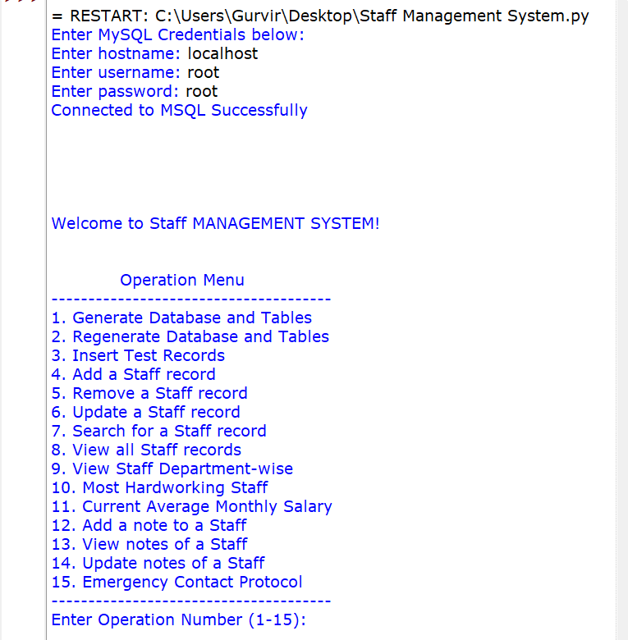

Operation 1:

(Front-end Output)

(Back-end Output)

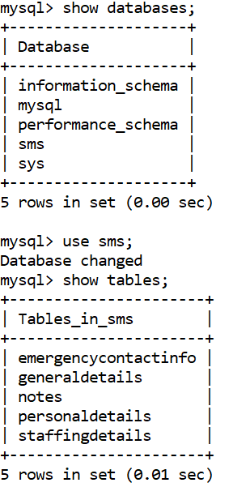

Operation 2:

(Front-end Output)

*Back-end output is same as (1)

Operation 3:

(Front-end Output)

(Back-end Output)

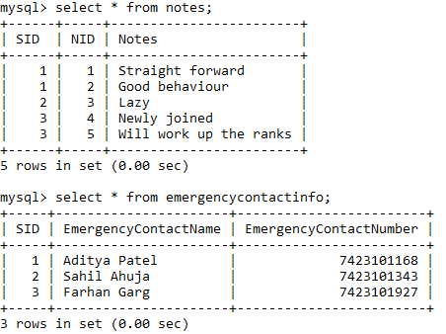

Operation 4:

(Front-end Output)

(Back-end Output)

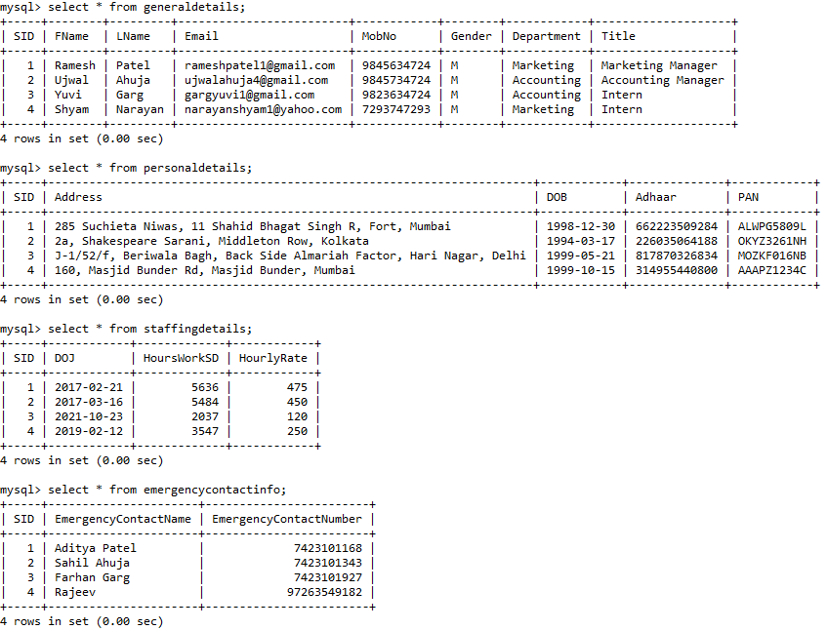

Operation 5:

(Front-end Output)

(Back-end Output)

Operation 6:

(Front-end Output)



(Back-end Output)

Operation 7:

Operation 8:

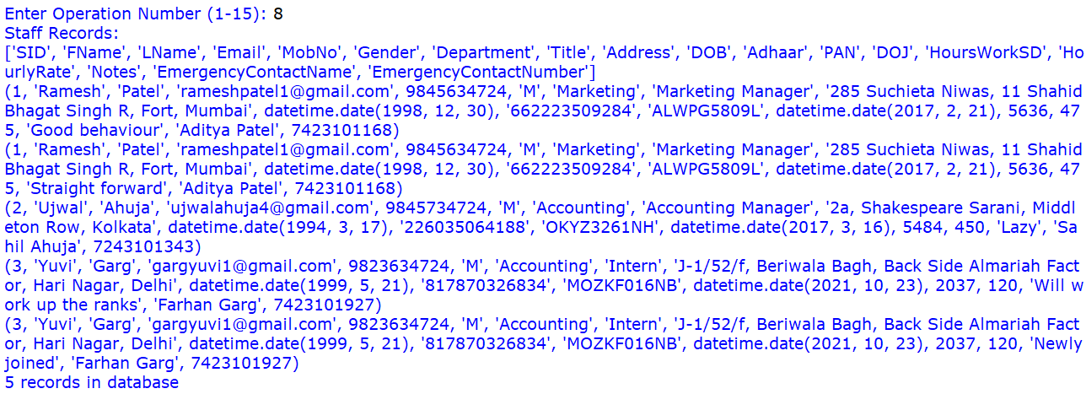

Operation 9:

Operation 10:

Operation 11:

Operation 12:

(Front-end Output)

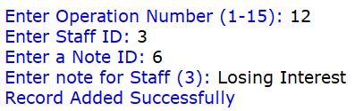

(Back-end Output)

Operation 13:

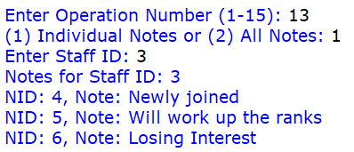

Operation 14:

(Front-end Output)

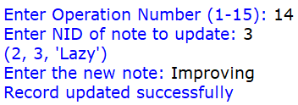

(Back-end Output)

Operation 15:



**FUTURE SCOPE**

In any project, though present satisfaction is important but also it is equally important to see and visualize the future scope. The project which is developed now may need to undergo some changes in future to match up the technology prevailing that time, thus change due to development in technology are advisable.

Some of the future scopes include:

1. Exporting MySQL Data to a .csv file or an excel spreadsheet.

2. Website or Mobile app for managing on the go.

3. A dashboard for HR to view analytics.

4. Access to training materials for the staff and to track their personal development.

5. Store staff related documents like resumes, certifications, and contracts.