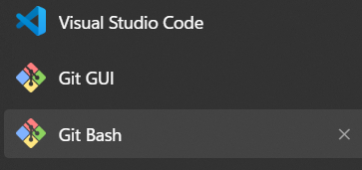

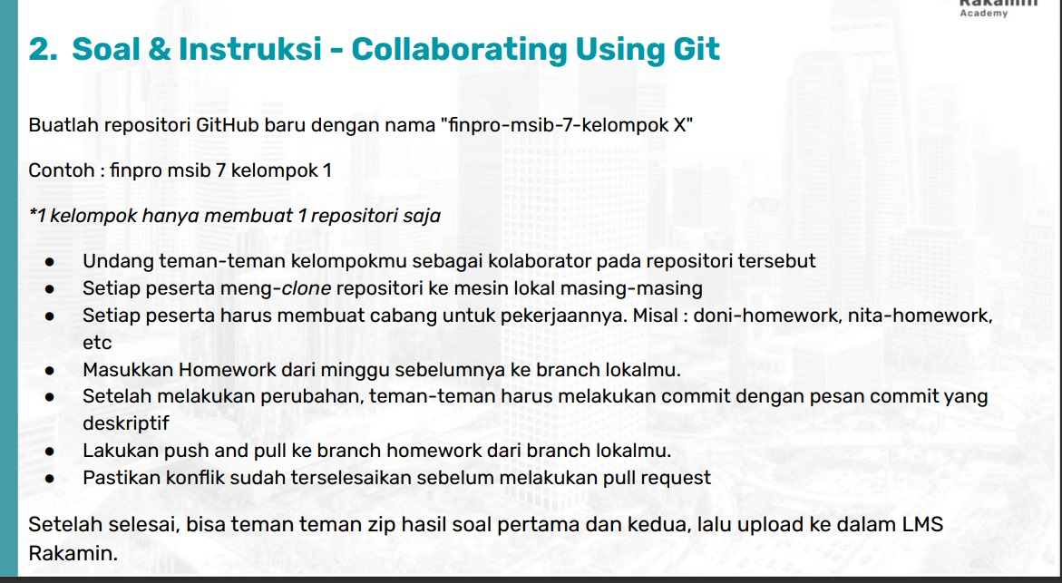

Summary :

Kita sudah mempelajar Fullstack Web Developer Career Path, SDLC & Design Thinking Implementation dan Basic Git & Collaborating Using Git