**CASE STUDY ON SMART MALL MANAGEMENT SYSTEM​**



**B-TECH/III YEAR CSE/V SEMESTER**

**19CSE301/COMPUTER NETWORKS**

|  |  |
| --- | --- |
| ROLL NO | NAME |
| CB.EN.U4CSE21137 | **MURUGESH JLP** |
| CB.EN.U4CSE21151 | **YASHWANTH S** |
| CB.EN.U4CSE21153 | **SANDEEP R HEGDE** |
| CB.EN.U4CSE21167 | **VIJAYABHASKARAMOORTHY V** |

**DEPARTMENT OF COMPUTER SCIENCE AND ENGINEERING**

**AMRITA SCHOOL OF COMPUTING, COIMBATORE**

**2022 -2023 ODD SEMESTER**

**PROBLEM STATEMENT​:**

Designing a smart mall management system in Cisco Packet Tracer to optimize security and resource utilization, integrating IoT devices for real-time monitoring, and enhancing operational efficiency through centralized control and analytics.

**RUBRICS COVERED​:**

1. Application layer protocols:

* TELNET(Teletype Network)
* DNS(Domain Name System)

1. Use of TCP/UDP based on application chosen:

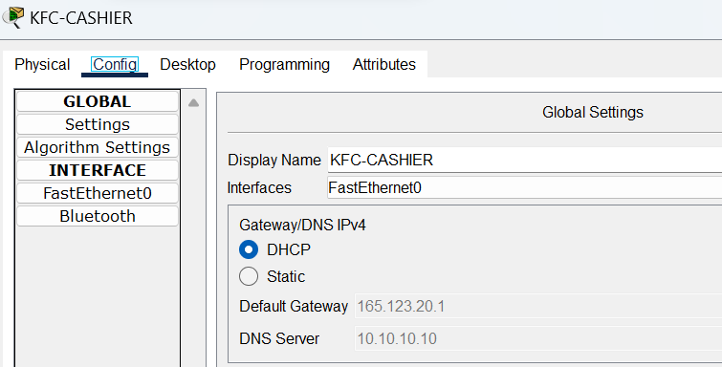

* Employing DHCP (Dynamic Host Configuration Protocol) for IP address allocation, leveraging the UDP (User Datagram Protocol) for efficient communication between devices, ensuring seamless connectivity and network resource optimization.
* Reduced Overhead and Quick Communication:

UDP is selected over TCP for its lower overhead and connectionless nature. In a mall management system, where real-time communication is crucial, UDP facilitates faster data transmission without the additional complexities of establishing and maintaining connections, making it suitable for tasks like device status updates and sensor data reporting.

* Scalability and Responsiveness: UDP's lightweight design makes it more scalable for handling a multitude of devices in a mall without the overhead associated with TCP's connection setup and acknowledgment mechanisms. This enhances the overall responsiveness of the system, crucial for real-time applications in a dynamic environment like a shopping mall.

1. IP addressing, subnetting concepts:

* Each hosts are given an appropriate IP address which has been given in the addressing table.
* Subnetting:
* To simplify the network, we have added around 11 subnets namely:
* Timezone, Solar panels room, Department-store, Network room, Safety room, Parking server, Food court, Penshoppe, Sports central, Jollibee and GQ barber shop.

1. Virtual LAN:

* Vlans are implemented at:
* Lower-ground-floor:
* Food-court
* Cyber-zone
* 1st –floor
* Mcdonalds
* KFC
* Jollibee
* 3rd-floor
* Timezone
* Gq-Barber-Shop

**DESCRIPTION​:**

TOPOLOGY:

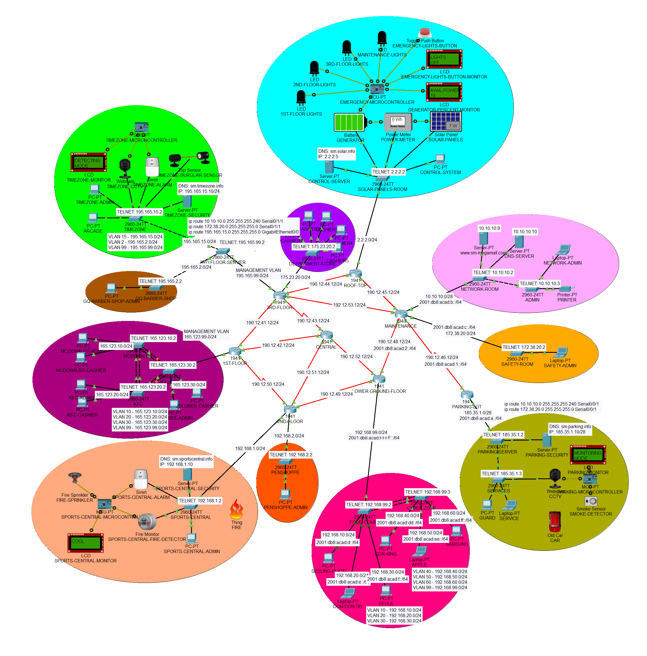

1. REGISTRATION SERVERS:

Prioritizing security is evident through the implementation of time zone security protocols. The central control server orchestrates seamless communication, while specialized security modules for sports areas and parking facilities enhance surveillance. Default login credentials, 'admin' for both username and password, streamline access. Notably, registration servers serve as pivotal components, efficiently managing registrations for various mall services and events, contributing significantly to the overall organizational efficiency and effectiveness of the mall management system.

1. WEB SERVERS:

* www.sm-megamall.com

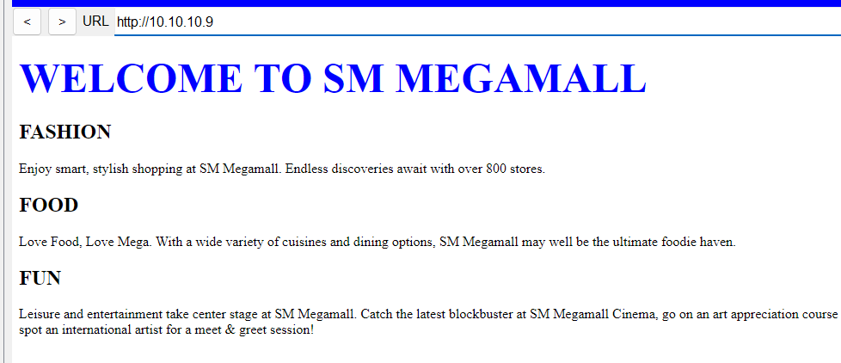

1. ROUTERS:

* 8 Routers are used.

1. SWITCHES:

* 17 Switches are used.

1. EMERGENCY POWER SYSTEM:

Within the system architecture, the EMERGENCY-LIGHTS-BUTTON-MONITOR serves as a critical indicator, providing real-time feedback on the activation status of the EMERGENCY-LIGHTS-BUTTON. In instances where the button remains unactivated, the system response is designated as "LIGHTS OFF." Conversely, upon button activation, the system promptly switches to "LIGHTS ON," ensuring an immediate response to emergency lighting needs. Additionally, the GENERATOR-PERCENT-MONITOR plays a crucial role by continuously monitoring and communicating the available power percentage in the generator, providing essential information for effective power management within the system.

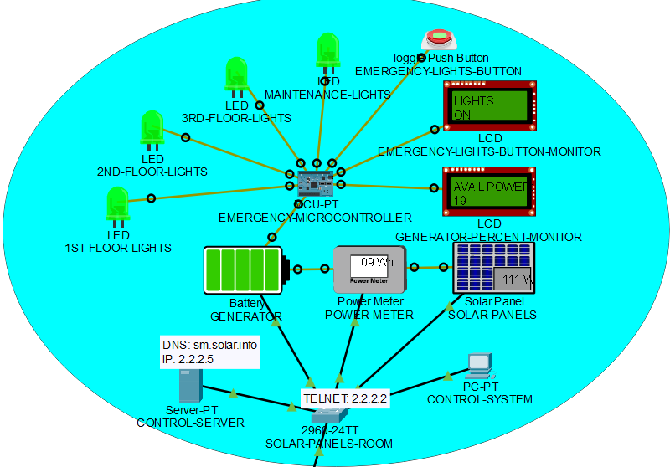

1. FIRE DETECTOR:

Situated within the SPORTS-CENTRAL area, the FIRE-SPRINKLER-ACTIVATOR holds a pivotal role in the security infrastructure. When triggered by fire detection, it activates both the FIRE-SPRINKLER and ALARM systems, ensuring a swift and comprehensive response to potential fire incidents. The SPORTS-CENTRAL-MONITOR provides real-time feedback on fire detection status. In the absence of any detected fire, the system indicates a reassuring "COOL" status. Conversely, if a fire is detected, the response is immediate, signaling a critical "FIRE!" status, prompting swift intervention measures to ensure the safety of individuals and assets within the SPORTS-CENTRAL area.

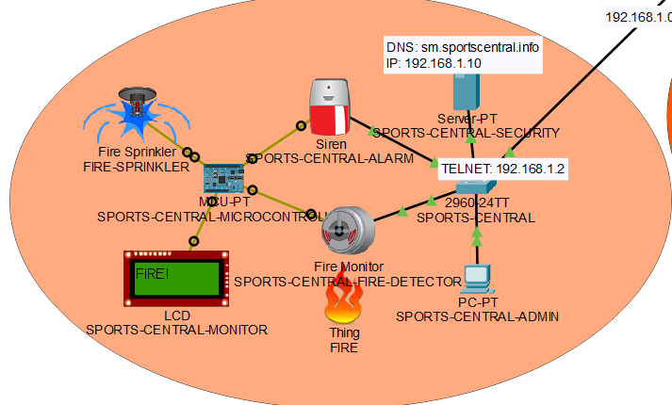

1. BURGLAR SENSOR:

Embedded within the security framework, the BURGLAR-SENSOR-ACTIVATOR, stationed strategically, plays a pivotal role in fortifying the system against potential security breaches. Upon activation of the BURGLAR-SENSOR, it triggers the simultaneous activation of the CCTV and ALARM systems, heightening security measures. The TIMEZONE-MONITOR continuously assesses the system for burglar detection. In the absence of any detected intrusion, the system maintains a vigilant "DETECTING MODE." However, upon detecting a potential threat, the system promptly switches to an alerting "BURGLAR!" status, signaling the need for immediate security intervention and response.

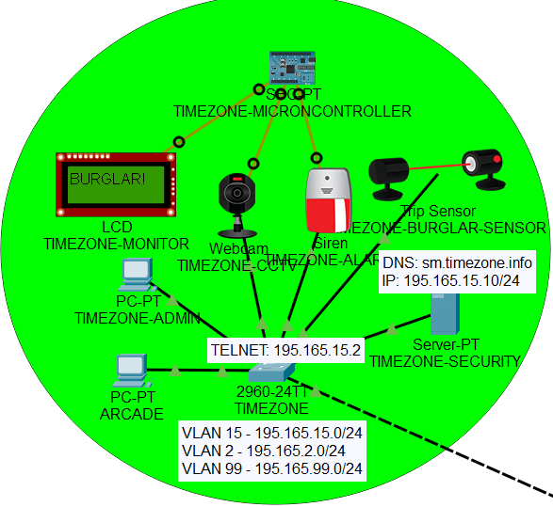

1. CAR DETECTOR:

Strategically positioned within the PARKING-LOT, the SMOKE-DETECTION-CCTV-ACTIVATOR serves as a crucial element in enhancing security measures. Activating the CCTV system upon detecting smoke emanating from a vehicle, it ensures immediate visual surveillance. The PARKING-MONITOR continuously assesses for car presence within the lot. In the event of a detected car, the system promptly signals a proactive "CAR DETECTED" status. Conversely, during periods of no incoming vehicles, the system maintains a vigilant "MONITORING MODE," indicating readiness to respond to potential parking activities.

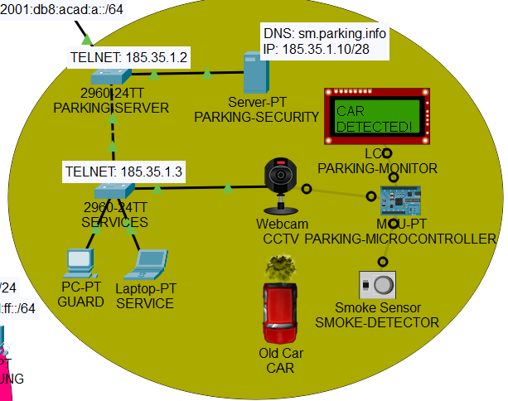

**PORT ASSIGNMENTS​:**

**PORT ASSIGNMENTS – FOOD-COURT:**

|  |  |  |
| --- | --- | --- |
| PORTS | ASSIGNMENT | NETWORK |
| F0/1-5 | VLAN 99 TRUNK | 192.168.99.0/24 |
| F0/6-10 | VLAN 10 | 192.168.10.0/24 |
| F0/11-15 | VLAN 20 | 192.168.20.0/24 |
| F0/16-20 | VLAN 30 | 192.168.30.0/24 |

**PORT ASSIGNMENTS – CYBER-ZONE:**

|  |  |  |
| --- | --- | --- |
| PORTS | ASSIGNMENT | NETWORK |
| F0/1-5 | VLAN 99 TRUNK | 192.168.99.0/24 |
| F0/6-10 | VLAN 40 | 192.168.40.0/24 |
| F0/11-15 | VLAN 50 | 192.168.50.0/24 |
| F0/16-20 | VLAN 60 | 192.168.60.0/24 |

**PORT ASSIGNMENTS – TIMZONE:**

|  |  |  |
| --- | --- | --- |
| PORTS | ASSIGNMENT | NETWORK |
| F0/1 | VLAN 99 TRUNK | 195.165.99.0/24 |
| F0/2-20 | VLAN 15 | 195.165.15.0/24 |

**PORT ASSIGNMENTS – GQ-BARBER-SHOP:**

|  |  |  |
| --- | --- | --- |
| PORTS | ASSIGNMENT | NETWORK |
| F0/1 | VLAN 99 TRUNK | 195.165.99.0/24 |
| F0/2 | VLAN 2 | 195.165.2.0/24 |

**PORT ASSIGNEMNT – 3RD-FLOOR-SERVER:**

|  |  |  |
| --- | --- | --- |
| PORTS | ASSIGNMENT | NETWORK |
| F0/1-3 | VLAN 99 TRUNK | 195.165.99.0/24 |

**ADDRESSING TABLE:**

|  |  |  |  |  |  |  |  |
| --- | --- | --- | --- | --- | --- | --- | --- |
| DEVICE | INTERFACE | IPv4 ADDRESS | | SUBNET MASK | IPv6 ADDRESS | DEFAULT GATEWAY | |
| CENTRAL | S0/0/0 | 190.12.43.14 | | 255.255.255.0 | N/A | N/A | |
| S0/0/1 | 190.12.52.12 | | 255.255.255.0 | N/A | N/A | |
| S0/1/0 | 190.12.51.14 | | 255.255.255.0 | N/A | N/A | |
| S0/1/1 | 190.12.42.14 | | 255.255.255.0 | N/A | N/A | |
| 1ST-FLOOR | S0/0/0 | 190.12.42.12 | | 255.255.255.0 | N/A | N/A | |
| S0/0/1 | 190.12.41.12 | | 255.255.255.0 | N/A | N/A | |
| S0/1/0 | 190.12.50.12 | | 255.255.255.0 | N/A | N/A | |
| G0/0.10 | 165.123.10.1 | | 255.255.255.0 | N/A | N/A | |
| G0/0.20 | 165.123.20.1 | | 255.255.255.0 | N/A | N/A | |
| G0/0.30 | 165.123.30.1 | | 255.255.255.0 | N/A | N/A | |
| G0/0.99 | 165.123.99.1 | | 255.255.255.0 | N/A | N/A | |
| 2ND-FLOOR | G0/0 | 192.168.1.1 | | 255.255.255.0 | N/A | N/A | |
| G0/1 | 192.168.2.1 | | 255.255.255.0 | N/A | N/A | |
| S0/0/0 | 190.12.51.12 | | 255.255.255.0 | N/A | N/A | |
| S0/0/1 | 190.12.50.14 | | 255.255.255.0 | N/A | N/A | |
| S0/1/0 | 190.12.49.14 | | 255.255.255.0 | N/A | N/A | |
| 3RD-FLOOR | G0/0.2 | 195.165.2.1 | | 255.255.255.0 | N/A | N/A | |
| G0/0.15 | 195.165.15.1 | | 255.255.255.0 | N/A | N/A | |
| G0/0.99 | 195.165.99.1 | | 255.255.255.0 | N/A | N/A | |
| G0/1 | 175.23.20.1 | | 255.255.255.0 | N/A | N/A | |
| S0/0/0 | 190.12.43.12 | | 255.255.255.0 | N/A | N/A | |
| S0/0/1 | 190.12.44.12 | | 255.255.255.0 | N/A | N/A | |
| S0/1/0 | 190.12.41.14 | | 255.255.255.0 | N/A | N/A | |
| S0/1/1 | 192.12.53.12 | | 255.255.255.0 | N/A | N/A | |
| LOWER-GROUND-FLOOR | S0/0/0 | 190.12.52.14 | | 255.255.255.0 | N/A | N/A | |
| S0/0/1 | 190.12.47.14 | | 255.255.255.0 | N/A | N/A | |
| S0/1/0 | 190.12.48.12 | | 255.255.255.0 | 2001:DB8:ACAD:2::2/64 | N/A | |
| S0/1/1 | 190.12.49.12 | | 255.255.255.0 | N/A | N/A | |
| G0/0.10 | 192.168.10.1 | | 255.255.255.0 | 2001:DB8:ACAD:D::1/64 | N/A | |
| G0/0.20 | 192.168.20.1 | | 255.255.255.0 | 2001:DB8:ACAD:E::1/64 | N/A | |
| G0/0.30 | 192.168.30.1 | | 255.255.255.0 | 2001:DB8:ACAD:F::1/64 | N/A | |
| G0/0.40 | 192.168.40.1 | | 255.255.255.0 | 2001:DB8:ACAD:DD::1/64 | N/A | |
| G0/0.50 | 192.168.50.1 | | 255.255.255.0 | 2001:DB8:ACAD:EE::1/64 | N/A | |
| G0/0.60 | 192.168.60.1 | | 255.255.255.0 | 2001:DB8:ACAD:FF::1/64 | N/A | |
| G0/0.99 | 192.168.99.1 | | 255.255.255.0 | 2001:DB8:ACAD:FFFF::1/64 | N/A | |
| ROOF-TOP | G0/0 | 2.2.2.1 | | 255.255.255.0 | N/A | N/A | |
| S0/0/0 | 190.12.44.14 | | 255.255.255.0 | N/A | N/A | |
| S0/0/1 | 190.12.45.12 | | 255.255.255.0 | N/A | N/A | |
| MAINTENANCE | G0/0 | 10.10.10.1 | | 255.255.255.240 | 2001:DB8:ACAD:B::1/64 | N/A | |
| G0/1 | 172.38.20.1 | | 255.255.255.0 | 2001:DB8:ACAD:C::1/64 | N/A | |
| S0/0/0 | 190.12.48.14 | | 255.255.255.0 | 2001:DB8:ACAD:2::1/64 | N/A | |
| S0/0/1 | 190.12.45.14 | | 255.255.255.0 | N/A | N/A | |
| S0/1/0 | 190.12.46.12 | | 255.255.255.0 | 2001:DB8:ACAD:1::1/64 | N/A | |
| S0/1/1 | 192.12.53.14 | | 255.255.255.0 | N/A | N/A | |
| PARKING-LOT | G0/0 | 185.35.1.1 | | 255.255.255.240 | 2001:DB8:ACAD:A::1/64 | N/A | |
| S0/0/1 | 190.12.46.14 | | 255.255.255.0 | 2001:DB8:ACAD:1::2/64 | N/A | |
| DEVICE | INTERFACE | IP ADDRESS | | SUBNET MASK | IPv6 ADDRESS | DEFAULT GATEWAY | |
| MCDONALDS | VLAN 10 | 165.123.10.2 | | 255.255.255.0 | N/A | 165.123.10.1 | |
| KFC | VLAN 20 | 165.123.20.2 | | 255.255.255.0 | N/A | 165.123.20.1 | |
| JOLLIBEE | VLAN 30 | 165.123.30.2 | | 255.255.255.0 | N/A | 165.123.30.1 | |
| SPORTS-CENTRAL | VLAN 1 | 192.168.1.2 | | 255.255.255.0 | N/A | 192.168.1.1 | |
| PENSHOPPE | VLAN 1 | 192.168.2.2 | | 255.255.255.0 | N/A | 192.168.2.1 | |
| DEPARTMENT-STORE | VLAN 1 | 175.23.20.2 | | 255.255.255.0 | N/A | 175.23.20.1 | |
| 3RD-FLOOR-SERVER | VLAN 99 | 195.165.99.2 | | 255.255.255.0 | N/A | 195.165.99.1 | |
| GQ-BARBER-SHOP | VLAN 2 | 195.165.2.2 | | 255.255.255.0 | N/A | 195.165.2.1 | |
| TIMEZONE | VLAN 15 | 195.165.15.2 | | 255.255.255.0 | N/A | 195.165.15.1 | |
| SOLAR-PANELS-ROOM | VLAN 1 | 2.2.2.2 | | 255.255.255.0 | N/A | 2.2.2.1 | |
| NETWORK-ROOM | VLAN 1 | 10.10.10.2 | | 255.255.255.240 | N/A | 10.10.10.1 | |
| ADMIN | VLAN 1 | 10.10.10.3 | | 255.255.255.240 | N/A | 10.10.10.1 | |
| SAFETY-ROOM | VLAN 1 | 172.38.20.2 | | 255.255.255.0 | N/A | 172.38.20.1 | |
| FOOD-COURT | VLAN 99 | 192.168.99.2 | | 255.255.255.0 | N/A | 192.168.99.1 | |
| CYBER-ZONE | VLAN 40 | 192.168.40.2 | | 255.255.255.0 | N/A | 192.168.99.1 | |
| PARKING-SERVER | VLAN 1 | 185.35.1.2 | | 255.255.255.240 | N/A | 185.35.1.1 | |
| SERVICES | VLAN 1 | 185.35.1.3 | | 255.255.255.240 | N/A | 185.35.1.1 | |
| DEVICE | INTERFACE | IP ADDRESS | | SUBNET MASK | IPv6 ADDRESS | DEFAULT GATEWAY | |
| DNS-SERVER | NIC | 10.10.10.10 | | 255.255.255.240 | N/A | 10.10.10.1 | |
| CONTROL-SERVER | NIC | 2.2.2.2.5 | | 255.255.255.0 | N/A | 2.2.2.2.1 | |
| SPORTS-CENTRAL-SECURITY | NIC | 192.168.1.10 | | 255.255.255.0 | N/A | 192.168.1.1 | |
| PARKING-SECURITY | NIC | 185.35.1.10 | | 255.255.255.240 | N/A | 185.35.1.1 | |
| TIMEZONE-SECURITY | NIC | 195.165.15.10 | | 255.255.255.0 | N/A | 195.165.15.1 | |
| www.sm-megamall.com | NIC | 10.10.10.9 | | 255.255.255.240 | N/A | 10.10.10.1 | |
| DEVICE | | | IPv6 ADDRESS | | LINK LOCAL | |
| SIZZLING-PLATE | | | 2001:DB8:ACAD:D::2/64 | | FE80::D | |
| DON-DON-TEI | | | 2001:DB8:ACAD:E::2/64 | | FE80:E | |
| SEOUL | | | 2001:DB8:ACAD:F::2/64 | | FE80:F | |
| CDR-KING | | | 2001:DB8:ACAD:DD::2/64 | | FE80::DD | |
| APPLE | | | 2001:DB8:ACAD:EE::2/64 | | FE80:EE | |
| SAMSUNG | | | 2001:DB8:ACAD:FF::2/64 | | FE80:FF | |
| SAFETY-ADMIN | | | 2001:DB8:ACAD:C::2/64 | | FE80::3 | |
| NETWORK-ADMIN | | | 2001:DB8:ACAD:B::2/64 | | FE80::2 | |
| GUARD | | | 2001:DB8:ACAD:A::2/64 | | FE80::1 | |
| SERVICE | | | 2001:DB8:ACAD:A::3/64 | | FE80::1 | |

**INTERNET OF THINGS:**

FIRE DETECTOR:

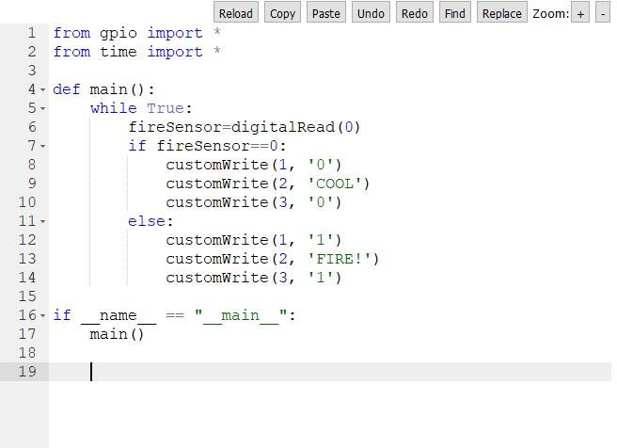

BURGLAR SENSOR:

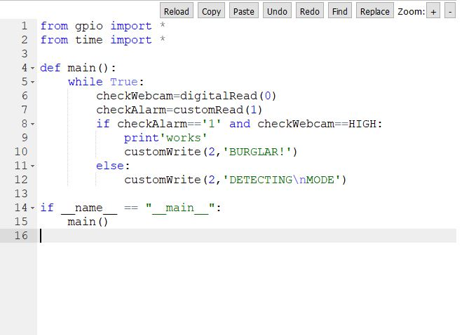

CAR DETECTOR:

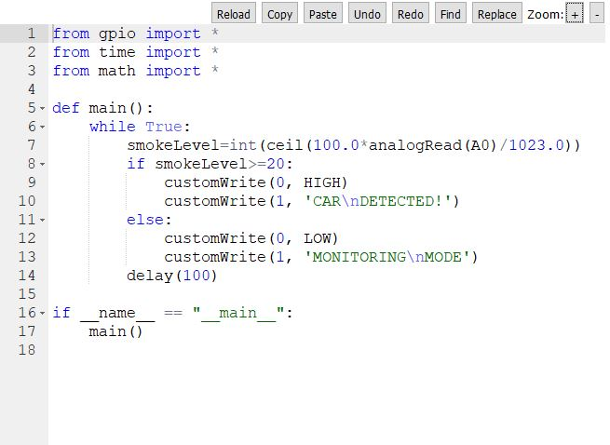

EMERGENCY POWER SYSTEM:

