Praemonitus - machine failure prediction from process parameters
Course project, Artificial Intelligence Systems
Gusiu
November 2026

1. Problem
The project predicts, from the parameters of one machining run, whether the run will end with a machine failure. The user is the maintenance department, which decides whether to stop the process and inspect the machine before the run.
- Task: binary classification, target Machine failure (0/1).
- Observation: one process run - product variant, air and process temperature, rotational speed, torque and tool wear - with its label.
- Output: failure probability, a decision at a cost-based threshold, and physically meaningful derived values (temperature difference, power, tool strain).
The course card and the final project specification require classification, while the list of topics in the exercises also allows regression; a classification task satisfies both sources.

2. Data
Source. AI4I 2020 Predictive Maintenance Dataset, UCI Machine Learning Repository, DOI 10.24432/C5HS5C, licence CC BY 4.0; source paper: S. Matzka, Explainable Artificial Intelligence for Predictive Maintenance Applications, AI4I 2020. The file data/raw/ai4i2020.csv (10 000 rows, 14 columns) is kept unchanged; data/SOURCE.md records the attribution, the download date and the SHA-256 checksum, which the code verifies before every load. The data are synthetic and contain no personal data.
Columns. UDI and Product ID are identifiers; Type (L/M/H) and five measured parameters are features; Machine failure is the label; the flags TWF, HDF, PWF, OSF and RNF describe the failure mode and define the label, so they are excluded from the features (they would be leakage) and used only in the error analysis. Column names are converted to snake_case in one place (ml/data.py).
How the label was generated (UCI description): tool wear failure (TWF) at a random moment at 200-240 min of wear; heat dissipation failure (HDF) when the process-air temperature difference is below 8.6 K and speed below 1380 rpm; power failure (PWF) when power is below 3500 W or above 9000 W; overstrain failure (OSF) when tool wear times torque exceeds 11 000 / 12 000 / 13 000 minNm for L / M / H; random failure (RNF) with probability 0.1%.

3. Data quality and analysis
Quality. No missing values, no duplicate rows (also after removing the identifiers), UDI and Product ID unique, the first letter of Product ID always equals Type. There are 339 failures (3.39%); a model that always says “no failure” has 96.61% accuracy. Failure rate by variant: L 3.92% (6000 runs), M 2.77% (2997), H 2.09% (1003). Values outside 1.5 IQR appear only for speed (418) and torque (69); they are physically plausible and are exactly where power failures happen, so nothing is removed.
Label consistency. The HDF, PWF and OSF rules recomputed from the inputs reproduce the flags in all 10 000 rows and explain 287 of 339 failures (84.7%). The remaining 52 are 43 with a TWF flag and 9 without any flag. The file differs from the UCI description:
Element | UCI description | File
TWF | 120 cases, 51 failures; window 200-240 min | 46 flags; wear at flag 198-253 min
RNF | 5 cases | 19 flags, only 1 with a failure
Label | failure = at least one mode | 9 failures without a flag; 18 RNF flags without failure
Decision: Machine failure stays the label unchanged, because it is the target; the discrepancies are a limitation of the data (section 10) and the unflagged failures are tracked in the error analysis.
Exploratory analysis (training set only, after the split):
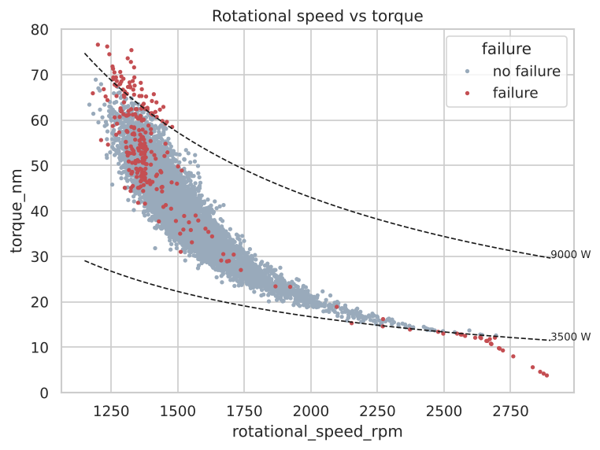
Rotational speed against torque; dashed lines are the 3500 W and 9000 W power limits
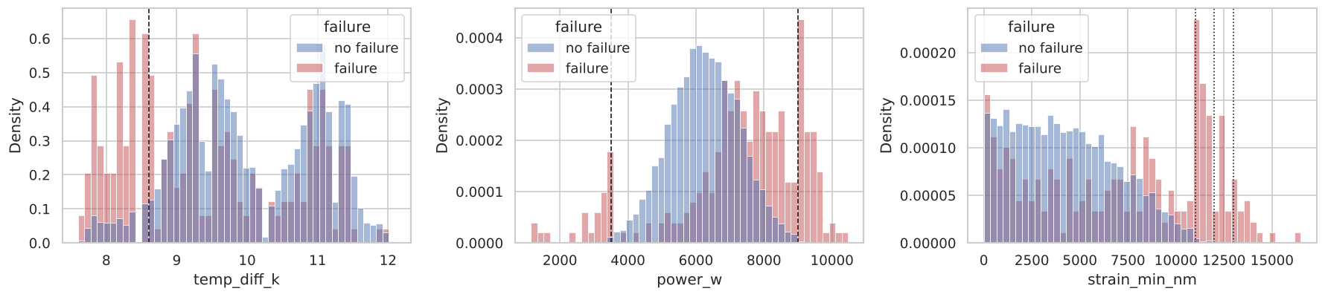
Derived features by class with the rule limits
Observations: (1) failures are concentrated at the extremes - high torque at low speed, very low torque at high speed, high tool wear; (2) the derived features separate the classes far better than the raw columns - failures pile up below 8.6 K, outside the 3500-9000 W band and above the strain limits; (3) air and process temperature are strongly correlated (0.88), and torque and speed strongly negatively correlated (-0.87), so raw columns are partly redundant and their combinations carry the signal.
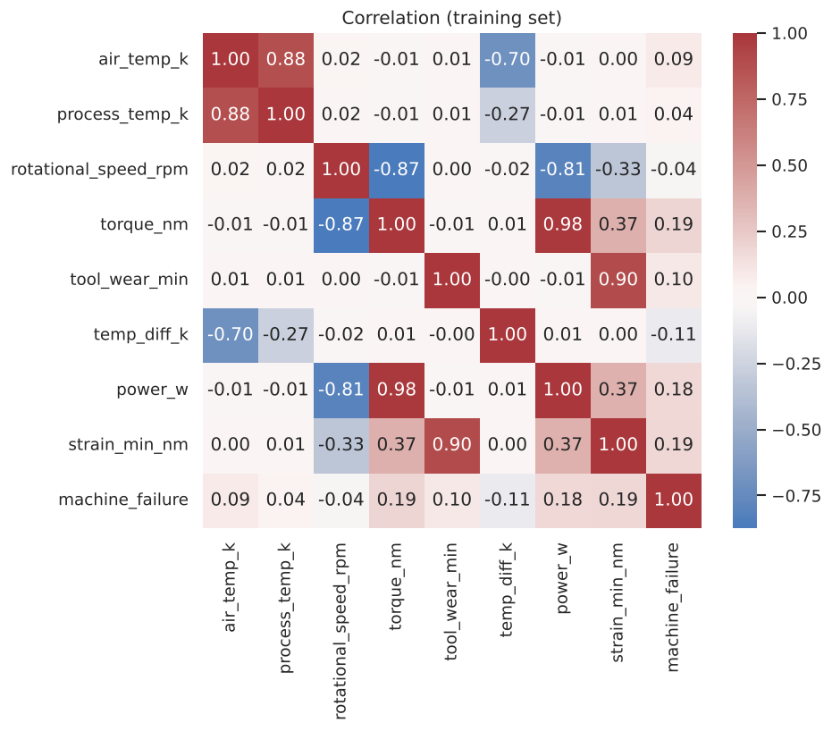
Correlation matrix of the training set

4. Data preparation
- The stratified 80/20 split (random_state=42) is the first operation after the quality checks: 8000 training runs (271 failures) and 2000 test runs (68 failures).
- All transformations are steps of a scikit-learn Pipeline: selecting the six inputs, computing derived features with a FunctionTransformer, one-hot encoding Type, and scaling numeric columns (logistic regression only). In cross-validation they are therefore fitted on the training part of each fold only.
- Two feature sets: raw (type and five parameters) and physics (raw plus temp_diff_k = process - air temperature, power_w = torque * rpm * 2*pi/60, strain_min_nm = tool wear * torque). The derived features use only values known before the run - domain knowledge, not leakage. Because they live in the Pipeline, the application passes raw values and the same code computes them.

5. Models
All models were evaluated on both feature sets with the same StratifiedKFold(5, shuffle=True, random_state=42) folds; small grids were tuned by GridSearchCV with PR-AUC (average precision) as the score.
Model | Configuration | Grid
Dummy | most frequent class | -
Logistic regression | scaler + one-hot, balanced classes, max_iter 2000 | C in {0.1, 1, 10}
Decision tree | balanced classes | max_depth in {3, 4, 5, 6, 8}
Random forest | 300 trees, balanced_subsample | -
Hist gradient boosting | default | learning_rate in {0.05, 0.1}, max_depth in {3, None}
Cross-validated results (mean +/- standard deviation over 5 folds; recall, precision and accuracy at the default 0.5 threshold):
Model | Features | PR-AUC | ROC-AUC | Recall | Precision | Accuracy
Hist gradient boosting | physics | 0.898 +/- 0.024 | 0.983 | 0.804 | 0.928 | 0.991
Random forest | physics | 0.892 +/- 0.025 | 0.975 | 0.749 | 0.981 | 0.991
Hist gradient boosting | raw | 0.812 +/- 0.040 | 0.973 | 0.672 | 0.840 | 0.984
Decision tree (depth 5) | physics | 0.792 +/- 0.038 | 0.940 | 0.923 | 0.410 | 0.952
Random forest | raw | 0.760 +/- 0.033 | 0.969 | 0.391 | 0.936 | 0.978
Decision tree (depth 8) | raw | 0.572 +/- 0.065 | 0.849 | 0.712 | 0.361 | 0.947
Logistic regression | physics | 0.486 +/- 0.026 | 0.916 | 0.838 | 0.159 | 0.844
Logistic regression | raw | 0.446 +/- 0.025 | 0.897 | 0.804 | 0.137 | 0.822
Dummy | either | 0.034 +/- 0.000 | 0.500 | 0.000 | 0.000 | 0.966
The physics features improve every model. ROC-AUC is high for almost every model and hides differences that PR-AUC shows; accuracy ranks the useless baseline above logistic regression.

6. Threshold and model choice
Threshold. A missed failure is assumed to cost ten times a false alarm. TunedThresholdClassifierCV chooses the threshold that minimises 10*FN + FP (per 1000 runs) on training folds. To estimate the quality of the whole procedure, it was wrapped in an outer cross-validation (each outer fold tunes its own threshold on inner folds):
Model | Features | Recall | False alarms / 1000 | Cost / 1000 | Threshold (std) | Latency
Random forest | physics | 0.849 | 5.6 | 56.9 +/- 11.6 | 0.248 (0.055) | 60 ms
Hist gradient boosting | physics | 0.856 | 10.2 | 59.0 +/- 11.9 | 0.147 (0.044) | 7 ms
Decision tree | physics | 0.804 | 14.2 | 80.5 +/- 17.2 | 0.726 (0.285) | 5 ms
Hist gradient boosting | raw | 0.860 | 34.8 | 82.2 +/- 15.5 | 0.062 (0.029) | 5 ms
Random forest | raw | 0.819 | 24.9 | 86.1 +/- 9.5 | 0.154 (0.019) | 65 ms
Logistic regression | physics | 0.639 | 56.0 | 178.5 +/- 22.3 | 0.722 (0.049) | 4 ms
Choice: random forest on physics features, not by one number:
- its PR-AUC equals that of gradient boosting within a quarter of one standard deviation, so the main metric does not separate the two leaders;
- at the cost-based threshold it has the lowest cost, the same recall and half the false alarms (5.6 vs 10.2 per 1000 runs) - fewer alarms matter for a maintenance team that must react to each one;
- its results are more stable between folds (std of false alarms 3.0 vs 6.2);
- the decision tree is interpretable but 40% more expensive and its threshold is unstable, so it is kept as an explanation model (section 7);
- the cost is speed (60 ms instead of 7 ms per prediction), irrelevant for interactive use.
The final model is the random forest pipeline wrapped in TunedThresholdClassifierCV, fitted on the whole training set; the threshold is 0.292.
Sensitivity to the cost ratio (threshold chosen on training folds; test columns computed after the choice was frozen):
FN:FP | Threshold | CV cost / 1000 | Test recall | Test false alarms | Test cost / 1000
5:1 | 0.316 | 29.1 | 0.824 | 5 | 32.5
10:1 | 0.292 | 55.6 | 0.824 | 5 | 62.5
20:1 | 0.054 | 106.3 | 0.912 | 96 | 108.0
Between 5:1 and 10:1 the decision barely changes; at 20:1 the model buys six more detected failures with 91 more false alarms. The ratio is a business decision to agree with maintenance.
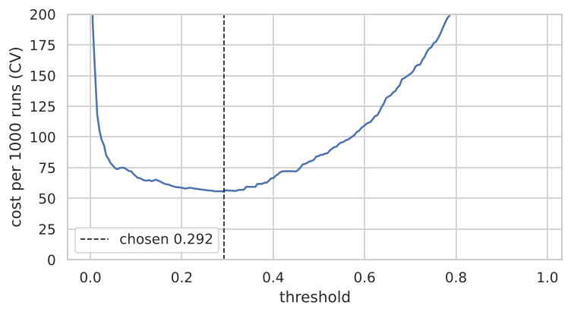
Cross-validated cost against the threshold

7. Evaluation on the test set
The test set was used once, after the choice and threshold were frozen:
Metric | Random forest (threshold 0.292) | Always “no failure”
PR-AUC | 0.871 | 0.034
ROC-AUC | 0.970 | 0.500
Recall | 0.824 (56 of 68) | 0.000
Precision | 0.918 | -
F1 | 0.868 | 0.000
False alarms / 1000 runs | 2.5 (5) | 0.0
Cost / 1000 runs | 62.5 | 340.0
Accuracy | 0.992 | 0.966
The test PR-AUC is within one standard deviation of the CV estimate (0.892 +/- 0.025), and so is the cost (56.9 +/- 11.6).
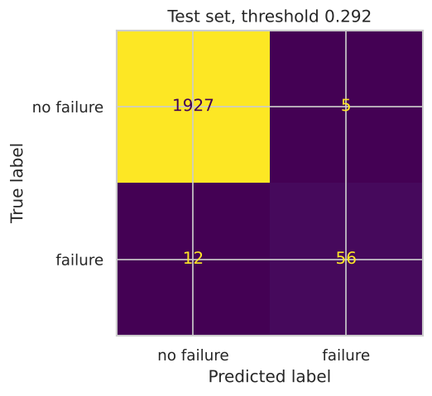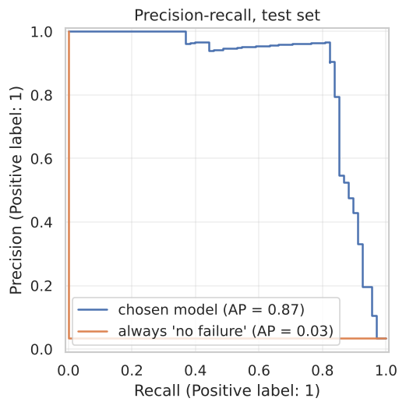
Error analysis (failure-mode flags used only here):
Cause | Failures | Detected | Missed | Recall
HDF | 29 | 28 | 1 | 0.966
PWF | 12 | 12 | 0 | 1.000
OSF | 16 | 16 | 0 | 1.000
TWF | 9 | 0 | 9 | 0.000
no flag | 2 | 0 | 2 | 0.000
all | 68 | 56 | 12 | 0.824
Failures produced by deterministic rules are found in 56 of 57 cases; the one miss is an HDF case at the very edge of the rule (temperature difference 8.6 K, probability 0.20). Tool wear failures happen at a random moment in the wear window, so the inputs only say that the tool is old; the two unflagged failures are explained by nothing in the data. The share of test failures explained by the rules (83.8%) is the realistic ceiling for recall from these inputs, and the model reaches 82.4% - the rest of the error is irreducible with these data. All 5 false alarms are near misses at rule boundaries (temperature difference 8.6 K at low speed, strain 10 941 minNm just under the 11 000 limit, power 8958 W close to 9000 W).
Explainability. Permutation importance on the test set (drop in PR-AUC): torque 0.65, rotational speed 0.53, air temperature 0.46, tool wear 0.32, process temperature 0.22, type 0.03.
The depth-5 decision tree, which never saw the rules or the flags, split at 1380 rpm and 8.55 K (HDF: 1380 rpm, 8.6 K), at 3496 W and 8995 W (PWF: 3500 and 9000 W) and at 11 014 minNm (OSF limit for type L, the most common variant). The model rediscovered the mechanism that generated the data; the higher OSF limits for types M and H were not found at this depth.
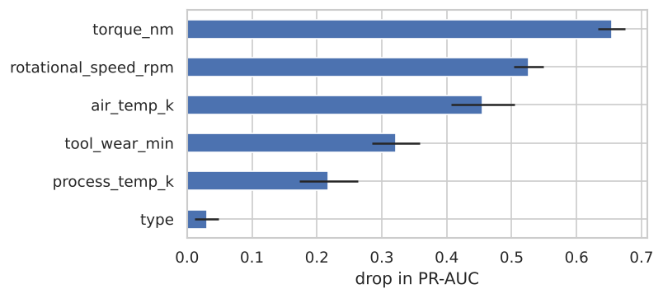
Permutation importance, test set

8. Application
- Core ml/predictor.py, shared by both interfaces. It compares the SHA-256 of models/model.joblib with models/model_card.json before loading, because joblib files are pickles and can execute code. It validates the input, predicts, computes derived values and logs the call.
- Validation ml/validation.py (Pydantic). Hard: type in {L, M, H}, finite numbers, temperatures and speed > 0, torque and wear >= 0 - otherwise the input is rejected with a readable message. Soft: a value outside the training range stored in the model card is predicted with an “out of range” warning.
- Streamlit app.py: form with training ranges as hints, probability and decision, derived values, out-of-range warning, history with a filter, CSV export, model information. The model is cached with st.cache_resource.
- Console cli.py: interactive prompts repeated on invalid values, --history N, --export file.csv, --batch file.csv.

9. Database and documentation
SQLite table predictions: id, time (UTC, ISO 8601), model id, source (streamlit, cli, batch), inputs as JSON, probability, threshold, decision, out-of-range flag, latency. Only parameterised queries are used (a test stores an SQL injection string as plain text), a connection is opened per operation, and no user data are stored - only what is needed to audit the predictions. The model id allows old predictions to be attributed to the model that made them after retraining.
The repository contains a README (installation, running, reproduction, tests), the executed notebook, this report, docs/defense.md with questions and answers on every decision, docs/demo.md with the demo script, and 55 automated tests (data checksum, leakage, feature formulas, validation, model save and reload, predictor, database, console and Streamlit app). python -m ml.train reproduces the model deterministically from the raw file.

10. Limitations and future work
Limitations:
- The data are synthetic: failures follow a few simple rules with sharp boundaries, much simpler than in a real plant. Excellent results here do not transfer to real machines without real data.
- Part of the label is random by definition (RNF and the timing of TWF) and 9 failures have no flag at all; this part of the error cannot be removed.
- The file differs from the UCI description (TWF and RNF counts, unflagged failures); the label was not corrected.
- The threshold depends on the assumed 10:1 cost ratio; the sensitivity analysis shows how the behaviour changes.
- Each run is treated independently; there is no history of sensor readings over time.
- The model predicts that a failure will happen, not which mode will cause it.
- Process note: during development the training script was once run end to end with gradient boosting as a placeholder choice and printed its test metrics (PR-AUC 0.903, recall 0.853) before the cross-validated comparison was complete. The final choice was made from cross-validation only and was not changed after the test evaluation, even though gradient boosting happened to score slightly better on the test set.
Future work: real data with sensor time series and features computed from them; classification of the failure type; storing the actual outcome of each run in the database to monitor model quality over time; agreeing the cost ratio with the maintenance team.

