**CPT202 2024/2025 Semester 2**

**Software Requirements Report for Software Engineering Group Project**

**Project C: An online meeting booking system**

Group number: 33

Student Name: Junhao Huang

Student ID: 2256792

Date: 2025.03.16

**Understanding of Scrum Framework**

Scrum is an Agile framework delivering products iteratively through fixed-length Sprints usually last 1 to 4 weeks. There are three main roles which are Product Owner, Scrum Master, and Developers.

PBIs (Product Backlog Items) are user-centric work items in the Product Backlog usually relevant to features, bugs, and tasks, dynamically prioritized by value. During sprint planning, the team selects PBIs for the Sprint Backlog, breaking them into task. PBIs ensure alignment with user/stakeholder needs. The Product Owner refines PBIs pre-sprint, and the team commits to delivering them as increments. PBIs foster transparency, adaptability, and incremental value.

(96 words)

**Pre-Groomed PBIs:**

**Feature 1: User Authentication**

**PBI 1: User Login**

* **User story**: As a user, I want to be able to login to the system with my own account, so that I can experience all the features related to meetings and bookings.
* **Acceptance criteria**:
  1. **Login Without Session**
     + **Given** that I am a user who has not logged into the system in the browser before,
     + **When** I want to directly access the dashboard of the system,
     + **Then** the login page with input fields of Email address and Password will display, and a pop-up message "You need to login first" will appear on the screen.
  2. **Login Successfully**
     + **Given** that I am an unlogged-in user who enters the correct username and password,
     + **When** I click the "Login" button,
     + **Then** the page should be navigated to the dashboard, with a pop-up successful login message "Success Login" appears on the screen.
  3. **Login with Unregistered Email Address**
     + **Given** that I am an unlogged-in user who enters an unregistered email address in the login page,
     + **When** I click the "Login" button,
     + **Then** a red error message "There is an error in your email address or password!" will appear above the input fields.
  4. **Login with Unmatched Password**
     + **Given** that I am an unlogged-in user who enters a password that does not match the email address,
     + **When** I click the "Login" button,
     + **Then** a red error message "There is an error in your email address or password!" will appear above the input fields.
  5. **Password Masking**
     + **Given** that I am a user who is typing my password in the Password field,
     + **When** the character is entered,
     + **Then** the characters in the Password field should be displayed as "*".
  6. **Empty Fields**
     + **Given** that I am an unlogged-in user and leave the email or password field empty,
     + **When** I click the "Login" button,
     + **Then** the empty field borders turn red with a message "Field required" appears below the empty field, and the border of corresponding field will turn red

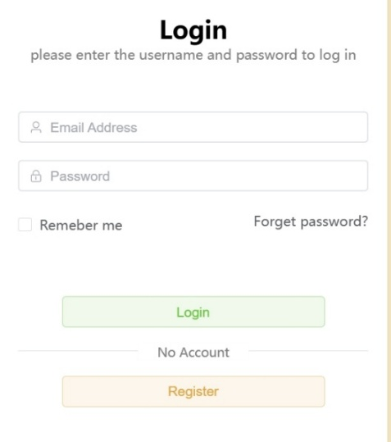

Fig 1. Login Page

**PBI 2: User Reset Password**

* **User story**: As a user who forgot my previous password and unable to login to the system, I want to reset it via email so I can regain access to my account.
* **Acceptance criteria**:
  1. **Request to Reset the Password**
     + **Given** that I am a user who forgot my password,
     + **When** I click the "Forgot Password?" link on the login page,
     + **Then** I will be redirected to the first phase of reset page with 2 input fields, which are Email Address and Check Code.
  2. **Unregistered Email Address**
     + **Given** that I am a user who enters an unregistered email address in the first phase of resetting,
     + **When** I click the "Send Check Code to Email" button,
     + **Then** a red error message "Unregistered email address" will appear below the Email filed and the border of this field will turn red.
  3. **Unmatched Check Code**
     + **Given** that I am a user who enters an unmatched check code in the first phase of resetting,
     + **When** I click the "Set New Password" button,
     + **Then** a red error message "Invalid Check Code" will appear below the Check Code field, and the border of this field will turn red.
  4. **Expired Check Code**
     + **Given** that I am a user who enters an expired check code in the first phase of resetting,
     + **When** I click the "Set New Password" button,
     + **Then** a red error message "Invalid Check Code" will appear below the Check Code field, and the border of this field will turn red.
  5. **Correct Check Code**
     + **Given** that I am a user who enters the correct email address and checks code in the first phase of resetting,
     + **When** I click the "Set New Password" button,
     + **Then** the second phase page will replace the first phase page with 2 input fields which are New Password, Confirm Password, and a "Confirm the Password" button.
  6. **New Password is Same as Old Password**
     + **Given** that I am a user who enters a duplicate new password in the second phase of resetting,
     + **When** I click the "Confirm the Password" button,
     + **Then** a red error message "Current password is same as old one, no need to change" will appear below the Password field.
  7. **Password with Less Than 8 Digits**
     + **Given** that I am a user who enters a new password less than 8 digits in the second phase of resetting,
     + **When** I finish typing the password,
     + **Then** a red error message will display below the Password fields with "The password must contain at least 8 digits", and the border of this field will turn red.
  8. **Confirm Password Is Not Same as New Password**
     + **Given** that I am a user who enters a different confirm password,
     + **When** I finish typing the confirm password,
     + **Then** a red error message will display below the Confirm Password fields with "Confirm password should same with new password", and the border of this field will turn red.
  9. **Password Reset Successfully** 
     + **Given** that I am a user who provides valid email address, new password, same confirm password and correct check code in the second phase of resetting,
     + **When** I click the "Confirm the Password" button,
     + **Then** I will be redirected to the login page, a pop-up successful reset message "Successful Reset" will appear on the screen.

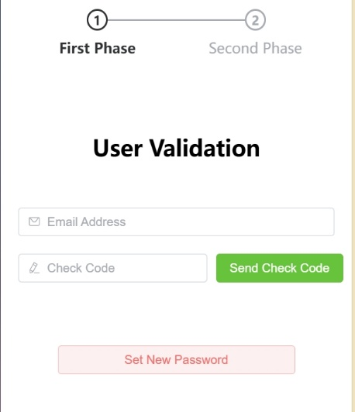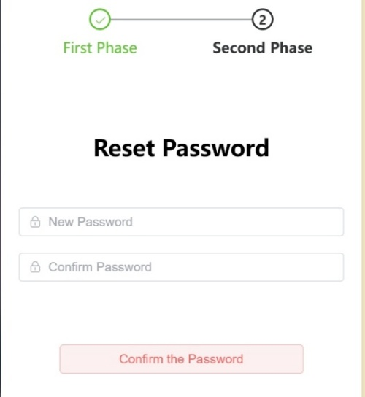

Fig 2. User Validation; Fig 3. Set new Password

**PBI 3: User Registration**

* **User story**: As a new student, I want to register with my university ID, email, and password so I can access meeting booking functions.
* **Acceptance criteria**:
  1. **Request to Sign Up**
     + **Given** that I am a new user who wants to register,
     + **When** I click the link "Sign up now" on the login page,
     + **Then** I will be redirected to the registry page with four input fields, which are University ID, Email Address, Password, and Check Code.
  2. **Registry with Duplicate University ID**
     + **Given** that I am an unregistered user who provides a duplicate university ID that has already been registered,
     + **When** I click the "Send Check Code" button,
     + **Then** a red error message "Account already be registered" will appear below the University ID field, and the border of this field will turn red.
  3. **Registry with Invalid Formatted Email Address**
     + **Give**n that I am an unregistered user who enters an invalid formatted email address,
     + **When** I click the "Send Check Code" button,
     + **Then** a red error message "Email address is invalid" will appear below the Email field, and the border of this field will turn red.
  4. **Registry with a Duplicate Email Address**
     + **Given** that I am an unregistered user who enters an email address that has already been registered,
     + **When** I click the "Send Check Code" button,
     + **Then** a red error message "Email already be registered" will appear below the Email field and the border of this field will turn red.
  5. **Registry with a Password Less Than 8 Digits**
     + **Given** that I am an unregistered user who enters a password less than 8 digits,
     + **When** I finish typing the password,
     + **Then** a red error message "The password must not contain at least 8 digits" will appear below the Password fields, and the border of this field will turn red.
  6. **Display the Security of Current Password**
     + **Given** that I am an unregistered user who enters a password,
     + **When** I finish typing the password,
     + **Then** an information box about the security level of password will be displayed on the right side of the input field, and it is judged based on whether the password is composited by irregular numbers and alphabets.
  7. **Successful Registration**
     + **Given** that I am an unregistered user who provides acceptable university ID, email address, password, and correct check code,
     + **When** I click the "Sign up" button,
     + **Then** I will be redirected to the login page, a pop-up window with successful message "Successful registration, the activation link has been sent to your email" will appear on the screen.

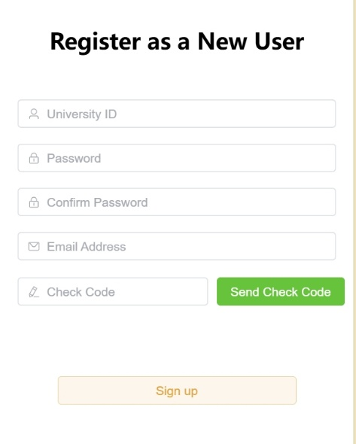

Fig 4. Register Page

**PBI 4: User Activates the Email**

* **User Story**: As a newly registered user, I want to activate my account via an email link to verify my identity.
* **Acceptance Criteria**:
  1. **Activate the Account by Valid Activation Link**
     + **Given** that I am a user, I just finished registration and clicked the activation link in my email,
     + **When** the link is valid and unexpired,
     + **Then** I will be redirected to a confirmation page with a message "Account activated. You may now log in".
  2. **Expired Activation Link**
     + **Given** that I am a user who clicks an expired activation link,
     + **When** the page loads,
     + **Then** I will be redirected to a page with a message "Activation link expired".
  3. **Already Activated Account**
     + **Given** that I am a user who clicks an activation link for an already-activated account,
     + **When** the page loads,
     + **Then** I will be redirected to a page with a message "Account already activated".
  4. **Network Error Handling**
     + **Given** the activation service is unavailable due to disconnection of internet,
     + **When** the activation link has been clicked,
     + **Then** the user is redirected to an error page with message “Activation failed due to a system error. Please try again later.”.
  5. **Rate Limiting Activation Attempts**
     + **Given** that I am a user who repeatedly submits invalid or expired activation links,
     + **When** the request exceeds 5 attempts within 10 minutes,
     + **Then** a pop-up error message window will appear on the screen with “Too many failed attempts. Try again later or contact support”.
  6. **Performance**
     + **Given** that user finished registration,
     + **When** the user is redirecting to login page,
     + **Then** the activation link should be sent to the provided email within half a minute.

**Feature 2: Searching Target Rooms**

**PBI 5: User Searches Specific Room**

* **User Story**: As a logged in student, I want to search for available rooms by name, capacity, or floors to book meetings efficiently.
* **Acceptance Criteria**:
  1. **Search by Room Name**
     + **Given** that I am a logged-in user who enters a room name (e.g., "Conference Room A"),
     + **When** I click the "Search" button,
     + **Then** all rooms matching the name or rooms with resemble names will be listed according to the degree of matching.
  2. **Filter by Valid Capacity**
     + **Given** that I am a logged-in user who selects a minimum capacity,
     + **When** I click the "Search" button,
     + **Then** rooms with capacity ≥ 10 will be listed.
  3. **Filter by Floor Features**
     + **Given** that I am a logged-in user who selects floors (e.g., 1(st) floor),
     + **When** I click the "Search" button,
     + **Then** only rooms with all selected features are shown.
  4. **Invalid Search Criteria**
     + **Given** that I am a logged-in user enter invalid criteria, such as negative capacity or floor number,
     + **When** I click the "Search" button,
     + **Then** an error "Invalid search criteria" appears, and fields turn red.
  5. **No Results Found**
     + **Given** that I am a logged-in user who provides a search criterion that no room matches,
     + **When** I click the "Search" button,
     + **Then** a message "No rooms found. Adjust your filters" will appear.
  6. **Leave the Search Field Empty**
     + **Given** that I am a logged-in user who leaves the search field empty,
     + **When** I click the "Search" button,
     + **Then** all the rooms will be listed in the search page.
  7. **Accessibility**
     + **Given** that I am a user who can only use a mouse to modify the search criteria,
     + **When** I choose the floor number or capacity,
     + **Then** I can click on the plus or minus sign with the mouse to control the increase or decrease of the number.

**Peer Review**

I think most of my group member's PBI can clearly reflect a solid understanding of Scrum principles, with clear user stories and logically organized acceptance criteria. In the peer review phase, I mainly focused on whether their PBIs met the user-centered design concept and whether they have showed explicit details in those PBIs with conditional judgement, validation and error handling.

First of all, I encouraged group mates to clarify metrics. When writing the PBI about “Username Validation Test”, the group mate just simply said to check the “validity” of username without clearly mention the exact rule, and in another PBI “New Password Complexity Test”, the “complexity” of password did not have a clear definition. Therefore, to ensure the testability and reduce the ambiguity of developers, I suggested to say that “username must be 3–20 characters” and “Irregular numeric and alphabetical sorting”.

Moreover, in the PBI regarding “Administrator Locks the User”, the group mate just directly wrote “A appropriate error message should display”. I thought it would be better to provide a precise error message content, such as “You do not have the permission to do it”. This will help the user understand what caused the error.

Eventually, breaking monolithic PBIs into smaller compositions. Initially, we combined the “Meeting Room Description Modification” and the “Meeting Room Picture Modification” into the “Room Information Modification”. After discussion, we decided to separate them, ensuring the vertical slices aligns better with Scrum's incremental delivery philosophy.

(241 words)

**Self-Review**

I learned the importance of details in PBIs, ensuring acceptance criteria are testable and unambiguous. Peer feedback highlighted my initial vagueness in the description of “check password validity”, prompting me to define explicit standards with “more than 8 characters”. Reviewing others’ PBIs revealed the value of vertical slicing, I split “Password Reset” into distinct PBIs for user verification and new password setup, this aligned with Scrum’s iterative delivery. Eventual incorporating feedback taught me to prioritize clarity over assumptions, use consistent terminology, and integrate performance metrics, such as “login within 2-seconds”. Overall, I grew in crafting user-centric PBIs that streamline development.

(100 words)