OMNI-TRACK: A Secure AI-Driven Suite for Multi-Camera Retail Analytics and Behavioral Integrity
  - Final Year Project Proposal
  - Session Spring 2026

BS in CS/SE/AI/CY



Department of CS/AI/SE/CY
Fast School of Computing
Fast National University, Karachi Campus
26 August 2025

Project Registration
Project ID (for office use)
Type of project |  |  | [ ] Traditional [ ] Industrial [ ] Continuing
Nature of project |  |  | [ ] Development [ ] Research & Development [ ] Research
Sustainable Development Goals(SDGs) |  |  | [ ] Good Health and Well-Being [ ] Quality Education  [ ] Industry, Innovation, and Infrastructure [ ] Gender Equality  [ ] Decent Work and Economic Growth [ ] Climate Action
Area of specialization |  |  | [ ] Artificial Intelligence (AI) [ ] Data Science and Analytics  [ ] Internet of Things (IoT) [ ] Blockchain  [ ] Mobile App Development [ ] Web Development [ ] Cybersecurity  [ ] Game Development [ ] Natural Language Processing (NLP)  [ ] Other
Project Group Members
Sr.# | Reg. # | Student Name |  | CGPA | Email ID | Phone # | Signature
(i) | 22K-4692 | Zeerak Shahzad |  | 2.4 | K224692@nu.edu.pk | 03132349359
(ii) | 22K-5147 | Asad Arif |  | 2.2 | K225147@nu.edu.pk | 03378097240
(iii) | 22K-4562 | Hassaan Akhtar |  | 2.12 | K224562@nu.edu.pk | 033318469721
Declaration: FYP group members have cleared all prerequisite courses for FYP-I as per their degree requirements.

Project Abstract
OmniTrack AI is a professional-grade retail analytics platform engineered to transform standard surveillance feeds into actionable business intelligence while maintaining a hardened security posture. In modern retail environments, CCTV cameras serve primarily as passive security tools with minimal contribution to operational insights. OmniTrack addresses this gap by deploying State-of-the-Art (SOTA) Computer Vision techniques, specifically the Ultralytics framework (YOLOv8/v11) for real-time person detection, PyTorch-based Torchreid for Global Re-Identification (Re-ID), and a suite of specialized analytics modules including video synopsis generation, shelf engagement and top-selling product detection, fire and smoke detection for safety compliance, crowd density estimation, checkout counter analytics, and customer emotion recognition.
Deep learning feature vectors (128-d or 512-d embeddings) are extracted from each detected person and stored in a pgvector-enhanced PostgreSQL database, enabling high-speed cosine similarity searches with sub-100ms retrieval latency for cross-camera identity matching. Beyond customer tracking, the platform provides a comprehensive operational intelligence layer: a Video Synopsis module condenses hours of surveillance footage into compact summaries; shelf-facing cameras analyze product interaction zones; a fire and smoke detection module ensures real-time safety monitoring; crowd density estimation classifies zones as crowded or uncrowded; checkout counter analytics track queue lengths and throughput; and a facial emotion recognition module gauges customer sentiment. The project follows a phased development across two semesters: FYP-I focuses on building and validating core AI modules and extended analytics; FYP-II delivers the fully integrated production-ready system. To satisfy BS Cybersecurity curriculum demands, the project implements a Decoupled Security Pipeline with SHA-256 hashing for tamper-evident audit trails, AES-256 encryption, and adversarial robustness evaluation using the Adversarial Robustness Toolbox (ART). The backend is powered by FastAPI and the frontend delivers real-time dashboards for all analytics modules.

1 Introduction
The retail industry is undergoing a digital transformation where physical operations increasingly rely on data-driven decision-making. Despite the widespread deployment of CCTV infrastructure in retail stores, the vast majority of video feeds remain underutilized serving only as passive recording devices for post-incident review. This represents a significant missed opportunity for extracting real-time operational intelligence such as customer flow patterns, dwell-time analytics, zone-level engagement metrics, safety monitoring, and customer sentiment analysis.
OmniTrack AI aims to bridge the gap between physical retail operations and digital data analytics by developing a multi-camera intelligence suite capable of identifying and tracking individuals throughout a store environment. Beyond person tracking, the system provides a holistic operational view by generating compact video synopses for rapid footage review, analyzing shelf engagement, detecting safety hazards, monitoring crowd density, tracking checkout efficiency, and recognizing customer emotions.
Main Sub-tasks
- Detection & Tracking: Ultralytics (YOLOv8/v11) combined with ByteTrack for real-time person detection and multi-object tracking across multiple camera feeds.
- Global Re-Identification (Re-ID): Torchreid (PyTorch) to extract 128-d or 512-d feature embeddings for cross-camera identity matching without facial recognition.
- Video Synopsis: Condensing hours of surveillance footage into compact video summaries by extracting and temporally compositing segments containing moving objects.
- Vector Search & Storage: PostgreSQL with pgvector extension for embeddings and cosine similarity search (IVFFlat/HNSW) for sub-100ms retrieval latency.
- Shelf Engagement & Top-Selling Detection: Zone-based dwell-time analysis to identify high-engagement and top-selling product zones.
- Fire & Smoke Detection: Custom-trained YOLO model for real-time safety monitoring with instant alerts.
- Crowd Density Analysis: Zone-level person count and area-based thresholds to classify regions as crowded or uncrowded.
- Checkout Counter Analytics: Queue lengths, average service time per customer, and order throughput metrics.
- Emotion Recognition: DeepFace/FER for customer sentiment (happy, neutral, frustrated, etc.) across store zones.
- Secure Backend: FastAPI-based asynchronous backend with JWT authentication, SHA-256 hashing, and AES-256 encryption.
- Visualization Dashboard: React.js frontend with Recharts and Tailwind CSS for real-time dashboards and security audit logs.

2 Success Criterion
Metric | Target | Method of Evaluation
Search Latency | < 100ms retrieval | pgvector cosine similarity queries on IVFFlat/HNSW
Detection Accuracy | > 85% mAP | YOLOv8/v11 on COCO, custom retail dataset
Re-ID Accuracy | > 70% Rank-1 | Market-1501, Torchreid embeddings
Video Synopsis | ≥ 10x compression | Hours condensed to summaries preserving moving-object events
Fire/Smoke Detection | > 90% precision, < 5% FPR | Custom YOLO on fire/smoke benchmarks
Crowd Classification | > 85% accuracy | Zone-level crowded/uncrowded vs ground truth
Checkout Metrics | Queue length ±1 person | Manual counting on sample checkout footage
Emotion Recognition | > 70% accuracy | FER-2013, DeepFace/FER
Integrity Verification | 100% tamper detection | SHA-256 chain verification
Throughput | 20+ FPS | Multi-camera via FastAPI async
Adversarial Robustness | Documented resilience | FGSM, PGD, adversarial patch via ART

3 Related Work
Person Detection & Tracking: Redmon et al. introduced YOLO for real-time object detection [1]. Ultralytics YOLOv8 refines this with anchor-free heads [2]. Zhang et al. proposed ByteTrack for multi-object tracking [3].
Person Re-Identification: Zhou et al. developed Torchreid for deep Re-ID [4]. Luo et al. proposed 'Bag of Tricks' for Re-ID [5]. Market-1501 by Zheng et al. is the standard benchmark [6].
Video Synopsis: Prabhakaran et al. and Rav-Acha et al. formalized video synopsis for condensing surveillance video [20], [21].
Vector Databases: Johnson et al. introduced FAISS [7]. pgvector enables native vector operations in PostgreSQL [8].
Adversarial ML: Goodfellow et al. introduced FGSM [9]. Madry et al. proposed PGD [10]. ART by Nicolae et al. evaluates robustness [11].
Fire & Smoke: Muhammad et al. and Saeed et al. demonstrated CNN/YOLO-based fire detection [12], [13].
Crowd Density: Zhang et al. introduced CSRNet [14]. Sindagi and Patel surveyed CNN-based crowd counting [15].
Emotion Recognition: Mollahosseini et al. (AffectNet) and Serengil and Ozpinar (DeepFace) [16], [17].
Retail Analytics: Prior work on customer behavior and shelf monitoring [18], [19]. OmniTrack advances this by integrating global Re-ID, video synopsis, multi-modal analytics, and a cryptographically secure audit trail.

4 Project Rationale
The motivation stems from two converging needs: (1) Retail Intelligence Gap physical stores generate enormous video data daily yet rarely leverage it for operational optimization; OmniTrack converts passive surveillance into active business intelligence. (2) Data Integrity & Security as AI-driven analytics become prevalent, tampered data could lead to flawed decisions; OmniTrack's Decoupled Security Pipeline ensures every data point is cryptographically verifiable.
4.1 Aims and Objectives
Aim: To develop a secure, AI-driven multi-camera retail analytics platform that provides comprehensive operational intelligence customer tracking, video synopsis, shelf analytics, safety monitoring, crowd management, checkout optimization, emotion recognition while maintaining cryptographic data integrity.
- Implement real-time person detection and multi-object tracking using YOLOv8/v11 and ByteTrack.
- Deploy global Re-Identification using Torchreid to match individuals across camera feeds.
- Implement Video Synopsis engine for compact, reviewable summaries.
- Build vector search infrastructure using pgvector for sub-100ms cross-camera matching.
- Develop shelf engagement analytics for top-selling zones.
- Implement fire and smoke detection with custom-trained YOLO.
- Build crowd density estimation (crowded/uncrowded zone classification).
- Develop checkout counter analytics (queue length, service times, throughput).
- Integrate facial emotion recognition using DeepFace/FER.
- Design Decoupled Security Pipeline with SHA-256 and AES-256.
- Evaluate detection model resilience against adversarial attacks (ART).
- Develop React.js dashboard for all analytics modules and audit logs.

4.2 Scope of the Project
The proposed system delivers a comprehensive, end-to-end intelligent video analytics suite designed for high-stakes environments. The technical scope encompasses real-time person detection and multi-object tracking, supplemented by cross-camera Re-Identification (Re-ID) to maintain identity persistence across expansive facilities.
To optimize forensic review, the system includes Video Synopsis generation, condensing hours of footage into searchable activity tubes. The backend utilizes PostgreSQL with pgvector for high-performance similarity searches, powering specialized modules for shelf engagement, top-selling product detection, checkout analytics (queue length and throughput), and crowd density monitoring.
Safety and behavioral intelligence are integrated via parallel streams for fire and smoke detection and emotion recognition (FER). Security is prioritized through a "Privacy-by-Design" approach, featuring SHA-256 audit trails, AES-256 metadata encryption, and adversarial robustness evaluation to protect against model manipulation. The architecture is delivered via a FastAPI backend secured by JWT authentication, a dynamic React.js dashboard, and a fully Dockerized deployment orchestrated with Nginx for scalable, production-ready performance.

5 Proposed Methodology and Architecture
1. Core Perception Engine
The foundation of the system, focusing on data acquisition and object persistence.
- Ingestion: OpenCV captures high-frequency RTSP/SDK video frames.
- Object Detection: YOLOv8/v11 models identify person instances in real-time.
- Object Tracking: ByteTrack maintains temporal consistency by assigning local IDs to detected entities across frames.
2. Re-Identification (Re-ID) & Vector Search
Handling long-term identity and cross-camera tracking.
- Embedding Extraction: Torchreid generates high-dimensional feature vectors (128-d to $512-d).
- Vector Database: pgvector (PostgreSQL) manages indexing and similarity searches for identity matching.
3. Specialized Analytics Modules
Parallel processing streams for specific business intelligence and safety metrics.
- Video Synopsis: Generates condensed video summaries using background subtraction, activity tubes, and temporal compositing.
- Retail Insights:
  - Shelf Engagement: Zone-based dwell-time analysis to measure product interest.
  - Checkout Analytics: Monitors queue length, average service time, and throughput.
- Behavioral & Safety:
  - Crowd Density: Real-time person counts per zone against configurable thresholds.
  - Emotion Recognition: DeepFace/FER analysis on cropped facial images.
  - Fire & Smoke Detection: A parallel YOLO instance specifically trained for hazard detection.
4. Security & Communication
Ensuring data integrity and real-time responsiveness.
- Alerting: WebSocket protocol for low-latency notifications (e.g., fire or security breaches).
- Data Security:
  - Integrity: SHA-256 hashing for audit chains.
  - Privacy: AES-256 encryption for sensitive metadata.
5. Frontend & Visualization
- Dashboards: Built with React.js for real-time data visualization.
- Compliance: Integrated Audit Log Viewer for security and historical review.

The system follows a layered pipeline architecture with the following distinct stages:
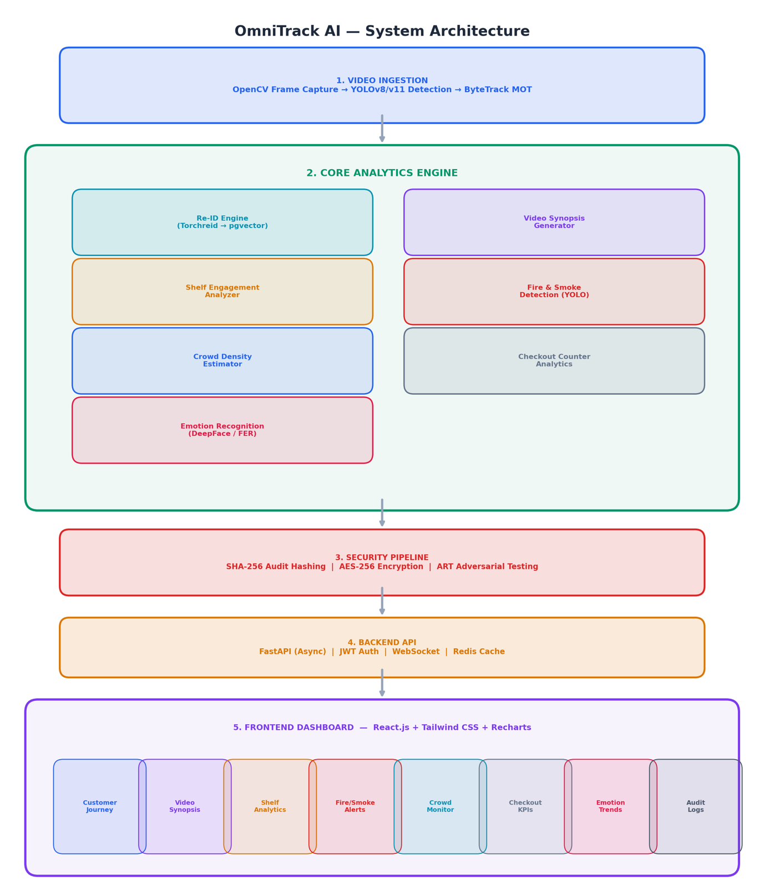

6 Individual Tasks
Team Member | Activity | Tentative Date
Hassan Akhter | Literature Review & Environment Setup | Feb 1 – Feb 28
Zeerak Shahzad | YOLO Detection & ByteTrack Integration | Mar 1 – Mar 28
Asad Arif | FastAPI Backend Development | Mar 29 – May 9
Hassan Akhter | Integration Testing & Final Report | May 3 – May 15
Hassan Akhter | Dataset Collection & Preprocessing | Feb 15 – Feb 28
Zeerak Shahzad | Torchreid Re-ID + Video Synopsis | Mar 1 – Apr 15
Asad Arif | React Frontend & Dashboard Development | Apr 16 – May 9
Asad Arif | Performance Benchmarking | May 10 – May 15
Zeerak Shahzad | pgvector Setup & Vector Search Tuning | Mar 15 – Apr 15
Zeerak Shahzad | SHA-256 / AES-256 Security Pipeline | Mar 29 – Apr 30
Zeerak Shahzad | Adversarial Robustness Testing (ART) | May 1 – May 9
Hassan Akhter | Presentation Preparation | May 10 – May 15

7 Gantt Chart
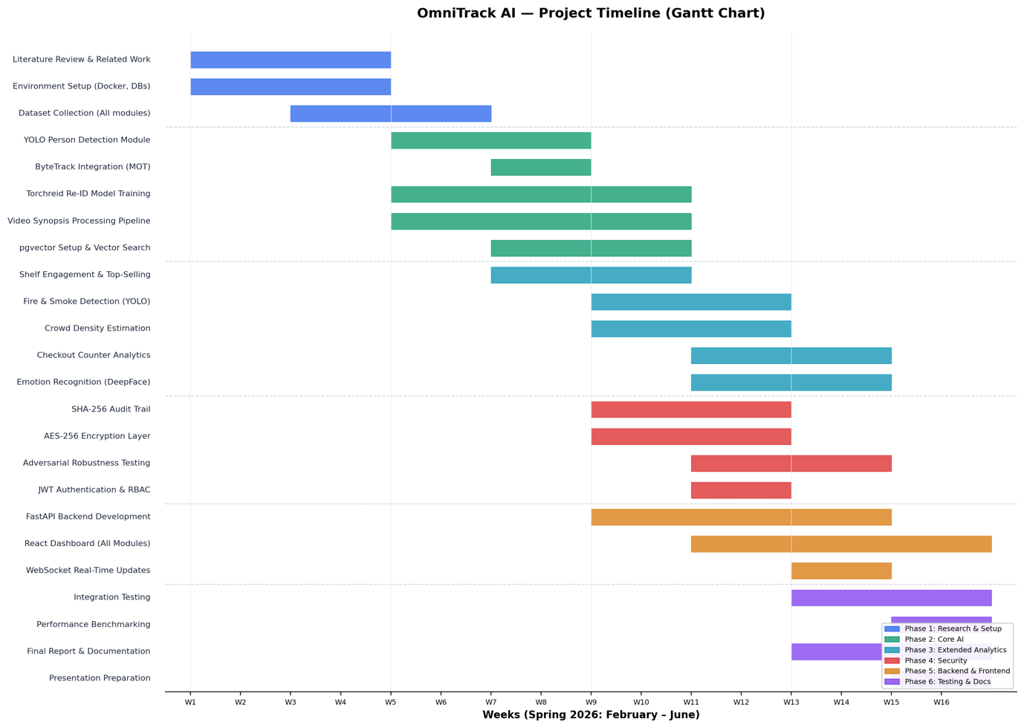
Session: SPRING 2026 Timeline: February to mid-May (15 weeks). The Gantt chart below shows task durations and parallel/serial relationships.

8 Tools and Technologies
Layer | Technologies | Purpose
Vision Engine | Ultralytics (YOLOv8/v11), PyTorch, Torchreid, OpenCV | Person detection, tracking, Re-ID, fire/smoke, video synopsis
Emotion Analysis | DeepFace, FER | Customer sentiment from facial expressions
Vector Database | PostgreSQL with pgvector | Embedding storage, cosine similarity (IVFFlat/HNSW)
Backend API | FastAPI (Async Python) | REST, WebSocket, AI pipeline orchestration
Frontend | React.js, Tailwind CSS, Recharts | Multi-module analytics dashboard
Security | PyCryptodome, JWT, ART | Encryption, audit integrity, adversarial evaluation
DevOps | Docker, Redis, Nginx | Containerization, caching, reverse proxy
Development | Git, GitHub, VS Code, Python 3.11+ | Version control, IDE, scripting

9 References
[1] J. Redmon et al., "You Only Look Once: Unified, Real-Time Object Detection," Proc. IEEE CVPR, 2016, pp. 779-788.
[2] G. Jocher et al., "Ultralytics YOLO," 2023. [Online]. Available: https://github.com/ultralytics/ultralytics
[3] Y. Zhang et al., "ByteTrack: Multi-Object Tracking by Associating Every Detection Box," Proc. ECCV, 2022.
[4] K. Zhou et al., "Omni-Scale Feature Learning for Person Re-Identification," Proc. ICCV, 2019, pp. 3702-3712.
[5] H. Luo et al., "Bag of Tricks and A Strong Baseline for Deep Person Re-identification," Proc. CVPRW, 2019.
[6] L. Zheng et al., "Scalable Person Re-identification: A Benchmark," Proc. ICCV, 2015, pp. 1116-1124.
[7] J. Johnson et al., "Billion-scale similarity search with GPUs," IEEE Trans. Big Data, vol. 7, no. 3, 2021.
[8] A. Kuz, "pgvector: Open-source vector similarity search for Postgres," 2023. [Online]. Available: https://github.com/pgvector/pgvector
[9] I. J. Goodfellow et al., "Explaining and Harnessing Adversarial Examples," Proc. ICLR, 2015.
[10] A. Madry et al., "Towards Deep Learning Models Resistant to Adversarial Attacks," Proc. ICLR, 2018.
[11] M.-I. Nicolae et al., "Adversarial Robustness Toolbox v1.0.0," arXiv:1807.01069, 2018.
[12] K. Muhammad et al., "CNN-Based Fire Detection in Surveillance Videos," IEEE Access, vol. 6, 2018.
[13] F. Saeed et al., "CNN-Based Early Fire Detection," Multimedia Tools and Applications, vol. 79, 2020.
[14] Y. Zhang et al., "Single-Image Crowd Counting via Multi-Column CNN," Proc. CVPR, 2016.
[15] V. A. Sindagi and V. M. Patel, "A Survey of Recent Advances in CNN-based Crowd Counting," Pattern Recog. Letters, 2018.
[16] A. Mollahosseini et al., "AffectNet: A Database for Facial Expression," IEEE Trans. Affective Computing, vol. 10, 2019.
[17] S. I. Serengil and A. Ozpinar, "LightFace: A Hybrid Deep Face Recognition Framework," Proc. IEEE ASYU, 2020.
[18] R. Vezzani and R. Cucchiara, "ViSOR: An Integrated Framework," Multimedia Tools and Applications, vol. 50, 2010.
[19] G. Tonioni et al., "Product Recognition in Store Shelves as a Sub-Graph Isomorphism Problem," Proc. ICIAP, 2017.
[20] Y. Pritch et al., "Nonchronological Video Synopsis and Indexing," IEEE TPAMI, vol. 30, no. 11, 2008.
[21] A. Rav-Acha et al., "Making a Long Video Short: Dynamic Video Synopsis," Proc. IEEE CVPR, 2006.

